Supplementary material
This supplement provides additional definitions, denominators, diagnostics, and reporting information for the nationwide study of therapeutic ERCP in Brazil's Unified Health System, 2021–2025. It reports prespecified analyses without converting unavailable results into null findings.

Policy, coding, and observation chronology
Four national landmarks framed the observation window: the final CONITEC recommendation on July 4, 2019; Portaria SCTIE/MS no. 39 on July 24, 2019; Portaria GM/MS no. 3,728 on December 22, 2020; and the presence of therapeutic ERCP code 0407030255 in the January 2021 SIGTAP archive. The code was absent from the December 2020 archive. January 2021 therefore marks the beginning of a homogeneous coded observation window, not the beginning of ERCP practice in Brazil. Hospitals active in that month were treated as left-censored prevalent users.

Data sources and acquisition boundaries
Supplementary Table 1. Data sources and acquisition boundaries.
Source | Custodian | Analytical role | Sharing boundary
SIH/SUS hospitalisation and procedure-detail records | DATASUS, Ministry of Health | AIH unit, procedure code, diagnoses, residence, provider, in-hospital disposition | Restricted individual rows are not redistributed
CNES-PF | DATASUS | Time-aligned hospital eligibility and capacity context | Public-source acquisition instructions only
Population and municipality geometry | IBGE | Adult denominators, municipal identifiers, geometry, audited city-seat anchors | Publicly documented acquisition route
IVS 2010 | Ipea-linked official source | Static municipal ecological context | No individual socioeconomic interpretation
Supplementary-insurance coverage | ANS | Municipal contextual measure | Contextual, not individual insurance status
OpenStreetMap extract | OpenStreetMap contributors | Road graph (brazil-260822.osm.pbf) | Licence and acquisition route documented
GraphHopper | Local reproducible service | ercp_car route and contour profile | Version/configuration evidence must be mirrored before final integrity
CONITEC, Portarias, SIGTAP | Ministry of Health | Policy and code chronology | Official sources and access dates documented
AIH, Autorização de Internação Hospitalar; ERCP, endoscopic retrograde cholangiopancreatography.
The study used SIH/SUS hospitalisation and procedure-detail records, CNES hospital data, IBGE population and municipality geography, the 2010 municipal IVS, supplementary-insurance coverage, OpenStreetMap road data, GraphHopper routing, and official policy sources. Record-level SUS files, credentials, and unredacted small cells are not distributed.

Code lists, linkage, and cohort construction
Procedure-detail rows containing 0407030255 were collapsed by competence month, provider CNES identifier, and AIH number before linkage. Cohort A contained 91,175 unique AIHs, all exactly linked; 90,146 involved adults. Among 33,888 AIHs with K80.3, K80.4, or K80.5 in a valid diagnostic field, 33,506 involved adults. Nine adult records were excluded because the principal diagnosis belonged to the C23 or C24 family, leaving 33,497 Cohort B AIHs. Duplicate counts were zero, and Cohort B was a strict subset of Cohort A.
Cohort B is an administrative diagnostic phenotype. No chart adjudication, sensitivity or specificity study, or externally validated performance estimate was available.

Variable availability and missing-data handling
Identifiers, linkage keys, procedure presence, first observed coded use, and primary outcomes were not imputed. Municipalities without a valid road anchor remained unknown rather than uncovered. Race or colour was represented by an explicit missing category in the prespecified outcome design because recording may be institutionally patterned. Variables lacking adequate semantic or analytical support were excluded rather than imputed after analysis.
The Aim 4 complete-context analysis included 30,900 of 33,497 Cohort B AIHs, 378 in-hospital deaths, and 360 hospitals. A variable-level decomposition of the 2,597 excluded records was unavailable. State-, year-, hospital-, and cohort-specific missingness patterns were therefore not inferred from aggregate totals.

Cross-aim estimands, denominators, and analysis boundaries
Supplementary Table 2. Cross-aim estimands, denominators, and analysis boundaries.
Component | Cohort / unit | Denominator | Estimand or descriptive target | Inference level | Missingness / unknown rule | Reporting status
Aim 1 observed uptake | Cohort A hospitals | 445 hospitals ever observed | First month of observed coded therapeutic ERCP use | Descriptive | January 2021 active hospitals are left-censored prevalent users | Reported
Aim 1 maintenance | Cohort A hospitals | 390 with a completed first 12-month window | Activity in at least 6 months of the first completed 12-month window | Descriptive | Incomplete windows excluded from the risk set | 252/390 (64.6%); reported
Aim 1 first-observed-use model | Eligible hospital-months | Frozen CNES risk set | Associational model of first observed coded use | Associational | No causal adoption interpretation | Associational; limited events per parameter
Aim 2 ecological equity | Cohort B municipality-years | 27,825 municipality-years | Adult-standardised treated-use gradient across ranked IVS | Ecological associational | Static 2010 IVS; no individual interpretation | SII and RII reported; modified-Poisson inference DOWNGRADE
Aim 2 realised routes | Cohort B routed AIHs | 33,321 routed AIHs | Flow-weighted route-time distribution among treated flows | Descriptive | Unrouted flows excluded from route summaries; no unmet-need inference | Reported
Aim 2 potential reach | Adult municipality-year population | 801,100,903 adult person-years in anchor audit | Population within 120 and cumulative 180 road-minutes of observed provider municipalities | Descriptive modelled opportunity | Invalid anchors remain unknown; one municipality unknown in 2025 | National component reported; regional and vulnerability-gap components NOT_EVALUATED
Aim 3 patient-flow network | Observed residence-to-provider flows and pooled municipal projection | 3,338 nodes; 166,959 shared-destination edges | Destination and shared-destination structure | Descriptive | Public cells below 5 suppressed; no patient-to-patient interpretation | Reported
Aim 3 service areas | Residence municipality-year records | 5,565 municipal IVS records for contextual summaries | Modal observed destination and destination share | Descriptive | Suppressed flows remain suppressed; no need or appropriateness inference | Reported
Aim 3 structural resilience | Potential-access matrix / adults | 8,723,036 matrix rows; 142,299 reachable rows | Adults losing an alternative provider under targeted hub removal | Descriptive structural stress test | Complete-case and upper-bound handling retain unknown anchors | Reported as a structural stress test; not a real-world counterfactual
Aim 4 supportive outcome | Cohort B complete-context AIHs | 30,900 AIHs; 378 deaths; 360 hospitals | Standardised risk contrast at hospital-volume p90 versus p10 | Associational/supportive | Complete-context design; no imputation-based alternative was used | Bootstrap DOWNGRADE; formal CI NOT_EVALUATED
Planned staggered-uptake analysis | Hospital-month design | No pre-first-observed-use hospital-months | Planned quasi-causal family | Not a release result | Structural absence of pre-period observations | Not reported because pre-period observations were unavailable
AIH, Autorização de Internação Hospitalar; ERCP, endoscopic retrograde cholangiopancreatography.

Observed uptake and maintenance diagnostics
Observed uptake was defined as first observed coded use rather than true adoption. Maintenance required coded activity in at least six months of the first complete 12-month window; only hospitals with a fully observable window entered the denominator. The first-observed-use model had limited events per parameter and was interpreted as associational.

Ecological equity, routing, and potential reach
The 2010 municipal IVS was carried forward as a static ranked ecological exposure through 2025. The RII was 0.55 and the SII was -2.56 treated AIHs per 100,000 adults. These estimates do not identify individual socioeconomic effects.
Realised route estimates were available for 33,321 Cohort B AIHs. The flow-weighted median was 23.2 minutes, the 90th percentile was 213.4 minutes, and 20.7% exceeded 120 minutes. Municipal anchors approximate locations rather than patient addresses or observed journeys.
All 456 provider-threshold routing entries were completed. IBGE city-seat anchors were substituted for municipalities 314800, 330010, and 510790 only after their original anchors returned Point not found. Twenty-nine timeout-only municipalities retained their original anchors with a longer runtime. Because raw contours were non-nested for 58 providers, cumulative 180-minute reach used the union of the 120- and 180-minute polygons. Adult person-year anchor coverage was 99.999504%; one municipality remained without a valid anchor in 2025. National 120-minute potential reach increased from 71.9% to 82.1%, and cumulative 180-minute reach from 81.2% to 90.4%. Regional coverage and a municipal vulnerability-gap analysis were not evaluated because the required region mapping and municipality-level IVS join were unavailable.
The prespecified modified-Poisson model produced some standardised potential-coverage predictions above 1. This model family was therefore downgraded and its predictions were excluded from formal inference. The descriptive national coverage series remains reported separately.

Patient-flow network, service areas, privacy, and structural resilience
The pooled municipal projection contained 3,338 nodes and 166,959 shared-destination edges. Public network displays suppressed counts below five, and suppressed values were not imputed. Centrality and service-area summaries do not establish referral quality, capacity, or appropriateness.
Structural resilience was examined by sequential removal of prespecified high-in-strength hubs and comparison with seeded random removal at k=1, 5, 10, and 20. Each threshold-scenario used 1,000 replicates with seed 20260830. Random 2.5th–97.5th percentile envelopes are simulation benchmarks, not confidence intervals. At 180 minutes, targeted removal of 5, 10, and 20 hubs newly uncovered 11.3, 25.5, and 33.5 million adults, compared with random means of 3.1, 6.4, and 12.3 million. The stress test does not model facility closure, capacity redistribution, behavioural adaptation, or actual rerouting.
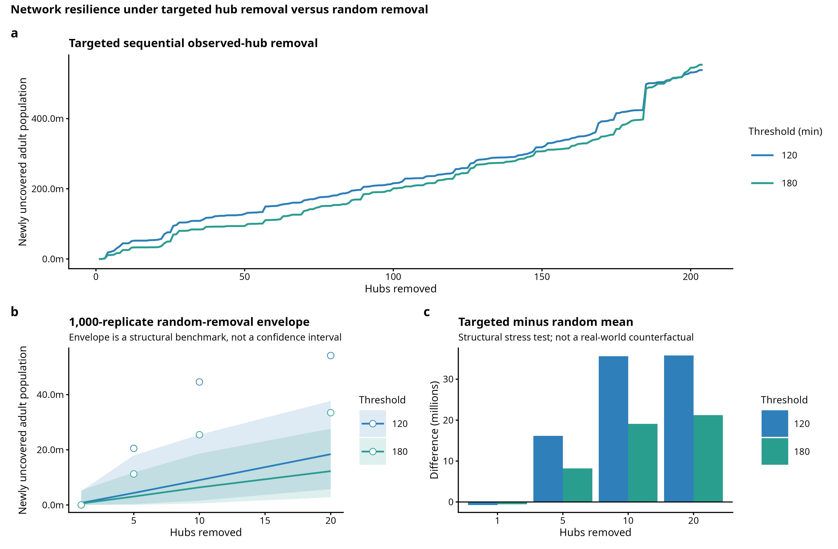
Supplementary Figure 1. Structural hub-removal stress test. Targeted high-in-strength hub removal is compared with seeded random-removal benchmarks. This is a structural stress test, not a prediction of real-world closure or rerouting.

Supportive in-hospital outcome analysis
The outcome was in-hospital death. Exposure was trailing 12-month all-indication unique Cohort A ERCP AIH volume at the treating hospital, represented by a four-knot restricted cubic spline. The complete model included prespecified patient, hospital, contextual, provider-state, and calendar-month terms. ICU use, length of stay, reimbursement, and other post-exposure variables were excluded. Reimbursement is a payment field, not a measure of cost.
Separation diagnostics triggered two prespecified bias-reduced estimators. Standardised risks at volume p10 and p90 were 0.014341850368641714 and 0.014306146454349527; the risk difference was -0.000035703914292186875 and the risk ratio was 0.9975105085205566. These are associational point estimates. Their numerical proximity does not establish no association or equivalence.
The hospital-cluster bootstrap used 2,000 replicates and seed 20260830. Formal inferential reporting required at least 1,900 valid replicates; 1,800–1,899 would support exploratory reporting, and fewer than 1,800 required downgrade. Only 618 AS_mean and 617 MPL_Jeffreys replicates were valid. Formal percentile intervals were therefore not evaluated, and bootstrap quantiles are not presented as confidence intervals. Among failed replicates, AS_mean had 726 nonconvergence and 656 rank-deficient failures; MPL_Jeffreys had 726 nonconvergence, 656 rank-deficient failures, and one unclassified failure. These categories concern computational validity rather than clinical heterogeneity. No reduced model, altered seed, lower replicate target, or substitute interval was used.

Planned quasi-causal analysis
No hospital-months preceded first observed coded use, so the prespecified causal eligibility condition could not be met. Quasi-causal estimates, negative controls, and associated robustness analyses are not presented. This absence is not a null finding.

Additional figure and tables
Supplementary Table 3. Ecological equity, travel, potential reach, and network measures.
Measure | Value | Denominator | Evidence | Key limitation
IVS relative index of inequality | 0.55 | 27,825 municipality-years | associational | IVS is an ecological contextual exposure and does not identify individual socioeconomic effects.
IVS slope index of inequality | -2.56 treated AIHs per 100,000 adults | 27,825 municipality-years | associational | IVS is an ecological contextual exposure and the association is not causal.
Flow-weighted median realised route time | 23.2 minutes | 33,321 AIHs with a route | descriptive | Municipal anchors approximate residence and provider locations; this is realised treated flow, not direct patient travel.
Flow-weighted 90th percentile realised route time | 213.4 minutes | 33,321 AIHs with a route | descriptive | Municipal anchors approximate residence and provider locations; this is realised treated flow, not direct patient travel.
Realised treated flow above 120 minutes | 20.7% | 33,321 AIHs with a route | descriptive | This describes routed treated flows and cannot be interpreted as population access or unmet need.
Adult population within 120 road-minutes in 2021 | 71.9% | 157,421,555 adults | descriptive | Modelled potential road access does not measure realised access, capacity, quality, or need.
Adult population within 180 road-minutes in 2021 | 81.2% | 157,421,555 adults | descriptive | The cumulative 180-minute estimand unions raw 120- and 180-minute contours when GraphHopper approximation is non-nested.
Adult population within 120 road-minutes in 2025 | 82.1% | 163,078,720 anchored adults | descriptive | One 2025 municipality lacks a road anchor; anchored-denominator and bounds must be reported.
Adult population within 180 road-minutes in 2025 | 90.4% | 163,078,720 anchored adults | descriptive | One 2025 municipality lacks a road anchor; the cumulative geometry rule and bounds must be retained.
Adult population road-anchor coverage | 99.9995% | 801,100,903 adult person-years | descriptive | Municipalities without anchors remain unknown and are never recoded as uncovered.
Aim 2 primary-family inferential status | DOWNGRADE | — | associational | Modified-Poisson standardized potential-coverage predictions exceeded probability 1; the model was not rerun or relaxed.
Pooled patient-flow projection nodes | 3,338 municipalities | — | descriptive | The patient-flow network reflects observed treated flows, not population need or referral appropriateness.
Pooled patient-flow projection edges | 166,959 edges | — | descriptive | Projection edges encode shared performing destinations and are not direct patient-to-patient links.
Potential-access matrix rows | 8,723,036 rows | — | descriptive | This is a modelled potential-access matrix and contains no capacity or realised-use inference.
Reachable potential-access matrix rows | 142,299 rows | 8,723,036 potential-access matrix rows | descriptive | Reachability is potential road access, not observed service use or capacity.
IVS municipal-total records selected | 5,565 municipalities | — | descriptive | The 2010 IVS is a static ecological contextual exposure carried across 2021-2025.
AIH, Autorização de Internação Hospitalar; ERCP, endoscopic retrograde cholangiopancreatography.
Supplementary Table 4. Supportive outcome-analysis measures and inferential limitations.
Measure | Value | Denominator | Evidence | Key limitation
Aim 4 complete primary analysis rows | 30,900 AIHs | 33,497 Cohort B unique AIHs | associational | Complete-context restriction and residual confounding limit generalisability and causal interpretation.
Aim 4 in-hospital death events | 378 deaths | 30,900 Aim 4 analysis AIHs | associational | Administrative in-hospital death does not capture post-discharge mortality.
Aim 4 hospitals | 360 hospitals | 30,900 Aim 4 analysis AIHs | associational | Hospital-level associations remain susceptible to residual confounding and referral selection.
Aim 4 bootstrap validity status | DOWNGRADE | 2,000 expected replicates | associational | The prespecified bootstrap validity criterion was not met; no reduced model or substitute interval was used.
Valid AS_mean bootstrap replicates | 618 replicates | 2,000 expected replicates | associational | Valid-replicate yield was below the prespecified threshold; inferential intervals are downgraded.
Valid MPL_Jeffreys bootstrap replicates | 617 replicates | 2,000 expected replicates | associational | Valid-replicate yield was below the prespecified threshold; inferential intervals are downgraded.
Planned quasi-causal analysis | Not reported | — | associational | No pre-first-observed-use hospital-months were available; quasi-causal estimates and negative controls are not reported.
AIH, Autorização de Internação Hospitalar; ERCP, endoscopic retrograde cholangiopancreatography.

RECORD reporting checklist
Supplementary Table 5. RECORD reporting checklist.
RECORD item group | Locator | Status
Routinely collected data source and setting | Methods: Data sources; the supplementary data-sources section | Reported
Code/algorithm-based population selection | Methods: Cohorts; the supplementary cohort-construction section | Reported
Validation of codes/algorithms | Discussion limitations; the supplementary cohort-construction section | No chart validation available; explicitly stated
Linkage methods and quality | Methods: Cohorts; the supplementary cohort-construction section | Exact linkage rule reported; reason-specific intermediate breakdown unavailable
Data cleaning and deduplication | Methods: Cohorts; the supplementary cohort-construction section | Reported
Data access and privacy | Data availability; the supplementary sections ‘Data sources and acquisition boundary’ and ‘Aim 3 patient-flow network, service areas, privacy, and resilience’ | Reported
Flow of records and exclusions | Figure 1; the supplementary sections ‘Code lists, linkage, and cohort construction’ and ‘Variable availability and missing-data handling’ | Aggregate flow reported; reason-specific intermediate breakdown unavailable
Extent of database access for replication | Code/Data availability; the supplementary reproducibility and declarations section | Reported with restricted-row boundary
AIH, Autorização de Internação Hospitalar; ERCP, endoscopic retrograde cholangiopancreatography.

STROBE reporting checklist
Supplementary Table 6. STROBE reporting checklist.
STROBE item | Locator | Status
Title/abstract design | Title; Structured abstract | Reported
Background and objectives | Introduction | Reported
Study design, setting, dates | Methods: Study design | Reported
Participants and eligibility | Methods: Cohorts; the supplementary cohort-construction section | Reported
Variables, outcomes, exposures, confounders | Methods by aim; the supplementary estimand map and Aim 4 section | Reported
Data sources and measurement | Methods: Data sources; the supplementary sections on data sources and the aim-specific methods | Reported
Bias | Methods: Missing data; Discussion limitations | Reported
Study size | National administrative census; the supplementary estimand map | Reported; no sampling power calculation used
Quantitative variables and statistical methods | Methods by aim; the supplementary estimand map and aim-specific sections | Reported
Missing data | Methods; the supplementary missing-data section | Reported within frozen local evidence limits
Participants and descriptive data | Results; Figures 1–2; Tables 1–2 | Reported
Outcome and main results | Results; Figures 3–6, Supplementary Figure 1, and Supplementary Tables 5–6 | Reported with downgrades
Other analyses | the supplementary aim-specific and quasi-causal eligibility sections | Reported; planned quasi-causal estimates excluded
Key results, limitations, interpretation, generalisability | Discussion | Reported
Funding | Declarations | Pending author metadata
AIH, Autorização de Internação Hospitalar; ERCP, endoscopic retrograde cholangiopancreatography.

