Completion of Cholecystectomy by Index Discharge and 90-Day Biliary-or-Acute-Pancreatitis Readmission After Coded Mild Biliary Acute Pancreatitis: A Nationwide NRD Study
Shuo Feng, Chao Shi, Tianming Liu, Haoran Ding, Fenghe Hang, Zhenghao Huang, Liwei Liu*
Provincial Key Laboratory of Hepatosplenic Surgery, The First Affiliated Hospital of Harbin Medical University
*Corresponding author: Liwei Liu, 18940835066@163.com

Abstract
Background. Guidelines recommend same-admission cholecystectomy for suitable patients with mild biliary acute pancreatitis. Contemporary national estimates using a common discharge time zero and explicit readmission definitions are limited. We estimated 90-day inpatient readmission by cholecystectomy completion at index discharge.
Methods. We analysed the 2018–2022 Nationwide Readmissions Database. Adults with coded mild biliary acute pancreatitis (principal K85.10 plus prespecified exclusions for severe-disease proxies) who were discharged alive from January through September were included. We compared cholecystectomy recorded before discharge with no recorded index-admission cholecystectomy. The primary outcome was 90-day inpatient readmission for biliary disease or acute pancreatitis. Overlap weighting with hospital-clustered bootstrap intervals estimated the adjusted association.
Results. Among 82,948 patients discharged alive, 34,530 had no recorded index-admission cholecystectomy and 48,418 had completed cholecystectomy by discharge. Standardized risks were 11.4% and 2.7%, respectively. The adjusted risk difference was 8.7 percentage points (95% CI, 8.3–9.1); risk was 4.18-fold higher without recorded cholecystectomy. Estimates were similar across prespecified sensitivity analyses.
Conclusion. In this selected national discharge-survivor cohort, completion by index discharge was associated with fewer observed 90-day inpatient biliary-or-acute-pancreatitis readmissions. The study provides a contemporary discharge-anchored benchmark, but incomplete capture of operative fitness and clinical severity limits causal interpretation.
Keywords: acute pancreatitis; cholecystectomy; readmission; administrative data; Nationwide Readmissions Database; overlap weighting.

Introduction
Mild biliary acute pancreatitis can be followed by recurrent biliary events, recurrent pancreatitis, and avoidable hospital use. Clinical guidelines recommend cholecystectomy during the index admission for patients who are suitable for surgery [1,2]. In the PONCHO randomised trial, same-admission surgery reduced recurrent gallstone-related complications compared with interval surgery [3], and its economic analysis supported the same strategy [4]. A large administrative-database study also found lower 30-day readmission among patients who underwent cholecystectomy during the index admission [5]. These studies establish the clinical importance of operative timing while leaving room to describe how recorded discharge status relates to subsequent inpatient use in contemporary national data.
Two interpretive issues are central to a claims-based analysis. First, cholecystectomy recorded by discharge is a post-admission status and should be distinguished from the causal effect of assigning a surgical strategy at admission. Second, a later K85.* diagnosis identifies acute pancreatitis but does not establish a biliary cause; broad pancreatitis readmissions therefore should be reported alongside narrower biliary components. Claims data also incompletely capture physiologic severity and operative fitness, so the estimand must be stated in terms of observed discharge status.
The Nationwide Readmissions Database supports this question by providing nationally sampled inpatient encounters with annual linkage and a common discharge date from which post-discharge events can be counted. A reproducible claims phenotype, a prespecified outcome hierarchy, and separate reporting of broad and narrower components make the observed readmission burden easier to interpret. These features complement, rather than replace, randomised evidence about treatment strategies.
We therefore used the 2018–2022 Nationwide Readmissions Database to compare patients with coded mild biliary acute pancreatitis who had a cholecystectomy recorded before index discharge with those without a recorded index-admission cholecystectomy. The primary endpoint was inpatient biliary-or-acute-pancreatitis readmission within 90 days after discharge. We estimated an adjusted discharge-status association and examined its stability under alternative claims definitions and adjustment sets.

Methods
Data source and design. We used the 2018–2022 Healthcare Cost and Utilization Project Nationwide Readmissions Database (NRD), which contains nationally sampled inpatient encounters and an annual patient linkage number [6]. Linkage and time-to-event variables were used only within the same calendar year. The analytic framework drew on doubly robust estimation [7] and double/debiased machine learning [8]. HFRS was considered as a frailty descriptor [9], and coded mild disease was distinguished from the Revised Atlanta clinical classification [10]. Reporting followed the RECORD statement [11], the NRD documentation defined the linkage, weighting, and small-cell rules [12], and the STROBE statement guided reporting of the observational study [13]. This was a retrospective adjusted-association study; the estimand was defined by recorded discharge status. Annual cohort and linkage reporting are provided in Supplementary Table S2.
Cohort and exposure. Adults aged 18 years or older with a principal K85.10 diagnosis were eligible. We excluded records with coded shock, acute respiratory failure, severe sepsis, invasive mechanical ventilation, or renal replacement therapy. We retained patients discharged alive from January through September and selected the earliest eligible admission for each annual linkage number. This phenotype is described as coded mild and is not equivalent to clinically adjudicated Revised Atlanta mild disease [8]. Administrative definitions of pancreatitis can be reproducible, but their validity depends on the code hierarchy and setting [14]. Cholecystectomy was identified from any procedure field beginning 0FT4 and verified against the procedure-day field. A0 denoted no recorded index-admission cholecystectomy; A1 denoted completion before index discharge. The eligibility gates and exposure split are shown in Figure 1a. The phenotype rules are detailed in Supplementary Table S1.
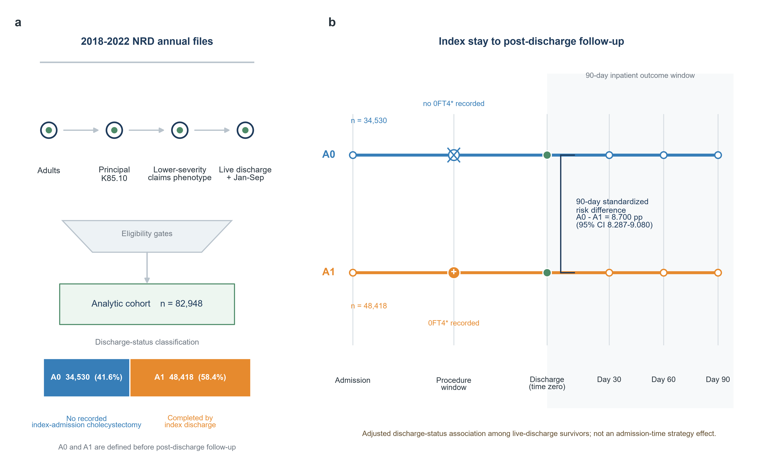
Figure 1. Cohort flow and discharge-anchored follow-up. (a) Annual NRD files pass through the eligibility criteria to the analytic cohort (n=82,948), which is divided into A0=34,530 and A1=48,418. (b) Both groups share index-discharge time zero and 90-day inpatient follow-up. A1 denotes cholecystectomy recorded before discharge; A0 denotes no recorded index-admission cholecystectomy.
Procedure-day information confirmed that the operation occurred before discharge and was not included as a baseline covariate. ERCP-compatible procedures, cholecystostomy, and biliary exploration were treated as care delivered during the index admission and were not included in the strict adjustment model because they may reflect the clinical trajectory leading to surgery.
Outcome and time zero. Time zero was the index discharge date. Follow-up began on post-discharge day 1 and ended at the first qualifying inpatient readmission or 90 days, within the same calendar year. The primary composite required a principal diagnosis beginning K80, K81, K83.0, or K85. Because K85.* includes acute pancreatitis that is not necessarily biliary, the primary endpoint is termed biliary-or-acute-pancreatitis readmission. K80.*, K81.*, K83.0, K85.*, and K85.1* were reported as separate components; the complete coding hierarchy is provided in Supplementary Table S1. The shared time zero and follow-up paths are shown in Figure 1b.
Covariates. The strict primary model included age, sex, payer, ZIP-code income quartile, residence, emergency or elective admission, weekend admission, year, quarter, hospital size, urbanicity, teaching status, ownership, and observed hospital use during the preceding 90 days. Acute same-admission diagnoses, Elixhauser proxies, Hospital Frailty Risk Score (HFRS), APR-DRG variables, procedures, length of stay, charges, discharge destination, and other post-admission variables were excluded from the primary model. Chronic diagnosis proxies and an expanded adjustment set were evaluated only in sensitivity analyses. HFRS was not used as a primary covariate because its diagnosis inputs are not reliably pre-admission in this setting [9]. Administrative-data pancreatitis phenotypes require explicit diagnosis definitions and validation context [14]. The Elixhauser framework and its mortality-weighted modification are established administrative comorbidity approaches [15,16], while ICD-9/10 coding algorithms require attention to diagnosis definitions and coding context [17]. Missing categorical values were retained as explicit categories, and NRD small-cell protections were applied. The strict-model specification and balance definitions are provided in Supplementary Table S5.

The annual NRD design was respected throughout. We selected the earliest qualifying admission within each annual linkage number, did not link patients across calendar years, and restricted discharge dates to January through September so that a 90-day observation window was available before year end. Discharge weights, NRD strata, and hospital identifiers were retained for estimation and resampling. Annual cohort and linkage counts are provided in Supplementary Table S2.

Full covariate balance, annual crude primary-event proportions, robustness intervals, and annual record-reporting diagnostics are shown in Supplementary Figure S1, Supplementary Figure S2, Supplementary Figure S3, and Supplementary Figure S4; complete balance values are provided in Supplementary Table S6.
Statistical analysis. We estimated design-weighted standardized risks in the overlap population. Overlap weighting targets the covariate patterns represented in both exposure groups [10]. An augmented inverse-probability weighted estimator was used for the primary risk difference [11], with hospital-grouped five-fold nuisance fitting based on double/debiased machine-learning principles [12]. Propensity-score methods and matching provide the conceptual basis for measured-confounder adjustment [18–20], and target-trial guidance informed the distinction between discharge status and an admission-time treatment strategy [21]. The reported risk difference was the standardized risk in A0 minus the standardized risk in A1. Effective sample sizes and standardized mean differences were reported as diagnostics of measured overlap. Supplementary Table S3, Supplementary Table S4, Supplementary Table S7, and Supplementary Table S8 provide data-completeness, event-reconciliation, bootstrap, and robustness details.Supplementary Table S3, Supplementary Table S4, Supplementary Table S7, and Supplementary Table S8 provide data-completeness, event-reconciliation, bootstrap, and robustness details.
The primary 95% confidence interval was obtained from 1,000 hospital-cluster bootstrap replicates sampled within NRD strata, with the nuisance models refitted in each replicate. Cluster-robust bootstrap methods and practical guidance for clustered inference informed the resampling specification [22,23]. Component outcomes and robustness analyses used labelled fixed-score hospital-cluster bootstrap intervals and were interpreted as supportive analyses.
Sensitivity analyses compared chronic-diagnosis and expanded adjustment sets with the strict model and varied cohort or linkage restrictions: resident-only admissions, APR-DRG severity levels 1–2, exclusion of all J96 respiratory-failure codes, and a broad K85.1* index phenotype. Sensitivity analysis for unmeasured confounding was treated as an interpretive aid rather than proof of exchangeability [24,25]. We did not convert these associations into a treatment-prioritization rule or a policy projection.

Results
The analytic cohort comprised 82,948 patients discharged alive, including 34,530 A0 and 48,418 A1 admissions. Figure 1a shows the eligibility gates and exposure split; Figure 1b shows the shared discharge time zero and 90-day follow-up. After overlap weighting, the maximum absolute standardized mean difference was 0.0049, and effective sample sizes were 29,011 in A0 and 40,052 in A1 (Table 1 and Figure 2a,b). Annual descriptive trends are shown in Figure 2c, with the complete balance display in Supplementary Figure S1 and Supplementary Table S6.
Table 1. Cohort characteristics and strict-model covariate balance
Characteristic | A0  unweighted | A1  unweighted | A0  weighted | A1  weighted | |SMD|  weighted
Age, years (mean) | 60.89 | 54.32 | 57.67 | 57.66 | 0.0005
Female sex, % | 56.8 | 63.0 | 58.7 | 58.7 | 0.0003
Prior admissions in observed 90-day lookback (mean) | 0.50 | 0.28 | 0.37 | 0.37 | 0.0004
Prior biliary admission in observed 90-day lookback, % | 6.9 | 3.5 | 5.0 | 5.0 | 0.0005
Prior acute-pancreatitis admission in observed 90-day lookback, % | 2.6 | 1.7 | 2.3 | 2.3 | 0.0006
Medicare, % | 47.2 | 33.8 | 41.0 | 41.0 | 0.0001
Medicaid, % | 16.4 | 19.4 | 16.8 | 16.8 | 0.0006
Private insurance, % | 29.7 | 38.1 | 34.2 | 34.2 | 0.0002
Lowest ZIP income quartile, % | 24.2 | 25.2 | 26.2 | 26.2 | 0.0002
Resident of hospital state, % | 95.1 | 95.2 | 94.6 | 94.6 | 0.0009
Emergency-department record, % | 58.7 | 58.0 | 58.8 | 58.8 | 0.0003
Elective admission, % | 2.1 | 2.1 | 2.4 | 2.4 | 0.0013
Weekend admission, % | 27.0 | 28.0 | 27.4 | 27.4 | 0.0002
Large hospital bed size, % | 49.2 | 51.8 | 49.9 | 49.9 | 0.0003
Urban teaching hospital, % | 70.0 | 72.2 | 70.7 | 70.7 | 0.0001
Private nonprofit hospital, % | 76.2 | 76.9 | 77.5 | 77.4 | 0.0002
Calendar year 2018, % | 22.0 | 20.9 | 21.8 | 21.8 | 0.0004
Calendar quarter 1, % | 32.9 | 33.3 | 33.1 | 33.1 | 0.0002
A0, no recorded index-admission cholecystectomy; A1, completion by index discharge. Values are percentages except age and prior admissions, which are means. The strict model includes demographics, admission context, payer/income/residence, calendar, hospital characteristics, and prior observed utilisation. Acute same-admission diagnoses and HFRS were excluded. SMD, standardized mean difference.
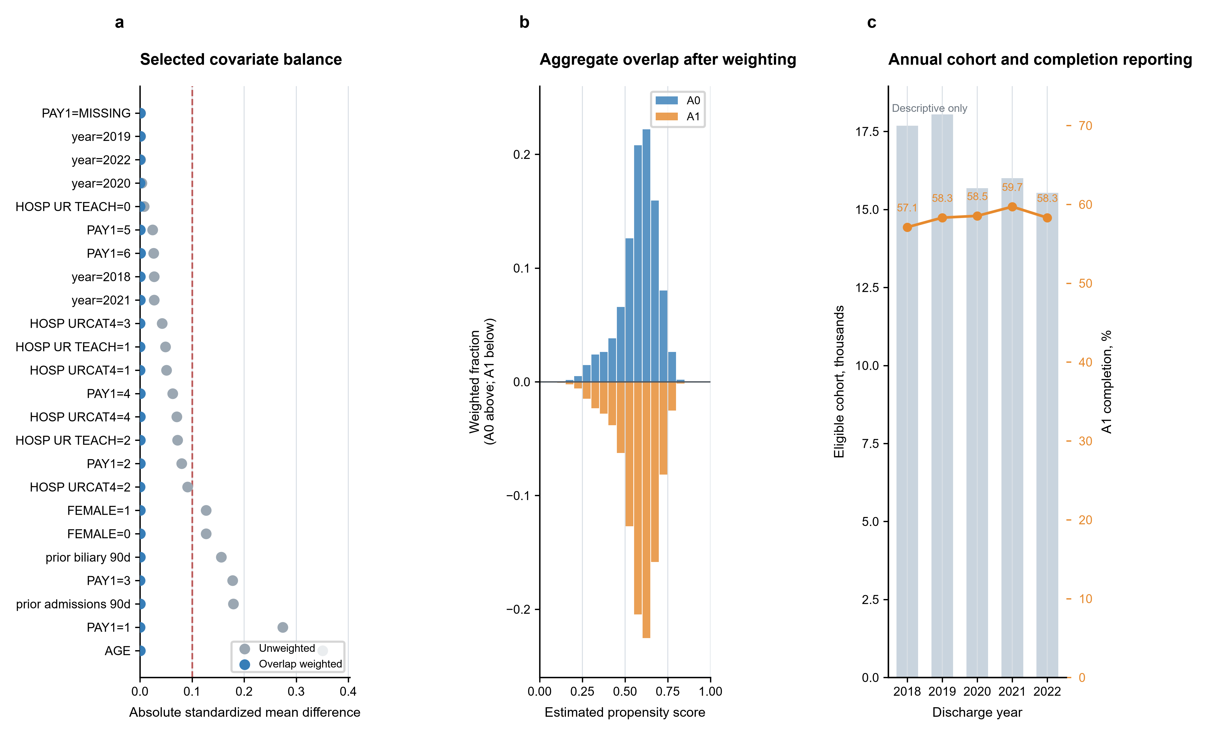
Figure 2. Strict-model covariate balance, overlap, and annual descriptive trends. (a) Absolute standardized differences for selected measured covariates before and after overlap weighting; the dashed line marks 0.10. (b) Weighted propensity-score distributions by discharge status. (c) Annual eligible cohort size and the proportion with A1.
There were 3,911 observed primary events in A0 and 1,291 in A1. Standardized primary-outcome risks were 11.438% and 2.738%, respectively. The adjusted association risk difference was 8.700 percentage points (95% CI, 8.287–9.080), and the A0-to-A1 risk ratio was 4.18 (Table 2 and Figure 3a,b).
Table 2. Primary and component readmission associations
Outcome or analysis | Role | A0 events/n | A1 events/n | A0 risk % | A1 risk % | RD pp (95% CI) | RR | Interval
Biliary-or-acute-pancreatitis readmission (K80.*, K81.*, K83.0, or K85.*) | Primary | 3,911 / 34530 | 1,291 / 48418 | 11.438 | 2.738 | 8.700 (8.287 to 9.080) | 4.18 | corrected full-refit
Cholelithiasis readmission (K80.*) | Key secondary | 1,320 / 34530 | 136 / 48418 | 3.775 | 0.275 | 3.500 (3.266 to 3.714) | 13.71 | fixed-score
Cholecystitis readmission (K81.*) | Supportive component | 135 / 34530 | <11 / 48418 | 0.374 | 0.007 | 0.367 (0.306 to 0.439) | 52.99 | fixed-score
Cholangitis readmission (K83.0) | Supportive component | 29 / 34530 | 13 / 48418 | 0.074 | 0.030 | 0.044 (0.012 to 0.079) | 2.47 | fixed-score
Acute-pancreatitis readmission (K85.*) | Key secondary | 2,528 / 34530 | 1,145 / 48418 | 7.514 | 2.437 | 5.077 (4.739 to 5.444) | 3.08 | fixed-score
Biliary acute-pancreatitis readmission (K85.1*) | Sensitivity component | 1,601 / 34530 | 293 / 48418 | 4.716 | 0.606 | 4.110 (3.864 to 4.342) | 7.78 | fixed-score
All estimates compare A0 with A1 in the design-weighted overlap population, so positive risk differences favour A1. The primary composite has the only full nuisance-refit hospital-cluster bootstrap interval. Component intervals use a fixed-score hospital-cluster bootstrap and are supportive. Figure 4 and Supplementary Table S7 report the six sensitivity analyses. Counts 1-10 are suppressed as <11.
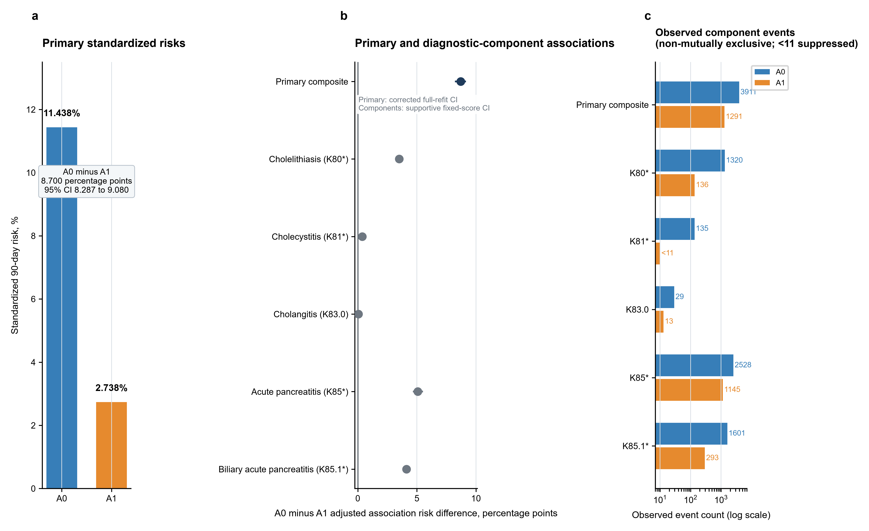
Figure 3. Ninety-day inpatient readmission associations for the primary and component outcomes. (a) Standardized primary-outcome risks in A0 and A1. (b) Adjusted A0-minus-A1 risk differences. (c) Component-outcome risks and event distributions.
For K80.* readmission, standardized risks were 3.775% in A0 and 0.275% in A1. For all K85.* readmission, the corresponding risks were 7.514% and 2.437%; for K85.1*, they were 4.716% and 0.606%. K81.* and K83.0 events were less frequent, with small-cell suppression where required. Component events were not summed because a patient could contribute more than one component across different readmissions; component patterns are displayed in Figure 3c.
The association was similar after chronic-diagnosis proxy adjustment and in the expanded adjustment model. Resident-only, APR-DRG severity, J96 exclusion, and broad K85.1* phenotype analyses are shown in Figure 4a–d and Supplementary Table S7. Complete robustness values are provided in Supplementary Table S8 and Supplementary Figure S3; feature-set estimates are tabulated in Supplementary Table S10.
The resident-only analysis had an adjusted risk difference of 8.867 percentage points (95% CI, 8.457–9.281). Restricting APR-DRG severity to levels 1–2 gave 8.845 percentage points (8.331–9.368), and the broad K85.1* phenotype gave 9.215 percentage points (8.821–9.627). These intervals are supportive because they used fixed-score rather than full nuisance-refit resampling.
Excluding all J96 respiratory-failure codes produced an adjusted risk difference of 8.676 percentage points (95% CI, 8.269–9.080). Across the prespecified phenotype and adjustment restrictions, the direction and approximate magnitude were stable. The estimates remain associations based on variables available in the NRD. Effect-scale, interval-method, and effective-sample-size diagnostics are shown in Figure 5; annual cohort and hospital-year practice summaries are shown in Figure 6.
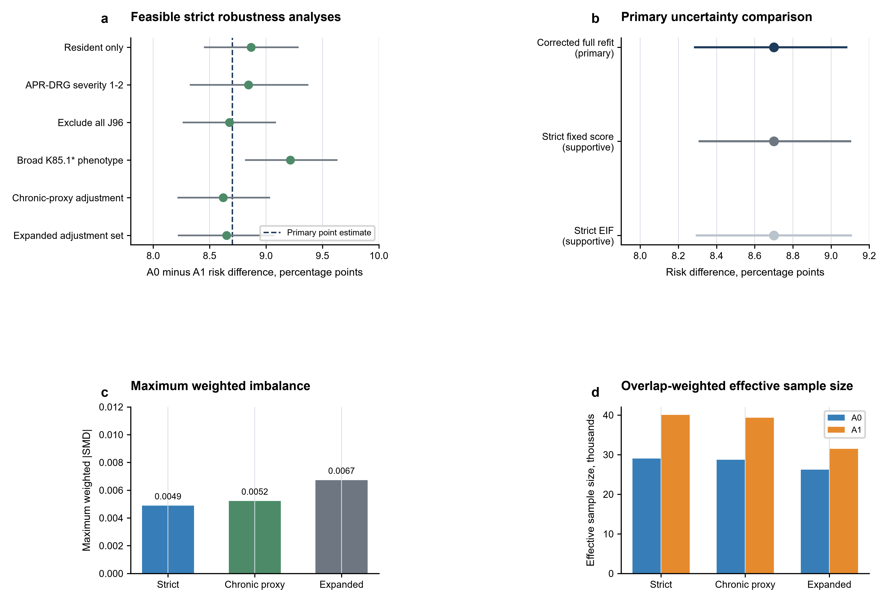
Figure 4. Stability across prespecified robustness analyses. (a) Six supportive analyses compared with the primary point estimate. (b) The primary interval compared with supportive fixed-score intervals. (c) Maximum weighted absolute standardized mean differences for the three adjustment sets. (d) Overlap-weighted effective sample sizes.
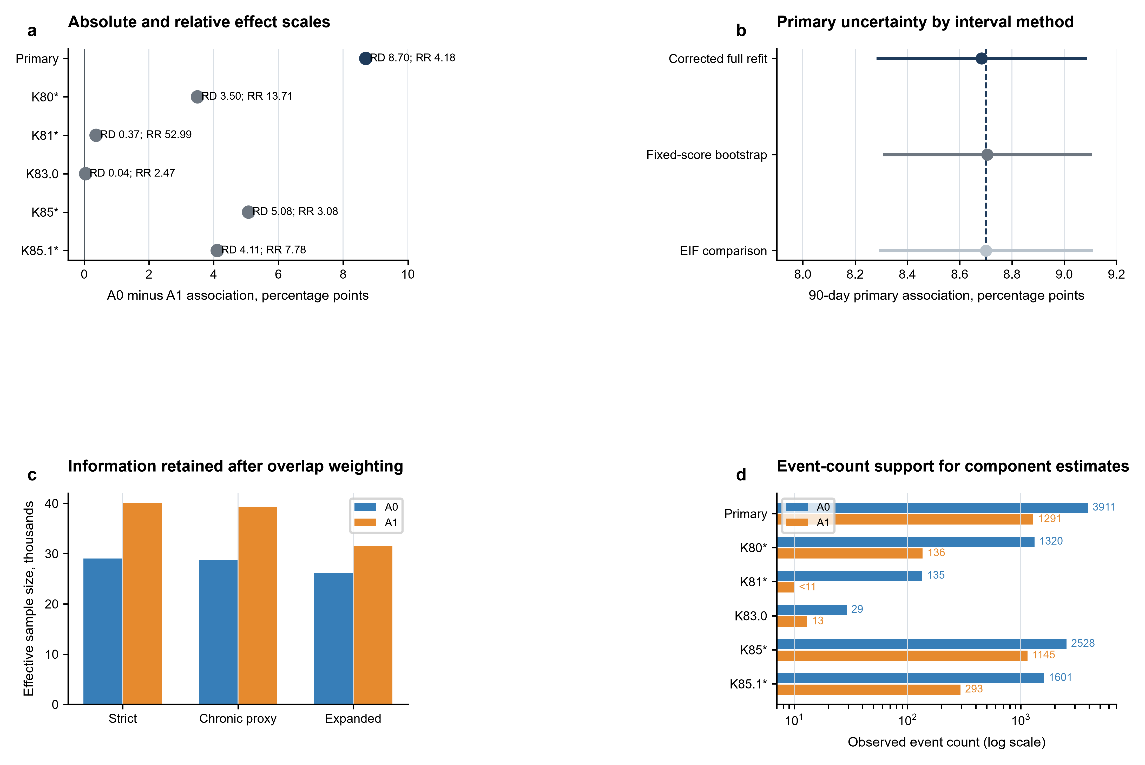
Figure 5. Effect-scale and uncertainty diagnostics. (a) Absolute risk differences and risk ratios for the primary and component outcomes; (b) primary-outcome intervals under corrected full-refit, fixed-score bootstrap, and EIF comparison; (c) effective sample sizes under the three adjustment sets; (d) observed event counts supporting component estimates.
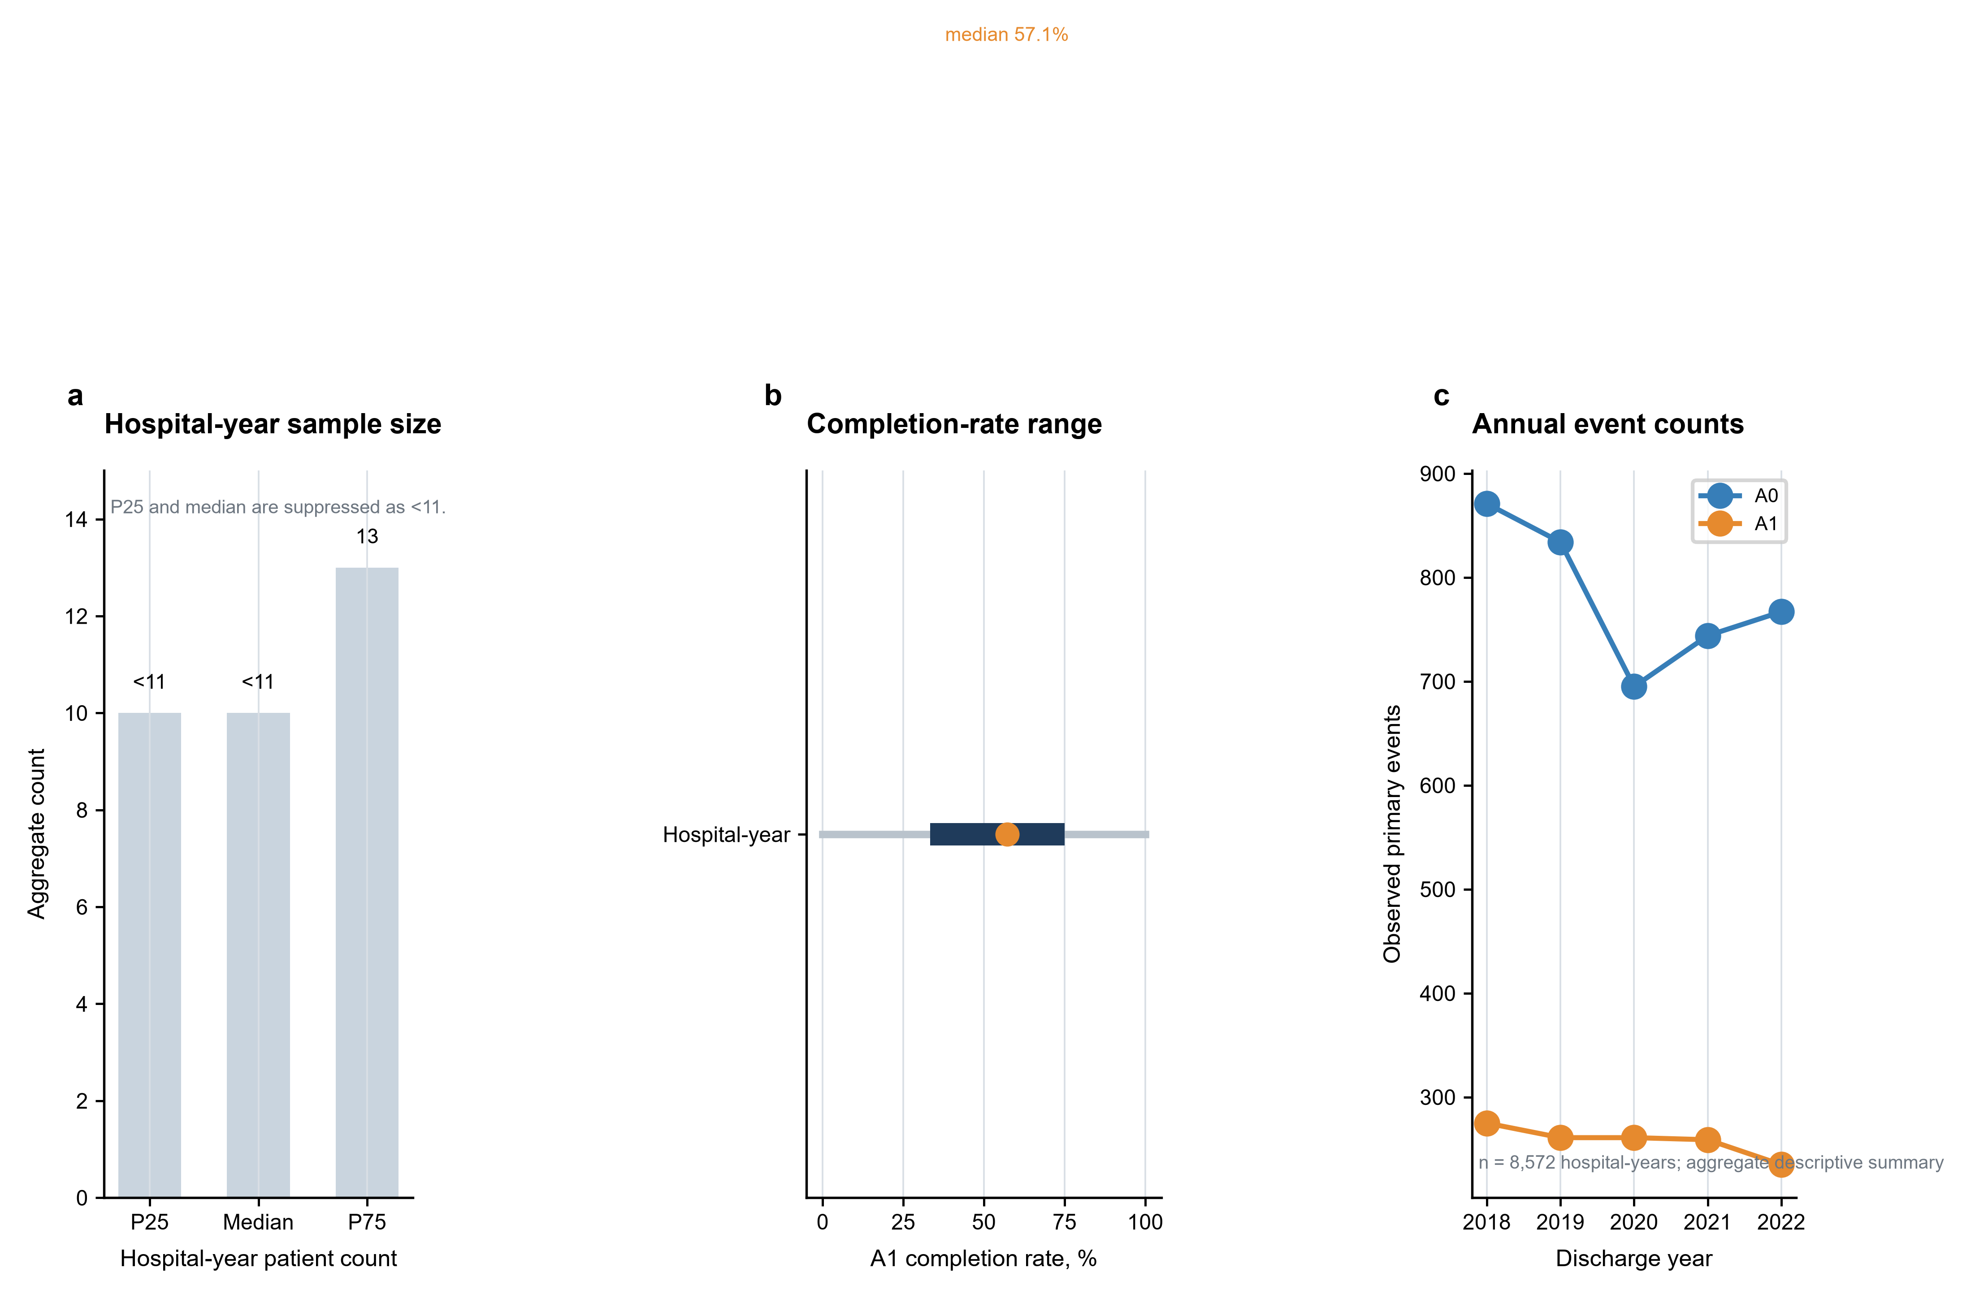
Figure 6. Annual cohort and hospital-year practice summaries. (a) Aggregate hospital-year patient-count summary; (b) hospital-year completion-rate range; (c) annual observed primary-event counts. All hospital panels are descriptive summaries and are not hospital quality rankings or causal comparisons.
Figures 5 and 6 provide effect-scale, annual-composition, and hospital-practice context without changing the primary estimand.

Discussion
In this selected national cohort of patients discharged alive, cholecystectomy completed by index discharge was associated with a substantially lower observed 90-day inpatient biliary-or-acute-pancreatitis readmission risk. The association was similar across the prespecified adjustment and cohort sensitivities. Earlier national and administrative studies have also linked recorded cholecystectomy or biliary care with subsequent readmission patterns [26–28]. The estimand distinction is consistent with target-trial guidance for observational data [21]. Annual cohort reporting is provided in Supplementary Table S12.
The study contributes a contemporary 2018–2022 national benchmark with a clearly defined discharge-time comparison and an explicit hierarchy of biliary and pancreatitis outcomes. Studies of index-admission surgery, early unplanned readmission, and ERCP in patients without cholecystectomy provide complementary context [29–32]. Separating K85.* from K85.1* avoids treating every pancreatitis readmission as biliary. The design improves interpretability of administrative data without claiming to measure clinical eligibility for surgery.
PONCHO directly compared same-admission with interval cholecystectomy in selected patients and therefore addressed a treatment-strategy question [3]. The present analysis begins among patients who survived to discharge and compares recorded completion status. Observational studies of early surgery, frail older adults, and interval waiting time have reported differences in outcomes across clinical contexts [33–36]. The present analysis extends the evidence by describing current inpatient readmission patterns at national scale; it does not replace randomised evidence about operative timing.
The component outcomes provide clinical context. Guideline-compliance audits and hospital-level analyses show that implementation varies across settings [37,38]. Studies of patients with end-organ dysfunction and international practice variation further illustrate why recorded treatment status is not a complete measure of clinical eligibility [39,40]. The K80.* pattern is consistent with fewer observed biliary readmissions among patients with recorded completion, whereas the broader K85.* component includes pancreatitis admissions of uncertain cause. These components should be interpreted as descriptive associations within the prespecified outcome hierarchy. Complete component estimates are provided in Supplementary Table S9, and the aggregate hospital-year summary is provided in Supplementary Table S11.
Several design choices define the estimand. The exposure was completion by index discharge rather than an admission-time treatment assignment, and follow-up began at discharge for both groups. Recurrence syntheses and readmission reviews emphasize that etiology, severity, and post-discharge care all shape recurrent events [41,42]. Studies of interval timing and post-hoc international cohorts provide additional evidence that timing and selection are intertwined [43,44]. The principal-diagnosis hierarchy keeps the broad and narrow components clinically interpretable, while stratified hospital-cluster bootstrap intervals account for hospital-level dependence in the reported uncertainty. The estimand and interpretation boundaries are summarized in Supplementary Table S13; annual cohort reporting is provided in Supplementary Table S12.
Residual confounding remains possible because operative fitness, physiologic recovery, anatomy, ductal findings, access to interval care, and patient preference are not fully recorded in the NRD. Socioeconomic inequity and guideline adherence have been associated with clinical outcomes in multicentre cohorts [45]. Other national studies show that readmission patterns vary by hospital, patient characteristics, and the type of biliary intervention [46–48]. The direction of any remaining bias cannot be inferred from measured covariate balance. The confidence interval therefore describes sampling uncertainty around the adjusted discharge-status association, not the full uncertainty of a counterfactual treatment comparison.
Inpatient readmission is an incomplete measure of subsequent care. Studies of cholangiography and post-ERCP readmission illustrate the range of inpatient outcomes captured by administrative data [49,50]. Emergency visits without admission, outpatient procedures, care outside the linkage frame, and deaths after discharge are not captured. Restriction to patients discharged alive also means that the study does not estimate mortality or total resource consequences from admission onward. Coding error and incomplete diagnosis-level present-on-admission information remain important limitations [6].
The findings are best used as a benchmark for future studies that link claims to laboratory, imaging, operative, and outpatient data. Such data could define clinical severity and eligibility more directly and evaluate a time-varying admission strategy. Until then, operative timing should continue to rely on randomised evidence and clinical judgement; this analysis describes observed outcomes after different recorded discharge statuses.

Conclusion
Among selected NRD patients with coded mild biliary acute pancreatitis who were discharged alive, cholecystectomy completed by index discharge was associated with fewer observed 90-day inpatient biliary-or-acute-pancreatitis readmissions. The estimate is a discharge-status association and should not be interpreted as a causal admission-time surgical strategy effect.

Data availability
The NRD data used in this study are available through the Healthcare Cost and Utilization Project of the Agency for Healthcare Research and Quality, subject to its data-use agreement. Aggregate analytic materials supporting the findings are available from the corresponding author on reasonable request.

Author contributions
Shuo Feng: Conceptualization, Methodology, Data curation, Software, Formal analysis, Validation, Visualization, Project administration, Writing - original draft, Writing - review & editing. Chao Shi: Methodology, Investigation, Validation, Interpretation of results, Writing - original draft, Writing - review & editing. Tianming Liu: Investigation, Data curation, Validation, Writing - review & editing. Haoran Ding: Investigation, Validation, Writing - review & editing. Fenghe Hang: Investigation, Resources, Validation, Writing - review & editing. Zhenghao Huang: Investigation, Resources, Validation, Writing - review & editing. Liwei Liu: Conceptualization, Methodology, Supervision, Project administration, Resources, Funding acquisition, Writing - review & editing. All authors critically reviewed the manuscript, approved the final version, and accept responsibility for the integrity of the work.

Funding
This work was supported by the National Natural Science Foundation of China (grant 82400750) and the Natural Science Foundation of Heilongjiang Province (grant PL2024H036). The funders had no role in study design, data analysis, interpretation of results, manuscript preparation, or the decision to submit the manuscript.

Ethics approval and informed consent
This study used only publicly available, de-identified, or aggregate database records. It did not involve participant recruitment, contact, or identifiable personal data; therefore, ethics approval and informed consent were not required.

Conflict of interest
The authors declare no conflict of interest.

References
1. Tenner S, Vege SS, Sheth SG, et al. American College of Gastroenterology Guidelines: Management of Acute Pancreatitis. Am J Gastroenterol. 2024;119:419-437. doi:10.14309/ajg.0000000000002645.
2. Working Group IAP/APA Acute Pancreatitis Guidelines. IAP/APA evidence-based guidelines for the management of acute pancreatitis. Pancreatology. 2013;13:e1-e15. doi:10.1016/j.pan.2013.07.063.
3. da Costa DW, Bouwense SAW, Schepers NJ, et al. Same-admission versus interval cholecystectomy for mild gallstone pancreatitis (PONCHO). Lancet. 2015;386:1261-1268. doi:10.1016/S0140-6736(15)00274-3.
4. da Costa DW, Dijksman LM, Bouwense SA, et al. Cost-effectiveness of same-admission versus interval cholecystectomy after mild gallstone pancreatitis in the PONCHO trial. Br J Surg. 2016;103:1695-1703. doi:10.1002/bjs.10222.
5. Krishna SG, Kruger AJ, Patel N, Hinton A, Yadav D, Conwell DL. Cholecystectomy during index admission for acute biliary pancreatitis lowers 30-day readmission rates. Pancreas. 2018;47:996-1002. doi:10.1097/MPA.0000000000001111.
6. Li F, Morgan KL, Zaslavsky AM. Balancing covariates via propensity score weighting. J Am Stat Assoc. 2018;113:390-400. doi:10.1080/01621459.2016.1260466.
7. Bang H, Robins JM. Doubly robust estimation in missing data and causal inference models. Biometrics. 2005;61:962-973. doi:10.1111/j.1541-0420.2005.00377.x.
8. Chernozhukov V, Chetverikov D, Demirer M, et al. Double/debiased machine learning for treatment and structural parameters. Econom J. 2018;21:C1-C68. doi:10.1111/ectj.12097.
9. Gilbert T, Neuburger J, Kraindler J, et al. Development and validation of a Hospital Frailty Risk Score focusing on older people in acute care settings. Lancet. 2018;391:1775-1782. doi:10.1016/S0140-6736(18)30668-8.
10. Banks PA, Bollen TL, Dervenis C, et al. Classification of acute pancreatitis-2012: revision of the Atlanta classification and definitions by international consensus. Gut. 2013;62:102-111. doi:10.1136/gutjnl-2012-302779.
11. Benchimol EI, Smeeth L, Guttmann A, et al. The RECORD statement. PLoS Med. 2015;12:e1001885. doi:10.1371/journal.pmed.1001885.
12. Agency for Healthcare Research and Quality. Healthcare Cost and Utilization Project Nationwide Readmissions Database documentation. Accessed 13 September 2026. https://hcup-us.ahrq.gov/db/nation/nrd/nrddbdocumentation.jsp.
13. von Elm E, Altman DG, Egger M, Pocock SJ, Gøtzsche PC, Vandenbroucke JP. The Strengthening the Reporting of Observational Studies in Epidemiology (STROBE) statement: guidelines for reporting observational studies. PLoS Med. 2007;4(10):e296. doi:10.1371/journal.pmed.0040296.
14. Moores KG, Bellows J. A systematic review of validated methods for identifying pancreatitis using administrative data. Pharmacoepidemiol Drug Saf. 2012;21(Suppl 1):194-202. doi:10.1002/pds.2334.
15. Elixhauser A, Steiner C, Harris DR, Coffey RM. Comorbidity measures for use with administrative data. Med Care. 1998;36(1):8-27. doi:10.1097/00005650-199801000-00004.
16. van Walraven C, Austin PC, Jennings A, Quan H, Forster AJ. A modification of the Elixhauser comorbidity measures into a point system for hospital death using administrative data. Med Care. 2009;47(6):626-633. doi:10.1097/MLR.0b013e31819432e5.
17. Quan H, Sundurarajan V, Halfon P, Fong A, Burnand B, Luthi JC, et al. Coding algorithms for defining comorbidities in ICD-9-CM and ICD-10 administrative data. Med Care. 2005;43(11):1130-1139. doi:10.1097/01.mlr.0000182534.19832.83.
18. Rosenbaum PR, Rubin DB. The central role of the propensity score in observational studies for causal effects. Biometrika. 1983;70(1):41-55. doi:10.1093/biomet/70.1.41.
19. Austin PC. An introduction to propensity score methods for reducing the effects of confounding in observational studies. Multivariate Behav Res. 2011;46(3):399-424. doi:10.1080/00273171.2011.568786.
20. Stuart EA. Matching methods for causal inference: a review and a look forward. Stat Sci. 2010;25(1):1-21. doi:10.1214/09-STS313.
21. Hernán MA, Robins JM. Using big data to emulate a target trial when a randomized trial is not available. Am J Epidemiol. 2016;183(8):758-764. doi:10.1093/aje/kwv254.
22. Cameron AC, Gelbach JB, Miller DL. Bootstrap-based improvements for inference with clustered errors. Rev Econ Stat. 2008;90(3):414-427. doi:10.1162/rest.90.3.414.
23. Cameron AC, Miller DL. A practitioner's guide to cluster-robust inference. J Hum Resour. 2015;50(2):317-372. doi:10.3368/jhr.50.2.317.
24. Haneuse S, VanderWeele TJ. Using the E-value to assess the potential effect of unmeasured confounding in observational studies. JAMA. 2019;321(6):602. doi:10.1001/jama.2018.21554.
25. Nabi G, Bhattacharya R, et al. Semiparametric sensitivity analysis: unmeasured confounding in observational studies. Biometrics. 2024;80(4):ujae106. doi:10.1093/biomtc/ujae106.
26. Laswi H, Attar B, Kwei R, Ishaya M, Ojemolon P, Natour B, et al. Readmissions after biliary acute pancreatitis: analysis of the Nationwide Readmissions Database. Gastroenterol Res. 2022;15(4):188-199. doi:10.14740/gr1548.
27. Rios-Diaz AJ, Lamm R, Metcalfe D, Devin CL, Pucci MJ, Palazzo F. National recurrence of pancreatitis and readmissions after biliary pancreatitis. Surg Endosc. 2022;36(10):7399-7408. doi:10.1007/s00464-022-09153-6.
28. Aziz H, Segalini N, Ahmed Z, Ahmad S, Goodman MD, Hertl M. National trends in cholecystectomy and endoscopic retrograde cholangiopancreatography during index hospitalization for mild gallstone pancreatitis. World J Surg. 2022;46(3):524-530. doi:10.1007/s00268-021-06389-6.
29. Gangu K, Bobba A, Chela HK, Basar O, Min RW, Tahan V, et al. Cutting out cholecystectomy on index hospitalization leads to increased readmission rates, morbidity, mortality and cost. Diseases. 2021;9(4):89. doi:10.3390/diseases9040089.
30. Chu BK, Gnyawali B, Cloyd JM, Hart PA, Papachristou GI, Lara LF, et al. Early unplanned readmissions following same-admission cholecystectomy for acute biliary pancreatitis. Surg Endosc. 2022;36(5):3001-3010. doi:10.1007/s00464-021-08595-8.
31. Qayed E, Shah R, Haddad YK. Endoscopic retrograde cholangiopancreatography decreases all-cause and pancreatitis readmissions in patients with acute gallstone pancreatitis who do not undergo cholecystectomy: a nationwide 5-year analysis. Pancreas. 2018;47(4):425-435. doi:10.1097/MPA.0000000000001033.
32. Garg SK, Campbell JP, Anugwom C, Wadhwa V, Singh R, Gupta N, et al. Incidence and predictors of readmissions in acute pancreatitis: a nationwide analysis. Pancreas. 2018;47(1):46-54. doi:10.1097/MPA.0000000000000952.
33. Nguyen GC, Rosenberg M, Chong RY, Chong CA. Early cholecystectomy and ERCP are associated with reduced readmissions for acute biliary pancreatitis: a nationwide, population-based study. Gastrointest Endosc. 2012;75(1):47-55. doi:10.1016/j.gie.2011.08.028.
34. Cho NY, Chervu NL, Sakowitz S, Verma A, Kronen E, Orellana M, et al. Effect of surgical timing on outcomes after cholecystectomy for mild gallstone pancreatitis. Surgery. 2023;174(3):660-665. doi:10.1016/j.surg.2023.05.009.
35. Nelson AC, Bhogadi SK, Hosseinpour H, Stewart C, Anand T, Spencer AL, et al. There is no such thing as too soon: long-term outcomes of early cholecystectomy for frail geriatric patients with acute biliary pancreatitis. J Am Coll Surg. 2023;237(5):712-718. doi:10.1097/XCS.0000000000000790.
36. Tozlu M, Karaca B, Acar S, Toka B, Karacaer C, Eminler AT, et al. Higher complications during the waiting period for interval cholecystectomy in patients with mild biliary pancreatitis. Surg Laparosc Endosc Percutan Tech. 2022;32(6):655-660. doi:10.1097/SLE.0000000000001094.
37. Podda M, Pacella D, Pellino G, Coccolini F, Giordano A, Di Saverio S, et al. coMpliAnce with evideNce-based cliniCal guidelines in the managemenT of acute biliaRy pancreAtitis: the MANCTRA-1 international audit. Pancreatology. 2022;22(7):902-916. doi:10.1016/j.pan.2022.07.007.
38. Etheridge JC, Castillo-Angeles M, Sinyard RD, Jarman MP, Havens JM. Impact of hospital characteristics on best-practice adherence for gallstone pancreatitis: a nationwide analysis. Surg Endosc. 2023;37(1):127-133. doi:10.1007/s00464-022-09444-y.
39. Liu JK, Braschi C, de Virgilio CM, Ozao-Choy J, Kim DY, Moazzez A. Early cholecystectomy in gallstone pancreatitis patients with and without end organ dysfunction: a NSQIP analysis. Am Surg. 2022;88(10):2579-2583. doi:10.1177/00031348221109488.
40. Kuzman M, Bhatti KM, Omar I, Khalil H, Yang W, Thambi P, et al. SOLVE study: a study to capture global variations in practices concerning laparoscopic cholecystectomy. Surg Endosc. 2022;36(12):9032-9045. doi:10.1007/s00464-022-09367-8.
41. Hajibandeh S, Jurdon R, Heaton E, Hajibandeh S, O'Reilly D. The risk of recurrent pancreatitis after first episode of acute pancreatitis in relation to etiology and severity of disease: a systematic review, meta-analysis and meta-regression analysis. J Gastroenterol Hepatol. 2023;38(10):1718-1733. doi:10.1111/jgh.16264.
42. Bogan BD, McGuire SP, Maatman TK. Readmission in acute pancreatitis: etiology, risk factors, and opportunities for improvement. Surg Open Sci. 2022;10:232-237. doi:10.1016/j.sopen.2022.10.010.
43. Blundell JD, Gandy RC, Close JCT, Harvey LA. Time to interval cholecystectomy and associated outcomes in a population aged 50 and above with mild gallstone pancreatitis. Langenbecks Arch Surg. 2023;408(1):380. doi:10.1007/s00423-023-03098-7.
44. Cioffi SPB, Spota A, Virdis F, Altomare M, Mingoli A, Cimbanassi S, et al. Mild acute biliary pancreatitis: still a surgical disease. A post-hoc analysis of the MANCTRA-1 international study. Eur J Trauma Emerg Surg. 2025;51(1):24. doi:10.1007/s00068-024-02748-9.
45. Di Martino M, Podda M, Raptis D, Machairas N, Ielpo B, Pata F, et al. The influence of socioeconomic inequity and guidelines compliance on clinical outcomes of patients with acute biliary pancreatitis: an international multicentric cohort study. HPB (Oxford). 2024;26(8):1022-1032. doi:10.1016/j.hpb.2024.05.001.
46. Adejumo AC, Pani L. Different hospital readmissions and outcomes of acute pancreatitis. Pancreas. 2020;49(7):975-982. doi:10.1097/MPA.0000000000001611.
47. Munigala S, Subramaniam D, Subramaniam DP, Buchanan P, Xian H, Burroughs T, et al. Predictors for early readmission in acute pancreatitis in the United States: a nationwide population-based study. Pancreatology. 2017;17(4):534-542. doi:10.1016/j.pan.2017.05.391.
48. Chandan S, Pinnam B, Dahiya DS, Mohan BP, Ramai D, Facciorusso A, et al. Effect of prophylactic biliary stent in reducing recurrence of adverse events among patients awaiting cholecystectomy: an analysis of the Nationwide Readmissions Database. IGIE. 2024;3(2):254-260. doi:10.1016/j.igie.2024.04.007.
49. Ng AP, Coaston TN, Ali K, de Virgilio C, Benharash P. National trends in utilization and readmission following intraoperative cholangiography in gallstone pancreatitis. Surg Open Sci. 2025;26:79-86. doi:10.1016/j.sopen.2025.05.002.
50. Radadiya D, Devani K, Ashhab A, Gaisinskaya P, Charilaou P, Reddy C, et al. US nationwide insight into all-cause 30-day readmissions following inpatient endoscopic retrograde cholangiopancreatography. J Clin Gastroenterol. 2023;57(5):515-523. doi:10.1097/MCG.0000000000001709.

