Multilevel Gaps in Recorded Biliary Procedure Completion Across Complementary Health-System Data Sources: A US–Brazil Analysis With a Biliary Pancreatitis Subgroup
Shuo Feng, Chao Shi, Tianming Liu, Haoran Ding, Fenghe Hang, Zhenghao Huang, Liwei Liu
Provincial Key Laboratory of Hepatosplenic Surgery, The First Affiliated Hospital of Harbin Medical University
Correspondence: Liwei Liu, 18940835066@163.com

Abstract
Importance: Definitive biliary treatment may be delayed for clinical, organizational, and access-related reasons. Administrative data can quantify observed treatment gaps but do not fully measure candidacy or recovery.
Objective: To describe multilevel gaps in recorded biliary procedure completion and subsequent observed biliary-related inpatient returns using complementary US and Brazilian health-system data, without assuming that the two systems measure the same estimand.
Design, setting, and participants: A fixed-landmark observational association analysis used 2018-2022 US National Readmissions Database admissions. The day-3 risk sets included 233,764 acute-cholecystitis and 117,293 choledocholithiasis admissions. A prespecified independent descriptive replication module used 2018-2022 Brazil SIH-SUS/CNES inpatient records, with 465,299 admission-level records across the two disease cohorts. Brazil records were analyzed at the admission and hospital-flow levels and were not linked to NRD patients.
Exposures: For acute cholecystitis, recorded cholecystectomy by day 3. For choledocholithiasis, a recorded duct-directed procedure proxy by day 3. Brazil analyses assessed observed care flows, municipal road access, and association-based standardized scenarios.
Main outcomes and measures: The US primary outcome was the first observed biliary-related inpatient return from day 4 through day 93, with observed inpatient death as a competing event. Because intent is not reliably encoded, the return outcome can include staged treatment and is not labeled recurrence. At 90 days, acute-cholecystitis cumulative incidence was 1.444% after recorded completion and 12.650% without completion (difference -11.206 percentage points; 95% bootstrap interval -11.519 percentage points to -10.909 percentage points). The corresponding choledocholithiasis difference was -3.012 percentage points (95% interval -3.297 percentage points to -2.735 percentage points).
Results: The nonbiliary negative-control differences were -4.407 percentage points for acute cholecystitis and -2.044 percentage points for choledocholithiasis. Hospital-year risk-standardized acute-cholecystitis completion ranged from 62.637% at the 10th percentile to 84.735% at the 90th percentile. In the Brazil inpatient module, primary completion was 69.279% for acute cholecystitis and 12.898% for choledocholithiasis. Brazilian road routing covered 18,107 of 18,149 external municipality pairs; median external road time was 109.4 minutes. Geographic contrasts were near zero to small, and standardized scenario changes were small and uncertain.
In a prespecified clinical-complexity subgroup, biliary acute pancreatitis was present in 15,779 acute-cholecystitis and 14,507 choledocholithiasis day-3 risk-set admissions. The overlap-weighted completion-to-readmission contrast was -5.947 percentage points with pancreatitis versus -11.572 percentage points without it for acute cholecystitis, and -2.444 percentage points versus -3.295 percentage points for choledocholithiasis. These subgroup estimates were used to assess heterogeneity, not to define a third primary cohort.
Conclusions and relevance: Earlier recorded completion was associated with fewer observed biliary-related inpatient returns in the US data. Negative-control findings indicate residual selection. Hospital-year and Brazilian admission-level pathway results identify settings for pathway audit, but they do not provide treatment-effect estimates, hospital rankings, recurrence-prevention estimates, or intervention forecasts.

Key Points
Question: Where are gaps in recorded biliary procedure completion visible across complementary health-system data sources?
Findings: Large US associations between day-3 recorded completion and observed biliary-related inpatient returns coexisted with negative-control differences. Completion variation was also visible across US hospital years and Brazilian admission-level care flows; road-based geographic contrasts and standardized scenarios were small. The pancreatitis subgroup showed heterogeneity in the acute-cholecystitis association and little interaction evidence in choledocholithiasis.
Meaning: Multilevel pathway measurement can prioritize audit of candidacy, transfer, and referral processes, while residual selection precludes a fixed treatment deadline or performance target.

Introduction
Acute cholecystitis and choledocholithiasis commonly lead to urgent hospital care. Guidelines support early definitive treatment when clinically appropriate, but claims records do not capture anatomy, physiologic recovery, patient preference, procedural availability, or the reason a treatment was deferred. A recorded procedure can therefore reflect both care delivery and selection into a procedure pathway.
This study treats the treatment gap as a multilevel measurement problem. The US component estimates an association after an explicitly defined administrative landmark and tests it against a broad negative control. The Brazil component examines care-flow categories, municipal road access, destination capability, and standardized association scenarios. The databases remain separate; they are not linked at the patient level.

Methods

Study architecture and data sources
The US analysis used the 2018-2022 National Readmissions Database, with within-year linkage. Index admissions were restricted to April through September to allow a 90-day same-calendar-year lookback and follow-up. Adults with urgent acute cholecystitis or choledocholithiasis admissions were analyzed in separate cohorts. Biliary or pancreatic malignancy was excluded. Same-day continuation records and rehabilitation transfers were not counted as outcome admissions.
The Brazil component was prespecified as an independent admission-level descriptive replication using 2018-2022 SIH-SUS RD/SP admissions linked to CNES resources and municipality-level IBGE 2022 population, gross domestic product, and centroids. RD and SP were connected through the AIH authorization number; SP procedure records were retained as inpatient procedure proxies. Road access was an OSRM driving route between official municipal centroids. It is not a patient-address travel measure, and Brazilian records were not linked at the patient level to NRD. The absence of a confirmed stable patient identifier limits this module to inpatient pathways, hospital capability, geography, and observed care flow; it does not validate the US 90-day association or provide a Brazilian 90-day recurrence analysis.
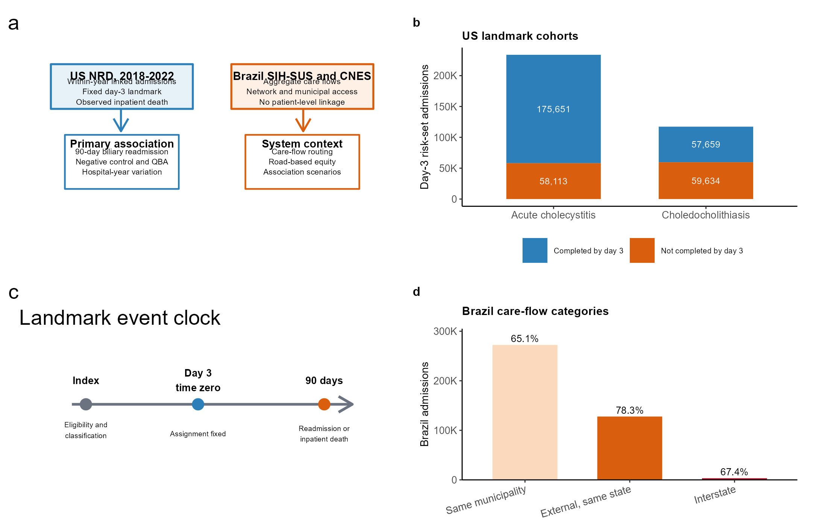
Figure 1 | Study architecture and cohort construction. a, The NRD and Brazil components are complementary system-level analyses without patient-level linkage. b, Day-3 US risk sets. c, Administrative landmark and event clock. d, Brazil acute-cholecystitis care-flow categories. Source data are provided in the figure source-data files.

Target-trial-inspired landmark specification
For acute cholecystitis, the exposure was recorded cholecystectomy by day 3. Percutaneous drainage without cholecystectomy was not completion. For choledocholithiasis, the exposure was a recorded duct-directed procedure proxy. It does not verify stone clearance and is not interpreted as definitive clearance. Prior gallbladder-state evidence was included in the propensity model, but the proxy remains clinically heterogeneous.
The primary time zero was the end of hospital day 3. Completion status was fixed at that landmark. Each day-2, day-3, and day-4 sensitivity analysis independently rebuilt the risk set, propensity model, weights, and time zero. The primary outcome was the first observed biliary-related inpatient return from day 4 through day 93, which may include planned staged treatment because the NRD does not reliably encode intent; we therefore do not label it recurrence. Observed inpatient death was a competing event, not complete mortality.
Biliary acute pancreatitis was identified from the prespecified ICD-10 diagnosis phenotype and was evaluated as a clinical-complexity subgroup within each primary disease cohort. We report completion and 90-day biliary-readmission estimates stratified by pancreatitis status and a treatment-by-pancreatitis interaction term. This analysis was prespecified as secondary heterogeneity assessment and did not create a third primary cohort.

Statistical analysis
Propensity scores were estimated separately by cohort and landmark using baseline demographic, admission, payer, residential, hospital, calendar, gallbladder-state, and preceding disease-volume variables. US estimates used DISCWT multiplied by the overlap weight; overlap weighting targeted the measured-covariate overlap population. Weighted Aalen-Johansen cumulative incidences were estimated with 2,000 bootstrap replicates resampled within YEAR-by-NRD_STRATUM strata with hospital clustering, refitting the propensity model and weights in every replicate. The negative control was first observed nonbiliary nonelective inpatient return; because general health-care use may also be affected by treatment pathways, it was treated as a bias diagnostic and was not subtracted from the primary contrast.
The Brazil models used municipal population and GDP, macroregion, road-time category, local and destination capability, and care-flow terms. Contrasts are model-standardized associations. The routing scenario selected the fastest observed capable in-state destination subject to a 20% observed-volume destination capacity cap. No policy, hospital, or burden quantity is interpreted as an intervention effect.

Results

Landmark associations and bias diagnostics
By day 3, 175,651 of 233,764 acute-cholecystitis admissions (75.1%) and 57,659 of 117,293 choledocholithiasis admissions (49.2%) had recorded completion. The maximum postweighting absolute standardized mean difference was 1.06e-09 and 4.30e-09, respectively.
Table 1 | Day-3 landmark cohorts and measured-covariate balance. † Records with unknown procedure timing were excluded before day-3 risk-set classification and are not a subgroup of Day-3 N.
Cohort | Day-3 N | Completed | Not completed | Unknown timing excluded† | Maximum postweight SMD
Acute cholecystitis | 233,764 | 175,651 (75.1%) | 58,113 (24.9%) | 7,833 | 1.06e-09
Choledocholithiasis | 117,293 | 57,659 (49.2%) | 59,634 (50.8%) | 3,181 | 4.30e-09

At 90 days, the observed biliary-related inpatient return incidence for acute cholecystitis was 1.444% after completion and 12.650% without completion. The analogous choledocholithiasis values were 4.512% and 7.524%. The negative-control differences were appreciable in both cohorts, indicating that residual differences in candidacy, recovery, health-care use, or follow-up access remained after measured-covariate balancing.
Biliary acute pancreatitis was coded in 15,779 of 233,764 acute-cholecystitis admissions and 14,507 of 117,293 choledocholithiasis admissions. In the overlap-weighted subgroup analysis, the completion-associated risk difference was -5.947 percentage points with pancreatitis versus -11.572 percentage points without pancreatitis; the corresponding estimates for choledocholithiasis were -2.444 percentage points and -3.295 percentage points. The treatment-by-pancreatitis interaction was positive for acute cholecystitis (0.804 (95% CI 0.596 to 1.012), P<.001) and near null for choledocholithiasis (0.024 (95% CI -0.160 to 0.207), P=0.80).
Table 2 | Primary day-3 90-day first observed biliary-readmission estimates
Cohort | Completion | No completion | Difference | 95% bootstrap interval | Successful replicates
Acute cholecystitis | 1.444% | 12.650% | -11.206 percentage points | -11.519 percentage points to -10.909 percentage points | 2,000/2,000
Choledocholithiasis | 4.512% | 7.524% | -3.012 percentage points | -3.297 percentage points to -2.735 percentage points | 2,000/2,000

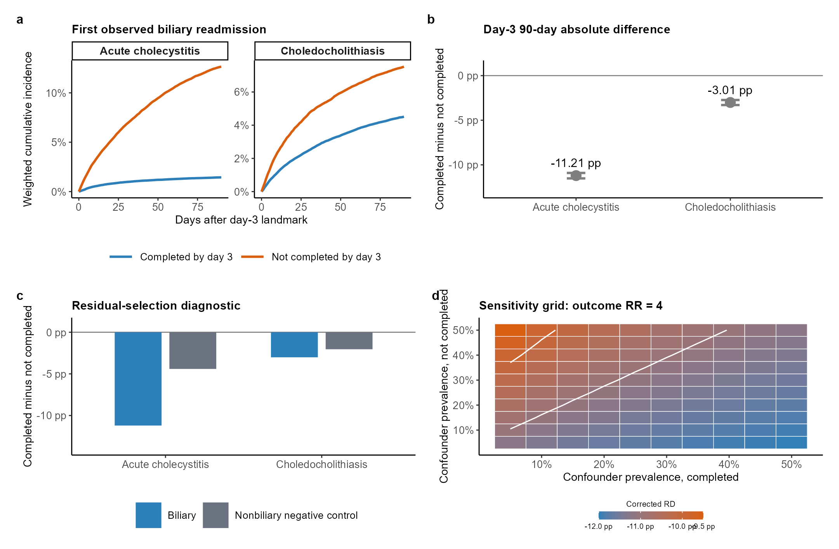
Figure 2 | Fixed-landmark association and bias diagnostics. a, Weighted cumulative incidence of the first observed biliary-related inpatient return. b, Day-3 90-day differences with 95% bootstrap intervals. c, Biliary-related and nonbiliary negative-control differences. d, Single-binary-confounder sensitivity grid for acute cholecystitis computed from the day-3 risk set, outcome risk ratio 4. The grid is a sensitivity analysis, not identification. Source data are provided in the figure source-data files.

US hospital-year patterns and associated burden
Acute-cholecystitis hospital-year treatment models included 9,356 hospital years. Under a peer-P75 completion-gap scenario, 23,265 additional recorded completions and 2,608 associated biliary readmissions were estimated nationally. This is a peer-benchmark association scenario, not a hospital-quality ranking or a forecast.
Table 3 | US hospital-year risk-standardized variation and associated-burden scenarios. No direct US–Brazil completion-rate comparison is made.
Cohort | Risk-standardized hospital-year P10-P90 completion | Hospital years | Associated additional completions at 100% gap closure | Associated biliary readmissions
Acute cholecystitis | 62.637%-84.735% | 9,356 | 23,265 | 2,608
Choledocholithiasis | 39.127%-61.981% | 7,562 | Not modeled | Not modeled

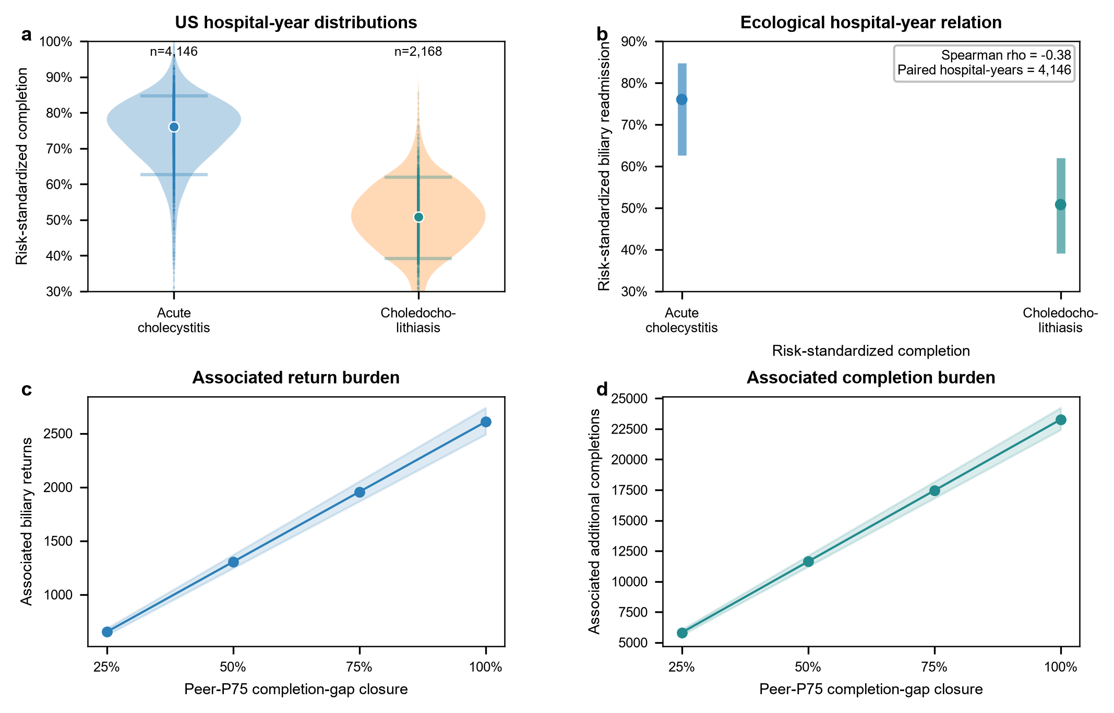
Figure 3 | US hospital-year variation and associated burden. a, Risk-standardized completion distributions by cohort. b, Paired acute-cholecystitis hospital-year completion and observed biliary-related return with an ecological trend line. c, Associated biliary-related returns under prespecified peer-gap-closure scenarios. d, Associated additional recorded completions under the same scenarios. These are descriptive or association-based quantities; no US–Brazil completion-rate comparison or hospital ranking is made. Source data are provided in the figure source-data files.

Brazil network, road access, and scenarios
Among acute-cholecystitis care flows, completion was 65.076% for same-municipality admissions, 78.285% for external within-state admissions, and 67.385% for interstate admissions. The three flow categories are mutually exclusive. The road-time contrast above 240 minutes versus 60 minutes or less was -0.346 percentage points (95% interval -0.792 percentage points to +0.101 percentage points). The combined capability and capacity-constrained routing scenario changed standardized acute-cholecystitis completion by +0.078 percentage points (95% interval +0.009 percentage points to +0.147 percentage points).
The admission-level Brazil pathway module covered 2018-2022 and recorded primary completion in 69.279% of acute-cholecystitis admissions and 12.898% of choledocholithiasis admissions. Acute-cholecystitis pathways were dominated by cholecystectomy alone, with smaller groups receiving bridge treatment, ERCP without cholecystectomy, or combined procedures. Choledocholithiasis pathways were heterogeneous; duct-directed treatment without observed cholecystectomy, cholecystectomy alone, and combined treatment were reported separately. The Brazilian completion measures are admission-level procedure proxies and not 90-day recurrence outcomes.
The small magnitude of these standardized scenario changes, together with their uncertainty, suggests that road access and routing alone are unlikely to account for the observed treatment gap. This result does not rule out local access barriers; it describes the variables and constraints represented in the model.
Table 4 | Brazil geographic-equity contrasts and association-based scenarios
Cohort | Road >240 vs <=60 min | Combined scenario change | 95% interval | External road-route median | Capacity cap
Acute cholecystitis | -0.346 percentage points | +0.078 percentage points | +0.009 percentage points to +0.147 percentage points | 109.4 min | 20% observed volume
Choledocholithiasis | +0.098 percentage points | +0.010 percentage points | -0.051 percentage points to +0.071 percentage points | 109.4 min | 20% observed volume

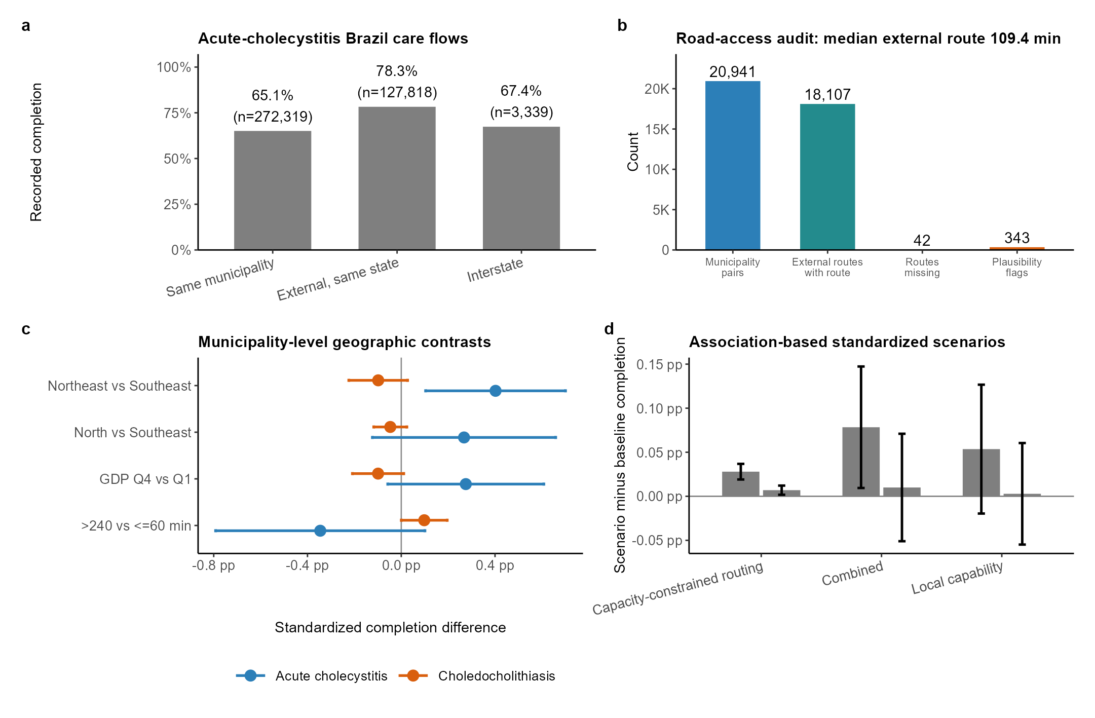
Figure 4 | Brazil network, road access, geographic equity, and association-based scenarios. a, Acute-cholecystitis care-flow completion. b, Road-routing quality checks; external road time is centroid to centroid. c, Model-standardized municipal geographic contrasts. d, Standardized scenario changes with a 20% observed-volume destination capacity cap. Scenarios are not intervention forecasts. Source data are provided in the figure source-data files.

Discussion
The central observation is not that one recorded procedure strategy is universally preferable. The main US finding is that a large observed completion difference coexists with substantial hospital-year variation and a nonzero nonbiliary diagnostic difference. The negative control makes the principal limitation visible: patients completing treatment earlier differed in ways that measured claims covariates did not eliminate.
The Brazil module provides an independent admission-level pathway description. External routing and destination capability were patterned, yet broad municipal road-time contrasts were modest and standardized reconfiguration scenarios shifted completion by less than one tenth of a percentage point. A pathway response should therefore audit local decision-making, candidacy, referral timing, and clinical capacity rather than assume that geographic routing alone will close a measured gap.
The pancreatitis subgroup adds clinical context without changing the study architecture. The completion-associated difference was less negative among acute-cholecystitis admissions with coded biliary pancreatitis, whereas the corresponding difference changed little in choledocholithiasis. These patterns may reflect differences in procedural candidacy, recovery, or competing clinical priorities. Because diagnosis codes do not capture severity or anatomy, the interaction is evidence of heterogeneity in observed pathways rather than a treatment effect.

Limitations
NRD does not capture outpatient procedures, care across state or calendar-year boundaries, complete mortality, laboratory values, anatomy, consultation timing, or reasons for noncompletion. Procedure day is recorded by hospital day. The observed biliary-related return outcome may include planned staged treatment because intent is not reliably encoded. Brazil lacks a confirmed stable patient identifier for longitudinal follow-up, so its independent module is restricted to admission-level treatment pathways, hospital capability, geography, and observed care flow. Brazil road time is centroid based and does not represent individual travel. The two systems are not treated as a single directly comparable outcome scale.

Conclusions
Earlier recorded completion was associated with fewer observed biliary-related inpatient returns in the US data, but residual selection was evident. Hospital-year variation and Brazil admission-level pathway differences identify settings for prospective pathway audit; they do not establish treatment effects, recurrence prevention, or a causal health-system gap.

Data Availability
NRD is available through HCUP under a data-use agreement and cannot be redistributed. Brazil aggregate source data are available from their public agencies subject to source terms.

Declarations

Author Contributions
Shuo Feng: conceptualization, methodology, data curation, software, formal analysis, validation, visualization, project administration, original draft writing, and review and editing. Chao Shi: methodology, investigation, validation, interpretation of results, original draft writing, and review and editing. Tianming Liu: investigation, data curation, validation, and review and editing. Haoran Ding: investigation, validation, and review and editing. Fenghe Hang: investigation, resources, validation, and review and editing. Zhenghao Huang: investigation, resources, validation, and review and editing. Liwei Liu: conceptualization, methodology, supervision, project administration, resources, funding acquisition, and review and editing. All authors critically reviewed the manuscript, approved the final version, and agree to be accountable for the integrity of the work.

Funding
This work was supported by the National Natural Science Foundation of China (grant 82400750) and the Natural Science Foundation of Heilongjiang Province (grant PL2024H036). The funders had no role in study design, data analysis, interpretation, writing, or the decision to submit.

Ethics and Consent
This study used only public, deidentified, or aggregate database records. It involved no recruitment, contact, intervention, or identifiable personal data. Ethics approval and informed consent were therefore not required.

Conflict of Interest
The authors declare no conflicts of interest.

References
1. Okamoto K, Suzuki K, Takada T, et al. Tokyo Guidelines 2018: flowchart for the management of acute cholecystitis. J Hepatobiliary Pancreat Sci. 2018;25:55-72. doi:10.1002/jhbp.516.
2. Pisano M, Allievi N, Gurusamy K, et al. 2020 World Society of Emergency Surgery updated guidelines for acute calculus cholecystitis. World J Emerg Surg. 2020;15:61. doi:10.1186/s13017-020-00336-x.
3. Buxbaum JL, Abbas Fehmi SM, Sultan S, et al. ASGE guideline on the role of endoscopy in the evaluation and management of choledocholithiasis. Gastrointest Endosc. 2019;89:1075-1105.e15. doi:10.1016/j.gie.2018.10.001.
4. Agency for Healthcare Research and Quality. HCUP National Readmissions Database documentation. https://hcup-us.ahrq.gov/nrdoverview.jsp.
5. Hernan MA, Robins JM. Using big data to emulate a target trial when a randomized trial is not available. Am J Epidemiol. 2016;183:758-764. doi:10.1093/aje/kwv254.
6. Li F, Morgan KL, Zaslavsky AM. Balancing covariates via propensity score weighting. J Am Stat Assoc. 2018;113:390-400. doi:10.1080/01621459.2016.1260466.
7. Lipsitch M, Tchetgen Tchetgen E, Cohen T. Negative controls: a tool for detecting confounding and bias in observational studies. Epidemiology. 2010;21:383-388. doi:10.1097/EDE.0b013e3181d61eeb.
8. Instituto Brasileiro de Geografia e Estatistica. 2022 municipality population, gross domestic product, and geographic reference data. https://www.ibge.gov.br/.
9. Open Source Routing Machine Project. OSRM routing engine. https://project-osrm.org/.
10. von Elm E, Altman DG, Egger M, et al. The STROBE statement. J Clin Epidemiol. 2008;61:344-349. doi:10.1016/j.jclinepi.2007.11.008.

