Lidar_Align Point to Plane

原理：通过gnss与imu获得车辆在各个时间的pose，将点云随时间累计转化到时间绝对坐标系中。假设点云和邻近点处在同一平面内， 对所得点云地图构建 点到面 的误差函数，以此进行优化。

具体算法流程：

Input：Sensor_msgs/PointCloud2, Geometry_msgs/TransformStamped

* Sensor_msgs/PointCloud2 -> pcl pointcloud
* Pcl pointcloud -> confine -> downsample
* Select key scan (every N scans)

Foreach keyscan :

Compute normals;

Scans <- keyscan;

* Transform keyscan points and normals into world coordinate frame.
* Construct map <- combine transformed keyscans

Foreach point:

Find k neareast neighbor points;

Construct point to plane error;

Minimize total error

此算法中实现的点到面误差形似：

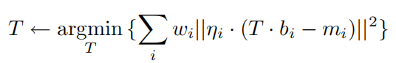

将点bi转换到世界绝对坐标系中， 找到最近邻k个点mi， 两点向量点成bi对应的法向量eta. Omega是权重（1或0）

测试调参：

N=20，voxel size = 0.5

"inital_guess"> [1.7, -1.3, -0.7, 0.02, -0.02, -0.01, 0.0]

K=10

[1.78972, -1.29136, -0.685824, 0.0216402, -0.0165764, -0.020626]

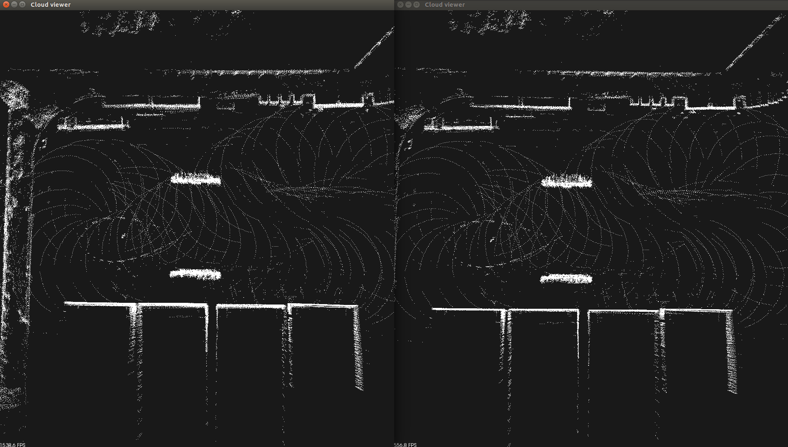

K=20

[1.78449, -1.29237, -0.712651, 0.0217226, -0.0184706, -0.019922]

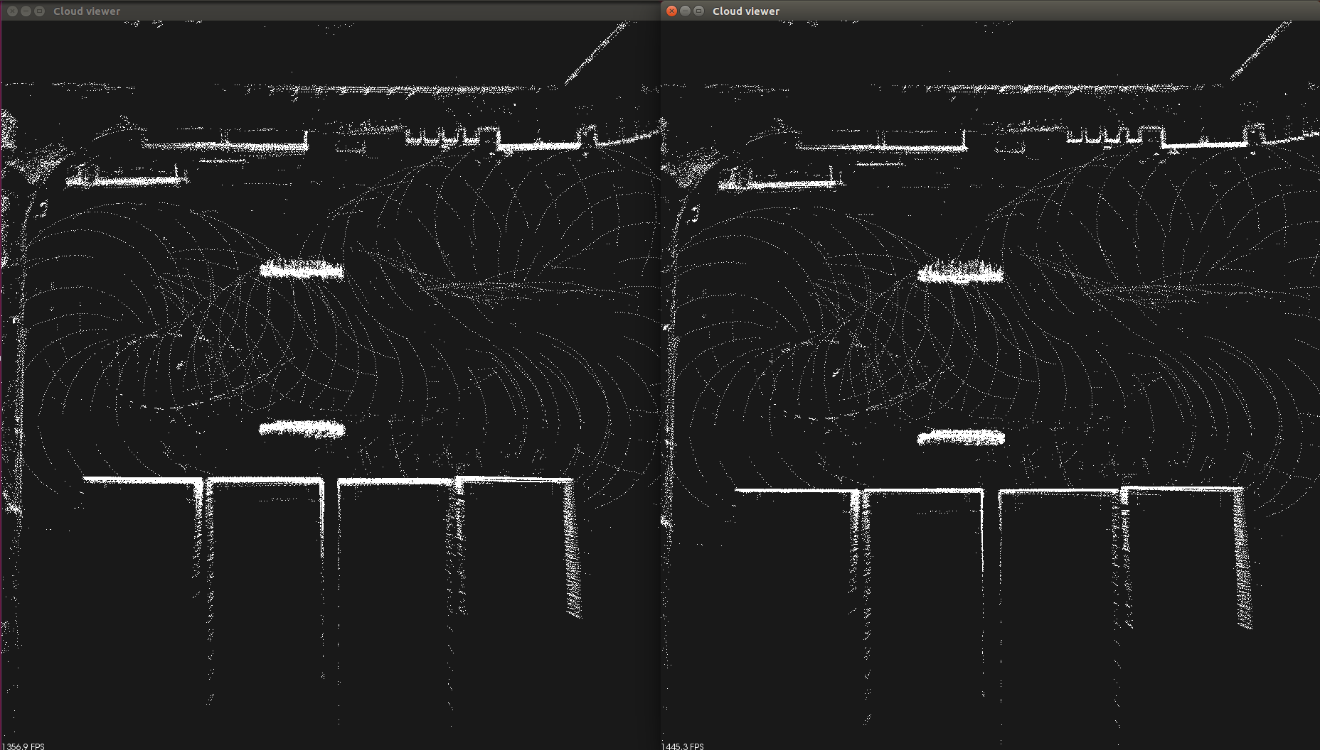

K=30

[1.77914, -1.28075, -0.7114, 0.0206191, -0.0194848, -0.0200118]

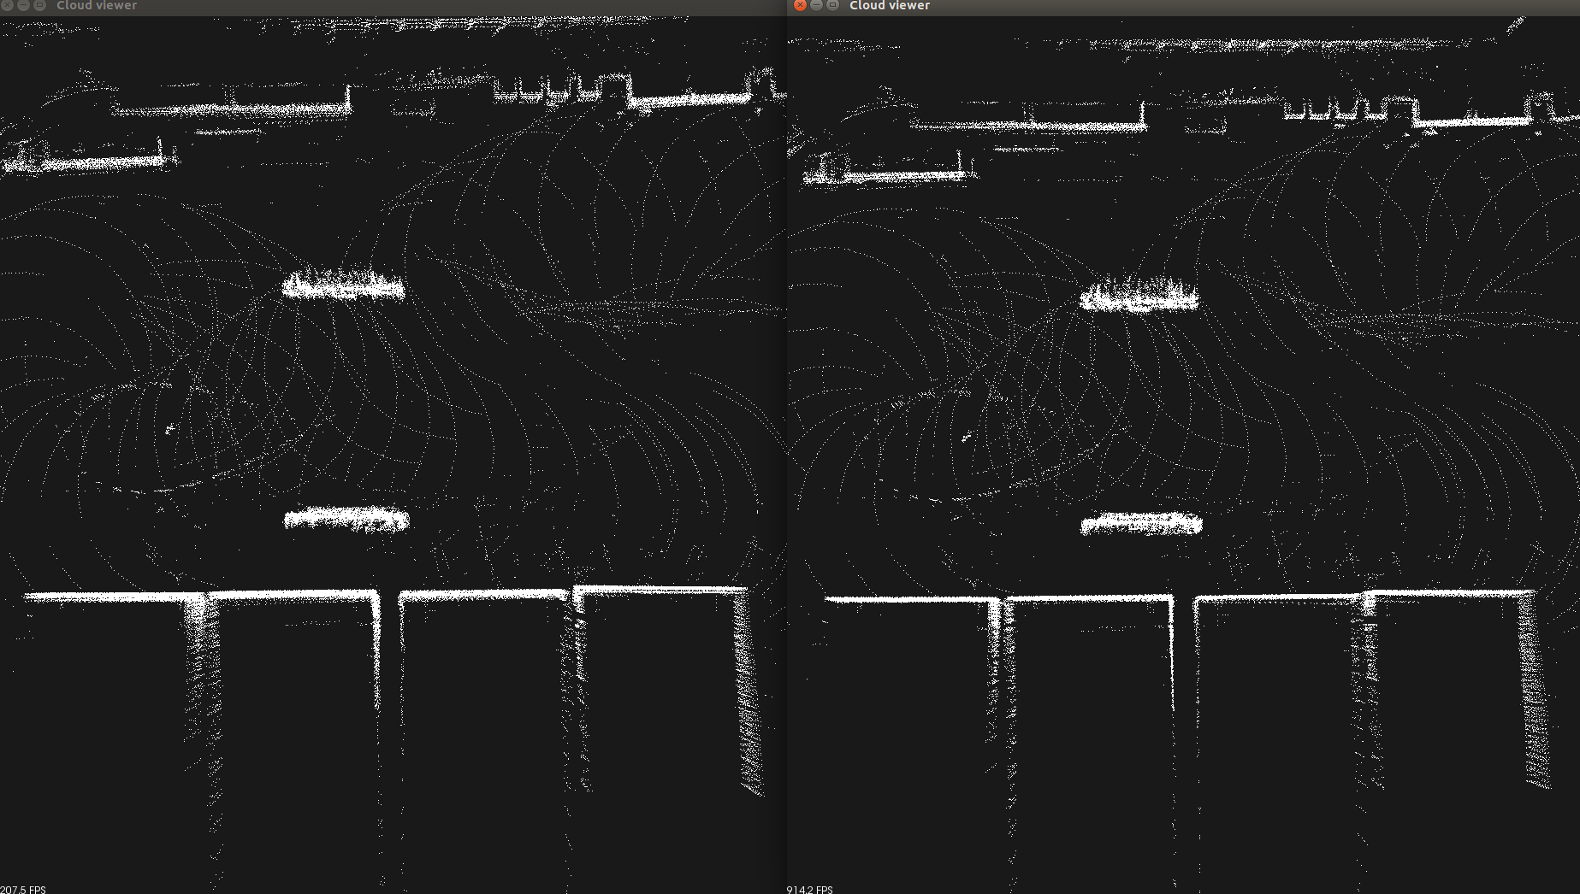

改进算法：

先计算normal， 再downsample点云

K =30, knn_max_dist =0.5, leafsize =0.1, keep_points_ratio = 0.1

优化后的参数：

[1.76956, -1.30465, -0.707013, 0.0196595, -0.0161821, -0.0197443]

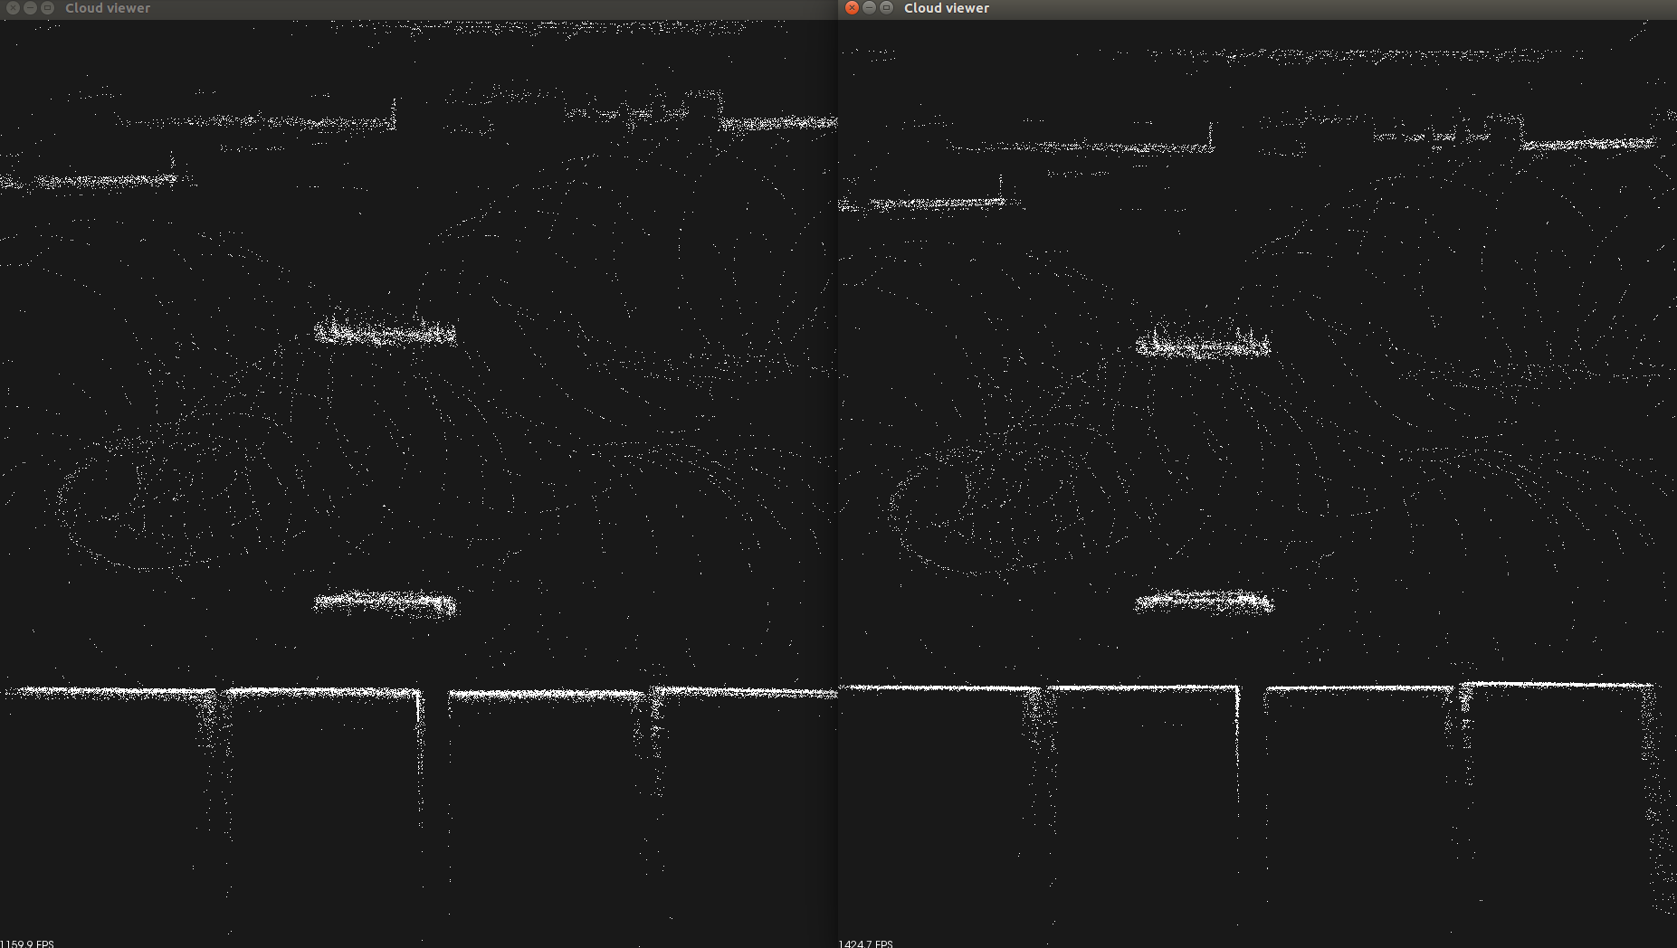

K =10

[1.80309, -1.30259, -0.698412, 0.0218793, -0.0168681, -0.0198129]

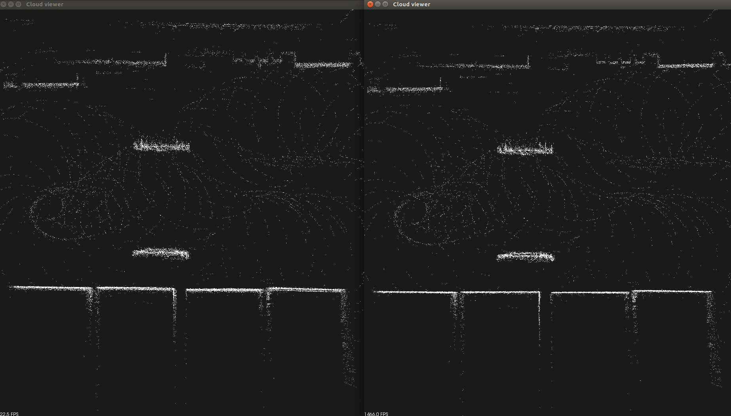

试验：点到点目标方程 与 点到面目标方程 优化的效果对比

1. 试验参数:

inital_guess [1.7, -1.3, -0.7, 0.02, -0.02, -0.01, 0.0]

knn_batch_size=1000

knn_k =10

local_knn_max_dist =0.5

leaf_size =0.1

keep_points_ratio = 0.1

Key_scan = 10

比较两种算法输出结果和效果图，均无太大差别

Point2Point (右图)

[1.78024, -1.30116, -0.687538, 0.0220039, -0.0129456, -0.0197961]

Point2Plane（左图）

[1.80309, -1.30259, -0.698412, 0.0218793, -0.0168681, -0.0198129]

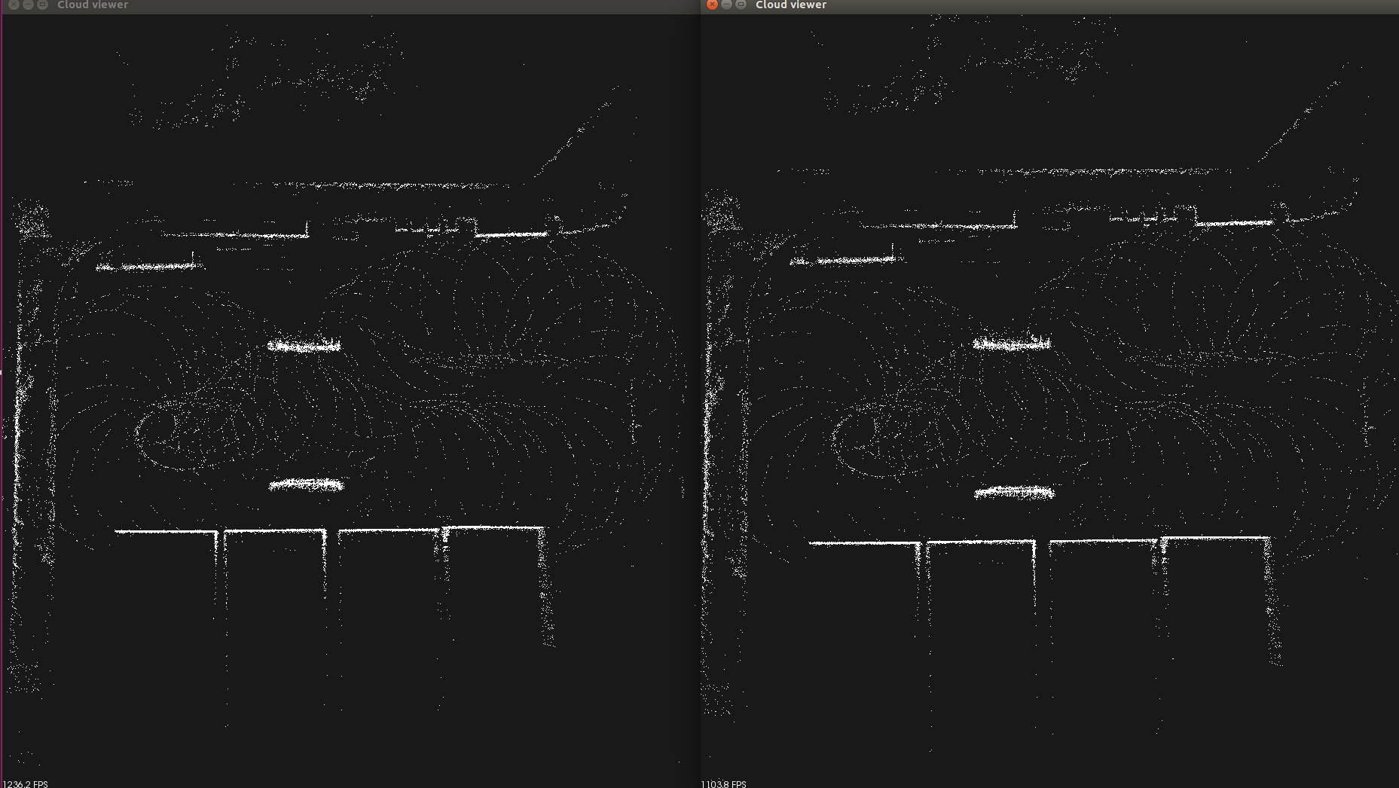

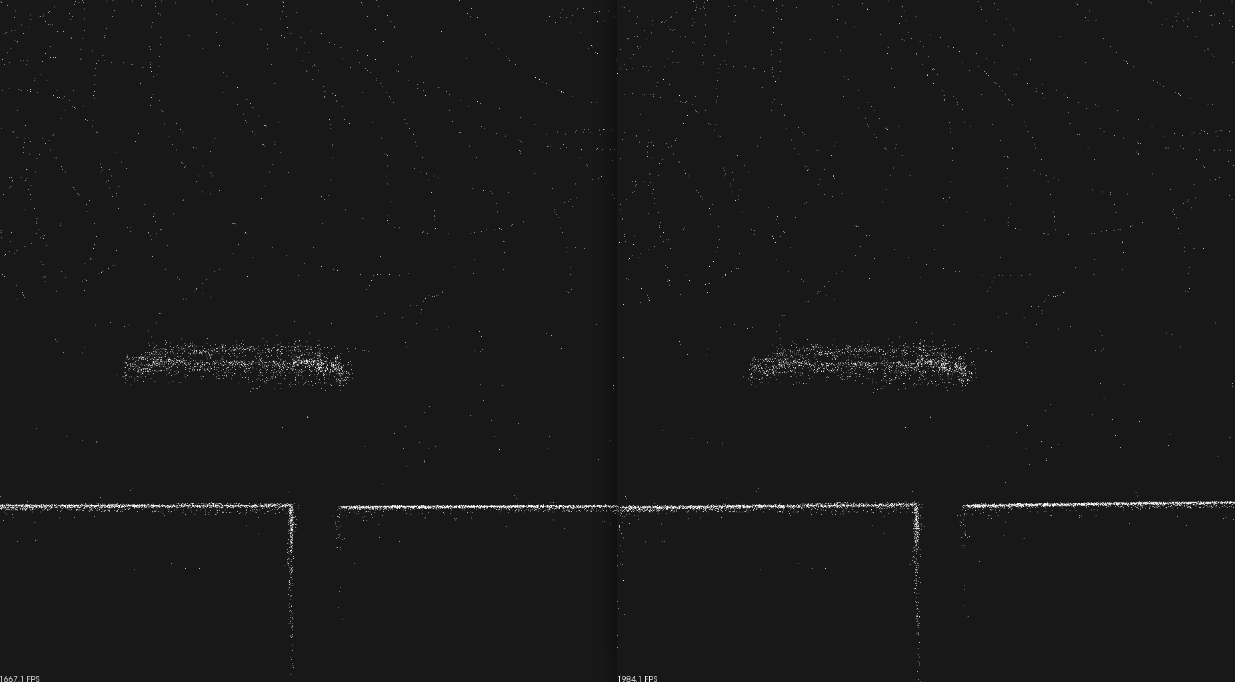

inital_guess [1.7, -1.3, -0.7, 0.02, -0.02, -0.01, 0.0]

knn_batch_size=1000

knn_k = 20

local_knn_max_dist =0.5

leaf_size =0.1

keep_points_ratio = 0.1

Key_scan = 10

Point2Point(右图)

[1.78301, -1.3019, -0.704295, 0.02264, -0.0120349, -0.0198052]

Point2Plane（左图）

[1.7829, -1.30518, -0.720336, 0.0189583, -0.0141766, -0.0194978]

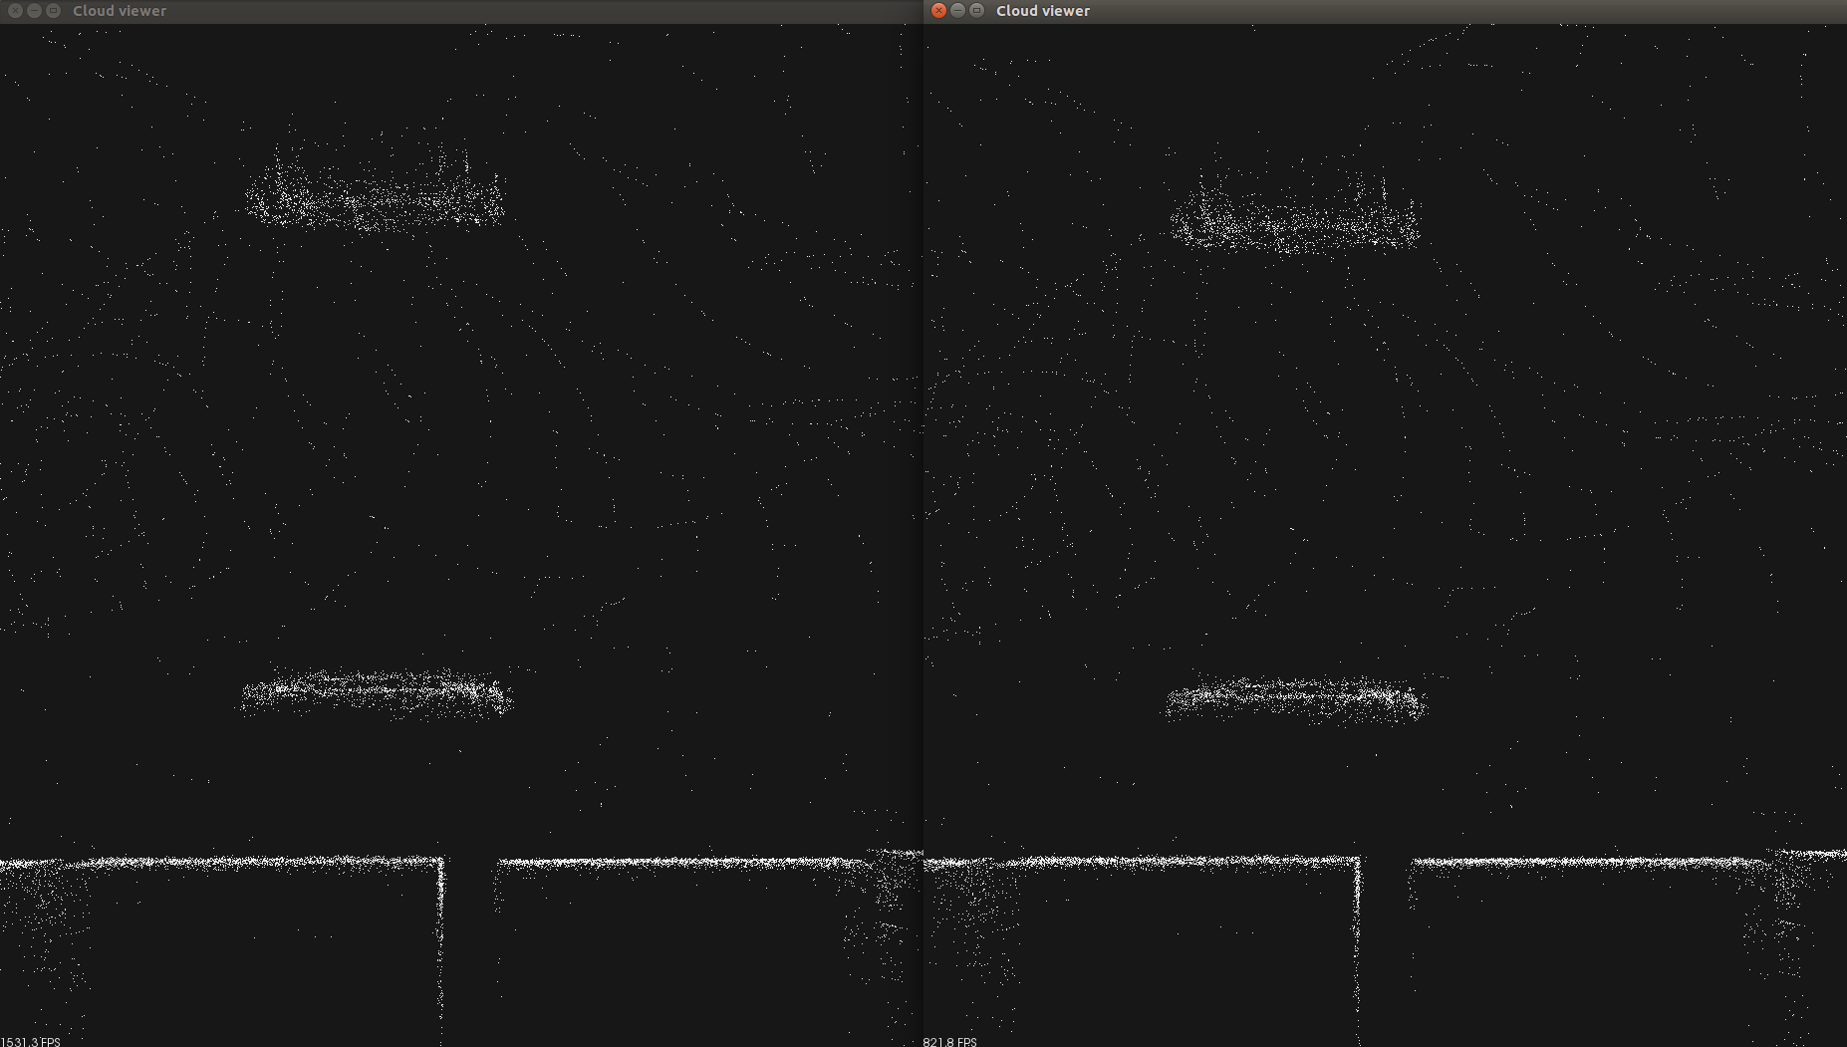

试验： 不同初始值，以上一次优化参数为初始值，进行多次连续优化

inital_guess [1.6, -1.4, -0.7, 0.0, 0.0, 0.0, 0.0]

knn_batch_size=1000

knn_k = 5

local_knn_max_dist =0.5

leaf_size =0.1

keep_points_ratio = 0.1

Key_scan = 10

Point2Plane

[1.6, -1.4, -0.7, 0.0, 0.0, 0.0, 0.0]

第一次优化：error 1453342 ->1228100

[1.72116, -1.29133, -0.661763, 0.0196098, -0.0156044, -0.0210562]

第二次优化： error 1228100 -> 1224556

[1.76083, -1.28892, -0.758811, 0.0201012, -0.0155248, -0.0204949]

第三次优化： 1224556 -> 1224448

[1.7714, -1.28892, -0.757679, 0.0201012, -0.0155248, -0.0204949]

第四次优化： 1224448 -> 1223436

[1.7712, -1.29359, -0.877635, 0.0190307, -0.0155969, -0.0205047]

下图从左到右，从上到下，分别为1、2、3、4次优化结果

二三四次优化墙壁比第一次稍整齐干净些。

