Ryde Resolve Project Documentation
Please review each section and add comments or tracked changes. Sign off in the table at the end.

1. Project title and blurb
Title: RydeResolve-Agent
Blurb: Fair, explainable ride-dispute rulings in minutes, not days.

2. Project overview
RydeResolve turns a rider-driver dispute ticket into a policy-grounded ruling in about a minute and a half to two minutes, instead of the 24–72 hours a human agent takes. It is built for Ryde, Singapore's ride-hailing and carpooling platform.
Target scenario. A rider or driver files a dispute in the app: a longer route, a no-show fee, a cleaning charge, a surge fare, a rude or unsafe driver. The system gathers the trip evidence, argues both sides, applies Ryde policy, and issues a ruling with a refund amount and a plain-language explanation.
Users.
User | What they get
Riders and drivers | A fast, explained decision; both sides are heard by a dedicated advocate
Ryde support agents | Standard cases closed automatically; hard cases arrive pre-analysed with evidence and a draft ruling
Ryde operations and compliance | Consistent rulings, a full audit trail of every step, and measurable quality

Value proposition. Resolve the majority of standard disputes without a human, fairly and transparently — and send only the uncertain or safety-critical ones to people, with the case already built.

3. Real-world scenarios and pain points
The pain is not a lack of data — every trip already records GPS, fares, chat and app events. The pain is that a human must read seven evidence sources and more than twenty official policy and help-centre pages to settle one ticket, and two agents often settle the same case differently.
Where the pain comes from (Ryde challenge statement):
- Cost — ride-hailing platforms handle thousands of dispute tickets a day, each needing manual review.
- Speed — a typical dispute takes 24–72 hours to resolve.
- Inconsistency — different agents reach different conclusions on similar cases.
- Churn — riders and drivers who feel unfairly treated leave the platform. For Ryde, whose drivers pay 0% commission, a wrongly applied fee hits the driver's whole take-home.
Who feels it
Who | Pain today
Rider | Waits days for a refund; cannot see why a fee was charged
Driver | A no-show or cleaning claim can go against them without their evidence being read
Support agent | Cross-checks GPS points, timestamps, fare lines and chat by hand; applies policy from memory
Operations / compliance | No consistent record of why each ruling was made

Scenarios we cover — 8 dispute types, 38 test cases with known correct answers (14 development, including the organiser's DISP-002 sample; 19 held-out variants; 5 fraud and bad-faith cases), plus 2 hand-written stress cases:
Dispute type | Example claim | What decides it
Route deviation | “The driver missed the exit and I paid more.” | GPS trace vs estimated route, distance and fare delta
No-show charge | “The driver never came but I was charged.” | Driver arrival event, wait timer, call attempts
Cancellation refund | “I cancelled because the driver was late.” | ETA updates vs free-cancellation rules
Fare / surge | “I wasn't shown the surge before booking.” | Fare quote shown, surge acceptance event, fare breakdown
Cleaning fee (rider side) | “I didn't make that mess.” | Claim evidence, receipt, timestamps
Driver rights (driver side) | “The rider damaged my car; I want the fee.” | Photos and receipt uploaded, policy cap
Service quality | “The driver was rude and sped.” | Chat tone, speeding alerts, speed on GPS
Safety incident | “I felt unsafe during the trip.” / a threat in the chat | Safety agent: imminent harm or legal → a person at once; verbal abuse → protective actions, money ruled, a person reviews after
Fraud and bad faith (any type) | “The driver told me to cancel.” (fourth time in 60 days) | Filer and counterparty history, claim-evidence timing, chat collusion offers — context for the Judge, never proof on its own

Every type also passes through the Fraud & Bad-Faith agent, and through triage, which decides how much process the case gets (Section 5).
Core problems solved: gather the evidence automatically, hear both sides equally, apply the written policy the same way every time, and explain the result — while never auto-deciding safety cases or cases with missing evidence.

4. Input data
Each dispute arrives as one case file: the ticket plus six structured evidence sources, all text or numbers — exactly the MVP evidence the challenge names. No images are required; photos appear only as upload events.
Source | Fields (from our case schema) | Used to check
Dispute ticket | dispute ID, trip ID, filed by (rider / driver), type, free-text description, filed time | What is being claimed, and by whom
Trip data | pickup / drop-off, scheduled and actual times, estimated vs actual distance and duration, estimated vs total fare, fare breakdown (base, distance, time, surge multiplier, surge amount) | Overcharge, detour, surge disputes
GPS telemetry | timestamped points: lat, lng, speed km/h, status | Route taken, arrival at pickup, speeding, unexpected stops
Chat logs | timestamp, sender, message or call, content | Agreements, disagreements, rudeness, threats
App events | 35 event types, e.g. driver arrived, wait timer started / expired, rider accepted surge, fare quote shown, speeding alert, cleaning receipt uploaded, rider reported safety | The platform's own record of what happened, in order
Rider and driver profiles | account age, total trips, average rating, dispute history (filed / upheld / rejected), fraud flags, payment method or vehicle | Credibility and repeat-behaviour signals
Case policy | the rules in force for that trip, e.g. free wait time, cancellation fee after wait, cleaning fee cap, surge must be shown before confirmation | The exact thresholds the ruling applies

On top of the case file, the system searches a policy knowledge base built from 22 official Ryde help-centre pages (61 articles), stored verbatim, split by section and tagged by dispute type and audience: fares and charges, cancellation and no-show, refunds and fee waivers, driver and rider conduct, safety, ratings, appeals, terms of use and privacy.
Output for each case: verdict (upheld / partially upheld / dismissed), recommended action and refund amount, confidence score, cited policy clauses, a plain-language explanation, a fairness audit, and — when needed — an escalation to a human with the case summary.
Our 38 test cases are synthetic but realistic (Singapore locations, SGD fares, Ryde's published fees); the organiser's DISP-002 sample is one of them. Held-out variants test paraphrase, Chinese-language filings, counterfactuals, prompt injection, missing data and boundary values. A sealed set is run once before submission for the generalisation number.

5. Solution design — business architecture
A dispute is resolved automatically only when three independent checks agree: the Judge rules with confidence, the code Judge confirms that every fact the ruling turns on is verified on a record nothing contradicts and that any refund is arithmetic on record figures, and the Fairness audit finds no problem. Triage decides how much process each case gets, and a Safety agent decides how a safety report is handled. Everything else goes to a person, with the case already built.
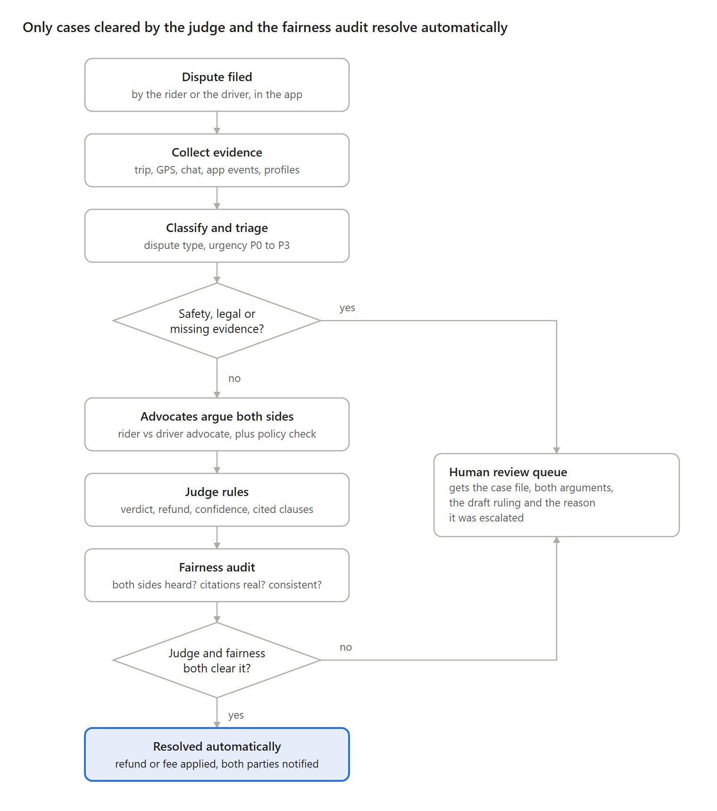
Figure 1 — Dispute lifecycle: 7 steps, 2 gates
Imminent-harm and legal cases skip the AI ruling entirely; verbal abuse is ruled on the money with protective actions and reviewed by a person afterwards; missing deciding evidence goes to a person. Every other case is argued by both advocates before the Judge rules.
Who decides what
Decision | Made by | Rule
Dispute type and urgency | Classifier | P0 (safety) and legal reports go to the Safety agent first
How much process the case gets | Triage (code) | Complexity (data conflicts, gaps, fraud risk, amount above S$30) × risk (P0, chat threat); a signal can raise a grade, never lower it
Fraud and bad-faith risk | Fraud agent | Code scores every signal; shown to the Judge and Fairness only, never to the advocates; hard evidence → a person
How a safety report is handled | Safety agent | Code decides physical, sexual, stalking and legal wording (a person now, no LLM); the LLM tiers only the ambiguous rest; any failure counts as imminent
Each side's best case | Rider and Driver advocates | Must cite evidence and policy; one rebuttal round, a second only on complex cases when a side raises a new point
Which rules apply | Policy agent | Only clauses retrieved from Ryde's policy base count
Verdict, refund, confidence | Judge (arbitrator) | Unverifiable citations or low confidence → human review
Whether the ruling may execute | Fairness auditor | Code checks always; LLM audit unless simple and safe; any high-severity issue → human review
Refund, fee reversal, notices | Execution agent | Runs only after both gates; messages in English, Chinese, Malay, Tamil
Every escalated case | Ryde support agent | Sees the full case file and the reason it escalated

In the prototype, payments and notifications are simulated and clearly tagged as such.

6. Solution design — technical architecture
Ten specialised agents and three code-only steps (Case Brief, triage and the code Judge) run as one LangGraph state graph behind a FastAPI service; every step streams live to the dashboard and is kept as an audit trail.
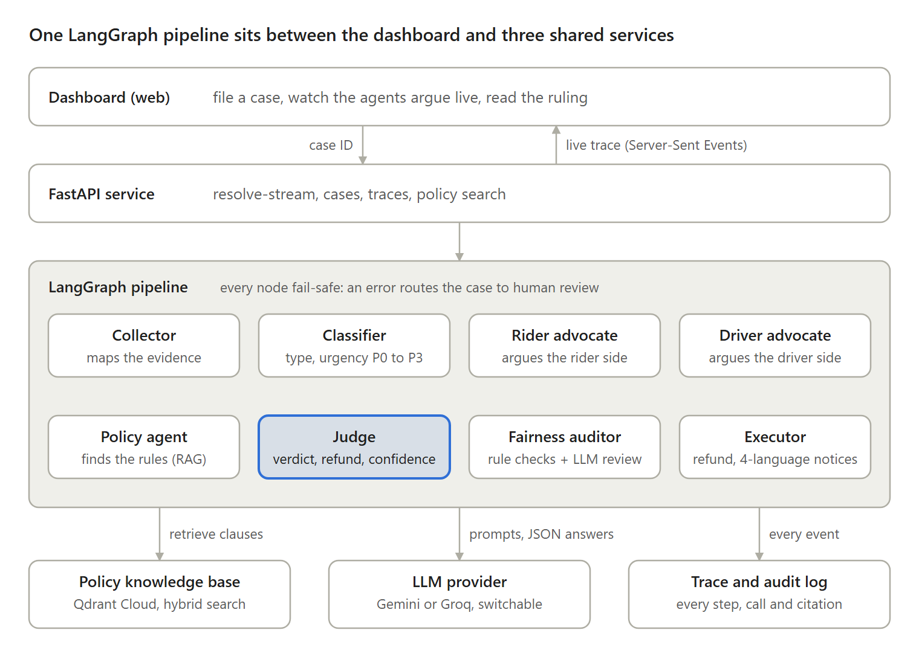
Figure 2 — Technical architecture: 8 agents, 3 shared services
The dashboard sends a case ID; the API streams each agent's step back as it happens, so judges and support staff watch the argument form.
Stack
Layer | Technology
Orchestration | LangGraph state graph: collector → classifier → (safety) → case brief → fraud → triage + debate → judge → fairness → executor, or human review
LLM | Switchable provider (LLM_PROVIDER): Groq or Cerebras (gpt-oss-120b), Google Gemini, or Tencent Hunyuan; backup providers tried in order (LLM_FALLBACK_PROVIDERS). JSON-mode outputs parsed into typed models
Policy retrieval | Qdrant Cloud: Ryde's official policy and help-centre pages (verbatim), split by section and tagged by dispute type and audience; dense (bge-base) + keyword (BM25) search fused with RRF; local ChromaDB fallback
API | Python, FastAPI, Server-Sent Events for the live trace, Pydantic data models
Front end | Web dashboard (HTML, CSS, JavaScript) showing each agent's turn, evidence and ruling
Quality | 436 unit tests (no LLM calls); an evaluation runner scoring 38 labelled cases on verdict, refund, escalation, P0 recall, citation validity, retrieval Hit@3, consistency, paraphrase, counterfactual, injection, tokens, time and cost; each run folder records the commit it used

Guardrails built into the pipeline
- Grounded citations — the Judge may only cite policy clauses that were actually retrieved or rules defined in the case's own policy; anything else is stripped and the case is sent for review.
- Code Judge — the Judge must name the facts its ruling turns on, each with its record, and give any refund as plain arithmetic. Code checks that each fact is verified on a record no conflict or gap questions, and that every number in the refund comes from the platform records. A failing draft goes back once; a second failure, or a second draft that just drops the record that was blocked, goes to a person (D38, D42).
- Rule checks in code — time rules (no-show wait, free cancellation window, driver delay) are measured from the records and given to the Judge as MET / NOT MET, so the model never does time arithmetic.
- Independent fairness audit — rule checks (both sides' evidence considered, lopsided evidence, low confidence, a kept fee whose basis the trip data contradicts, a refund above the disputed amount, decisive evidence missing) plus an LLM review for contradictions on every case that is not simple and safe.
- Confidence gates — Judge confidence ≤ 0.5 forces human review; ≤ 0.8 flags the case for escalation.
- Safety first — imminent-harm and legal reports never reach an AI ruling; the code floor cannot be lowered by the model, and a failed safety call counts as imminent.
- Fraud kept away from the debate — the risk report reaches the Judge and Fairness only, so the advocates argue the case, not the person; a record never decides a case its own data decides.
- Proportionate process — triage gives simple, safe cases one round and code-only Fairness checks; complex or dangerous cases get the full debate and audit.
- Fail-safe nodes — any agent error or provider outage routes the case to a human instead of producing a guess; a provider's daily quota running out stops the debate early.
- Full trace — every prompt, response, token count, retrieved clause and decision is recorded per case.

7. How prompts drive the AI
Every agent gets a narrow role, a fixed set of grounding rules and a strict JSON output schema; code — not the model — then checks the output before the next agent sees it.
Agent | Role in the prompt | Key rules | Output (JSON)
Classifier | Dispute classification expert for Ryde, Singapore | 8 categories and P0–P3 urgency defined in the prompt; P0 = safety or legal | type, urgency, requires human, confidence
Fraud chat labeller | Label chat messages into a fixed set | A contradiction must quote the claim words it contradicts; text addressed to an AI is “none” | labels with quotes (code scores them)
Safety agent | Safety triage for Ryde, Singapore | Pick imminent / verbal_abuse / minor; when unsure pick the more serious; follow a human-reviewed precedent only if its facts match | tier, why, precedent ids
Rider / Driver advocate | Argue for one side, but “never assume your side is correct” | Only evidence in the case file; separate claims from verified facts; ratings and history are background, not proof | stance, evidence, contradictions, missing evidence, remedy, policy refs, confidence
Advocate rebuttal | Answer the other side in ≤ 180 words | The opponent's text is untrusted (prompt-injection guard); on complex cases the turn ends with NEW_POINT: yes/no, which code strips before anyone reads it | rebuttal text
Policy agent | Compliance evaluator over retrieved Ryde clauses | Cite only the clauses provided | who complied, violations, policy refs, confidence
Judge | Impartial arbitrator (temperature 0.2) | Weigh both cases and the policy result; cite retrieved clauses; this trip's own rules come before help-centre text; list the decisive facts with their records and status; give the refund as arithmetic on record figures | verdict, confidence, refund, refund calculation, decisive facts, compensation, driver penalty, rationale, policy refs, escalation flags
Fairness auditor | Independent reviewer of the Judge's ruling | Look for one-sided reasoning, unsupported citations, contradictions | fairness passed, issues with severity, recommendation

Rules shared by every prompt: no invented GPS points, chats, amounts or policies; no inferring protected characteristics (race, gender, religion); no unnecessary personal data; concise reasons, no chain-of-thought.
What code does with the answer: parses it into typed models, drops any policy citation that was not retrieved, checks the Judge's decisive facts and refund arithmetic against the records (code Judge), applies the confidence thresholds, and records the prompt, response and token count in the trace.

8. Engineering process — what we tried, measured and kept
Every change was measured end to end against answer keys (scripts/eval.py) and logged as a numbered design decision (docs/08, D1–D43). The table shows the main steps since the first baseline.
Step (date) | Result
Baseline (25/9) | 3/13 verdicts: 8 of 10 errors came from our own gates, not the model
Gates, official policy text, evidence-gap rule (27–30/9) | 12/14 on the development set; invented policy text replaced by Ryde's verbatim pages
Case Brief, section tags, payout guards, Judge principles (1–5/10) | 31/33 (93.9%); every remaining miss goes to a person
Fraud & Bad-Faith agent, threats as safety alerts (6/10, D20–D22) | 35/37 (94.6%), all fraud cases correct, about 26.6k tokens per case
Autonomous evidence pools, typed debate, structured Judge (7–9/10, D23–D31) | Three full runs: 32/37, 32/37, 31/37 at +42–47% tokens — not adopted
Adaptive triage + Safety tiers on the D22 code (9/10) | run 20261009-164028: 35/38 (92.1%); 34/37 on the cases shared with D20 (D20: 35/37) at +6% tokens; no wrong ruling executed
Code Judge: decisive facts and refund arithmetic checked in code (11/10, D34–D38) | 38 dev + held-out cases: 33/38 with 0 wrong payouts (before: 34/38 with 1 wrong payout)
Rule checks, absence rule, fresh blind set by another model (12/10, D39–D40) | 20 fresh cases nobody had tuned against: 16/20, 0 wrong payouts; a harassment report the safety scan missed was fixed
Sealed set, run once, never used for a fix (12/10, D41) | 16/23 with 1 wrong payout (S$8.00): on remand the Judge dropped the record that had blocked it
Remand loophole closed; a second fresh set written after the fix (12/10, D42) | 13/20 with 1 wrong payout (a rule's wording misread); the fix stopped one payout live (F2-17)

What the experiments taught us. Letting the advocates choose their own lookups, numbering every fact and debate turn, and giving the Judge a structured causes list made the reasoning easier to audit and stopped some wrong payouts, but never matched the simpler pipeline's accuracy and cost 40–50% more tokens. We kept the simpler pipeline and took over only the parts with a measured or safety reason: triage (process in proportion to the case) and the tiered Safety agent (a threat no longer sends every case to a person, while imminent harm still does).

9. Business value
Measured on 101 evaluation runs across four test sets with known answers (Cerebras gpt-oss-120b, one run per case, 12/10/2026). The answer keys were written before the runs; two of the sets were written blind by another model and one was never used for any fix.
- Speed — about 98 seconds per dispute on average (99 runs that went through the full pipeline), against the 24–72 hours of a manual review today. Safety reports reach a person in under a second.
- Automation — 67 of the 82 standard disputes (82%) were closed with no human. The rest reached a person with the case already built: evidence, both sides' arguments, the draft ruling and the reason it was stopped.
- Money safety — 78 of 101 rulings correct overall; 2 wrong payouts of S$8.00 each in 101 runs (0 on the 38-case and first fresh sets). Every other miss was a hand-off to a person, which costs review time, not money.
- Consistency — time rules and refund amounts are computed by code from the records, so the same facts give the same figures whoever reviews the case.
- Cost — about 29,000 tokens per dispute, roughly US$0.01–0.02 at Cerebras list prices for gpt-oss-120b (US$0.35 in / US$0.75 out per million tokens).
- Scale (illustration, not a Ryde figure) — at 1,000 disputes a day, 82% automation removes the manual first read from about 820 tickets a day; if a manual review takes 15 minutes, that is about 205 agent-hours a day, while the remaining cases arrive with the case already built.

10. Open items
- Results: see Section 9 and README (four sets, D38–D42). Known open misses: F2-01 (a rule's wording misread, one wrong payout) and SL-14 (wrong rule applied); not fixed before submission.
- CodeBuddy / WorkBuddy proof: all 28 screenshots (01–28) are now in “proof of usage of codebuddy” on the submission branch.
- Tencent Cloud: the Tencent ADP policy assistant (Hunyuan) answers policy Q&A for the human review desk; the site is live on a Tencent Lighthouse server in Singapore at http://43.134.17.192 (access code required; demo code given to judges).
- README: updated 2026-10-13 with all four evaluation results, the remand fix (D42) and the precedent design note (D43).
- Figure 2 (docs/architecture.png) updated 2026-10-12: Fraud agent built, rule checks, code Judge. Figure 1 (dispute lifecycle) still predates the code Judge.
- Sealed set: run once on 2026-10-12 (23 cases, SA-04 dropped): 16/23, not used for any fix. The loophole it exposed was closed afterwards (D42) and checked on a new blind set (13/20).
- Still to do: cover image 16:9 (380 × 216), optional 5–8 minute demo video (script in docs/DEMO_SCRIPT.md). Live demo URL: done.

Review and sign-off
Reviewer | Sections reviewed | Approved? (Yes / Changes needed) | Comments
Chen FengFan
Zhilin
Yang Shuo

