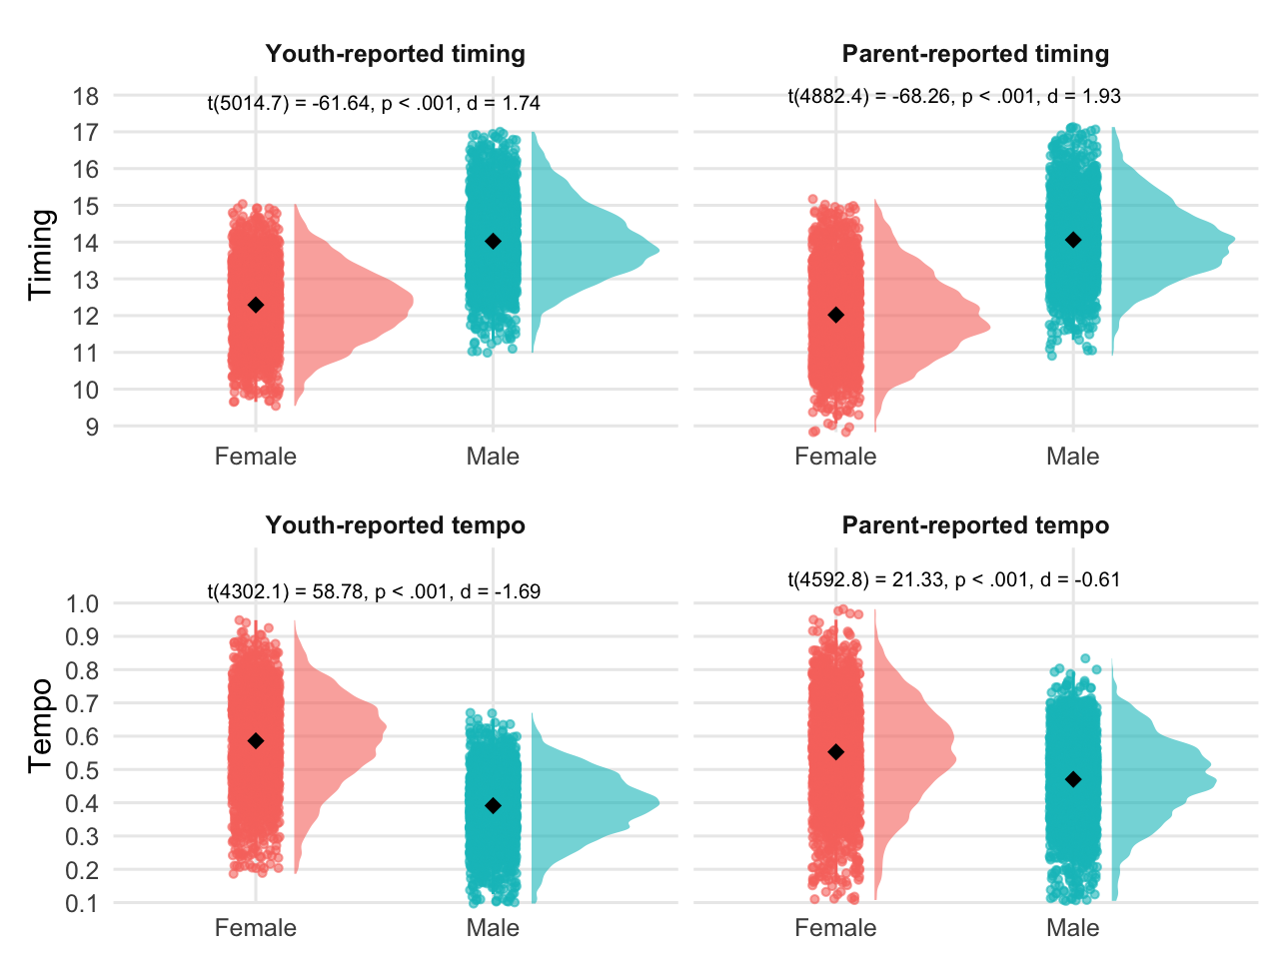


B). Youth-reported puberty
A). Parent-reported puberty
Figure 2. Pubertal timing and tempo, presented separately by sex and reporter (youth vs. parent). A). Pubertal timing and tempo derived from parent reported pubertal status. B). Pubertal timing and tempo derived from parent reported pubertal status. Diamonds reflect the sex-specific averages for timing and tempo.

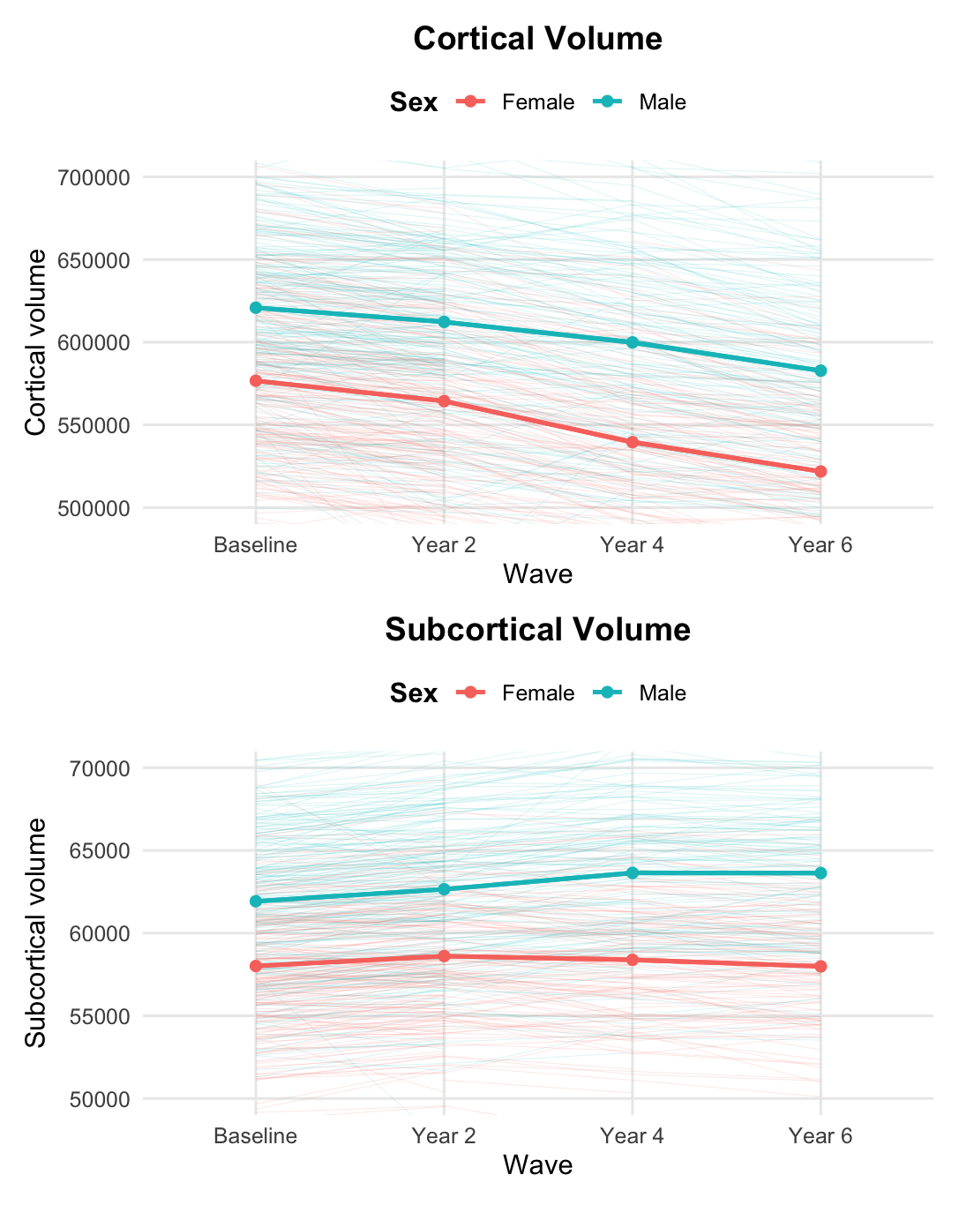
A). Cortical gray matter volume
A). Parent-reported puberty


B). Subcortical gray matter volume


Figure 3. Gray matter volume, presented separately by sex and regions (cortical vs. subcortical). A). Cortical gray matter volume. B). Subcortical gray matter volume.

Table 2. Overall sample characteristics by sex (N=5041)
 | Overall | Female | Male | ttest | Effect size
 | M(SD) | M(SD) | M(SD) | (p value) | (d)
Working memory
Baseline | 16.10 (2.98) | 16.05 (2.89) | 16.15 (3.06) | 0.2 | 0.03
Year 6 | 18.99 (2.92) | 18.92 (2.87) | 19.06 (2.97) | 0.1 | 0.05
ELA | 1.82 (1.79) | 1.82 (1.81) | 1.81 (1.77) | 0.8 | 0.01
Age
Baseline | 10.00 (0.62) | 9.99 (0.61) | 10.01 (0.62) | 0.4 | 0.03
Year 2 | 11.96 (0.64) | 11.94 (0.63) | 11.98 (0.64) | 0.036 | 0.06
Year 4 | 14.21 (0.71) | 14.21 (0.72) | 14.21 (0.71) | >0.9 | 0
Year 6 | 16.09 (0.66) | 16.07 (0.65) | 16.11 (0.66) | 0.094 | 0.05
Pubertal development
Pubertal timing (youth) | 13.20 (1.32) | 12.29 (0.98) | 14.02 (1.02) | <0.001 | 1.74
Pubertal timing (parent) | 13.09 (1.47) | 12.02 (1.10) | 14.06 (1.02) | <0.001 | 1.93
Pubertal tempo (youth) | 0.48 (0.15) | 0.59 (0.13) | 0.39 (0.10) | <0.001 | 1.69
Pubertal tempo (parent) | 0.51 (0.14) | 0.55 (0.15) | 0.47 (0.12) | <0.001 | 0.61
Cortical volume
Baseline | 599,882.78  (55,480.87) | 576,678.18  (47,804.96) | 620,863.97  (53,560.18) | <0.001 | 0.87
Year 2 | 590,073.87  (56,675.02) | 564,370.16  (49,037.04) | 612,261.40  (53,360.34) | <0.001 | 0.93
Year 4 | 571,685.50  (59,305.46) | 539,552.83  (48,321.20) | 599,878.46  (53,428.77) | <0.001 | 1.18
Year 6 | 553,814.04  (57,711.57) | 521,795.51  (46,385.55) | 582,759.04  (51,308.32) | <0.001 | 1.24
Subcortical volume
Baseline | 60,067.51  (4,859.74) | 58,010.51  (4,183.17) | 61,927.42  (4,676.53) | <0.001 | 0.88
Year 2 | 60,781.42  (4,998.06) | 58,612.66  (4,308.95) | 62,653.50  (4,791.58) | <0.001 | 0.88
Year 4 | 61,187.02  (5,342.42) | 58,387.82  (4,348.78) | 63,643.01  (4,908.39) | <0.001 | 1.13
Year 6 | 60,952.23  (5,472.07) | 57,988.19  (4,374.53) | 63,631.73  (4,959.62) | <0.001 | 1.2
Notes. ELA: early life adversity. M: Mean, SD: Standard deviation.

Table 3. Cortical gray matter volume by sex
 |  | Girls |  |  |  |  |  | Boys
 |  | Estimate | SE | p | LLCI | ULCI |  | Estimate | SE | p | LLCI | ULCI
Latent variables
Intercept |  | 12.31 | 0.203 | <0.001 | 11.975 | 12.645 |  | 11.931 | 0.185 | <0.001 | 11.626 | 12.236
Slope |  | -9.133 | 0.71 | <0.001 | -10.301 | -7.966 |  | -8.803 | 0.636 | <0.001 | -9.849 | -7.756
Covariances
Intercept, Slope |  | -0.315 | 0.039 | <0.001 | -0.379 | -0.251 |  | -0.306 | 0.04 | <0.001 | -0.371 | -0.24
Intercept, Timing |  | 0.108 | 0.02 | <0.001 | 0.075 | 0.142 |  | 0.056 | 0.021 | <0.001 | 0.021 | 0.09
Intercept, Tempo |  | 0.136 | 0.021 | <0.001 | 0.101 | 0.171 |  | 0.115 | 0.021 | <0.001 | 0.081 | 0.149
Slope, Tempo |  | -0.055 | 0.038 | 0.148 | -0.119 | 0.008 |  | -0.028 | 0.039 | <0.001 | -0.092 | 0.036
Timing, Tempo |  | 0.289 | 0.021 | <0.001 | 0.255 | 0.323 |  | 0.252 | 0.022 | <0.001 | 0.216 | 0.288
Path coefficients
Timing Slope |  | 0.341 | 0.043 | <0.001 | 0.27 | 0.413 |  | 0.383 | 0.037 | <0.001 | 0.322 | 0.443
ELA Intercept |  | -0.146 | 0.022 | <0.001 | -0.181 | -0.11 |  | -0.139 | 0.021 | <0.001 | -0.174 | -0.103
ELA Slope |  | 0.002 | 0.039 | 0.952 | -0.062 | 0.066 |  | 0.024 | 0.041 | 0.553 | -0.043 | 9%
ELA Timing |  | -0.185 | 0.021 | <0.001 | -0.22 | -0.15 |  | -0.003 | 0.021 | 0.879 | -0.038 | 0.031
ELA Tempo |  | -0.219 | 0.022 | <0.001 | -0.255 | -0.183 |  | -0.171 | 0.021 | <0.001 | -0.205 | -0.136
Intercept WM |  | 0.167 | 0.026 | <0.001 | 0.124 | 0.211 |  | 0.117 | 0.023 | <0.001 | 0.079 | 0.156
Slope WM |  | -0.009 | 0.044 | 0.839 | -0.081 | 0.063 |  | -0.089 | 0.044 | 0.044 | -0.162 | -0.016
Timing WM |  | 0.04 | 0.027 | 0.142 | -0.005 | 0.085 |  | 0.068 | 0.026 | <0.001 | 0.025 | 0.112
Tempo WM |  | 0.096 | 0.022 | <0.001 | 0.06 | 0.132 |  | 0.125 | 0.021 | 0.01 | 0.091 | 0.16
ELA WM |  | -0.108 | 0.022 | <0.001 | -0.143 | -0.072 |  | -0.083 | 0.021 | <0.001 | -0.117 | -0.049
Means
Timing |  | 11.154 | 0.158 | <0.001 | 10.895 | 11.413 |  | 13.832 | 0.202 | <0.001 | 13.5 | 14.165
Tempo |  | 3.927 | 0.065 | <0.001 | 3.82 | 4.034 |  | 4.061 | 0.064 | <0.001 | 3.955 | 4.166
ELA |  | 1.014 | 0.018 | <0.001 | 0.985 | 1.043 |  | 1.027 | 0.017 | <0.001 | 0.999 | 1.055
WM |  | 3.824 | 0.436 | <0.001 | 3.107 | 4.541 |  | 3.387 | 0.495 | <0.001 | 2.573 | 4.202
Fit statistics
saBIC |  | 94345.275 |  |  |  |  |  | 105770.462
Notes. Intercept represents initial cortical gray matter volume (GMV). Slope represents change in cortical GMV over time. SE = standard error. LLCI = lower limit of the 95% confidence interval. ULCI = upper limit of the 95% confidence interval. ELA = early life adversity. WM = working memory. Timing = pubertal timing (relative timing of pubertal development). Tempo = pubertal tempo (rate of pubertal progression).

Table 4. Subcortical gray matter volume by sex
 |  | Girls |  |  |  |  |  | Boys
 |  | Estimate | SE | p | LLCI | ULCI |  | Estimate | SE | p | LLCI | ULCI
Latent variables
Intercept |  | 14.055 | 0.246 | <0.001 | 13.65 | 14.46 |  | 13.525 | 0.213 | <0.001 | 13.174 | 13.876
Slope |  | - | - | - | - | - |  | 1.237 | 0.538 | 0.021 | 0.352 | 2.122
Quadratic Slope |  | -8.573 | 0.668 | <0.001 | -9.672 | -7.473 |  | - | - | - | - | -
Covariances
Intercept, Slope |  | - | - | - | - | - |  | 0.32 | 0.05 | <0.001 | 0.237 | 0.403
Intercept, Slope² |  | 0.111 | 0.06 | 0.063 | 0.013 | 0.209 |  | - | - | - | - | -
Intercept, Timing |  | 0.019 | 0.021 | 0.383 | -0.016 | 0.054 |  | -0.01 | 0.021 | 0.621 | -0.045 | 0.024
Intercept, Tempo |  | 0.069 | 0.022 | 0.002 | 0.032 | 0.105 |  | 0.051 | 0.021 | 0.017 | 0.016 | 0.086
Slope, Slope² |  | - | - | - | - | - |  | - | - | - | - | -
Slope, Tempo |  | - | - | - | - | - |  | 0.169 | 0.036 | <0.001 | 0.109 | 0.229
Slope², Tempo |  | 0.084 | 0.042 | 0.048 | 0.014 | 0.153 |  | - | - | - | - | -
Timing, Tempo |  | 0.289 | 0.021 | <0.001 | 0.254 | 0.323 |  | 0.252 | 0.022 | <0.001 | 0.216 | 0.288
Path coefficients
Timing Slope |  | - | - | - | - | - |  | 0.084 | 0.037 | 0.022 | 0.024 | 0.145
Timing Slope² |  | 0.505 | 0.045 | <0.001 | 0.431 | 0.58 |  | - | - | - | - | -
ELA Intercept |  | -0.112 | 0.022 | <0.001 | -0.149 | -0.076 |  | -0.131 | 0.022 | <0.001 | -0.166 | -0.095
ELA Slope |  | - | - | - | - | - |  | -0.01 | 0.037 | 0.793 | -0.07 | 0.051
ELA Slope² |  | -0.088 | 0.035 | 0.012 | -0.146 | -0.031 |  | - | - | - | - | -
ELA Timing |  | -0.185 | 0.021 | <0.001 | -0.22 | -0.15 |  | -0.003 | 0.021 | 0.904 | -0.037 | 0.032
ELA Tempo |  | -0.219 | 0.022 | <0.001 | -0.256 | -0.183 |  | -0.17 | 0.021 | <0.001 | -0.204 | -0.136
Intercept WM |  | 0.138 | 0.022 | <0.001 | 0.102 | 0.174 |  | 0.129 | 0.026 | <0.001 | 0.087 | 0.172
Slope WM |  | - | - | - | - | - |  | -0.038 | 0.045 | 0.399 | -0.111 | 0.036
Slope² WM |  | 0.05 | 0.05 | 0.321 | -0.033 | 0.132 |  | - | - | - | - | -
Timing WM |  | 0.026 | 0.033 | 0.425 | -0.028 | 0.08 |  | 0.042 | 0.02 | 0.035 | 0.009 | 0.075
Tempo WM |  | 0.102 | 0.022 | <0.001 | 0.066 | 0.138 |  | 0.14 | 0.022 | <0.001 | 0.104 | 0.175
ELA WM |  | -0.108 | 0.022 | <0.001 | -0.144 | -0.072 |  | -0.084 | 0.02 | <0.001 | -0.117 | -0.05
Means
Timing |  | 11.155 | 0.158 | <0.001 | 10.895 | 11.414 |  | 13.829 | 0.202 | <0.001 | 13.497 | 14.162
Tempo |  | 3.927 | 0.065 | <0.001 | 3.82 | 4.034 |  | 4.061 | 0.064 | <0.001 | 3.956 | 4.166
ELA |  | 1.014 | 0.018 | <0.001 | 0.985 | 1.043 |  | 1.027 | 0.017 | <0.001 | 0.999 | 1.055
WM |  | 4.271 | 0.649 | <0.001 | 3.204 | 5.338 |  | 3.744 | 0.465 | <0.001 | 2.979 | 4.509
Fit statistics
saBIC |  | 55075.363 |  |  |  |  |  | 60402.93
Notes. Intercept represents initial subcortical gray matter volume (GMV). Slope represents change in subcortical GMV over time. Slope² represents the quadratic change in subcortical GMV over time. SE = standard error. LLCI = lower limit of the 95% confidence interval. ULCI = upper limit of the 95% confidence interval. ELA = early life adversity. WM = working memory. Timing = pubertal timing (relative timing of pubertal development). Tempo = pubertal tempo (rate of pubertal progression).

