Summary and Timeline
Leading theoretical perspectives suggest that adversity exposure affects not only the degree of pubertal maturation and brain volume at a single time point, but also the developmental trajectories of these processes over time. However, empirical tests of these theoretical models have been limited due to a lack of longitudinal, multimodal data, and the analytic and methodological complexity involved. The proposed analyses will capitalize on the unprecedented longitudinal data from the ABCD Study to clarify the effects of adversity on pubertal and GMV development, as well as subsequent impacts on working memory. By using a registered report format and providing open code and data, this work will ensure replicability and reproducibility, offering a critical contribution to a literature marked by heterogeneous analytic approaches and inconsistent findings. Findings will also provide an essential foundation for future investigations that seek to disentangle the effects of different types of adversity on timing and tempo, as well as possible region-specific impacts. Data cleaning and analyses will be completed by the end of November 2025, and the Stage 2 manuscript will be submitted by the end of February 2026.
Knowledge of data
The authors have published prior studies using ABCD Study data and are familiar with some of the variables in the analysis. The authors have not constructed or analyzed any of the variables in the ways described in the present manuscript.
Method
We harmonized the longitudinal neuroimaging data to account for variation across study sites and scanners. Across the 21 ABCD Study sites, 34 different scanners from three different manufacturing brands have been used (Siemens Prisma, General Electric 750, and Phillips). Technical variations across these scanners can introduce noise and bias in structural and functional imaging metrics. We used Longitudinal ComBat, a harmonization procedure for longitudinal datasets (Beer et al., 2020), to harmonize the cortical and subcortical GMV data and included sex, age, and timepoint as covariates.

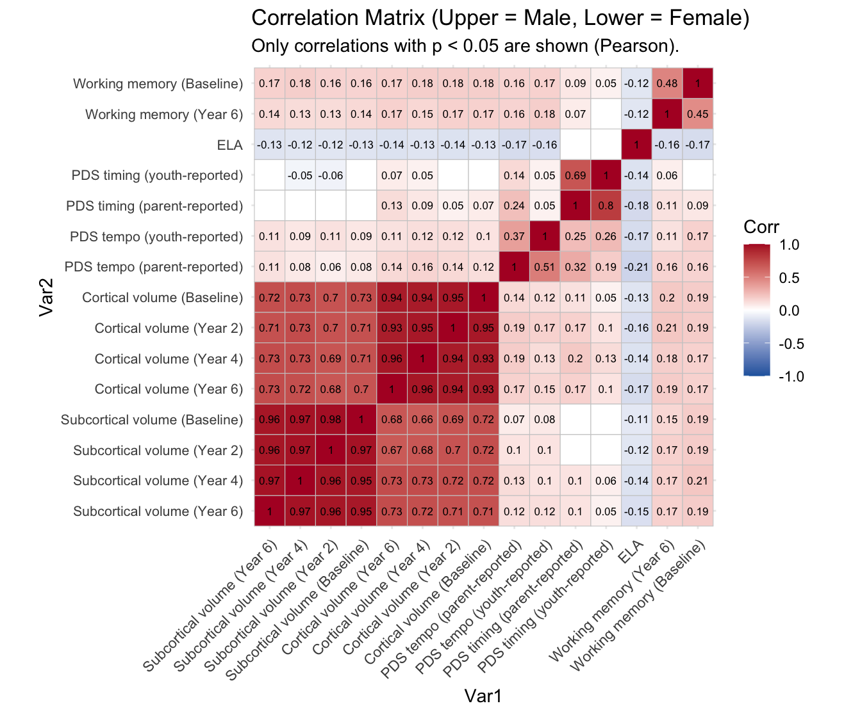
Figure S1. Correlations of all focal variables. Correlations for males are presented in the upper triangle and correlations for females are presented in the lower triangle. Only significant correlations (p < .05) are depicted. The color reflects the strength of the correlation.
Table S2. Female cortical gray matter volume
 | Model 1 |  |  |  |  |  | Model 2
Females | Estimate | SE | p | LLCI | ULCI |  | Estimate | SE | p | LLCI | ULCI
Latent variables
Intercept | 12.162 | 0.204 | <0.001 | 11.826 | 12.498 |  | 12.31 | 0.204 | <0.001 | 11.975 | 12.644
Slope | -9.129 | 0.707 | <0.001 | -10.292 | -7.965 |  | -9.137 | 0.711 | <0.001 | -10.306 | -7.968
Covariances
Intercept, Slope | -0.312 | 0.039 | <0.001 | -0.376 | -0.248 |  | -0.315 | 0.039 | <0.001 | -0.38 | -0.251
Intercept, Timing | 0.132 | 0.02 | <0.001 | 0.099 | 0.165 |  | 0.108 | 0.02 | <0.001 | 0.075 | 0.142
Intercept, Tempo | 0.163 | 0.021 | <0.001 | 0.128 | 0.197 |  | 0.136 | 0.021 | <0.001 | 0.101 | 0.171
Slope, Tempo | -0.055 | 0.038 | 0.147 | -0.117 | 0.007 |  | -0.055 | 0.038 | 0.151 | -0.118 | 0.008
Timing, Tempo | 0.318 | 0.02 | <0.001 | 0.285 | 0.351 |  | 0.289 | 0.021 | <0.001 | 0.255 | 0.323
Path coefficients
Timing Slope | 0.341 | 0.043 | <0.001 | 0.269 | 0.412 |  | 0.341 | 0.043 | <0.001 | 0.27 | 0.413
ELA Intercept | - | - | - | - | - |  | -0.145 | 0.022 | <0.001 | -0.181 | -0.11
ELA Slope | - | - | - | - | - |  | 0.003 | 0.039 | 0.938 | -0.061 | 0.067
ELA Timing | - | - | - | - | - |  | -0.185 | 0.021 | <0.001 | -0.22 | -0.15
ELA Tempo | - | - | - | - | - |  | -0.218 | 0.022 | <0.001 | -0.255 | -0.182
Intercept WM | - | - | - | - | - |  | - | - | - | - | -
Slope WM | - | - | - | - | - |  | - | - | - | - | -
Timing WM | - | - | - | - | - |  | - | - | - | - | -
Tempo WM | - | - | - | - | - |  | - | - | - | - | -
ELA WM | - | - | - | - | - |  | - | - | - | - | -
Means
Timing | 10.966 | 0.158 | <0.001 | 10.706 | 11.225 |  | 11.154 | 0.158 | <0.001 | 10.895 | 11.413
Tempo | 3.707 | 0.063 | <0.001 | 3.603 | 3.81 |  | 3.926 | 0.065 | <0.001 | 3.819 | 4.033
ELA | - | - | - | - | - |  | 1.014 | 0.018 | <0.001 | 0.985 | 1.044
WM | - | - | - | - | - |  | - | - | - |  | -
Fit statistics
saBIC | 74058.118 |  |  |  |  |  | 83016.938
Males | Estimate | SE | p | LLCI | ULCI |  | Estimate | SE | p | LLCI | ULCI
Latent variables
Intercept | 11.789 | 0.186 | <0.001 | 11.482 | 12.095 |  | 11.931 | 0.185 | <0.001 | 11.627 | 12.236
Slope | -8.779 | 0.63 | <0.001 | -9.816 | -7.743 |  | -8.808 | 0.636 | <0.001 | -9.854 | -7.762
Covariances
Intercept, Slope | -0.307 | 0.04 | <0.001 | -0.373 | -0.24 |  | -0.306 | 0.04 | <0.001 | -0.371 | -0.241
Intercept, Timing | 0.055 | 0.021 | 0.008 | 0.021 | 0.09 |  | 0.056 | 0.021 | 0.008 | 0.021 | 0.09
Intercept, Tempo | 0.135 | 0.02 | <0.001 | 0.102 | 0.169 |  | 0.114 | 0.021 | <0.001 | 0.08 | 0.148
Slope, Tempo | -0.033 | 0.039 | 0.395 | -0.098 | 0.031 |  | -0.028 | 0.039 | 0.463 | -0.092 | 0.035
Timing, Tempo | 0.248 | 0.022 | <0.001 | 0.212 | 0.284 |  | 0.252 | 0.022 | <0.001 | 0.216 | 0.287
Path coefficients
Timing Slope | 0.383 | 0.037 | <0.001 | 0.323 | 0.443 |  | 0.383 | 0.037 | <0.001 | 0.323 | 0.443
ELA Intercept | - | - | - | - | - |  | -0.139 | 0.021 | <0.001 | -0.174 | -0.104
ELA Slope | - | - | - | - | - |  | 0.025 | 0.041 | 0.54 | -0.042 | 0.092
ELA Timing | - | - | - | - | - |  | -0.17 | 0.021 | <0.001 | -0.037 | 0.032
ELA Tempo | - | - | - | - | - |  | -0.003 | 0.021 | 0.9 | -0.204 | -0.136
Intercept WM | - | - | - | - | - |  | - | - | - |  | -
Slope WM | - | - | - | - | - |  | - | - | - |  | -
Timing WM | - | - | - | - | - |  | - | - | - |  | -
Tempo WM | - | - | - | - | - |  | - | - | - |  | -
ELA WM | - | - | - | - | - |  | - | - | - |  | -
Means
Timing | 13.83 | 0.201 | <0.001 | 13.499 | 14.16 |  | 13.832 | 0.202 | <0.001 | 13.499 | 14.165
Tempo | 3.888 | 0.064 | <0.001 | 3.784 | 3.992 |  | 4.062 | 0.064 | <0.001 | 3.956 | 4.167
ELA | - | - | - | - | - |  | 1.026 | 0.017 | <0.001 | 0.998 | 1.055
WM | - | - | - | - | - |  | - | - | - | - | -
Fit statistics
saBIC | 83167.763 |  |  |  |  |  | 93083.506

