**WIRELESS DIGITAL NOTICE BOARD**

**Abstract**

Conventional Notice Board employs manual display and monitoring with papers and ledgers. The objective of the project is to display the message on the notice board from anywhere and anytime. The projects aim at designing an LCD module-based message display controlled from an android mobile phone. The proposed system makes use of wireless technology to communicate from android mobile phone. This notice board is primary thing in any institution or public utility places like bus stations, railway stations, colleges, malls, etc.

**Introduction**

We know the importance of notice boards in public places like railway stations, bus stations and airports. But changing notices day-to-day is a difficult task. The project displays the data on LCD whatever we sent from the mobile. Nowadays conveying messages at large using notice boards are widely used ones ranging from schools to organizations. We know the significance of notice boards in public areas like bus stands, railway stations, airports, and banks, etc. But day to day changing these boards is a very difficult task and a waste of time. At present, all electronic boards are designed with a wired system. The major drawback of designing these boards is; not flexible and cannot be located anywhere due to messy wire. To overcome this problem, a wireless board is designed to display the latest information. The main goal of this project is to design a wireless board using Bluetooth module which can replace the currently used conventional notice boards.

**Flow chart**

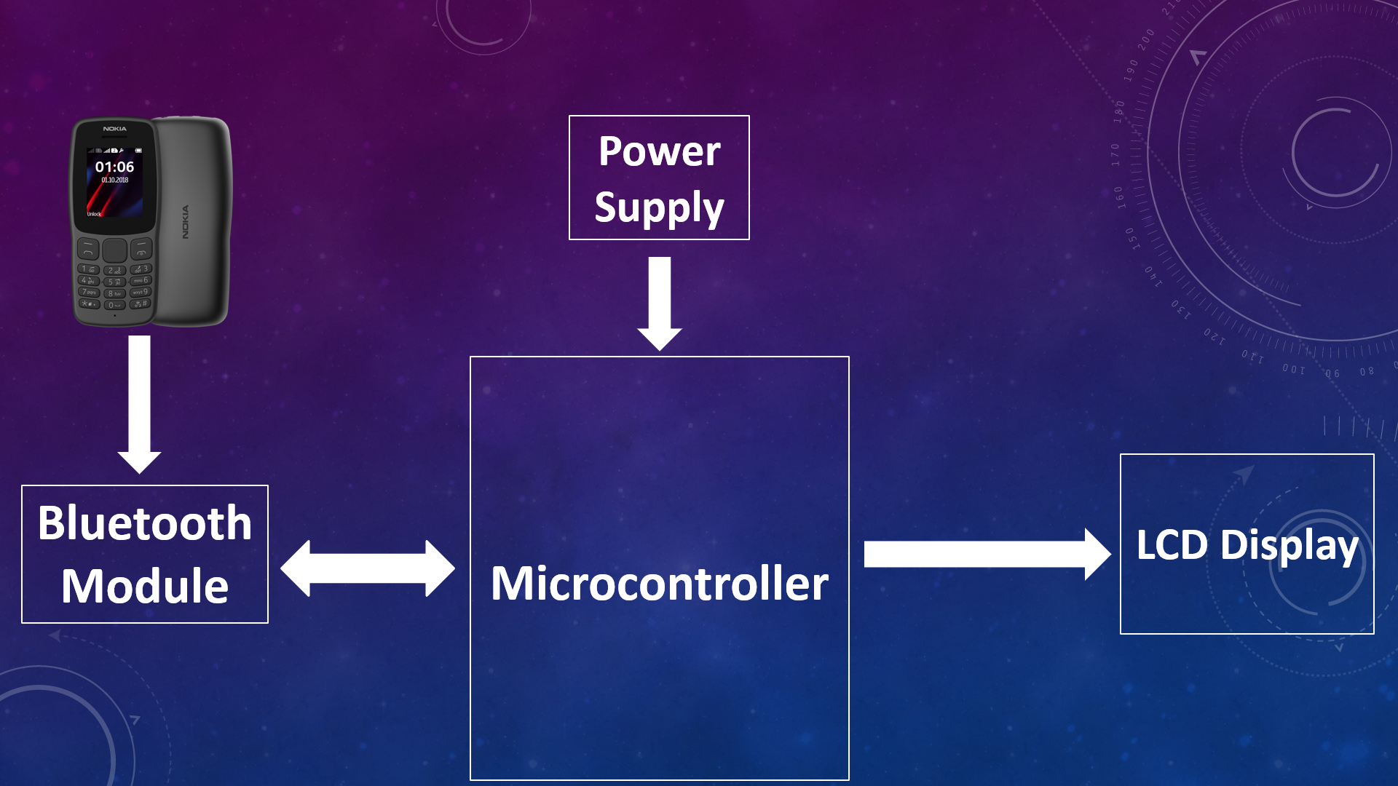

**Circuit diagram**

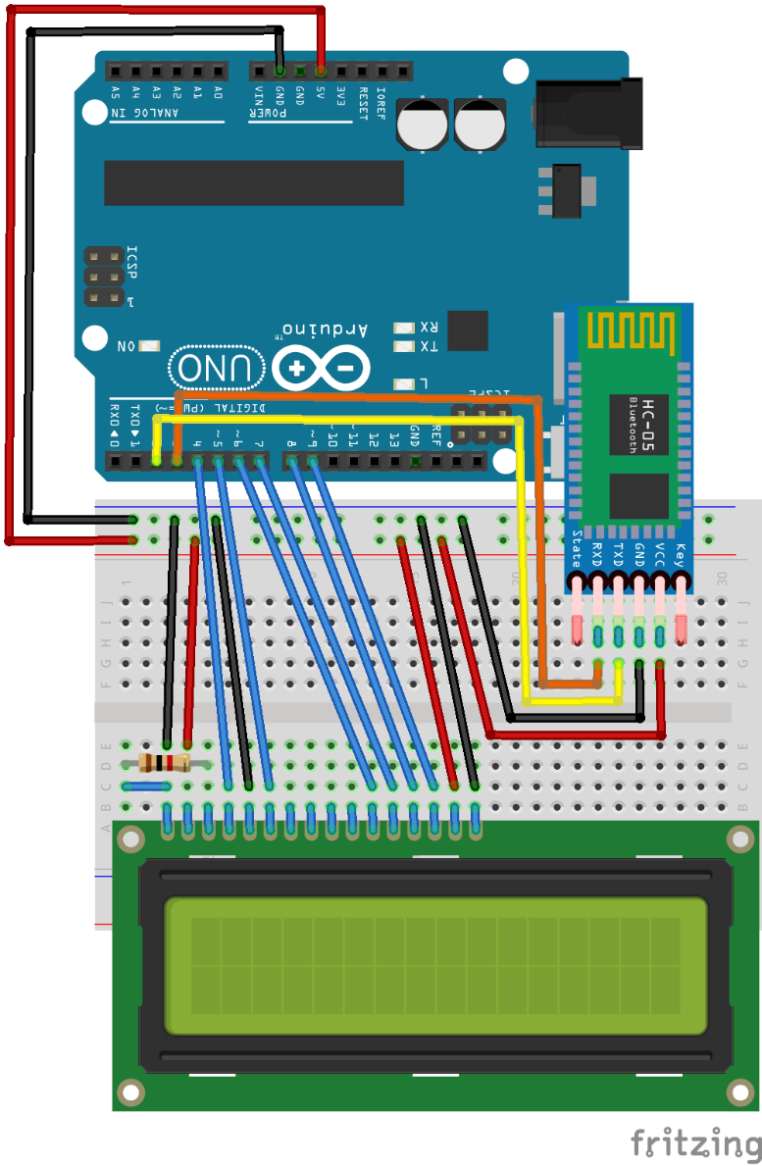

**Design specifications**

* Nodemcu ESP8266
* Bluetooth Module HC-05
* 16 x 2 LCD Module
* Breadboard
* 50K Ohm Potentiometer
* 1.5 V Battery
* Jumper wires

**Working principle**

* We will be using Arduino automation app in the mobile.
* When we open the app, we need to connect our mobile to the Bluetooth HC-05 module.
* It prompts a pop-up window where it will ask you to type something in order to display on the notice board.
* Here when we type something in the mobile the information will be received by Bluetooth module via Bluetooth medium.
* The Bluetooth module has Tx & Rx pins which transmit information to the Rx & Tx pins of Nodemcu ESP8266 respectively.
* The Nodemcu ESP8266 reads the message from the Bluetooth module will be executing set of instructions which are coded into the Nodemcu ESP8266 memory (ROM).
* The Nodemcu ESP8266 and LCD module are connected with the 4 Bit data transfer pins, anode, cathode, enable and contrast pins.
* The contrast of the LCD module is adjusted with the help of a potentiometer.
* The input received from the mobile will be displayed on the LCD module.
* Here a 1.5volts battery is connected to the Nodemcu ESP8266 3volts analog pin in order to make the voltage of 4.5volts (nearly 5volts) so that it drives the LCD Module.

**Code**

**#include <LiquidCrystal.h>**

**#include <SoftwareSerial.h>**

**LiquidCrystal lcd(D0, D1, D2, D3, D4, D5);**

**SoftwareSerial mySerial(D7, D6); //(Rx,Tx)**

**String val = "No Data";**

**String oldval;**

**String newval = "No Data";**

**int length;**

**int l;**

**void setup()**

**{**

**// put your setup code here, to run once:**

**lcd.begin(16, 2);**

**mySerial.begin(9600);**

**Serial.begin(9600);**

**lcd.setCursor(0, 0);**

**lcd.print("Wireless Notice");**

**lcd.setCursor(0, 1);**

**lcd.print(" Board ");**

**delay(3000);**

**lcd.clear();**

**lcd.print("Welcome!");**

**}**

**void loop()**

**{**

**val = mySerial.readString();**

**length=val.length();**

**val.trim();**

**Serial.println(val);**

**if(length!=0)**

**{**

**l=length;**

**}**

**if (val != oldval)**

**{**

**newval = val;**

**}**

**lcd.clear();**

**lcd.setCursor(0, 0);**

**lcd.print(newval);**

**delay(1000);**

**if(l>16)**

**{**

**for (int i=0;i<l-16;i++)**

**{**

**lcd.scrollDisplayLeft();**

**delay(250);**

**}**

**delay(1000);**

**for (int i=0;i<l-16;i++)**

**{**

**lcd.scrollDisplayRight();**

**delay(250);**

**}**

**}**

**val = oldval;**

**}**

**Photos of model**

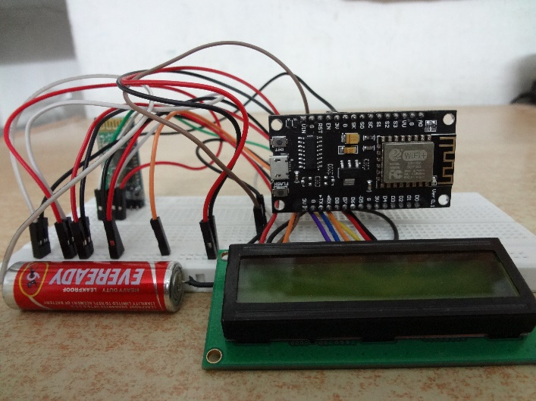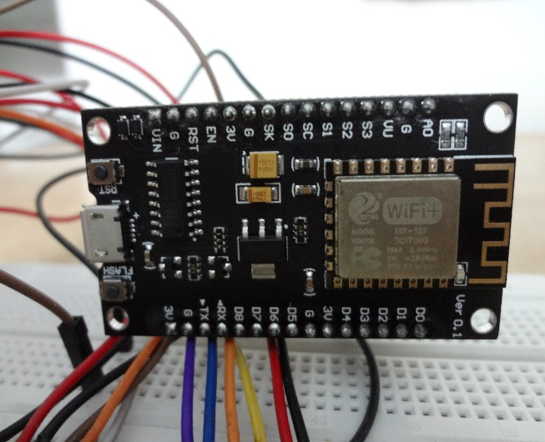

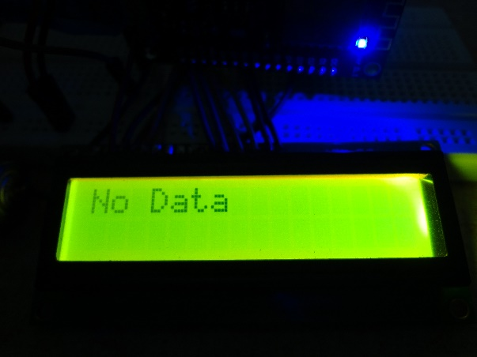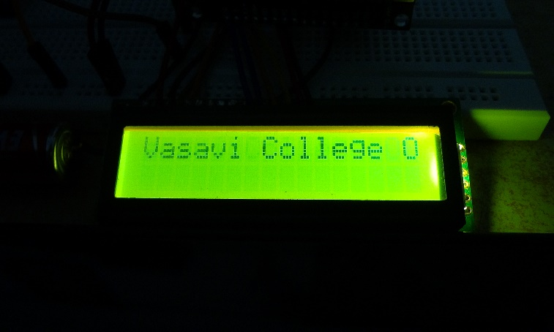

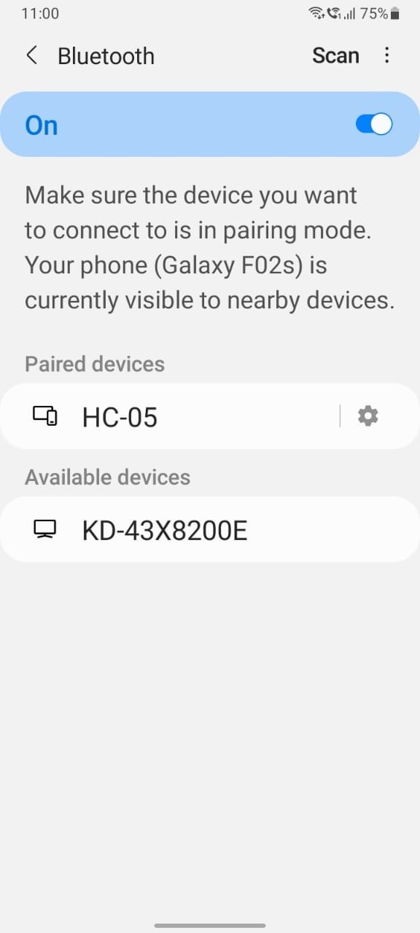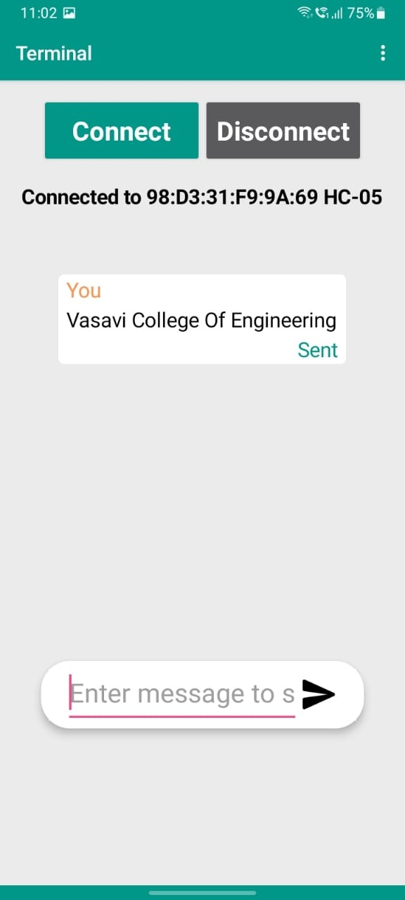

**Here are some links of the videos. To view them place your cursor on the link and press ctrl+rightclick.**

[**https://drive.google.com/file/d/1vmsXG12TvLq6k1CCi6PNenO0hmLCXeZo/view?usp=sharing**](https://drive.google.com/file/d/1vmsXG12TvLq6k1CCi6PNenO0hmLCXeZo/view?usp=sharing)

[**https://drive.google.com/file/d/1QZ9Rx02B1Aa-ObYiPiTnXxzfDkDwF9Ow/view?usp=sharing**](https://drive.google.com/file/d/1QZ9Rx02B1Aa-ObYiPiTnXxzfDkDwF9Ow/view?usp=sharing)

**Conclusion**

* With the day-to-day advancement in technology the notice

boards are also evolving from a hand-written system to a digital display and further to a wireless display system.

* Hence, we have chosen wireless digital notice board which is designed, implemented, tested and verified.

**Future scope and references**

* As India is aiming towards Digital India, we need to upgrade ourselves with latest technologies in the Digital World.
* We need to replace the traditional methods with the latest methods in order to enrich the access and services to the people.

**Applications**

* Used in bus stations, railway stations, parks, etc. to display the messages wirelessly.
* This Project can also be used in colleges and organizations.  
    
   **THANK YOU**