**CONTENT**

**S.NO**

1. Abstract & Introduction

2. Literature Survey & Motivation

3. Components Required

4. Nodemcu ESP8266, Neo 6M Gps Module &

OLED Module

5. Circuit Diagram

6. Working Principle

7. Applications & Future Scope

8. Conclusion & Photos Of Model

9. References

**ABSTRACT AND INTRODUCTION**

Nowadays, security is the utmost concern for us, whether it is related to our assets like vehicles, homes or our children. In this case, GPS tracker devices are very useful. They can be easily used to track the real-time position of the vehicles or assets in case of any emergency like theft, accidents, etc. They can also be kept with children to track their location. In the upcoming digital world, there will be no toll booths present for collecting a toll from the passing traffic. Hence based on the travelling history of the person tax will be generated and sent it to them.

Here we are building the GPS tracking device to monitor the real-time location of the vehicle from anywhere. Here cloud will be used to store the history of locations from where the vehicle has traversed. In this **IOT GPS tracker,**we will display a link on the webpage which will take the user to Google map showing the vehicle location.

**COMPONENTS REQUIRED**

1. NodeMCU ESP8266

2. NEO-6M GPS Module

3. OLED Display Module

4. Breadboard

5. Jumper Wires

6. 18650 Lithium Cell

7. 18650 Lithium Cell Holder

**NodeMCU ESP8266**

**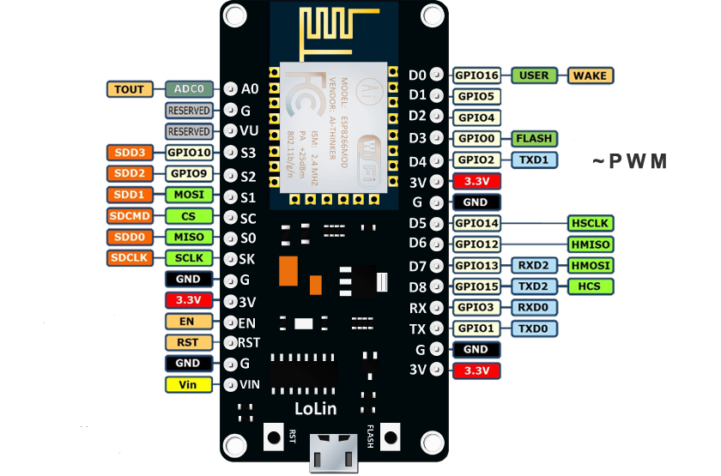**

The [NodeMCU](http://nodemcu.com/index_en.html" \t "_blank) (Node MicroController Unit) is an open source software and hardware development environment that is built around a very inexpensive System-on-a-Chip (SoC) called the [ESP8266](https://en.wikipedia.org/wiki/ESP8266). The ESP8266, designed and manufactured by Espressif Systems, contains the crucial elements of a computer: CPU, RAM, networking (WiFi), and even a modern operating system and SDK. That makes it an excellent choice for Internet of Things (IoT) projects of all kinds.

**NEO-6M GPS Module**

**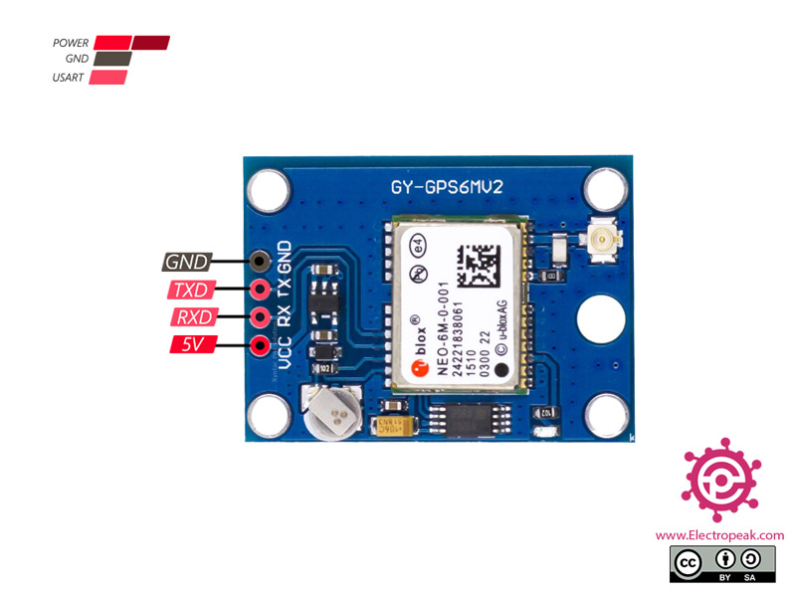**

GPS stands for Global Positioning System, which is a worldwide radio-navigation system. To track the location of the device, the GPS tracking system uses the **Global Navigation Satellite System (GNSS)** Network. This network consists of a range of satellites that uses microwave signals to transmit the data which will be received by the GPS receiver module. It can do up to 5 location updates a second with 2.5m Horizontal position accuracy. One of the best features the chip provides is Power Save Mode (PSM). It allows a reduction in system power consumption by selectively switching parts of the receiver ON and OFF.

**OLED Module**

**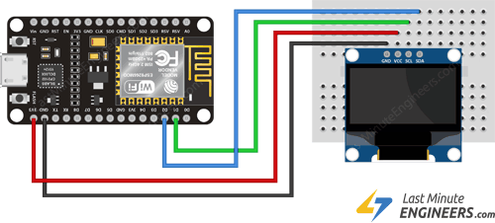**

An organic light-emitting diode (OLED) is a high-contrast and high-resolution display, making it easy for users to be readable. This kind of displays doesn’t have a backlight and create the backlight themselves and this makes them sharper, clearer and smoother than LCDs. Small OLED modules are very useful in electronics projects. Simple wiring and high readability of displays are suitable for showing data, numbers and simple images. You can find different size and colors of these panels with different resolutions.

**Circuit Diagram**

**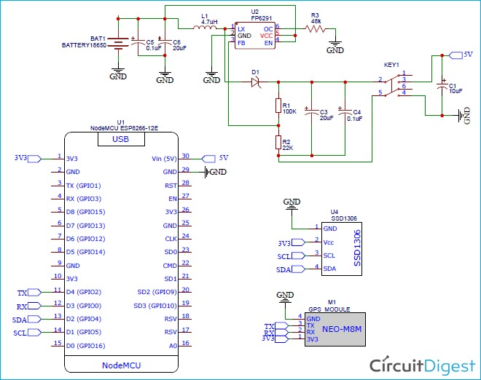**

**Working Principle**

The GPS module consists of an antenna, which produces the co-ordinates, speed, distance and sends them to the Nodemcu esp8266. This will try to print the co-ordinates, speed, distance on the OLED module in order to display it to the user. As you move from one location to another location the latitude, longitude, speed, distance gets updated with time. This information is sent to a webserver where we can know the location of the person carrying the GPS tracker, for this facility we need to use also GSM module so that he is connected to internet always. This is how we can remotely access the location of the user in order to know where he is going.

**Applications**

* Military
* Search and rescue
* Gps tracking of vehicles
* Aviation
* Marine
* Farming

**Extension**

* In the near future as there will be no toll booths on highways, we planned a car with this GPS tracker which tracks the distance travelled by car and generates the toll tax based on the number of kilometres travelled by the car.

**Conclusion**

Over the past two decades, global positioning system (GPS) technology has been rapidly developed and used for various applications in different industries. At present, the GPS still has limits to accurate measurement and the signal does not penetrate solid walls or structures. The application of GPS is however promising as a navigation, survey and information tool because it can measure dynamic and static displacements in real time, whereas the conventional monitoring system using other sensors such as accelerometers cannot measure static and quasi-static displacements. In addition, rapid advances in GPS devices and algorithms can mitigate erroneous GPS data sources, and integrated systems using GPS receivers with additional sensors can provide accurate measurements.

**Photos Of Model**

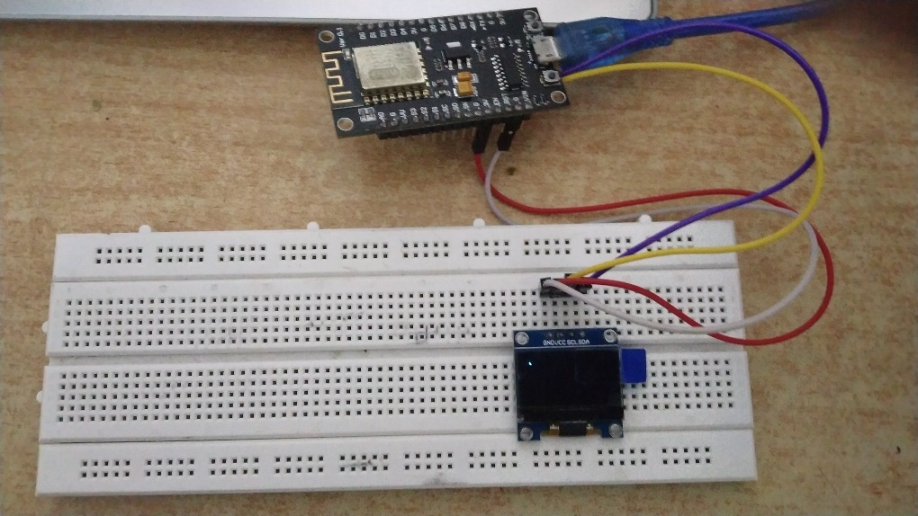

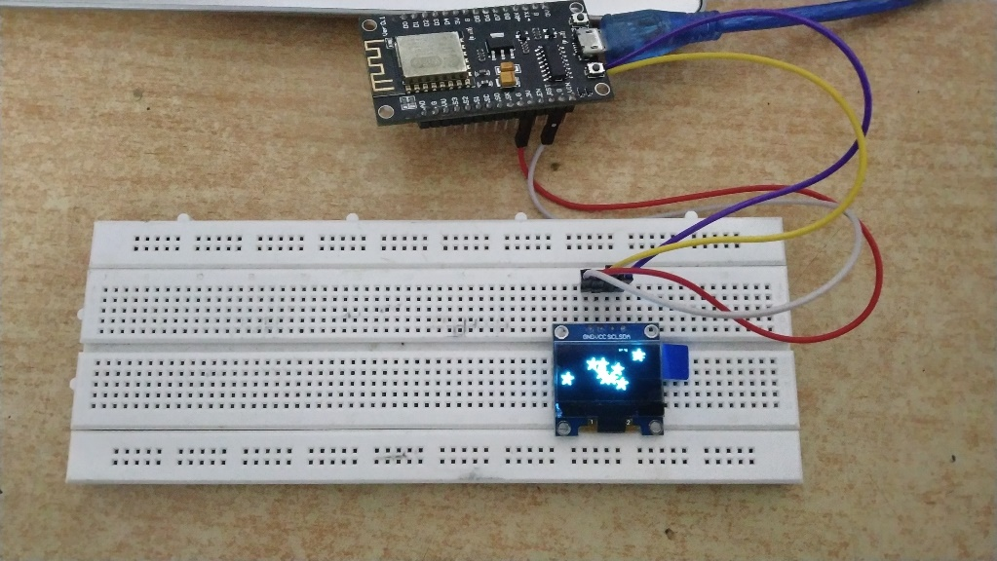

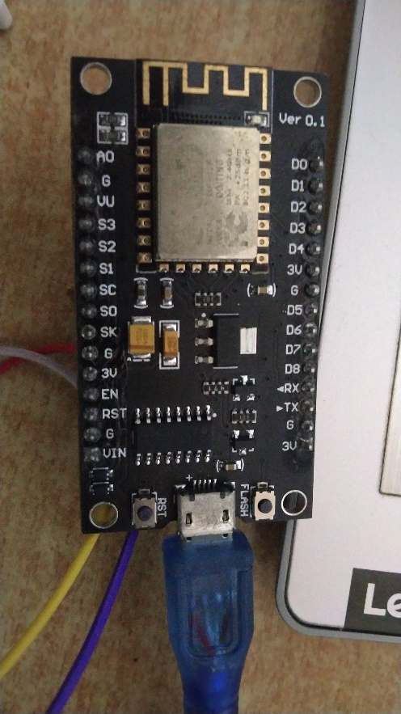

**References**

* [**https://youtu.be/gXK2vExOuxQ**](https://youtu.be/gXK2vExOuxQ)
* [**IoT Based GPS Location Tracker using NodeMCU and GPS Module – Save GPS co-ordinates and view on Google Maps (circuitdigest.com)**](https://circuitdigest.com/microcontroller-projects/iot-based-gps-location-tracker-using-nodemcu-track-and-save-gps-location-on-google-maps)