FES 524: Natural Resources Data Analysis

Reading 3.2

**Contents**

Other readings to do before class 1

Multiple comparisons 1

Type I and Type II errors 1

Beyond Type I and Type II errors 2

When to use an adjustment 2

Options for adjustments in emmeans 3

Inconclusive results 3

Issue of sample size 4

Issue of variation 4

Limitations 4

Power analysis 5

Basic approach 5

Why do a power analysis? 6

Simulations 6

Class 3.2 will be another review class, covering concepts you learned in your basic statistics classes.

# Other readings to do before class

Read Gelman’s blog post “This is what power = .06 looks like”, <https://andrewgelman.com/2014/11/17/power-06-looks-like-get-used>, and Handout 3.6, which has two examples of discussing inconclusive results. Come prepared with questions or comments on these to discuss more as a class.

Read the description of the study that assignment 3 is based on in Handout 3.2 and come prepared to discuss the research question, scope of inference, and aspects of the study design.

# Multiple comparisons

This week we will do a quick review of the issue of multiple comparisons. Multiple comparisons is most often considered to be an issue when doing many comparisons using the same response variable, although sometimes folks consider comparisons from related response variables. All the comparisons we consider to be related in some way may be referred to as the *family* of comparisons.

The issue of multiple comparisons comes up when people are worried about the *familywise* Type I error rate; the Type I error rate for the whole family of comparisons.

## Type I and Type II errors

Type I errors are when we falsely reject a “true” null hypothesis. If we make a Type I error we end up saying something is going on when there really isn’t. The more comparisons we do, the more likely it is we’ll make a mistake “by chance alone”. The terms *false positive* or *false discovery* can also be used for this kind of mistake

You will see a lot of focus on Type I errors in statistics classes. However, this is not the only kind of error you can make nor is it unquestionably the most important kind of error to worry about. Type II errors, while less discussed, are also important. Type II errors occur when we fail to reject a false null hypothesis. These are issues of *false negatives*, where we say nothing is going on when there really is.

Type I and Type II errors are about long run behavior. They can only be calculated if we do the exact same study many times, taking a different sample in each study iteration. In addition, and more important, they can only be calculated if we *already know the true answer*. To calculate a Type I error rate we must assume there really is no difference among means or relationship between variables (i.e., we assume the null hypothesis is actually true). To calculate a Type II error rate we must assume there is really a difference among, e.g., group means and we’d need to know exactly how large that true difference is.

While the concepts of Type I and Type II errors can be useful when in the planning stages of a study, they are not useful when looking at observed results. First, they can help lead us into dichotomous thinking, where we say there absolutely was or wasn’t an effect only based on statistical measures. Second, observed results from a single study are not long run averages; Type I and Type II errors aren’t meaningful when looking at the observed results from a single analysis.

## Beyond Type I and Type II errors

Instead of thinking about Type I/Type II errors in purely a statistical sense, we can use them as a proxy for thinking about our study results and whether we are most concerned with overstating or understating the observed study results.

We need to think about how likely it is that whatever we are studying should show some effect, such as a difference in means or a non-zero slope. The probability that what you see is a “false discovery” is really based on an underlying truth we don’t know. Given that, we need to think about what we believe that underlying truth to be based on expert knowledge when thinking about how to frame our results.

What kind of mistake are you willing to make in your own research? Are you more concerned with being too conservative and reporting little effect when there really was a large effect? This would be a situation where your confidence interval is overly wide and so you are being conservative since a wide confidence interval has many plausible values in it for the true effect. Or are you more concerned about overstating the results, making a strong statement of an effect that is actually spurious? This would be a situation where your confidence intervals are too narrow, and you overstate the precision of the results. Come prepared to discuss this in class.

## When to use an adjustment

Given the issues with Type I and Type II errors, do we need to adjust for multiple comparisons? The answer, like so many in statistics, is a solid “maybe”. It depends on the goals of your research and your answers to some of the questions I listed above. It also may depend on your field. For good or ill, some fields always use certain multiple comparison adjustments regardless of any of the other issues we’ll discuss.

The amount of planning that went into the comparisons is something to consider when deciding about whether you will use an adjustment or not. A few, carefully planned comparisons you defined before you collected any data is considered by many to be a different situation than when you are doing all possible pairwise comparisons across many groups. With preplanned comparisons you may be able to justify not using a multiple comparisons adjustment because you planned things so carefully using *a priori* knowledge. If you have a strong idea that there will be an effect based on a current scientific theory (i.e., reducing competition increases growth), it may be easier to justify not doing an adjustment. When doing all pairwise comparisons, though, you may be more concerned about overstating the results and so decide to use an adjustment for multiple comparisons.

The type of research you are doing could also affect your decision to make an adjustment or not. Confirmatory research is usually more strict about being careful not to overstate results than exploratory research. But note that investigators doing exploratory genetics research tend to use multiple comparisons adjustments as a standard practice.

What the results are going to be used for may affect whether we want to be more conservative (wider CI) or less conservative (narrower CI). This is based on scientific expertise and not statistics, which is one reason why I can’t give you a blanket rule on when we should or shouldn’t use multiple comparisons adjustments.

Whatever you choose to do, you should state which adjustment you used and why. This indicates you thought about the problem and made a decision as an expert in your field. I’ve listed some examples of stating why adjustments were or were not used in Week 3 Handout 4 so you can see the kind of language you might use in assignments and in your thesis.

## Options for adjustments in emmeans

We are using package emmeans in this class for doing comparisons of means across groups. This package comes with several built-in adjustments for multiple comparisons. You can see more information on these adjustments in the documentation for summary.emmGrid. Also review your notes from previous statistics classes if you can’t remember when some of these are used.

I’ve listed the emmeans built-in adjustments below. The stars indicate adjustments that are extremely conservative for large families of comparisons. Unless these are standard in your field or you are very concerned about overstating results, these adjustments should likely be avoided.

Tukey’s HSD

Scheffe’s method

Sidak correction*

Bonferroni correction*

Dunnett’s method

Multivariate-t correction

No correction

# Inconclusive results

Unfortunately, there are going to be situations where the results of a study are inconclusive. The thinning example from week 2 is one such situation. In the graphic showing the results below, we can see that the differences between the moderate and heavy thinning vs the light thinning were in the expected direction but were smaller than the practically important difference. In addition, the confidence intervals are extremely wide, encompassing both practically important differences and differences in the “wrong” direction.

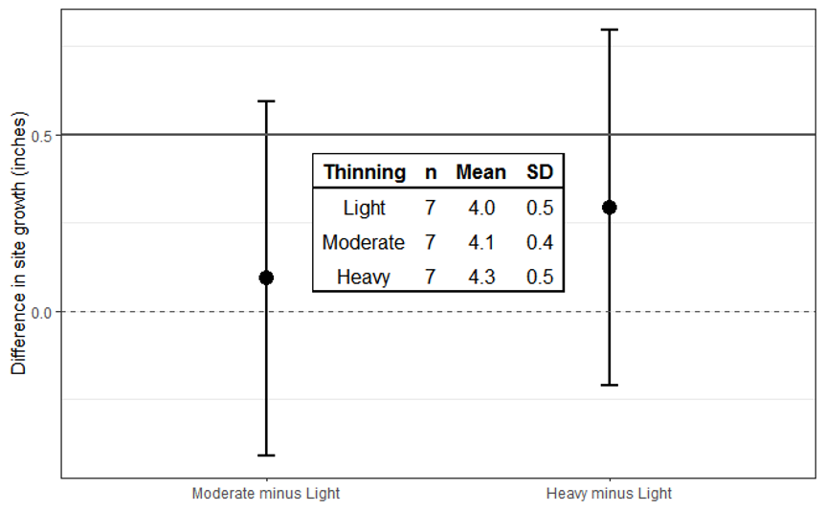

There isn’t anything we can do about this after the fact. Investigators need to be up front that little was learned, which can be difficult to admit. Week 3 Handout 6 goes through some of the problems with inconclusive results, which we’ve already touched on, and has one idea on how to frame inconclusive results in the larger research framework.

## Issue of sample size

Having wide confidence intervals is a common problem when an analysis ends up with inconclusive results. The size of the confidence interval is affected by the standard errors. Standard errors are affected by the sample size.

As a reminder, here is the calculation of the standard error:

$$\frac{SD}{√n}$$

What happens to the standard error as n gets large?

Given the same standard deviation (SD), a larger sample will reduce the standard error and so the size of confidence intervals.

## Issue of variation

Unexplained variation is another important factor that can cause wide confidence intervals. This is variation that is not explained by other variables in the model or controlled for by the study design.

What happens to the standard error as the SD gets small, given a fixed sample size?

The affect of unexplained variation on the results is why we spent time talking about sources of variation. If we can explain the variation via study design or through covariates we can get a more precise answer without having to sample more units.

## Limitations

You will be asked to discuss study limitations on assignments and in your final project.

One such limitation for inconclusive results like the one above could be related to a wide confidence interval. If you believe the study should have chosen a larger sample size, be specific on how that would help with conclusions in a future study.

The amount of unexplained variation is another common limitation for studies with inconclusive results. If so, you could discuss other factors that you think investigators should control in future studies.

The representativeness of the sample to the population of inference could be a limitation you want to discuss. For example, you could question how representative a very small sample really is of the population. We know from the simulation in week 1 that a single sample, random chosen or not, can poorly represent the population of interest. The smaller the sample, the more likely this is to happen by chance alone.

Scope of inference will commonly come up in your limitations section even if results were “conclusive”. I find this especially true for observational studies done in a single year or some other short time frame.

# Power analysis

Statistical power is defined mathematically as 1 minus the probability of a Type II error. In words, power is the probability that we will reject a false null hypothesis at some fixed alpha level. This is a statistical term that involves long-run averages and assuming we know the truth; remember to avoid dichotomous thinking in observed results as discussed earlier.

## Basic approach

1. Define an effect size

This is a realistic effect size that you think would indicate something practically important in your field. The larger the effect size, the fewer samples you need.

1. Define the expected variance around that effect size.

Again, this must be a realistic estimate of the variance. The smaller the variance, the fewer samples you need.

The effect size and expected variance may come from previous research. But beware the winner’s curse! These values should not be solely based on estimates from small pilot studies. Studies with very low power can lead to exaggerated effect sizes while severely underestimating the true variance. The short blog post by Andrew Gelman you are also reading this week hits on this same idea. If you are interested in more information on the winner’s curse, see the Button et al. 2013 paper ["Power failure: why small sample size undermines the reliability of neuroscience"](https://www.nature.com/articles/nrn3475).

1. Choose a minimum power your study should have

This is where you think about the seriousness of making a Type II error in what you are studying. The higher the power you choose (i.e., the lower the Type II error rate), the more samples you will need.

1. Choose an alpha value

This is where you think about the seriousness of making a Type I error. This means you shouldn’t simply blindly choose 0.05 as your cut-off but seriously consider what it would mean to your research to make a Type I error as well as how likely you think it is that you will see an effect. The larger the alpha value the fewer samples you’ll need.

Unlike after you have observed the results, considering Type I and Type II error rates and how serious each is in your research makes some sense during the design phase.

Once you have all of these pieces of information you can calculate the number of samples you need per group (for simple study designs). If working with categorical explanatory variables, we usually make the simplifying assumption that we will have the same number of observations in every group when doing a power analysis.

## Why do a power analysis?

There are a lot of positives that come out of doing a power analysis.

Investigators must define the effect of interest. This means they are forced to consider the size of the effect they think would be important, which is a big improvement over only considering the value from the null hypothesis.

Since values are needed for both an effect size and a reasonable estimate of variance around that effect, investigators must review the previous research that is similar to the proposed research with a critical eye. For example, they need to consider how “good” estimates are that are coming out of previous research.

Analyses are based on a lot of assumptions, and a power analysis forces investigators to state those assumptions. This includes the alpha value they are willing to consider as well as a value for power.

For simple analyses, such as a t-test or a basic ANOVA, you may find simple power analysis calculators such a G*Power useful. For more complicated study designs or models like mixed models or generalized linear models you will more likely need to use a simulation based approach.

# Simulations

Simulations are a powerful approach to exploring design trade offs and understanding how a model works in less-than-ideal circumstances (such as if an assumption hasn’t been met). Simulations usually involve a fair amount of coding, which makes them difficult to fit into most classes that are set up like this one. We unfortunately will not learn to do simulations in this class.

You can see some blog posts on how to do get started doing simulations in R for different kinds of linear models here: <https://aosmith.rbind.io/tags/#simulation-list>. We will talk a little more about one of these posts in class as time allows.