FES 524: Natural Resources Data Analysis

Reading 4.2

**Contents**

Other readings to do before class 1

Transformations 1

Change relative spacing 1

Change relationships 3

Why transform? 4

Types of transformations 4

Alternatives to transformation 5

The log-normal distribution 5

What about zeros? 7

Multiplicative models 7

Inference to medians 8

Multiplicative differences 8

Percentages 8

Percentage change vs ratios 9

Class 4.2 will be another review class, covering concepts you learned in your previous statistics classes.

# Other readings to do before class

Read the description of the study that assignment 4 is based on in Handout 4.2 and come prepared to discuss the research question, comparisons, and aspects of the study design.

In addition, work through the problems in Handout 4.4.

# Transformations

Transformations are still commonly used in statistical analyses. It is important to understand why we sometimes use transformations as well as modern alternatives to transformations.

The use of transformations is generally to change the scale of the response variable. Because the spacing changes, transformations also lead to changes in relationships among variables. Make sure you can recognize what amounts to a transformation vs a location or scale shift after seeing the examples below.

## Change relative spacing

Changing the scale of the response variable with a transformation means we are changing the relative spacing among observations.

Below is a graphic showing two plots. In the top plot you can see I plotted the observations from a variable Y using letters from A-O as labels based on the rank of the particular Y value (i.e., A represents the lowest Y value and O represents the highest Y value). The bottom plot shows the same thing after taking the natural logarithm of Y.

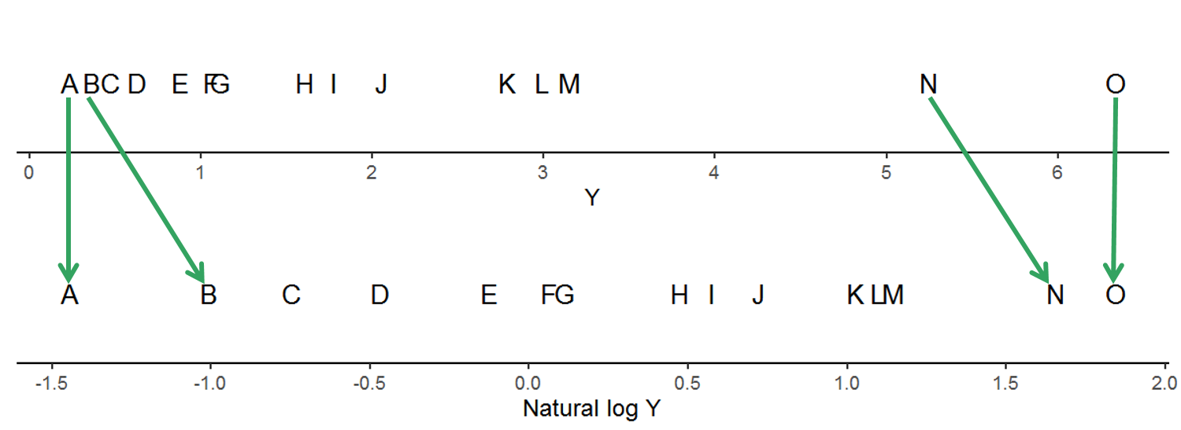

You can see that the relative spacing among the observations changed after taking the natural logarithm of Y compared to the relative spacing among the original Y values. Taking the logarithm of a variable is a transformation.

We can see something similar when using the square root of Y. The relative spacing of the observations changed compared to the original spacing of Y. Taking the square root of a variable is a transformation.

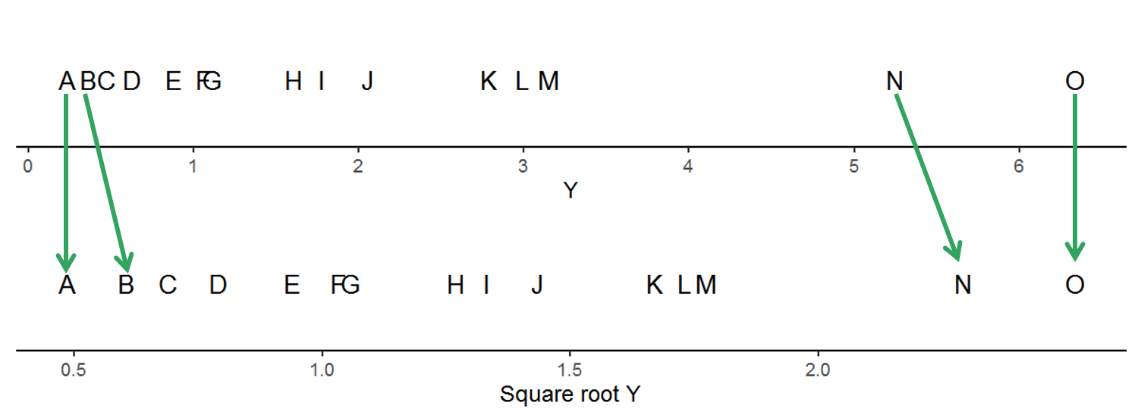

An additive shift does not change the relative spacing. In the plots below you can see that the values on Y axis have changed due to a location shift but the spacing among observations is unchanged. Adding a value to Y is not a transformation.

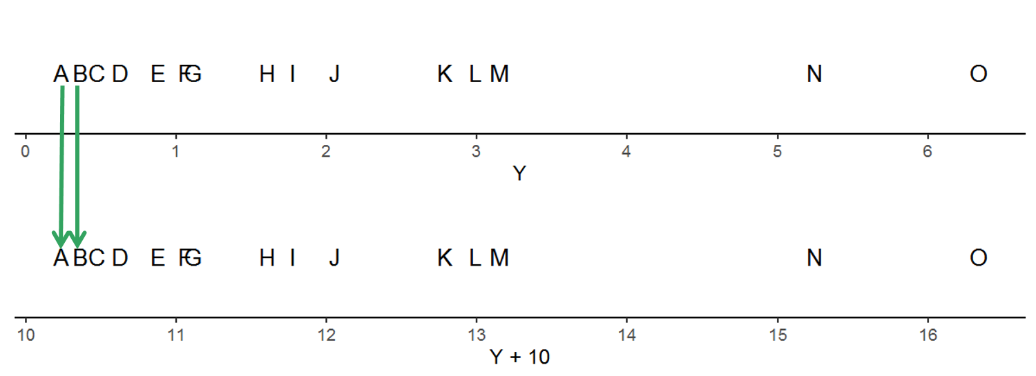

A multiplicative shift, where both the location and scale of the data changes, is also not a transformation. While the values after multiplying Y by 3 have changed, the relative spacing of observations is still the same.

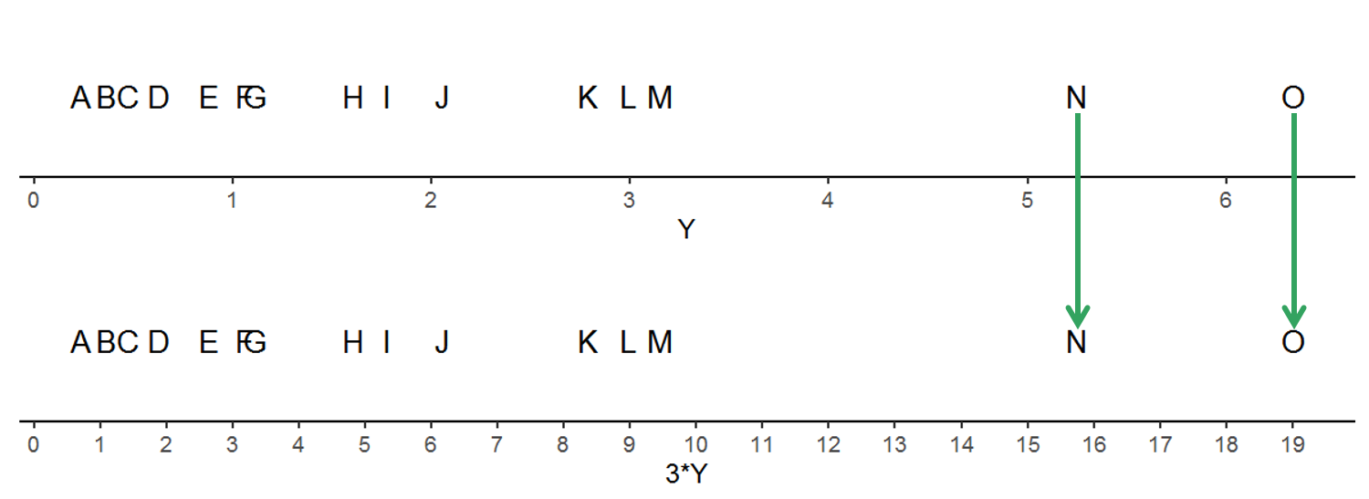

## Change relationships

Transformations change relationships among variables. Shifting the location and/or scale of Y does not. This is demonstrated in the plot below, where four different variables based on Y are plotted against the same X variable. Compare the subplot of the raw values of Y in the upper left-hand corner of the plot with the other three subplots. The strip label indicates how the original Y values were changed for each subplot.

Only when Y is transformed does the relationship of Y vs X change (shown in the lower right subplot).

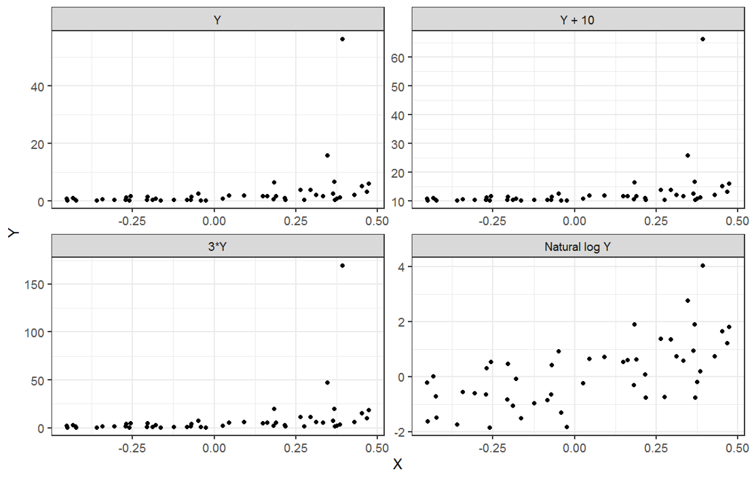

## Why transform?

Most often investigators do transformations in an attempt to meet assumptions of the linear model that aren’t met when using the raw data. Most common transformations you may have heard of are what are called “variance stabilizing transformations”. While many practitioners focus on normality of the errors when thinking about transformations, you know that issues of nonconstant variance is a bigger problem for linear models than departures from normality. Addressing issues of nonconstant variance is generally the purpose of transformations.

## Types of transformations

There are many different transformations available that can help stabilize variances.

Here are just a few examples:

Reciprocal: $\frac{1}{Y}$

Square: $Y^{2}$

Square root: $\sqrt{Y}$

Log base 10: $\log_{10}{Y}$

How do you choose a transformation?

The first thing to ask is what scale you are interested in making inference on. If you want to talk about things on the original scale of the data, will a back-transformations allow you to do that? Or, alternatively, maybe there is a transformation that allows for a natural interpretation. For example, working with the cube root of volume can be a useful in some fields where it makes sense to talk about the results as lengths.

Below are a couple of examples of the kind of inference that can be made after different transformations of the response variable:

Differences in mean square root biomass

Estimated slope between mean growth cubed and rainfall

Are such results interesting? This is a question you always need to be asking yourself when you are considering using a transformation.

I would argue that, no, the example results above are not interesting because they are not easily interpretable. I see the focus on transformations as only a way to meet model assumptions as pretty old-fashioned. I still see a lot of discussion online about Box-Cox and other transformations, but for practical problems like we are doing in this class where the goal is estimation this is all fairly obsolete. We want estimates on an interpretable scale, not to force things into a certain shape so we can meet model assumptions.

That being said, do note that transformations can be more useful when the goal is prediction instead of estimation. Even in that case, though, we often have other options to consider.

Unlike other transformations, the log transformation can often be useful. We will talk more about the log transformation, the log-normal distribution, and how to make inference after a log transformation in the next section.

Another potentially useful transformation when working with continuous proportion data is the logit transformation (i.e., log odds). We will not discuss this more in this class, but if you are struggling with meeting assumptions with continuous proportion data take a look at the Warton and Hui 2011 paper on transformations for proportions called “The arcsine is asinine”. You will find a link to this paper in the “Additional resources” section on Canvas.

## Alternatives to transformation

In modern statistics we have many alternatives to doing transformations. I list three options here, but there are more than this.

For relaxing assumption of constant variance, we can “extend” the linear model. In R this can be done using the gls() function in R from package nlme. Linear mixed models can also be extended in the lme() function. We will see a brief code example of this in lab this week and later this quarter.

Generalized linear models (GLM’s) using distributions with an appropriate mean-variance relationship are common analysis tool for some kinds of variables, such as counts and counted proportions. You will be introduced to GLM’s later this quarter. While GLM’s have been standard since the early 2000’s, if you are working in a field where they are not widely adopted yet I recommend starting with Stroup’s 2015 Agronomy paper “Rethinking the analysis of non-normal data in plant and soil science”. The paper was written for applied scientists and is fairly readable. I’ve put a link to it in “Additional resources” for this week and will bring it up again in week 7.

Robust regression can be used if the main problem you are having is extreme outliers. There are also options to deal with nonconstant variance and correlations among errors, although these modeling approaches have not been as widely adopted in natural resources fields as they have been in, e.g., economics.

# The log-normal distribution

The log-normal distribution is the distribution of a continuous variable whose *logarithm* is normally distributed. I will be talking about the natural logarithm, but this is true for any logarithm base. The log-normal distribution is the distribution you are using if you log transform a response variable, so it is important to understand this distribution in order to figure out when it is going to be useful to you in difference scenarios.

Features of the log-normal distribution:

1. The *support* of the log-normal distribution is strictly positive. This means the range of values that a variable following the log-normal distribution can have are positive and cannot contain 0.
2. A variable following the log-normal distribution is continuous. It is not, for example, integer-valued like counts.
3. A variable (or model residuals) that comes from the log-normal distribution will show right skew, even if the skew is minor.
4. The variance of a log-normally distributed variable increases with the mean. This is something you would see in, for example, a residuals vs fitted plot.

Seeing some examples of data drawn from a log-normal distribution can help show these features.

Below is a plot showing a log-normal distribution. The raw data is on the left and the log-transformed data is on the right, showing that it is approximately normally distributed after transformation. The range of the variable is listed in the title so you can see the support. In this case, which is common with log-normally distributed variables, the range is quite large. This particular log-normal distribution is very right-skewed.

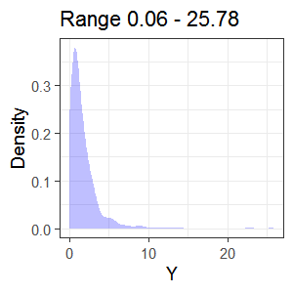 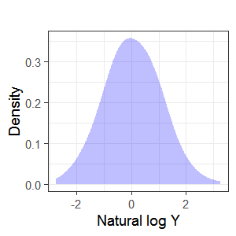

Here are a couple more examples of log-normally distributed data. All show strictly positive support, but the amount of skew and the range of values in the distribution varies.

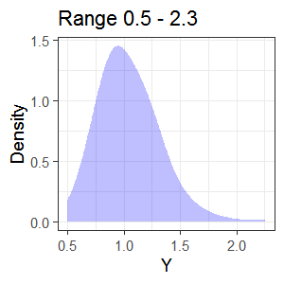 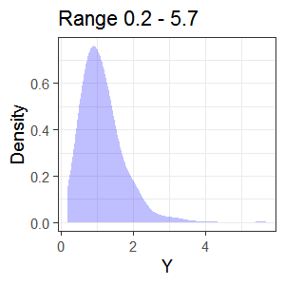

## What about zeros?

Now that you know more about the log-normal distribution you can see that this distribution does not contain 0 values. If you have 0 values in a variable that you want to log-transform you will need to carefully think through your options. I unfortunately see people thoughtlessly add something to the 0 values and go ahead with a log transformation without spending time thinking about what the 0 values in the data mean and whether or not they can justify adding something to those values. Adding 1 is particularly attractive to people in this situation, which can fail rather spectacularly for certain types of data.

You may not be surprised to learn that the actual steps you should take are more complicated than simply adding an arbitrary value and transforming the variable. Finding a reasonable analysis approach when you have 0 values along with positive, continuous data involves careful thought and scientific expertise. It is possible that you will end up justifying that you can add some value and shifting your entire distribution away from 0. However, you first have to make sure other options aren’t available for your particular situation and that adding something to the zeros makes scientific sense.

If you ever run into a situation where you have 0 values along with right-skewed data and the variance increasing with the mean, you need to do more reading on possible analysis approaches. One place to start is with this blog post, <https://aosmith.rbind.io/2018/09/19/the-log-0-problem/>, and then going to some of the other discussions linked to from there.

## Multiplicative models

When working with a log-transformed response variable, the model is an additive model on the log scale. Here is what the statistical model looks like for a two group linear model:

log(Yt) = β0 + β1I.g2t + εt

One of the reasons the log transformation is so attractive, though, is that we can still make inference on the original scale and not the log scale. We back-transform from a natural logarithm transformation by exponentiating both sides of the model.

This results in a *multiplicative* model and estimates need to be expressed multiplicatively (i.e., times or percentage changes) instead of additively. You can see things are multiplicative in the statistical model because the model now contains multiplication symbols instead of plus signs:

Yt = exp(β0) * exp(β1I.g2t) * exp(εt)

## Inference to medians

After back-transformation, all inference from your model of a log-transformed response variable will be about *medians* instead of means.

The reason for this has to do with symmetric distributions. Since a log-normal distribution is symmetric after transformation, then Mean[ log(Y) ] = log[ Median(Y) ]. If you are interested in more details, you can see more discussion on this topic in the Statistical Sleuth chapter 3.

For real distributions, the estimated median based on the model and the observed median from the original data are not identical. This is because we are making inference to the *population* median but, of course, we only have a sample. However, we can still make inference to medians. Alternatively, you can talk about geometric mean if that is of interest in your field.

Here is an example plot showing the median of the original data and the estimated median after log transformation:

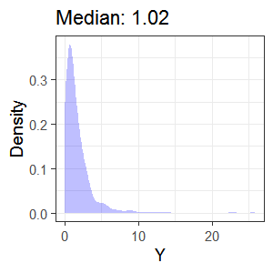 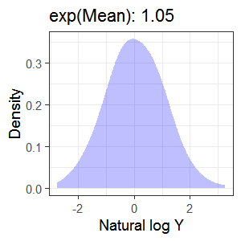

## Multiplicative differences

When back-transforming additive differences among groups after a log transformation, remember that results will be expressed as estimated ratios of medians. If working with slopes (continuous explanatory) instead of group differences (categorical explanatory), results are about an estimated multiplicative change in median Y for some change in a continuous X variable.

We will practice calculating ratios of medians as differences among groups as well as for a change in some continuous X in class. Plan on bringing a calculator to class.

# Percentages

When working with a percentage as a response variable, there can be a lot of ambiguity between whether the change expressed is additive (a percentage point change) or multiplicative (a percentage change).

This XKCD cartoon expresses this well (<http://xkcd.com/985/>):

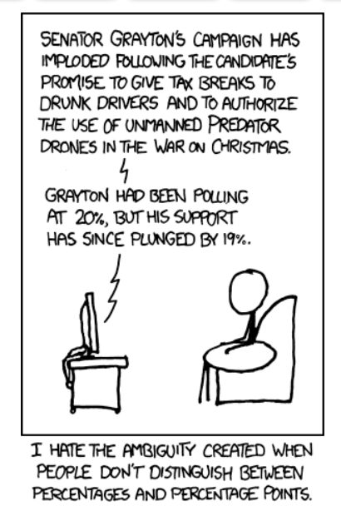

You will practice calculating the additive vs multiplicative change using the example in this cartoon in handout 4.4. Make an attempt to answer all problems prior to lecture.

I recommend using the term “percentage point change” to indicate additive changes for simple differences; i.e., 40% - 20% = 20 percentage point change.

If talking about a multiplicative change, use the term percentage change. In a multiplicative change, the estimated change is relative to a baseline.

## Percentage change vs ratios

We can either use percentage changes or ratios to express multiplicative differences. A lot of us tend to default to using percentage changes. However, percentage changes are not symmetric and so we can confuse our reader if we are not careful.

For example, the inverse of a 100% increase from 2 to 4 is a 50% decrease from 4 to 2. An increase from 3 to 4 is a 33% increase but the inverse, a decrease from 4 to 3, is a 25% decrease. If you change the order of a comparison you will always need to recalculate your percentage changes.

This is not true for ratios. They are always exactly symmetric. Going from 2 to 4 is a doubling (2) and going from 4 to 2 is a halving (1/2). Going from 3 to 4 is an increase by a factor of 4/3 while going from 4 to 3 is a decrease by a factor of 3/4. To change the order of the comparison you only need to invert that ratio.

This feature of ratios is why Frank Harrell argues that we should be using ratios and not percentage changes when reporting multiplicative results. You can read his argument here: <http://www.fharrell.com/post/percent/>.