FES 524: Natural Resources Data Analysis

Reading 6.1

**Contents**

Other readings to do before class 1

Introduction to repeated measures 1

Repeated measures in time 2

Repeated measures in space 2

Design details 3

Analysis options 3

Assumptions about repeated measures models 6

Independence of subjects 6

Within subject dependence 7

Constant variance 7

Correlation 7

Positive correlation 8

Negative correlation 9

Checking for correlation 10

This week’s topic, repeated measures and correlation structures, is one that students have historically struggled with. The concepts will be split over both readings this week so we have plenty of time to discuss.

# Other readings to do before class

Read Week 6 Handout 1: “Study on the effect of birch competition on oak height” and come prepared to use this example to talk about the topics covered over the past few weeks as well as in reading 6.1. Make sure you’ve had time to think about the answers to the questions in that handout.

# Introduction to repeated measures

We refer to a study as having a *repeated measures* design when the investigators repeatedly measured a study unit. Given this definition, you should recognize that we’ve already been working with some simple repeated measures designs. Any time we use subsampling, like sampling multiple trees within a stand, we have repeatedly measured a study unit.

Measurements of the same study unit across time is what most people think of when they hear the term repeated measures. However, we can and do have repeated measures through space. This week’s motivating example is a study with repeated measures in space.

The big difference in what we are going to be doing this week compared to what we’ve been doing since we began working with mixed models in week 3 is that we will now assume some sort of pattern to the correlation among repeated measurements. Usually with repeated measures design in space or time, we believe the *distance* among measurements is related to how correlated the measurements are. We most often think measurements closer in space or time are more alike, but in some studies we are concerned that things closer in space or time are actually less alike. We will see examples later to clarify what this all means.

Having repeated measures can complicate the analysis. We saw the first complication when we started using random effects to deal with simple repeated measures designs like we had last week. Allowing for different types of correlation patterns complicates things even more. So why would we use a repeated measures design?

First, we might have a question involving the repeated measurements, such as how some mean response changes over time. Second, we may use a so-called “within-subject” design to reduce variation. This is common for time series repeated measurements. If a researcher samples different subjects every year they likely have increased variability due to always using different subjects. In addition, variability due to years and variability due to subjects are confounded. Instead, researchers often choose to sample the same subject through time in order to account for subject-to-subject variability and so make more precise estimates. Recognize that using this latter design can limit the scope of inference.

## Repeated measures in time

Below are three examples of studies that involve repeated measures through time. Repeated measures through time can involve short or long time frames. Complicated studies can involve both.

Example 1: Short time frame

Response: Suspended sediment

Measured: After every storm event

Time frame: Over one winter

Example 2: Longer time frame

Response: Amount of large wood

Measured: Every summer

Time frame: 10 years

Example 3: Short and longer time frames

Response: Dissolved oxygen

Measured: Every 5 minutes

Time frame: Every summer for 5 years

## Repeated measures in space

Studies involving soil cores are classic examples of repeated measures in space. The study unit, the soil core, is measured multiple times for some response variable. This can involve only a few measurements or many measurements.

Example 1:

Response: Carbon-to-nitrogen ratio

Measured: At 3 depths

Total core length: 60 cm

Example 2:

Response: Amount fine sediment

Measured: Every cm

Total core length: 7 m

This week’s motivating example involves repeated measures in space. Each transect is measured three times.

Last week’s example was also about repeated measures in space since study units were measured multiple times. Multiple stands were measured in each watershed and multiple locations were measured in each stand. See Week 5 Handout 1 if you need a reminder of that study design.

## Design details

When working with repeated measures designs we need to be able to identify:

1. The *subject*. This is the study unit that was repeatedly measured.
2. The *repeated factor*. This is the factor of interest that is applied to or measured at the level of the repeated measurements
3. I will refer to the study units that represents the replicate of the repeated factor as the *repeated measurements units*. Many times the repeated measurements units are what makes up the total number of observations in the study.

For me this is often the most difficult thing to identify in a repeated measures study. It helps if you have used explicit naming of all physical/study units, including the units that are at the observation level. This helps keep the factor of interest separate from the physical unit that was measured.

1. Spacing of repeated measurements. To understand what kind of correlation is possible we need to establish if spacing among measurements is equal/approximately equal or not.

We will practice defining each of these for some example study designs in class.

## Analysis options

The kind of analysis we can use when working with repeated measures depends on the research question. For many research questions the analysis will be more complicated than what we’ve done in the past. However, for certain research questions we may be able to simplify things.

Let’s go through a hypothetical study example and talk about different types of research questions.

Below is a plot of the estimated means from some study with repeated measurements through time. The repeated factor is time. There is a second factor that has three levels, represented by the different shapes. To keep things simple as we talk about research questions, no expression of variability is included on this plot.

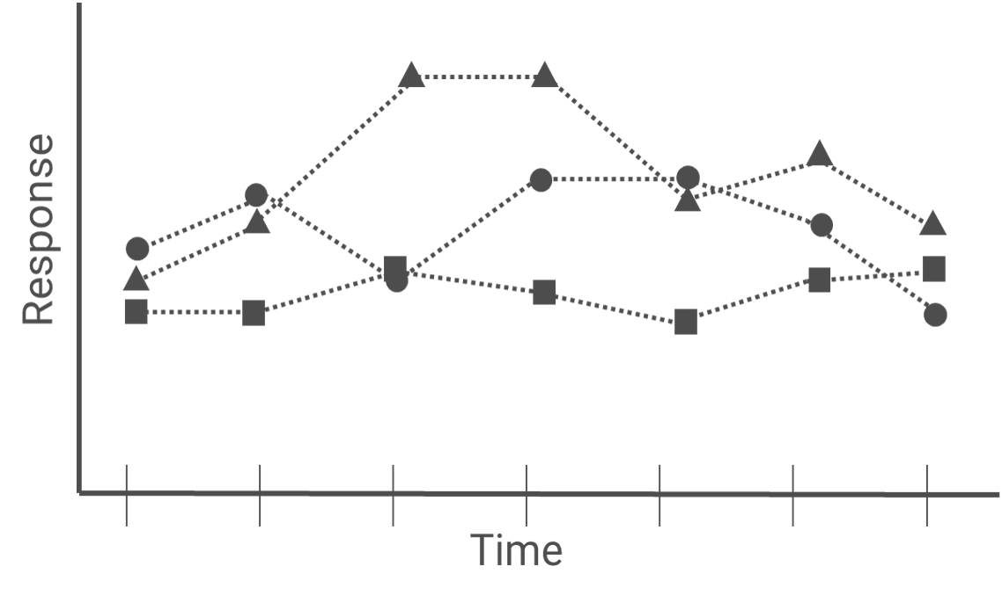

*Questions involving time*

If the research question involves the repeated factor we will need to work with an analysis option where we’ve accounted for the correlation caused by repeatedly measuring the same study unit. Below are two examples with research questions that involve the repeated factor.

Example 1:

What are the differences in mean response among groups at each time point?

I’ve circled the means that might be used to answer this question for one time point.

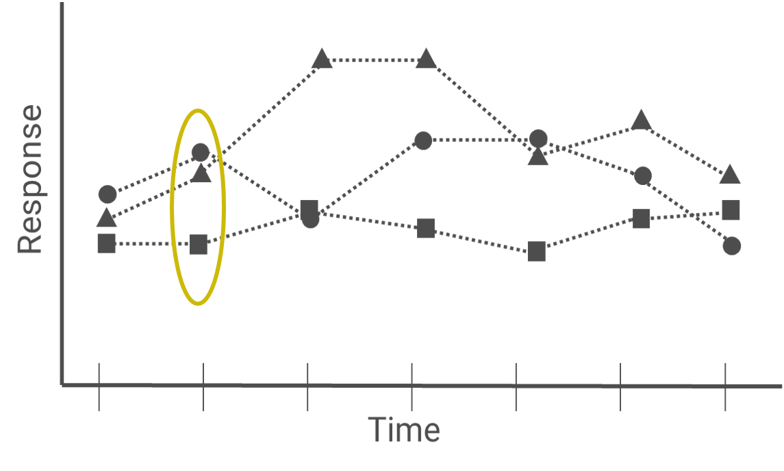

Example 2:

Is the recovery pattern in mean response for the other groups the same as for the control?

Comparisons to answer this question will involve estimating differences in mean response across time within a group, which is how I’ve drawn the circle below. However, the way I’ve worded this really implies a question about *differences in the differences* in means. Creating the comparisons of interest is more complicated for such questions.

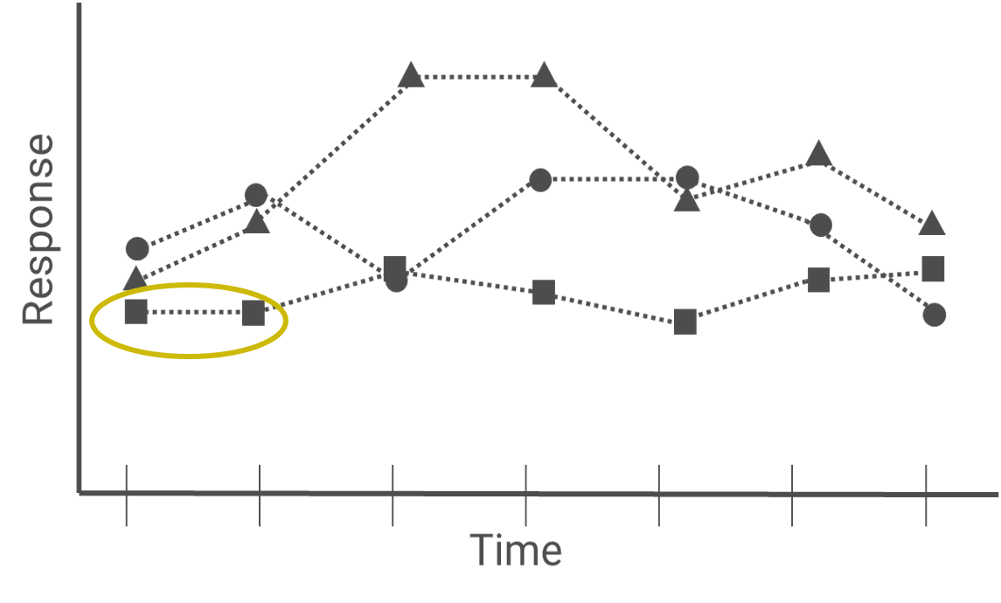

*Questions that don’t involve time*

If the research question doesn’t involve the repeated factor directly, the analysis can likely be simplified. If there is not explicit interest in the repeated factor, it may be that the repeated measurements were really a type of subsampling.

Example 1:

How did groups differ in mean response by the end of the study?

In this case, while many measurements were taken only the last measurement is of interest. The other measurements are not needed and won’t be part of the analysis.

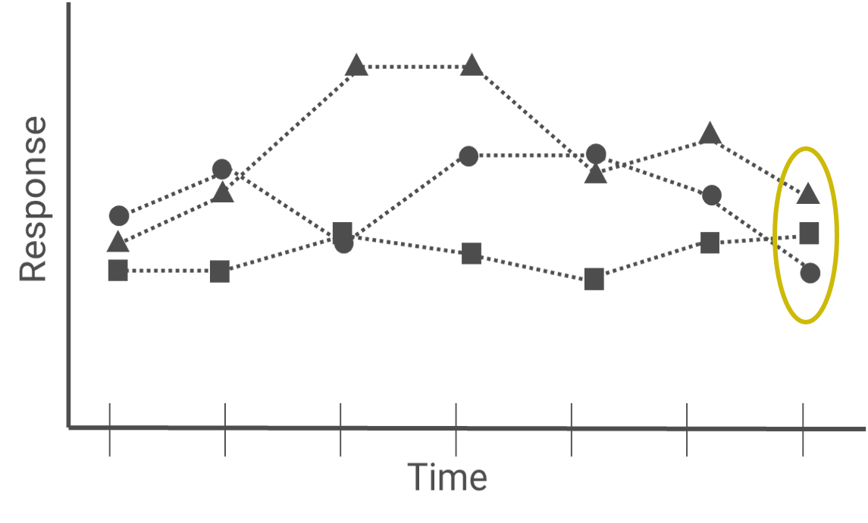

Similarly, if the question is worded as one that involves only overall differences among groups, the repeated measures could be averaged over like we did in week 2.

Example 2:

How did the overall change from the beginning to end of the study differ among groups?

To answer this question, we could calculate the difference between the first and last measurement for every observation and analyze that as the response variable. Then we would be back to a simple analysis. A second option would be to only work with the first and last repeated measures. While the analysis would still need to account for repeated measures, things are simpler when there are only two repeated measures.

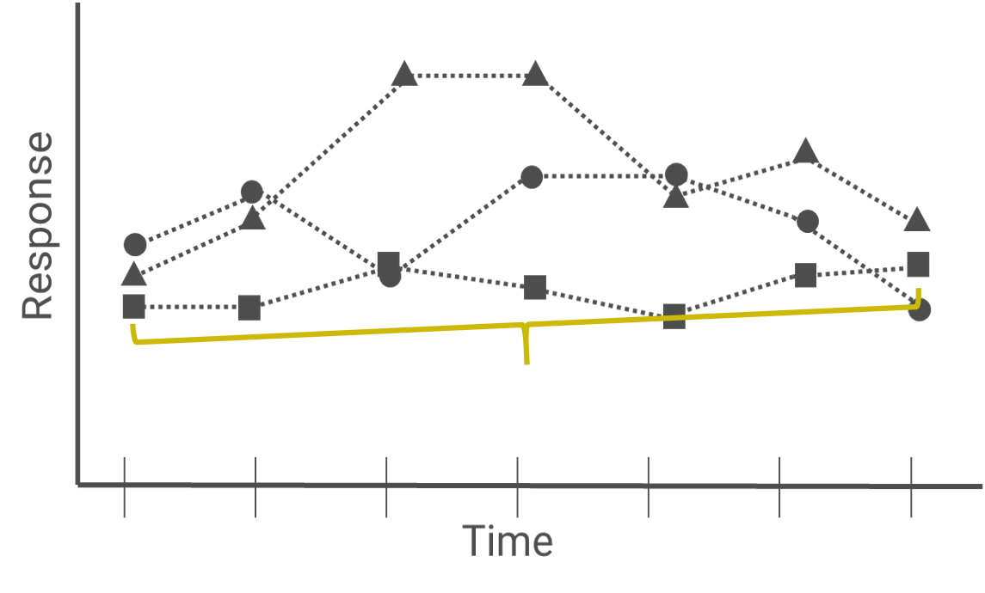

While the question I wrote above is about the change over the duration of the study, sometimes we will have research questions about differences in means among groups at the end of the study after accounting for the initial measurement. The initial measurement would be considered the “baseline”. This baseline variable should be included as a covariate in a model using the final measurement as the response variable rather than taking a difference between the first and last measurement and using that as the response variable. I would argue we need to consider more “baseline as covariate” models in ecology rather than always jumping to analyzing differences (i.e., “change from baseline”). If relevant to you, a place to start reading about problems with change from baseline is at https://hbiostat.org/bbr/md/change.html#whats-wrong-with-change-in-general.

The take home message from these examples is that if we can collapse over the repeated measurements in some way and can still answer the research question we may be able to simplify the analysis. However, simplifying the analysis is not required.

# Assumptions about repeated measures models

Many of the assumptions of models we can use for analyzing data from repeated measures designs are the same as for earlier models we’ve used.

## Independence of subjects

We assume that the subjects, the study units that were repeatedly measured, are independent. This is the same assumption we made about, e.g., blocks in earlier studies. This means we don’t think that physical units that are closer in space are more alike than physical units that are far apart. We usually use scientific expertise to justify this assumption. If this isn’t a reasonable assumption then you will need a more complex analysis than what we are learning in this class.

## Within subject dependence

For models we have fit so far this term we assumed that the errors were independent after accounting for other variables that have a systematic effect on the response variable. In studies we are discussing this week we now expect that the *within subject* *errors* are correlated in some way. This means that after accounting for all other variables in the model we think there is still some sort of pattern of dependence in the model errors.

The models we will learn in this class assume that this within subject dependence is shared across all subjects, regardless of if they are in different groups or had different protocols applied. If this isn’t reasonably true you will need more complicated analysis tools than what you will see in this class.

*Nested designs and dependence*

As discussed earlier, nested designs are a type of repeated measurement. We were assuming that there would be some sort of dependence among observations taken within the larger physical unit. However, we assumed that the effect of the larger unit was *systematic*, which involves a very particular type of correlation. Using a mixed model for analysis was a way to model that type of correlation so the model errors were independent.

We will formalize the kind of correlation that is implied by a mixed model in the second reading of the week.

## Constant variance

Constant variance among errors of the repeated factors is still an assumption when doing an analysis of repeated measures data using some sort of linear model. It is not uncommon to need to relax this assumption.

For example, think about a study where some sort of extreme vegetation control is done at the beginning of the study and then vegetation cover is measured through time. In the early years we’d expect cover to be less variable, since we removed vegetation cover. In later years, as things start to recover, we’d expect to start seeing more variability in vegetation cover. In a study like this we can pretty much expect that we’ll need to relax the assumption of constant variance of errors through time.

# Correlation

Now that we’ve spend talking about repeated measures in general, let’s start to think about correlations more formally.

Take a look at the schematic below. It shows three observations taken on a single subject, along with their errors. Can we calculate a correlation between the first two errors, ε1 and ε2?

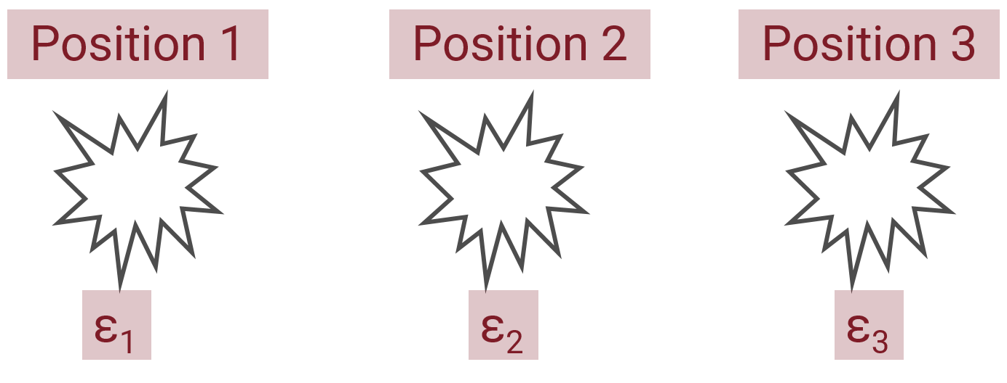

The answer is no. For a single subject we cannot calculate a correlation between any two errors. This is an important point, and one you should think about carefully.

To calculate correlation between any two positions we need to have multiple observations of those positions. In other words, we need multiple subjects. This is a reason we assume the correlation is the same among subjects. To calculate correlations among errors for position 1 vs position 2, we’d use the errors for all the subjects.

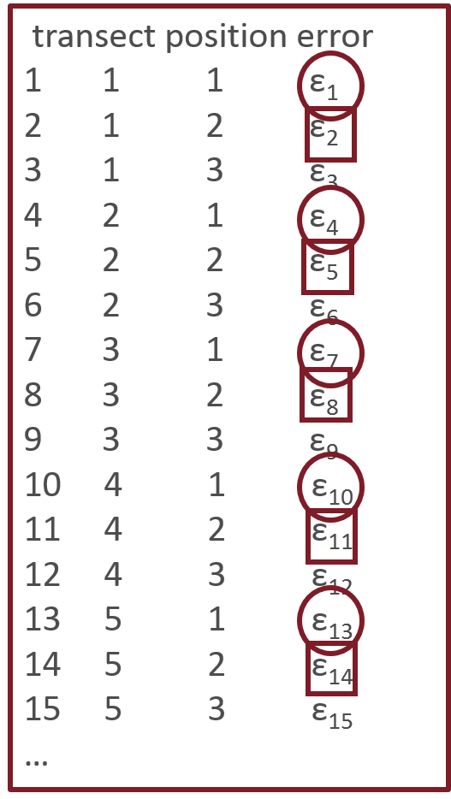I’ve pasted an example of the data for the motivating example, using symbols to represent the errors, on the left. The transects are the subjects that were repeatedly measured, and the positions are the repeated factor of interest.

We can calculate the correlation for the position 1 errors (circles), ε1, ε4, ε7, ε10, ε13, and the position 2 errors (squares), ε2, ε5, ε8, ε11, ε14. In practice the software will use the estimates of the errors to do this.

## Positive correlation

With positive correlation (i.e., correlation > 0), errors are more alike within subjects than between subjects. Positive correlation is also indicated when errors closer in time or space are more alike than errors farther apart.

We have been assuming positive correlation among observations for blocked and other nested designs. We assume there is some sort of systematic difference among study units; an “average” effect of the unit. In the examples I give I will show the correlations among observations instead of errors in order to try to clarify what positive correlation means.

Example 1:

Below is a schematic showing three watersheds with positive within-watershed correlation. On average the first watershed has large values, the second has small values, and the third has medium values.

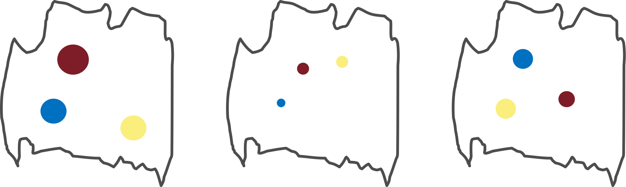

Example 2:

Growth through time is an example of how measurements close in time will be more alike than measurements far apart in time. In the picture below, we can see the tree getting larger through time. The measurements of size at times 1 and 2 are both relatively small, while the measurements of size at times 4 and 5 are relatively large.

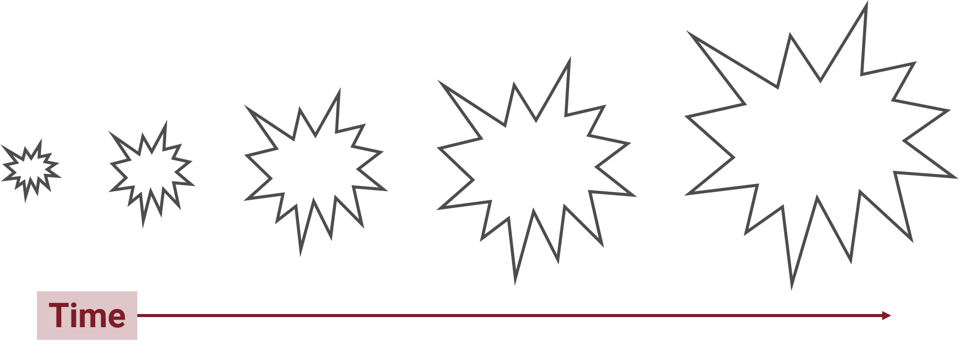

Note that measuring anything cumulatively, such as cumulative growth, is an extreme example of positive correlation since all earlier measurements are included in the current measurement.

## Negative correlation

With negative correlation (i.e., correlation < 0), errors are more alike between subjects than within subjects. Measurements or errors closer in space or time are less alike than those that are farther apart.

Negative correlation is less common than positive correlation in many types of research.

Example 1:

The main example I could find for how subjects are more alike between subjects than within subjects is an example of a sports team and the players on a sports team. The players on the team are chosen because they have very different skills, so players within the team are not very similar in their skills. However, the sports teams in general have similar types of players. The sports teams are more alike across teams than within teams. In the schematic below you can see that the dots within each watershed vary considerably in size but the pattern across watersheds is similar.

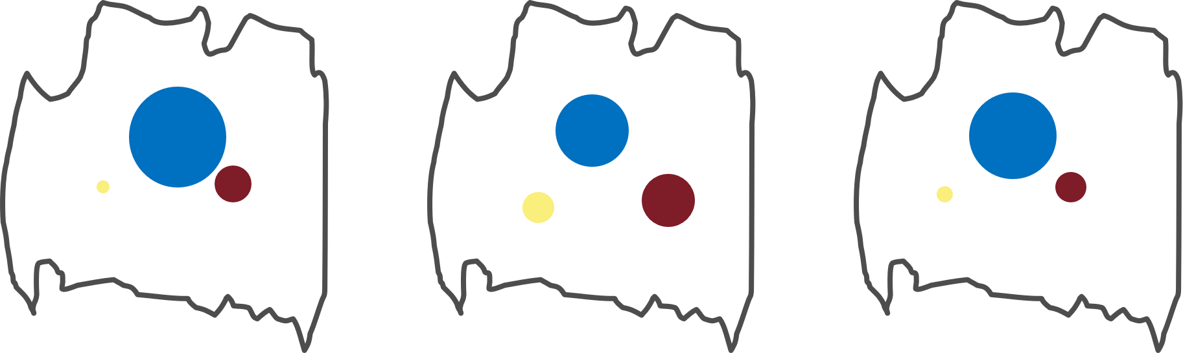

Example 2:

Competition can cause negative correlation. In the simplistic example below, we can see that a large tree can lead to a small tree 1 unit away, which then leads to a large tree, etc. Note that this means there is negative correlation for trees 1 unit apart but positive correlation for trees 2 units apart.

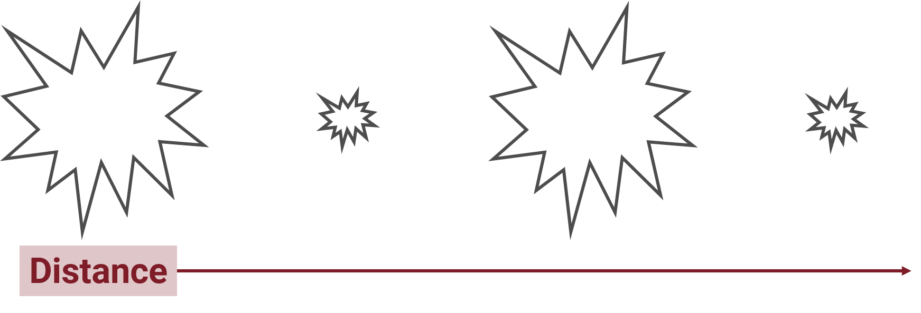

## Checking for correlation

We use residuals to check for dependence among errors within subjects. If we have long time series or many observations in space we have graphical tools to assist with this.

There is no rule for how many “many” is for the number of within subject repeated measures, but generally if we have only very few repeated measurements like the examples in this class (3 or 4), these tools aren’t particularly useful. We’ll talk about an algorithm to use for when we are in a situation where we can’t graphically check for autocorrelation of errors in the next reading.

The tools we can use for checking for within-subject correlation of the errors depends on if we consider our repeated measures to be equally spaced or not. Time series are often equally spaced (measuring once a week, once a year, etc.) but can be unequally spaced (measuring after every storm event). Measurements in space are most often unequally spaced, but measuring along a soil core could involve equal spacing.

When using tools to check for residual autocorrelation, we must ensure calculations are done only within subjects and not between subjects. This can involve more complicated coding, which we will not cover in this class. If you are in this situation you’ll need to get more background on this. One place to start is with this blog post, <https://aosmith.rbind.io/2018/06/27/uneven-grouped-autocorrelation/>.

Equally spaced repeated measures

Autocorrelation function (ACF) plots can be used to check for correlation patterns among equally spaced repeated measures. To use these plots we need a variable that represents the spacing of measurements within each subject so R understands the order of values within each subject. For example, if you have one measurement per subject per year, a year variable would represent the spacing of observations within subjects.

Below are two ACF plots, one with correlation and one without.

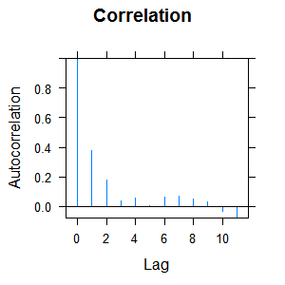 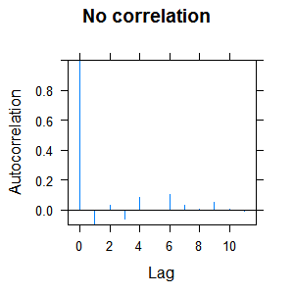

Unequal spacing

When observations are unequally spaced we can use semivariograms of the residuals to check for autocorrelation. You’ll hear about semivariograms most often in spatial statistics, but these are also appropriate to use if you have unequal spacing of measurements through time.

In order to use semivariograms you’ll need one or more continuous variables that represent the distance between observations. This could be Julian day, for example, if you measured the same subject on a variety of different days but the time between days is not constant. Latitude and longitude are common distance variables for measurements in space.

Below are two semivariograms for an unevenly spaced time series, one plot with correlation and one without.

