
Comité Départemental
du Pas de Calais de canoë-kayak
Maison des Sports du Pas de Calais
Tipcd62@aol.com

Angres, le 11/12/2012

14th International Tournament of Pas-de-Calais of Canoe Polo
Under 16 years, Dames, Division 1 and Division 2

Dear sports friends,

As every year, we organize the International Tournament of Pas-de-Calais of Canoe Polo, April 20th and 21th, 2013.

This 14th edition will be organized on the city of Saint Omer (north of France). You will find the entry form and informations about meals and accommodations (free camping).
Fédération
Française
de canoë-kayak

Best regards

José Lenoir Philippe Lalliot
Président of CDCK62 Président of Saint Omer’ club

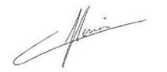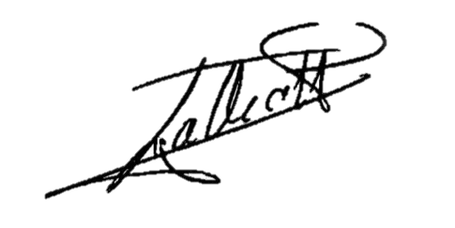

Entry form
International Tournament
of Pas de Calais 2013

Team Name :

Divisions :

Under 16 / Dames / Division 1 / Division 2

* Block the useless grades
/ If we have not 6 « dames » teams, these teams will play in division 2

Team Leader :

Address :

Post code :
City :
Country :

E mail :

Tel : 0033 (0) +

2 choices of inscription for Dames, Division 1 and Division 2:
1st choice : 70 € per team for only Inscription
2nd choice : 220 € per team for Inscription + Breakfasts (Saturday and Sunday), Lunchs (Saturday and Sunday) and Dinners of Saturday

2 choices of inscription for U16 TEAMS:
1st choice : 30 € per team for only Inscription
2nd choice : 180 € per team for Inscription + Breakfasts (Saturday and Sunday), Lunchs (Saturday and Sunday) and Dinners of Saturday

* Block the useless choice

Other choice :
(if you are not the 2nd choice)

Only dinner for Saturday night : 12 euros by person

How many persons ?

12 euros x persons = euros

Inscriptions will be definitely taken into account on receiving of the regulation

Bank : CL St Omer (06034)
Name of Account holder : CDCK 62
IBAN : FR63 3000 2060 3400 0011 7029 A71
Code BIC : CRLYFRPP

Prices : 1st Division 1 = 150 euros 1st Division 2 = 100 euros
2nd Division 1 = 100 euros 2nd Division 2 = 70 euros
3rd Division 1 = 50 euros 3rd Division 2 = 40 euros

Team composition

Club of :

ICF rules
N° | SURNAME | NAME | Date of birthday | N° License

REFEREES

SURNAME | NAME | QUALIFICATION

                - Intend to arrive on Fridays evening :  YES  NO

Entry form before the 30th March of 2013
Email : tipcd62@aol.com

