

**期末项目设计报告**

|  |  |  |  |
| --- | --- | --- | --- |
| 题 目 | 基于Oracle的宠物论坛的数据库设计 | | |
| 课程 | Oracle数据库应用 | | |
| 学 院 | 计算机学院 | | |
| 专 业 | 软件工程 | 年级 | 2018级 |
| 学生姓名 | 徐政发 | 学号 | 201810414126 |
| 指导教师 | 赵卫东 | 职称 | 副教授 |

|  |  |  |  |
| --- | --- | --- | --- |
| **评分项** | **评分标准** | **满分** | **得分** |
| 文档整体 | 文档内容详实、规范，美观大方 | 10 |  |
| 表设计 | 表，表空间设计合理，数据合理 | 20 |  |
| 用户管理 | 权限及用户分配方案设计正确 | 10 |  |
| PL/SQL设计 | 存储过程和函数设计正确 | 25 |  |
| 备份方案 | 备份方案设计正确 | 25 |  |
| 容灾方案 | DataGuard设计正确 | 10 |  |
| **得分合计** | | |  |

2021 年 6 月 1 日

目录

一.背景 3

二． 创建表空间 3

三． 创建角色 4

四． 创建用户 6

五．创建表及插入数据 7

六．PL/SQL语言设计存储过程和函数 18

七．备份方案 21

一.背景

目前，宠物经济越来越受人关注。随着养宠物的家庭不断增多，宠物正在成为不少家庭里的新成员。由于对宠物的不了解，致使人们想买一只自己所倾心的宠物却变得有些繁琐，导致很多人有养宠物的想法却总是那么难实现的情况发生。那么，我们是否可以依托网络，为那些想养宠物的人群提供服务。

当前网络上也可以搜索到很多关于宠物这方面的信息与资料，但存在的问题是宠物资料的信息比较分散，致使用户不能很好的对宠物进行比较与分析，从而选择起来比较麻烦。浪费大量的时间与精力。

为了避免客户在购买宠物时造成宠物翻阅损耗等一系列费用与时间，可以将宠物资料信息进行规纳和整合，从而帮助宠友了解更多关于宠物的信息，并且在了解关注的同时也提供一个交流询问的平台。不仅有助于那些爱宠人士的交流也有利于我们的发展与进步。

1. 创建表空间

1.创建space01

CREATE TABLESPACE space01 DATAFILE

'/home/oracle/app/oracle/oradata/orcl/xzf/space01_1.dbf'

SIZE 100M AUTOEXTEND ON NEXT 10M MAXSIZE UNLIMITED,

'/home/oracle/app/oracle/oradata/orcl/xzf/space01_2.dbf'

SIZE 100M AUTOEXTEND ON NEXT 10M MAXSIZE UNLIMITED

EXTENT MANAGEMENT LOCAL SEGMENT SPACE MANAGEMENT AUTO;

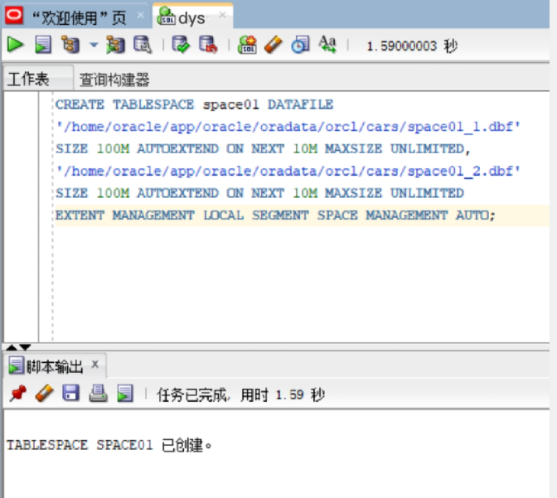

1. 创建表空间sapce02

CREATE TABLESPACE space02 DATAFILE

'/home/oracle/app/oracle/oradata/orcl/xzf/space02_1.dbf'

SIZE 100M AUTOEXTEND ON NEXT 10M MAXSIZE UNLIMITED,

'/home/oracle/app/oracle/oradata/orcl/xzf/space02_2.dbf'

SIZE 100M AUTOEXTEND ON NEXT 10M MAXSIZE UNLIMITED

EXTENT MANAGEMENT LOCAL SEGMENT SPACE MANAGEMENT AUTO;

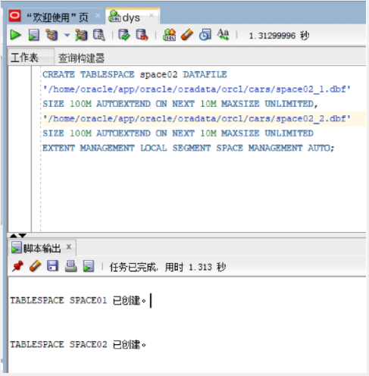

1. 创建角色
2. 创建管理员角色

CREATE ROLE admins;

GRANT create any table, alter any table, create tablespace, alter tablespace, create user, alter user,

create any procedure, alter any procedure, create session, alter session

to admins with admin option;

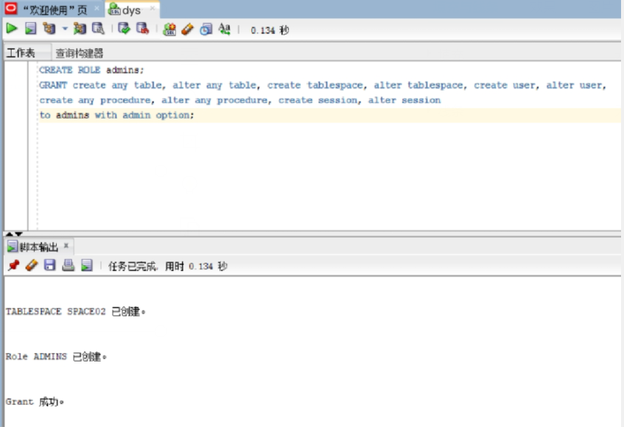

1. 创建用户角色

CREATE ROLE users;

GRANT create session to users with admin option;

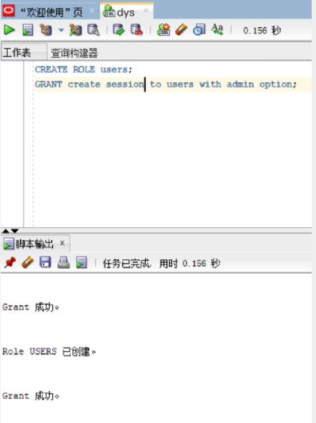

1. 创建用户
2. 创建管理员用户

创建管理员用户admin_01,并赋予它所有权限

CREATE USER user_01 IDENTIFIED by 123;

GRANT users to user_01;

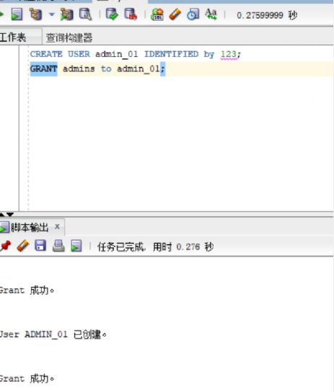

1. 创建普通用户的用户

CREATE USER user_02 IDENTIFIED by 123;

GRANT users to user_02;

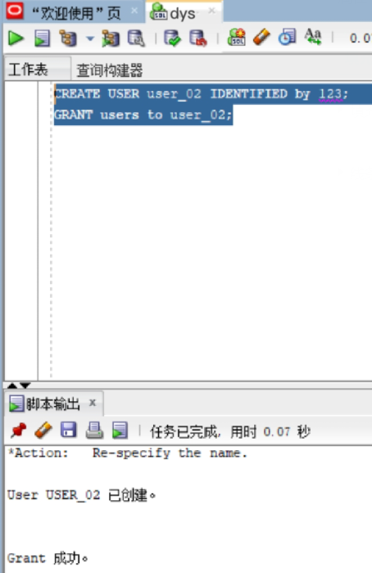

五．创建表及插入数据

1.板块表

|  |  |  |  |  |  |  |
| --- | --- | --- | --- | --- | --- | --- |
| 表名 | Bankuai | | | | | |
| 字段编号 | 物理字段 | 逻辑字段 | 字段类型 | 是否主键 | 是否非空 | 备注 |
| 1 | 版块名 | name | VARCHAR2 | Y | 非空 |  |
| 2 | 板块描述 | instruction | VARCHAR2 |  | 非空 |  |

DROP TABLE Bankuai;

CREATE TABLE Bankuai (

"name" VARCHAR2(255 BYTE) VISIBLE NOT NULL ,

"introduction" VARCHAR2(255 BYTE) VISIBLE NOT NULL

)

TABLESPACE "SPACE01"

LOGGING

NOCOMPRESS

PCTFREE 10

INITRANS 1

STORAGE (

BUFFER_POOL DEFAULT

)

PARALLEL 1

NOCACHE

DISABLE ROW MOVEMENT

;

COMMENT ON COLUMN Bankuai."name" IS '板块名';

COMMENT ON COLUMN Bankuai."introduction" IS '板块的描述';

ALTER TABLE Bankuai ADD CONSTRAINT "SYS_C0038651" PRIMARY KEY ("name");

-- ----------------------------

-- Checks structure for table Bankuai

-- ----------------------------

ALTER TABLE Bankuai ADD CONSTRAINT "SYS_C0038649" CHECK ("name" IS NOT NULL) NOT DEFERRABLE INITIALxzf IMMEDIATE NORExzf VALIDATE;

ALTER TABLE Bankuai ADD CONSTRAINT "SYS_C0038650" CHECK ("introduction" IS NOT NULL) NOT DEFERRABLE INITIALxzf IMMEDIATE NORExzf VALIDATE;

插入数据

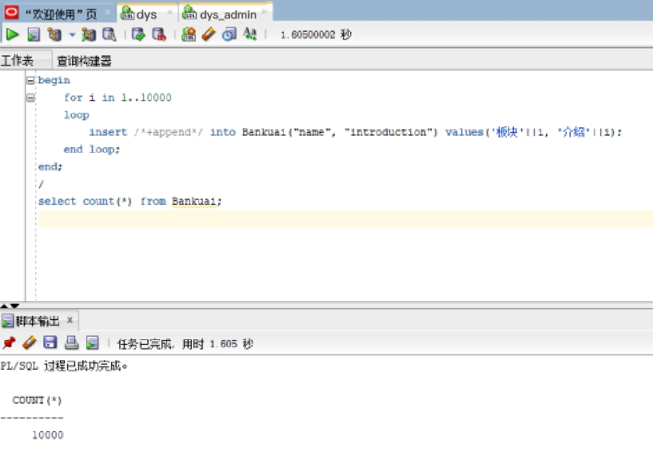

1. 话题表

|  |  |  |  |  |  |  |
| --- | --- | --- | --- | --- | --- | --- |
| 表名 | post | | | | | |
| 字段编号 | 物理字段 | 逻辑字段 | 字段类型 | 是否主键 | 是否非空 | 备注 |
| 1 | 话题id | id | NUMBER | Y | 非空 |  |
| 2 | 所属板块名 | name | VARCHAR2 |  | 非空 |  |
| 3 | 发帖人id | User_id | NUMBER |  | 非空 |  |
| 4 | 话题标题 | title | VARCHAR2 |  | 非空 |  |
| 5 | 话题细节 | details | VARCHAR2 |  | 非空 |  |
| 6 | 提起时间 | time | DATE |  | 非空 |  |

DROP TABLE post;

CREATE TABLE post (

"id" NUMBER VISIBLE NOT NULL ,

"name" VARCHAR2(255 BYTE) VISIBLE NOT NULL ,

"user_id" NUMBER VISIBLE NOT NULL ,

"title" VARCHAR2(255 BYTE) VISIBLE NOT NULL ,

"details" VARCHAR2(255 BYTE) VISIBLE NOT NULL ,

"time" DATE VISIBLE NOT NULL

)

TABLESPACE "SPACE01"

LOGGING

NOCOMPRESS

PCTFREE 10

INITRANS 1

STORAGE (

BUFFER_POOL DEFAULT

)

PARALLEL 1

NOCACHE

DISABLE ROW MOVEMENT

;

COMMENT ON COLUMN post."id" IS '话题id';

COMMENT ON COLUMN post."name" IS '所属板块名';

COMMENT ON COLUMN post."user_id" IS '发帖人id';

COMMENT ON COLUMN post."title" IS '话题标题';

COMMENT ON COLUMN post."details" IS '话题细节';

COMMENT ON COLUMN post."time" IS '提起时间';

ALTER TABLE post ADD CONSTRAINT "SYS_C0038667" PRIMARY KEY ("id");

-- ----------------------------

-- Checks structure for table post

-- ----------------------------

ALTER TABLE post ADD CONSTRAINT "SYS_C0038661" CHECK ("id" IS NOT NULL) NOT DEFERRABLE INITIALxzf IMMEDIATE NORExzf VALIDATE;

ALTER TABLE post ADD CONSTRAINT "SYS_C0038662" CHECK ("name" IS NOT NULL) NOT DEFERRABLE INITIALxzf IMMEDIATE NORExzf VALIDATE;

ALTER TABLE post ADD CONSTRAINT "SYS_C0038663" CHECK ("user_id" IS NOT NULL) NOT DEFERRABLE INITIALxzf IMMEDIATE NORExzf VALIDATE;

ALTER TABLE post ADD CONSTRAINT "SYS_C0038664" CHECK ("title" IS NOT NULL) NOT DEFERRABLE INITIALxzf IMMEDIATE NORExzf VALIDATE;

ALTER TABLE post ADD CONSTRAINT "SYS_C0038665" CHECK ("details" IS NOT NULL) NOT DEFERRABLE INITIALxzf IMMEDIATE NORExzf VALIDATE;

ALTER TABLE post ADD CONSTRAINT "SYS_C0038666" CHECK ("time" IS NOT NULL) NOT DEFERRABLE INITIALxzf IMMEDIATE NORExzf VALIDATE;

插入数据

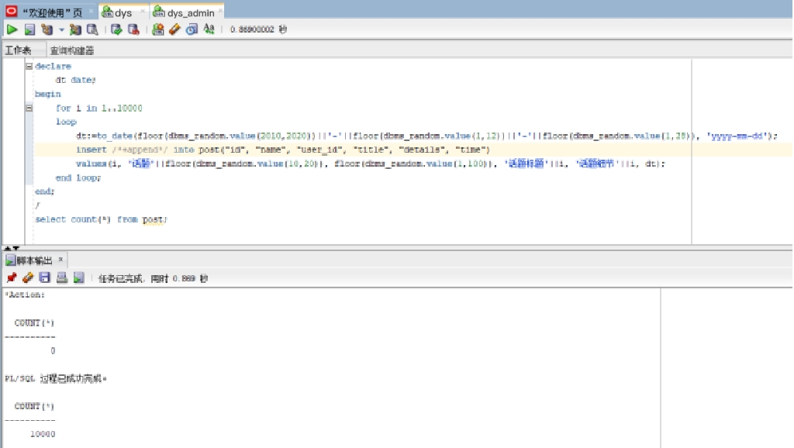

1. 回复表1

|  |  |  |  |  |  |  |
| --- | --- | --- | --- | --- | --- | --- |
| 表名 | repxzf_one | | | | | |
| 字段编号 | 物理字段 | 逻辑字段 | 字段类型 | 是否主键 | 是否非空 | 备注 |
| 1 | 回复id | id | NUMBER | Y | 非空 |  |
| 2 | 话题id | post_id | NUMBER | Y | 非空 |  |
| 3 | 回复用户id | User_id | NUMBER |  | 非空 |  |
| 4 | 回复内容 | details | VARCHAR2 |  | 非空 |  |
| 5 | 回复时间 | time | DATE |  | 非空 |  |

DROP TABLE repxzf_one;

CREATE TABLE repxzf_one (

"id" NUMBER VISIBLE NOT NULL ,

"post_id" NUMBER VISIBLE NOT NULL ,

"user_id" NUMBER VISIBLE NOT NULL ,

"details" VARCHAR2(255 BYTE) VISIBLE NOT NULL ,

"time" DATE VISIBLE NOT NULL

)

TABLESPACE "SPACE01"

LOGGING

NOCOMPRESS

PCTFREE 10

INITRANS 1

STORAGE (

BUFFER_POOL DEFAULT

)

PARALLEL 1

NOCACHE

DISABLE ROW MOVEMENT

;

COMMENT ON COLUMN repxzf_one."id" IS '回复id';

COMMENT ON COLUMN repxzf_one."post_id" IS '话题id';

COMMENT ON COLUMN repxzf_one."user_id" IS '回复用户id';

COMMENT ON COLUMN repxzf_one."details" IS '回复内容';

COMMENT ON COLUMN repxzf_one."time" IS '回复时间';

ALTER TABLE repxzf_one ADD CONSTRAINT "SYS_C0038673" PRIMARY KEY ("id", "post_id");

-- ----------------------------

-- Checks structure for table repxzf_one

-- ----------------------------

ALTER TABLE repxzf_one ADD CONSTRAINT "SYS_C0038668" CHECK ("id" IS NOT NULL) NOT DEFERRABLE INITIALxzf IMMEDIATE NORExzf VALIDATE;

ALTER TABLE repxzf_one ADD CONSTRAINT "SYS_C0038669" CHECK ("post_id" IS NOT NULL) NOT DEFERRABLE INITIALxzf IMMEDIATE NORExzf VALIDATE;

ALTER TABLE repxzf_one ADD CONSTRAINT "SYS_C0038670" CHECK ("user_id" IS NOT NULL) NOT DEFERRABLE INITIALxzf IMMEDIATE NORExzf VALIDATE;

ALTER TABLE repxzf_one ADD CONSTRAINT "SYS_C0038671" CHECK ("details" IS NOT NULL) NOT DEFERRABLE INITIALxzf IMMEDIATE NORExzf VALIDATE;

ALTER TABLE repxzf_one ADD CONSTRAINT "SYS_C0038672" CHECK ("time" IS NOT NULL) NOT DEFERRABLE INITIALxzf IMMEDIATE NORExzf VALIDATE;

插入数据

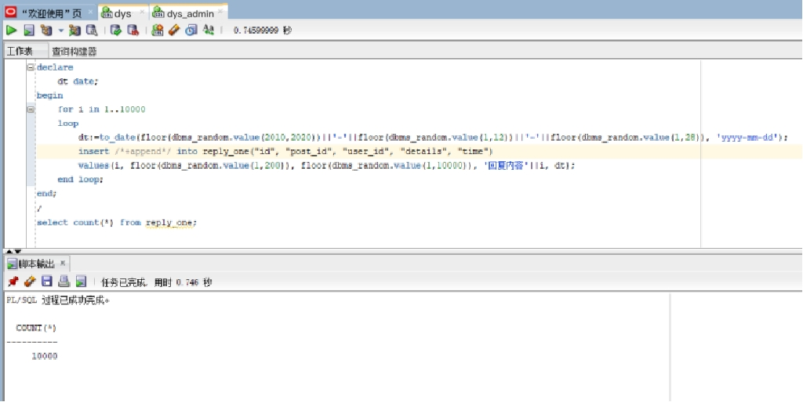

1. 回复表2

|  |  |  |  |  |  |  |
| --- | --- | --- | --- | --- | --- | --- |
| 表名 | repxzf_two | | | | | |
| 字段编号 | 物理字段 | 逻辑字段 | 字段类型 | 是否主键 | 是否非空 | 备注 |
| 1 | 再次回复的id | id | NUMBER | Y | 非空 |  |
| 2 | 话题id | post_id | NUMBER | Y | 非空 |  |
| 3 | 回复的id | repxzf_id | NUMBER | Y | 非空 |  |
| 4 | 回复用户id | user_id | NUMBER |  | 非空 |  |
| 5 | 回复内容 | details | VARCHAR2 |  | 非空 |  |
| 6 | 回复时间 | time | DATE |  |  |  |

DROP TABLE repxzf_two;

CREATE TABLE repxzf_two (

"id" NUMBER VISIBLE NOT NULL ,

"post_id" NUMBER VISIBLE NOT NULL ,

"repxzf_id" NUMBER VISIBLE NOT NULL ,

"user_id" NUMBER VISIBLE NOT NULL ,

"details" VARCHAR2(255 BYTE) VISIBLE NOT NULL ,

"time" DATE VISIBLE NOT NULL

)

TABLESPACE "SPACE01"

LOGGING

NOCOMPRESS

PCTFREE 10

INITRANS 1

STORAGE (

BUFFER_POOL DEFAULT

)

PARALLEL 1

NOCACHE

DISABLE ROW MOVEMENT

;

COMMENT ON COLUMN repxzf_two."id" IS '再次回复的id';

COMMENT ON COLUMN repxzf_two."post_id" IS '话题id';

COMMENT ON COLUMN repxzf_two."repxzf_id" IS '回复的id';

COMMENT ON COLUMN repxzf_two."user_id" IS '用户id';

COMMENT ON COLUMN repxzf_two."details" IS '回复内容';

COMMENT ON COLUMN repxzf_two."time" IS '回复时间';

ALTER TABLE repxzf_two ADD CONSTRAINT "SYS_C0038680" PRIMARY KEY ("id", "post_id", "repxzf_id");

-- ----------------------------

-- Checks structure for table repxzf_two

-- ----------------------------

ALTER TABLE repxzf_two ADD CONSTRAINT "SYS_C0038674" CHECK ("id" IS NOT NULL) NOT DEFERRABLE INITIALxzf IMMEDIATE NORExzf VALIDATE;

ALTER TABLE repxzf_two ADD CONSTRAINT "SYS_C0038675" CHECK ("post_id" IS NOT NULL) NOT DEFERRABLE INITIALxzf IMMEDIATE NORExzf VALIDATE;

ALTER TABLE repxzf_two ADD CONSTRAINT "SYS_C0038676" CHECK ("repxzf_id" IS NOT NULL) NOT DEFERRABLE INITIALxzf IMMEDIATE NORExzf VALIDATE;

ALTER TABLE repxzf_two ADD CONSTRAINT "SYS_C0038677" CHECK ("user_id" IS NOT NULL) NOT DEFERRABLE INITIALxzf IMMEDIATE NORExzf VALIDATE;

ALTER TABLE repxzf_two ADD CONSTRAINT "SYS_C0038678" CHECK ("details" IS NOT NULL) NOT DEFERRABLE INITIALxzf IMMEDIATE NORExzf VALIDATE;

ALTER TABLE repxzf_two ADD CONSTRAINT "SYS_C0038679" CHECK ("time" IS NOT NULL) NOT DEFERRABLE INITIALxzf IMMEDIATE NORExzf VALIDATE;

插入数据

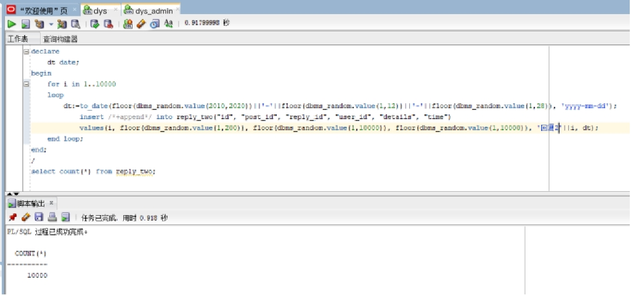

1. 用户表

|  |  |  |  |  |  |  |
| --- | --- | --- | --- | --- | --- | --- |
| 表名 | user_table | | | | | |
| 字段编号 | 物理字段 | 逻辑字段 | 字段类型 | 是否主键 | 是否非空 | 备注 |
| 1 | 用户id | id | NUMBER | Y | 非空 |  |
| 2 | 用户名 | user_name | VARCHAR2 |  | 非空 |  |
| 3 | 用户性别 | sex | VARCHAR2 |  |  |  |

DROP TABLE user_table;

CREATE TABLE user_table (

"id" NUMBER VISIBLE NOT NULL ,

"user_name" VARCHAR2(255 BYTE) VISIBLE NOT NULL ,

"sex" VARCHAR2(255 BYTE) VISIBLE

)

TABLESPACE "SPACE01"

LOGGING

NOCOMPRESS

PCTFREE 10

INITRANS 1

STORAGE (

BUFFER_POOL DEFAULT

)

PARALLEL 1

NOCACHE

DISABLE ROW MOVEMENT

;

COMMENT ON COLUMN user_table."id" IS '用户id';

COMMENT ON COLUMN user_table."user_name" IS '用户名';

COMMENT ON COLUMN user_table."sex" IS '用户性别';

ALTER TABLE user_table ADD CONSTRAINT "SYS_C0038687" PRIMARY KEY ("id");

-- ----------------------------

-- Checks structure for table user_table

-- ----------------------------

ALTER TABLE user_table ADD CONSTRAINT "SYS_C0038685" CHECK ("id" IS NOT NULL) NOT DEFERRABLE INITIALxzf IMMEDIATE NORExzf VALIDATE;

ALTER TABLE user_table ADD CONSTRAINT "SYS_C0038686" CHECK ("user_name" IS NOT NULL) NOT DEFERRABLE INITIALxzf IMMEDIATE NORExzf VALIDATE;

插入数据

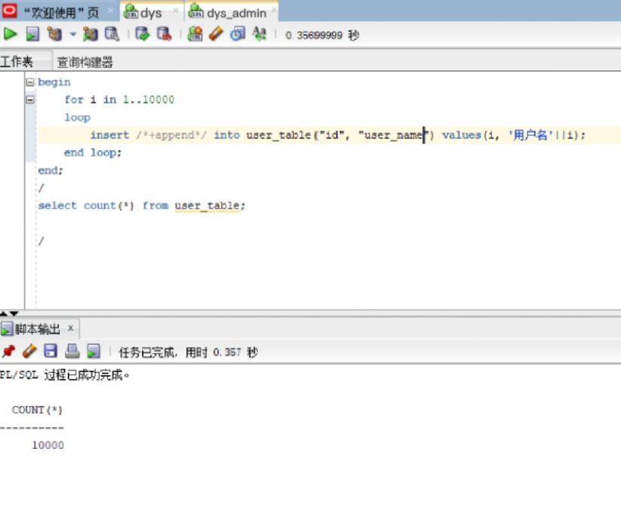

六．PL/SQL语言设计存储过程和函数

1. 函数

create or replace PACKAGE MyPack IS

--获取一个用户的发起的话题、回复、再回复总数

FUNCTION get_posts_num_of_users(user_id int) RETURN int;

--按照结构显示一个话题

PROCEDURE show_post(post_id int);

END MyPack;

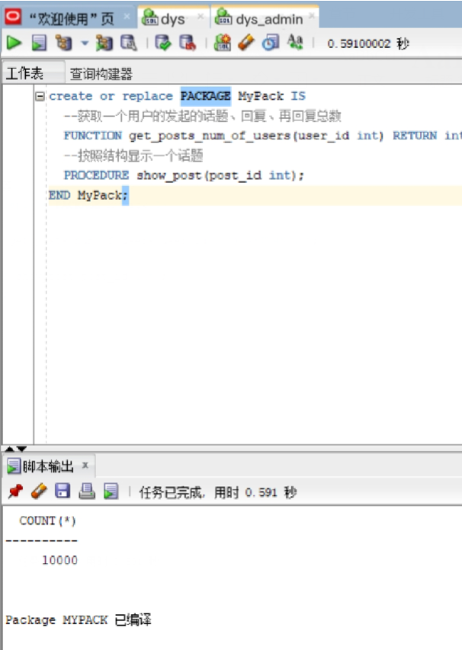

1. 存储过程

create or replace PACKAGE BODY MyPack IS

FUNCTION get_posts_num_of_users(user_id int) RETURN int

AS

posts int;

repxzf_one int;

repxzf_two int;

begin

select count(*) into posts from post where "user_id" = user_id;

select count(*) into repxzf_one from post where "user_id" = user_id;

select count(*) into repxzf_two from post where "user_id" = user_id;

return posts+repxzf_one+repxzf_two;

end;

PROCEDURE show_post(post_id int)

AS

temp varchar2(255);

leftspace varchar2(255);

begin

leftspace:=' ';

select "title" into temp from post where "id"=post_id;

DBMS_OUTPUT.PUT_LINE('标题：'||temp);

select "details" into temp from post where "id"=post_id;

DBMS_OUTPUT.PUT_LINE('细节：'||temp);

for v in (select * from repxzf_one where "post_id"=post_id)

loop

DBMS_OUTPUT.PUT_LINE(leftspace||'用户'||v."user_id"||'回复：'||v."details");

end loop;

END;

END MyPack;

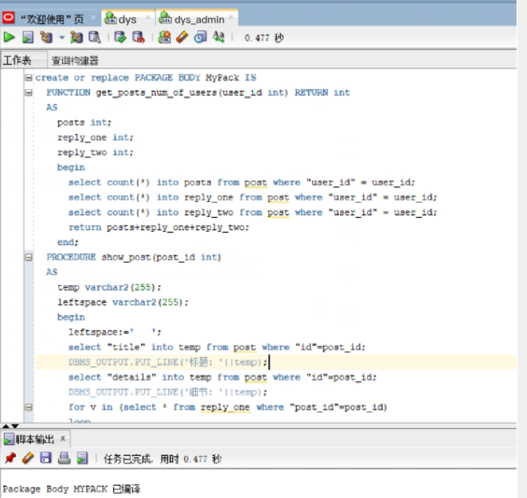

七．备份方案

数据库备份采取每月一次进行数据库全备份，并且在每日凌晨十二点自动开始增量备份的方式进行备份。

1. 开始全备份

全库0级备份

[oracle@deep02~]$ sqlplus study/123@pdborcl

run{

configure retention policy to redundancy 1;

configure controlfile autobackup on;

configure controlfile autobackup format for device type disk to '/home/student/rman_backup/%F';

configure default device type to disk;

crosscheck backup;

crosscheck archivelog all;

allocate channel c1 device type disk;

allocate channel c2 device type disk;

allocate channel c3 device type disk;

backup incremental level 0 database format '/home/student/rman_backup/level0_%d_%T_%U.bak';

report obsolete;

delete noprompt obsolete;

delete noprompt expired backup;

delete noprompt expired archivelog all;

release channel c1;

release channel c2;

release channel c3;

}

## 全库1级增量备份

run{

configure retention policy to redundancy 1;

configure controlfile autobackup on;

configure controlfile autobackup format for device type disk to '/home/student/rman_backup/%F';

configure default device type to disk;

crosscheck backup;

crosscheck archivelog all;

allocate channel c1 device type disk;

allocate channel c2 device type disk;

allocate channel c3 device type disk;

backup incremental level 1 database format '/home/student/rman_backup/level1_%d_%T_%U.bak';

report obsolete;

delete noprompt obsolete;

delete noprompt expired backup;

delete noprompt expired archivelog all;

release channel c1;

release channel c2;

release channel c3;

}

2. 备份后修改数据

[oracle@deep02~]$ sqlplus xzf/123@pdborcl

SQL> create table t1 (id number,name varchar2(50));

Table created.

SQL> insert into t1 values(1,'zhang');1 row created.

SQL> commit;

Commit complete.

SQL> select * from t1;

ID NAME

---------- --------------------------------------------------

1 zhang

SQL> exit

3. 数据库完全恢复

oracle登录linux,不是student用户,dedicated专用连接模式

需要全库停机，需要oracle用户

sys登录到orcl，查看全库的数据文件

$ sqlplus / as sysdba

SQL> select file_name from dba_data_files;

- 全库停机

$rman target /

RMAN> shutdown immediate; 或者 shutdown abort;

RMAN> exit

- 数据文件改名，模拟文件损失

$mv /home/student/pdb_xzf/pdbtest_users02_1.dbf /home/student/pdb_xzf/pdbtest_users02_1.dbf2

- 全库恢复

$rman target /

RMAN> startup mount;

RMAN> restore database;

RMAN> recover database;

RMAN> alter database open;

## 4.单库完全恢复/不完全恢复

$ sqlplus system/123@202.115.82.8/xzf

SQL> select file_name from dba_data_files;

/home/student/pdb/ xzf /system01.dbf

/home/student/pdb/ xzf /sysaux01.dbf

/home/student/pdb/ xzf /undotbs01.dbf

/home/student/pdb/ xzf /users01.dbf

/home/student/pdb/pdbtest_users02_1.dbf

/home/student/pdb/pdbtest_users02_2.dbf

/home/student/pdb_xzf/pdbtest_users02_1.dbf

/home/student/pdb_xzf/pdbtest_users02_2.dbf

SQL> select * from xzf.mytable;

ID NAME

---------- --------------------------------------------------

3 zhang

4 wang

5 abc

SQL> select to_char(sysdate,'yyyy-mm-dd hh24:mi:ss') as currentdate from dual;

CURRENTDATE

-------------------

2021-06-14 08:02:24

SQL> update xzf.mytable set id=id+1;

SQL> commit;

SQL> select * from xzf.mytable;

ID NAME

---------- --------------------------------------------------

4 zhang

5 wang

6 abc

SQL> select to_char(sysdate,'yyyy-mm-dd hh24:mi:ss') as currentdate from dual;

CURRENTDATE

-------------------

2021-06-14 08:03:01

SQL> exit;

- 关闭xzf数据库

$rman target sys/123@202.115.82.8/orcl:dedicated

RMAN> alter pluggable database xzf close;

RMAN> exit;

或者

$sqlplus sys/123@202.115.82.8/orcl:dedicated as sysdba;

SQL>SELECT server FROM v$session WHERE SID=(SELECT DISTINCT SID FROM v$mystat);

SQL>alter session set container=xzf;

SQL>shutdown immediate; 或者 shutdown abort;

- 数据文件改名，模拟文件损失

$mv -f /home/student/pdb_xzf/pdbtest_users02_1.dbf /home/student/pdb_xzf/pdbtest_users02_1.dbf2

- 选项1：单库完全恢复

$rman target sys/123@202.115.82.8/orcl:dedicated

RMAN> restore pluggable database xzf;

RMAN> recover pluggable database xzf;

RMAN> alter pluggable database xzf open;

RMAN> exit;

- 完全恢复成功后，xzf用户登录xzf，

$ sqlplus xzf/123@202.115.82.8/xzf

SQL> select * from mytable;

ID NAME

---------- --------------------------------------------------

4 zhang

5 wang

6 abc

可见，完全恢复成功，数据是最新的（即2021-06-14 08:03:01），无损失。

## 选项2：单库不完全恢复,恢复到update语句之前的状态，即恢复到2021-06-14 08:02:24时刻的数据

$rman target sys/123@202.115.82.8/orcl:dedicated

RMAN> restore pluggable database xzf;

RMAN> recover pluggable database xzf until time "to_date('2021-06-14 08:02:24','yyyy-mm-dd hh24:mi:ss')" AUXILIARY DESTINATION '/home/student/xzf';

正在开始介质的恢复

线程 1 序列 1624 的归档日志已作为文件 /home/oracle/app/oracle/product/12.2.0/dbhome_1/dbs/arch1_1624_1064951903.dbf 存在于磁盘上

线程 1 序列 1625 的归档日志已作为文件 /home/oracle/app/oracle/product/12.2.0/dbhome_1/dbs/arch1_1625_1064951903.dbf 存在于磁盘上

RMAN> alter pluggable database xzf open resetlogs;

已处理语句

RMAN>exit

- 不完全恢复成功后，xzf用户登录xzf，

$ sqlplus xzf/123@202.115.82.8/xzf

SQL> select * from mytable;

ID NAME

---------- --------------------------------------------------

3 zhang

4 wang

5 abc

可见，不完全恢复成功，数据回到了修改前的状态.