Feeds: Personalized Social Platform

## Project Overview

This project involves developing a scalable social media platform tailored to diverse user groups: Kids (0–16 years), Premium Users, and Normal Users. Key features include profile management, content sharing, chats, games, and personalized notifications. Special focus is placed on age categories, privacy controls, and premium functionalities like ad-free access. Built using HTML, CSS, and JavaScript, the platform supports API integrations for future scalability and seamless connectivity. The goal is to create a secure and engaging online space for users while promoting meaningful interactions and safety.

1. **Team Composition**

* Bin1 Members
  + Gourav Khakse (S20230010093) 🡪 Frontend (Html Part)
  + Ayush (S20230010032) 🡪 Backend (Database MongoDB)
* Bin2 Members
  + Atin Chowdhury (S20230010028) 🡪 Backend
  + Arnav Ranjan (S20230010024) 🡪 Backend
* Bin3 Members
  + Vakadani Kavyamrutha (S20230010249) 🡪 Frontend (Css Part)

3. **Types of Users**

1. Normal Users
2. Below 16
   1. Kids (0-8 years)
   2. Students (8-16 years)
3. Premium Users
   1. Channels/ Pages belonging to their respective categories
   2. Incognito/ Private window
   3. Normal Premium

## 4. Technology Stack

The project will use the JS stack, including:  
- Frontend: HTML, CSS, JavaScript, EJS for templates  
- Backend: Node.js and Express.js  
- Database: In-memory databases for initial development, scalable to NoSQL in later phases

## 5. Core Features

1. User Registration
2. Profile Management
   1. Edit Profile Details
   2. Your Activity
   3. Daily Usage
   4. Preferable Language
   5. Permissions
   6. Logout
   7. Delete Account
   8. Share Profile
   9. Copy Profile URL
3. Follow/Unfollow Functionality
4. Secure Communication for Users
5. Daily Streaks
6. Content Posting
7. Games Section
8. Like, Dislike, Share, download on device, Save, Archive
9. Search Account or Channel
10. Stories
11. Feed
12. Notifications
13. Reels
14. Block and Report Account

## 6. Users with Respective Features

1. Below 16
   1. Kids (0-8 years)
      1. Core Features without interactions like Chatting, Commenting, Posting, etc.,
      2. Limited Screen time – customizable (by default 2hrs)
      3. Can do Gaming but for limited time
      4. Can only see content from the kids Channel
      5. Age restricted Ads
      6. Parental control
   2. Students (8-16 years)
      1. Core Features
      2. Can only see content from specific category Channels
      3. Limit on posting content like video time limit, multi-pic post.
      4. Limited Screen time – customizable (by default 2hrs)
      5. Gaming for unlimited time
2. Premium
   1. Channels / Pages
      1. Core Features
      2. Each Channel will have a particular Category of content
      3. Privacy policy for violation of any rules
      4. Category symbol like Ⓜ for Music
      5. Ads Free
      6. No limit on posting content like video time limit, multi-pic post.
   2. Incognito / Private window
      1. Core Features with only Read Mode
      2. Stalk anyone without being noticed
      3. Ads Free
      4. View Story without being noticed
   3. Premium Users
      1. Core Features
      2. Ads Free
      3. Will notified who searched you
      4. Customized Wallpapers
      5. Limit on content posting size but they can post more than non-premium users
3. Normal Users (Non-premium)
   1. Core Features
   2. Will not be notified who searched you
   3. Ads
   4. Limit on content like maximum 10 pics per multi-pic post

7. Flow-Chart of the Site

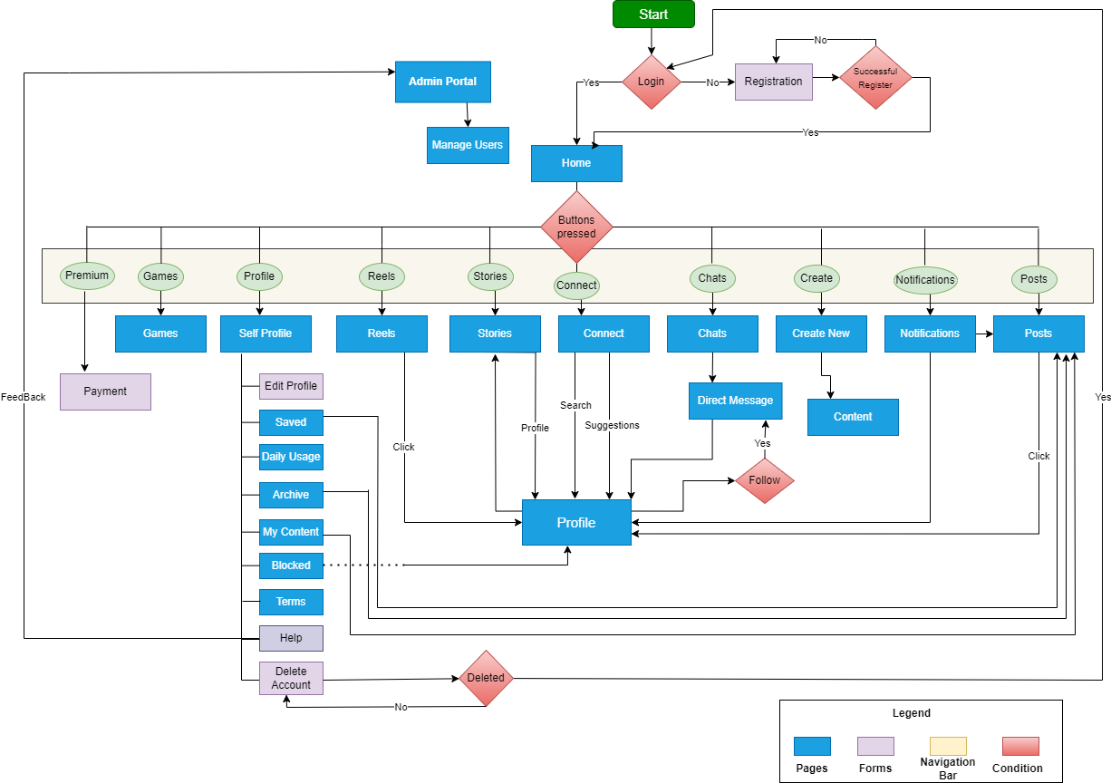

8. Pages

|  |  |  |  |
| --- | --- | --- | --- |
| 1. Home | 2. Profile | 3. Posts/Reels | 4. Stories |
| 5. Chats | 6. Games | 7. Connect | 8. Notifications |
| 9. Direct Message | 10. Help | 11. Terms | 12. Archive |
| 13. Saved | 14. Daily Usage | 15. Activity | 16. Blocked |

## 9. Forms

* Login
* Registration
* Delete Account
* Edit Profile
* Payment Form (For Premium Purchase)

## 10. Revenue Model

1. Premium Subscriptions: Exclusive features and content for premium users.  
2. Ad Integration.  
3. Partnerships: Collaborations with platforms.

**11. Project Timeline**

* Mid Review: Frontend Part of creation of Pages and Forms.
* End Review: Complete the Whole Project as a Multi-page Application