USER’S
MANUAL
For
[Leave Management System]
[Document details here.]
 | Name | Date | Signature
Prepared By | Md Feroj Mahmood | 03/07/2018
Reviewed By

Revision History
Name | Date | Reason for Changes | Version
Draft

Contents
3 Organization of the manual 4
3.1 General Information: 4
3.2 System Overview: 4
3.3 Background: 4
4 System Summery 5
4.1 System Configuration 5
4.2 User Access Levels 5
4.3 Contingencies 5
5 Getting Started 5
5.1 Installation and Logging In 5
5.2 System Menu 5
5.2.1 User Log In: 5
5.2.2 Forget Password: 7
5.2.3 Registration: 7
5.2.4 Home Page: 9
5.2.5 Leave Management 10
5.2.6 My Leave Balance 16
5.2.7 My Leave Status: 17
5.2.8 Reports: 18
5.2.9 Maintenance: 19
6 Non Functional Requirements 22
6.1 Usability Requirement 22
6.2 User & Product Documentation Requirements 22
• Test case & Test Result 22
6.2.1 Training Requirements 22
User will be given training if required. One training session can be arranged in this scope. 22
6.2.2 Security Requirements 22
6.2.3 Data Conversion Requirements 22
6.2.4 Performance Requirements 22
6.2.5 Data Retention requirement 22
7 23
8 Assumptions 23
9 Risk 24
1 24
2 24
10 Dependencies: 25
11 WBS Break down 26
12 Cost : 26
13 Payment Structure: 26
14 Warranty: 27
15 Delivery Timeline: 27
16 Appendix 27
16.1 Leave Rules: 27

.

Organization of the manual
The user’s manual consists of five sections: General Information, System Summary, Getting Started, Using The System, and Reporting.
General Information section explains in general terms the system and the purpose for which it is intended.
System Summary section provides a general overview of the system. The summary outlines the uses of the system’s hardware and software requirements, system’s configuration, user access levels and system’s behavior in case of any contingencies.
Getting Started section explains how to get Leave Management System application on the computer. The section presents briefly system menu.
Using The System section provides a detailed description of system functions.
Reporting section describes in what way information collected by the application are presented and how to access the information.

General Information:
This is new Development. Currently there is no automated leave management process in CCA department. This software will manage leaves of employees for this department.

System Overview:
Leave management is the process, an employer uses to handle absences whether these leave requests are due to illness or injury or any type of leave declared by the organization. The goal of a well-managed process is to control unexplained, unscheduled or excessive absenteeism. Leave records of employees help to keep track of their diligence. It also indicates the interest your employee has in his/her work. The more the leaves, the less the interest. Leave management software helps you keep the most accurate track of the amount of paid leave, Extra ordinary leave and other leaves employee is entitled to.

Background:
CCA team requires a leave management system where employee can register their leave request so that administration can efficiently control and monitor all types of leaves declared in the organization. Each leave request will have specific approval flow so no paper based sign up will not be required. Authorized body can also view the leave status of different employees through reports. After approval, there will be mail notification to requester confirming or rejecting the leave request.

System Summery
System Summary section provides a general overview of the system. The summary outlines the uses of the system’s hardware and software requirements, system’s configuration, user access levels and system’s behavior in case of any contingencies.

System Configuration
Leave management system is a web application which can be operated in any browser. There is no dependency on operating system. The application requires connection to Internet in order to save data to database. Data saved in database can be seen using any Internet browser. After deploying the war file in the application server (Tomcat is used as application server), Leave Management System can be used immediately without any further configuration.

User Access Levels
Everyone can use application, but only registered users are able to save data to database.

Contingencies
In case of power outage data are not saved in internal memory of the operating device (except photos that are stored in external storage folder of the device). In case there is no Internet connection available data cannot be saved in internal memory of the operating device

Getting Started
Getting Started section explains how to get Leave Management System and and deploy this in application server. The section presents briefly system menu.

Installation and Logging In
Initially LMS. war will be deploed in webapps location of the application server. User will access the link below to use this application. The link is http://www.supremetechnolab.com/LMS/. User ID and password are delivered to user together with the package. User will be able to change the passwrod

System Menu
Leave Management System is a tabbed application, which consists of 7 tabs (Figure 1). 'Home' tab represents home page. 'Leave Management' has two subtabs. 1. Leave Application. 2.Leave Approval. Then there is 'My Leave Balance' tab through which user can view his own leave balance. Then there is 'My Leave Status' through which user can view his leave request status whether it is 'In Progress' or 'Approved'. Then there is 'Report' tab. In this tab there are two reports.1.Leave Status 2. Subordinate Leave Balance. Then there is 'Maintenance' tab. this tab is used by system admin for doing various types of data manipulation. Then at last, there is 'User Management' tab which is used by user for updating personal data. Functionalities of all tabs will be discussed in detail below.

User Log In:

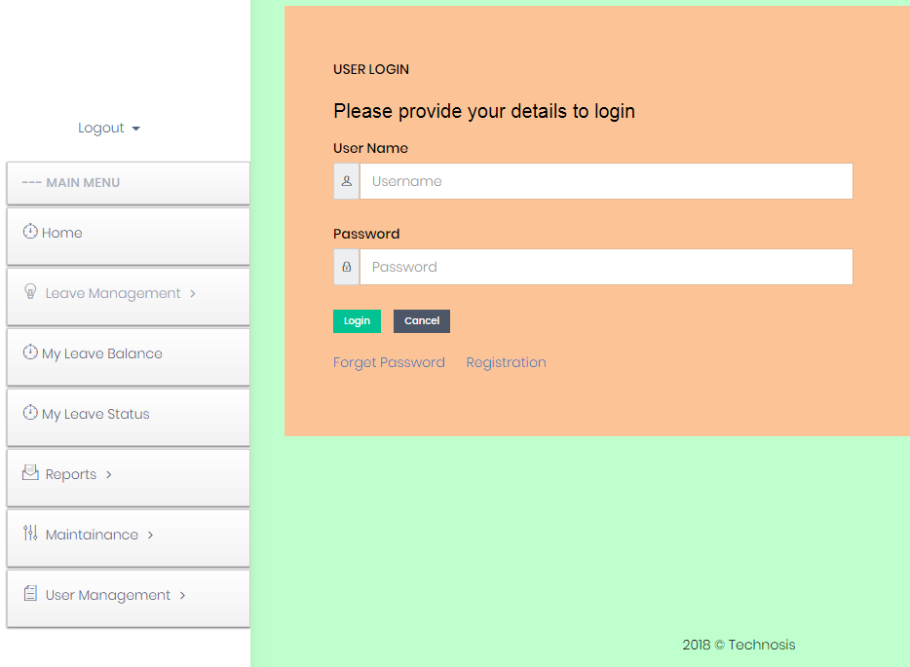
Figure 1. Log In Page
User will put his user name and password to enter into the system. Authorized user will be able to log into the system and get home page.

Forget Password:

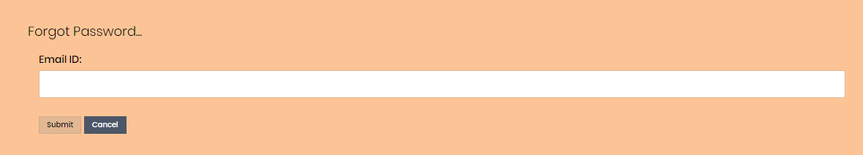
Figure 2. Forget Password
Users who have forgotten password can get password from this page. He has to put his email ID and press on 'Submit' button. Then he can retrieve his password.

Registration:
New user can register through this page.
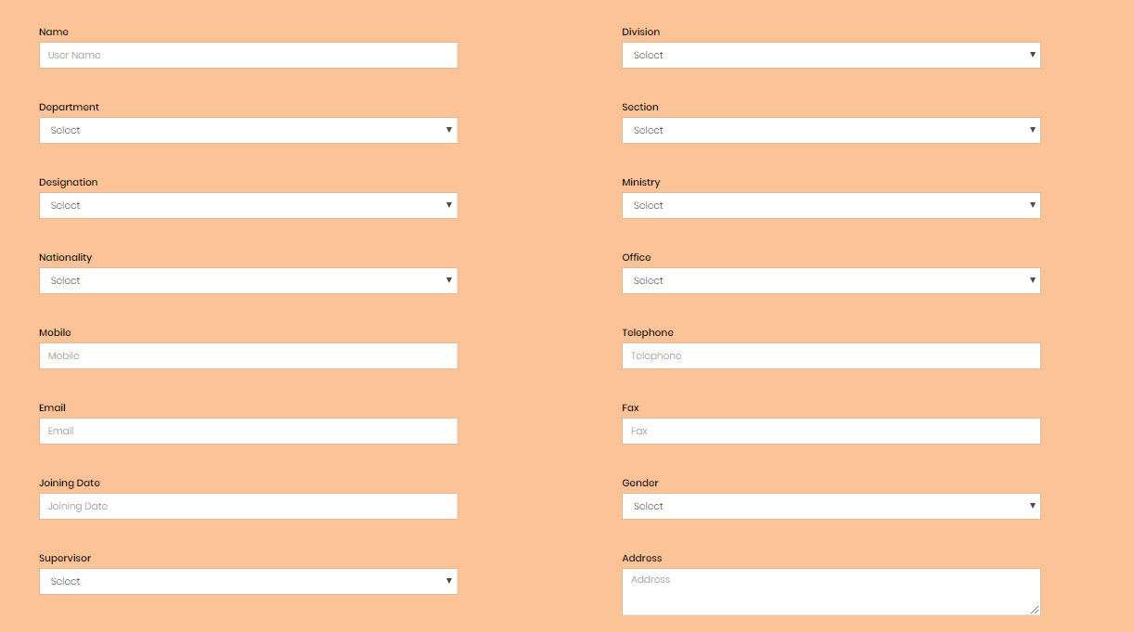
Figure 3. Registration(Upper view)
Field Descriptions:
Name(M): Name of the employee
Division(M): Division of the employee.
Department(M): Department of the employee.
Section(M): Section of the employee. When a department is selected, corresponding sections are populated in the section dropdown list.
Designation(M): Designation of the employee.
Ministry(M): Ministry of the employee.
Nationality(M): Nationality of the employee.
Mobile(O): Mobile of the employee.
Office(O): Office location of the employee.
Telephone(O): Telephone of the employee.
Email(M): Email of the employee.
Fax(O): Fax of the employee.
Joining Date(M): Joining Date of the employee.
Gender(M): Gender of the employee.
Supervisor(M): Supervisor of the employee.
Address(O): Address of the employee.

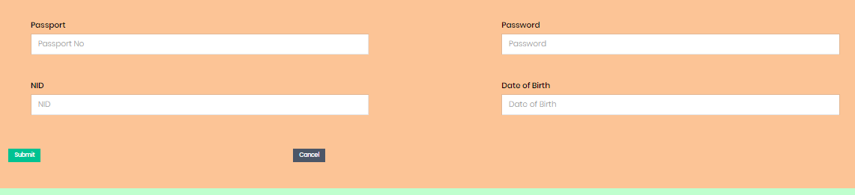
Figure 4. Registration(Lower view)

Passport(O): Passport number of the employee.
Password(M): Password needs to be given.
NID(O): NID of the employee.
Date Of Birth: Date of birth of the employee. It's very important. Based on this date, retirement date is calculated. Retirement date= Birth date + 59 yrs.
Button(Submit): After submission request will go to Admin for approval. After approval from admin, user can access in this application using password.

Home Page:
After successful log in from log in page user will be able to view this page. In this page user's name, his section name and a leave notice board will be displayed. In the notice board list of employees who are on leave currently will be shown with few detail. In table
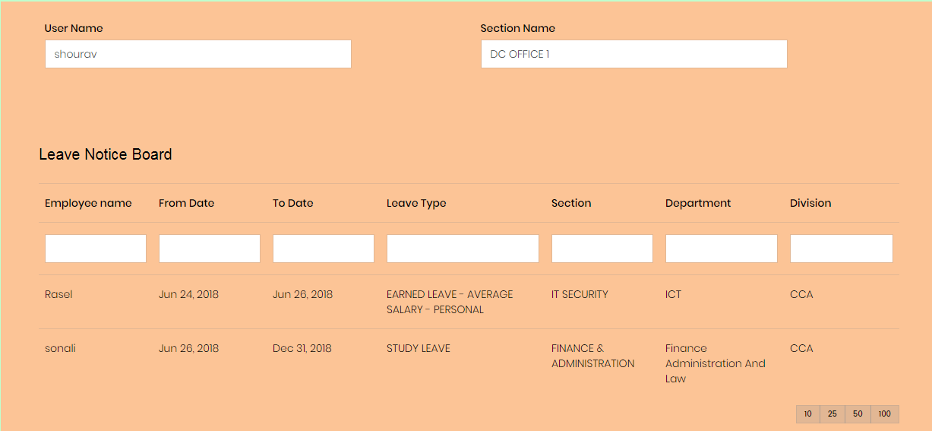
Figure 5. Home Page
Field Descriptions:
Employee Name: Employee name who has taken leave.
From Date: From which date employee has taken leave.
To Date: Up to which date has has taken leave.
Leave Type: Which leave type employee has taken. There are 26 leave types in this application. We'll discuss in detail while discussing Leave Application page.
Section: Section name of the employee is shown here.
Department: Department name of the employee is shown here.
Division: Division name of the employee is shown here.

Leave Management
The Leave Management tab has three sub tabs.
- Leave Application
- Leave Approval
- Cancel Approved Leave

Leave Application

The Leave Management (Figure 3 and Figure 4) consists of 16 input fields containing information about leave application details. Here User ID & User Name will be populated automatically. After selecting 'Leave type' few more information will be auto populated. These are describes below.
Leave Type: There are 19 leave categories through which user can apply for a leave
1. EARNED LEAVE - AVERAGE SALARY - PERSONAL : This leave is taken for personal reason.
2. EARNED LEAVE - HALF AVERAGE SALARY - PERSONAL: This leave is taken for personal reason
3. STUDY LEAVE: For study purpose an employee can take maximum two years in this category
4. QUARUNTINE LEAVE : For specific contagious disease, an employee can take maximum one month in this category. If more leave is required, he has to raise another leave request. Generally admin generates leave request on behalf of employee.
5. MATERNITY: A female employee can take this leave 2 times in her job life. Each time she can take for maximum 6 months.
REST & RECREATION
6.LEAVE NOT DUE WITH MEDICAL CERTIFICATE: This leave can be taken only when there is no balance in ' EARNED LEAVE - HALF AVERAGE SALARY - PERSONAL'. Showing medical certificate, maximum 12 months can be taken in this category.
7. POST RETIREMENT LEAVE: An employee can take maximum one year from the day of retirement based on availability of 'EARNED LEAVE - AVERAGE SALARY - PERSONAL'.
8.CASUAL LEAVE : An employee can take maximum 20 days in a year in this category.
9. OPTIONAL: An employee can take maximum 3 days in a year.
10 Rest & Recreation.: This leave can be taken for 15 days(Consecutive) in every 3 years for recreation or rest.
11.SPECIAL DISABILITY LEAVE: Approval of medical board is required for this approval. In such case approval doc needs to be attached while applying for leave.
12. HOSPITAL LEAVE: An employee who has risk of being injured by accident or being sick can take this leave. It can be taken for maximum three months in every three years.

13.OUTSIDE BANGLADESH LEAVE: This leave can be taken for the purpose going outside Bangladesh. This is consumed from earned leave with avg salary.
14.EXTRAORDINARY LEAVE - PERMANENT: This leave can be taken on special condition when no other leave(Earned Leave)is available.
15.STUDY LEAVE - ADDITIONAL - EXTRAORDINARY : If any employee wants more leave to complete study, this type leave can be taken.
16.EARNED LEAVE - AVERAGE SALARY - MEDICAL: If any employee want to enjoy earn leave with avg salary for 6 months, he can apply in this category.
17.EARNED LEAVE - HALF AVERAGE SALARY - MEDICAL: If any employee want to enjoy earn leave with avg salary for 2 years, he can apply in this category.
18.LEAVE NOT DUE WITHOUT MEDICAL CERTIFICATE: This leave can be taken only when there is no balance in ' EARNED LEAVE - HALF AVERAGE SALARY - PERSONAL'. By not showing medical certificate, maximum 3 months can be taken in this category.
19.STUDY LEAVE - MEDICAL : After completing 2 years of study leave, an employee can apply for leave in this category for maximum 4 months.

Leave eligibility: If value is 'Yes', user is eligible to take this leave. If sufficient balance is there, it is shown 'Yes'.
Leave Balance: How many days are available to take leave.
Total Leave: Number of days allocated for such leave.
Leave Taken: Number of days allready taken for this leave.
Leave Applied: Number of days applied which are not yet approved for this leave. After approval, this count is set 0. When an employee applies for leave, this leave is considered to check leave availability in this leave category

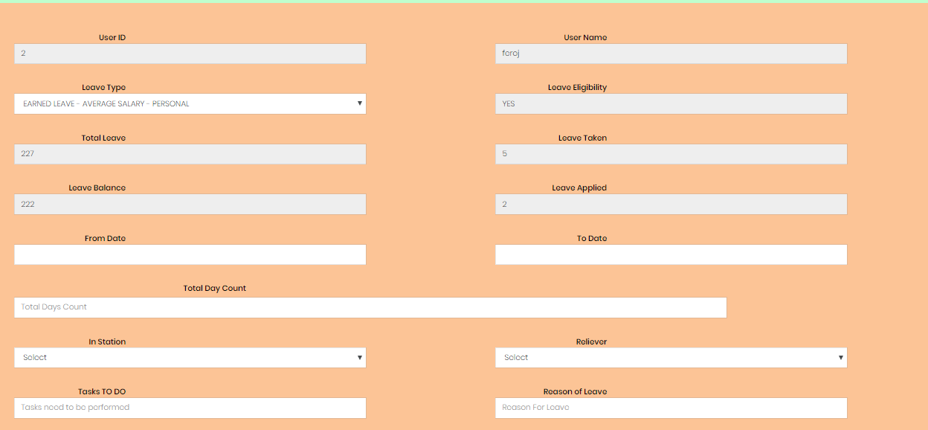
Figure 6. Leave Application(Upper view)
From Date(M): This is the start date for taking leave.
To Date(M): Up to which date user intends to take leave.
Total Day Count: Application will calculate how many days will be consumed within the duration, considering weekend and public holidays.
In Station(M): Employee will set 'Yes' if he can be available in office in spite of being on leave. If employee can't be available in office while enjoying this leave, he will set 'No'.
Reliever(O): An employee must set reliever who will take care of his job responsibilities when he'll be on leave.
Task TO Do(O): What tasks he'll complete before taking leave, he will write here. Approver will check this before approval.
Reason of Leave(M): User will mention the reason for taking this leave.

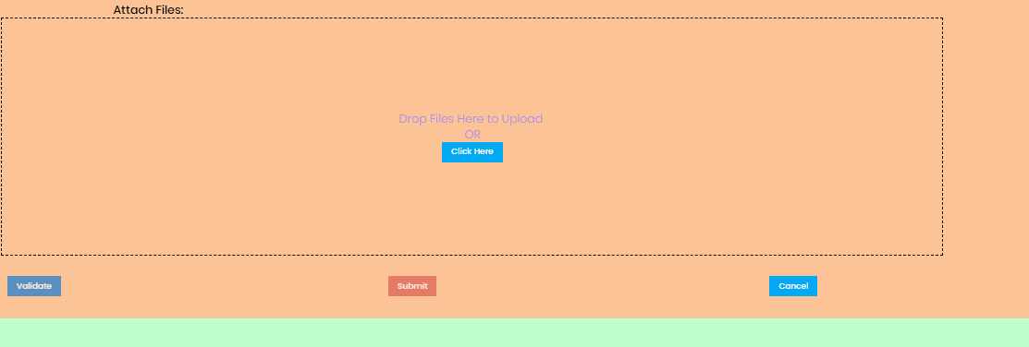
Figure 7. Leave Application(Lower view)
Attach files(O): User can attach multiple files to justify the reason of leave. Maximum 10 attachments(Each max 10 mb ) can be attached. Max 10 files can be attached.
Validate(Button): After filling mandatory fields, this button will be enable. Eligibility will be checked after pressing this button.
Submit (Button): If user is eligible to take leave, this button will be enabled.

Leave Approval:
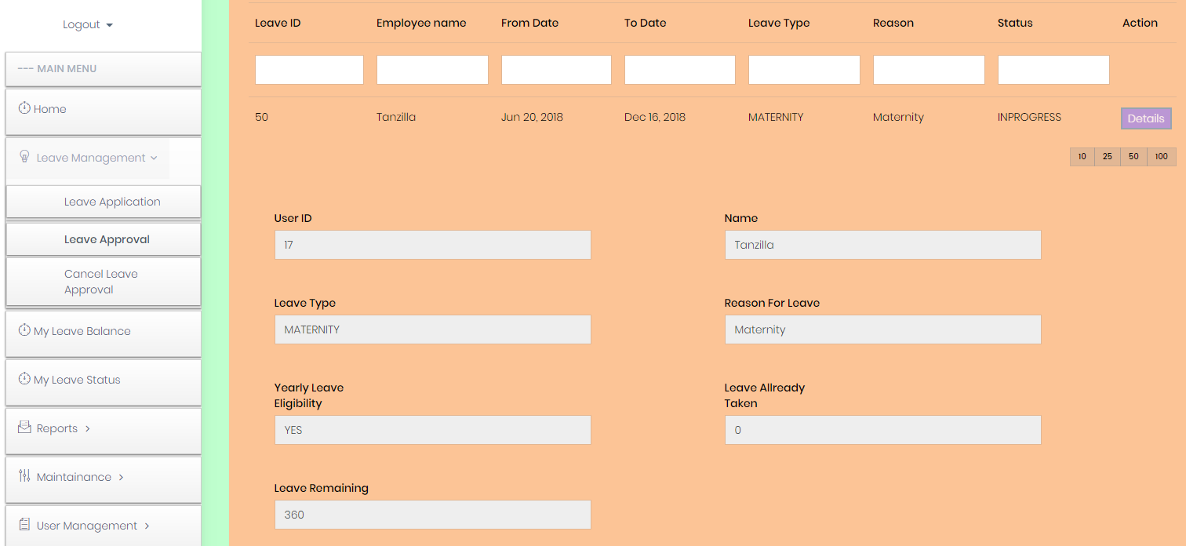
Figure 8. Leave Application(Upper view)
When approver opens this page, he will see a list of items which landed to him for approval. He can see details of the leave application on pressing 'Details' button. Based on his judgment he can approve or reject leave request. All attachment will be listed in 'Download Files' option from where approver can download the files.
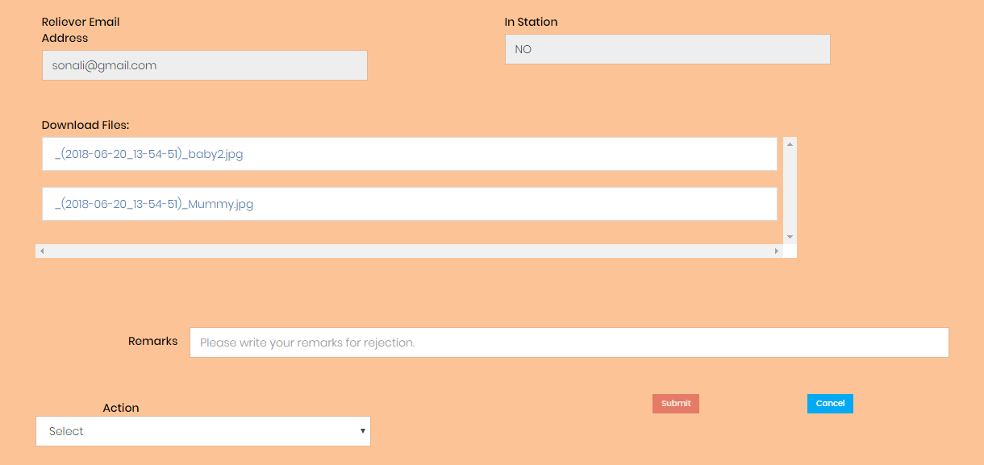
Figure 9. Leave Application(Upper view)
Here in 'Action' dropdown list, there are two options. 1. Accepted 2. Rejected. If approver accepts, the request is forwarded to next approver. If he rejects, the application cycle is ended at this point. While rejection, approver must write reason of rejection, otherwise 'Submit' button will not be enabled.

Cancel Approved Leave:

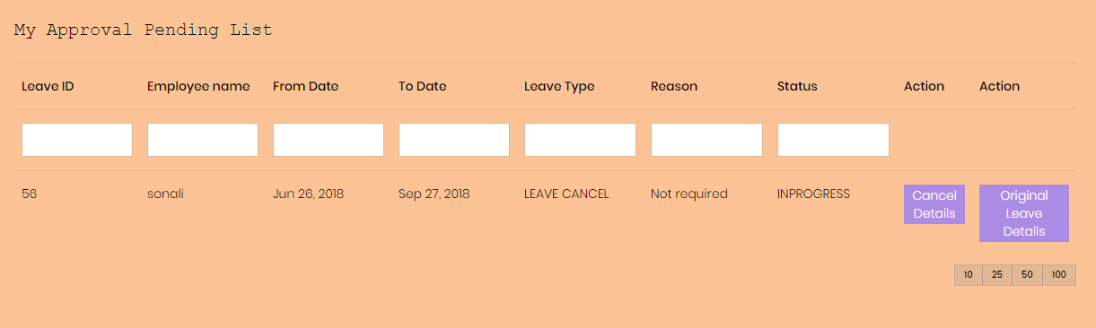
In this page list of leaves will be appeared which are requested for Cancellation. Only approver can view the list.
Figure 10. List Cancel Requests
There are two action buttons.
1.Cancel Details: After pressing this approver can view details cancel request.
2.Original Leave Detail: Approver can check some information of original leave requests which are required to take decision of cancellation.
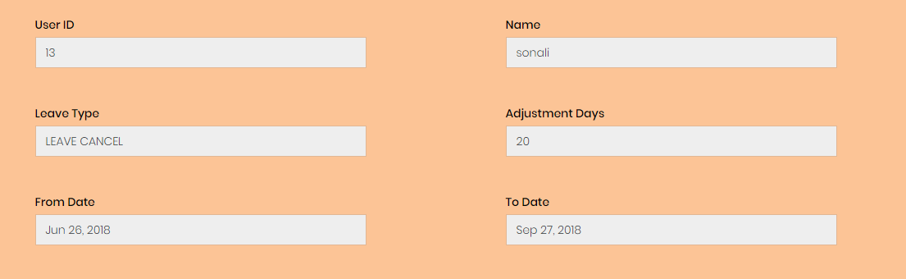
Figure 11. Details of cancel request
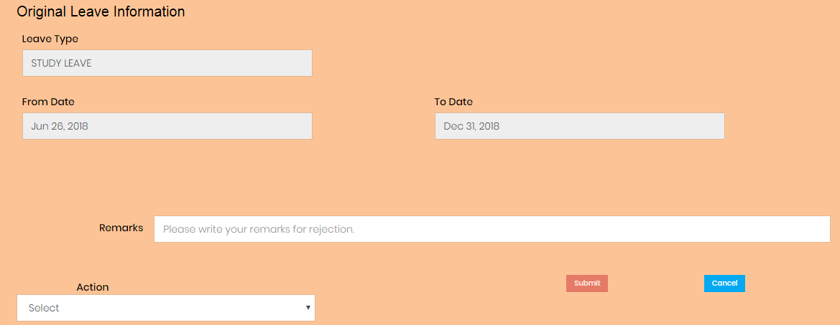
Figure 12. Original Leave request
Here in 'Action' dropdown list, there are two options. 1. Accepted 2. Rejected. If approver accepts, the request is approved. If he rejects, cancel request is rejected. While rejection, approver must write reason of rejection, otherwise 'Submit' button will not be enabled. Here only one level approver is present. After approval, adjusted days, mentioned above is adjusted with user's leave account. Leave balance is increased and leave taken is reduced from his account.

My Leave Balance
User will be able to view his own leave balance from this page. After pressing 'Leave Balance' button user will view his leave balance for different leave types
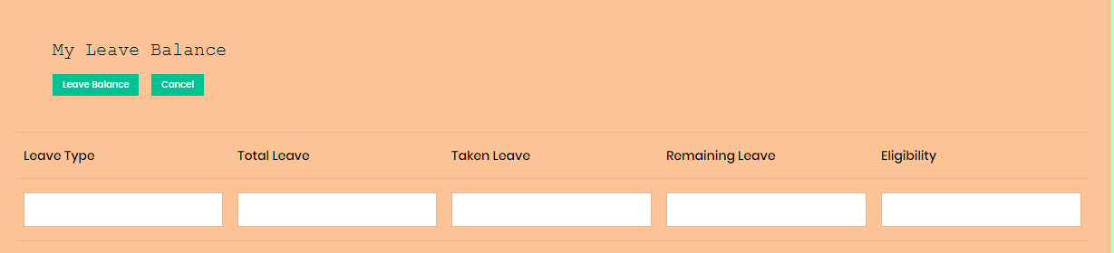
Figure 13. My Leave Balance

My Leave Status:
From this page, user will be able to see the status of all leaves he has applied.
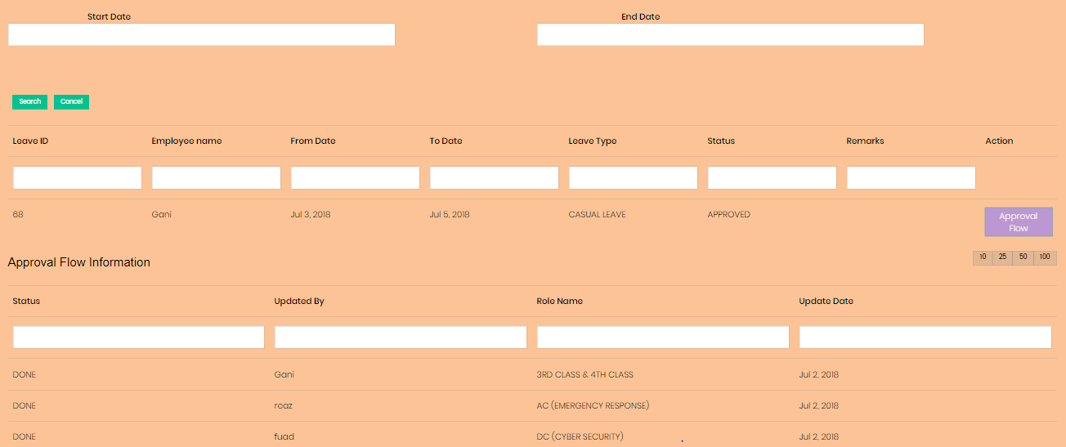
Figure 14. My Leave Status
User can put a date range. For example if he wants to see the leaves which he has applied between 1-jun-2018 to 15-jun-18, he can set start date as 1-jun-2018 and end date as 15-jun-18 and press 'Search' button he'll see the list of leaves. By pressing 'Approval Flow' he can check details approval flow.

Table Column Descriptions(Approval Flow):
Status: Status of each hop. If approver approves, it will be set as 'Done'. If he rejects it will be set as 'Rejected'.
Updated By: Name of the person who updated the status.
Role Name; Role/Designation of the person who worked on this.
Update Date: Date when approver changed the status.

Reports:

Subordinate Leave Status:

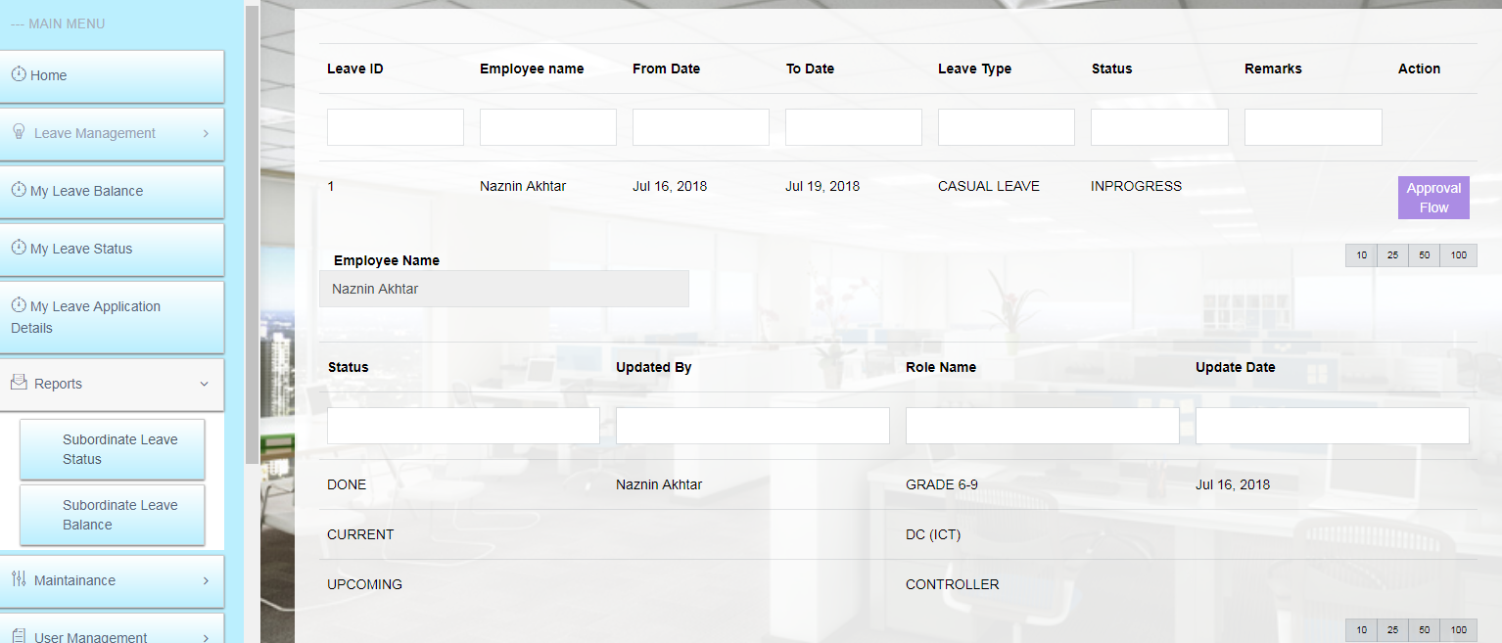
Figure 15. Subordinate Leave Status
Only employee who have subordinates will be able to access this page. After entering this page, user will see the list of subordinates who has applied for leave. After pressing 'Approval Flow' button, they can see the status of leave approval. AC will view all his subordinates, DC can view all under his department and controller and secretary can view all employees in CCA.

Subordinate Leave Balance:
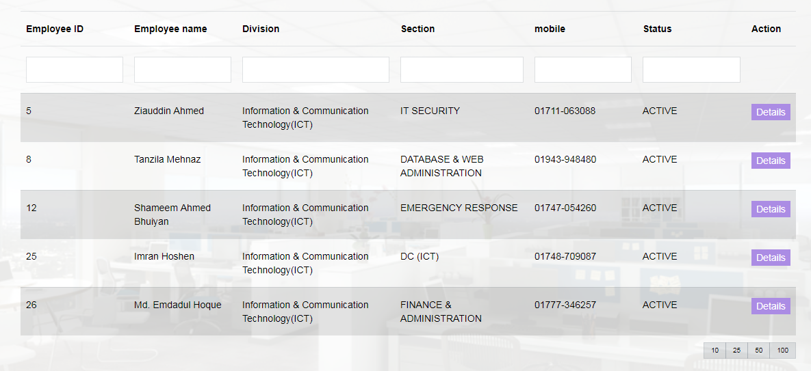
Figure 16. Subordinate Leave Status

Only employee who have subordinates will be able to access this page. After entering this page, user will see the list of subordinates. After pressing 'Detail' button, user can see the leave balance of each subordinate. AC will view all his subordinates, DC can view all under his department and controller and secretary can view all employees in CCA

Maintenance:
There are few sub items under this menu. These sub items will be used by admin only. Other employees will not be able to view these pages .

Manage User:

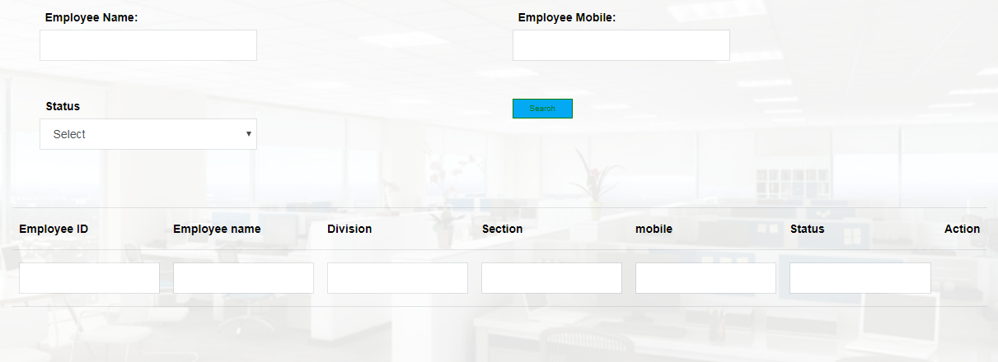
Figure 17. Manage User(Upper view)
Admin will do below activities from this page
- Search user by name or mobile number or status
- Change the status from 'PENDING' to 'ACTIVE' for new registered user.
- Assign work flow role(AC ADMIN,AC LAW,DC ICT and so an) and application role(Applicant/Approver/Report viewer).
- Change any personal of official information of an employee.

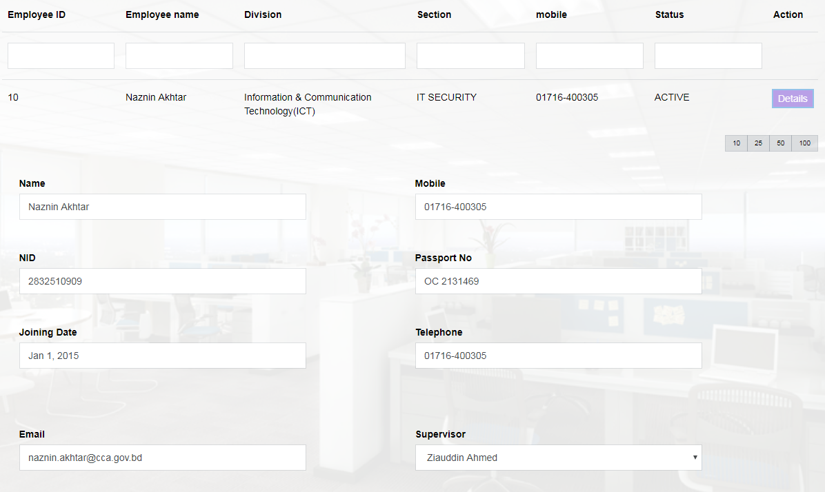
Figure 18. Manage User(Lower view)

Division

Admin can add or remove division from this page. Generally ' Information & Communication Technology(ICT)' division can't be deleted since all users are under this division.

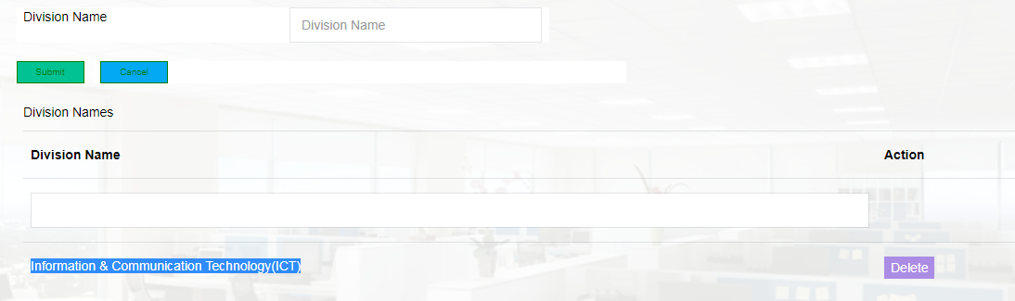
Figure 19.Division

Ministry
Admin can add or remove ministry from this page. Generally ' Posts, Telecommunications & Information Technology' ministry can't be deleted since all users are under this ministry.

Holiday:
Admin can view ,add and delete all national holiday from this page. He needs to configure all yearly govt holidays on 1st day of the year.
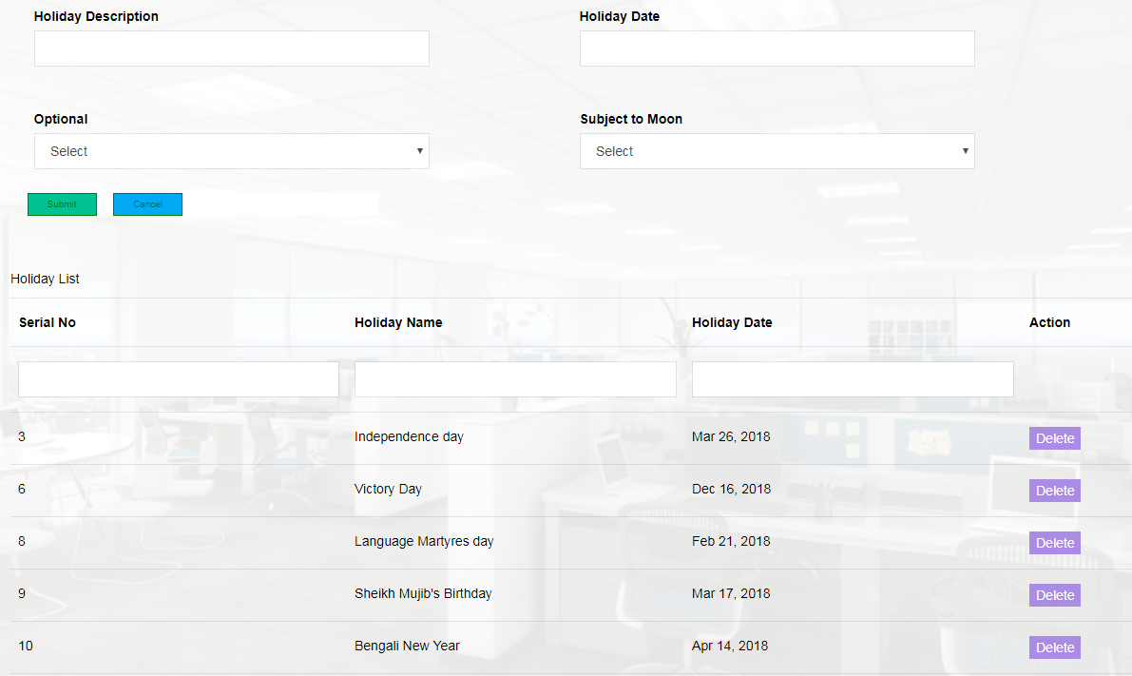
Field Descriptions:
Holiday Description: This is basically the name of the holiday.
Holiday Date: The date when holiday is observed.
Optional: This is an optional filed which indicates whether the holiday is 'Optional' or not.
Subject TO Moon: This is a filed which indicated whether this holiday depends on the visibility of moon. Admin needs to change the date based on moon.

Leave Rules:

SL | Leave Type | Rules | Max Duration
1 | EARNED LEAVE - AVERAGE SALARY - PERSONAL | 1.All permanent employees can take this based on availability | Maximum 4 months (120 days)
2 | EARNED LEAVE - HALF AVERAGE SALARY - MEDICAL | 1.All permanent employees can take this based on availability | Maximum 6 months (180 days)
3 | EARNED LEAVE - HALF AVERAGE SALARY - PERSONAL | 1.All permanent employees can take this based on availability | Maximum 1 Year (365 days)
4 | EARNED LEAVE - HALF AVERAGE SALARY - PERSONAL | 1.All permanent employees can take this based on availability | Maximum 2 years (730 days)
5 | STUDY LEAVE | 1.All permanent employees can take this based on availability  Not Eligible If:  1.Total Job Life <5 yrs  2.Within 3 years of the date when an employee is ready for retirement.  3.The date when an employee completes 25 yrs Total Job life, within 3 yrs of that date. | Maximum 2 years(730 days) in job life
6 | STUDY LEAVE - ADDITIONAL - EXTRAORDINARY | 1.All permanent employees can take this based on availability  Not Eligible If:  1.Total Job Life <5 yrs  2.Within 3 years of the date when an employee is ready for retirement.  3.The date when an employee completes 25 yrs Total Job life, within 3 yrs of that date. | Maximum 4 months(120 days) in job life.
7 | STUDY LEAVE - MEDICAL | 1.All permanent employees can take this based on availability  Not Eligible If:  1.Total Job Life <5 yrs  2.Within 3 years of the date when an employee is ready for retirement.  3.The date when an employee completes 25 yrs Total Job life, within 3 yrs of that date. | No specific limit. Based on approval by authority.
8 | QUARANTINE LEAVE | All permanent employees can take this based on availability | Maximum 30 days in a year
9 | MATERNITY | 1. Male employee can take this leave | Maximum 6 months(180 days) at a time. 2 times in job life
10 | LEAVE NOT DUE WITH MEDICAL CERTIFICATE | When earn leave half average salary is not available. | Maximum 12 months (365 days)can be taken in total job life
11 | LEAVE NOT DUE WITHOUT MEDICAL CERTIFICATE | When earn leave half average salary is not available. | Maximum 180 days can be taken in total job life.
12 | POST RETIREMENT LEAVE | 1. Earned Leave should be available | Maximum 1 year(365 days) from next day of retirement
13 | CASUAL LEAVE | All permanent employees can take this | Maximum 20 days in year  Maximum 10 days at a time  Maximum 3 days can be added with weekly or public holiday
14 | OPTIONAL | All permanent employees can take this  Need to apply and approve by 31st January of each year. | Max 3 days in a year  Max 1 at a time
15 | REST & RECREATION | If taken leave for 15 days on every three years, then he is eligible for taking one month salary.  Next eligible date will be considered based on previous leave start date, not previous leave end date. | 15 days(Consecutive) every 3 years
16 | SPECIAL DISABILITY LEAVE | Approver will check previous history before approval of leave.  Approval of medical board is required for this approval. In such case approval doc needs to be attached while applying for leave. Based on this approver will approve. | Maximum 24 months (730 days)  for one type of disability in job life
17 | HOSPITAL LEAVE | Who has risk of being injured by accident or being sick  Can be added with other due leave(earned leave) but total leave duration must not be more than 28 months | 3 months(90 days) in every three year
18 | OUTSIDE BANGLADESH LEAVE | This is one type EARNED LEAVE - AVERAGE SALARY - PERSONAL  Secretary is final approver of the leave. | Maximum 4 months if EARNED LEAVE - AVERAGE SALARY - PERSONAL is available
19 | EXTRAORDINARY LEAVE - PERMANENT | When no other leave(Earned Leave)is available or apply for such leave for special condition.  If anyone is on leave without prior approval, then such leave can be applied as Extraordinary Leave.  Admin can raise leave request on behalf of him | Maximum 180 days in a year

Usability Requirement
User will accept the software based on 100% UAT success rate.

User & Product Documentation Requirements

Test case & Test Result
- User Manual

Training Requirements

User will be given training if required. One training session can be arranged in this scope.

Security Requirements
Application will ensure that only authorized users will be access in the system.

Data Conversion Requirements
Existing employee details & leave information need to be transferred to system .

Performance Requirements
Application should perform well. There should not be significant delay while working with the application.

Data Retention requirement
There is no data retention requirement. All data need to be kept in database.

Assumptions
- All the requirements are placed by CCA department. No business logic changes will come in the middle of development. Any changes to requirement during design/development will be addressed as separate change request.
- CCA team will ensure Infrastructure readiness (OS installation, Network connectivity , Network security) before the start UAT.
- CCA team will provide Master Data (Employee information, Leave information) to load this data in database. These data will be required for Leave calculation and reporting.
- CCA team will ensure connectivity between application server and mail server to send mail notification to user.
- CCA team will involve a project manager who will facilitate all required support.
- CCA team will share UAT cases earlier which will help to increase accuracy of the implementation process.

Risk

Sl | Risk Area | Risk Details | Mitigation Plan
1 | Functional | Some features may not work as expected by client | Development will be based on sign off Specification document. Any new change requirement needs to be addressed by change management process.  SIT will be ensured properly.  UAT will be done based on user prepared UAT cases. All test cases should be passed before implantation.
2 | Implementation | Implementation timeline may be deviated for justified reasons. | For any unavoidable circumstances, clients will be notified few days earlier
 | Operational | Application, Database & Web server will be resided in one server. Any interruption of this server will interrupt full application. | Need to ensure back up of application & database.
 | Communication | Contact persons from CCA team may be unavailable for few days. It may delay project activities | Back up resource need to be allocated
 | Change Management | After deployment, if there is any change requirement for bug fixation or other reason, then need to deployment the new change in production environment | Prepare UAT environment along with production environment

Dependencies:

SL | Dependencies | Impact | Severity
1 | Server needs to be ready before UAT session | UAT can't be started as per plan | High
2 | Connectivity should be ok between application server and mail server. | Mail notification feature can't be tested. | Medium
 | Users need to use updated browsers(IE9 & above or chrome) to get latest features of the application | Users will not be able to use new technology. | Medium

WBS Break down
(Effort should be in Number of Work days)
Phase | Effort(Man Days)
Business Analysis | 8
Build | 34
Database & System design | 8
QA / Testing | 6
UAT Support | 5
Documentation | 6
Deployment | 3
Master Data Insertion | 3
Project Management | 7
Total Effort: 80

Cost :
Item | Cost
'Leave Management System 'Development & Implementation | 1,15,000 BDT

Payment Structure:
Phase | Payment Portion
Work order issue | 30%
UAT sign off | 60%
Implementation | 10%

Warranty:
2 Months service & Support will be provided after deployment. Within this duration any product bug will be fixed which are under the specification doc. But new changes need to follow change management process(Analysis, Effort estimation, Effort approval, Work order, Development, Testing, UAT & implementation)

Delivery Timeline:
After receiving pay order , approximately two months will be required to deliver the product.

Appendix

Leave Rules:

