**EVIDENCIADE ACTIVIDADES EN CLASE / PRACTICA**

|  |  |  |  |  |  |  |  |  |  |  |  |
| --- | --- | --- | --- | --- | --- | --- | --- | --- | --- | --- | --- |
| **Nombre del alumno:** | | Ismael Iván López Murillo | | | | | | | A person looking at the camera  Description generated with very high confidence | | |
| **Registro** | 15300147 | | | | | | | |
| **Carrera:** | Desarrollo de Software | | | | | | | |
| **Materia:** | Programación Web I | | | | | | | |
| **Clave:** | MPF2707DSO | | | **Grupo** | | 7I1 | | **Semestre:** | | | 7 |
| **Profesor:** | Luis Rene Duran Hernandez | | | | | | | | | | |
| **Parcial** | 3 | | **EVIDENCIAS O PRODUCTOS DE APRENDIZAJE DE LA UNIDAD**  **(Clave)** | |  | |  | | |  | |
| **Competencia**  **Genérica**  Desarrolla innovaciones y propone soluciones a problemas a partir de métodos establecidos | . | | **Competencias Disciplinares.**  . | | . | | **Competencias Profesionales**  . | | | . | |

Foto credencial

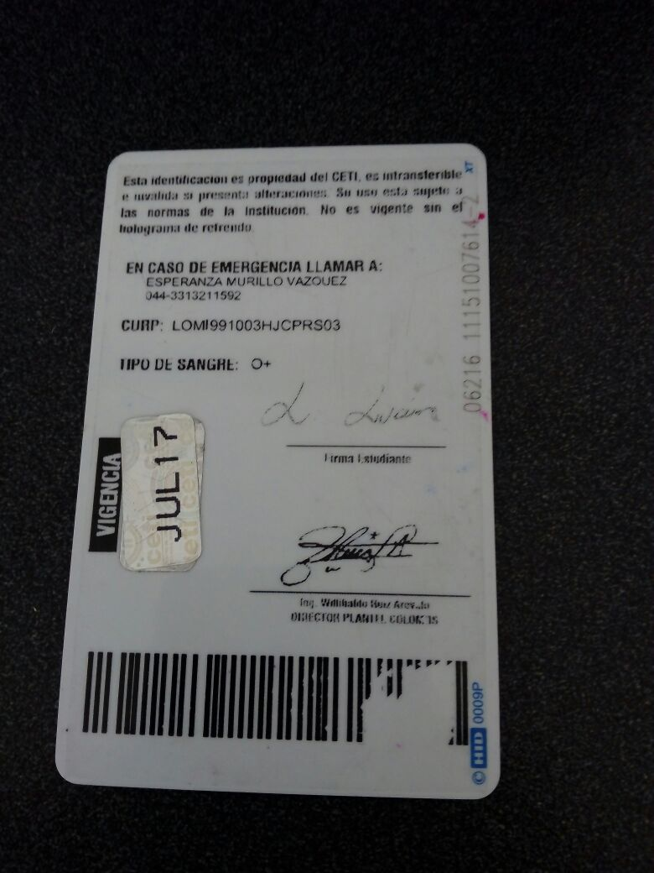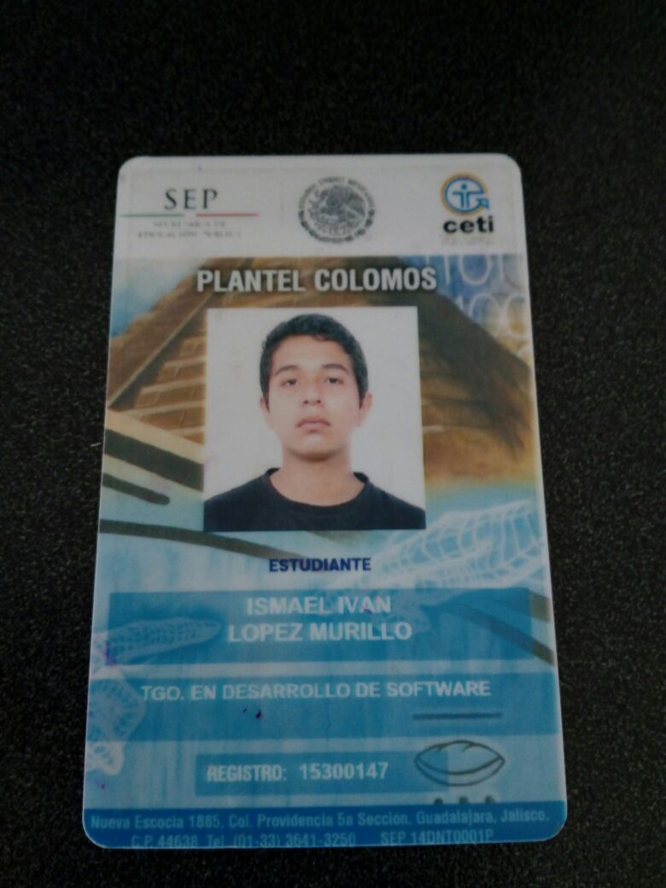

**Work Breakdown Structure**

**A screenshot of a cell phone

Description generated with very high confidence**