Задание 1:

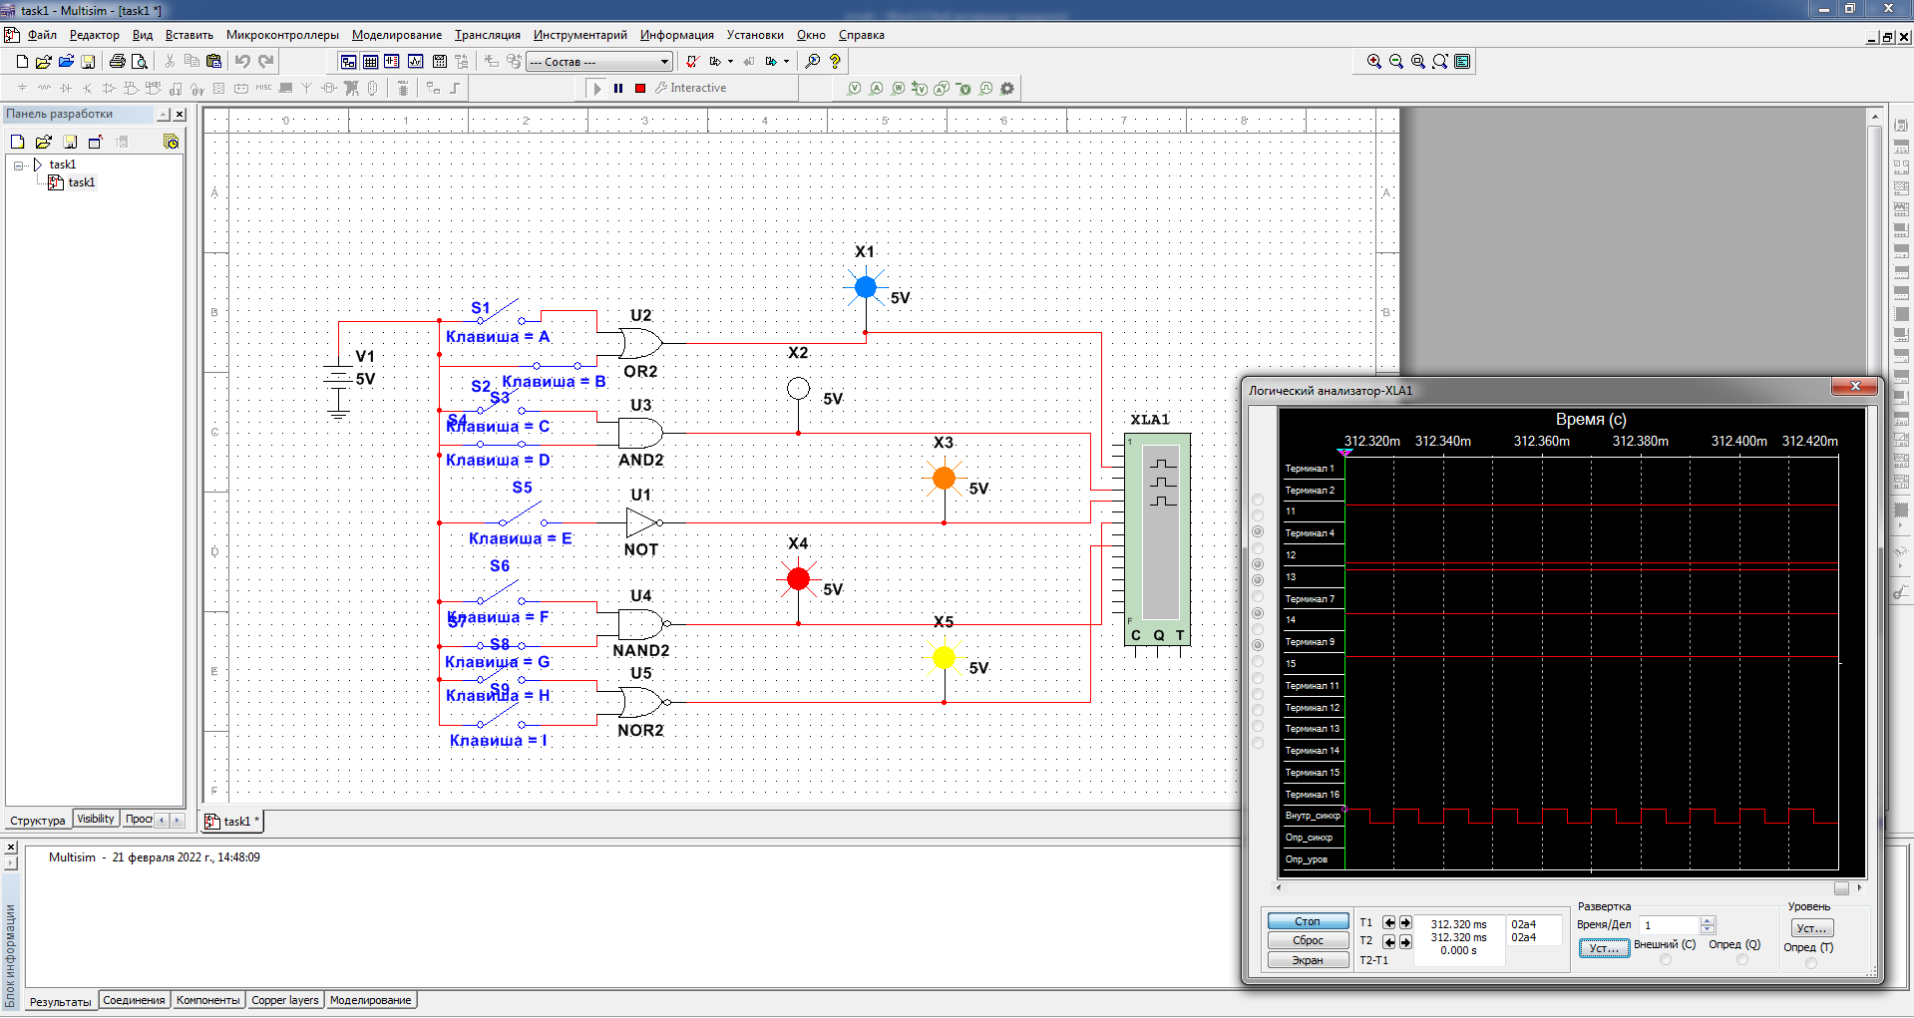

Таблица истинности:

|  |  |  |  |  |  |  |  |  |  |  |  |  |  |
| --- | --- | --- | --- | --- | --- | --- | --- | --- | --- | --- | --- | --- | --- |
| Дизъюнктор [ИЛИ (**OR**)] | | | Конъюнктор  [И (**AND**)] | | | Инвертор  [НЕ (**NOT**)] | | Штрих Шеффера [И-НЕ (**NAND**)] | | | Стрелка Пирса  [ИЛИ-НЕ (**NOR**)] | | |
| *х*1 | *х*2 | *y* | *х*1 | *х*2 | *y* | *x* | *y* | *х*1 | *х*2 | *y* | *х*1 | *х*2 | *y* |
| 0 | 0 | 0 | 0 | 0 | 0 | 0 | 1 | 0 | 0 | 1 | 0 | 0 | 1 |
| 0 | 1 | 1 | 0 | 1 | 0 | 0 | 1 | 1 | 0 | 1 | 0 |
| 1 | 0 | 1 | 1 | 0 | 0 | 1 | 0 | 1 | 0 | 1 | 1 | 0 | 0 |
| 1 | 1 | 1 | 1 | 1 | 1 | 1 | 1 | 0 | 1 | 1 | 0 |

Задание 2 (15 вариант):

