Первый сайт

However, my favourite website is YouTube, because I can watch or download any types of video there. I can also share my favourite videos with the rest of the world. Everybody knows that it is the most popular video site in the world. I like it for three reasons. Firstly, I can listen to the music that I like on this site and watch the video clips of the new songs. Secondly, I can find almost every new movie or cartoon there. Thirdly, on YouTube I see the latest news that happened around the world.

Второй сайт

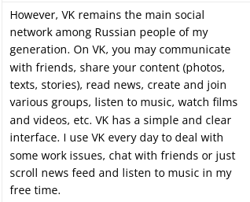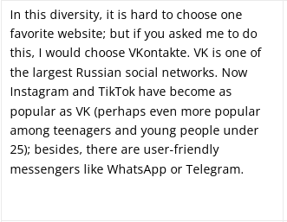

Третий сайт

GitHub is an web service for hosting IT projects and their joint development. The creators of the site call GitHub a "social network for developers."