

Tutorial

Tutorial

Overview
Welcome to NetCracker’s Tutorial. This seven-part tutorial is designed to:
- introduce you to NetCracker Designer’s functionality,
- familiarize you with the Graphical User Interface (GUI),
- provide you with step-by-step instructions so you can create network designs.
This tutorial uses four sample project files, which are included with your NetCracker Designer Software. While you can start at any point, it is recommended that you begin with Lesson 1.
You will learn how to:
- Use the NetCracker Designer software
- Work with an existing NetCracker Designer file
- Create a NetCracker Designer project
- Use animation features
- Use network simulation and statistics
- Create multi-leveled network designs
- Discover existing networks
- Use advanced features
- Conduct a database search
- Use the Device Factory Wizard

Tutorial Lessons
Tutorial 2
Overview 2
Tutorial Lessons 2
Lesson 1 -- Introduction To NetCracker Designer 3
Lesson 2 -- Using Animation Features 11
Lesson 3 -- Creating a New NetCracker Designer Project 16
Lesson 4 -- Creating Multi-level Network Designs 23
Lesson 5 – Customizing the Database and Database Search 29
Lesson 6 -- How to Use AutoDiscovery 37
Conclusion 42

Lesson 1 -- Introduction To NetCracker Designer
This section is designed to:
- introduce you to the Graphical User Interface(GUI),
- identify each of the elements of NetCracker Designer’s main application screen, and
- show you how to access tools and modes.
Time to complete: 20 minutes
- Start the NetCracker Designer application if it is not already started by selecting Programs==>NetCracker Designer 4.1 ==>NetCracker Designer from the Start menu.

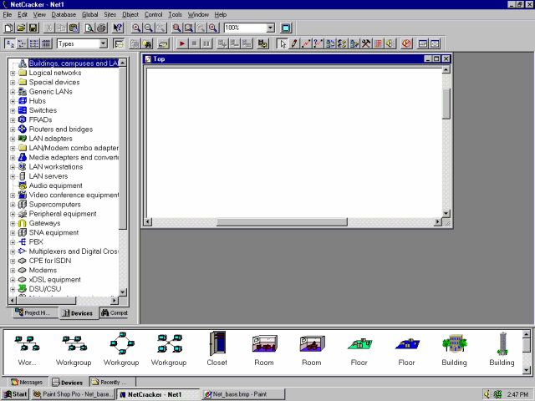
The main application window is displayed. In addition to the title bar, main menu and toolbars, NetCracker Designer’s main window consists of three panes: the browser, the workspace, and the Image pane. When you start NetCracker Designer, the workspace contains an empty Net1 site. The Image pane is populated by images of devices and applications from the selected database entry (Buildings, campuses, and LAN workgroups).

NetCracker Designer main application window
- Open a NetCracker Designer (.NET) file.
To display the Open dialog, from the File menu select Open.
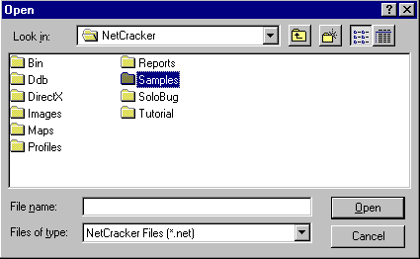
Open dialog box
Double-click on the Samples folder in the Selection pane to display its contents. Click on the Techno.net filename and press the Open button, or double-click on the Techno.net filename.
A site window will appear in the workspace pane.
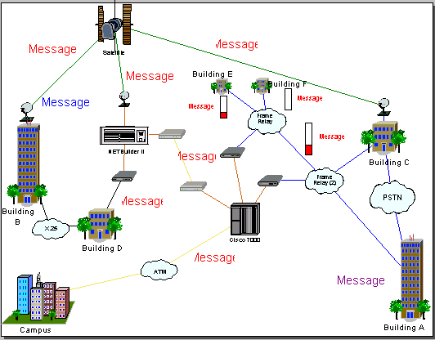
Site window
- Position the site window in the workspace for maximized viewing by clicking on the site window’s Maximize button. Increase the viewing area by pressing the Zoom to page button .
- Scroll through the Device browser and locate the Routers and bridges listing. In the Device browser, to the left of Routers and bridges listing click on the expansion symbol (+).
The Routers and bridges listing expands to show all the categories of these devices.
- Expand the listing further by clicking on the expansion symbol for Backbone routers, then expanding the list to display routers manufactured by Cisco Systems. You have fully expanded the Cisco listing.
As you expanded listings in the Device browser, a scrollbar on the right-hand side of the Device browser appeared.
- To select a device in the Device browser, click on the Cisco 7010 item. Notice that the Image pane changes to display all the devices in this category.
- Move the Device browser scrollbar down until you locate the LAN adapters listing. Expand LAN adapters then the Ethernet listing, and click on the 3Com Corp. folder.
The Image pane displays the Ethernet LAN adapter cards manufactured by 3Com Corp. Use the Image pane scrollbar to scroll the Image pane and see the device images.
- Click on the Fast EtherLink 10/100 PCI device image in the Image pane.
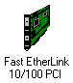
Device image
- Locate the Database toolbar, which has the Large Icons button, selected as a default.
Database toolbar
- To change the listing mode in the Image Pane, on the Database toolbar select the Details button, .
The Device images that appear in the Image pane are displayed in a smaller format.
- Change the mode of the Database browser by going to the Database toolbar and in the combo box select Vendors.
The device database is re-sorted alphabetically by vendor name:
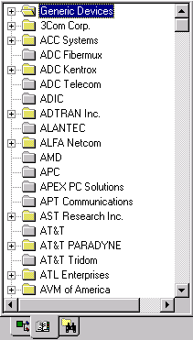
Device Browser sorted by vendor name
- Now locate and select the Fast EtherLink 10/100 PCI in the Device browser by expanding listed items (Path: 3 Com Corp.→LAN adapters→Ethernet) In the Image Pane, scroll down and locate the Fast Ethernet 10/100 PCI.
- You probably noticed the three tabs on the Image pane. Click on the Recently Used tab on the Image pane.
The Image pane now displays Device images associated with the project displayed in the workspace. As you build a network design, NetCracker stores a copy of each Device image you have included. When you want to create a project using multiple copies of a device, you can select that device from either the Devices tab or the Recently Used tab on the Image pane.
Since a NetCracker project is already open, let’s take a look at it.
To receive information about a device in the workspace, double-click on the device. Start by getting information about the devices used to create the Techno.net project. Double-click on the Cisco 7000 router located in the center of the site window.
The Configuration dialog for the Cisco 7000 router is displayed.
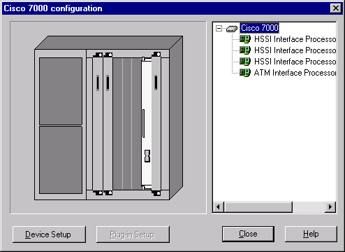
Configuration dialog
Configuration dialogs include a Device Image, the configuration Selection panel, the Device Setup button, the Plug-in Setup button, the Close button, and the Help button.
a. To select the HSSI Interface Processor, in the Selection panel, below the Device name, click on the first plug-in listed. Notice that as you select a plug-in, the device image changes to indicate where the plug-in is located in the device. Repeat to locate the other three plug-ins.
b. Now try clicking on each slot on the Device image. As you select each plug-in it is highlighted both on the Device image and the Selection panel. The Plug-in Setup button is also enabled.
c. To access information about a plug-in use one of the following methods:
• In the Selection panel, click on the ATM Interface Processor TAXI multi-mode plug-in, press the right mouse button to display the local menu, and select the Properties command.
• In the Selection panel, click on ATM Interface Processor TAXI multi-mode plug-in and press the Plug-in Setup button.
• On the Device image, click on the ATM Interface Processor TAXI multi-mode plug-in and press the Plug-in Setup button.
The Properties dialog for that plug-in is displayed.
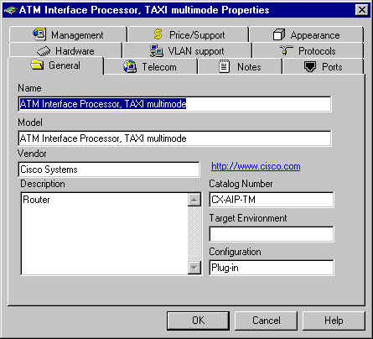
Plug-in Properties dialog
d. In the Plug-in Properties dialog, click on the Protocols tab to see what protocols for this plug-in are enabled.
e. To close the Plug-in Properties dialog press either the Cancel or OK button.
You are now back to the configurations dialog.
- To see how the Cisco 7000 is configured, on the configuration dialog press the Device Setup button. Select the Ports tab to see how many ports are in use and not in use, then close the Properties dialog by pressing the Cancel or OK button.
Do not close the Configuration dialog yet!
g. Next, insert another plug-in in this device. Press the Recently Used tab on the Image pane. On the Image pane, scroll down until you locate the ATM Interface Processor, DS3. Click on the ATM Interface Processor card to select it, continue to hold down the left-mouse button and drag the plug-in to the Configuration dialog until the mouse is positioned over an open slot in the Device image on the dialog box, then release the mouse button.
NOTE: When you first select the plug-in, the cursor changes to indicate that the plug-in cannot be placed where it is (). As you drag the plug-in to the workspace and position it over an open slot on the Configuration dialog, the cursor changes to a plus symbol () to indicate that you can insert the plug-in into that slot.
Another method of inserting plug-ins involves selecting the plug-in from the Image pane and inserting it directly into the Device image in the workspace. Using this method does not require the Configuration dialog to be open.
h. Close the Configuration dialog by pressing the Close button.

NOTE: Use the same methods to get information about any other device in the project, or click on a device and from the Object menu, select the Properties command.
- To obtain general information, position the cursor over an object on the site window to see ToolTips. Additional information can be heard (audible tips), by using Say commands. To use the Say commands, right-click on the device to display the local menu, select one of the Say (Say Notes, and Say Description) and release the mouse button.
NOTE: If you do not have a sound card all Say commands will be disabled (grayed).
- To see what kinds of links are used to connect the devices, from the View menu, select the Media Colors command.
The Media Colors dialog is displayed.
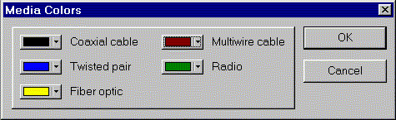
Media Colors dialog
Use this dialog to set up media color.
To change the color of media click on the box next to media type and select the color.
- You can obtain information about your entire network by accessing project reports.
To see report options, from the Tools menu select the Reports sub-menu.
a. To select the Bridges and Routers report command, press the Next button on the Report Wizard, then press the Finish button to display the Bridges and Routers report. The report is displayed in the workspace and Report toolbar appears above the report.
Report toolbar
b. Export a copy of the report.
To display the Export dialog, press the Export report button. Then select options from the Format and Destination fields, and press the OK button. Depending on the format and destination selected additional dialogs may appear.
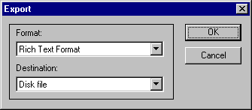
Export dialog
NOTE: After you select export options your settings are retained (become defaults).
The Choose Export File dialog appears. Use this dialog box to name your exported report file, indicate a directory, and modify the file type. Then, press the Save button.
NOTES:
- If you have already exported a file by that name, a message appears asking you if you want to overwrite the file. Respond with Yes (to overwrite) or No.
- NetCracker automatically creates a Reports directory located in the NetCracker program group. To print the report, on the Report toolbar press the Print Report button. A standard Print dialog appears. Use the Print dialog to select print options, then press the OK button.
c. To re-display the project site window without dismissing the report, from the Window menu, select Top window.
d. To select the Bill of Materials (BOM) report for a complete list of equipment and cost breakdown for this site, select the Tools menu, then select reports, and then click on Bill of Materials. On the Report Wizard, press the Next button, then press the Finish button to display the Bill of Materials report.
NOTE: The Device Summary report provides the same information on equipment as the Bill of Materials report does, but without the financial breakdowns.
e. Close each report by selecting each report’s Close button.
HINT: You may want to update prices after the database is updated. To update pricing and all other properties for a single device, first select the device in your project, then from the Object menu, select the Acquire Update command. To update pricing and all other properties for a project from the Global menu, select the Acquire Update All command.
Database updates are available though a subscription package. For more information refer to the NetCracker Technology web site at www.netcracker.com.
- To close the Techno.net project file without saving it , from the File menu, select the Close command. If a dialog box appears asking you if you want to save the file, press the NO button.
- Options:
• Close NetCracker, from the File menu select the Exit command.
• Continue to work with the NetCracker Designer Tutorial (Lesson 2 ).

Lesson 2 -- Using Animation Features
In this section you will learn how to use NetCracker animation and presentation features.
Time to complete: 20 minutes
- Start the NetCracker Designer application if it is not already started by selecting Programs==>NetCracker Designer 4.1==>NetCracker Designer from the Start menu.
- To open the sample NetCracker file named Router.net from the File menu, select Open.
- To select the directory where NetCracker is located, use the Directory combo box. To display the folder’s contents, in the Selection pane, double click on the Samples Folder. Click on the Router.net filename and press the Open button, or double-click on the Router.net filename.
A site window will appear in the workspace pane.
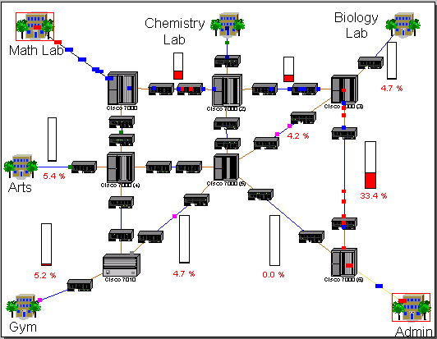
Site window with animation
- Select the Top window from the Windows menu. Position the Top site window in the workspace for maximized viewing by using the Maximize and Zoom to page buttons.
- To start the project animation on the Control toolbar press the Start button , or from the Control menu select the Start command.
Network activity (packets moving in the workspace) starts.

Control toolbar
NOTE: It may take a few seconds for the packets to move from buildings to the Top site view.
- To adjust the parameters of the animation, click on the Animation Setup button.
The Animation Setup dialog is displayed:
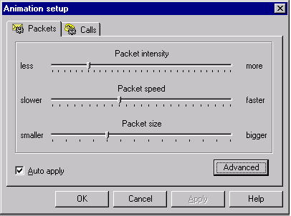
Animation Setup dialog
- Use the left mouse button to set the Packet speed and Packet size to the values you prefer. Then click on the OK button to apply the settings and close the dialog box.
- Open a lower level by double-clicking on the building labeled Math Lab on the top left-hand portion of the network and use the Zoom to page button to maximize your view.

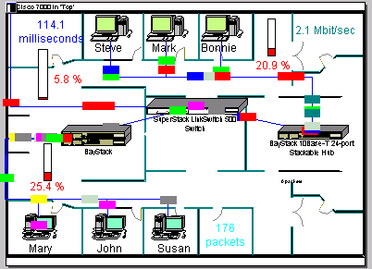
Math Lab site window
- To move to the top level, close the Math Lab site window by using the site window’s Close button .
- Click on the Top site window, then click on the Zoom In button several times to get a closer look at the network’s configuration. Adjust the scroll bars in the Top site window so that the link between the Cisco 7000 (3) and Cisco 7000 (6) routers is in the center of the site window. Make sure that animation is still running.
- To break a link, in the Modes toolbar left click on the Break/Restore button . Then place the cursor on top of the link between the two Cisco routers and click on the link.
A red flash appears on the link you have broken and traffic on the link stops. Traffic is re-routed according to the routing protocol.
- Check the routing protocol.
a. Left click on the Zoom to page button and right click on any blank space in the Top site window to access the local menu. Select Model Settings, select the Protocols tab.

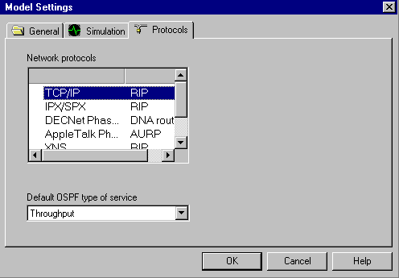
Protocols tab on the Model Settings dialog
b. Click on different network protocols. In the right column you can see the default routing protocol for that network protocol. For example the selected routing protocol for TCP/IP is RIP. Since RIP has been specified for TCP/IP, re-routing of TCP/IP packets follows this specification.
- To close the Model Setting dialog without modifying any of the settings, click on the Cancel button.
- Now, let’s restore the link. Place the cursor over the broken link (flashing point) and left click. Make sure you are in the Break/Restore mode.
The cursor changes to a wrench to indicate you are in Restore mode as you move the cursor over the broken link, the red flashing disappears, and traffic is restored.
- To turn off the Break/Restore mode, on the Modes toolbar, press the Standard mode button .
- To pause animation, on the Control toolbar, press the Pause button .
- To obtain packet information place the cursor directly over any frozen packet. A ToolTip appears. With the cursor still positioned over the packet, right click to access the local menu and select the Say Info command to hear packet information.
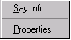
Local menu for packets
NOTE: If you do not have a sound card the Say Info command will be disabled.
- With the cursor still positioned over the packet, right click to access the local menu and select the Properties command. The Packet Properties dialog is displayed.

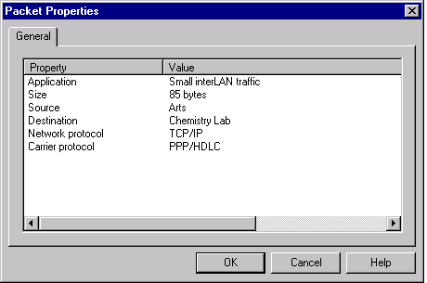
Packet Properties dialog
Information regarding the application, size, source, destination, network protocol, and carrier protocol is displayed.
Close the dialog box by clicking on the OK button or pressing the Enter key.
- Create a bend in a link.
a. If it is not already running, resume animation by pressing the Pause button (to toggle the Pause state). Hold down the CTRL button on the keyboard and double-click the mouse button directly on a link.
b. A grab handle (black square) appears on the link. Click and hold the mouse key down on the grab handle and drag it to a new location, then release the left mouse button.
The link bends at the points(s) you have bent it and data follows around the bends in the link.
NOTE: The cursor must be placed exactly on the link as you are double-clicking the mouse button in order for the grab handle (bend point) to appear.
- In Lesson 1 you learned how to add a plug-in to a chassis by dragging the plug-in into the Configuration dialog. Now, let’s use another technique to add and delete a plug-in from a chassis.
a. Make sure the Device browser is visible by pressing the Devise browser tab. The Devices tab must also be pressed on the Image pane.
Browser tabs
In the Device browser, click on the plus sign or expansion symbol (+) next to the Routers and bridges entry, click the expansion symbol next to the Backbone entry, click on the expansion symbol next to the Cisco Systems entry, then click on the Cisco 7000 entry.
The Image pane is now populated with Cisco 7000 chassis and plug-ins.
b. Use the scroll bars in the Image pane to view all plug-ins. Click and drag the first plug-in displayed in the Image pane until the cursor dragging the plug-in is positioned above the Cisco 7000 router. Once the cursor turns to a plus sign (the tool recognizes the plug-in can be added to the chassis), release the mouse button.
c. Now to delete a device, click on the Cisco 7000 router to select it, access the local menu, and select the Delete command.
You are prompted to confirm the fact that you want to delete the device. Press the Yes button or the Enter key when you see this message.
The Cisco 7000 is removed from the network design. Notice that all links to the Cisco 7000
are also removed.
- To rename a site, first right click on the building labeled GYM to access the local menu and select the Properties command.
The Properties dialog is displayed. Notice that in the Name field GYM is already highlighted.
- Type Cafe in the name field, then press the OK button or Enter key to apply your changes and close the Properties dialog.
The building is renamed to cafe.
- To close the project first stop animation on the Control toolbar by pressing the Stop button. From the File menu, select Close. When you are prompted to save your changes, click on the No button to close the Router.net project without saving changes.
- Options:
• Close NetCracker, from the File menu select the Exit command.
• Continue to work with the NetCracker Designer Tutorial (Lesson 3).

Lesson 3 -- Creating a New NetCracker Designer Project
In this section you will learn how to:
- create a NetCracker Designer project,
- populate it with devices,
- link devices after installing switches, and
- annotate your project to enhance your presentation.
Time to complete: 30 minutes
1. Start the NetCracker Designer application if it is not already started by selecting Programs==>NetCracker Designer 4.1==>NetCracker Designer from the Start menu.
2. From the File menu, select the New command.
NOTE: If a .NET file is already open and displayed in the workspace, you will be prompted to save that project before opening another project. Do not save any of the sample NetCracker Designer files.
An empty site window is displayed in the workspace.
Maximize the site window by pressing the site window’s Maximize button then pressing the Zoom to page button.
3. In the Device browser, locate Switches.
Make sure Types is displayed in the database Hierarchy combo box. In the Database browser, click on the expansion symbol for Switches, expand the Workgroup, expand the Ethernet, and click on the Bay Networks folder to display the Bay Networks switches in the Image pane.
4. To place a switch onto the workspace, take the following steps:
a. Select Lattice Switch model number 28104 in the Image pane by clicking on it and dragging the switch onto the workspace.
b. Enlarge the device image (of the switch) in the workspace for better visibility by pulling, dragging, then releasing the sizing handles. De-select the device image by clicking in the workspace.
c. Increase the visibility of the switch name by right clicking on the switch name just below the switch to access the local menu and selecting Properties.
The Title Properties dialog appears.
d. In the Size combo box change 16 to 36, and press the OK button or Enter key to apply your settings and close the dialog. Then, move the label slightly away from the device image by clicking on the label and dragging it a short distance away. Enlarge the label by pulling the sizing handles.
5. Place two workstations onto the workspace.
a. Use the scroll bar in the Device browser to locate the Switches entry and collapse this entry (close the listings under it) by clicking on the minus sign (-) to the left of the Switches entry.
b. Use the scrollbar in the Device browser to locate LAN workstations, left click on the expansion symbol next to LAN workstations, expand the Workstations branch, then click on the Digital Equipment folder.
The Image pane displays LAN workstations manufactured by Digital Equipment Corporation.
c. Select an Alpha Station 200 4/166 workstation by clicking on it then dragging it onto the workspace. While it is still selected, use the handles to enlarge the workstation image. Then, increase the label’s font size as you did in Steps 4c-d above.
d. Expand the PC branch under LAN workstations. Now use the scroll bar in the Device browser to locate the IBM folder entry and click on it.
PCs manufactured by IBM are displayed in the Image pane.
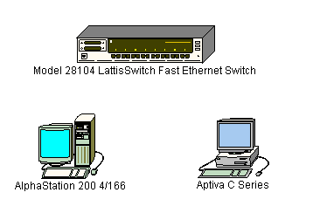
Select Aptiva C Series from the Image pane. Click on the Device image, drag it to the workspace, resize the Device image, increase the label’s font size to 36 point, and resize the label. Your network design should look something like the following:
Sample Network Design
6. Place LAN adapter cards in each of the two workstations.
a. First, collapse the LAN workstation entry in the Device browser by clicking on the minus symbol.
b. Use the scroll bars to locate LAN adapters, expand the LAN adapters entry, expand the Ethernet entry, then click on the 3COM Corp. folder.
3COM LAN adapters are displayed in the Image pane.
c. Use the scroll bar in the Image pane to locate the Fast EtherLink 10/100 PCI card, select it by clicking on the Device image, drag the card onto the Alpha Station 200 4/166, then release the mouse button when the cursor changes to a plus sign (+).
NOTE: The cursor should change to a plus sign (+) when the card is dropped onto the workstation. If the cursor does not change, this indicates that this workstation does not accept the card. Select another card that is compatible.
d. Select the Fast EtherLink 10/100 PCI card again, drag onto the workplace, and onto the Aptiva C Series workstation, then releasing the mouse button when the cursor changes to a plus sign (+).
OPTIONAL: To locate devices that are compatible with the selected device, take the following steps:
- Click on the device.
- Select Find Compatible command from the Object menu or press the Compatibles button the Database toolbar.
- Expand the LAN adapters listing, expand the Ethernet listing, and click on any vendor folder.
- Then select a compatible device from the Image pane and insert it in your device.
7. Link the workstations to the switch.
a. On the Modes toolbar, left click on the Link devices button .
b. Place the cursor over the alpha station and left click on the Device image, then place the cursor over the switch and left click on it.
The Link Assistant dialog appears.
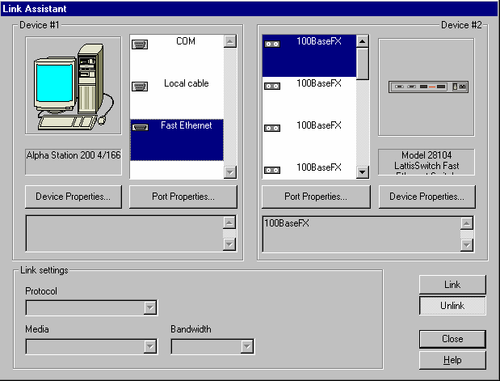
Link Assistant dialog
c. Click on the Link button, then press the Close button to create the link and close the dialog.
d. Next, use the Quick Link method to link the IBM workstation to the switch by pressing the Shift key, left clicking on the switch, then left clicking on the IBM workstation (remember that you must still be in Link Mode with the Link devices button selected).
The Link Assistant dialog is not displayed when the link between the second workstation and the switch is established.
8. Verify media types. You may have noticed that the color of the link is yellow.
a. To verify media types, you need to access the Legends dialog. From the View menu, select the Legends command.
Yellow indicates that this is a fiber optic link.
b. Close the Legends dialog by clicking on its Close button.
9. Assign a traffic profile to the workstation.
a. Click on the Set Traffics button .
b. Left click on the Alpha workstation, then left click on the IBM workstation.
The Profiles dialog appears.
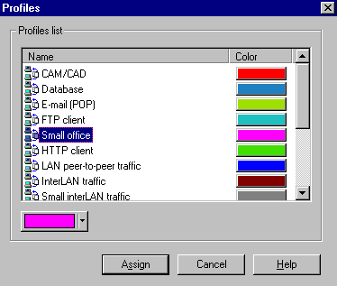
Profiles dialog
c. To specify the Small Office traffic between the two workstations, click on the Small office entry in the Profiles list selection panel.
Optional: Select traffic color from the color combo box. The “Do you want to update” message appears. Press the Yes button to make all traffic with the email profile that color. Press the No button to make only this one traffic that color without changing the color of other traffic based on the email profile.
d. Press the Assign button to assign the traffic and close the dialog.
e. Repeat Steps 9b-d, but this time select the IBM workstation first, and the Alpha workstation next.
10. Verify that traffic has been established between the two workstations by starting animation
Press the Start button on the Control toolbar.
Traffic from the workstations appears and flows through the switch.
11. Change packet intensity.
a. Click on the Animation Setup button to access the Animation Setup dialog, click on the Packet intensity slide bar, move the slider all the way to the left side, then move the slider to the right four (4) notches.
b. Click the OK button to apply your changes and close the dialog.
After a few seconds, the packet intensity changes.
12. Increase packet speed.
a. Click on the Animation Setup button to access the Animation Setup dialog, then click on the Packet speed slider bar and move the slider bar to the highest setting.
b. Click the OK button to apply your changes and close the dialog.
After a few seconds, the packet speed changes.
13. Increase the size of the packet image.
- Click on the Animation Setup button to access the Animation Setup dialog, then click on the Packet size slider bar and move the slider bar to the highest setting.
- Click the OK button to apply your changes and close the dialog.
14. View all the devices used in a network by clicking on the Recently used tab, located below the Image pane. Re-display the devices that correspond with the selection in the Device browser by clicking on the Devices tab.
15. Place a map in the background.
Resume animation, if it is not already running (press the Pause button to toggle animation ON or the Start button to start animation).
a. Right click somewhere in the background of the workspace (not on a Device image, link, or label) to display the local menu and select the Site Setup command.
The Site Setup dialog is displayed.
b. Click on the Background tab, then click on the Map checkbox to select it.
- Use the Browse button to access the Browse dialog, locate and select the desired map file, then press the Open button. The filename appears in the Selected map file field. Press the OK button to apply the change and close the dialog.
The dialog box should look like this as you make your selection:.
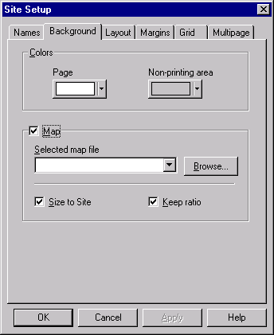
Site Setup dialog
NOTE: Besides the maps which ship with the product, you can use your own maps.
d. Click on the OK button to apply your changes and close the dialog box.
16. Place a color in the background.
From the Sites menu, select the Site Setup command.
The Site Setup dialog is displayed.
a. Click on the Background tab, then click on the Map field to de-select it.
The Selected map file combo box is disabled.
b. Click on the Page combo box to display color swatches, select a color, and push the mouse button.
c. Click on the Non-printing area combo box to display color swatches, select a different color, and push the mouse button.
d. Press on the OK button to apply your changes and close the dialog.
New background and non-printing region colors are displayed.
NOTE: You can also add a background color to a site window containing a map.
17. View traffic profiles.
From the Global menu, select the Data flow command.
The Data Flow dialog is displayed.
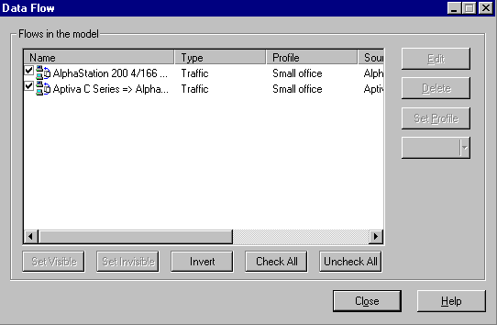
Data Flow dialog
Notice that the two traffic profiles you created are listed in the Flows in the model panel.
Press the Close button to close the dialog.
18. Add and delete stackable devices.
a. Select the Standard cursor in the Standard Modes toolbar by clicking on the Standard button.
b. Use the scroll bar in the Device browser, expand the Hubs listing, expand the Shared media listing, expand the Ethernet listing, then left click on the Bay Networks folder.
c. In the Image pane, select a BayStack Model 250 Stackable Hub, drag the stackable hub into an open area of the workspace, then release the mouse button. Use the selection handles to enlarge the Device image for better viewing.
d. Return to the Image pane and select the same device, drag it into the workspace and position the second stackable hub over the first one, and when the cursor changes to a plus sign (+) release the mouse button.
NOTE: The two devices now function as one unit. You can enlarge or move the stackable hubs as if they were one device.
e. To delete a stackable hub, select the stackable hub, right-click the mouse button to access the local menu, select the Delete command, and release the mouse button. When a confirmation dialog appears asking you if you want to delete the object, press the Yes button. Repeat this step for the other stackable hub.
19. From the File menu, select the Save command.
Since you have not already saved this file, the Save As dialog appears.
20. The default filename Net1.net is displayed in the Name field. Highlight the filename, type your first name followed by “1” (for example, John1) and press the Save button. The .NET file extension is automatically added to the file name.
21. To close this project, first stop animation by pressing the Stop button, then from the File menu, select the Close command.
Congratulations! You have just created a NetCracker Designer project!
22. Options:
• Close NetCracker, from the File menu select the Exit command.
• Continue working with the NetCracker Designer Tutorial (Lesson 4 ).

Lesson 4 -- Creating Multi-level Network Designs
In this lesson you will learn:
- how a multi-leveled project is structured,
- to navigate from one level to another,
- how to create multi-level network designs, and
- how to create client/server architecture
Before you start this module, you should complete Lesson 3, “Lesson 3 - Creating a New NetCracker Designer Project”.
Time to complete: 30 minutes

- Start the NetCracker Designer application if it is not already started by selecting from the Start menu, Programs==>NetCracker Designer 4.1==>NetCracker Designer.
The main application window is displayed.
2. Open a NetCracker Designer (.NET) file.
a. To display the Open dialog, from the File menu, select Open.
b. Use the Directory combo box to select the directory where NetCracker Designer is located. Double-click on the Samples folder in the Selection pane to display its contents. Click on the Tutor.net filename and press the Open button, or double-click on the Tutor.net filename.
A site window appears in the workspace pane.
3. Position the site window in the workspace for maximized viewing.
4. Access the Project Hierarchy browser.
If it is not already displayed, display the Browser by selecting from the View menu, the browser from the Bars sub-menu.
Access the Project Hierarchy browser using one of these methods:
- From the View menu, select Project Hierarchy
- Press the Project Hierarchy tab
The Project Hierarchy browser is displayed.

Projects are shown as hierarchical structures with the top-most level of the structure listed first and subordinate levels nested under it. For projects with only one level, only the Top level will be shown. Each level has an associated expansion symbol, similar to the ones seen in the Device browser. Expansion symbols are used for expanding (plus sign +) or collapsing (minus sign -) the hierarchical structure. Each entry in the Project Hierarchy browser corresponds to a site window. You can double-click on an entry in the Project Hierarchy browser to display the corresponding site window or make it the selected (current) site window, if more than one is displayed in the workspace.
5. Locate the container object, the building on the left side of the Top site window, and double-click on it.
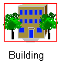
Container object
The Building site window is displayed (becomes the current site window).
6. Now, to use a different navigation technique to re-display the Top site window, from the Window menu, select the Top command.
7. To display both site windows in the workspace, from the Window menu, select the Cascade command.
8. Reposition, resize, and use the Zoom to page button so you can see all the objects on each site window. Make the Top site window the current site window. Your workspace may look like this:
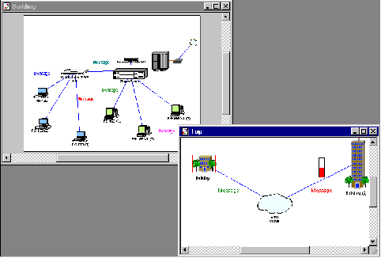
Multi-level project
Now, close the Top site window by pressing its Close button.
9. To re-open the Top site window, in the Building site window, double-click on the connector icon.
The Top site window is displayed. Use the scroll bars, reposition the window, and use the Zoom to page button as you did in Step 8.
10. Rename a site window.
a. First, make the Top site window the current site window by clicking on it.
b. Then access the Site Setup dialog by doing one of the following:
- On the Sites menu, select the Site Setup command.
- In the background of the Top site window, right-click to display the local
menu and select the Site Setup command.
The Site Setup dialog is displayed.
c. Select the Names tab. Highlight the name (Top) in the Site name field, if it is not already highlighted, then type “The MacNally Corporation”.
d. Press the OK button to apply your changes and close the dialog box.
e. Rename the Building site window “The MacNally Building” by making Building the current site window and repeating Steps 10b-d
The new names The MacNally Corporation and the MacNally Building appear in the title bars, the Project Hierarchy browser, and the Window menu commands.
11. Use drawing tools to annotate a project.
a. Make the MacNally Building the current site window and locate the connector icon.
b. On the Modes toolbar, click on the Draw mode button.
c. On the Drawing toolbar, click on the Line button. Use the Line tool to draw an arrow that points to the upper right-hand corner of the site window. Return to Standard mode by clicking on the Standard cursor button.
d. Change the color of the arrow you drew by:
- Selecting a line,
- From the Object menu, from the Styles submenu, select the Draw color command,
- Select a color and press the OK button,
- Repeat for each segment of the arrow.
The Arrow appears in the new color.
e. To label the connector icon do the following:
- From the Modes toolbar, select the Draw button,
- From the Drawing toolbar, select the Text tool,
- Outline the rectangle in which the text will appear.
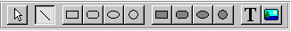
Drawing toolbar
f. Type “Link to MacNally Corporation” and press the Enter key.
g. Return to Standard mode by going to the Modes toolbar and pressing the Standard mode button.
12. Highlight the path of traffic flowing from one device to another within a site using the Trace mode.
a. Start animation by pressing the Start button.
With the two site windows visible, you can see traffic flowing from individual workstations in the MacNally Building, through the Cisco router, out the connector link, and into the MacNally Corporation site window. Traffic from MacNally Corporation flows to the MacNally Building as well.
b. On the Modes toolbar, press the Trace mode button , click on the workstation (P5-166 XL (3)) on the far right of the MacNally Building site window, then click on the workstation on the far left (P5-133 XL (3)).
The path between these workstations is highlighted in red.
13. Highlight the path of traffic flowing from a device in one site window to an object in another site window.
a. With the Trace mode button still selected, click on the far left workstation (P5-133 XL (3)) in the MacNally Building site window.
b. Then click on Building (2) in the MacNally Corporation site window.
The path between the two objects is highlighted in red.
c. Return the project to Standard mode by clicking on the Standard mode button.
NOTE: If you click on the Trace mode button, the highlighted path will no longer appear in red. However, you will still be in Trace mode.
14. Stop the animation by clicking the Stop button.
15. From the File menu, close the current project without saving the file by selecting Close.
16. Open a new project file from the File menu by selecting New.
A site window appears in the workspace.
17. On the Device browser, click the Devices tab. Click on the Buildings, campuses and LAN workgroups listing in the Device browser.
Buildings, campuses and LAN workgroup object images appear in the Image pane.
17. Select one of the Building object images from the Image pane and drag it into the Top site window.
18. Expand the building. Select the building object in the site window if it is not already selected, then either:
• Right click to open a local menu and select the Expand command, or
• From the Object menu, select the Expand command.
You have created a multi-level network design that includes a Top level and a second level (with its own site window entitled “Building”). The Building image in the Top window is shown with a red frame around it, indicating it is a container object.
NOTE: To see the hierarchical structure, on the Browser select the Project Hierarchy tab.
19. Let’s complete the project by populating the building using client/server architecture.
We will use primarily generic devices that are pre-configured. Generic devices are included in NetCracker Designer’s device database.
On the browser, click the Devices tab, then in the Devices browser expand LAN workstation, expand workstations branch, and click on generic devices folder.
Generic workstations are displayed in the Image pane.
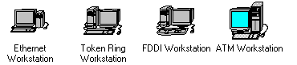
Sample workstation device images
a. On the Image pane, select and drag the Ethernet workstation into the Building site window.
NOTE: The Ethernet workstation is already configured with a LAN adapter card.
b. From the Edit menu, select Duplicate.
c. In the Device browser expand Switches, expand Workgroup, expand Ethernet, and click on the generic devices folder.
A Generic Ethernet switch is displayed in the Image pane.
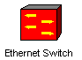
Sample switch device image
d. From the Image pane select the generic ethernet switch and drag it into the Building site window.
e. Click on the Link devices button .
f. Click on a workstation and drag the link over to the switch. Release the left mouse button.
The Link Assistant dialog is displayed. In the Link Assistant, press the Link Button, then press the Close button.
g. Repeat this for the other workstation.
h. Make the Top site window the current window by clicking on it.
i. Change to Standard mode, then select the Buildings, campuses and LAN workgroups listing on the Device browser.
Buildings, campuses and LAN workgroup device images appear in the Image pane.
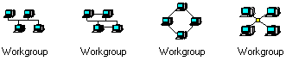
Sample Generic workgroup device images
j. Select and drag a generic workgroup device image from the Image pane to the Top site window
k. To link the workgroup to the Building object in the Top site window, from the Modes toolbar, select the Link devices tool, click on the workgroup, then click on the Building icon.
NOTE: A dotted line indicates that this is not a completed link!
l. Change to Standard mode and double-click on the Building image in the Top site window.
The Building site window becomes the current site window.
m. From the Modes toolbar select the Link devices button. In the Building site window click on the connector icon, then click on the switch to complete the connection.
The Link Assistant dialog appears.
NOTE: The Connector icon is usually located in the corner of the Site window. If needed, use the zoom in button to locate the connector icon.
n. Select the Ethernet port from the Switch Port Configuration option panel (the last option), press the Link button, then press the Close button.
The Link Assistant dialog is closed and the link from the Building to the top of the network design project is completed.
20. Make one of the workstations a server by taking the following steps:
a. In the device browser scroll down to “Network and enterprise software” and expand it by clicking on the plus (+) sign. Click on “Server software”. The available server types are now displayed in the Image pane.
b. Drag the E-mail server to the workgroup. The pointer should change to a an arrow with a plus sign that means that you can insert this software into the computer.
21. Assign client/server traffic by taking the following steps:
a. On the Modes toolbar, press the Set Traffic button.
b. In the Top site window, click on the Workstatio0n without the server software, then in the same site window, click on the Workstation with server software.
The Profiles dialog is displayed.
c. Select E-mail as the traffic type from the Profiles dialog and press the Assign button.
22. Assign other traffic by taking the following steps:
a. In the Top site window, click on the Workgroup image, then in the Building site window, click on the Workstation with out server software.
The Profiles dialog is displayed.
c. Select Small office as the traffic type from the Profiles dialog and press the Assign button.
d. To start the animation, on the Control toolbar, press the Start animation button.
e. To stop the animation, press the Stop button.
23. From the File menu, select the Save command.
Since you have not already saved this file, the Save As dialog is displayed.
24. The default filename Net1.net is displayed in the Name field.
If not already highlighted, highlight the filename, type your first name followed by “2” (for example, John2) and press the Save button. The .NET file extension is automatically added to the file name.
25. To close this project, from the File menu, select the Close command.
Congratulations!
You have just created a multi-level NetCracker Designer project!
26. Options:
• Close NetCracker, from the File menu select the Exit command.
• Continue working with the NetCracker Designer Tutorial (Lesson 5)

Lesson 5 – Customizing the Database and Database Search
This section introduces you to the Device Factory and Compatible Search functions.
Time to complete: 20 minutes

- Start the NetCracker Designer application if it is not already started by selecting Programs==>NetCracker Designer 4.1==>NetCracker Designer from the Start menu.
2. To open the Router.net project, from the File Menu, select Open and from the Samples directory in the NetCracker program group select Router.net.
NOTE: If a .NET file is already open and displayed in the workspace, you will be prompted to save that project before opening another project. Do not save any of the sample NetCracker Designer files.
The project site window is displayed in the workspace.
3. Display the Project Hierarchy database by clicking on the Project Hierarchy tab.
The Project Hierarchy browser is displayed.
4. In the browser, double-click on the Math Lab site to make the Math Lab the current site window.
5. Click on Steve’s workstation to select it.
6. Invoke the Device Factory Wizard using one of the following methods:
• Press the Device Factory button .
• From the Database menu, select Device Factory.
• From the Object menu, select Add to Database: Via Factory.
NOTE: While the Device factory can be started using any of the above methods, use Add to Database: Via Factory from the object menu for this example. When a device that is based on an existing device is created there is a difference between using the Device Factory button or Device Factory from the Database menu and Add to Database: Via Factory from the Object menu. The button and Database command refer to devices selected in the Image pane, the Add to Database: Via Factory refers to devices selected in the Project pane.
The Device Factory Wizard is displayed.

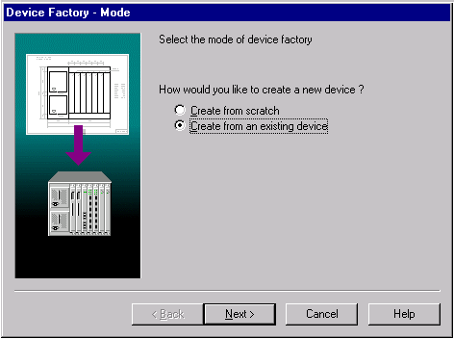
Device Factory Mode Screen
The Device Factory Wizard asks you if you want to:
• Create from scratch
• Create from Steve
7. Select “Create from Steve” and press the Next button.
The type of device is highlighted and you are prompted to confirm that this is the device type you want to modify.
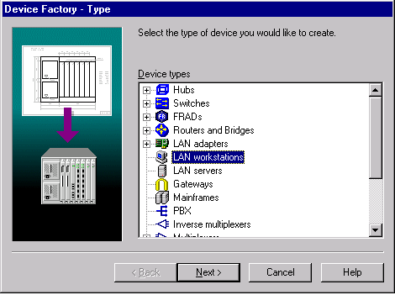
Device Factory Type Screen
At this time you can elect to change the device type by scrolling through the Device selection panel.
NOTE: The looks like the Device browser.

8. Press the Next button.
The Device Factory Computer screen is displayed.
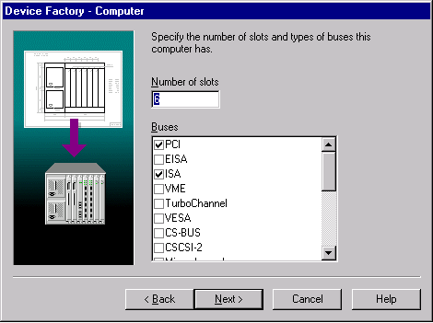
Device Factory Computer Screen
9. To change the number of slots to 4, type 4.
This is how many spaces the computer has for plug-ins such as adapters and internal modems.
10. Check the VESA checkbox in the Buses section. Also check the PCI and the ISA checkboxes if they are not already checked.
The newly created device only excepts plug-ins such as adapters and internal modems that have one of those bus types.
11. Click the Next button.
The Device Factory Name screen is displayed.
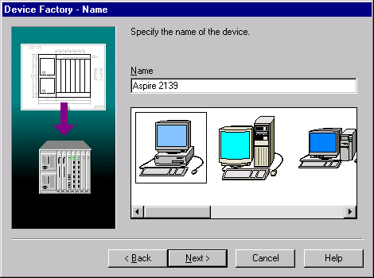
Device Factory Name Screen
12. Type “Development Group Workstation” and press the Next button.
The Device Factory Port Groups screen is displayed.
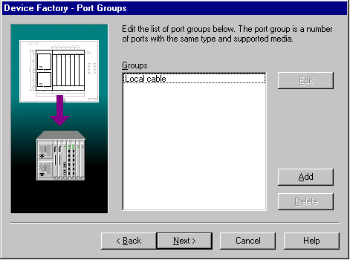
Device Factory Port Groups Screen
13. Add a port group by pressing the Add button
The Port Factory Number screen is displayed
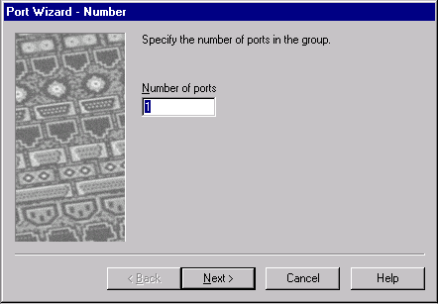
Port Factory Number Screen
NOTE: If you enter a number of ports that is invalid for the device type, an error message is displayed and you will not be able to create the device using the incorrect port specification.
14. Change the number of ports in a group to 2 and press the Next button.
The Port Factory Link Type screen is displayed
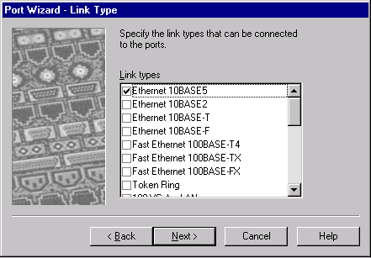
Port Factory Link Type Screen
All the ports in a group only except links of the type checked.
NOTE: At least one port type must be selected. If nothing is specified an error message is displayed.
15. Check the Ethernet 10BASE2, and Ethernet 10BASE-T checkboxes and press the Next button.
NOTE: Ethernet 10BASE5 is already checked.
Port Factory wizard Media screen is displayed.
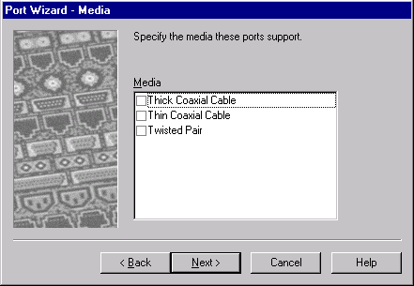
Port Factory Media Screen
All the ports in a group only except media of the type checked.
NOTE: At least one media type must be selected. If nothing is specified an error message is displayed.
16. Check the Thick Coaxial Cable, Thin Coaxial Cable, and Twisted Pair media types and press the Next button.
You have just added a port group, click Finish to return to the Device Factory.
17. Click the Next button on the Device Factory Port Groups page and then click Finish to save the Device you just created into the user database.
18. Open the File menu, select Close. Do not save changes to the Router.net project- press No.
19. To open a new project using one of the following methods:
- Press the New button on the Standard toolbar.
- From the File menu select the New command.
20. To display the database browser, from the View menu, select the Database Browser command.
21. To display the devices in the user database including the one you just created, in the Hierarchy combo box, select User.
Make sure that on the Image pane the Devices tab is selected.
22. In the Image pane. select the workstation you just created, “Development Group Workstation” and drag it into the workspace.
23. To find the devices that are compatible with the “Development Group Workstation”, on the Database toolbar, press the Compatible button or from the Object menu, select the Find Compatible command.
The Browser automatically switches to Compatible Device Browser mode and the compatible device hierarchy is displayed.
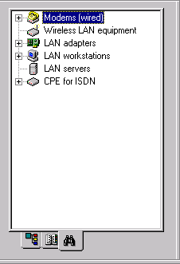
Compatible Search Results
The browser displays only devices compatible with the selected device.
24. To search the database to find a compatible ATM card:
a. Select Types in the Database Hierarchy combo box if not selected already.
b. Expand LAN adapters listing and then expand the ATM listing.
c. Open Interphase folder.
25. Select 5525 PCI ATM adapter and drag it onto the new workstation. The cursor changes to a plus symbol to indicate that the card is compatible.
26. To replicate the workstation with the adapter card, from the Edit menu, select the Replicate command.
The Replicate dialog is displayed.
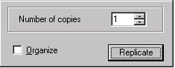
Replicate Dialog
a. To create ten copies, type in 10 in the Number of copies field.
b. To arrange new copies in a geometrical pattern, check the Organize box.
27. Check the Replicate button.
The Organize dialog is displayed.
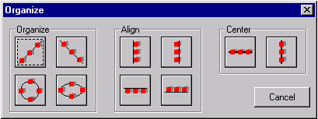
Organize dialog
NOTE: You can organize any group of objects by selecting the group and from the Object menu choose the Organize command.
28. Select the circle pattern. The dialog automatically closes when you select an organizational pattern.
The ten replicated objects (workstations with cards) are displayed in a circular pattern. Since the newly created device is de-selected once you replicate it, it is not included in the organizational pattern you selected.
29. To find devices in the database based on other criteria you can use Database search. To start the search press the Find in Database button
30. The Find dialog opens.
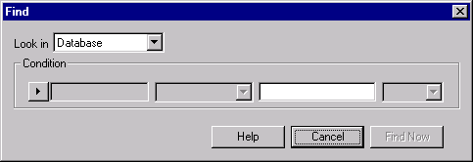
Find Dialog
31. Click on the Condition button and select Model.
32. In the next combo box select Includes.
33. In the third combo box write 7000.
34. Press the Find Now button.
The Browser automatically switches to Search Device Browser mode and the device hierarchy that fulfils the condition is displayed.
35. Close the project without saving it.
36. Options:
• Close NetCracker, from the File menu select the Exit command.
• Continue working with the NetCracker Designer Tutorial (Lesson 6)

Lesson 6 -- How to Use AutoDiscovery
In this section you will learn how to use NetCracker network discovery features.
Time to complete: 20 minutes

- Start the NetCracker Designer application if it is not already started by selecting Programs==>NetCracker Designer 4.1==>NetCracker Designer from the Start menu.
- To start network AutoDiscovery, from the File Menu, select Discovery...
NOTE: Starting AutoDiscovery automatically creates a new project in NetCracker. If there is a project already loaded all changes to it will be lost, unless its saved, Once AutoDiscovery starts it will display a screen like this:
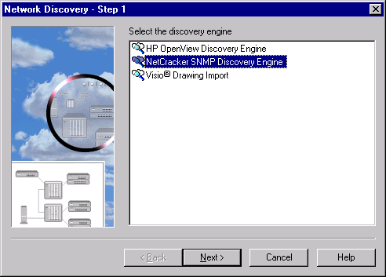
NetCracker first AutoDiscovery screen
- Select the NetCracker SNMP Discovery Engine and press the Next button.
- Type in “discovey_sample” in the Start IP field.
The screen should look like this:
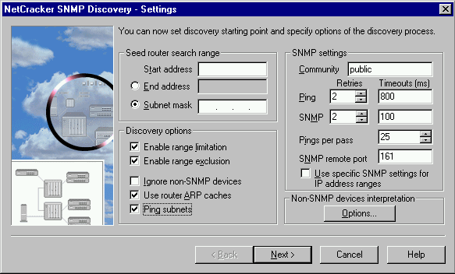
NOTE: Typing in “discovery_sample” in the Start address field will open a sample discovery file, as opposed to discovering a real network. For more information on how to correctly set up the SNMP engine itself look at Help, Discovery book.
- Press the Next button.
It might take some time for NetCracker to read the sample file depending on your computer configuration. Please be patient. Once the file is read NetCracker will match devices.
- Press the Next button once NetCracker Discovery – Step 2 Matching Devices finishes.
- In the Network Discovery – Step 3 press the View/Edit Results button.
Pressing the View/Edit Results button will open up the Editing Results screen:
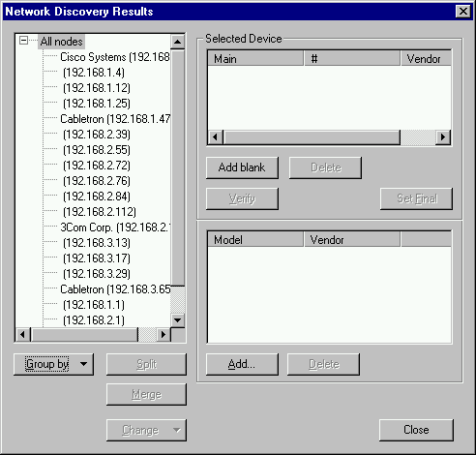
- Select IP addresses 192.168.1.4 and 192.168.1.12
Use the CNRL key to select the second address.
- Press the Merge button.
Pressing the Merge button will combine two discovered devices into one device. The new “merged” device will have the IP addresses of all devices combined. The new device will have the functionality of the first device on the list.
- Select Cisco Systems router IP 192.168.1.1
- Press the Split button.
Pressing the Split button will split a device that has several IP addresses into two devices. The Split button is also the only way to see the available interfaces of a devices at this stage. This device has 3 interfaces:
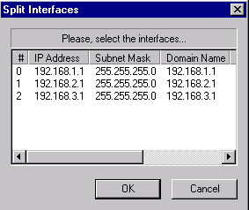
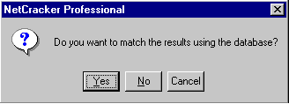
- Select interface number 1 and 2 and press the OK button.

Use the CTRL key to select multiple interfaces. Once you press the OK button this dialog will come up

Answering YES will result in the new device being matched against the NetCracker database. The result will be exactly the same as the original device. Answering NO will not match the device to the database, so a blank device with the specified interfaces will be created.
- Press the Yes button
A new device is created, it will be exactly the same as the original device, a Cisco 2518 router. Please note that depending on your computer configuration the search for a match in the database may take some time. After the match is complete there is a new device at the button of the list.
- Select Cabletron IP 192.168.3.65
As you can see the Selected Device window of the dialog is blank. Even though the manufacturer of the device was recognized it was not matched to anything in the NetCracker database, including a generic device type. Since the device is completely unrecognized it will not appear on the NetCracker diagram unless it is matched manually.
- Press the Add Blank button.
This adds a blank device as a match to the device selected (Cabletron IP 192.168.3.65).
- To define the blank device press the Add button at the bottom of the dialog.
A database browser window opens to allow you to select device components.
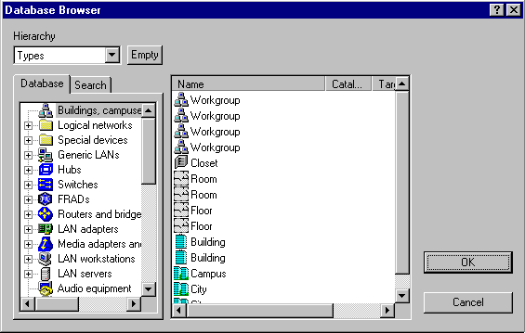
This dialog is an alternative interface to the NetCracker database. It has all the normal NetCracker database features including Type, Vendor or User sort, Device Factory and Search functions. The center window of the dialog is the equivalent of the image pane where the devices from the database are displayed.
- In the browser window of the dialog go to Switches ➔ WorkGroup ➔ Ethernet ➔ Cabletron ➔ SmartSTACK Ethernet Switch
- Select the SmartSTACK Ethernet Switch from the center window and click OK.
You have now added the SmartSTACK chassis as a component of this device.
- Click the Add button again
- From the same path in the database select the FE-100TX SmartSTACK plug-in and press the OK button.
You have now added the plug-in to the device.
- Click the Verify button.
When you click the Verify button NetCracker checks to make sure that all the parts of a device can work together, and it is a legal NetCracker device. Devices which fail Verification can not be part of a NetCracker diagram.
- Click the Set final button.
Once you click the Set Final button a yellow arrow will appear next to the device in the Selected Device window. That means that the device has been verified, is a legal NetCracker device and that is the device which will be used in the diagram. If the are several devices which are a possible match the Set Final button is used to select which one of the choices will be the device imported into the NetCracker diagram.
- Click the Close Button.
- Click the Next button in the Network Discovery – Part 3 window.
The NetCracker diagram in now being created.
- Click Done. You have just imported a discovered network.
- You can now examine the project you have just created.
- Options:
- Close NetCracker, from the File menu select the Exit command.
- Continue working with the NetCracker Designer Tutorial (Conclusion)

Conclusion
Congratulations! You have just completed the tutorial and you are ready to use NetCracker.
While all the basics have been covered in the five lessons of this tutorial NetCracker has many more features and functions. So while you are working on your project here are things to look for:
Multi Page Sites
A site can consist of several printing pages. Open the Site Setup dialog and click the Multipage tab.
Circuit Switching
You can assign calls between devices in a manner very similar to how you assign traffic. Use the Set Calls button next to the Set Traffic button.
Device Data Flow
Select Associated Data Flow command from either the Object menu or local device menu to view data flow distribution to and from this device.
Options Dialog
To access this dialog, from the Tools menu select the Options command. Use this dialog to set AutoSave time intervals, select NetCracker start up options, enable/disable confirmations, and set default animation parameters.
Cable Length Checking
In the Link Assistant you can set the length of a link. If it is outside the permissible range for that link type an error message is displayed. If the value is zero the length is not checked.
And more…
Refer to the Readme file and Help for more information about NetCracker.

