Users Guide and Reference Manual
Table of Contents
Introduction 8
Welcome to NetCracker Professional 4.1 8
About this guide 8
Documentation Conversions 8
Documentation 8
Contacting NetCracker Technology 9
Getting Started 11
Working with Projects and NetCracker® Windows 11
Designing a Simple Project 12
Printing a Project, Page or Report 14
About NetCracker Professional 15
Statistical Indicators 15
Custom Data Flow Profiles 15
Changing the Look of the Site 16
Changing the Name of a Site or its Container 16
Parts of a Site Window 18
Changing Colors of the Page and Non-Printing Region 19
Adding Maps as Backgrounds on a Site Page 19
4 19
Adding a grid to a Site Page 20
Adding an Image to a Site Page 20
Creating Bends In Links 22
Titles, of links 22
Devices 23
Adding a Device To a Project 23
Changing a Device Label 24
Changing a Component's Display Size 24
Viewing Device Configuration 24
Viewing or Changing Device Properties 26
Changing Properties Of a Component or Sub-component 26
Stacks 27
Adding and Deleting Stackable Devices 27
Viewing the Configuration of a Device in a Stack 27
Changing the Properties of a Device in a Stack 28
Establishing Connectivity 29
Adding Plug-Ins or Network Cards To a Device 29
Linking Devices in the Same Site 29
Linking Devices in Different Sites 31
Changing Link Properties 32
Quick Linking 33
Tracing the Path Between Devices 33
Generating Data Flow 34
Assigning Traffic or Calls 34
Viewing or Changing a Traffic or Call Profile 35
Setting up Client Sever Relationships 35
Permanent Virtual Circuits in Frame Relay Clouds 35
Creating a New Profile 36
Running the Animation 37
Understanding NetCracker Animation 37
Changing How Animation Appears 37
Advanced Animation Setup 38
Multilevel Design 39
Adding Levels and Sites Using Containers 39
Converting a Traffic Generator or Receiver To a Container 40
Tips for Creating Hierarchical Designs 40
Testing Scenarios 41
How to Display Statistics 41
Obtaining Reports 41
Rerouting Traffic and Calls 41
Frequently Asked Questions 43
Technical Support 43
Copyright 43
Discovery 44
What is AutoDiscovery 44
AutoDiscovery -- Selecting Discovery Engine 44
NetCracker SNMP Discovery -- Settings 45
NetCracker SNMP Discovery -- Limiting Ranges 48
NetCracker SNMP Discovery -- Excluding Ranges 49
NetCracker SNMP Discovery -- Range SNMP Settings 50
NetCracker SNMP Discovery - Ready to start 52
AutoDiscovery -- Matching Devices 53
AutoDiscovery -- Matching Results 54
AutoDiscovery -- Editing Results 55
AutoDiscovery -- Database 58
AutoDiscovery -- Creating NetCracker Design 59
Visio Drawing Import - File Name 60
Visio Drawing Import - Finish 61
Visio ® Drawing Import console 61
Commands, Menus and Dialogs 63
Menu Overview 63
File Menu 63
Edit Menu 63
View Menu 64
Database Menu 66
Global Menu 66
Sites Menu 66
Object Menu 70
Control Menu 73
Tools Menu 74
File Menu 76
New Command (File Menu) 76
Discover Command (File Menu) 76
Open Command (File Menu) 76
Close Command (File Menu) 77
Save Command (File Menu) 77
Save As Command (File Menu) 78
Send Command (File Menu) 79
Properties Command (File Menu) 79
Print (File Menu) 79
Print Preview (File Menu) 80
Print Setup (File Menu) 80
Recent File Command (File Menu) 81
Exit Command (File Menu) 81
Edit Menu 82
Cut (Edit Menu) 82
Copy (Edit Menu) 82
Paste (Edit Menu) 83
Delete (Edit Menu) 83
Duplicate (Edit Menu) 84
Replicate (Edit Menu) 84
Select All (Edit Menu) 85
Find (Edit Menu) 85
View Menu 86
Status Bar Command (View Menu) 86
Full Screen Command (View Menu) 86
Media Colors Command (View Menu) 86
Legends Command (View Menu) 86
Database Browser Command (View Menu) 87
Compatible Components Command (View Menu) 90
Break Color For Site Name Command (View Menu) 90
Zoom 90
Zoom: Zoom In Command (View Menu) 90
Zoom: Zoom Out Command (View Menu) 91
Zoom: Zoom to Page Command (View Menu) 91
Zoom: Zoom 1:1 Command (View Menu) 93
Zoom: Zoom to One Side (View Menu) 93
Zoom: Undo Change Zoom Command (View Menu) 94
Zoom to Region Command 94
Bars 95
Bars: Standard Toolbar Command (View Menu) 95
Bars: Zoom Toolbar Command (View Menu) 95
Bars: Drawing Toolbar Command (View Menu) 96
Bars: Modes Toolbar Command (View Menu) 97
Bars: Control Toolbar Command (View Menu) 99
Bars: Database Toolbar Command (View Menu) 101
Bars: Trace Toolbar Command (View Menu) 101
Bars: Browser Pane Command (View Menu) 102
Bars: Image Pane Command (View Menu) 103
Image Pane 104
Image Pane: Large Icons Command (View Menu) 104
Image Pane: Small Icons Command (View Menu) 105
Image Pane: List Command (View Menu) 106
Image Pane: Details Command (View Menu) 106
Database Menu 107
Hide Empty Folders Command (Database Menu) 107
Hierarchy Command (Database Menu) 107
Find Command (Database Menu) 107
Device Factory Command (Database Menu) 108
Global Menu 113
Model Settings Command (Global Menu) 113
Data Flow Command (Global Menu) 113
Project Setup Command (Global Menu) 113
Acquire Update All Command (Global Menu) 113
Profiles Command (Global Menu) 113
Sites Menu 114
Site Setup Command (Sites Menu) 114
Modes 114
Modes: Standard Command (Sites Menu) 114
Modes: Draw Command (Sites Menu) 114
Modes: Link Command (Sites Menu) 114
Modes: Draft Link Command (Sites Menu) 115
Modes: Set Traffic Command (Sites Menu) 115
Modes: Set Voice Call Command (Sites Menu) 115
Modes: Set Data Call Command 115
Modes: Break/Restore Command (Sites Menu) 116
Modes: Trace Path Command (Sites Menu) 116
Modes: Say Info Command (Sites Menu) 116
Draw 117
Draw: Pointer Command (Sites Menu) 117
Draw: Line Command (Sites Menu) 117
Draw: Rectangle Command (Sites Menu) 117
Draw: Round Rectangle Command (Sites Menu) 117
Draw: Ellipse Command (Sites Menu) 117
Draw: Circle Command (Sites Menu) 117
Draw: Filled Rectangle Command (Sites Menu) 117
Draw: Filled Round Rectangle Command (Sites Menu) 117
Draw: Filled Ellipse Command (Sites Menu) 117
Draw: Filled Circle Command (Sites Menu) 117
Draw: Text Command (Sites Menu) 117
Draw: Image Command (Sites Menu) 117
Trace 118
Trace: Set Trace Color Command (Site Menu) 118
Trace: Multi-Trace Mode Command (Site Menu) 118
Trace: Reset Trace Command (Site Menu) 118
Object Menu 118
Properties Command (Object Menu) 118
Open Command (Object Menu) 118
Expand Command (Object Menu) 118
Configuration Command (Object Menu) 118
Configure Ports Command (Object Menu) 119
Define Statistics Command (Object Menu) 119
Associated Data Flow Command (Object Menu) 119
Find Compatible Command (Object Menu) 119
Acquire Update Command (Object Menu) 119
Break Command (Object Menu) 119
Restore Command (Object Menu) 120
Organize Command (Object Menu) 121
Say 121
Say: Current Statistics Command (Object Dialog) 121
Say: Notes Command (Object Menu) 121
Say: Description (Object Menu) 121
Add to Database 121
Add to Database: Selected Component Command (Object Menu) 121
Add to Database: Via Factory Command (Object Menu) 121
Styles 122
Styles: Draw Color Command (Object Menu) 122
Styles: Fill Color Command (Object Menu) 122
Styles: Text Command (Object Menu) 122
Styles: Font Command (Object Menu) 122
Styles: Title Command (Object Menu) 122
Styles: Image Command (Object Menu) 122
Arrange 122
Arrange: Move To Front (Object Menu) 122
Arrange: Move To Back (Object Menu) 122
Arrange: Move Forward (Object Menu) 123
Arrange: Move Back (Object Menu) 123
Control Menu 124
Start Command (Control Menu) 124
Stop Command (Control Menu) 124
Pause Command (Control Menu) 124
Simulation Faster Command (Control Menu) 124
Simulation Slower Command (Control Menu) 124
Animation Faster Command (Control Menu) 124
Animation Slower Command (Control Menu) 124
Animation Default Command (Control Menu) 124
Animation Setup Command (Control Menu) 124
Quiet Command (Control Menu) 125
Tools Menu 126
IP Planner (Tools Menu) 126
HTML Export (Tools Menu) 126
Graphics Export (Tools Menu) 126
Default Layout Command (Tools Menu) 126
Options Command (Tools Menu) 126
Reports 126
Reports: BOM Command (Tools Menu) 126
Reports: Device Summery Command (Tools Menu) 126
Reports: Workstations Command (Tools Menu) 127
Reports: Servers Command (Tools Menu) 127
Reports: Network Adapters Command (Tools Menu) 127
Reports: Hubs Commands (Tools Menu) 127
Reports: Switches Command (Tools Menu) 127
Reports: Bridges and Routers Command (Tools Menu) 127
Reports: Wizard Command (Tools Menu) 127
Window Menu 128
New Window Command (Window Menu) 128
Cascade Command (Window Menu) 128
Tile Command (Window Menu) 128
Arrange Icons Command (Window Menu) 128
Help Menu 129
Topics and Index Command (Help Menu) 129
How to Use Help Command (Help Menu) 129
Quick Tour Command (Help Menu) 129
Tutorial Command (Help Menu) 129
NetCracker on the Web Command (Help Menu) 129
About NetCracker Command (Help Menu) 129
Dialogs 130
Media Colors Dialog 130
Break Color For Site Name Dialog 130
Site Setup Dialog 130
Name Tab: Site Setup Dialog 130
Background Tab: Site Setup Dialog 131
Layout Tab: Site Setup Dialog 131
Margin Tab: Site Setup Dialog 132
Grid Tab: Site Setup Dialog 132
Multipage Tab: Site Setup Dialog 132
Animation Setup Dialog 133
Packet Tab: Animation Setup Dialog 133
Calls Tab: Animation Setup Dialog 133
Options Dialog 134
General Tab: Options Dialog 134
Confirmations Tab: Options Dialog 134
Packets Tab: Options Dialog 135
Calls Tab: Options dialog 135
Legends Dialog 136
Packet Shapes Tab: Legends Dialog 136
Device Dialogs 137
Statistical Items Dialog 137
Find Dialog 138
Associated Data Flow Dialog 138
Properties and Configuration Dialogs 139
Properties Dialog 139
Ports Configuration Dialog 140
Port Properties Dialog 142
Model Settings Dialog 144
Device Configuration Dialog 144
Simple Device Configuration Dialog 144
Document Properties Dialog 145
Connectivity and Data Dialogs 146
Link Assistant Dialog 146
Data Flow Dialog 149
Profiles Dialog 152
Editing Dialogs 154
Organize Dialog 154
Replicate Dialog 154
Device Find Dialog 154
Project Setup Dialog 156
Devices Tab: Project Setup Dialog 156
Font Tab: Project Setup Dialog 156
Export Dialogs 157
HTML Export Wizard 157
Snapshot Wizard 157
Glossary 158
Local Menu 158
Connector Icon 158
Device Images 158
Project 158
Site Window 158
Site 158
Container 158

Introduction

Welcome to NetCracker Professional 4.1
Welcome to NetCracker® Professional, the second member of the NetCracker suite of products. NetCracker Professional is a network design and simulation tool that represents a model of the network in a unique, dynamic, and visual way using Intelligent Animation™. A database with thousands of network devices, a break/restore function, automatic connectivity checking, and a graphical, drag-and-drop interface enable you to design and plan networks easily - without training. After you design your network you can also easily check its performance using NetCracker Professional simulation engine and statistical reports. Another one of the many features of NetCracker Professionals is a Device Factory Wizard that gives you the flexibility to define new or prototype network devices and add them to your network designs.
Because NetCracker tools are intuitive, the Quick Start Guide, the Tutorial, and this User’s Guide and Reference Manual is all you need to come up to speed - all are available with the product. It is suggested that you start with the Quick Start Guide and then move to the Tutorial and then use the User’s Guide and Reference Manual for additional reference.
You are breaking new ground - and introducing a new paradigm. Network design should no longer be done using the “back of the envelope” or “napkin” approach. By using NetCracker Professional, you take network design to a new level - where solid network planning and design drastically reduce network downtime and degradation and dramatically increase network performance and overall satisfaction.

About this guide
This User’s Guide and Reference Manual is designed to help you work quickly and efficiently with NetCracker. The User’s Guide gives you instructions for NetCracker features. The Reference Manual gives information on specific NetCracker commands and dialogs.

Documentation Conversions
We use the following documentation conversions:
- Menu names, commands, parts of user interface, and names of dialog boxes are in initial capitals, for example the File menu.
- When we want to emphasize a specific point or instruction the text is in bold format.

Documentation
NetCracker comes with complete documentation including:
- Quick Start Guide
We recommend that you start with the Quick Start Guide. It contains all the information needed to start using NetCracker. Included is an overview of the product, brief description of NetCracker features, step by step instructions for creating a NetCracker project, and a description of all NetCracker toolbars.

- Tutorial
We recommend that you go though the Tutorial after reading the Quick Start Guide. It contains seven (7) easy lessons that are designed to teach you the basics of working with NetCracker software. The Tutorial is also available as a Help file that can be access from the Help menu of NetCracker.
- Users Guide and Reference Manual
This document. Users Guide and Reference Manual mirror NetCracker’s on-line Help system. They are designed to help you use NetCracker more efficiently.
- Release Notes
Release Notes (also referred to as a Readme file) contain information about the specific release, technical notes, and a list of known software issues.

Contacting NetCracker Technology
You can contact NetCracker Technology by one of the following methods:
E-mail: support@netcracker.com
Web page: http://www.netcracker.com
Telephone: (781)736-0860
Fax: (781)736-1735
Address: 1159 Main St.
Waltham, MA 02154
User’s Guide

Getting Started

Working with Projects and NetCracker® Windows
The network design you create with NetCracker is called a Project. Creating a network design that is multi-layered, or hierarchical, involves dividing a Project into more than one Site. Each Site can be viewed in its own discrete Site window.
When you start a new Project, NetCracker opens Top -- a Site window that is the top level in your Project hierarchy. For a simple Project, Top may be the only site.

NOTE: Each Site name can be modified using the Site Setup dialog box

A Project can contain an unlimited number of Sites. (refer to Adding Levels and Sites Using Containers).

To create a NetCracker project:

- Start a new Project.
On the File menu select New. NetCracker starts a new Project and opens a Site window labeled Top.
- Name a Project file.
Select Save As on the File menu and edit the Name text entry box in the Save As dialog box.
NetCracker automatically assigns a .NET file extension.
- View the Project hierarchy and open any Site window.
Click the Project Hierarchy tab of the browser. Double-click on any Site window to open it.
- Rename a Site window
On the Sites menu select Site Setup and edit the Name field in the Name Tab of the Site Setup dialog box.

__________
See also
Adding Levels and Sites Using Containers

Designing a Simple Project
In this section you create a simple network. The sample project that you create consists of two workstations and a switch. The workstations are linked to the switch. After you establish traffic you run the animation.

To design a simple project:

- Open a New Project
Click New on the File menu. NetCracker opens the Top Site window.
- Drag two workstations to the Project Page.
Browse the Device database and double-click the LAN workstations ➔ Workstations ➔ Generic devices folder. NetCracker displays the available workstations in the Product Image pane. Select and drag two workstations to the page. See Adding and Configuring Devices for more information.
- Add Ethernet cards.
Use the Device database browser to find LAN adapters and double-click on that folder. Then double-click on the Ethernet folder. Click on the Generic devices folder. Drag and drop a generic Ethernet card by selecting it from the Image Pane and placing it on one of the workstations. Notice that the cursor will change from a stop sign to a plus sign as you drag the card over the workstation. Repeat for the second workstation. See Adding Plug-Ins or Network Cards for more information.
- Add a switch.
Return to the Device database. Double-click on the Switches ➔ Workgroup ➔ Ethernet folder and drag the generic switch from the Images Pane to the project page.
- Link workstations and switch.
- Click the Link Devices button on the Modes toolbar .
- With the pointer in Link mode, click one workstation, and then click the switch. NetCracker opens the Link Assistant dialog box.
- To accept the default port assignments and create the link press the Link button and click Close.
- Perform a Quick Link by clicking on the switch, depressing and holding down the SHIFT key, then moving the cursor over to the second workstation, and clicking on it. Release the SHIFT key.

NOTE: For more information about linking devices see Linking Devices in the Same Site.

- Generate traffic.
- To generate Traffic between two devices, click the Set Traffic button .
Click on one workstation, then click on the other workstation.
NetCracker opens the Profiles dialog box.
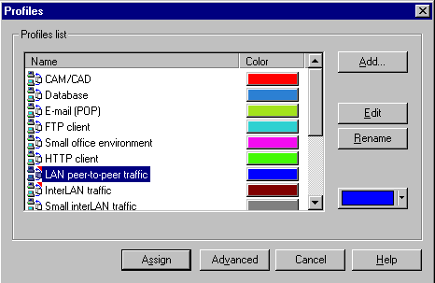
Profiles dialog
In the Profiles list selection panel, click on a profile.
Press the Assign button to assign traffic type between the devices.
Close the Profiles dialog.
NOTE: See also Assigning Traffic or Calls for more information on Traffic assignment.
Start Animation.
Click the Start button on the Control toolbar to see the traffic flow.
Save the Project.
- Stop animation by using the Stop button on the Control toolbar.
- From the File menu select the Save command.
The Save As dialog will be displayed.
- Type example.net in the File name field and press Save.
Exit NetCracker.
Select Exit from the File menu to exit the NetCracker application.

__________
See Also
Opening Existing Project Files
Profiles dialog
Understanding NetCracker Animation

Printing a Project, Page or Report
The Print functions include:
- An active Site
- An active Site with its subsites
- Entire project
- Equipment reports

To print a Project or Site
Use one of the following methods to select the print command:
- From the File menu select Print.
- Press the Print button
The Print dialog is displayed.
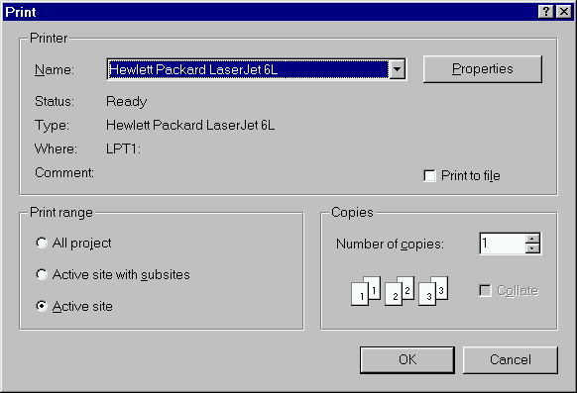
Print dialog
Select the desired print options, then press the OK button to close the dialog and print the selected Site(s) page(s).

To print a Report
In the report window on the Report toolbar click the Print Report button .

NOTE: When a report is displayed in the workspace the Print command in the File menu, the Print Preview button and the Print button on the Standard toolbar are disabled.

About NetCracker Professional
Welcome to NetCracker Professional. NetCracker Professional is the second network tool in the NetCracker suite. Unlike NetCracker Designer which is a network design tool NetCracker Professional is capable of network design and simulation. While it is very similar to NetCracker Designer in terms of user interface it has several important additional features. Two of the major features that different distinguish NetCracker Professional from NetCracker Designer are statistical indicators and custom data flow profiles.
If you are already familiar with NetCracker Designer the transition to NetCracker Professional should be a simple one. If you are using NetCracker for the first time it is recommended that you first go though the Tutorial.

Statistical Indicators
NetCracker Professional is capable of calculating and displaying a variety of statistical information related to network performance. Any device, link or data flow can have statistics. Statistical information can be displayed in the form of numbers, bar graph, or histogram.
To display statistics for any object select it and either right click and select Statistics command from the local menu or open the object menu and select Define Statistics command. This will open a Statistical Item dialog. Select the information you want to display and close the dialog. Both bar graphs and text windows can be resized for easy viewing. To change the size or color of the text right click on the text box, select Properties command and use the Text Properties dialog to format your indicator. Look at the sample file Router.net for some examples of statistical indicators.

Custom Data Flow Profiles
NetCracker Professional allows you to create your own custom defined data flow profiles. NetCracker Professional comes with a variety of traffic, voice calls and data calls profiles. If you want to create your own profile follow the steps described in the Creating a New Profile.

Changing the Look of the Site

Changing the Name of a Site or its Container

To change a Site name by using the Site Setup dialog:
Use one of the following to access the Site Setup dialog:
- From the Site menu select Site Setup
- Right-click in the Site window to display the local menu, and select Site Setup
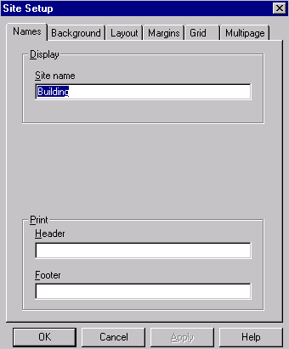
Site Setup dialog
After you display the Site Setup dialog box chose the Names tab and edit the Site name field.
Press the OK button to apply the changes and close the dialog box.

To change a Site name by the Properties dialog for the container object:
Use one of the following methods to access the Properties dialog:
- Select the container. From the Object menu select the Properties command.
- Right click on the container. From the Local menu select the Properties command.
Edit the Name field.
Press the OK button to apply the changes and close the dialog box.

To change a Site name by editing the label:
Select the container label by double-clicking on the label only.
The Text editor dialog is displayed.
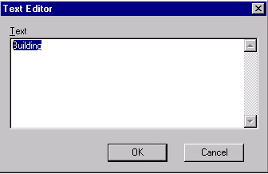
Text editor dialog
Edit the container name highlighted in the Text field.
Press the OK button to apply your changes and close the Text editor dialog.
This change also applies to the Site window label.

NOTE: Changing the name of the Site or its container automatically changes the name in each place where it is displayed.

Parts of a Site Window
Each NetCracker Site window consists of two regions: the Page (or printing) region and the Non-Printing region. NetCracker prints the parts of your design located on the Page. Components in the Non-Printing region are part of the design and animation, but they do not print. Besides changing the on-screen colors, NetCracker’s Site Setup dialog box enables you to add a map or grid and change the Page size.
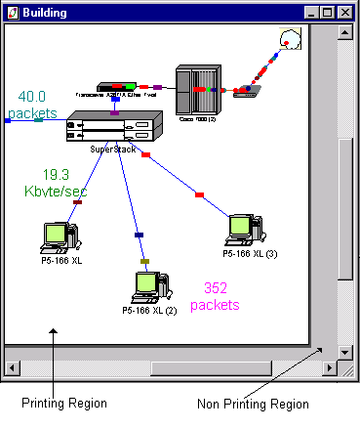
Project Pane or Workspace

__________
See also
Changing colors of a page (project pane) and non-printing region

Changing Colors of the Page and Non-Printing Region
Use one of these methods:
- In the Site window click the right mouse button to display the local menu, select Site Setup. Click the Background tab. In the Colors box, select Page and Non-Printing Region colors and click OK.
- On the Sites menu click Sites Setup and then click the Background tab. In the Colors box, select the Page and Non-Printing Region colors and click OK.
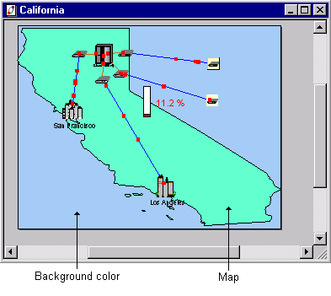
Site window with background color and map applied

Adding Maps as Backgrounds on a Site Page
Maps can be used as Page backgrounds and can be displayed on your monitor and printed. Use one of these methods to add a map to a Site page:
- Right click in the Site window and click Site Setup from the local menu. In the Background tab of the Site Setup dialog box, click the Map box. Select a map from the list or use the browse button to find other map files and click OK.
- On the Sites menu click Site Setup. In the Background tab of the Site Setup dialog box, click the Map box. Select a map from the list or use the browse button to find other map files and click OK.

4

Adding a grid to a Site Page
Use one of these methods:
- Right click in the Site window and click Site Setup from the local menu. Check Show Grid on the Grid tab of the Site Setup dialog box, select a color, and click OK.
- On the Sites menu, click Site Setup. Check Show Grid on the Grid tab of the Site Setup dialog box, select a color, and click OK.

Adding an Image to a Site Page
If you want to use an illustration as a background for a Site window, use one of these methods to select an image file:
Use the:
- Local menu to access the Site Setup dialog box.
- Site Setup command on the Sites menu.

To add an Image to a Site Page using the Local Menu:
- Right click in the Site window (not on an object).
- Select Site Setup from the local menu.
The Site Setup dialog is displayed.
Site Setup dialog

Click on the Background tab and click on the Map box to enable the background feature.

Press the Browse button.
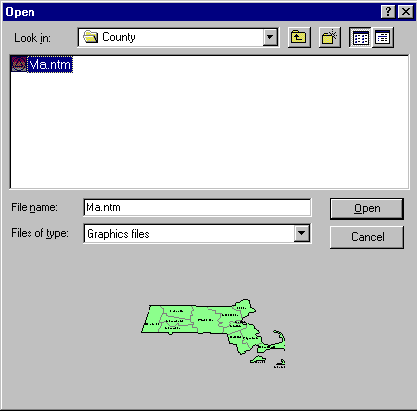
The Open dialog box is displayed.

Open dialog
Select an image file from the Selection pane and press the OK button to apply the background to the Site window and close the Site Setup dialog.
Map example

To add an Image to a Site Page using the Sites Menu:
- From the Sites menu select Site Setup.
- Select the Background tab , then click on the Map box to enable the background feature.
- Click on the Browse button to display the Browse dialog box.
- Select an image file from the list and press the OK button to apply the background to the Site window and close the Site Setup dialog.

__________
See also
Draw: Image Command (Sites Menu)

Creating Bends In Links
With NetCracker you can create polyline or bent links. Bending the link effects only the appearance of the project.
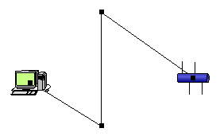
A bent link
To bend a link
- Depress the <Ctrl> key and double-click on a link.
This creates a bend point on the link. The bend point is indicated as a grab handle.
- Drag the link by the grab handle and reposition it.
NOTE: You can bend the link as many times as you want by repeating the above steps.
To straighten a link
Hold down <Ctrl> and double-click on the grab handle. A bend point disappears and the link straightens at that point. Repeat for each bend point.

Titles, of links
Link titles are automatically changed only if user did not change them manually. Users can show/hide title for every multi-site link’s part independently from other parts. So the same link can have its title displayed in one site and have it hidden in the other.

Devices

Adding a Device To a Project
Every device in the NetCracker database has detailed product information supplied by the vendor or other sources. You can view this information by selecting the object in the Site window, then accessing its Properties dialog box.

To add components to a NetCracker Site
- Locate the device type on the Device browser.
- Use one of the following methods to display the Device browser, if it is not already displayed:
- Click on the Device browser tab of the browser.
- From the View menu select the Database Browser command.

The Database browser is displayed.
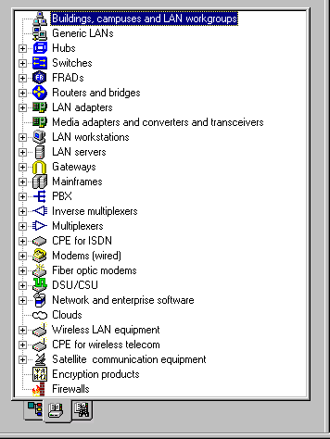
Device Database browser
- Use the scrollbar to scroll through the database to find different device types.
- Expand the desired folder, if it is not already expanded, by clicking on the expansion symbol .
- Then, click on the desired category to highlight it and display the corresponding device images in the Image pane.
NOTES:
- The Devices tab in the Image pane must be selected in order for you to see the devices in the Image pane.
- For each device type, generic devices are included in the top-level of the category and can be displayed in and selected from the Image pane. Generic devices represent the device type, function as the device type, but do not contain vendor-specific characteristics.
Locate a generic device by highlighting the device category.

- Select a device by clicking on it, dragging it into the Project pane, and releasing the mouse button.

Changing a Device Label
When the image and its label are selected separately or together, then the device label can be modified.
To change a label
Use one of the following methods to change the label:
- Right click on the object and select Properties from the local menu to display the Properties dialog .
The Properties dialog is displayed.
- Edit the Name field and click the OK button
- Click on the device image’s label and access the Text Editor dialog.
The Text Editor dialog is displayed.
Edit the name in the Name field. Then, press the OK button to apply your changes and close the dialog box.

Changing a Component's Display Size
To change a component’s on-screen size
Select the component and use the grab handles to re-size it.

Viewing Device Configuration
To view device configuration:
Use one of the following methods to open a Configuration dialog box:
- Double-click on the device.
- Right click on the device (not a container), then from the local menu select the Open command.
- Select the device (not a container), then from the Object menu select the Open command.
- Select the device, then from the Object menu select the Configuration command.
The Configuration dialog is displayed.
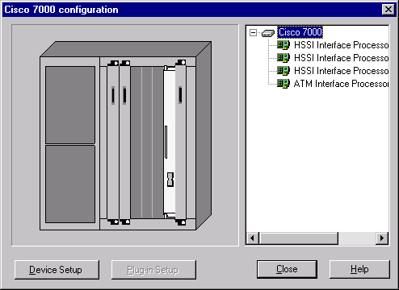
Configuration dialog

View the configuration of the device by pressing the Device Setup button to open the Device Properties dialog box.
View the configuration of the plug-in by pressing the Plug-in Setup button to open the Device Properties dialog box for the plug-in.
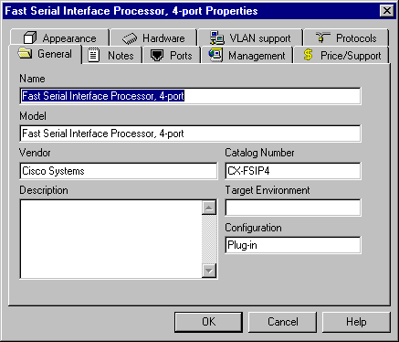
Device or Plug-in Properties dialog box

Viewing or Changing Device Properties
Properties include the vendors’ product information as well as user-supplied notes.

To view or change device properties
Use one of the following methods to access the Properties dialog:
- Right click on the device and select Properties from the local menu .
- Select the device and select Properties from the Object menu.
Select the desired tab on the Properties dialog, then enter, delete, or change information in the desired field(s).
Press the OK button to apply your changes and close the dialog, or press the Cancel button to close the Properties dialog box without changing the device’s properties.
__________
See also
Configuration dialog
Properties dialog
Port Properties dialog
Viewing or Changing a Device's Configuration

Changing Properties Of a Component or Sub-component

To change the properties of a component or sub-component
Use one of the following methods to display the Configuration dialog:
- Double-click on the component to open the Configuration dialog box.
- Click on the Setup button for the component or the sub-component to open the Properties dialog box.
Make any changes and press the OK button to apply your changes and close the dialog box.
__________
See also
Adding Plug-Ins or Network Cards to a Device
Configuration dialog
Properties dialog
Port Properties dialog
Viewing or Changing Device Properties

Stacks

Adding and Deleting Stackable Devices
Some networking components can be stacked. Once devices are stacked, NetCracker treats the stack as one device. This means:
- Available ports are common to the devices in the stack.
- Traffic can be routed through the stack as a whole.
- On-screen re-sizing and other Draw functions apply to the whole stack.

To assemble a stack
Follow these steps:
- Drag a stackable device to the active Site window.
Certain hubs, switches and routers can be stacked.
- Add devices to the stack.
Point the database browser to a branch that has devices that you would like to stack. Drag devices from the image pane to the stack. When the pointer changes from a No Sign to a Plus Sign release the mouse button. NetCracker adds the device to the stack.
- Repeat until you complete the stack.

NOTE: If the pointer does not change to a Plus Sign, the devices can not be stacked. Possible reasons are either that the stackable devices are not compatible or the maximum number of devices in a stack is exceeded.
To delete a stack
- To delete the whole stack select it and press the Delete key on the keyboard.
- To delete a single device in a stack right click on it to open the local menu and select the delete command.
__________
See also
Changing the Properties of a Device in a Stack
Viewing or Changing the Configuration of a Device In a Stack

Viewing the Configuration of a Device in a Stack

To view or change the configuration of a device in a stack
Use one of the following methods to open the Configuration dialog box:
- Right click on a device in the stack and select Open from the local menu .
- Double-click on a device in the stack.

NOTE: There is no configuration dialog box for the entire stack. Each device in a stack has its own Configuration dialog box.

__________
See also
Changing the Properties of a Device in a Stack
Adding and Deleting Stackable Devices
Properties dialog
Configuration dialog

Changing the Properties of a Device in a Stack
You can change the properties of a stackable object by clicking on a single object in the stack.

To change the properties of a device in a stack
- Click on a single object in the stack.
- Use one of the following methods to open the Properties dialog box:
- Right click on the device in the stack and select Properties from the local menu .
- Select the device and select Properties from the Object menu .
- Select the desired tab in the Properties dialog by clicking on it.
- Add, delete, or change information in the editable fields.

NOTE: A stack as a unit does not have any properties and the Properties dialog cannot be opened for the entire stack, only individual components of the stack.

__________
See also
Viewing or Changing the Configuration of a Device In a Stack
Adding a Device to a Stack
Properties dialog

Establishing Connectivity

Adding Plug-Ins or Network Cards To a Device
You can work directly on the Page or open a Configuration dialog box to assemble modular devices, such as hubs or routers, or to add network cards to workstations.

For modular devices NetCracker displays both the available chassis and plug-ins in the Product Image panes.

Network cards are stored in the special database branch called LAN Adapters.

To assemble modular devices or add network cards to workstations
Drag the device to the Site.
For example, start with a hub or router chassis. Notice that when you select a modular device from the Device Database, the product list and Image panes display both the chassis and the compatible sub-components.
Add the sub-components.
Use one of the following methods to add the sub-components:
- Drag the sub-components from the Image pane to the component.
The pointer changes from a Stop Sign to a Plus Sign when it can be dropped into the component.
- Double-click on the device to open its Configuration dialog box. Drag the sub-components from the Image pane to the component image in the Configuration dialog box. The pointer changes from a Stop Sign to a Plus Sign when it can be dropped into the component.

NOTE: If the pointer does not change to a Plus Sign, the sub-component is not compatible with the component. Select another sub-component that is compatible with the device, or use generic sub-components (refer to Adding a Device to a Project for an explanation of how to display generic devices in the Image Pane).

__________
See also
Changing Properties of a Component or Sub-component

Linking Devices in the Same Site
NetCracker’s connectivity checking prevents you from linking incompatible devices. To link two compatible devices in the same Site, follow these steps:
To link devices in the same site:
- With the Site window active, press the Link Devices button .
The pointer is now in Link mode.
- Draw a connection between the two devices.
Use either of these methods:
- Click on one device, move the pointer to the other device, and click it.
- Click on one device, drag the mouse to the other device, and release the mouse button.
NetCracker opens the Link Assistant dialog box.
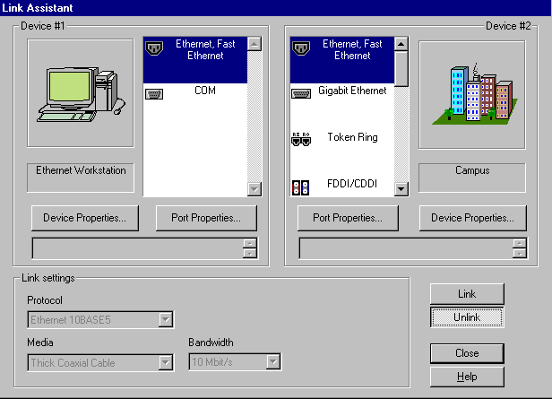
Link Assistant dialog
- Establish the link.
By default, Link Assistant proposes to link the first available port on each device. Press the Link button to accept the defaults or select other ports and press the Link button.
- Adjust the link settings, if necessary.
Once the link is established, NetCracker displays the link settings. You can change the protocol, media, length, and bandwidth as needed.
Continue in Link Devices mode to establish other links. To return to the standard pointer , click the Standard button in the Modes toolbar .

__________
See also
Changing Link Properties
Link Assistant dialog box

Linking Devices in Different Sites
Creating a link between two compatible devices in different Sites.

To link devices on different levels:
- Make sure you are in Link mode by pressing the Link Devices button .
The cursor changes to indicate you are in Link mode . Create a link between one device or a container or between two containers. The Link Assistant dialog does not appear, since the link is incomplete. However a connector icon is displayed at the linked (container) site. This connector represents the end of the link in one Site window if that link is going to another site. A link can be continued from the connector to another container or to a device in the site. When there are devices on both ends of the link, the link is complete and the Link Assistant dialog is displayed.

NOTE: The Link Assistant dialog is not displayed if links were made using the Quick Link technique.

- Adjust the link settings, if necessary.
Once the link is established, NetCracker then displays the default link settings. You can change the protocol, media, length, and bandwidth, as needed.
- Return to Standard mode.
To return to the Standard pointer , click the Standard button on the Modes toolbar .

NOTE: You can also change port properties by right-clicking on the device and selecting Properties from the local menu . Click the Ports tab, select the port, and click Port Setup.
__________
See also
Link Assistant dialog box
Linking Devices in the Same Site

Changing Link Properties
Use this procedure to modify link properties after a link is established between two devices in the same or different Sites.
To change link properties:
- Once a link is established open Link Assistant by double clicking on the link.
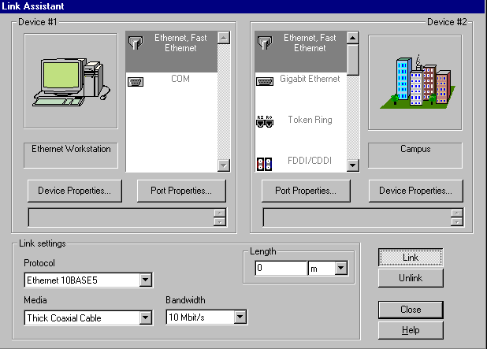
Link Assistant

Edit the link settings and click close.

NOTE: You can use NetCracker Quick Linking feature to connect two devices without having to specify ports or link settings for the link.

__________
See also
Linking Devices in the Same Site
Linking Devices in the Different Sites
Quick Linking

Quick Linking
After you populate your network design project with devices by placing device images on the Project pane, you can then create links between the devices. To link two compatible devices in the same Site using Quick Link, follow these steps:
To use the Quick Link function:
- With the Site window active, press the Link Devices button .
The cursor changes to indicate you are in Link mode.
- Create a connection between the two devices.
Press the Shift key then click on one device and then click on the other device.

NOTES:
- NetCracker’s connectivity checking feature prevents you from linking incompatible devices.
2. You can not use Quick Linking to connect two devices on different Sites. To connect such devices see Linking Devices on Different Levels.

NetCracker connects the two devices if they are compatible.

To open the Link Assistant dialog once a link is established double click on the link.
__________
See also
Link Assistant dialog box
Linking Devices in the Same Site
Linking Devices in the Different Sites

Tracing the Path Between Devices
The NetCracker software traces the path of data between traffic/call sources and traffic/call destinations. If there are multiple paths available between devices Trace Path will show one path for each type of relation.
To trace the path of data between the source and destination
- With the Site window active, press the Trace Path button .
The cursor indicates you are in the Trace Path mode () and the Trace Toolbar appears.
- Click on a traffic/call sources (a device).
- Click on the traffic/call destination (a device).
Either the traffic source or the traffic destination can be in any Site on any level of the Project hierarchy.
NetCracker displays the path between the source and destination by highlighting the path in color that you chose from the Trace Toolbar.
__________
See also
Assigning Traffic or Calls
Trace Path Command

Generating Data Flow

Assigning Traffic or Calls
Any component capable of generating load is a traffic generator. For NetCracker, traffic generators include all container objects (LANs, buildings, cities, campuses, and floors) as well as workstations, servers, and peripheral devices.

NetCracker supplies pre-defined Traffic and Call profiles. Before assigning a traffic or call profile, you may want to establish connectivity and link the devices. See Linking Devices. Traffic and Call profiles can be assigned to components that are not linked.

To assign a Traffic or Call profile
- With the Site window active, press the Set Traffic, Set Voice Calls or Set Data Calls button.
The pointer is now in Set Traffic or Set Call mode.
- Click on one device, move the pointer to the other device, and click on it.
NetCracker opens the Profiles dialog box .
- Assign a Profile.
Select a Traffic or Call profile in the Profiles dialog and press the Assign button to apply your changes and close the dialog box.
Return to the Standard cursor by pressing the Standard button in the Modes toolbar.

To convert a traffic generator to a container
Traffic generators are objects that can have traffic profiles assigned to them. Certain objects can be converted to containers; these include buildings, LANs, floors, cities, and campuses. Converting an object to a container creates a new Site and opens a new Site window. When a traffic generator is converted to a container, assigned traffic profiles are deleted; traffic no longer originates from the object or comes to the object.

To assign a Traffic or Call profile between objects on different sites
Follow the same steps as for assigning profiles on the same level.

__________
See also
Viewing or Changing a Traffic or Call Profile
Tracing Path Between Devices

Viewing or Changing a Traffic or Call Profile

To see the Traffic or Call assigned to a device:
Select Data Flow on the Global menu. Browse the list of assignments in the Data Flow dialog box.
To change a Traffic or Call assignment
- On the Global menu, click the Data Flow command.
NetCracker displays the list of assignments in the Data Flow Dialog box .
- Select the profile you want to change and click the Edit button.
NetCracker opens the Profiles dialog box.
- In the profiles dialog box, select a different Profile and click Assign.
The selected profile is assigned and the profiles dialog box closes.

Setting up Client Sever Relationships
To create a client server relationship
- Drag two computers into the workspace
Both of those computers can be workstations or servers. In the database the computers are split into those categories based on manufacturers definitions. For networking purposes the severs are determined by adding software, not by getting a computer from the server branch of the database.
- Add Server software
Software for creating a server is a type of plug-in found in the Network and enterprise software➔Server software folder of the database. One computer can serve as several types of server at the same time.
- Make sure that the computers are linked and assign traffic.
When assigning traffic, assign it from the client to the server. The servers response will be automatic. To change the properties of the reply traffic from the sever open server’s Properties dialog, and click on the Server tab.
NetCracker does employ connectivity checking at server application level. So if the traffic to be assigned is not compatible with the server software an error message will appear.

Permanent Virtual Circuits in Frame Relay Clouds
To set up a PVC (Permanent Virtual Circuit) in a Frame Relay cloud
- Open the Properties dialog of the frame relay cloud and click on the PVC’s tab.
A frame relay cloud can be used two ways. If PVCs are not used data can flow from any point to any point in the cloud. If PVCs are set up then data can flow only on the path assigned in the Properties dialog.
- Check the “Use PVC” box.
By checking the box you are putting the cloud in PVC mode.
- Click the Add PVC button to define a new connection.
This will open a PVC definition dialog. In this dialog you can assign between what two ports in a cloud there is a permanent virtual circuit.
- To delete the connection that has already been made highlight it and click the Delete PVC button.
- To change the port assignment on an already established connection highlight it and click on the Edit PVC button.

Creating a New Profile
To create your own profile:
- Open the Profiles dialog by clicking on Global➔Profiles
- Click on the Add button and select profile type
- In the Traffic dialog fill out all the fields with appropriate information and close the dialog.
- Close the Profiles dialog.

Running the Animation

Understanding NetCracker Animation
NetCracker’s animation is a reflection of events that occur in your Project. For example:
- Data speed is a function of link bandwidth
- Number of data units per second is a function of traffic/call volume
- Data unit color indicates the traffic/call profile
- Data unit shape indicates the transport protocol

Understanding advanced animation setup
The sliders in the Animation Setup dialog change the overall speed or intensity. To change the ratios of speed or intensity use the advanced animation setup.
To see advanced animation setup, click the Advanced button in the animation setup dialog. For the intensity the minimum stands for the number of animation packets/calls per time unit that you see with the smallest traffic/call in your project. The maximum stands for the number of animation packets/calls per time unit that you see with the largest traffic/call in your project. The number of packets/calls for traffic/calls that fall in between the smallest and the largest is distributed on a linear scale.
The speed of packets/calls is calculated in a similar fashion. For the speed, the minimum stands for the speed of animation packets/calls that you see on the slowest (least bandwidth) link in your project. The maximum stands for the speed of animation packets/calls that you see on the fastest (most bandwidth) link in your project. The speed of animation packets/calls on links with bandwidth that fall in between the smallest and the largest is distributed on a linear scale.

NetCracker’s traffic and call profiles allow you to create a load on your network. The animation represents the network conditions visually.

The Break and Restore functions let you temporarily disable a part of the network to understand how the network would behave under different conditions.
__________
See also
Animation Setup Command,
Packet Tab: Animation Setup Dialog
Calls Tab: Animation Setup Dialog
Break and Restore functions
Changing How the Animation Appears

Changing How Animation Appears
NetCracker’s animation is based on the network activity as defined in your Project.

Open the Animation Setup dialog box using one of the following methods:
- Press the Animation Setup button on the Animation toolbar.
- Select Animation Setup command from the Control menu.

To make the animation appear to move faster or slower
Use one of the following methods:
- On the Animation toolbar click Faster or Slower.
NOTE: This does not require the Animation dialog to be open.
- Adjust the speed slider(s) in the Packet Tab: Animation Setup Dialog and/or Calls Tab: Animation Setup Dialog

To change the number of packets/calls per second (intensity)
Adjust the intensity slider in the Animation Setup dialog box.

To make packets/calls appear larger or smaller on the screen
To change how large or small packets/calls appear on the screen during animation, move the Packet/Call size slider.
To interpret colors assigned to the media linking components
On the View menu, select Media Colors.

To interpret the data unit shape
On the View Menu, select Legends. Then select the Packet Shape tab.
__________
See also
Understanding NetCracker Animation

Advanced Animation Setup
This dialog is used to set the minimum and maximum possible values for packet/call speed and intensity.
__________
See also
Understanding NetCracker Animation
Changing How the Animation Appears

Multilevel Design

Adding Levels and Sites Using Containers
To create a site place a device that can be converted to a container into the project, then expand the device to a container. Containers are the only way to create new sites.
Adding a Site to a Project opens a new Site window. Buildings, cities, campuses, floors, and LAN objects can be converted (also referred to as expanded) to containers using the Expand command on the Object menu or on the local menu for the object.

When you expand a container you create a new Site, open a new Site window, and change the appearance of the expanded object
- In the Site window occupied by the container, the expanded object appears with a red frame to indicate that it is a container. Objects that can be expanded to a new Site but that have not been expanded do not have the red frame.
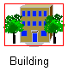
- The new Site window takes on the same name used to label the container before it was expanded.
If you change the name of either the container or the Site, NetCracker automatically changes the name everywhere it appears. This includes the Site window title bar, container name, the Window menu options, and the Project Hierarchy browser If there is a link between devices in Sites on different levels, NetCracker displays a connector that symbolizes the end of the link located one Site up.
To add a site to a current project:
- Select an object to convert to a container.
Objects that can be converted to containers include LANs, buildings, cities, floors, and campuses. If the Site window does not already contain an object that can be converted to a container, select Buildings, campuses, LAN and workgroups from the browser and then select one of the objects from the Image pane and drag it to the Project pane.
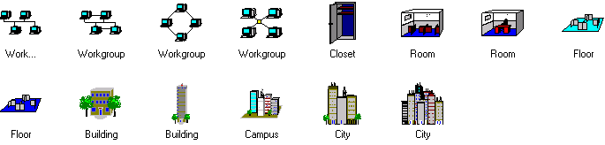
Image pane displaying sample objects
- Convert the object to a container.
Select the object to expand.
From the Object menu select Expand..
NetCracker opens a new Site window. The new Site window has the same name as the expanded object.
__________
See Also
- Changing the name of a site or its container
- Converting a traffic generator to a container

Converting a Traffic Generator or Receiver To a Container
Traffic/call generators and receivers are objects that can have data flow profiles assigned to them. Certain objects can be converted (also referred to as expanded) to containers; including buildings, LANs, floors, cities, and campuses. To convert an object to a container, from the Object menu use the Expand command.
- When you convert an object to a container, a new Site is created and a new Site window is opened.
- When an object that has data flow assigned to it is converted to a container, assigned traffic/call profiles are deleted; traffic/calls no longer originate from the object or are delivered to the object.

__________
See also
Linking Devices on Different Levels.
Adding Levels and Sites Using Containers

Tips for Creating Hierarchical Designs
There are many ways to approach creating a network project using NetCracker. If you have a network map or a diagram, you can re-create the network in NetCracker.

Hierarchical designs contain more than one Site. The two basic ways to approach creating a design are level-by-level or drilldown.
- Level-by-level
Construct the entire level in complete detail, before expanding to the next level down in the hierarchy. This may involve establishing several Sites on one level.
- Drilldown
Construct one entire hierarchical branch from top to bottom partially constructing each level. Once the first branch hierarchy is in place, complete construction of the next branch. Once the branches are complete, review each level to ensure that all Sites are included.

Testing Scenarios

How to Display Statistics
NetCracker Professional is capable of calculating and displaying a variety of statistical information related to network performance. Any device, link or data flow can have statistics. Statistical information can be displayed in the form of numbers, bar graph, or histogram. It can also be spoken by the computer (requires a sound card and speakers), and printed out as a report.
To set up statistics for devices and links
- Select the device or a link
- Open the Object menu and click on Define Statistics, or right click to open a local menu and select Statistics.
- Use the Statistical Items dialog to select what statistics you want to display and how.

To set up statistics for data flow
- Open the Data Flow dialog.
- Select a data flow and press the Statistics button.
- Use the Statistical Items dialog to select what statistics you want to display and how.

To print statistical information as a report
From the Tools menu select Reports, then select a statistical report or use the wizard.

Obtaining Reports
NetCracker supplies equipment reports such as a Bill of Materials.
To obtain a pre-defined equipment report
Select the Tools menu item and then select the Reports submenu. Select the report you want to open.
To choose one of the custom-defined reports
Select the Tools menu, then the Reports sub-menu, and select the Wizard command. This opens the Report Wizard.
The report opens in a separate window. You can use the navigation toolbar to view the report. You can also print the report.

Rerouting Traffic and Calls
With NetCracker you can examine how data flow is routed in a complex network. You can also cause traffic/calls to be rerouted by breaking or restoring a component or by changing the model’s routing algorithms.

To break and restore components
Select the component and use one of the following methods:
- In the local menu, click the Break or Restore command.
- In the Object menu, click the Break or Restore command..

NOTE: You can also use a Break/Restore tool from the Modes toolbar.

To change the model’s routing algorithm
In the Global menu select Model Settings, then in the Model Settings dialog box, click the Protocols tab. Select a different Protocol to change the routing algorithm.

Frequently Asked Questions

Technical Support
To receive technical support, please send e-mail to
support@netcracker.com

Problem reports should include:
- System Configuration (CPU, RAM, OS, video card manufacturer, and video memory)
NOTES:
- If you do not know the name of your video card manufacturer that information is not absolutely necessary in most cases.
- If you do not know the amount of video memory your video card has you can use a simple procedure to approximate it. Go to Start→Settings→Control Panel, in the Control Panel window double click on Display and select Settings tab. Set the Desktop Area slider to maximum. Now look at the number of colors in the color palette. Multiply the desktop area by the number of bytes in color (256 colors = 1 byte, 65536 High color = 2 bytes, 16777216 True color = 3 bytes). The number that you get is your approximate video memory in bytes. Round the number up (do not round down) to 1Mb, 2Mb, 4 Mb or 8Mb. This way of determining video memory is not always affective, but it will supply accurate information in most cases.
- Detailed problem description (include exact error message text or error condition)
- A description of how to reproduce the problem

Copyright
Copyright © 1997-1999 Advanced Visual Data, Inc. All Rights Reserved.
NetCracker® is a registered trademark of Advanced Visual Data, Inc.

Advanced Visual Data, Inc.
1159 Main Street
Waltham, Massachusetts 01254

Speech engine by ©1996 Lernout and Hauspie Speech Products. All rights reserved.

Information in this document is subject to change without notice.

Discovery

What is AutoDiscovery
NetCracker 4.1 includes a brand new major feature called AutoDiscovery. AutoDiscovery allows you to gather information about an existing network and put it in NetCracker as a project with minimal effort.
The AutoDiscovery process is subdivided into four steps:
- Establishing the range of devices to be discovered
- Discovery of the devices
- Editing devices to be put into the NetCracker project
- Creating a NetCracker project with the discovered devices

To Start NetCracker AutoDiscovery
Go to File ➔ Discover... and click on the Discover command. This will start the discovery wizard.

AutoDiscovery -- Selecting Discovery Engine
To Start NetCracker AutoDiscovery
Go to File ➔ Discover... and click on the Discover command. This will start the discovery wizard.
The first screen of Auto Discovery is used to select the Discovery engine.
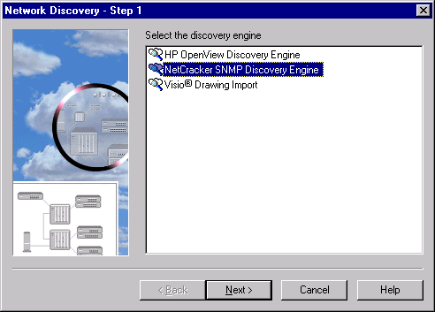
AutoDiscovery – First screen
NOTE: Besides NetCracker SNMP discovery engine, HP SNMP discovery engine can also be used if it is already installed on the computer. This document covers NetCracker features only, and does not cover external applications.

After selecting the NetCracker discovery engine push the Next button, to go on to NetCracker SNMP Discovery Settings.

NetCracker SNMP Discovery -- Settings
NetCracker SNMP Discovery -- Settings is the first screen after selecting the NetCracker discovery engine.
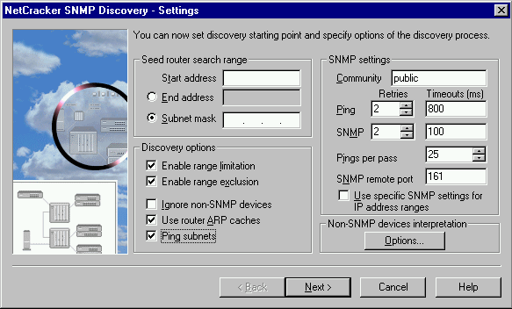
NetCracker SNMP Discovery Settings
IP address range -- Start Address | Use this field to input the IP address, which will define the beginning of an IP address range.
IP address range -- End Address | Use this field to input the IP address, which will define the end of an IP address range. The other way to define the limits of an IP address range is by using subnet mask.
IP address range --Subnet Mask | Use this field to input the subnet mask, which together with the Start Address defines the IP address range. The other way to define the limits of an IP address range is by using End address IP.
Discovery options -- Enable range limitation | Checking this box will add a Limiting Ranges screen to the discovery set up process. NetCracker will not continue discovery outside the limiting ranges.
Discovery options -- Enable range exclusion | Checking this box will add an Excluding screen to the discovery set up process. If there is an IP range or ranges that you don’t want to discover, but which fall within the discovery range, check this box.
Discovery options -- Ignore non-SNMP devices | If a device is not SNMP enabled the only information that can be discovered about it is the IP address, which NetCracker treats as a workstation. If this box is checked all non-SNMP devices are NOT included in the discovery process.
Discovery options -- Use router ARP caches | If this box is checked ARP caches are used in the discovery process. If it is not checked only the specified seed range plus any information found in routing tables is used.
Discovery options -- Ping subnets | If the IP range you defined contain subnets, checking this box will discover them, even if the IP addresses within the subnet fall outside the seed discovery limits. If this box is not checked subnets that fall outside the defined IP range will not be discovered.
SNMP settings – Community | This string is used as a password to get read rights on the SNMP network. Typically the read password is “public”, if your network uses a different password check with your network administrator to find out what it is.
SNMP settings -- Ping | In this section you can set how many times the discovery engine pings each IP address, and what is the timeout of each ping.
SNMP settings -- SNMP | In this section you can set how many times the discovery engine sends a SNMP query to each discovered IP address, and what is the timeout of each query.
SNMP settings – Pings per pass | In this field you can set how many IP addresses the discovery engine checks per one ping pass.
SNMP settings – SNMP remote port | In this field you can set the remote port, which is used to get SNMP information for agents. The default port is 161.
SNMP settings -- SNMP settings for IP ranges | Checking this box will add a Range SNMP screen to the discovery set up process. If there is an IP range or ranges that you want to discover using different settings for Community, Ping and SNMP, check this box.
Non-SNMP devices interpretation -- Options | Use this button to set interpretation mode for non-SNMP devices

- The Starting IP address range section is used to set up the seed limits of the network segment to be discovered. If NetCracker finds accessible routing tables or ARP caches (only if Use ARP caches is checked) within that range it will go on to discover the devices specified in those tables. This will continue while Community is good, potentially the whole Internet. Check the Enable range limitation box to specify the limits of the discovery.
- The discovery options section is used to set up different discovery preferences which, among other things effect what screens will be displayed. It will also effect how the discovery engine will handle certain aspects of the discovery process.
- The SNMP settings section is used to set up the way the engine discovers your network.

__________
See also
NetCracker SNMP Discovery -- Limiting Ranges
NetCracker SNMP Discovery -- Excluding Ranges
NetCracker SNMP Discovery -- Range SNMP Settings

NetCracker SNMP Discovery -- Limiting Ranges
NetCracker SNMP Discovery – Limiting Ranges is an optional screen, which comes up only if the Enable range limitation checkbox on the NetCracker SNMP Discovery –Settings screen is checked. The discovery engine will not go outside the limits specified in this screen.
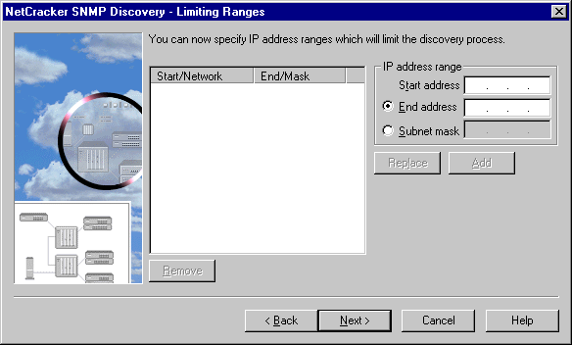
NetCracker SNMP Discovery Limiting Ranges
IP address range -- Start Address | Use this field to input the IP address, which will define the beginning of an IP address range.
IP address range -- End Address | Use this field to input the IP address, which will define the end of an IP address range. The other way to define the limits of an IP address range is by using subnet mask.
IP address range --Subnet Mask | Use this field to input the subnet mask, which together with the Start Address defines the IP address range. The other way to define the limits of an IP address range is by using End address IP.
Add button | Use this button to add the defined IP range to the list.
Remove button | Use this button to delete the highlighted IP range from the list.
Replace button | Use this button to replace the highlighted IP range on the list with the defined IP range.
IP Address Range Window | This window displays the list of IP ranges. Depending on the screen those can be ranges to be discovered ranges to be excluded from discovery, or ranges to be discovered with different SNMP settings.
__________
See also
NetCracker SNMP Discovery –Settings
NetCracker SNMP Discovery -- Excluding Ranges
NetCracker SNMP Discovery -- Range SNMP Settings

NetCracker SNMP Discovery -- Excluding Ranges
NetCracker SNMP Discovery – Excluding Ranges is an optional screen, which comes up only if the Enable range exclusion checkbox on the NetCracker SNMP Discovery –Settings screen is checked. This screen is used to define an IP range or ranges that you do not want to discover, but which otherwise fall within the discovery range.
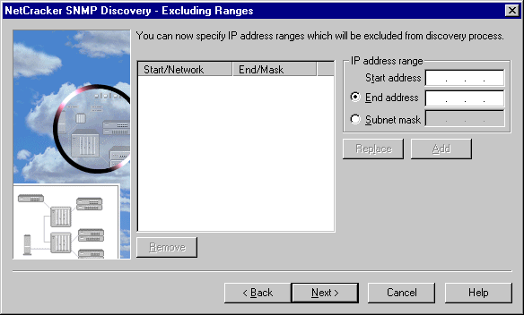
NetCracker SNMP Discovery Excluding Ranges
IP address range -- Start Address | Use this field to input the IP address, which will define the beginning of an IP address range.
IP address range -- End Address | Use this field to input the IP address, which will define the end of an IP address range. The other way to define the limits of an IP address range is by using subnet mask.
IP address range --Subnet Mask | Use this field to input the subnet mask, which together with the Start Address defines the IP address range. The other way to define the limits of an IP address range is by using End address IP.
Add button | Use this button to add the defined IP range to the list.
Remove button | Use this button to delete the highlighted IP range from the list.
Replace button | Use this button to replace the highlighted IP range on the list with the defined IP range.
IP Address Range Window | This window displays the list of IP ranges. Depending on the screen those can be ranges to be discovered ranges to be excluded from discovery, or ranges to be discovered with different SNMP settings.
__________
See also
NetCracker SNMP Discovery –Settings
NetCracker SNMP Discovery -- Limiting Ranges
NetCracker SNMP Discovery -- Range SNMP Settings

NetCracker SNMP Discovery -- Range SNMP Settings
NetCracker SNMP Discovery – Range SNMP Settings is an optional screen, which comes up only if the SNMP settings for IP ranges checkbox on the NetCracker SNMP Discovery –Settings screen is checked. This screen is used to define SNMP settings different from default settings (as defined in the NetCracker SNMP Discovery – Settings) for a particular IP address range.

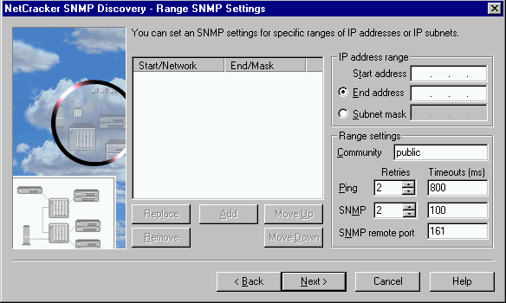
NetCracker SNMP Discovery Range SNMP Settings
IP address range -- Start Address | Use this field to input the IP address, which will define the beginning of an IP address range.
IP address range -- End Address | Use this field to input the IP address, which will define the end of an IP address range. The other way to define the limits of an IP address range is by using subnet mask.
IP address range --Subnet Mask | Use this field to input the subnet mask, which together with the Start Address defines the IP address range. The other way to define the limits of an IP address range is by using End address IP.
SNMP settings -- Community | This string is used as a password to get read rights on the SNMP network. Typically the read password is “public”, if your network uses a different password check with your network administrator to find out what it is.
SNMP settings -- Ping | In this section you can set how many times the discovery engine pings each IP address, and what is the timeout of each ping.
SNMP settings -- SNMP | In this section you can set how many times the discovery engine sends a SNMP query to each discovered IP address, and what is the timeout of each query.
SNMP settings -- SNMP remote port | In this field you can set the remote port, which is used to get SNMP information for agents. The default port is 161.
Add button | Use this button to add the defined IP range to the list.
Move up button | Use this button to move the range on the list one ahead. The discovery process is preformed sequentially with first ranges on the list being discovered first.
Move down button | Use this button to move the range on the list one behind. The discovery process is preformed sequentially with last ranges on the list being discovered last.
Remove button | Use this button to delete the highlighted IP range from the list.
Replace button | Use this button to replace the highlighted IP range on the list with the defined IP range.

__________
See also
NetCracker SNMP Discovery –Settings
NetCracker SNMP Discovery -- Limiting Ranges
NetCracker SNMP Discovery -- Excluding Ranges

NetCracker SNMP Discovery - Ready to start
This is the last screen in the NetCracker SNMP Discovery wizard.
Once the Start button is pressed the Netcracker SNMP Discovery Console is displayed and discovery process is started. Press Back if you wish to modify to any parameters.
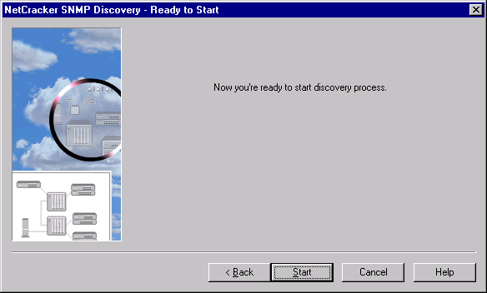NetCracker SNMP Discovery – Ready to Start
NetCracker SNMP Discovery Console
SNMP Discovery Console is the screen, which comes up after all settings for the AutoDiscovery process have been set. The console is for information purposes only, it displays the progress of the discovery. It also allows you to restart the discovery process or cancel it.
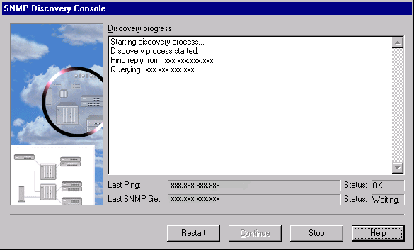NetCracker SNMP Discovery Console Screen
NOTE: On large networks discovery process can take a long time. You can check what IP address the discovery engine is on by looking at the Last Ping status line, or on the main Discovery progress screen.

AutoDiscovery -- Matching Devices
This screen is displayed after the device information has been gathered from the network. After the information is gathered NetCracker matches the information gathered from the discovered devices to the information about devices in the NetCracker database.
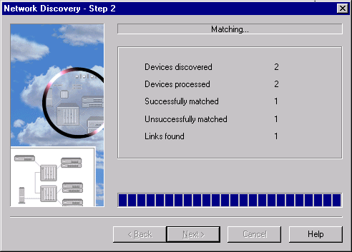
NetCracker Matching Devices Screen

AutoDiscovery -- Matching Results
This screen is displayed after NetCracker matched information about found network components with the database information. This screen displays the number of found devices and links, and also allows to edit results. Since some manual will be required in most cases it is important to view, and possibly edit matching results.
- To view detailed matching results press the View/Edit the Results button.
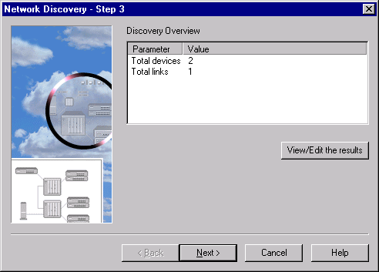
NetCracker Matching Results screen

AutoDiscovery -- Editing Results
After the network has been discovered the results are matched to the NetCracker database. The View/ Edit Results screen allows you to adjust this information. To open this screen click on the View/Edit the results button in Step 3 – Matching Results.
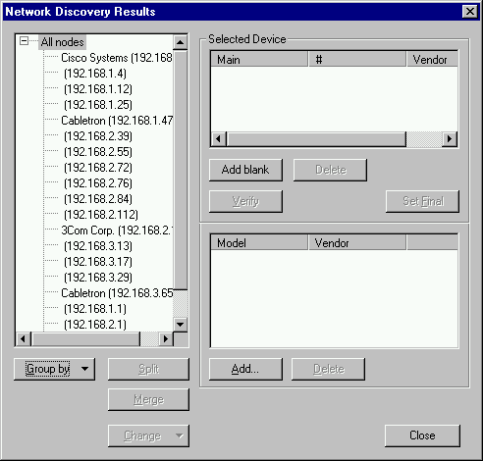
NetCracker AutoDiscovery View / Edit Results screen
Devices Found During Discovery | This pane displays the devices as they have been found on the network. This information can be grouped or sorted in different ways using the Group by and Sort by buttons. You can also split a device into several separate devices using the Split button , or combine several devices into one using the Merge button . You can also edit the device class and vendor using the Change button.
Match in NetCracker Database | This window displays a match from the NetCracker database to the device found on the network. It is possible for no devices to be matched in which case you have to set up the match manually, or to have more then one match in which case you have to select the appropriate one.
Components of the Device | This window displays the individual components, such as chassis and plug-ins for of the matched device.
Group by button | There are several ways to group devices found on the network, including no grouping or grouping by: device class, number of interfaces, subnets, or vendor. This button is used to select the type of group.
Sort by button | There are several ways to sort devices found on the network, including no sort or sorting by: device class, number of interfaces, subnets, or vendor. This button is used to select the type of sort.
Split button | This button is used to split a device into two devices. This button is also the only way to view the interfaces of a device. After pressing the split button the Interface list comes up  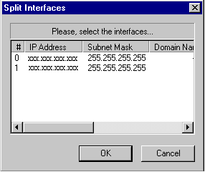  Split Interfaces dialog  To split the device select the interface and press the OK button.
Merge button | This button is used to combine two devices into one device with multiple interfaces.  To merge devices select two or more deices and press the merge button.
Change button | This button is used to change the class and / or the vendor of the found device.  To change device parameters select the parameter you want to change, enter a new value and close the Change dialog.
Add blank button | This button is used to create a device which is a match for the selected device found on the network. Pressing this button will create the device. To define the device, select it and press the Add button.
Delete button | Use this button to delete the selected device / device component from the match.
Verify button | This button is used to Verify that the configuration of the device as described can be imported into NetCracker. If the button becomes disabled that means the device passed verification. If the button stays active the device failed verification. Devices that fail verification can not be imported into NetCracker.
Set Final button | If more then one device from the database is matched to one device from the network you need to select which device you want to use. Select the device and press the Set Final button to set it as the device to be imported. The device which is set to be imported is marked by a yellow arrow.
Add button | This button is used to select device components and new device type. Pressing the Add button will open the AutoDiscovery – Database dialog. In this dialog you can select the device or plug in. The device is displayed in the Match in database pane, the individual components of the device are displayed in the Components of the Device pane.
Close button | This button is used to close this dialog.

AutoDiscovery -- Database
Pressing the Add button will bring up the AutoDiscovery database browser. This browser is used much like the regular NetCracker database browser to select devices and device components.

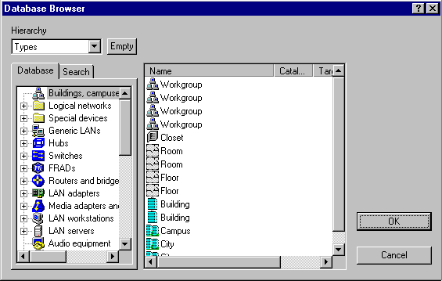
AutoDiscovery Database Window
Hierarchy box | This is the Hierarchy Combo box for this database browser.
Empty button | This is the Show / Hide button for this database browser.
Database Browser pane | This pane is the database browser. Using the browser you can navigate the NetCracker database to select a device.
Image pane | This pane displays the content of the selected database branch. This is the pane you select the device from.
Device Factory button | This button is used to start the Device Factory, to create a new device in the database.
Search button | This button is used to start a database search.

AutoDiscovery -- Creating NetCracker Design
This is the last screen in the NetCracker AutoDiscovery wizard. It displays the progress of creating a NetCracker project from all the gathered information. Once the Done button is pressed AutoDiscovery closes and the network layout is displayed in the NetCracker project window.
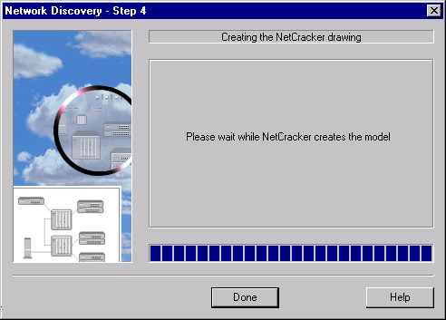
NetCracker Creating Design screen

Visio Drawing Import - File Name
The first screen of Visio Drawing Import wizard is used to select the drawing file name.
Use the Browse button to find and select the file you want to import.
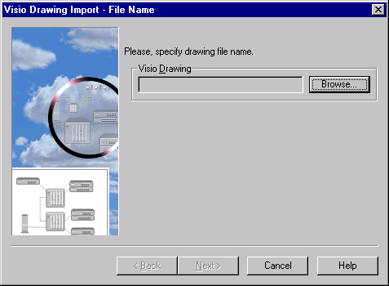
Visio Drawing Import – File Name

Visio Drawing Import - Finish
This is the last screen in the Visio Drawing Import wizard.
Once the Finish button is pressed the import is started.
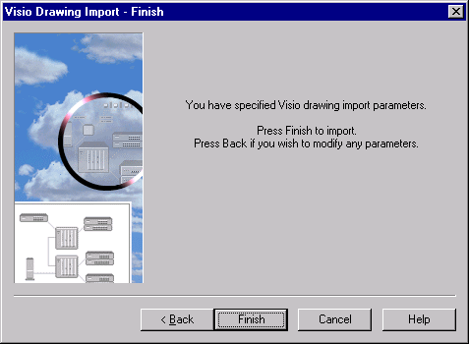
Visio Drawing Import – Finish

Visio ® Drawing Import console
Visio ® Drawing Import console is the screen, which comes up after drawing file name have been set. The console is for information purposes only, it displays the progress of the import. It also allows you to cancel the import process.

Reference Manual

Commands, Menus and Dialogs

Menu Overview

File Menu
Use the File menu to execute commands that manage network project files.

Menu Option | Button | Description
¹New |  | Creates a new Project and opens a Site window labeled Top.
¹Open |  | Opens an existing NetCracker Project file.
²Close |  | Closes a project file.
²Save |  | Saves a project file.
²Save As |  | Enables the user to save an existing project file and assign a new filename, or save new project files.
²Send |  | Accesses the installed MAPI-enabled e-mail application with the selected project file automatically included in the message portion as a file attachment.
¹Discover |  | Starts NetCracker Discovery
²Properties |  | Show the document properties.
²Print |  | Prints the project file on the installed printer. If a multi-layered project is open, only the selected site window is printed.
² Print Preview |  | Displays an Image of the selected site window as it would be printed.
¹ Print Setup |  | Enables the user to select print options.
¹ MRU1, MRU2, MRU3, and MRU4 |  | Opens the (four) most-recently used (MRU) project files.
¹ Exit |  | Exits software application.
¹This command is displayed when no project is open and displayed in the Project pane.
²This command is displayed when a NetCracker project is open and displayed in the Project pane.

Edit Menu
Use Edit menu commands to execute commands that affect device images placed in the Project pane.

Menu Option | Button | Description
Cut |  | Cuts a selected object (device image, link, container, etc.).
Copy |  | Copies a selected object to the Clipboard.
Paste |  | Pastes an item copied into the clipboard to the Project pane.
Delete |  | Deletes a selected object.
Duplicate |  | Duplicates the selected object, including any specified settings or properties.
Replicate |  | Replicates the selected object a specified number of times
Select All |  | Selects all objects in the selected Site window.
Find |  | Finds the object either by name or by IP address

View Menu
Use View menu commands to:
- Modify the display factors of the current Site window
- Display or hide toolbars, browsers, and panes
- Select the type of browser to display
- Display media and packet type legends

Menu Option | Sub-menu | Button | Description
Zoom |  |  | Displays zoom options.
 | Zoom in |  | Zooms in to the selected site window.
 | Zoom out |  | Zooms out from the selected site window.
 | Zoom to page |  | Maintains the aspect ratio and fits the contents of the selected site window to its aperture.
 | Zoom 1:1 |  | Displays the selected site window contents in 100% zoom mode.
 | Zoom one side |  | Zoom to one side (enabled only when reports are displayed in the Project pane.)
 | Zoom undo change |  | Reverts to previous display settings.
Bars |  |  | Displays or hides toolbars.
 | Standard |  | Displays or hides Standard toolbar.
 | Zoom |  | Displays or hides Zoom toolbar.
 | Drawing |  | Displays or hides Drawing toolbar.  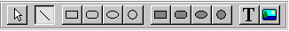
 | Modes |  | Displays or hides Modes toolbar.
 | Control |  | Displays or hides Control toolbar.
 | Database |  | Displays or hides Database toolbar.
 | Trace |  | Displays or hides the Trace Toolbar
 | Browser Pane |  | Displays or hides the browser pane.
 | Image Pane |  | Displays or hides the Image pane.
Status bar |  |  | Displays or hides the Status bar.
Image Pane |  |  | Specifies the size and the detail level of the device icons in the Image pane.  NOTE: Sub-menu commands are enabled only when the Image pane is displayed and selected.
 | Large icons |  | Displays large device icons in the Image pane.
 | Small icons |  | Displays small device icons in the Image pane.
 | List |  | Displays device icons in the Image pane in the list format.
 | Details |  | Displays objects in the Image pane in the details format.
Full Screen |  | . | Displays the Site window in its maximum view and without the NetCracker application interface.
Legends |  |  | Displays the Legends dialog.
Database Browser |  |  | Displays the Database view of the NetCracker browser.
Project Hierarchy |  |  | Displays the Project Hierarchy view of the NetCracker browser.
Compatible Components |  |  | Displays the Compatible Search view of the NetCracker browser
Devices
 | Generic View |  | Change all realistic device images to generic images.
 | Reduce to Icons |  | Enables some devices to be shown as icons.
Break Color For Site Name |  |  | Enables one to highlight the site name if it contains broken devices.

Database Menu
Use the Database menu to:
- Change how the database is sorted
- Launch the Device Factory Wizard

Hide Empty Folders |  | Shows or hides empty folders in the database. Uncheck this command to see all folders including the empty folders.
Hierarchy |  | Sorts the database by device types, vendors or user. When user sort is selected only the user customized database is displayed.
Find |  | Use this command to search the database for specific devices.
Device Factory |  | Launches the Device Factory wizard that is used to create user defined devices.

Global Menu
Use the Global menu commands to modify project-level display and settings factors.

Menu Option | Description
Model Settings | Displays the Model Settings dialog.
Data Flow | Displays the Data Flow dialog.
Acquire Update All | Updates the properties of all the devices in the project with current database information.
Profiles | Displays the Profiles dialog.

Sites Menu
Use the Sites menu commands to:
- Specify site-level display factors, including background color and map templates
- Modify the Site name
- Specify how to divide a single site for printing on multiple pages
- Change the mode of NetCracker
- Select a drawing tool to use

Menu Option | Submenu | Button | Description
Site Setup |  |  | Displays the Site Setup dialog.
Modes |  |  | Changes the selected mode. In most cases, the cursor will change to reflect the current mode.
 | Standard |  | Activates Standard mode. Standard mode is used for most selection functions, including the drag and drop functions used to select device icons from the Image pane and selection function used to obtain information about a device image or link in the Project pane.  Standard mode cursor
 | Draw |  | Activates Draw mode and enables selection of Draw tools from the Draw toolbar or Sites➔Draw sub-menu.  Draw mode cursor
 | Link |  | Activates Link devices mode. To create links between devices in the Project pane select appropriate devices.  See Linking between devices and Linking between devices in multilayerd projects .  Link devices cursor
 | Draft Link |  | Activates Draft Link devices mode. To create links between devices in the Project pane select appropriate devices  Draft Link devices cursor
 | Set Traffic |  | Activates the Set Traffic mode. To specify the traffic between two devices, select the appropriate devices and then select the traffic type from the Profiles dialog.  Set traffic cursor
 | Set Voice Call |  | Activates the Set Calls mode. To specify calls between two devices, select the appropriate devices and then select the call type from the Profiles dialog.  Set calls cursor
 | Set Data Call |  | Activates the Set Calls mode. Calls between two devices can be specified by selecting the appropriate devices and then selecting the call type from the Profiles dialog.  Set calls cursor
 | Break/Restore |  | Activates the Break/Restore mode. To break or restore links and devices, select the appropriate link or device. When objects (links or devices) are broken, traffic/calls are rerouted. Animation does not need to be running in order to use the Break/Restore tool, however traffic/call rerouting can only be viewed while animation is running.  Break/Restore cursor 
 | Trace Path |  | Activates the Trace mode. To trace the path between two traffic/call generators select the two generators. The path is indicated in red in the same site, or between sites in multi-layered projects. If there are multiple paths available between devices Trace Path will show one path for each type of relation.  Trace path cursor
 | Say Info |  | Activates the Say Notes mode.  Say Info cursor
Draw |  |  | Enables selection of Draw tools used to annotate projects. Draw tools can only be selected when the application is in Draw mode.  See Draw mode
 | Pointer |  | Select the Pointer tool to select objects and functions while the application is in Draw mode. The Pointer tool is similar to the Standard tool.  This command is enabled only when the application is in Draw mode.
 | Line |  | Select the line tool to draw straight lines.  This command is enabled only when the application is in Draw mode.
 | Rectangle |  | Select the Rectangle tool to draw open rectangles.  This command is enabled only when the application is in Draw mode.
 | Round Rectangle |  | Select the Round Rectangle tool to draw open rectangles with rounded corners.  This command is enabled only when the application is in Draw mode.
 | Ellipse |  | Select the Ellipse tool to draw open ellipses.  This command is enabled only when the application is in Draw mode.
 | Circle |  | Select the Circle tool to draw open circles.  This command is enabled only when the application is in Draw mode.
 | Filled Rectangle |  | Select the Filled Rectangle tool to draw filled rectangles.  This command is enabled only when the application is in Draw mode.
 | Filled Round Rectangle |  | Select the Filled Round Rectangle tool to draw filled round rectangles.  This command is enabled only when the application is in Draw mode.
 | Filled Ellipse |  | Select the Filled Ellipse tool to draw filled ellipses.  This command is enabled only when the application is in Draw mode.
 | Filled Circle |  | Select the Filled Circle tool to draw filled circles.  This command is enabled only when the application is in Draw mode.
 | Text |  | Select the Text editing tool to type text.  This command is enabled only when the application is in Draw mode.
 | Image |  | Access the Browse dialog, to select an image and insert it in the Project pane. The selected image is inserted at the cursor’s position.  This command is enabled only when the application is in Draw mode.

Object Menu
Use the Object menu to:
- Obtain information about object’s properties
- Convert objects to containers, which creates multi-layered project designs
- Check the data flow from and to the object
- Access database functions related to this object
- Position objects relative to one another
- Arrange multiple objects in selected patterns

Menu Option | Sub-menu Option | Description
Properties |  | Displays the Properties dialog.
Open |  | Opens the Configuration dialog or opens a new site window if the object has been converted to a container.
Expand |  | Converts the selected traffic generator to a container, which opens a new site window and creates additional levels for multi-leveled project.
Configuration |  | Opens the Configuration dialog.
Configure Ports |  | Displays the Port configuration dialog.
Define Statistic |  | Displays the Statistical Items dialog.
Say |  | Displays commands for obtaining information in audible form.
 | Current Statistic | Provides an audible report of the current statistic for the selected object. This command is enabled only when an object is selected.
 | Notes | Provides an audible reading of notes for the selected object. This command is only enabled when an object is selected. When there aren’t any notes for the object, this command is disabled.  To specify notes for a selected object, using the Properties command to open the properties dialog, select the Notes Tab and fill in the Notes field with the appropriate text.
 | Description | Provides an audible reading of descriptions for the selected object. This command is only enabled when an object is selected. When there isn’t a description for the object, this command is disabled.  To specify a description for a selected object, using the local menu, select Properties, click the General tab and fill in the description field with the appropriate text.
Associated Data Flow |  | Displays the [Object] data flow dialog, which identifies the origins and destinations of all data flows to or from this object.  If traffic/call type is not specified for the selected object, a Message dialog is displayed.  This command is enabled only when the selected object is a traffic/call generator.
Find Compatible |  | Switches the browser to the compatible devices view and searches for all devices compatible with the selected device.
Acquire Update |  | Updates the properties of the selected object from the database.
Add to Database
 | Selected Component | Adds the selected object to the user database, keeping all the properties.
 | Via Factory | Launches the Device Factory wizard with an option to create a new device based on the device selected
Break |  | Breaks the selected object and displays a red flash on the object (device or link).  NOTE: This command is not enabled for containers..
Restore |  | Restores the selected object to service and removes the red flash on the object (device, traffic generator, or link).
Styles |  | Enables selection of Styles sub-menu commands.
 | Draw color | Displays the Color dialog to change the color of the drawing object.  This sub-menu option is only enabled when the selected object is a drawn object for which this style type applies.
 | Fill color | Displays the Color dialog used to change the fill color (for solid objects) of the drawing object.  This sub-menu option is only enabled when the selected object is a drawn object for which this style type applies.
 | Text | Enables changes to the text created using the Text tool.  This sub-menu option is only enabled when the selected object is of the type for which this style type applies.
 | Font | Displays the Font dialog. The Font dialog changes the font type, font style, size or effects for the selected text.  This sub-menu option is only enabled when the selected object is of the type for which this style type applies.
 | Title | Displays or hides the label for the selected object.  This sub-menu option is only enabled when the selected object has a title.
 | Image | Enables changes to the image that represents the selected object.
Arrange |  | Changes the position of an object in relation to other objects on the Project pane.
 | Move forward | Moves the selected object one position up in the z-order or plane.
 | Move back | Moves the selected object one position back in the z-order or plane.
 | Move to front | Moves the selected object to the front.
 | Move to back | Moves the selected object to the back.
Organize |  | When multiple objects are selected, displays the Organize dialog. The Organize dialog arranges objects in several different geometric patterns.

Control Menu
Use the Control menu options to control animation.

Menu Command | Button | Description
Start |  | Starts animation.
Stop |  | Stops animation.
Pause |  | Pauses animation. Packets/calls are still visible, but are in a frozen state.
Simulation Faster |  | Speeds up simulation and animation.
Simulation Slower |  | Slows down simulation and animation.
Animation faster |  | Speeds up animation.
Animation slower |  | Slows down animation.
Set Animation Default |  | Sets the animation parameters to the defaults chosen in the Options dialog.
Animation setup |  | Displays the Animation setup dialog that specifies the packet/call intensity, speed, and size.
Quiet |  | Halts synthesized speech.

Tools Menu
Use the Tools menu to select reports and set project options.

Menu Option | Submenu | Description
Reports |  | Access Report sub-menu.
 | Bill of Materials | Displays the Bill of Materials Report Wizard for specifying report parameters and displaying the report in the Project pane.
 | Device Summary | Displays the Network Report Wizard for specifying report parameters and displaying the report in the Project pane.
 | Work-stations | Displays the Work-stations Report Wizard, for specifying report parameters and displaying the report in the Project pane.
 | Servers | Displays the Servers Report Wizard, for specifying report parameters and displaying the report in the Project pane.
 | Network Adapters | Displays the Network Adapters Report Wizard, for specifying report parameters and displaying the report in the Project pane.
 | Hubs | Displays the Hubs Report Wizard, for specifying report parameters and displaying the report in the Project pane.
 | Switches | Displays the Switches Report Wizard, for specifying report parameters and displaying the report in the Project pane.
 | Bridges and Routers | Displays the Bridges and Routers Report Wizard, for specifying report parameters and display the report in the Project pane.
 | Wizard | Displays the Select a Report dialog. The Select Report displays a listing of all reports available for the project. As a report name is selected, a description of the report is provided in the Description pane.
Default Layout |  | Resets the Browser, Image and Project panes to their default layout.
Options |  | Displays the Options dialog. This dialog specifies the frequency that files are auto-saved, NetCracker start up options, confirmations, and default animation settings.

File Menu

New Command (File Menu)
Use this command to create a new Project and open a Site window labeled Top.
__________
See also
File Menu
Working with Projects and NetCracker Windows

Discover Command (File Menu)
Use this command to create a new project and start the AutoDiscovery wizard.

Open Command (File Menu)
Use this command to open an existing NetCracker Project file.

To Open a NetCracker file:
- Select Open from the File menu.
The Open dialog is displayed. NetCracker defaults to the NetCracker directory.
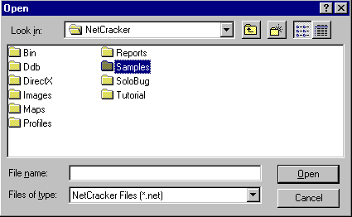
Open dialog
NOTES:
- NetCracker files are identified by their .NET file extensions.
- NetCracker automatically displays the current NetCracker directory.
- Files included with the software application and described in the Tutorial can be found in the Samples directory.

- Use the Directory combo box to access a different directory, open any closed folders, then to open a project use one of the following methods:
- Double-click on a NetCracker file in the Selection panel.
- Click on NetCracker file name in the Selection panel and press the Open button.
- Type the NetCracker file name in the File name entry field and press the Open button.

If a NetCracker file is already displayed in the Project pane, and you have not made changes to the file, the current file will close and be replaced by the selected NetCracker file.
If you have modified the current NetCracker file, you will be prompted to save your changes. Select Yes to save your changes and close the Project file, select No to close the Project file without saving changes, or select Cancel to continue working in the current Project file.
If you have closed the current Project file and opened another one, the selected NetCracker file is displayed in the Project pane.

__________
See also
Close Command
File Menu
Save As Command

Close Command (File Menu)
Use this command to close a NetCracker Project .
To close a Project file from the File menu, select close.
- If animation is running, you are prompted to stop animation before closing the file. To stop animation, use either the Stop Command on the Control menu or the Stop button .
- If you have modified the current NetCracker file, you are prompted to save your changes before exiting. Select Yes to save your changes and close the Project file, select No to close the Project file without saving changes, or select Cancel to continue working in the current Project file.
- If you have closed the Project file and opened a new one, the selected Project file is displayed in the Project pane.

__________
See also
Open Command
File Menu
Save As Command

Save Command (File Menu)
Use this command to save a Project file.
To save a Project file:
From the File menu select Save.
- If the file is a new Project file, the Save As dialog is displayed. Select a directory for the Project file using the Directory combo box, enter a name in the File Name field, then press the Save button.
NOTES:
- You do not need to type the .NET file extension, it is automatically appended to the file name.
- Do not assign file extension type other than .NET; NetCracker Project files can only be assigned .NET extensions.
- If the file is a current file, the Project is saved. A Save dialog is not displayed.

__________
See also
File Menu
Save As Command

Save As Command (File Menu)
Use this command to save a new Project file and assign it a file name, or to save a current project file under a different name.
To use the Save As command:
- From the File menu select Save As.
The Save As dialog is displayed.
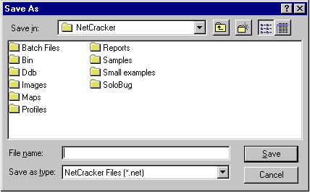
Save As dialog
- Select the desired directory by using the Directory combo box, then enter the file name in the File Name field box and press the Save button.

NOTES:
- You do not need to type the .NET file extension; it is automatically appended to the file name.
- Do not assign file extension other than .NET; NetCracker Project files can only be assigned .NET extensions.
The Project file is saved.

Send Command (File Menu)
Use this command to send a NetCracker file to another NetCracker user.
To send a NetCracker file to another NetCracker user:
- Start the NetCracker application, if it is not already running.
- From the File menu select Send.
NetCracker invokes the MAPI-enabled mail application.
NOTES:
- You must have a Messaging Application Programming Interface [MAPI] compatible mail system, such as Microsoft Exchange, installed on your system in order to use this option.
- Only other NetCracker users can open and see .NET (NetCracker) files.

- Follow the instructions provided by your e-mail application for selecting a recipient.
The Project file is sent to the designated user as an attachment to an electronic mail message.

NOTE: You can also send a NetCracker file as an e-mail attachment to NetCracker users when NetCracker is not running. Follow your e-mail applications procedures for attaching files to send .NET files as attachments.

Properties Command (File Menu)
Use this dialog to view document properties
__________
See also
File Menu

Print (File Menu)
Use this command to display printing options and print the current Project or individual sites in the project.
To print network design projects using the Print command:
- Open the desired NetCracker Project file if is not already displayed in the Project pane.
NOTE: To change the page orientation (Landscape or Portrait), access the Site Setup dialog, select the Layout tab, and modify the desired parameters.
- From the File menu select Print.
- Select the printer and enter the desired number of copies and print range, then press the OK button.
__________
See also
File Menu
Print Preview
Print Report
Print Setup Command

Print Preview (File Menu)
Use the Print Preview command to view the current Site window in Print Preview mode.

To preview Site windows prior to printing:
- Open the desired NetCracker Project file, if is not already displayed in the Project pane.
- Select the Site window you want to view.
NOTE: To change the page orientation (Landscape or Portrait), access the Site Setup dialog, select the Layout tab, and modify the desired parameters.
- Select Print Preview from the File menu. The selected Site window is displayed in the Print Preview dialog.
NOTE: The Print Preview command is disabled while animation is running or paused.

OPTIONS:
- Close the dialog by pressing the Close button.
- Navigate a multi-page Site by pressing the Next and Previous buttons.
- Zoom in/out to magnify parts of the Site window.
- Print directly from the Print Preview dialog by pressing the Print button.

__________
See also
File Menu
Print Command
Print Report
Print Setup Command

Print Setup (File Menu)
Use this command to choose Page setup options such as size, margin, and orientation.

NOTE: You can specify Print Setup options at any time.

To specify printing options:
- From the File menu select Print Setup.
The Print Setup dialog is displayed.
- Specify which printer to use by selecting an installed (local and network) printers from the (printer) Name combo box.
- Select a paper size and source from the Paper panel combo boxes.
- Specify if you want the Site windowSite_Window to print in Landscape (horizontally) or Portrait (vertically) mode by selecting one of the Orientation radio buttons.
- Save your print options by pressing the OK button.

__________
See also
File Menu
Print Command
Print Preview Command
Print Report
Site Setup: Layout

Recent File Command (File Menu)
NetCracker displays the four most recently opened Project files in this location on the File menu.

To select a most recently opened file (also referred to as MRU):
From the File menu select the file name.

The selected file is displayed in the workspace.

__________
See also
File Menu

Exit Command (File Menu)
Use this command to exit the NetCracker application.

To exit NetCracker:
Exit the NetCracker application by:
- From the File menu select Exit.
- From the System Command menu select the Close command or press the Application Close button .

Exiting conditions
Condition | Then…
If a Project file is open and animation is running, | You are prompted to stop animation before exiting.
If a Project file is open and you have made changes to the Project file, | You are prompted to save the file prior to exiting. Press:  - Yes to save your changes  - No to exit the application without saving changes  - Cancel to cancel operation and keep the application open
If a Project file is not open, | The NetCracker application closes without any prompting.

Edit Menu

Cut (Edit Menu)
Use this command to cut selected items from the Site window . Objects that can be cut include:
- Objects such as drawn items,
- Device images
To cut one or more objects:
- Select object(s) from the Project pane.
Make sure you are in Standard mode (using the Standard pointer), then:
- Click on a single object.
- Select multiple objects by using one of the following methods:
- Select the first object, depress the Shift key, then click on additional object(s)
- To use the “rubber band” method, click in the Project pane near object(s) you want to select, drag the cursor down until a selection rectangle appears, then release the mouse button.
The selected object(s)’ grab handles appear.
- From the Edit menu select the Cut command or press the Cut button .
NOTE: When the Cut command is used, selected objects are removed from the current location and placed on the Clipboard.

__________
See also
Edit Menu
Copy Command
Delete Command
Paste Command
Select All Command

Copy (Edit Menu)
Use this command to copy selected items to the clipboard. Objects that can be copied include:
- Objects such as drawn items,
- Device images
To copy one or more objects:
- Select object(s) from the Project pane.
Make sure you are in Standard mode (using the Standard pointer), then:
- Click on a single object.
- Select multiple objects by using one of the following methods:
- Select the first object, depress the Shift key, then click on additional object(s)
- To use the “rubber band” method, click in the Project pane near object(s) you want to select, drag the cursor down until a selection rectangle appears, then release the mouse button.
The selected object(s)’ grab handles appear.
- From the Edit menu select the Copy command or press the Copy button.
NOTE: When the Copy command is used, selected objects are placed on the Clipboard.

__________
See also
Edit Menu
Duplicate Command
Paste Command
Cut Command
Select All Command

Paste (Edit Menu)
Use the Paste Command to paste the contents of the Clipboard to the Project pane.

NOTE: To paste the contents of the Clipboard into the Project Pane you must first have used the Cut or Copy commands.
Press the Paste button or from the Edit menu select the Paste command.

__________
See also
Edit Menu
Copy Command
Duplicate Command
Cut Command
Select All Command

Delete (Edit Menu)
Use this command to delete selected items from the Site window .
To delete one or more objects:
- Select object(s) from the Project pane.
Make sure you are in Standard mode (using the Standard pointer), then:
- Click on a single object.
- Select multiple objects by using one of the following methods:
- Select the first object, depress the Shift key, then click on additional object(s)
- To use the “rubber band” method, click in the Project pane near object(s) you want to select, drag the cursor down until a selection rectangle appears, then release the mouse button.
The selected object(s)’ grab handles appear.

- From the Edit menu select the Delete command.
NOTE: When the Delete command is used, selected objects are permanently removed.

__________
See also
Edit Menu
Cut Command
Select All Command

Duplicate (Edit Menu)
Use this command to duplicate selected item(s) in the Site window. Objects that can be duplicated include:
- Objects such as drawn items
- Device images

To duplicate one or more objects:
- Select object(s) from the Project pane.
Make sure you are in Standard mode (using the Standard pointer), then:
- Click on a single object.
- Select multiple objects by using one of the following methods:
- Select the first object, depress the Shift key, then click on additional object(s)
- To use the “rubber band” method, click in the Project pane near object(s) you want to select, drag the cursor down until a selection rectangle appears, then release the mouse button.
The selected object(s)’ grab handles appear.
- From the Edit menu select the Duplicate command.
__________
See also
Edit Menu
Copy Command
Paste Command
Select All Command

Replicate (Edit Menu)
Use this command to replicate selected item(s) several time in the Site window . Objects that can be replicated include:
- Objects such as drawn items
- Device images

To duplicate one or more objects:
- Select object(s) from the Project pane.
Make sure you are in Standard mode (using the Standard pointer), then:
- Click on a single object.
- Select multiple objects by using one of the following methods:
- Select the first object, depress the Shift key, then click on additional object(s)
- To use the “rubber band” method, click in the Project pane near object(s) you want to select, drag the cursor down until a selection rectangle appears, then release the mouse button.
The selected object(s)’ grab handles appear.
- From the Edit menu select the Replicate command.
- Select the number of copies you what to make of the object(s) by typing in the appropriate number in the Number of copies field.
Check the Organize box to call the Organize command right after replicating the object(s)

__________
See also
Edit Menu
Copy Command
Paste Command
Organize command
Select All Command

Select All (Edit Menu)
Use this command to select all the objects in the current Site window .

To select all the objects in the current site window:
From the Edit menu select the Select All command.
All objects on the Site window are selected.
__________
See also
Edit Menu

Find (Edit Menu)
Use this command to show the Find Device Dialog. This dialog is used to search for devices. The site can be searched using a variety of criteria that are selected via the Find Device Dialog.
To show Find Device Dialog:
From the Edit menu select the Find command.
Device Find Dialog appears.
__________
See also
Edit Menu
Find Device Dialog

View Menu

Status Bar Command (View Menu)
The Status Bar provides the following types of information:
- General information relating to the position of the cursor, such as the name of the pane in which the cursor is positioned.
- Information about the function of the buttons on the tool bars.
- Instructions to press the F1 key to access the Help system.

To display or hide the Status Bar:
Select Status Bar from the View menu.

__________
See also
View Menu

Full Screen Command (View Menu)
Use the Full Screen command to see the project window full screen.

To Access the Full Screen Zoom command use one of the following methods:
- Press the Toggle Full Screen button
- From the View menu, select the Full Screen command.

NOTE: Zoom tools are only visible when the Zoom toolbar is displayed.

__________
See also
Zoom In Command
Zoom Out Command
Zoom to Page Command
Zoom 1:1 Command
Undo Change Zoom Command
Zoom to One Side Command
Zoom Control Combo Box
Zoom To Region Command

Media Colors Command (View Menu)
Use this command to change media color via the Media Colors dialog.

Legends Command (View Menu)
The Legend command identifys:
- Data unit types, associated with the shapes of the packets/calls

NOTES: The shapes associated with packet/call types are assigned by NetCracker Technology and cannot be customized.

To view the Legend, from the View menu select the Legends command.
Press the Close button on the Legends dialog to close the dialog.

__________
See also
View Menu
Packet shapes dialog
Link Assistant dialog
Profiles dialog

Database Browser Command (View Menu)
The Database Browser command displays the database view of the NetCracker browser.
To view the database browser use one of the following methods:
- From the View menu select the Database Browser command.
- On the Browser pane press the Database Browser tab.
NOTE: If the Browser is not displayed, open the pane by selecting the View menu, the Bars sub-menu, Browser Pane command.
To use the Database Browser:
- Click on any folder once to display it’s content in the Image pane.
- Double click on a folder to display it’s contents in the image pane and expand it.

To open and close the browser pane:
To display or conceal the Browser pane select from the View menu; the Bars sub-menu, the Browser Pane command.
.
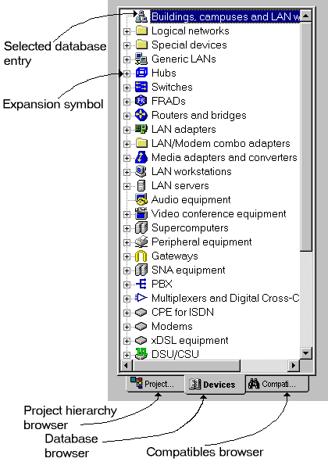
Database Browser

Project Hierarchy Command (View Menu)
The Project Hierarchy command displays the Project hierarchy view of the NetCracker browser. The Project Hierarchy browser is used to display the hierarchical view of a multi-layered, or complex project. For projects that have only one level, there is only one branch in the hierarchical view.
To view the Project Hierarchy browser use one of the following methods:
- From the View menu select Project Hierarchy command.
- On the Browser pane press the Project Hierarchy tab.
NOTES:
- If the Browser is not displayed, open the pane by selecting the View menu, the Bars sub-menu, the Browser Pane command.
- The Project Hierarchy reflects the hierarchical structure of open projects (the name of the project has a .NET file extension). If NetCracker is open, but a project is not open, the Project Hierarchy browser is empty.
To navigate through a multi-layered project:
- Display the Browser pane, if it is not already displayed.
- Open a NetCracker project.
NOTE: The sample directory included with the installation software contains HEIR.NET, a sample project that serves as a good example of a hierarchical project
- Display the Project Hierarchy browser, if it is not already displayed.
- In the Project Hierarchy browser Expand and collapse the NetCracker project by:
- Double-clicking on the top-level of the NetCracker project
- Clicking on the expansion symbol
- Open a subordinate (lower) level of the NetCracker project by double-clicking on a lower-level entry in the Project Hierarchy Browser.
The corresponding Site window is displayed in the Project pane.
NOTE:
- To select (make current) any of the sites of the NetCracker project use the Project Hierarchy browser and double-click on the site window’s name.
- Changing a site window’s name changes its listing in the Project Hierarchy browser.

To open and close the browser pane:
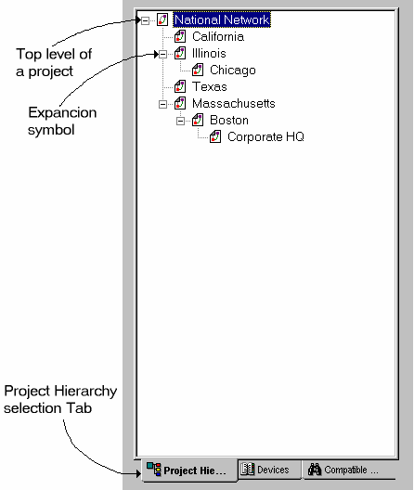
To display or conceal the Browser pane. Select the View menu, the Bar’s sub-menu, the Browser Pane command.

Project Hierarchy Browser

Compatible Components Command (View Menu)
Use the Compatible Components Browser command to display the compatible components view of the NetCracker browser. This view is very similar to the Database Browser view and is used to display the results of a compatible device search.
To view the Compatible Components browse use one of the following methods:
- From the View menu, select Compatible Components.
- Press the Compatible Components tab on the Browser pane.
NOTE: If the Browser is not displayed, open the pane by selecting View menu, the Bars sub-menu, Browser Pane command.

Break Color For Site Name Command (View Menu)
This dialog appears when you chose Break Color from Site Name command from view menu.
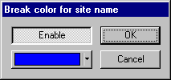
When expanded object contain a broken device its name highlighting in color that you chose from Break Color For Site Name Dialog.

• Enable – Enables this feature
• Set Color – Sets color for the site name

Zoom

Zoom: Zoom In Command (View Menu)
Use the Zoom In command to magnify the contents of the Site window, both Page and Non-Printing region.

Access the Zoom In command by using one of the following methods:
- Press the Zoom In button .
- From the View menu select Zoom, then from the sub-menu select Zoom In.

NOTE: Zoom tools are only visible when the Zoom toolbar is displayed.

__________
See also
Zoom Out Command
Zoom to Page Command
Zoom 1:1 Command
Zoom to One Side Command
Zoom to Page Command
Undo Change Zoom Command
Zoom Control Combo Box
Full Screen Command
Zoom To Region Command

Zoom: Zoom Out Command (View Menu)
Use the Zoom Out command to reduce the contents of the Site window, both Page and Non-Printing region.

Access the Zoom Out command by using one of the following methods:
- Press the Zoom Out button .

- From the View menu select Zoom, then from the Zoom sub-menu select Zoom Out.

NOTE: Zoom tools are only visible when the Zoom toolbar is displayed.

__________
See also
Zoom In Command
Zoom to Page Command
Zoom 1:1 Command
Zoom to One Side Command
Zoom to Page Command
Undo Change Zoom Command
Zoom Control Combo Box
Full Screen Command
Zoom To Region Command

Zoom: Zoom to Page Command (View Menu)
Use the Zoom to Page command to resize the Page to fill the window frame.

Access the Zoom to Page command by using one of the following methods:
- Press the Zoom to Page button .
- From the View menu select Zoom, then from the Zoom sub-menu select Zoom to Page.

NOTE: Zoom tools are only visible when the Zoom toolbar is displayed.

__________
See also
Zoom In Command
Zoom Out Command
Zoom to One Side Command
Zoom 1:1 Command
Undo Change Zoom Command
Zoom Control Combo Box
Full Screen Command
Zoom To Region Command

Zoom: Zoom 1:1 Command (View Menu)
Use the Zoom 1:1 command to set zoom to 100 percent.

Access the Zoom 1:1 command by using one of the following methods:
- Press the Zoom Real Size button .
- From the View menu select Zoom, then from the Zoom sub-menu select Zoom 1:1 command
NOTE: Zoom tools are only visible when the Zoom toolbar is displayed.
The images will print in the zoomed size.

__________
See also
Zoom In Command
Zoom Out Command
Zoom to One Side Command
Zoom to Page Command
Undo Change Zoom Command
Zoom Control Combo Box
Full Screen Command

Zoom: Zoom to One Side (View Menu)
Use the Zoom to One side command to the width of the page if it has a portrait orientation and to the height of the page if it has landscape orientation.

Access the Zoom to One side command by using one of the following methods:
- Press the Zoom One side button
- From the View menu select Zoom, then from the Zoom sub-menu select Zoom to One side .

NOTES:
1. The Zoom to One Side command is only used for getting a closer view of reports.
2. Zoom tools are only visible when the Zoom toolbar is displayed.

__________
See also
Zoom In Command
Zoom Out Command
Zoom to Page Command
Zoom 1:1 Command
Undo Change Zoom Command
Zoom Control Combo Box
Full Screen Command

Zoom: Undo Change Zoom Command (View Menu)
Use the Undo Change Zoom command to return to the previous zoom.

Access the Undo Change Zoom command by using one of the following methods:
- Press the Undo Change Zoom button
- From the View menu select Zoom, then from the Zoom sub-menu select Undo Change Zoom
NOTE: Zoom tools are only visible when the Zoom toolbar is displayed.

__________
See also
Zoom In Command
Zoom Out Command
Zoom to Page Command
Zoom 1:1 Command
Zoom to One Side Command
Zoom Control Combo Box
Full Screen Command
Zoom To Region Command

Zoom to Region Command
Use the Zoom to Region command to select a region to magnify.

Access the Zoom to Region command by:
- Pressing the Zoom to Region button
NOTE: Zoom tools are only visible when the Zoom toolbar is displayed.

__________
See also
Zoom In Command
Zoom Out Command
Zoom to Page Command
Zoom to One Side Command
Zoom 1:1 Command
Undo Change Zoom Command
Zoom Control Combo Box
Full Screen Command

Bars

Bars: Standard Toolbar Command (View Menu)
The Standard toolbar provides access to standard Windows functions.

To display/conceal this toolbar from view:
- From the View menu select the Bars sub-menu
- From the Bars sub-menu select Standard.
NOTE: A check mark appears next to the Standard command on the Bars sub-menu when the Standard toolbar is displayed. If the Standard command is de-selected from the Bars sub-menu, the Standard toolbar is hidden.

__________
See also
New Command
Open Command
Save Command
Cut Command
Copy Command
Paste Command
Print Preview Command
Print (current site window) Command
About NetCracker
Context Sensitive Help

Bars: Zoom Toolbar Command (View Menu)
The Zoom toolbar includes controls that change the size of objects in a Site window.
This toolbar provides access to standard Windows zoom functions as well as some zoom functions which are specific to NetCracker.

To display/conceal this toolbar from view:
- From the View menu select the Bars sub-menu
- From the Bars sub-menu select Zoom.
NOTE: A check mark appears next to the Zoom command on the Bars sub-menu when the Zoom toolbar is displayed. If the Zoom command is de-selected from the Bars sub-menu, the Zoom toolbar is hidden.

__________
See also
Zoom In Command
Zoom Out Command
Undo Change Zoom Command
Zoom to Page Command
Zoom To Region Command
Zoom 1:1 Command
Zoom to One Side Command
Zoom Control Combo Box
Full Screen Command

Bars: Drawing Toolbar Command (View Menu)
The Drawing toolbar includes drawing controls for lines, colors, and fonts.

To display/conceal this toolbar from view:
- From the View menu select the Bars sub-menu
- From the Bars sub-menu select Drawing.
NOTE: A check mark appears next to the Drawing command on the Bars sub-menu when the Drawing toolbar is displayed. If the Drawing command is de-selected from the Bars sub-menu, the Drawing toolbar is hidden.

Activate the Drawing toolbar using one of the following methods:
- From the Modes toolbar click the Draw Button .
- From the Sites menu select the Modes sub-menu then select the Draw command.

__________
See also
Pointer tool
Line tool
Rectangle tool
Round Rectangle tool
Ellipse tool
Circle tool
Filled Rectangle tool
Filled Round Rectangle tool
Filled Ellipse tool
Filled Circle tool
Text tool
Image tool

Bars: Modes Toolbar Command (View Menu)
The Mode toolbar includes NetCracker specific controls for changing application mode.

To display/conceal this toolbar from view:
- From the View menu select the Bars sub-menu
- From the Bars sub-menu select Modes.
NOTE: A check mark appears next to the Modes command on the Bars sub-menu when the Modes toolbar is displayed. If the Modes command is de-selected from the Bars sub-menu, the Modes toolbar is hidden.

This toolbar includes tools to:
- Activate the Draw toolbar
- Establish links
- Establish draft links
- Assign Traffic
- Assign Calls
- Break and restore components
- Trace a path between two traffic/call generators
- Turn on notes broadcasts
- Turn audible reports off (quiet button)
- Turn on and off generic view
- Reduce images to icons
Each tool has a special cursor associated with it. To return to the Standard pointer, on the Modes toolbar click the Standard button .
Sub-menu | Button Name | Button | Description
Standard | Standard |  | Activates Standard mode. Standard mode is used for most selection functions, including the drag and drop functions and the selection functions.  The drag and drop function is used to select device images from the Image pane and place them on the Project pane.  The selection function is used to obtain information about a device image or link in the Project pane.  Standard mode cursor
Draw | Draw |  | Activates Draw mode and enables the selection of Draw tools from the Draw toolbar or the Sites➔Draw sub-menu.  Draw mode cursor
Link | Link devices |  | Activates Link devices mode. Links between devices on the Project pane can be created in this mode.  See Linking between devices and Linking between devices in multi site projects.  Link devices cursor
Draft Link | Draft Link |  | Activates Draft Link devices mode. To create links between devices in the Project pane select appropriate devices  Draft Link devices cursor
Set Traffic | Set Traffic |  | Activates the Set Traffic mode. Traffic between two devices can be specified by selecting the appropriate devices and then selecting the traffic type from the Profiles dialog.  Set traffic cursor
Set Voice Call | Set Voice Calls |  | Activates the Set Calls mode. Calls between two devices can be specified by selecting the appropriate devices and then selecting the call type from the Profiles dialog.  Set calls cursor
Set Data Call | Set Data Calls |  | Activates the Set Calls mode. Calls between two devices can be specified by selecting the appropriate devices and then selecting the call type from the Profiles dialog.  Set calls cursor
Break/Restore | Break/Restore |  | Activates the Break/Restore mode. Components can be broken or restored in the current network design project. When objects (links or devices) are broken, traffic/calls are rerouted. Animation does not need to be running in order to use the Break/Restore tool, however traffic/call rerouting can only be viewed while animation is running.  Break/Restore cursor
Trace Path | Trace Path |  | Activates the Trace mode and shows Trace Toolbar. The paths between two traffic/call generators can be verified in this mode. Tracing can be done within the same site and between sites in multi-layered projects. If there are multiple paths available between devices Trace Path will show one path for each type of relation.  Trace path cursor
Say Info | Say Info |  | Activates Say Notes mode. To hear (synthesized speech) user supplied notes click on any device.  Say Info cursor
Quiet | Quiet |  | Toggles voice synthesis off.
 | Generic View |  | Change all realistic device images to generic images.
 | Reduce to Icons |  | Enables some devices to be shown as icons.

Bars: Control Toolbar Command (View Menu)
The Control toolbar includes controls to start, stop, pause/resume, and speed up and slow down animation.

To display/conceal this toolbar from view:
- From the View menu select the Bars sub-menu
- From the Bars sub-menu select Control.
NOTE: A check mark appears next to the Control command on the Bars sub-menu when the Control toolbar is displayed. If the Control command is de-selected from the Bars sub-menu, the Control toolbar is hidden.

Button Name | Button | Description
Start |  | Starts animation.
Stop |  | Stops animation.
Pause |  | Pauses animation. Packets/calls are still visible, but are in a frozen state.
Animation faster |  | Speeds up animation.
Animation slower |  | Slows down animation.
Set Default Speed |  | Sets the animation parameters to defaults chosen in the Options dialog.
Animation setup |  | Displays the Animation setup dialog that specifies packet/call intensity, speed and size.

Bars: Database Toolbar Command (View Menu)
The Database toolbar includes database functions and controls to change image formats.
To display/conceal this toolbar from view:
- From the View menu select the Bars sub-menu
- From the Bars sub-menu select Database.
NOTE: A check mark appears next to the Database Toolbar command on the Bars sub-menu when the Database toolbar is displayed. If the Database command is de-selected from the Bars sub-menu, the Database toolbar is hidden.

This toolbar includes tools to:
- Display the devices in the Image pane using one of the following formats: large image, small image, list or detail.
- Sort the database by device type, by vendor or by user
- Hide or show empty folders in the database
- Find all devices in the database compatible with the selected device
- Create custom devices using the Device Factory wizard.
Large images |  | Displays large device images in the Image pane.
Small images |  | Displays small device images in the Image pane.
List |  | Displays device images in the Image pane in the list format.
Details |  | Displays objects in the Image pane in the details format.
Hide Empty Folders |  | Shows or hides empty folders in the database. Uncheck this command to include the empty folders
Find Compatible |  | Switches the browser to the compatible devices view and searches for all devices compatible with the selected device.
Find |  | Use this command to search the database for specific devices.
Device Factory |  | Launches the Device Factory wizard that is used to create custom devices.

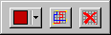
Bars: Trace Toolbar Command (View Menu)
The Trace toolbar includes controls to set trace color and activate multi-trace mode.

To display/conceal this toolbar from view:
- From the View menu select the Bars sub-menu
- From the Bars sub-menu select Trace.
NOTE: A check mark appears next to the Trace command on the Bars sub-menu when the Trace toolbar is displayed. If the Trace command is de-selected from the Bars sub-menu, the Trace toolbar is hidden.

Activate the Trace toolbar using one of the following methods:
- From the Modes toolbar click the Trace Button.
- From the Sites menu select the Modes sub-menu then select the Trace Path command.

Button name | Button | Description
Trace Color |  | Use this button to set the color of the trace path.
Toggle Multi –trace mode |  | If you press this button you can see more then one trace path at a time.
Reset Trace |  | Use this button to hide all trace paths.

Bars: Browser Pane Command (View Menu)
When checked, this command displays the browser pane in the NetCracker work area. There are three browsers from which to select:
- Project Hierarchy browser
- Database browser
- Compatibles browser

Database browser

To display/conceal this pane from view:
- From the View menu select the Bars sub-menu
- From the Bars sub-menu select Browser.
NOTE: When the Browser pane is displayed, there is a check mark next to the Browser pane command on the Bars sub-menu. If you select the Browser command when the Browser pane is displayed, you hide the pane (de-select it from the Bars sub-menu).

NOTE: Selected database entries correspond with the device images displayed in the Image pane.
__________
See also
Default Layout

Bars: Image Pane Command (View Menu)
The Image pane displays device images from the NetCracker database.

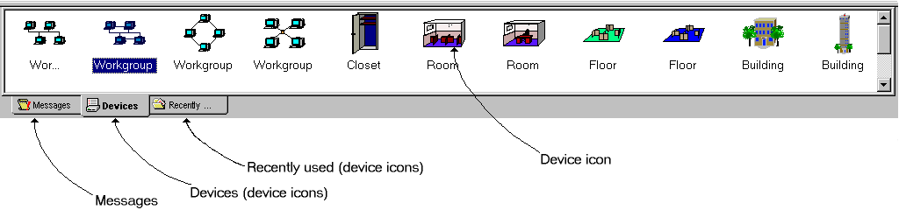
Image Pane
To display/conceal this pane from view:
- From the View menu select the Bars sub-menu
- From the Bars sub-menu select Browser.
NOTE: When the Browser pane is displayed, there is a check mark next to the Browser pane command on the Bars sub-menu. If you select the Browser command when the Browser pane is displayed, you hide the pane (de-select it from the Bars sub-menu).

The Image pane tabs can be selected to display graphical representations of devices (called device images) and the most recently used device images.
For a detailed description of how to use the Image pane to create network design projects, select the Tutorial from the Help menu.
__________
See also
Default Layout

Image Pane

Image Pane: Large Icons Command (View Menu)
The Large Icons command displays objects in the Image pane in the large icon format.
To specify that objects in the Image pane are to be displayed in large icon format:
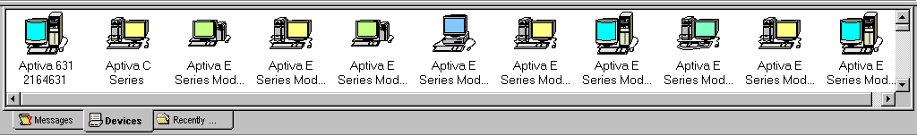
Press the Large Icon button on the Database toolbar, or select form the View menu, the Image Pane sub-menu, the Large Icons command.
Image pane with objects shown in Large Icon format
NOTES:
The Large Icon button is only visible when the Database toolbar is displayed. When the Database toolbar is concealed, from the View menu, the Image Pane sub-menu, select the Large Icon command.

__________
See also
Database Toolbar
View Menu

Image Pane: Small Icons Command (View Menu)
The Small Icons command displays objects in the Image pane in the small icon format.
To specify that objects in the Image pane are to be displayed in small icon format:
Press the Small Icon button on the Database toolbar or select from the View menu, the Palette sub-menu, the Small Icons command.
NOTES: The Small Icon button is only visible when the Database toolbar is displayed. When the Database toolbar is concealed, from the View menu, the Image Pane sub-menu, select the Small Icon command.

__________
See also
Database Toolbar
View Menu

Image Pane: List Command (View Menu)
The List command displays objects in the Image pane in the list format.
To specify that objects in the Image pane are to be displayed in list format:
Press the List Format button on the Database toolbar or select form the View menu, the Image Pane sub-menu , the List command.
NOTES: The List Format button is only visible when the Database toolbar is displayed. When the Database toolbar is concealed, from the View menu, the Image Pane sub-menu, select the List command.

__________
See also
Database Toolbar
View Menu

Image Pane: Details Command (View Menu)
The Details command displays objects in the Image pane in the Details format.
To specify that objects in the Image pane are to be displayed in Details format:
Press the Details Format button in the Database toolbar or select from the View menu, the Image Pane sub-menu, the Details command.
NOTE: The Details Format button is only visible when the Database toolbar is displayed. When the Database toolbar is concealed, from the View menu, the Image Pane sub-menu, select the Details command.

__________
See also
Database Toolbar
View Menu

Database Menu

Hide Empty Folders Command (Database Menu)
Use this command to show or hide empty device and vendor folders in the database.
When this command is checked folders in the database that do not contain any devices are not displayed.

Hierarchy Command (Database Menu)
Use this command to change how the database is sorted as well as to show or hide empty folders.
The Database information can be sorted by:
- Device or object type
- Vendor name
- Custom database

The hierarchy command calls a dialog that has a hierarchy combo box and a check box to show or hide empty folders.
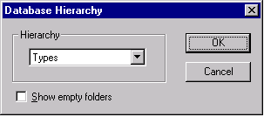
Hierarchy dialog

__________
See also
Database toolbar

Find Command (Database Menu)
Use this command to search the database for specific devices. The database can be search using a variety of criteria that are selected via the Find dialog.
See also
Find Dialog

Device Factory Command (Database Menu)
Use this command to launch the Device Factory wizard. This wizard enables you to create new, custom devices that are either brand new or are based on an already existing device.
To launch the Device Factory wizard use one of the following methods.
- From the Database menu select the Device Factory command
- Press the Device Factory button .

Device Factory Overview

- If a device is selected either in the Project pane or the Image pane the Device Factory-Mode screen comes up.
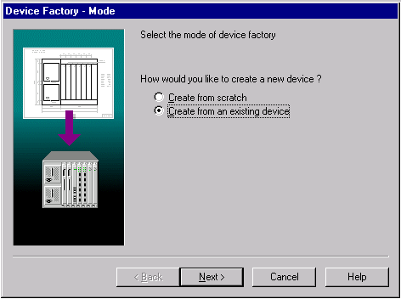
Device Factory Mode
Use this screen to select whether to create your device from scratch or to base it on the selected device. If a device in the image pane is not selected before the device factory starts, a new device from scratch is created.
- The Device factory-Tree screen is used to determine what type of a device you what to create. If you are basing your device on the one that already exists the type of the original device is selected by default.
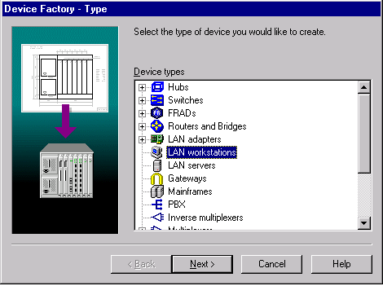
Device Factory Tree
To select a new device type double click on a folder. Some folders may contain subfolders. If a folder has subfolders you are required to select one.
- The type of screen that appears after the Device factory-Tree screen depends on the type of a device you are creating.
Type of device being created | Screen
Computer (workstation or server) | Device Factory-Computer
Adapter | Device Factory-Bus
Stackable | Device Factory-Stackable
Chassis | Device Factory-Slots
All others | No third screen

- The Device factory-Name screen is used to select the picture and enter the name of your new device.
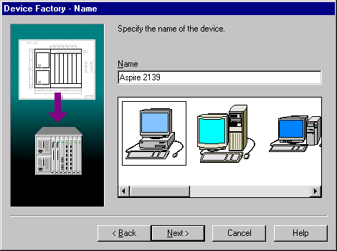
Device Factory Name
- If the device being created can have more then one port, a Device Factory – Port Groups screen comes up.
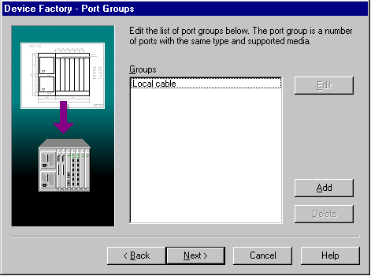
Device Factory Ports
Use this screen to add, edit and delete port groups. A port group can contain up to 64 ports that are capable of using the same link type and media. To add or edit groups of ports the Port Factory wizard is launched.

Note: If the device being created does not have port groups you are done.

Port Factory Overview
The Port Factory Wizard is launched by the Device Factory wizard if the device being created can have more then one port. All the ports in a device are split into groups. All the ports that have the same link type and media can constitute one group.

- Use the Port Wizard – Number screen to specify the number of ports in a group.
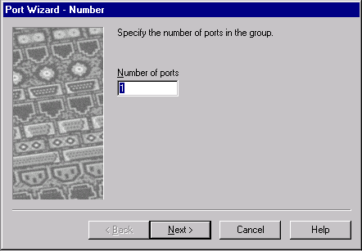
Port Factory Number
- Use the Port Wizard – Link type screen to specify all the link types that can be connected to all the ports in a group. A check next to the link type means that this link type can be connected to the port(s). Click on the checkboxes to check/uncheck them.
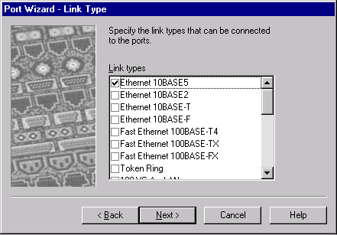
Port Factory Link Type
Note: The possible choices of link types are generated depending on the type of device being made.
- Use the Port Wizard – Media screen to specify the media type that can be connected to all the ports in a group. A check next to the media type means that this media type can be connected to the port(s). Click on the checkboxes to check/uncheck them.
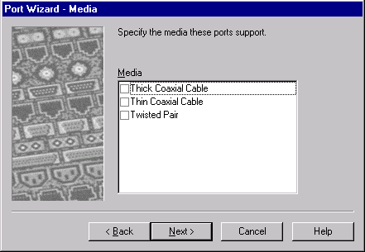
Port Factory Media
Note: The possible choices of media types are generated depending on the link types selected.

After those three steps a new port group is created, and you are returned to the Device Factory wizard.

Global Menu

Model Settings Command (Global Menu)
Use this command to change the name and protocols of a Project Model.
__________
See also
Model settings dialog

Data Flow Command (Global Menu)
Use this command to view and re-assign traffic and calls.

__________
See also
Data Flow Dialog

Project Setup Command (Global Menu)
Use this command to change default device size and font properties in the project. This command calls the Project Setup dialog.

Acquire Update All Command (Global Menu)
Use this command to update the properties of all the devices in the project with current database information.

Profiles Command (Global Menu)
Use this command to display all available traffic and call profiles, and to create new profiles.

__________
See also
Profiles Dialog

Sites Menu

Site Setup Command (Sites Menu)
Use this command to change the name, background, layout, margins, grid, or size in printing page(s) for the active Site.
__________
See also
Name Tab: Site Setup Dialog
Background Tab: Site Setup Dialog
Layout Tab: Site Setup Dialog
Margins Tab: Site Setup Dialog
Grid Tab: Site Setup Dialog
Multipage Tab: Site Setup Dialog

Modes

Modes: Standard Command (Sites Menu)
Use this command to activate Standard mode. Standard mode is used for most selection functions, including:
- The drag and drop functions used to select device images from the Image pane
- The selection function used to obtain information about a device image or link in the Project pane.
Standard Pointer

Modes: Draw Command (Sites Menu)
Use this command to activate Draw mode and enable the selection of Draw tools from the Draw toolbar or the Sites➔Draw sub-menu.
NOTE: If the Draw toolbar is not already displayed when the Draw mode is selected, the toolbar is displayed automatically.

To return to the Standard pointer, click the Standard button in the Modes toolbar or, point to Modes on the Sites menu and click Standard.
Draw Pointer

Modes: Link Command (Sites Menu)
Use this command to activate Link mode. This mode is used to create links between devices in the Project pane.

To return to the Standard pointer, click the Standard button in the Modes toolbar or on the Sites menu point to Modes and click Standard.
Link Pointer

Modes: Draft Link Command (Sites Menu)
Use this command to activate Draft Link mode. This mode is used to create draft links between devices in the Project pane.

To return to the Standard pointer, click the Standard button in the Modes toolbar or on the Sites menu point to Modes and click Standard.
Draft Link Pointer

Modes: Set Traffic Command (Sites Menu)
Use this command to activate Set Traffic mode that is used to specify traffic. Traffic between two devices can be specified by selecting the appropriate devices and then selecting the traffic type from the Profiles dialog.

To return to the Standard pointer, click the Standard button in the Modes toolbar or on the Sites menu point to Modes and click Standard.
Set Traffic Pointer

Modes: Set Voice Call Command (Sites Menu)
Use this command to activate Set Calls mode that is used to specify voice calls. Calls between two devices can be specified by selecting the appropriate devices and then selecting the call type from the Profiles dialog.

To return to the Standard pointer, click the Standard button in the Modes toolbar or on the Sites menu point to Modes and click Standard.
Set Calls Pointer

Modes: Set Data Call Command
Use this command to activate Set Calls mode that is used to specify data calls. Calls between two devices can be specified by selecting the appropriate devices and then selecting the call type from the Profiles dialog.

To return to the Standard pointer, click the Standard button in the Modes toolbar or on the Sites menu point to Modes and click Standard.
Set Calls Pointer

Modes: Break/Restore Command (Sites Menu)
Use this command to activate the Break/Restore mode. This mode enables the breaking and restoring of connections or devices in the current network design project. Break/Restore components (link(s) or device(s)) by clicking on them. When components are broken, traffic/calls are rerouted. Animation does not need to be running in order to use the Break/Restore tool, however traffic/call rerouting can only be viewed while animation is running.

To return to the Standard pointer, click the Standard button in the Modes toolbar or on the Sites menu point to Modes and click Standard.
Break/Restore Pointer

Modes: Trace Path Command (Sites Menu)
Use this command to activate the Trace mode. Trace mode is used to verify paths between two traffic/call generators. The path is determined by selecting the two traffic/call generators, color links indicate the path. Paths can be verified within the same site and between sites in multi-layered projects. If there are multiple paths available between devices Trace Path will show one path for each type of relation.

To return to the Standard pointer, click the Standard button in the Modes toolbar or on the Sites menu point to Modes and click Standard.
Trace pointer

Modes: Say Info Command (Sites Menu)
Use this command to broadcast the notes from the Properties dialog. Click on a device to say it’s notes.

To return to the Standard pointer, click the Standard button in the Modes toolbar or on the Sites menu point to Modes and click Standard.

Say Notes Pointer

Draw

Draw: Pointer Command (Sites Menu)
Use this command to return to the normal pointer in draw mode.

Draw: Line Command (Sites Menu)
Use this command to draw a line.

Draw: Rectangle Command (Sites Menu)
Use this command to draw a rectangle.

Draw: Round Rectangle Command (Sites Menu)
Use this command to draw a round rectangle.

Draw: Ellipse Command (Sites Menu)
Use this command to draw an ellipse.

Draw: Circle Command (Sites Menu)
Use this command to draw a circle.

Draw: Filled Rectangle Command (Sites Menu)
Use this command to draw a filled rectangle.

Draw: Filled Round Rectangle Command (Sites Menu)
Use this command to draw a filled round rectangle.

Draw: Filled Ellipse Command (Sites Menu)
Use this command to draw a filled ellipse.

Draw: Filled Circle Command (Sites Menu)
Use this command to draw a filled circle.

Draw: Text Command (Sites Menu)
Use this command to create a text box.

Draw: Image Command (Sites Menu)
Use this command to insert an image.

Trace

Trace: Set Trace Color Command (Site Menu)
Use this command to set the color of the trace path.

Trace: Multi-Trace Mode Command (Site Menu)
If you chose this command you can see more than one trace path at a time.

Trace: Reset Trace Command (Site Menu)
Use this command to hide all trace paths.

Object Menu

Properties Command (Object Menu)
Use this command to view and edit Properties of the selected object.
__________
See also
Properties Dialog

Open Command (Object Menu)
Use this command to perform the following operation on the selected object:
- For devices, open a [Device] Configuration dialog box.
You can configure complex or modular devices such as hubs, routers, and some workstations using this dialog box.
- For links, open the Link Assistant dialog box.
- For objects that have been converted to containers (such as LANs, buildings, cities, campuses and floors), open the associated Site window .

From the any [Component] Configuration dialog box, click Setup to open the Properties dialog box.

Expand Command (Object Menu)
Use this command to convert an object to a container, opening a new Site window with the same name as the container.

Objects that can be converted to containers include LANs, buildings, cities, campuses, and floors. See Adding Levels and Sites Using Containers

Configuration Command (Object Menu)
Use this command to view and change the configuration of the selected object.

__________
See also
Configuration Dialog

Configure Ports Command (Object Menu)
Use this command to open a Port Configuration dialog.

Define Statistics Command (Object Menu)
Use this command to open Statistical Items dialog. This dialog is used to set up which statistics are displayed for an object, and in what format. It is also used to select which statistic is broadcast using synthesized speech.

__________
See also
Say: Current Statistics

Associated Data Flow Command (Object Menu)
Displays the [Object] Data Flow dialog , which identifies the origins and destinations of all data flows to or from this object. If a traffic/call type has not been specified for the selected object, a Message dialog is displayed. This command is enabled only when the selected object is a traffic generator.

Find Compatible Command (Object Menu)
Switches the browser to the compatible devices view and searches for all devices compatible with the selected device.

Acquire Update Command (Object Menu)
Use this command to update the selected device from the database.

Break Command (Object Menu)
Use this command to de-activate a component (device or link). Animation shows how traffic/calls are rerouted.

When a device or a link is broken, NetCracker shows a over the component and traffic/calls are re-routed, if possible, or dropped. Dropped traffic/calls appear as an intermittent flash or burst during the animation. For example if packets/calls were being dropped in a workstation it would look like this: 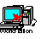

Restore Command (Object Menu)
Use this command to restore a broken component (device or link). Animation shows how traffic/calls are routed.

When a device or link is restored, the is removed and traffic/calls can flow through the device or link.

Organize Command (Object Menu)
Use this command to arrange objects in a specified geometrical pattern such as a circle or line.

__________
See also
Organize Dialog

Say

Say: Current Statistics Command (Object Dialog)
Use this command to Broadcast (synthesized speech) statistics selected in the Statistical Items dialog.

Say: Notes Command (Object Menu)
Use this command to Broadcast (synthesized speech) custom Notes about the selected object.

To enter or change notes, in the Properties dialog box click on the Notes tab and edit the Notes field.
To open the dialog box, use one of the following methods:
- Right click on the object and on the local menu click Properties .
- Select the object and on the Object menu click Properties.

Say: Description (Object Menu)
Use this command to broadcast (synthesized speech) a vendor-supplied description of the selected object.

To enter, change or read the description, in the [Component] Properties dialog box click the Description tab.
To open this dialog box, use one of the following methods:
- Right click on the object and on the local menu click Properties.
- Select the object and on the Object menu click Properties.

Add to Database

Add to Database: Selected Component Command (Object Menu)
Adds the selected object to the custom database, keeping all the properties.

Add to Database: Via Factory Command (Object Menu)
Launches the Device Factory wizard giving the user an option to create a new device based on the device selected in the project pane.
__________
See also
Device Factory

Styles

Styles: Draw Color Command (Object Menu)
Use this command to change the outline color of the selected object.

Styles: Fill Color Command (Object Menu)
Use this command to change the fill or background color of the selected object.

Styles: Text Command (Object Menu)
Use this command to edit the text in the label of the selected object.

Styles: Font Command (Object Menu)
Use this command to change the font of the label of the selected object.

Styles: Title Command (Object Menu)
Use this command to display or hide the title of the selected object, link’s part or indicator.

Styles: Image Command (Object Menu)
Use this command to change the image that represents a selected object.

Arrange

Arrange: Move To Front (Object Menu)
Use this command to move the selected object to the front.

Arrange: Move To Back (Object Menu)
Use this command to move the selected object to the back.

Arrange: Move Forward (Object Menu)
Use this command to move the selected object forward one position in the z-order or plane.

Arrange: Move Back (Object Menu)
Use this command to move the selected object back one position in the z-order or plane.

Control Menu

Start Command (Control Menu)
Use this command to start the animation.

Stop Command (Control Menu)
Use this command to stop the animation.

Pause Command (Control Menu)
Use this command to pause the animation.

To resume the animation, use one of the following methods:
- In the Control menu click Pause again.
- In the Animation toolbar Click the pause button.

Simulation Faster Command (Control Menu)
Use this command to speed up simulation and animation. The top simulation speed can be severely limited by the speed of the computer NetCracker Professional is running on.

Simulation Slower Command (Control Menu)
Use this command to slow down the simulation and animation.

Animation Faster Command (Control Menu)
Use this command to speed up the animation.

Animation Slower Command (Control Menu)
Use this command to slow down the animation.

Animation Default Command (Control Menu)
Use this command to set all animation parameters to the defaults. Defaults can be changed in the Options dialog under the Packet Tab and Calls Tab.

Animation Setup Command (Control Menu)
Use this command to change packet and call image size, intensity, and speed.

__________
See also
Packets Tab: Animation Setup dialog
Calls Tab: Animation Setup Dialog
Advanced Animation Setup

Quiet Command (Control Menu)
Use this command to halt all synthesized speech.

Tools Menu

IP Planner (Tools Menu)
Use this command to start IP Planner. IP Planner allows you to assign IP addresses to the device ports based on physical subnet divisions and IP subnets.
__________
See also
IP Planner Dialog
Tools Menu

HTML Export (Tools Menu)
Use this command to export your project to HTML format. Once the project has been exported the HTML version can be view with any Internet browser.

Graphics Export (Tools Menu)
Use this command to export your project to graphics format. Once the project has been exported the graphic version it can be viewed with any graphics viewer.

Default Layout Command (Tools Menu)
Resets the Browser, Image and Project panes to their default layout.
NOTE: The default layout is selected by NetCracker Technology and can not be changed.

Options Command (Tools Menu)
Use this command to displays the Options dialog. This dialog is used to specify how frequently files are auto-saved, NetCracker start up options, confirmations, and default animation settings.
__________
See also
General Tab: Options Dialog
Confirmations Tab: Options Dialog
Packets Tab: Options dialog
Calls Tab: Options Dialog

Reports

Reports: BOM Command (Tools Menu)
Use this command to generate a bill of materials report.

Reports: Device Summery Command (Tools Menu)
Use this command to generate a device summary report

Reports: Workstations Command (Tools Menu)
Use this command to create a workstations report.

Reports: Servers Command (Tools Menu)
Use this command to generate a servers report.

Reports: Network Adapters Command (Tools Menu)
Use this command to generate a network adapters report.

Reports: Hubs Commands (Tools Menu)
Use this command to generate a hubs report.

Reports: Switches Command (Tools Menu)
Use this command to generate a switches report

Reports: Bridges and Routers Command (Tools Menu)
Use this command to generate a bridges and routers report.

Reports: Wizard Command (Tools Menu)
Use this command to launch a report wizard.

Window Menu

New Window Command (Window Menu)
Use this command to open another window for the same site.

Cascade Command (Window Menu)
Use this command to rearrange open Site windows in an overlapping cascade.

Tile Command (Window Menu)
Use this command to rearrange open Site windows in non-overlapping tiles.

Arrange Icons Command (Window Menu)
Use this command to arrange Site windows icons at the bottom of the work area.

Help Menu

Topics and Index Command (Help Menu)
Use this command to open Help.

How to Use Help Command (Help Menu)
Use this command to display Microsoft Windows™ Help on how to use Help.

Quick Tour Command (Help Menu)
Use this command to display the “Designing a Simple Project” topic from NetCracker help.

Tutorial Command (Help Menu)
Use this command to open the Tutorial. The Tutorial is another help file that tells you step by step how to use NetCracker.

NetCracker on the Web Command (Help Menu)
Use this command to open your default Internet browser to NetCracker Technology’s home page at www.netcracker.com.

About NetCracker Command (Help Menu)
Use this command to view copyright and NetCracker version information.

Dialogs

Media Colors Dialog
Use this dialog to set up media color.

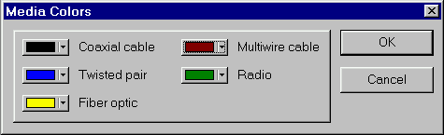
Media Colors Dialog
To change the color of media click on the box next to media type and select the color.

Break Color For Site Name Dialog
This dialog appears when you chose Break Color from Site Name command from view menu.
When expanded object contain a broken device its name highlighting in color that you chose from Break Color For Site Name Dialog.

• Enable – Enables this feature
• Set Color – Sets color for the site name

Site Setup Dialog

Name Tab: Site Setup Dialog
To change the name of the Site
Edit the Name text box.

Name changes apply to the Site window. If there is a container object (such as a building, LAN, city, campus, or floor) associated with the Site window, the name of the container changes when you change the Site window name.

Background Tab: Site Setup Dialog
To change the background color of the Printing Region of a Site window.
Select a color in the Page color box. Click on the button below the color palette to see more colors.
This color applies to the on-screen Page appearance and printing if you use a color printer.

To change the color of the Non-Printing Region of a Site window
Select a color in the Non-Printing Region color box. Click on the button below the color palette to see more colors.
This color appears on-screen. It does not print.

To add a background map or image to a page
Check the Map box. To select a map you can use one of the following methods:
- Select a map from the Select map file combo box
- Click the Browse button. A file Open dialog is displayed. This dialog opens to the NetCracker Maps directory.
Select any graphics file and click the OK button.
NOTE: Native NetCracker map files have a NTM extension.
The image is inserted in real size. To stretch the image over the entire site, check the Size to Site box. If the Size to Site box is checked, the Keep Ratio box becomes enabled. Check this box to keep the original vertical to horizontal ratio of the image. Uncheck this box to disregard proportions when stretching the image to fit the site.

Layout Tab: Site Setup Dialog
To change Page size use one of the following methods:
- Select the size of the page from the Paper Size combo box.
- Press the Get Printer Layout button to use the default paper size of the selected printer.
- Type in the Width and Height of the page in the size section.

To change Page orientation
Click the Portrait (vertical) or Landscape (horizontal) radio button.

Margin Tab: Site Setup Dialog
To change margin size use one of the following methods:
- Type in the size of each margin in the appropriate fields.
- Select margin type from the combo box. Click the Set button to apply it.
- Click Get Printer Margins to use the smallest margins the selected printer can print.

Grid Tab: Site Setup Dialog
To apply or remove a grid to a Page
Click or clear the Show Grid box.

To turn on or off the automatic alignment to the grid
Click or clear the Snap to Grid box.

To change grid color
Select a color in the Grid Color selection box.

To change the spacing of the grid
Edit the values for the Horizontal and Vertical fields.

Multipage Tab: Site Setup Dialog
A site can consist of several printing pages. Check the Enable Multiple Pages box to turn on this feature.
To change the number of pages lengthwise used for that site, edit the Horizontal field. To change the number of pages heightwise used for that site, edit the Vertical field.
Check the Show Sheet Edges box to show the borders between the printing pages. Uncheck this box to hide the borders between the printing pages.

Animation Setup Dialog

Packet Tab: Animation Setup Dialog
Animation Setup dialog is used to change the appearance and speed of the animation.
To change the number of packets per second (intensity)
Adjust the intensity slide bar.

To change packet speed
Adjust the packet speed slide bar.

To change the packet image size
Adjust the packet size slide bar.

Any changes apply to the on-screen appearance of the packets and do not affect any network or data flow parameters.

To see the changes as you make them, check the auto apply box.

To change the scale of intensity or speed, click on the Advanced button and edit the minimum and maximum values.
The greater the difference between the minimum and maximum values, the greater the difference between packet/call speeds and intensities.
__________
See also
Animation Default Command
Packets Tab: Options dialog
Advanced Animation Setup
Understanding NetCracker Animation
Changing How the Animation Appears

Calls Tab: Animation Setup Dialog
Animation Setup dialog is used to change the appearance and speed of the animation.
To change the number of calls per second (intensity)
Adjust the intensity slide bar.

To change call speed
Adjust the call speed slide bar.

To change the call image size
Adjust the call size slide bar.

Any changes apply to the on-screen appearance of the calls and do not affect any network or data flow parameters.

To see the changes as you make them, check the auto apply box.

To change the scale of intensity or speed, click on the Advanced button and edit the minimum and maximum values.
The greater the difference between the minimum and maximum values, the greater the difference between packet/call speeds and intensities.
__________
See also
Animation Default Command
Calls Tab: Options Dialog
Advanced Animation Setup
Understanding NetCracker Animation
Changing How the Animation Appears

Options Dialog

General Tab: Options Dialog
Use this dialog to specify:
- How frequently files are auto-saved
- NetCracker start up options
- Confirmations
- Default animation settings.
To access this dialog from the Tools menu use the Options command.
- To enable auto save, check the Auto-save enabled box and type in the time interval between saves in the Every (number) minutes field.
- To change NetCracker’s start-up options, select one of the radio buttons.

Confirmations Tab: Options Dialog

To access this dialog select Options from the Tools menu then select the Confirmations tab.
Use this page to sets confirmations. For the each event checked, a confirmation message appears when the event occurs.

Packets Tab: Options Dialog
The Options dialog is used to change the default parameters of the animation. To set your current animation parameters to the defaults, use the Animation Default Command. To change the animation parameters without changing the default parameters, use the Animation Setup Command.
To change the number of packets per second (intensity)
Adjust the intensity slide bar.

To change the packet speed
Adjust the packet speed slide bar.

To change the packet image size
Adjust the packet size slide bar.

Any changes apply to the on-screen appearance of the packets and do not affect any network or data flow parameters.

To change the scale of intensity or speed, click on the Advanced button and edit the minimum and maximum values.
The greater the difference between the minimum and maximum values, the greater the difference between packet/call speeds and intensities.
__________
See also
Packet Tab: Animation Setup Dialog
Advanced Animation Setup
Understanding NetCracker Animation
Changing How the Animation Appears

Calls Tab: Options dialog
Options dialog is used to change the default parameters of the animation. To set your current animation parameters to the defaults use the Animation Default Command. To change the animation parameters without changing the default parameters use the Animation Setup Command.
To change the number of calls per second (intensity)
Adjust the intensity slide bar.

To change call speed
Adjust the call speed slide bar.

To change the call image size
Adjust the call size slide bar.

Any changes apply to the on-screen appearance of the calls and do not affect any network or data flow parameters.

To see the changes as you make them, check the auto apply box.

To change the scale of intensity or speed, click on the Advanced button and edit the minimum and maximum values.
The greater the difference between the minimum and maximum values, the greater the difference between packet/call speeds and intensities.
__________
See also
Calls Tab: Animation Setup Dialog
Advanced Animation Setup
Understanding NetCracker Animation
Changing How the Animation Appears

Legends Dialog

Packet Shapes Tab: Legends Dialog
The packet Shapes tab shows what data flow types are associated with what shape.
Users cannot change these shapes.

Device Dialogs

Statistical Items Dialog
Statistical Items dialog is used to designate what statistical indicators are displayed, and in what format. It is also used to set what statistical information is broadcast in Say Statistics mode. This dialog is different for different objects, since only statistics relevant to the selected device, link or data flow are displayed. To select an indicator put a check in the checkbox next to it. There are three types of indicators (not all are available for all statistics): bar graph, number and histogram. Any number of indicators can be selected for one object.
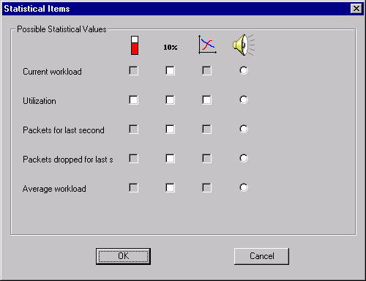
Statistical Items dialog

Find Dialog
The Find dialog is used to select the database search parameters.
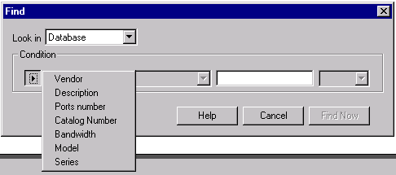
Find Dialog
The first field in the dialog is used to specify according to what property the search is conducted. The second field is used to specify the relation type (greater then, less then, etc.). The third field is used to specify the value to be searched for. The last field is used to specify units, if any.
After the search is complete the browser pane automatically switches to a Find view, which displays found devices. After that you can run a search only among devices already found, by running find again.

Associated Data Flow Dialog
Use this dialog to view data flow distribution to and from this device. Information about the origin(s) of incoming data and destination(s) of out going data is presented in pie chart format.

Properties and Configuration Dialogs

Properties Dialog
This dialog box is assembled dynamically from the relevant NetCracker data.
The Properties dialog is used to view and edit device properties. The tabs and fields in this dialog vary depending on the device type.

To access the Properties dialog use of one of the following methods:
- Open the local menu by right clicking on the device and selecting the Properties command.
- Select a device then from the Object menu, select Properties.
- Double click on the device or from the Object menu select Configuration to open the Configuration dialog. To open Properties dialog for the selected component click on the Device setup or Plug-in setup button in the Configuration dialog.
Help on selected fields:
NOTE: Some of the fields described below do not appear for some of the devices

Tab | Name of field | Description
General | Vendor | Name of the company that manufactures this device.
General | Description | A description of the device supplied by the manufacturer.
General | Name | The name of the device in the project.
General | Model | Model name supplied by the manufacturer.
General | Catalog number | Catalog number of the device supplied by the manufacturer.
General | Target Environment | Information about device environment supplied by the manufacturer.
General | Configuration | Information about device configuration.
Notes | Notes | Additional information about this device supplied by you. Also see: Say Notes
Price/Support | Price | The price of the device supplied by the manufacturer
Stack | Max. number in stack | The maximum number of those devices that can be stacked. Also see: Adding a Device to a Stack
Protocols | Supported bridging protocols | List of bridging protocols that can be used by this device.
Protocols | Supported network protocols | List of network protocols this device is capable of routing. The device acts as a bridge for the protocols that are not checked
Protocols | Network protocol | The network protocol this device uses to send and receive packets.
Protocols | Supported routing protocols | List of routing protocols that can be used by this device.
Chassis | Slots | Number of slots for plug-ins. Also see: Adding Plug-Ins or Network Cards To a Device
Hardware | Slots | Number of slots for network cards. Also see: Adding Plug-Ins or Network Cards To a Device
Hardware | I/O Bus type | This read only field shows what buses this device supports.
Computer | Performance Benchmark | Type of test used to determine the performance of this device.
Computer | Performance Value | The score of this device on the benchmark test described above

To view or change the setup of a port
Click on the Ports tab, select a port, and click the Setup button. The Port Properties dialog is displayed.
__________
See also
Model Settings Dialog

Ports Configuration Dialog
Use this dialog to quickly check which ports are busy in a device and also to access Port Properties dialog.
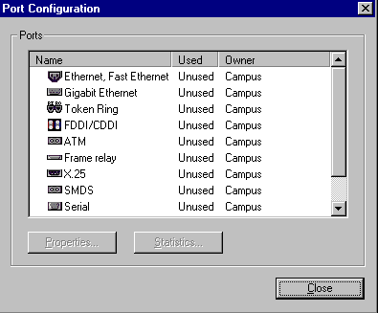
Port Configuration Dialog

Port Properties Dialog
The Port Properties dialog is used to view and edit port properties. The tabs and fields in this dialog vary depending on the port type.
To open this dialog box in any Device Properties dialog box, select the Ports tab and press th Setup Port button.

Help on selected fields:
NOTE: Some of the fields described below do not appear for some of the devices
General | Name | This field is showing the port’s name.
General | Interface | List of Physical layer protocols for WAN’s and physical and MAC layer protocols for LAN’s only.
General | Connector | Type of physical connector to a port. Example: RJ48, DB, AUI, etc.
General | Media | List of media types supported by this port.
General | Description | The vendor or custom supplied description of this port.
Protocols | Routing protocol | The routing protocol this port uses. The model routing protocol is used by default.
Protocols | Bridging protocol | The bridging protocol this port uses. The model bridging protocol is used by default.
Protocols | MAC Address | Use this field to type the device’s MAC Address.
Protocols | Subnet Name | IP Planner uses this field to show the subnet name.
Protocols | Subnet Mask | Use this field to type the subnet mask of the network.
Protocols | IP Address | This group of controls is used for setting IP Addresses. Users can either add IP Addresses or edit and delete existing IP Addresses.  Note: This field is also used by IP Planner to assign an IP Address to a selected device.
Protocols | Routed protocols | List of protocols this port routes. If the protocol is checked it is routed. If the protocol is not checked it is bridged.
Telecom | Maximum bandwidth | The maximum bandwidth this port supports. Links with throughput greater then the maximum bandwidth of a port can not be connected to that port.

__________
See also
Model Settings Dialog

Model Settings Dialog
The Model Settings dialog is used to view and edit model properties.
To access the Model Settings dialog, on the Global menu use the Model Settings command.

Dialog fields:
Protocols | Network protocols | List of network protocols supported in this model
Protocols | Routing protocol | A default routing protocol for the network protocol selected
Protocols | Default OSPF type of service | Type of OSPF service if OSPF routing is selected for a TCP/IP network
General | Name | The name of the whole model
Simulation | Reset statistics after topology changes | Specifies whether reset performance statistics after topology changes. When this checkbox is selected, the warm up period is applied after each topology change as well.
Simulation | Warm-up period | Sets the warm up time for the simulation (in units of simulation time). During this period, performance statistics are not being collected

Device Configuration Dialog
Use this dialog box to add plug-ins or network cards, view the configuration, and access device or sub-component properties.

To add a component
Drag the sub-component from the Image pane to the image in the [Component] Configuration dialog box. The cursor changes to a “plus sign” if the sub-component is accepted into the configuration.

To view or change the properties of a component or sub-component
Click Device Setup to view or edit the chassis. Select a sub component and click Plug-In Setup to view or edit a sub-component.
NetCracker displays the Properties dialog box for the sub-component.

To remove a plug-in or network card from a component
Select the sub-component and then select Delete from the local menu.

Simple Device Configuration Dialog
To view or edit the properties of a device
In the Configuration dialog box, click the Setup button, make changes in the Properties dialog box, and click OK.

Document Properties Dialog
Use this dialog to view document properties

Connectivity and Data Dialogs

Link Assistant Dialog
The Link Assistant is used to:
• Establish a link between two devices
• Obtain information about an established link
• Specify which ports to use when establishing a link
• Specify the length of the link
• Delete a link between two devices
• Access the Device Properties dialog

Link Assistant dialog

Link Assistant: Device Image | This field displays the image of the device.
Link Assistant: Device Name | This field displays the name of the device.
Link Assistant: Device Properties Button | The Device Properties button is used to open the Device Properties dialog from Link Assistant.
Link Assistant: Port Properties Button | The Device Properties button is used to open the Port Properties dialog from Link Assistant.
Link Assistant: Ports Selection Panel | The port selection panel is used to select ports to be connected. Highlight a port in one device, then highlight a compatible port in another device and press the Link button to connect them.  - If devices can not be connected, the link assistant still opens so that the reason why the devices cannot be connected can be quickly determined.  - The first ports that can be connected are highlighted by default. In the case that the devices cannot be linked, none of the ports are highlighted.  - A port that already is in use displays a different icon compared to an available port.
Link Assistant: Ports Description | This field displays the description of the selected port.
Link Assistant: Protocols Field | The Protocol field is displayed only when a link has been established. This field is used to select a data link protocol. The available choices depend on the types of ports connected.
Link Assistant: Media Field | The Media field is displayed only when a link has been established. This field is used to select physical layer cable type. The available choices depend on the selected protocol and types of ports connected.
Link Assistant: Bandwidth Field | The Bandwidth field is displayed only when a link has been established. This field is used to select bandwidth/physical layer protocol. The available choices depend on the selected protocol, media, and types of ports connected. If certain Physical layer protocols are selected an additional combo box will appear next to the bandwidth combo box. That combo box is used to add to the information selected in the bandwidth combo box.
Link Assistant: Length Field | The Length field is displayed only when a link has been established. This field is used to select the physical length of the link. If the link length contradicts the rules of network topology an error message is displayed. If the link length is 0 then the length check is not performed.  NOTE: Only LAN (Ethernet, Token Ring and FDDI) links are checked.
Link Assistant: Link Button | Press the Link button to link two selected ports.
Link Assistant: Unlink Button | Press the Unlink button to delete (unlink) an established link.
Link Assistant: Close Button | Press the Close button to exit the Link Assistant.

Access the Link Assistant by:
• Creating a link using the Link tool
• Double-clicking on an established link

To establish a link between two devices
1. From the Modes toolbar select the Link tool .
The cursor changes to indicate you are in Link mode .
2. Click on one device, then click on the second device.
NOTES:
1) If a connection cannot be made because one or both of the devices lacks an adapter card or other plug-in, or are incompatible with one another, an error message is displayed.
2) If a connection cannot be made because one or both of the devices hasn’t any available ports, an error message is displayed.
The Link Assistant dialog, shown above, is displayed.
3. Specify a port for each device to use, identified as Device #1 and Device #2, or use the (default) first available ports. Use the scrollbar to display the entire list.
NOTES:
1) The Link Assistant automatically selects the first available port, shown highlighted in the Port Selection Panel.
2) You can easily distinguish between the available ports by looking at the Port icon displayed in the Port Selection Panel. If a port is in use, it appears to have a connector plugged into it. If the port is not in use, a connector does not fill the port.
4. Press the Link button.
A link is established between the two devices.
5. Edit Link settings or click Close to accept the defaults.
NOTE: NetCracker checks link length to verify that this length is allowed for this type of link. If the length equals zero, a check is not performed.

To change the link settings:
Once a link between two devices is established, you can modify link specifications.
1. Double-click on the link between two devices whose settings you want to change.
The Link Assistant dialog is displayed.
2. Change any of the settings.
3. Press the Close button to apply your changes and close the Link Assistant dialog.

NOTE: You have to establish the link by clicking the Link button before you can view and edit the settings.

To remove a link between two devices:
1. Double-click on the link between two devices whose settings you want to change.
The Link Assistant dialog is displayed.
2. Press the Unlink button to remove the link between the two devices.
3. Press the Close button to apply your changes and close the Link Assistant dialog.

Data Flow Dialog
The Data Flow dialog box displays all the traffic and call profiles assigned between all devices in a NetCracker project.
To access the Data Flow dialog, from the Global menu select Data Flow.
NOTE: Multiple traffic/call types can be assigned to each link.
Click on different parts of the picture to learn more about Data Flow Dialog.
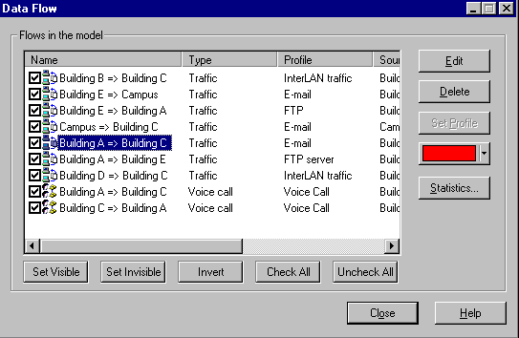
Data Flow dialog
Data Flow: Flows in the model | Name column: Identifies the two devices between which there is a traffic/calls flow.  Type column: Identifies data flow type. The possible data flow types are traffic or call.  Profile column: Identifies the name of the data flow profile that is assigned between the two objects.  Source Column: Identifies the source of the data flow  Destination Column: Identifies the destination of the data flow
Data Flow: Edit Button | Use the Edit button to open the Profile dialog and modify the data flow profile between two objects. The Edit button is only enabled when a data flow has been selected.
Data Flow: Delete Button | Use the Delete button to delete the data flow between the two selected devices. The Delete button is only enabled when a data flow has been selected.
Data Flow: Set Profile Button | Use the Set Profile button to assign a profile (name) to the data flow. If the data flow already has a profile this button remains disabled.
Data Flow: Color Box | Use the color combo box to change the color of the data flow between two selected objects. This color change effects only this data flow, the color of other flows that use the same profile remains unchanged.
Data Flow: Statistics Button | Use this command to open the Statistical Items dialog. This dialog is used to set up the traffic statistics and the format to be displayed. It is also used to select which statistic is broadcasted using synthesized speech.
Data Flow: Set Visible Button | Press this button to select the traffic. When the traffic is selected, the corresponding packets will be shown during animation.
Data Flow: Set Invisible Button | Press this button to deselect the traffic. When the traffic is deselected, the corresponding packets will not be shown during animation.
Data Flow: Invert Button | Press this button to either select or deselect the traffic.
Data Flow: Check All Button | Press this button to select all traffic.
Data Flow: Uncheck All Button | Press this button, to deselect all traffic.
Data Flow: Close Button | Use the Close button to apply the changes and close the dialog.
To change the assigned data flow profile
- To access the Data Flow dialog, from the Global menu select Data Flow.
The Data Flow dialog is displayed.
- In the Flows, in the Model selection select the assigned flow panel and press the Edit button.
The Profiles dialog box is displayed, indicating the pre-defined Profiles.
- Select a different profile from the Profiles list and press the Assign button.
The new profile is assigned and the Profiles dialog closes.
- Repeat Steps 2 and 3 for additional data flows patterns, as needed.
- Press the Close button to apply all changes and close the Data Flow dialog.

To delete the assigned traffic/call profile
- To access the Data Flow dialog, from the Global menu select Data Flow.
The Data Flow dialog is displayed.
- In the Flows, in the Model selection panel select the assigned flow and press the Delete button.
You will be prompted to confirm that you want to delete the data flow.
- To delete the data flow press the Yes button or press the No button to retain the current data flow specification.
The data flow is deleted.
- Repeat Steps 2 and 3 for deleting data flows patterns, as needed.
- Press the Close button to apply all changes and close the Data Flow dialog.

To show statistics for assigned traffic/call profile
- To access the Data Flow dialog, from the Global menu select Data Flow.
The Data Flow dialog is displayed.
- In the Flows, in the Model selection select the assigned flow panel and press the Statistics button.
The Statistical Items dialog box is displayed.
- Select the statistics you want to display and close the dialog
- Repeat Steps 2 and 3 for additional data flows patterns, as needed.
- Press the Close button to apply all changes and close the Data Flow dialog.

__________
See also
Profiles dialog

Profiles Dialog
Use the Profiles dialog box to assign a data flow profile. Profiles dialog box supplies pre-defined traffic and call profiles, or you can create your own profile.
There are three types of data flow:
- Traffic
- Voice Calls
- Data Calls

To assign a profile:
Select a profile from the list and click the Assign button.

To change the color associated with the profile:
1. Select traffic/call color from the color combo box. The “Do you want to update” message appears.
2. Press the Yes button to change the color of all traffic/calls using this profile. Press the No button to change the color of the traffic/call without changing the color of other traffic/calls using this profile.

Profiles dialog

To create your own profile:
- Click on the Add button and select profile type.
- In the Traffic dialog fill out all the fields with appropriate information and close the dialog.

NOTES:
- To return to the Standard pointer from either Set Traffic, Set Voice Call or Set Data Call Mode, click the Standard button (arrow) on the Modes toolbar or on the Sites menu point to Modes and click Standard.
- The Profiles dialog box opens when you perform one of the following operations:
- Assign a data flow between two devices in Set Traffic or Set Calls mode.
- From the Global menu select the Profiles command.
- From the Data Flow dialog click Edit profiles.

Editing Dialogs

Organize Dialog
Use this dialog to organize selected objects.
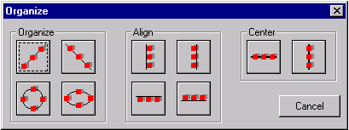
Organize Dialog
- The Organize section functions find the center point by calculating the average position of all selected objects. It then arranges the objects around that center in a selected pattern.
- The Align section functions move all selected objects in line with the object that is the furthest down, up, right, or left; depending on the button selected
- The Center section functions find the center line (vertical or horizontal) by calculating the average position of all selected objects. It then arranges the objects on that line.

Replicate Dialog
Use this dialog to select the number of times you what to copy an object(s). Check the Organize box to position copied objects using the Organize dialog.

Device Find Dialog
The Find Device Dialog is used to search for devices.
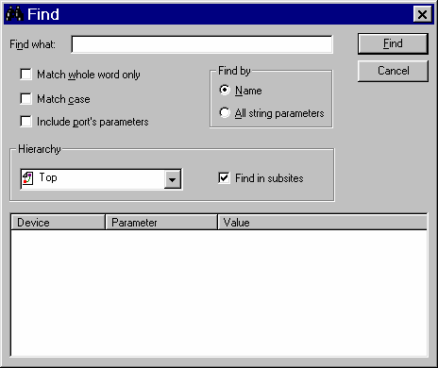
Device Find Dialog
Device Find: Find What | Use this field to enter the string for searching.
Device Find: Match whole word only | Check this option if you want to find the indicated text as a whole word.
Device Find: Match case | Check this option if you want to match the case in the search string.
Device Find: Include port’s parameters | If you check this option NetCracker will find devices containing the prescribed text in the port parameters as well.
Find by Name | If you chose this option NetCracker will find devices containing prescribed text in the Name field.
Find by All string parameters | If you chose this option, NetCracker will find devices containing prescribed text in any string properties.
Device Find: Find in subsites | If you check this option, NetCracker will find text in selected site and in all its subsites.
Device Find: Hierarchy | From this combobox you can choose in what site you will find text.
Device Find: Find Button | Press this button to start searching.
Device Find: Cancel Button | Press this button to close this dialog.
Device Find: Result Window | This window is used to see search results. Double click on found device will select this device and show it in the Project plane.

Project Setup Dialog

Devices Tab: Project Setup Dialog
To change default device size in the project:
Type in the size (from 1 to 32 767) in the field Size.

To set size from the field Size as default device size for newly created projects:
Click Store As Initial Default.

To copy size value from currently selected device to the field Size
Click Get Selected.

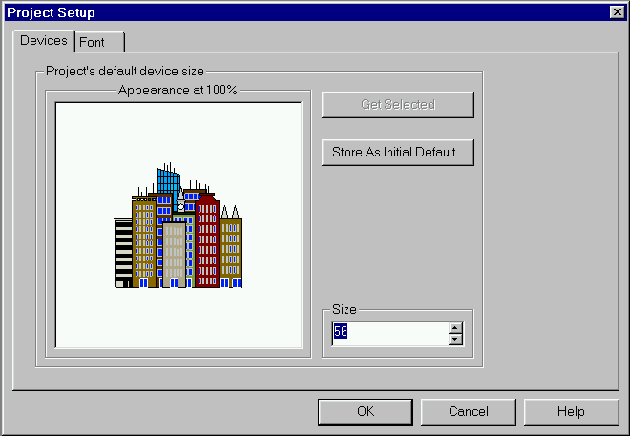
Devices Tab: Project Setup Dialog

Font Tab: Project Setup Dialog
To change project’s default font style:
Set up font attributes.

To set font style as default font style for newly created projects:
Click Store As Initial Default.

To copy font style from currently selected title to the dialog
Click Get Selected.

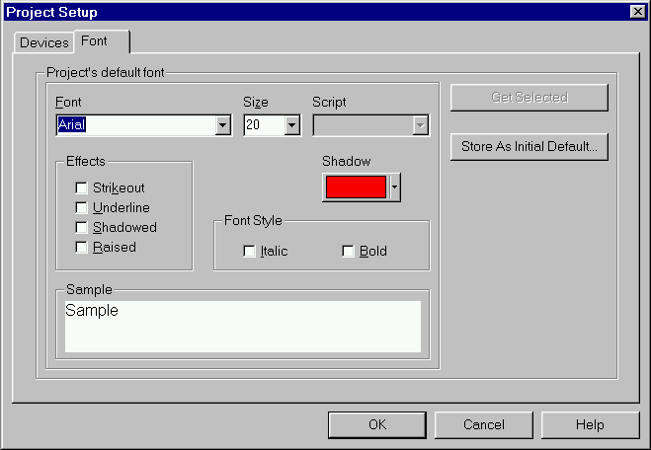
Font Tab: Project Setup Dialog

Export Dialogs

HTML Export Wizard
Use this wizard to specify parameters of export your project to HTML format. Once the project has been exported the HTML version can be view with any Internet browser.

Snapshot Wizard
Use this wizard to specify parameters of export your project to graphic format. Once the project has been exported the graphic version can be view with any graphics viewer.
Creating a New Profile

Glossary

Local Menu
Local or shortcut menus list commands pertaining to that screen region or selection only. Access local menus by selecting the object or pane, then right-clicking the mouse button.

Connector Icon
A connector icon is a symbolic (graphical) representation of the end of a link.

Device Images
A device image is a graphical representation of an object used to create a network design project. Device images are displayed in the Image pane. The contents of the Image pane correspond with the selected folder in the Device browser.
Device images are selected by clicking on the image in the Image pane. Use the Windows Drag & Drop method to place the images in the Project pane.

Project
Your total network design in NetCracker is called a project. A project can consist on an unlimited number of sites, allowing you to create a hierarchical network structure. In NetCracker only one project can be opened at one time. A saved NetCracker file is also sometimes referred to a Project file.

Site Window
A site window is where you draw your network. Each site may be displayed in more then one site window. This is useful when you have a very large site. Closing a site window does not delete the site. To delete a site, delete the container it is associated with. The Top site can not be deleted.

Site
NetCracker lets you divide Projects into Sites each with a discrete NetCracker window. Project can have multiple Sites in a tree like structure allowing for hierarchical network design. A container in one site is used to represent a site below it.

Container
A container is an object that is used to represent a site below the one on which container is located. Any device from Buildings, Campuses and LAN Workgroups can be expanded into a container. To make a device into a container, thereby creating a new site use the Expand command from the Object menu.

Index
[
[Component] Configuration 144
[Component] Properties Dialog 139
[Simple Device] Configuration Dialog 144
A
about 129
About NetCracker Command (Help Menu) 129
About NetCracker Professional 15
Acquire Update All Command (Global Menu) 113
add 83
Add to Database
Selected Component Command (Object Menu) 121
Via Factory Command (Object Menu) 121
Adding a Device 23
Adding a grid to a Site window 20
Adding an image to a Site window 20
Adding Grids 20
Adding Images 20
Adding maps as backgrounds on a Site window 19
Adding Plug-Ins or Network Cards 29
Adding Plug-Ins or Network Cards To a Device 29
Advanced Animation Setup 38
align 154
animation 124, 125
Animation 135, 136
Basics 12
Color 37
Controls 37
Speed 38
Animation Faster Command (Control Menu) 124
Animation Setup Command (Control Menu) 125
Animation Slower Command (Control Menu) 124
Appearance 37
Aquire Update Command (Object Menu) 119
arrange 121, 122, 123, 128
Arrange
Move Back (Object Menu) 123
Move Forward (Object Menu) 123
Move To Back (Object Menu) 122
Move To Front (Object Menu) 122
Arrange Command (Window Menu) 128
attachment 79
autosave 126
Auto-save 134
AVD 129
AVD Inc. 43
avdinc.com 129
B
Background 18
Background Colors 19
Background Tab
Site Setup 131
Backgrounds
adding maps to 19
backround 114, 131
bar 86, 101
bars 101
Bars
Animation Toolbar Command (View Menu) 99
Browser Command (View Menu) 102
Database Toolbar Command (View Menu) 101
Drawing Toolbar Command (View Menu) 96
Modes Toolbar Command (View Menu) 97
Palette Command (View Menu) 103
Standard Toolbar Command (View Menu) 95
Zoom Toolbar Command (View Menu) 95
bend 22
bent links 22
bill of materials 126
BOM 126
BOM Report Command (Tools Menu) 126
BOM Reports 41
break 116, 119
Break Color For Site Name 90
Break Command (Object Menu) 119
bridges 127
broadcast 121
browser 87, 88, 89, 90, 102, 103
browser pane 102
C
call 115
calls 113, 115, 135, 136
Calls 34, 35
Calls Tab
Animation Setup Dialog 133
Options dialog 135
cascade 128
Cascade Command (Window Menu) 128
center 154
Change Site Name 16
Changing 40
Changing a component's display size 24
Changing a device label 24
Changing colors of Project panes and Non-Printing Regions 19
Changing How the Animation Appears 37
Changing link properties 32
Changing properties of a component or sub-component 26
Changing the name of a site or its container 16
Changing the properties of a device in a stack 28
chassis 144
circle 117
Circuit Switching 34, 35
Client 35
clone 84, 154
close 77
Close Command (File Menu) 77
closing 77
color 122
Color 18
Colors 19
compatible 119
alike 90
compatible components 90
Compatible Components (View Mennu) 90
Complex Design 40
component 121
Component
changing sizes 24
components 26, 139
Components
Breaking 41
configuration 118, 119, 144
Configuration 27, 28, 29
changing a device's 24
changing for devices in a stack
Stackable objects
changing the configuration of 27
Configuration Command (Object Menu) 119
configure 119, 140
Configure Ports Command (Object Menu) 119
configure print 132
Connecting 29
Contacting AVD 43
containers 118
Containers 16, 39
Convert to 39
contents 129
control 124, 125
Control Menu 73
Convert to 40
Converting a traffic generator or receiver to a container 40
copy 82, 83, 84, 154
clone
edit 85
Copy (Edit Menu) 82
Copyright
disclaimer 43
Creating a New Profile 36, 157
Creating Bends In Links 22
Creating Polyline Links 22
Custume Data Profiles 15
cut 82
Cut (Edit Menu) 82
D
data 115
data flow 113, 149, 150, 151, 152, 153
Data Flow 34
Data Flow Command (Global Menu) 113
Data Flow Dialog 149, 150, 151
database 101, 108, 119, 121
Database Browser Command (View Menu) 87
database Hierarchy Command (Database Menu) 107
Database Menu 66
databese 104, 105, 106
databese toolbar 104, 105, 106
datebase 113
default 124, 126
default font 113, 156
Default Layout (Tools Menu) 126
default size 113, 156
Define Statistics Command (Object Menu) 119
delete 82, 83, 84
Delete (Edit Menu) 83
description 121, 139
Design 40
designer 129
Designing a Simple Project 12
destination 119, 138
device 26, 103, 108, 109, 110, 111, 112, 121, 144
database browser 103
Device 23, 24, 25, 27
Stackable 27, 28
device database 87
device factory 108, 109, 110, 111, 112, 121
Device Factory Command (Database Menu) 108
Device Find Dialog 154
Device Summery Report (Tools Menu) 126
Devices
Adding to a project 23
changing labels 24
Devices in a stack 27
changing configuration 27
changing properties of 28
viewing 27
Devices Tab
Project Setup Dialog 156
dial up 115
dialog 130, 131, 132, 134, 136, 139, 142, 144, 146, 148, 149, 150, 151, 152
disable 119
Discover 76
Display 18
Display Size 24
draw 114, 117
Draw
Circle Command (Sites Menu) 117
Ellipse Command (Sites Menu) 117
Filled Circle Command (Sites Menu) 117
Filled Ellipse Command (Sites Menu) 117
Filled Rectangle Command (Sites Menu) 117
Filled Round Rectangle Command (Sites Menu) 117
Image Command (Sites Menu) 117
Line Command (Sites Menu) 117, 118
Rectangle Command (Sites Menu) 117, 118
Round Rectangle Command (Sites Menu) 117
Text Command (Sites Menu) 117
duplicate 83, 84
Duplicate (Edit Menu) 84
E
edit 82, 83, 84, 85
Edit Menu 63
ellipse 117
email 79
enable 120
end 124
erase 83
everything 85
exit 81
Exit Command (File Menu) 81
expand 118
Expand 40
Expand Command (Object Menu) 118
export 157
F
faster 124
file 76, 77, 78, 79, 80, 81
File Menu 63
File New 11
fill 122
filled circle 117
filled ellipse 117
filled rectangle 117
filled round 117
find 107, 138
Find Command (Database Menu) 107
Find Compatible Command (Object Menu) 119
Find Dialog 138
find path 116
flash 119
follow 33
Font Tab 156
Project Setup Dialog 157
fonts 122
forward 123
Frame Relay 35
front 122
full screen 86
Full Screen Command (View Menu) 86
G
General Tab
Options dialog 134
Getting Started 12, 40
global 113
Global Menu 66
Graphic Export 157
grid 114, 132
Grid 18, 20
Grid Tab
Site Setup 132
H
hardcopy 79
help 43, 129
Help Topics Command (Help Menu) 129
hide empty folders
empty folders
remove empty folders
show/hide 107
Hide Empty Folders Command (Database Menu) 107
hierarchy 88, 89
browse hierarchy 107
Hierarchy 31, 39
How to display statistics 41
How to Use Help Command (Help Menu) 129
HTML 157
HTML Export 126
HTML Export Wizard 157
hubs 127
Hubs 29
I
icons 104, 105, 106
image 117, 122
image pane 103
Images 20
adding to Site windows 20
insert 117
instructions 129
intensity 125
IP Planner 126
L
label 122
labels 122
Labels 12, 24
Large Icons Command (View Menu) 104
Layers 29, 31, 39
layout 114, 131
Layout Tab
Site Setup 131
legends 87, 136
Legends Command (View Menu) 87
lessons 129
Levels 29, 31, 39
line 117, 122
link 22, 114, 115, 146, 148, 149
link assistant 146, 148, 149
Link Assistant Dialog 146
Link properties
changing 32
linking 146
Linking 29, 31, 32, 33
Devices Between 31
Same Site 29
linking mode 114, 115
Links 22
load 81
Load 34, 35
M
magnify 90
make device
create device 108
manage 154
map 131
Map 18
maps 114
Maps 19
Margin Tab
Site Setup 132
margins 132
media 87
media color 86, 130
Media Colors Command (View Menu) 86
Media Colors Dialog 130
Menu 63, 64, 66, 70, 71, 73, 74
model 113, 144
Model Settings Command (Global Menu) 113
Model Setup
General and Protocol Tabs 144
Modes
Break/Restore Command (Sites Menu) 116
Draw Command (Sites Menu) 114
Link Command (Sites Menu) 114, 115
Set Call Command (Sites Menu) 115
Set Data Call Command 115
Set Traffic Command (Sites Menu) 115
Standard Command (Sites Menu) 114
Trace Path Command (Sites Menu) 116
Modes: Draft Link Command (Sites Menu) 115
Modular devices
assembling of 29
move 82, 83, 122, 123
Multipage Site Setup 132
multiple pages 132
N
name 78, 113, 130, 144
Name Tab
Site Setup 130
network adapters 127
new 76, 128
New 11
New Command (File Menu) 76
New Device 23
New Window Command (Windows Menu) 128
Non-Printing Region 18
Non-printing regions
changing colors 19
normal zoom 93
notes 121, 139
O
object 118, 119, 120, 121, 122, 123
Object Menu 70
open 76, 77, 81, 118
Open Command (File Menu) 76
Open Command (Object Menu) 118
open dialog 76
options 126
Options 135
Options Command (Tools Menu) 126
organize 121
Organize Command (Object Menu) 121
Organize Dialog 154, 155
output 79
overview 129
P
packet shapes 87
Packet Shapes Tab
Legends 136
Packet Tab
Animation Setup Dialog 133
packets 125, 136
Packets 135
Packets Tab
Options Dialog 135
Page 18
print 14
page setup 114
palette 103, 104, 105, 106
Palette
Details Command (View Menu) 106
List Command (View Menu) 106
Small Icons Command (View Menu) 105
pane 102, 103, 104, 105, 106
Parts of a Site Window 18
paste 83
Paste (Edit Menu) 83
pause 124
Pause Command (Control Menu) 124
Performance 41
Phone Numbers 43
pie chart 119, 138
play 124
plug-ins 144
Plug-Ins 29
pointer 114, 115, 116, 117
Pointer Command (Sites Menu) 117
port 119
Port Properties Dialog 142
ports 140, 142, 146, 148
Ports Configuration Dialog 140
possible traffic 113
preview 80
previous zoom 94
print 14, 79, 80, 81, 132
Print (File Menu) 79
print orientation 131
Print Preview (File Menu) 80
print setup 80
Print Setup (File Menu) 80
printing 79, 80
Printing 14
Printing a Project
Page or Report 14
profiles 113, 149, 150, 151, 152, 153
Profiles 35
Profiles Command (Global Menu) 113
Profiles Dialog 152, 153
project 12, 13, 88, 89, 90, 113
Project 11
Names 11
print 14
project hierarchy 107
Project Hierarchy Command (View Menu) 88
Project panes
changing colors 19
Project Properties 11
Project Setup Command (Global Menu) 113
properties 26, 32, 118, 119, 125, 139, 140, 142, 144
Properties 11
Properties Command 79
Properties Command (Object Menu) 118
protocol 144
protocols 42, 113
PVC 35
Q
Quick 33
Quick Linking 33
Quick Tour Command (Help Menu) 129
quiet 125
Quiet Command (Control Menu) 125
quit 81
R
Receiver
converting to a container 40
recent 81
Recent File Command (File Menu) 81
rectangle 117
reduce 91
refresh 113, 119
Region 94
remove 82, 83
rename 24, 78
Rename 16
Rename Site 16
replace 83
replicate 84, 85
Replicate Command (Edit Menu) 84
Replicate Dialog 154
Report
print 14
report wizard 127
reports 126, 127
Reports 41
Bill of Materials 41
Bridges and Routers Command (Tools Menu) 127
Hubs Commands (Tools Menu) 127
Network Adapters Command (Tools Menu) 127
Servers Command (Tools Menu) 127
Statistical 41
Switches Command (Tools Menu) 127
Workstations Command (Tools Menu) 127
reports zoom 93
Rerouting Traffic 41
reset 126
restore 116, 120
Restore Command (Object Menu) 120
round rectangle 117
routers 127
Routers 29
routing 144
S
save 77, 78
save as 78
Save As Command (File Menu) 78
Save Command (File Menu) 77
saving 77
say 116, 121
Say
Current Statistics Command (Object Dialog) 121
Description (Object Menu) 121
Notes Command (Object Menu) 121
Say Info Command (Sites Menu) 116
search 107, 138
Sections 29, 31, 39
Segments 29, 31, 39
select 85
select all 85
Select All (Edit Menu) 85
send 79
Send Command (File Menu) 79
servers 127
service 144
Set Calls 34
Set Default Speed Command (Control Menu) 124
Set Traffic 34
set up 80, 125
settings 26
setup 80, 144
Sever 35
shape 122, 136
show compatible 119
Show Traffic Command (Object Menu) 119
shut up 125
simulation 124
Simulation
Animation 37
Simulation Faster Command (Control Menu) 124
Simulation Slower Command (Control Menu) 124
simulationslow 124
site 114, 130, 131, 132
Site 16, 17, 40
Add 39
Change name of 39
Site window
adding grids 20
adding maps 19
Site Window 18
Site windows
adding an image to 20
sites 114, 115, 116, 117, 118
Sites 11
Expanding Containers 39
Linking Devices Between 31
Names 11
Sites Menu 66
Sites Setup Command (Sites Menu) 114
size 125
Size 24
slower 124
snapshot 157
Snapshot Wizard 157
software 35
sort 121
sound 125
speech 125
speed 124
Stack
Assembling of 27
Changing Properties 28
stacks 144
Stacks 27
standard 114
start 124
Start Command (Control Menu) 124
start-up options 134
Statistical Indicators 15
Statistical Reports 41
statistics 41, 119, 121
statisticsStatistical Items Dialog 137
status bar 86
Status Bar Command (View Menu) 86
stop 124
Stop Command (Control Menu) 124
Style
Title Command (Object Menu) 122
styles 122
Styles
Draw Command (Object Menu) 122
Fill Color Command (Object Menu) 122
Font Command (Object Menu) 122
Image Command (Object Menu) 122
Text Command (Object Menu) 122
Sub-Components 27, 29
Support 43
switches 127
synopsis 129
System Requirements 145
T
Technical Support 43
text 117, 122
tile 128
Tile Command (Window Menu) 128
Tips for Creating Complex Designs 40
title 22, 122
titles 22
of links 22
toolbar 101
toolbars 95, 96, 97, 99, 101
animation 99, 100
drawing 96, 102
modes 97
standard 95
zoom 95, 96
tools 126, 127
Tools Menu 74
Top 11
Top Site 11
Top Window 11
topics 129
tour 129
trace 33, 116
Trace Toolbar 101
Tracing Path Between Devices 33
traffic 113, 115, 119, 138, 149, 152, 153
Traffic 34, 35, 41
Rerouting 41
Traffic Destinations 138
Traffic generator
converting to a container 40
Tutorial Command (Help Menu) 129
type 117
U
Understanding NetCracker Animation 37
undo 94
update 113, 119
URL 129
using help 129
Utilization 41
V
view 86, 87, 88, 89, 90, 91, 92, 93, 94, 95, 96, 97, 99, 101, 102, 103, 104, 105, 106
View 26
View Menu 64
Viewing
device configurations 24
Viewing or changing a device's configuration 24
Viewing or changing device properties 26
Viewing or changing the configuration of a device in a stack 27
voice 116, 121, 125
W
Web 129
Web Site 129
what-if 116
window 102, 103, 128
Windows 11
New 39
wizard 127
Wizard Command (Tools Menu) 127
workstations 127
Workstations 29
Z
zoom 86, 91, 92, 93, 94
Zoom 94
Undo Change Zoom (View Menu) 94
Zoom 1
1 Command (View Menu) 93
Zoom In Command (View Menu) 90
Zoom Out Command (View Menu) 91
Zoom to One Side (View Menu) 93
Zoom to Page Command (View Menu) 91
zoom in 90
zoom in reports 93
zoom out 91
zoom to 100% 93
zoom to fit 91, 93
zoom to one side 93

