 | INTERNATIONAL TELECOMMUNICATION UNION  TELECOMMUNICATION  STANDARDIZATION SECTOR  STUDY PERIOD 2017-2020 |  | FG-AI4H-DEL5.3
 |  |  | ITU-T Focus Group on AI for Health
 |  |  | Original: English
WG(s): |  | Plenary | E-meeting, 30 September – 2 October 2020
DOCUMENT
Source: |  | Editors DEL5.3
Title: |  | Data annotation specification
Purpose: |  | Discussion
Contact: |  | Shan Xu, CAICT, China |  | Email: xushan@caict.ac.cn
Contact: |  | Sebastian Bosse, Fraunhofer HHI, Germany |  | Email: sebastian.bosse@hhi.fraunhofer.de
Contact: |  | Jianrong Wu  Tencent Healthcare (Shenzhen), China |  | Email: edwinjrwu@tencent.com

Abstract: | This document describes the topics to be addressed in the forthcoming Deliverable 5.3 "Data Annotation Specification". Data annotation would be one of the most dependable factors on model performance, it serves as one important aspect of data quality control on Artificial Intelligence for health. This document is addressed to give a general guideline of data annotation specification, including definition, background and goals, framework, standard operating procedure, scenario classifications and corresponding criteria, as well as recommended metadata, etc. A questionnaire is attached to seek input and collaboration with topic groups in FG-AI4H regarding data annotation. This version is based on the update on FG-AI4H meeting K, 27-29 Jan 2021. This document was submitted as M-045 at the FG-AI4H meeting M (e-meeting), 28 to 30 Sept 2021. A revision marked version is found in document FGAI4H-M-045-A02.

 |  | International Telecommunication Union
 |  | ITU-T | FG-AI4H Deliverable
 |  | TELECOMMUNICATION  STANDARDIZATIONSECTOR  OFITU |  | (draft 2023-01-28)
FG AI4H Deliverable
Proposed Standard for Data Annotation in Health

Summary
This document describes the topics to be addressed in the forthcoming deliverable "DEL05-A03: Data Annotation Specification". Data annotation is one of the most dependable factors on model performance, it serves as an important aspect of data quality control on Artificial Intelligence for health. This document is committed to give a general guideline of data annotation specification, including definition, background and goals, framework, standard operating procedure, scenario classifications and corresponding consistency criteria, as well as recommended metadata, etc. A questionnaire is attached to seek input and collaboration with topic groups in FG-AI4H regarding data annotation.

Keywords
Consistency criteria, Data Annotation, Metadata, Quality control, Standard operating procedure

Editors: | Marc Lecoultre  MLLab.ai | Email: ml@mllab.ai
 | Shan Xu  CAICT, China | Email: xushan@caict.ac.cn
 | Sebastian Bosse  Fraunhofer HHI, Germany | Email: sebastian.bosse@hhi.fraunhofer.de
 | Jianrong Wu  Tencent Healthcare (Shenzhen), China | Email: edwinjrwu@tencent.com

Contributors: | Yanwu Xu  Intelligent Healthcare Unit, Baidu, China | Email: xuyanwu@baidu.com
 | Nathan Guo  ShuKun Techonology, China | Email: guoning@shukun.net
 | Yajun Zhang  Tencent Technology (Shenzhen), China | Email: yajunzhang@tencent.com
 | Chunyang Niu  Zhejiang Lab, China | Email: niucy@zhejianglab.com
 | Guoqiang Li  Zhejiang Lab, China | Email: gli@zhejianglab.com
 | Huihui Fang  Artificial Intelligence Innovation Business, Baidu, China | Email: fanghuihui@baidu.com
 | Harpreet Singh  ICMR, India | Email: hsingh@bmi.icmr.org.in

CONTENTS
Page
1 Scope 7
2 Normative Reference 7
3 Terms and definitions 7
3.1 Terms defined elsewhere 7
3.2 Terms defined in this document 8
3.2.1 Annotation: The process of adding metadata, labels or other information to data. 8
3.2.2 Annotator: A person or system responsible for creating or modifying annotations. 8
3.2.3 Annotation guidelines: A set of rules and instructions for creating annotations. 8
3.2.4 Annotation quality: The level of accuracy, completeness and consistency of the annotations. 8
3.2.5 Data: A set of information that can be annotated. 8
3.2.6 Metadata: Data that describes other data. 8
4 Abbreviations and acronyms 8
5 General requirements 9
5.1 Data types 9
5.2 Annotation methods 9
5.3 Annotation process 9
5.4 Annotation tasks and domains 10
5.5 Annotation format 10
5.6 Annotation guidelines 10
6 Annotation requirements 10
6.1 Annotation types 10
6.2 Annotation format 10
6.3 Annotation guidelines 10
6.4 Quality assurance 10
6.5 Validation 11
7 Evaluation and reporting 11
7.1 Evaluation metrics 11
7.2 Procedures 11
7.3 Reporting 11
8 Background and goals 11
9 Framework 11
10 Standard operating procedure 12
10.1 Independent annotation 13
10.2 Label fusion 13
10.3 Arbitration 13
10.4 Expert reviewing 13
10.5 Decision making box 13
10.6 Annotators training and assessment 14
10.7 Variable description 14
11 Consistency judgement 14
11.1 Input data type classification 14
11.2 Output requirement classification 15
11.3 Criteria option matrix 16
11.4 Post-processing of the annotations 20
12 Recommended metadata 20
13 Output file 20
14 File saving 20
Annex A Questionnaire on data annotation 22
Annex B Examples of endoscopic image metadata 26
Annex C Bibliography 28

List of Tables
Page
Table 1: Summary of common medical measurement modalities 11
Table 2: Summary of input data modalities for AI4H tasks 11
Table 3: Output requirements 12
Table 4 Criteria options in different scenarios 12
Table 5: Criteria calculation for classification 14
Table 6: Criteria calculation for Image detection and segmentation 15
Table 7 Recommended metadata 17

List of Figures
Page
Figure 1: Framework of data annotation and its external relations 8
Figure 2: Data annotation procedure 9

Proposed Standard for Data Annotation in Health - Part 1 : General Requirements and Guidelines

Scope
This part of the proposed standard specifies general requirements and guidelines for data annotation to ensure consistency and quality of the annotations. It applies to various types of data including, but not limited to, images, text, audio, and video. The standard covers both manual and automated methods of annotation and applies to all stages of the annotation process, including design, creation, quality assurance, and maintenance. The standard does not address specific annotation tasks or health domains.

Normative Reference
The following documents are referred to in this text.

[ISO/IEC 2382:2015] ISO/IEC 2382-1:2015, Information technology - Vocabulary - Part 1: Fundamentals
[ISO/IEC 25012:2008] ISO/IEC 25012:2008, Software engineering - Quality metrics - Data annotation

------
[IEC 62304] IEC 62304:2006 + A1:2015, "Medical device software – Software life cycle processes"
[IEC 82304] IEC 82304-1 Health software – Part 1: General requirements for product safety
[FDA] FDA's "Proposed Regulatory Framework for Modifications to Artificial Intelligence / Machine Learning (AI/ML) Based Software as Medical Device
[NMPA] Key Points for the Review and Evaluation of Deep Learning Based Software as Medical Device

Terms and definitions
For the purposes of this document, the following terms and definitions apply:

Terms defined elsewhere
This document uses the following terms defined elsewhere:
3.1.1 Artificial intelligence [ISO/IEC 2382:2015]: Branch of computer science devoted to developing data processing systems that perform functions normally associated with human intelligence, such as reasoning, learning, and self-improvement.
3.1.2 Machine learning [ISO/IEC 2382:2015]: Automatic learning, process by which a functional unit improves its performance by acquiring new knowledge or skills, or by reorganizing existing knowledge or skills.
3.1.1 Medical device [GHTF/SG1/N71:2012]: Any instrument, apparatus, implement, machine, appliance, implant, reagent for in vitro use, software, material or other similar or related article, intended by the manufacturer to be used, alone or in combination, for human beings, for one or more of the specific medical purpose(s) of: a) diagnosis, prevention, monitoring, treatment or alleviation of disease; b) diagnosis, monitoring, treatment, alleviation of or compensation for an injury; c) investigation, replacement, modification, or support of the anatomy or of a physiological process; d) supporting or sustaining life; e) control of conception, f) disinfection of medical devices; g) providing information by means of in vitro examination of specimens derived from the human body; and does not achieve its primary intended action by pharmacological, immunological or metabolic means, in or on the human body, but which may be assisted in its intended function by such means.
3.1.4 Software as a medical device [IMDRF/SaMD WG/N12FINAL:2014]: Software intended to be used for one or more medical purposes that perform these purposes without being part of a hardware medical device.

Terms defined in this document
This document defines the following terms:

Annotation: The process of adding metadata, labels or other information to data.

Annotator: A person or system responsible for creating or modifying annotations.

Annotation campaign:.

Annotation guidelines: A set of rules and instructions for creating annotations.

Annotation quality: The level of accuracy, completeness and consistency of the annotations.

Data: A set of information that can be annotated.

Metadata: Data that describes other data.

Reviewer: A person or system responsible for reviewing annotations.

-----

3.2.1 Controlled vocabulary: An organized arrangement of words and phrases used to index content and to retrieve content through browsing or searching.
3.2.2 Data annotation: Perform operations such as categorizing, sorting, editing, marking, and annotating on the data to be labelled such as images, and add tags to the data to generate machine-readable data codes that meet the requirements of machine learning training.
3.2.3 Metadata: Data that provides information about other data.
3.2.4 Supervised learning: The machine learning task of learning a function that maps an input to an output based on example input-output pairs.
3.2.5 Unsupervised learning: A type of machine learning that looks for previously undetected patterns in a data set with no pre-existing labels and with a minimum of human supervision.

Abbreviations and acronyms
This document uses the following abbreviations and acronyms:
AI | Artificial Intelligence
AI4H | Artificial Intelligence for health
FG-AI4H | Focus Group on Artificial Intelligence for health
ML | Machine Learning
SOP | Standard Operating Procedure

General requirements
The general requirements chapter includes the general requirements for data annotation. This chapter provides an overview of the types of data that the standard applies to, the methods of annotation that are covered by the standard, and the stages of the annotation process that are covered by the standard. It also specifies any limitations or exclusions of the standard. This chapter also includes the format that the annotations should be in, and the guidelines that should be used in the annotation process.

Data types
The standard applies to various types of data included in the following table.
Table 1: Data types and formats covered by the standard
Data type | Formats | Description
Image | ANALYZE 7.5  NIFTI  MINC  DICOM  TIFF | Medical image is a visual representation of a body part or internal organs. Medical image file formats contain more information about the patient’s details and equipment setting. Medical image data was aligned in the form of an array of picture element called as the pixel in two dimensional and voxel in three dimensional.  Image format describes the standardized procedure to store the data inside an image. Medical image dataset contains more images to represent the three-dimensional view.  Medical image intimates the information about the number of pixels in the horizontal and vertical direction, number of bits per pixel (X-ray, CT, MRI are produced grey scale images with 8 bits or 16 bits, PET and SPECT scanner has given colour images with 24 bits per pixel) and number of images per subject. In addition, medical format must be converted to digital format to process and view images. Medical image format conversion is a critical task done before annotation can start.
Text
Audio
Video

Annotation methods
The standard covers both manual and automated methods of annotation. Annotation methods refer to the techniques and processes used to annotate data.
Annotation methods include manual annotation, automatic annotation, and hybrid annotation methods that combine manual and automatic methods. For example, manual annotation can involve having annotators manually label images, text, or audio data with tags or categories, while automatic annotation can involve using machine learning algorithms to automatically label data. The selection of the appropriate annotation method depends on the specific requirements and goals of the application.

Image annotation methods

Manual annotation
This technique involves annotators manually drawing bounding boxes, polygonal regions, or scribbles around objects, attributes, or regions of interest in images. This technique is widely used because it is the most reliable and accurate way to annotate images. It can be time-consuming, however, and requires a significant amount of human effort. To ensure the accuracy of annotations in the medical domain, it is important to use qualified annotators who have experience in the medical field and knowledge of anatomy and physiology.

Full image

Bounding boxes
Bounding box is a popular image annotation technique used to label and localize objects in medical images, such as X-rays, CT scans, or MRI images, to identify and outline regions of interest. The technique involves creating a rectangular box around the target region, such as a bone, organ, or tissue, and assigning labels to describe the contents of the box. The process involves:

Identifying the objects in an image that need to be annotated.

Defining a rectangular box or a boundary around each object. This box is known as a bounding box.

Specifying the coordinates of the bounding box corners. The coordinates are represented in the format (xmin, ymin, xmax, ymax), where xmin and ymin are the coordinates of the top-left corner, and xmax and ymax are the coordinates of the bottom-right corner.

Assigning a class label to each object, which is used to specify the type of object contained within the bounding box.

Repeating the above steps for each object in the image.
The resulting annotation information, which includes the bounding box coordinates and class labels. In health, the accuracy and precision of the bounding boxes is critical, as it can have a significant impact on the diagnosis and treatment of patients. Therefore, it is important to have well-defined standards and guidelines for creating and using bounding boxes in medical imaging.

Polygonal Segmentation
Polygonal segmentation is an image annotation technique used to label and localize objects in images that have complex shapes. Unlike bounding boxes, which use rectangular boxes to define object boundaries, polygonal segmentation uses a series of points connected by straight lines to define the boundaries of objects. This technique is particularly useful in the field of health, where it can be used to segment medical images such as X-rays, CT scans, or MRI images into separate regions, such as bones, organs, or tissue. The process typically involves the following steps:

Identifying the objects in an image that need to be annotated.

Defining the boundary of each object by connecting a series of points that outline the object's shape. These points can be created using an annotation tool or by manually clicking on the image.

Assigning a class label to each object, which is used to specify the type of object contained within the polygonal boundary.

Repeating the above steps for each object in the image.
The resulting annotation information, which includes the polygonal boundary coordinates and class labels, is used to train machine learning algorithms to detect and classify objects in new images. The accuracy of the polygonal segmentation annotations is an important factor in determining the accuracy of the trained models. To ensure high-quality annotations, the process should be done by human annotators and reviewed by annotators to minimize errors.
Polygonal segmentation is more time-consuming than bounding box annotation, but it provides a more accurate representation of object boundaries, especially for objects with complex shapes.

Keypoint
Keypoint annotation is an image annotation technique used to identify and localize specific points of interest in an image. In the field of health, keypoint annotation is used to annotate medical images such as X-rays, CT scans, and MRI images. For example, keypoint annotation may be used to annotate specific points on the human body, such as joints, bones, or organs. The process typically involves the following steps:

Identifying the objects or parts of objects in an image that need to be annotated.

Placing a marker or a dot on the image to indicate the location of each keypoint. This is done by clicking on the image or using an annotation tool.

Assigning a class label to each keypoint to indicate its type or significance. For example, keypoints may be used to annotate the joints of a human body, the corners of a building, or the tip of a nose.

Repeating the above steps for each keypoint in the image.
The resulting annotation information, which includes the x and y coordinates of each keypoint and the associated class label, is used to train machine learning algorithms to detect and track objects in new images.

Polylines
Polyline annotation is a method of image annotation that involves drawing a series of connected line segments along the edges or contours of an object in an image. This method is commonly used for annotating medical images to identify the shape and position of structures in the images. In healthcare, polyline annotation can be used to label various structures such as blood vessels, nerves, tumors, organs, and lesions. The labels can include specific types of vessels or nerves, such as arteries or veins, or indicate the presence of a pathology, such as a malignant tumor or an aneurysm. Additionally, labels can be used to describe the location or extent of the structure being annotated, such as a distal or proximal segment of a vessel, or the size of a lesion.
The process typically involves the following steps:

Identifying the objects or parts of objects in an image that need to be annotated.

Tracing manually the contours of the object of interest using a series of line segments. The segments should be connected to form a closed loop that outlines the entire object

Labelling it with any additional information that may be relevant, such as the type of object or its location within the image

Repeating the above steps for each object in the image.

Elipse and circle

Cuboid

Straight line

Quadratic curves

Video annotation methods

Tracking

Annotation process
The standard applies to all stages of the annotation process, including design, creation, quality assurance, and maintenance.

Role definitions

Annotator
Depending on my task I am everything between a fast learner to an expert in the field. I provide metadata on myself, such as age, experience, etc. I was vetted before getting started and the quality of my diagnostics assessments were evaluated during an onboarding. I am aware of my task, so I know what (task-specific medical calibration) and how (task-specific technical calibration) to contribute (onboarding). I am always aware of my pending tasks and I know how much time I spent on each of my tasks, so I can anticipate when I will be finished. I know my supervisor, whom I can contact for any task specific non-technical question.

Reviewer
I am an extension of the annotator role. The only difference is that I am an expert in the field and that I am not annotating the data from scratch but I have to add, delete and/or modify existing annotations. These annotations may have been provided by one or many annotators. After my contribution the annotation is unambiguous and may be considered the ground truth. However, if even I cannot make a final call I would contact my supervisor, for clarification of the next steps.

Supervisor (Task)
I am an expert in my field. I know the qualifications and the diagnostic quality of my annotators and reviewers. I know better than anyone else what the task is supposed to be. I am responsible for the medical calibration, hence I am the one to be asked for any task-specific medical questions. I am responsible for consistency and quality of the annotations (quality control). I, however, do not contribute by annotating nor reviewing any existing annotations. Therefore, I need to view all annotations done by any annotator and reviewer and I need to understand the history of annotation changes. I may at any point in time contact any annotator or reviewer in order to discuss with him/her his/her decisions and help him/her to achieve best quality annotations. In case I see a degradation of the annotation quality, I may temporarily suspend any annotator or reviewer until the root cause for the degradation is identified.

Manager (Campaign)
I set up campaigns. I can add any number of data points to a campaign. These data points may have been subsetted before based on various conditions. I define the medical task and the diagnoses that need to be done, which in consequence may affect the tooling that is available to the annotators and reviewers. I parameterize the task by setting the minimum number of annotations and I assign annotators and reviewers to campaigns. At any time I can see who is doing what. I know how much time each annotator and reviewer spends on the tasks and I can assess their productivity and compare it to other users. I am starting and closing campaigns and know at any time what the status of the progress is.

Data steward
I am responsible for ingestion and provision of the data points. I make sure the data points fit the tasks and are nor corrupted in any way or form.

Workflows
An annotation campaign is the process of creating annotations for a dataset by using annotators and reviewers. The specific process can vary depending on the specific context and requirements of the application, but here is a general overview of the process:
- Data preparation: Before starting the annotation campaign, the data is prepared by splitting it into smaller chunks, such as images, text, or audio, and creating a protocol for the annotation process. This can include defining the annotation classes, the annotation format, and the annotation instructions.
- Annotation guidelines: A set of guidelines is created to specify the type of annotation, the format, and the rules for creating annotations. These guidelines are shared with the annotators and reviewers.
- Annotator recruitment: Once the data is prepared and the guidelines are in place, annotators are recruited for the annotation campaign. This can include screening potential annotators, training them on the guidelines and the annotation tool, and testing their skills before assigning them to the annotation task.
- Annotation tool: An annotation tool is selected and configured to support the annotation process, such as a graphical user interface, a command-line tool, or a web-based platform.
- Annotators: Annotators are selected and trained to create the annotations according to the annotation guidelines and using the annotation tool.
- Annotation process: The annotators start the annotation process by reviewing the data and creating the annotations. The annotation tool helps the annotators to create the annotations and to check their quality.
- Annotation progress monitoring: During the annotation process, the progress of the annotation campaign is monitored and tracked. This can include monitoring the number of annotations completed, the quality of the annotations, and the efficiency of the annotators.
- Quality control: A quality control process is applied to the annotations to ensure their accuracy and consistency. This process can include several methods such as self-review, peer-review, and automated checks.
- Reviewers: Reviewers are selected and trained to review the annotations and to provide feedback to the annotators. Reviewers can be responsible for checking the annotations for accuracy, consistency, and completeness.
- Review process: The reviewers start the review process by reviewing the annotations and providing feedback to the annotators. The annotators then use this feedback to improve the quality of their annotations. The review process can be done online, offline, or in combination.
- Conflict resolution: In case of conflicting annotations, a conflict resolution process is applied. This can include having an experienced annotator or supervisor review the conflicting annotations, conducting a majority voting process, or using automated conflict resolution techniques.
- Finalization: Once the annotation campaign is completed, the data is finalized and delivered to the end-users. This can include cleaning up the data, creating a final report, and providing technical support to the end-users.
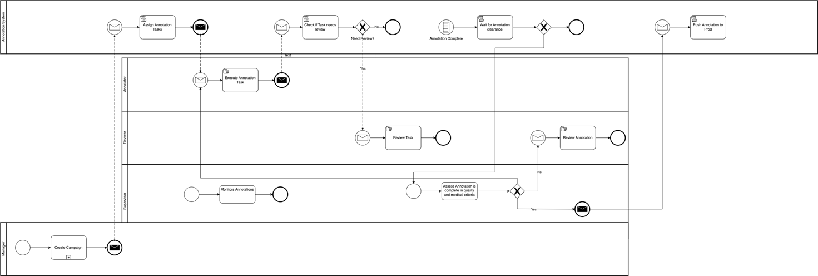

Annotation tasks and domains
The standard does not address specific annotation tasks or domains.

Annotation format
The annotations shall be in a machine-readable format. Annotation outputs are usually exported in one of the following file formats: Comma Separated Value (CSV) files, text files, Java Script Object Notation (JSON), Tensorflow Records (TFRecord). JSON is a lightweight data-interchange format, which is considered easy for humans to read and write and also for machines to parse and process.

Annotation guidelines
The annotation process shall be guided by a set of annotation guidelines.

Annotation requirements
The annotation requirements chapter defines the specific requirements for annotation, such as the types of annotation, the format and structure of the annotations, the guidelines for creating annotations, and the requirements for quality assurance and validation of the annotations. This chapter provides detailed information about the requirements for creating and maintaining high-quality annotations.

Annotation types
The standard shall specify the types of annotation that should be used.

Semantic segmentation

Image classification

Object detection

Pose estimation

Annotation format
The standard shall specify the format and structure of the annotations.

Annotation guidelines
The standard shall provide guidelines for creating annotations.

Calibration

Quality assurance
The standard shall require a quality assurance process to ensure the accuracy and consistency of the annotations.

Validation
The standard shall require a validation process to ensure the annotations meet the requirements

Evaluation and reporting
The evaluation and reporting chapter describes the methods for evaluating and reporting the quality of the annotations, including the evaluation metrics, procedures, and requirements for testing and reporting. This chapter provides detailed information about how to evaluate the quality of the annotations and how to report the results of the evaluation.

Evaluation metrics
The standard shall specify the evaluation metrics to be used to assess the quality of the annotations.

Procedures
The standard shall specify the procedures for testing and measuring the quality of the annotations.

Reporting
The standard shall specify the requirements for reporting the results of the evaluation.

Background and goals
The great potential of digital technologies, especially Machine Learning (ML) and Artificial Intelligence (AI) are recognized to revolutionize the fields of medicine and public health in an unprecedented manner. While holding great promise, this rapidly developing field raises a number of uncertainties, for example if the model is poorly designed or the underlying training data are biased or incorrect, errors or problematic results can occur. AI technology can only be used with complete confidence if it has been quality controlled through a rigorous evaluation in a standardized way. Among all the quality controls, the data annotation would be one of the most dependable factors on model performance. In the case of mislabelled or inaccurate training instances, it is difficult for the supervised model to obtain the expected results.
Quality control on data annotation is a factor that is easily overlooked but crucial to the model performance. It is especially critical to models based on large-scale dataset. Therefore, this addresses the following:
- To assist the quality control of data annotation from standard operating procedure.
- To reduce model performance problems caused by inconsistent data annotations.
- To enable large-scale dataset projects on high diversity of data formats and multi-annotators.
- To facilitate the training and education for non-professional annotators and improve common understandings.

Framework
Data annotation is one of the most dependable factors on the performance of supervised machine models. If the annotation for machine learning is incorrect, the decision rules built by the machine will be biased. As a part of the entire AI4H project, data annotation works as shown in Figure 1. During the testing and evaluation of the supervised machine models, unqualified annotation may be identified, which should be relabelled or deleted from the dataset.
With the help of annotators and annotation tools, a standard operating procedure of data annotation can convert input dataset into qualified annotations for supervised machine learning. This standard operating procedure will be discussed in clause 7 in details.
The information from the data annotation process and the raw dataset can be used for training dataset for supervised machine learning and optimization, as well as testing dataset for the evaluation process. Therefore, data annotation has a very close relationship to the above core process of AI4H model, as a result, recognized as one of the most dependable factors on the model performance.
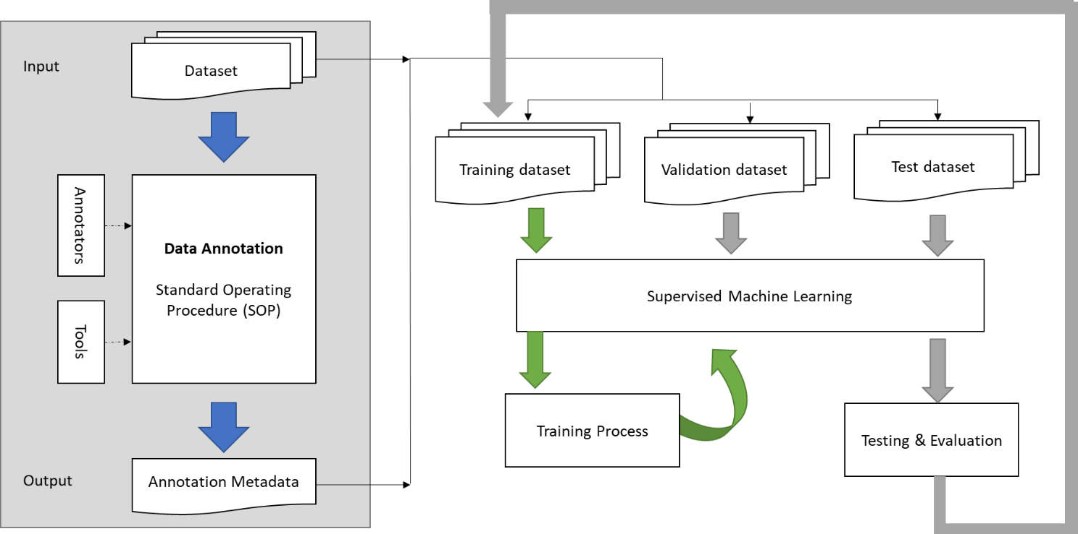
Figure 1: Framework of data annotation and its external relations

Standard operating procedure
To establish a unified understanding and quality control mechanism, a standard operating procedure is recommended. Figure 2 illustrates a formulated process of data annotation, with much feasibility through variables and configurable threshold.
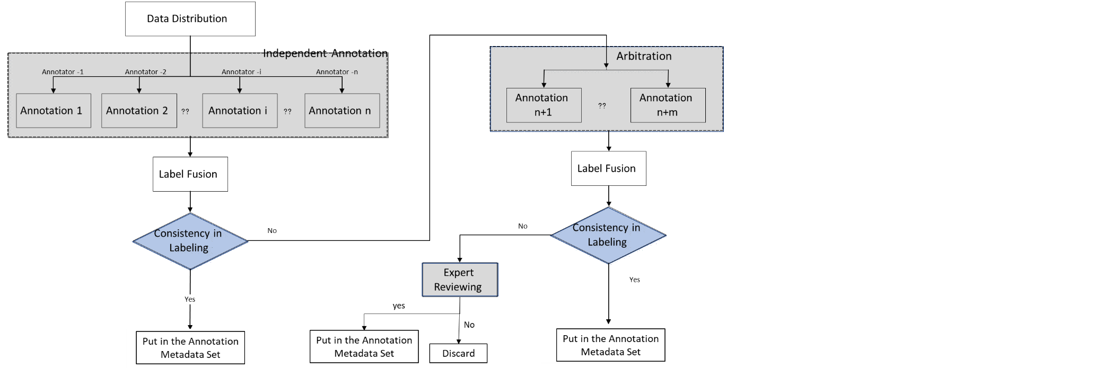
Figure 2: Data annotation procedure

Independent annotation
The data annotation process starts with independent annotation, represented by the left grey box in Figure 2, each instance in the dataset need to be labeled by all or part of annotators independently. To avoid bias in data distribution, it is suggested that the process is carried out by grouping and crossing, and ensure the effective resolution of inconsistencies. Several annotators (represented as variable n in the figure) are invited to label the raw dataset. Certain qualifications are required on the annotators, for example doctors and trained annotators in specific case domain.
However, for cost considerations, some projects will also set up one annotator (Set n to 1) in this parallel independent annotation part, and then goes to arbitration if encounter difficulties.

Label fusion
<TBD>

Arbitration
In the above independent annotation part, if there is an inconsistency that cannot be acceptable, or difficulties and uncertainties in single annotator setting, additional annotator with more experience should be introduced for the arbitration, represented by the upper right grey box in Figure 2. Stricter requirements on the arbitration annotator qualifications, for example, doctor with more than 3 years of experience in the case domain.

Expert reviewing
The expert reviewing is represented by the lower right grey box in Figure 2. This final review deals with some very tricky cases which cannot reach an agreement on the previous steps. Annotations confirmed by review experts will be marked as a final answer, and cases not approved could be considered to send back to arbitration process and arbitrated by another arbitration expert. Stricter requirements on the expert qualifications, for example, with 5 years of experience or more.

Decision making box
Represented by the blue boxes in Figure 2, the judgment and decision making on labelling consistency cannot be avoided anywhere in the independent annotation, arbitration and expert reviewing. The simple mechanism should be: If the consistency satisfies the specific requirements, like reaches a certain threshold or a combination of conditions, the annotation shall be saved with confidence; if the consistency dose not satisfy the specific requirements, like dose not reach a certain threshold or a combination of conditions, the annotation will be discarded. Therefore, the criteria of consistency and corresponding requirements should be identified, and they are usually designed according to different scenarios, with more details in clause 8.

Annotators training and assessment
With the continuous popularity of the AI4H model afterwards, we may expect a future with more mature and extensive mechanisms for annotators’ engagement. In addition to the experienced doctors mentioned above, candidates with no professional qualification but well-trained and quantitative assessed are also possible to be invited in the process of data annotation.
The training and assessment of annotators may include the following ways:
- Gold standard materials: Data annotation made by review experts or arbitration groups can be seen as gold standards, a unified document with examples can be developed as reference to teach candidates to how to achieve the tasks.
- Training courses: In addition to paper documents, training courses is also an effective way to educate candidates and reach a common understanding on data annotation tasks, especially in large-scale dataset and numerous annotators.
- Quantitative assessment: To evaluate the performance of different annotators, examinations and certifications with specific evaluation metrics can be conducted. Only after the corresponding evaluation metrics calculated with gold standard and annotator’s results reaches a certain requirement, like beyond a certain threshold, candidate can be assigned to the annotation task being certificated.

Variable description
Variables and configurable threshold in this procedure are listed here for your convenience.
- Number of independent annotators
- Number of arbitration experts
- Number of review experts
- Different options on consistency criteria (usually the same in 7.1-7.3)
- Configurable requirement or threshold on consistency criteria in the independent annotation
- Configurable requirement or threshold on consistency criteria in the arbitration
- Configurable requirement or threshold on consistency criteria in the expert reviewing

Consistency judgement
For decision box in Figure 2, different criteria on consistency is selected according to different application scenarios. Main considerations are from two perspectives: one is input data type, elaborated in clause 8.1; the other is the output requirement for AI4H models, elaborated in clause 8.2. Under these two different classification dimensions, the options on consistency criteria will be different, elaborated in clause 8.3.

Input data type classification
Biomedical information evolved with the medicine practice and engineering technologies at an unprecedented speed through the medical images obtained by human body imaging, high-resolution viewing of cells, and pathological specimens. Modalities covered in common measurement include X-ray, ultrasound, magnetic resonance (MR), X-ray computed tomography (CT), nuclear medicine, and high-resolution microscopy, etc. Table 1 refers to their specific information.
Table 1: Summary of common medical measurement modalities
 | Dimensionality | Description | Anatomies
X-ray | 2D, 2D+t | Produces images by measuring the attenuation of X-ray through the body, via a detector array[1] | Most organs
CT | 2D, 3D, 3D+t | Creates 2D cross-sectional images of the body by using a rotating X-ray source and detector[2] | Most organs
Ultrasound | 2D, 2D+t, 3D, 3D+t | A transducer array emits acoustic pulses and measure he echoes from tissue scatters [1] | Most organs
MRI | 3D, 3D+t | Use a magnetic field to align protons; RF and gradient pulses are used to selectively excite protons in tissues and blood in order to measure their spatially encoded unclear magnetic resonance signals[3] | Most organs
Nuclear | 2D, 3D, 3D+t | Measures the emission of gamma rays through decay of radioisotopes introduced into the body via external detectors/Gamma cameras. [1] | All organs with radioactive tracer uptake
Microscopy | 2D, 3D, 3D+t | Typically uses an illumination source and lenses to magnify specimens before capturing an image[1] | Primarily biopsies and surgical specimens

Based on the above common medical measurement modalities, a classification of input data modalities for AI4H tasks are given in Table 2, with text and numbers added in specific cases of case history descriptions and blood pressure or respiratory rate, etc.
Table 2: Summary of input data modalities for AI4H tasks
Data | Dimensionality | Description | Examples
Image | 2D | Two-dimensional medical imaging | - Fundus photos
3D images | 3D | Three-dimensional spatial imaging | - Sets of CT slices
4D | 4D（3D+t） | 3D space imaging changes over time | - Heart film imaging
Video | 2D +t | Camera or monitor recording | - Falls among the elderly
Audio/ signal | 1D +t | Sound or transmitted in signal form. | - Heart sound /ECG
Text | 1D, 2D | Structured/ unstructured description in words | - Case history, diagnosis extraction
Single number | 1D | Single measurement data | - Blood pressure or respiratory rate

Output requirement classification
When the final output requirements of models are different, even if it is the same input data format, data annotations will be different. Different output requirements include classification, detection, segmentation, localization, etc. Corresponding description and examples are given in Table 3.
Table 3: Output requirements
Task | Description | Examples
- Classification | - The problem of classifying instances into two or more classes. | - Identify abnormal tissue  - Diabetic retinopathy grade
- Detection | - Identify an object, usually marked with rectangle for further processing. | - Detect the position of a coronary plaque for further processing
- Segmentation | - separate certain lesions, and draw the specific outline of the lesion | - Tumour segmentation
- Localization | - Calculate the central coordinate of the anatomical structure | - Localize the optic disc or macular fovea for further analysis of ocular fundus diseases

Criteria option matrix
With the above two dimensions, a matrix can be developed according to different data input format and model output requirements. This matrix can act as a reference for the selecting criteria options. Details are shown in Table 4, and other scenarios are to be added to cover all possible use cases in the FG and the AI4H industry.
Table 4 Criteria options in different scenarios
Task  Data type | Classification | Detection | Segmentation | Localization
- Image | Type 1: Classification | Type 2: Detection and segmentation for images |  | Type 3: Localization
- 3D images |  | (a) slicing 3D data into different 2D  views before fusing to obtain a final detection or segmentation regions (b) exploit the 3D data by using architectures that perform 3D convolutions and then train the network from scratch on 3D medical images[4][5][6][7] |  | (a) slicing 3D data into 2D views to obtain the regions of the target object before calculate the final position coordinate  (b) exploit the 3D data by using architectures that perform 3D convolutions and then train the network from scratch on 3D medical images
- 4D |  | condensing the 4D data into three dimensions |  | _
- Video |  | condensing the 2D +t data into three dimensions |  | _
- Audio/ signal
- Text
- Single number

Type 1: Classification
For this type, criteria like Cohen's kappa, weighted kappa, Fleiss' kappa and Krippendorff's alpha are recommended to use for classification tasks. The detailed calculation methods are shown in Table 5.
- Cohen's kappa: Cohen's kappa coefficient (κ) is a statistic that is used to measure inter-rater reliability for qualitative items. It is generally thought to be a more robust measure than simple percent agreement calculation, as κ considers the possibility of the agreement occurring by chance.
- Weighted kappa: Weighted kappa allows disagreements to be weighted differently, and is especially useful when codes are ordered. Three matrices are involved, the matrix of observed scores, the matrix of expected scores based on chance agreement, and the weight matrix.
- Fleiss' kappa: Fleiss' kappa is a statistical measure for assessing the reliability of agreement between a fixed numbers of raters when assigning categorical ratings to a number of items or classifying items. This contrasts with other kappas such as Cohen's kappa, which only work when assessing the agreement between not more than two raters or the interrater reliability for one appraiser versus themselves.
- Krippendorf’s alpha: Krippendorf’s alpha is an assessment of inter-rate reliability dealing with missing data, various sample sizes, categories and numbers of raters, and any type of measurement level. It can be seen as a generalization of Fleiss’ kappa (and others).

Type 2: Detection and segmentation for images
For this type, criteria like Jaccard index and Dice's coefficient are recommended to use for detection and segmentation for images. Detailed calculation methods are shown in Table 6.
- The Jaccard index: Jaccard index is also known as Intersection over Union (IoU) and the Jaccard similarity coefficient, which is a statistic used for gauging the similarity and diversity of sample sets.
- Dice's coefficient: Dice's coefficient is the quotient of similarity and ranges between 0 and 1.This coefficient is not very different in form from the Jaccard index, and they have a connection as J=D/(2-D)，D=2J/(1+J)

Type 3: Localization
For this type, criteria like Euclidean Distance (ED) is recommended to use for localization. Euclidean distance is a commonly used definition of distance, which refers to the true distance between two points in the m-dimensional space.
In 2D space,$ED\left((x_{1},y_{1}),(x_{2},y_{2})\right)=\sqrt{{(x_{1}-x_{2})}^{2}+{(y_{1}-y_{2})}^{2}}$.
In 3D space, $ED\left((x_{1},y_{1},z_{1}),(x_{2},y_{2},z_{2})\right)=\sqrt{{(x_{1}-x_{2})}^{2}+{(y_{1}-y_{2})}^{2}+{(z_{1}-z_{2})}^{2}}$

Table 5: Criteria calculation for classification
Criteria | Situation | Calculation method | Parameter explanation
Cohen's kappa | Assessing the agreement between not more than two raters or the interrater reliability for one appraiser versus themselves. | $κ=\frac{p_{o}-p_{e}}{1-p_{e}}=1-\frac{1-p_{o}}{1-p_{e}}$  If the raters are in complete agreement then kappa =1; If there is no agreement among the raters other than what would be expected by chance kappa =0. It is possible for the statistic to be negative which implies that there is no effective agreement between the two raters or the agreement is worse than random. | where $p_{o}$ is the relative observed agreement among raters (identical to accuracy), and $p_{e}$ is the hypothetical probability of chance agreement, using the observed data to calculate the probabilities of each observer randomly seeing each category  $p_{e}=\frac{1}{N^{2}}\sum_{k}{}n_{k1}n_{k2}$
Weighted kappa | Allows disagreements to be weighted differently, and is especially useful when codes are ordered. | $κ=1-\frac{\sum_{i=1}^{k}{}\sum_{j=1}^{k}{}w_{ij}x_{ij}}{\sum_{i=1}^{k}{}\sum_{j=1}^{k}{}w_{ij}m_{ij}}$ | where k is the number of codes and $w_{ij}$, $x_{ij}$, and $m_{ij}$ are elements in the weight, observed, and expected matrices, respectively. The weights in the diagonal cells are all 1 (i.e., $w_{ij}=1$, for all i), and the weights in the off-diagonal cells range from 0 to <1 (i.e., ${0≤w}_{ij}<1$, for all $i≠j$).
Fleiss' kappa | Assessing the reliability of agreement between a fixed number of raters when assigning categorical ratings to a number of items or classifying items. | $κ=\frac{\underline{P}-{\underline{P}}_{e}}{1-{\underline{P}}_{e}}$  If the raters are in complete agreement, then Fleiss' kappa =1. If there is no agreement among the raters (other than what would be expected by chance) then Fleiss' kappa <0. | The factor $1-{\underline{P}}_{e}$ gives the degree of agreement that is attainable above chance, and $\underline{P}-{\underline{P}}_{e}$ gives the degree of agreement actually achieved above chance.
Krippendorf’s alpha | Assessment of inter-rate reliability dealing with missing data, various sample sizes, categories and numbers of raters, and any type of measurement level. Generalization of Fleiss’ kappa (and others) | $α=1-\frac{D_{o}}{D_{e}} D_{0}=\frac{1}{n}\sum_{c∈R}{}\sum_{k∈R}{}δ\left(c,k\right)\sum_{u∈U}{}m_{u} \frac{n_{cku}}{P\left(m_{u},2\right)}D_{e}=\frac{1}{P\left(n,2\right)}\sum_{c∈R}{}\sum_{k∈R}{}δ\left(c,k\right)P_{ck} P_{ck}=\{_{n_{c}(n_{c}-1), if c=k}^{n_{c}n_{k}, if c≠k}$ | $D_{o}$: Disagreement observed  $D_{e}$: Disagreement expected by chance  $δ:$ Metric function  $n$: Number of pairable elements  $m_{u}:$ Number of items per unit/sample  $n_{c,k,u}:$Number of pairs in unit $u$  $P:$ Permutation function  $P_{c,k}:$ Number of permutations in pair $\left(c,k\right)$

Table 6: Criteria calculation for Image detection and segmentation
Criteria | Calculation method | Graphical representation
Jaccard index | Numerator represents the area of overlap between two annotations; Denominator represents the area encompassed by two annotations. Dividing the area of overlap by the area of union yields our final score.  $J(A,B)=\frac{\left|A∩B\right|}{\left|A∪B\right|}=\frac{\left|A∩B\right|}{\left|A\right|+\left|B\right|-\left|A∩B\right|}$ | 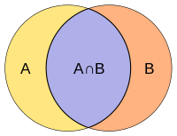  J=D/(2-D)，D=2J/(1+J)
Dice's coefficient | Numerator represents the double area of overlap between two annotations; Denominator represents the sum of two annotation area. Dividing the area of overlap by the sum area yields our final score.  $D=\frac{2\left|A∩B\right|}{\left|A\right|+\left|B\right|}$

Post-processing of the annotations
After the criteria calculation and consistency judgment, different post-processing methods on annotations that are acceptable as consistent will also cause different result. For example, calculate the average value of the marked results (x, y, w, h) or a maximum area with a consistency above threshold in an image is to be discussed later.
<TBD>

Recommended metadata
Metadata is considered to be the output of the data annotation process, all necessary information for the annotation process should be included in the metadata. A metadata format is to be given in Table 7, more details will be discussed and added in the future.

Output file
The output files include the annotation documents and the origin images. The formats of the annotation documents include but are not limited to xml, json, txt, etc. The annotation documents should include at least three items: image path, object name and object coordinates. Supporting document may be given if it’s necessary to interpret the annotation information. Annex C gives an example of the annotation document for endoscopic images.

File saving
Both the images and the documents should be named according to the same rules for easy querying. For example, they can be named with the number of the classification of the object, and the document’s name is the same with the corresponding origin images.

Table 7 Recommended metadata
Type | Content
General information | - Institution and responsible or corresponding PI;  - Construction dates of annotation dataset;  - Regulatory aspects (e.g. Data privacy)  - Description of use case
Annotation procedure information | - Details on data annotation process (annotator number, experts group setting, tools, etc.)  - Achieved consistency and criteria employed  - Post- processing method employed on annotations  - Ontology employed  - Label list or description
Data acquisition information | - collection device model  - collection frame rate/ Sampling rate
- Instance Information | - Instance identification code  - patient information (age, gender)  - diagnosis information (symptoms)
Annotation information | Task  Data type | Classification | Detection | Segmentation | Localization
 | - Image | class labels | - signal instance | - label per instance | - coordinate label of signal instance
 | - 3D images
 | - 4D
 | - Video
 | - Audio/ signal
 | - Text |  |  | Label per word, intent, or sentence | _
 | - Single number

Annex A
Questionnaire on data annotation

By Google Form: https://forms.gle/3fYrm3SZSrNQu3eeA

The aim of this questionnaire is to gather insights into the current practices, the specific requirements of data annotation in the FG-AI4H topic groups and AI4H products.

Your input and suggestion will be of great value for us in forming a data annotation specification together, as one of the deliverables with the FG-AI4H. We would appreciate it if you could take the time to complete the questionnaire, or if you have further ideas, please feel free to contact us. (xushan@caict.ac.cn; sebastian.bosse@hhi.fraunhofer.de, edwinjrwu@tencent.com
)

1．To which topic group are you contributing?
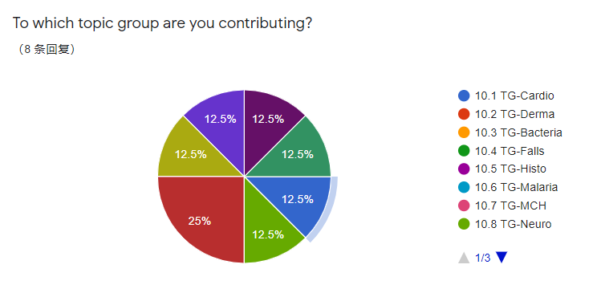

2. Which annotation task category is relevant for your project within the topic group?
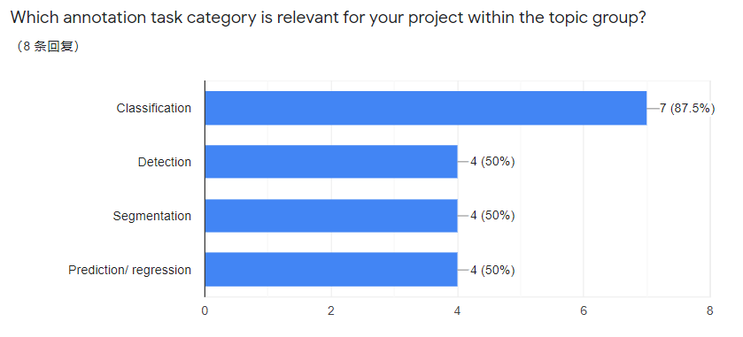

3. Is there any gold standard (or state-of-the-art task intervention method) relevant for your project within the topic group?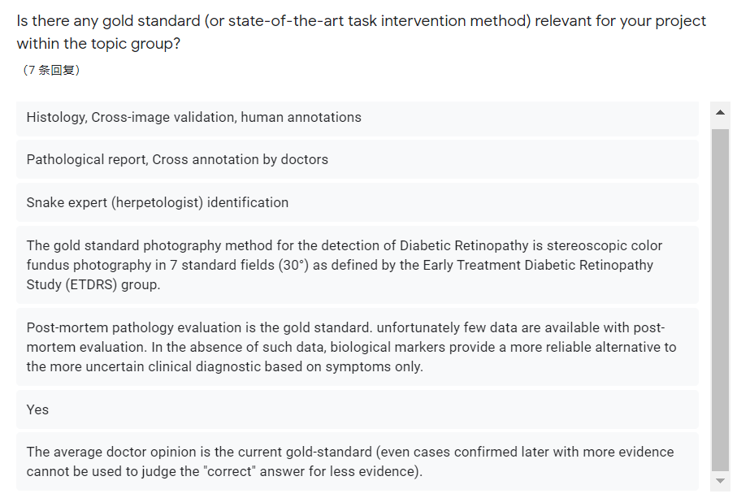

4. What is your data source for the training and testing dataset? (appreciated if you can give more info)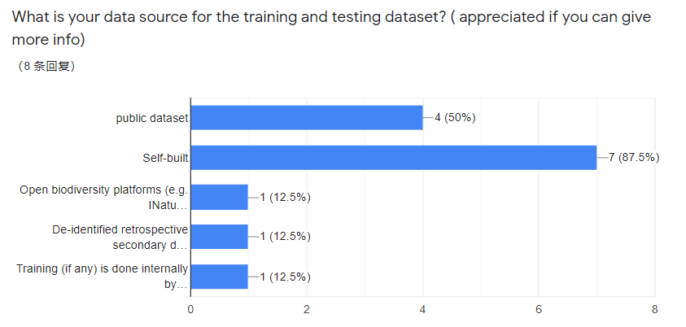

5. Which signal or data modalities are relevant for your project with the topic group?
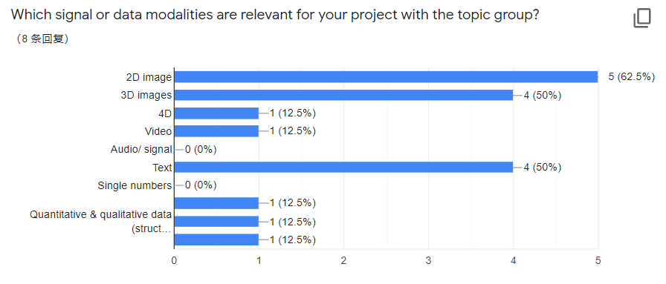

6. What is the nature of the annotation?

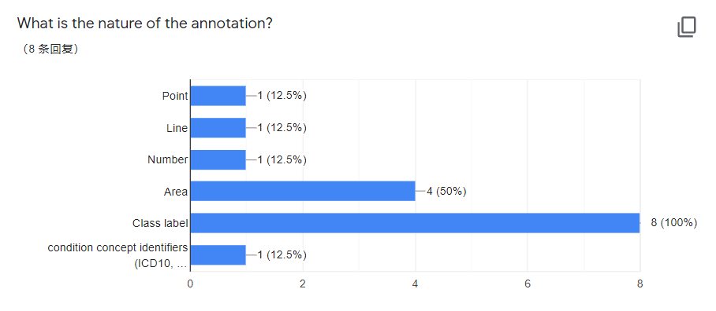

7. What kind of annotation procedure are you using? any annotation tool that you use?

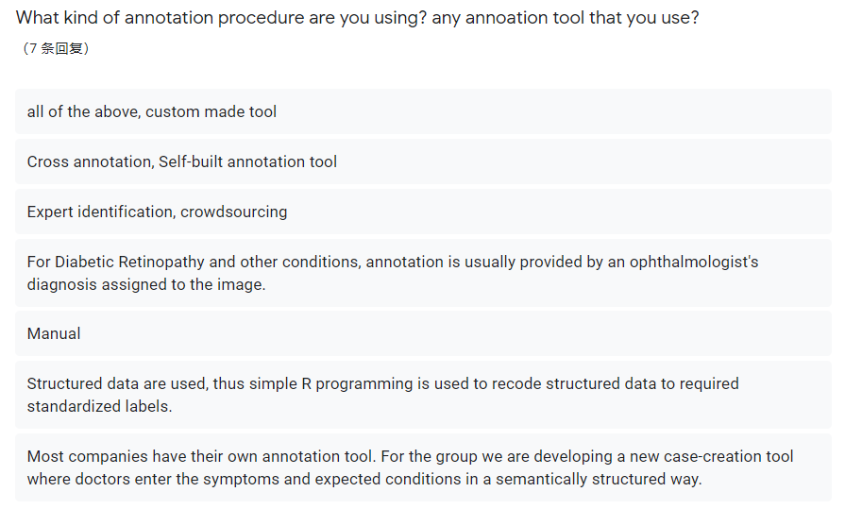

8. What annotation quality criterions are currently used in your topic group?

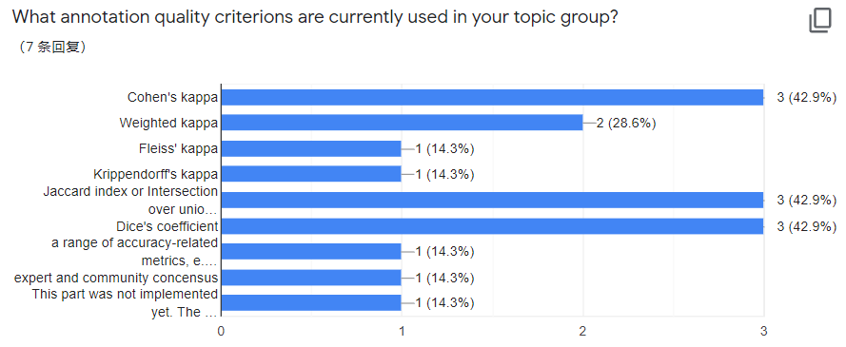

9. What kind of metadata do you consider relevant for data annotation?

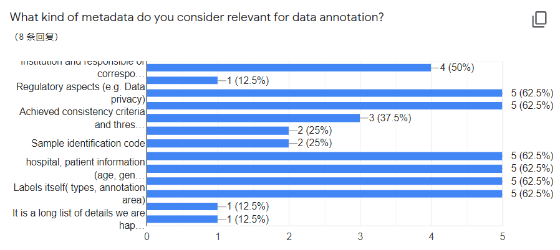
10. What type of ontology are you using? (If any)
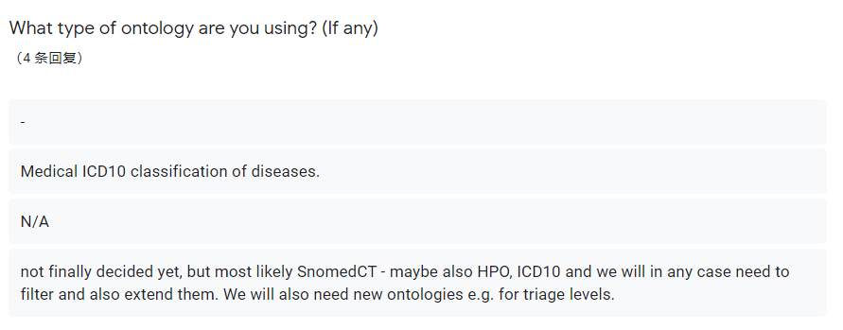
11.Which additional information do you need to encode the actual meaning of the annotation?

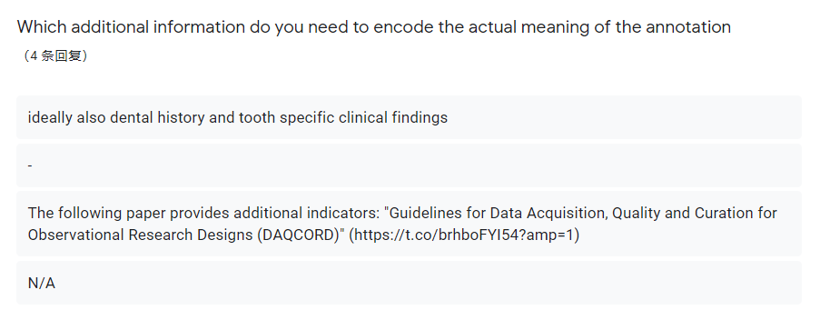

Annex B
Examples of endoscopic image metadata

There is an example of metadata of Endoscopic image. The annotation results include:

Attributes | Examples
json version | -
folder number | Trial_Date_Hospital_Batch
filename | PatientNum_Uniquecode.png
file path | /Data/Endoscopic/Trial_Date_Hospital_Batch/ PatientNum_Uniquecode.png
source | Hospital  Equipment
size: width/ height/depty | 1280×720
segmented object: name, coordinates | "label_classification": [  {  "name": "lesion",  "value": "polyp"  },  {  "name": "modality",  "value": "colonoscopy"  }  ],  "label_segmentation": [  {  "name": "lesion",  "type": "2d_mask",  "label": [  {  "name": "lesion",  "value": "polyp"  }  ],  "value": "/Data/Endoscopic/Trial_Date_Hospital_Batch/SegNum_PatientNum_Uniquecode.nii.gz"  }  ],  "label_detection": [  {  "name": "lesion",  "type": "2d_boundingbox",  "label": [  {  "name": "lesion",  "value": "polpy"  }  ],  "value": [123, 223, 40, 50]  }  ]

Annex C
Bibliography

[1] J. T. Bushberg et al., The Essential Physics of Medical Imaging. Philadelphia, PA, USA: Lippincott Williams Wilkins, 2011.
[2] J. Hsieh, Computed Tomography: Principles, Design, Artifacts, and Recent Advances.Bellingham,WA, USA: Soc. Photo-Opt. Instrum. Eng.,2009.
[3] Panayides A S, Amini A, Filipovic N D, et al. AI in Medical Imaging Informatics: Current Challenges and Future Directions[J]. IEEE Journal of Biomedical and Health Informatics, 2020, 24(7): 1837-1857.
[4] Q. Dou et al., “Automatic detection of cerebral microbleeds from MR images via 3D convolutional neural networks,” IEEE Trans. Med. Imag., vol. 35, no. 5, pp. 1182–1195, May 2016.
[5] J. Ding, A. Li, Z. Hu, and L. Wang, “Accurate pulmonary nodule detection in computed tomography images using deep convolutional neural networks,” in Proc. Int. Conf. Med. Image Comput. Comput.-Assisted Intervention, Sep. 2017, pp. 559–567.
[6] S. Korolev, A. Safiullin, M. Belyaev, and Y. Dodonova,. ‘‘Residual and plain convolutional neural networks for 3D brain MRI classification,” Jan. 2017. [Online]. Available: https://arxiv.org/abs/1701.06643
[7]D. Nie, H. Zhang, E. Adeli, L. Liu, and D. Shen, “3D deep learning for multi-modal imaging-guided survival time prediction of brain tumor patients,” in Proc. MICCAI, 2016, pp. 212–220.

Below are some data annotation tools for the reference
Sangkuhl K, Whirl-Carrillo M, Whaley R M, et al. Pharmacogenomics Clinical Annotation Tool (Pharm CAT)[J]. Clinical Pharmacology & Therapeutics, 2020, 107(1): 203-210.
Hou R, Denisenko E, Forrest A R R. scMatch: a single-cell gene expression profile annotation tool using reference datasets[J]. Bioinformatics, 2019, 35(22): 4688-4695.
Philbrick K A, Weston A D, Akkus Z, et al. RIL-Contour: a Medical Imaging Dataset Annotation Tool for and with Deep Learning[J]. Journal of digital imaging, 2019, 32(4): 571-581.
Kraljevic Z, Bean D, Mascio A, et al. MedCAT--Medical Concept Annotation Tool[J]. arXiv preprint arXiv:1912.10166, 2019.
Ramos A H, Lichtenstein L, Gupta M, et al. Oncotator: cancer variant annotation tool[J]. Human mutation, 2015, 36(4): E2423-E2429.
Iakovidis D K, Goudas T, Smailis C, et al. Ratsnake: a versatile image annotation tool with application to computer-aided diagnosis[J]. The Scientific World Journal, 2014, 2014.
Seifert S, Kelm M, Moeller M, et al. Semantic annotation of medical images[C]//Medical Imaging 2010: Advanced PACS-based Imaging Informatics and Therapeutic Applications. International Society for Optics and Photonics, 2010, 7628: 762808.
Russell B C, Torralba A, Murphy K P, et al. LabelMe: a database and web-based tool for image annotation[J]. International journal of computer vision, 2008, 77(1-3): 157-173.
Diete A, Sztyler T, Stuckenschmidt H. A smart data annotation tool for multi-sensor activity recognition[C]//2017 IEEE International Conference on Pervasive Computing and Communications Workshops (PerCom Workshops). IEEE, 2017: 111-116.
Oronoz M, Casillas A, Gojenola K, et al. Automatic annotation of medical records in Spanish with disease, drug and substance names[C]//Iberoamerican Congress on Pattern Recognition. Springer, Berlin, Heidelberg, 2013: 536-543.
Ferreira P M, Mendonça T, Rozeira J, et al. An annotation tool for dermoscopic image segmentation[C]//Proceedings of the 1st International Workshop on Visual Interfaces for Ground Truth Collection in Computer Vision Applications. 2012: 1-6.
Kim E, Huang X, Tan G. Markup SVG—An Online Content-Aware Image Abstraction and Annotation Tool[J]. IEEE Transactions on Multimedia, 2011, 13(5): 993-1006.
Rubin D L, Mongkolwat P, Kleper V, et al. Annotation and image markup: accessing and interoperating with the semantic content in medical imaging[J]. IEEE Intelligent Systems, 2009, 24(1): 57-65.
Rubin D L, Mongkolwat P, Kleper V, et al. Medical Imaging on the Semantic Web: Annotation and Image Markup[C]//AAAI Spring Symposium: semantic scientific knowledge integration. 2008: 93-98.
Karlgren K, Dahlström A, Ponzer S. Design of an annotation tool to support simulation training of medical teams[C]//European Conference on Technology Enhanced Learning. Springer, Berlin, Heidelberg, 2008: 179-184.
Karlgren K, Dahlström A, Lonka K, et al. A new educational annotation tool for supporting medical teams to improve their teamwork and communication[J]. ICEM/ILE, 2007: 20-22.
Yao B, Yang X, Zhu S C. Introduction to a large-scale general purpose ground truth database: methodology, annotation tool and benchmarks[C]//International Workshop on Energy Minimization Methods in Computer Vision and Pattern Recognition. Springer, Berlin, Heidelberg, 2007: 169-183.
Kumar A, Jawahar C V. Content-level annotation of large collection of printed document images[C]//Ninth International Conference on Document Analysis and Recognition (ICDAR 2007). IEEE, 2007, 2: 799-803.
Hollink L, Schreiber G, Wielemaker J, et al. Semantic annotation of image collections[C]//Knowledge capture. 2003, 2.
Kipp M. Anvil-a generic annotation tool for multimodal dialogue[C]//Seventh European Conference on Speech Communication and Technology. 2001.

____________________________

