Installation Guide

Used equipments:

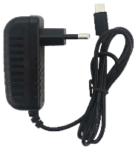

Power connector

ESP32 microcontroller

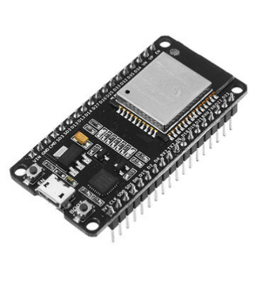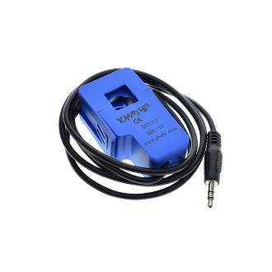

Energy Sensor – SCT-013

**1.** Open the power sensor tab.

**2.** Place the power sensor tab around the lead wire (live – brown lead) of the electrical panel in the house.

**3.** Close the tab well so that there are no errors in reading consumption.

**4.** Connect the 3.5mm connector (male) of the power sensor to the 3.5mm connector (female) that is connected to the microcontroller.

**5.** Connect the power connector to the microcontroller.

**6.** Plug the power connector into an outlet to power the devices.

**7.** Wait about 30 seconds (if you haven't already registered on the platform, you can use this time to do the same).

**8.** With the help of a Wi-Fi capable device, connect to the “SEM” network that was created by the microcontroller.

**9.** After connecting, wait about 10 seconds until the configuration page opens automatically.

• If the configuration page does not open automatically, open a browser of your choice and acesso the URL: 192.168.4.1 .

**10.** On the configuration page, select the option “Configure WiFi”.

**11.** On the page opened in step 11, select your home's Wi-Fi network, or manually enter its SSID, and enter its password. Then fill in the username (email you registered with) and password for the platform.

• You can use the “Refresh” button for the equipment to update the networks available around it (only connection to networks operating at 2.4 GHz is possible).

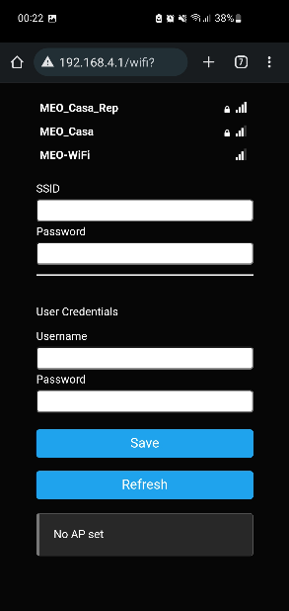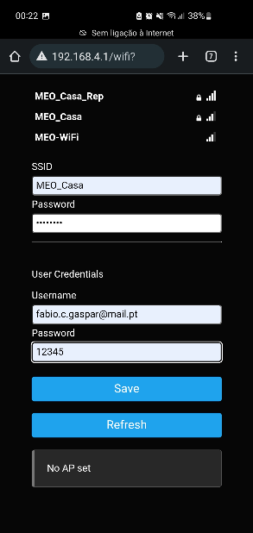

**12.** When filling in all the information, press the “Save” button.

**13.** Close the configuration window.

**14.** Make sure that the Wi-Fi network “SEM” is not already displayed on the device to make connection.

• If the setup has not been performed correctly, the “SEM” Wi-Fi network will remain active to perform a new setup (Start at step 7).

**15.** Access the online platform.

**16.** Log in with your user account.

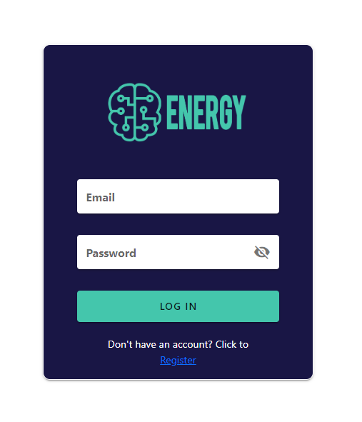

**The next settings will also be shown on the web platform to simplify the process**

**17.** Open the settings page, open the “Divisions” page.

**18.** On the “Divisions” page, add each of the divisions you have in your home.

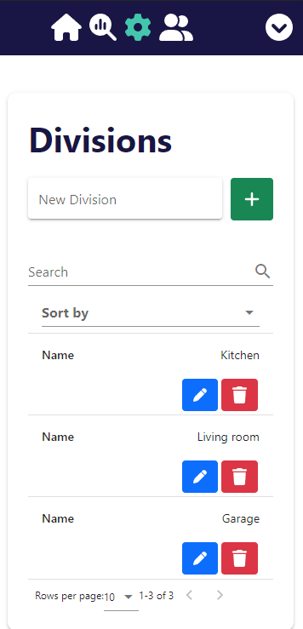

**19.** Open the settings page, open the “Equipments” page.

**20.** On the “Equipments” page, add the information of each of the equipments you have in your home.

**21.** On the “Profile” page, add your energy price per kWh.

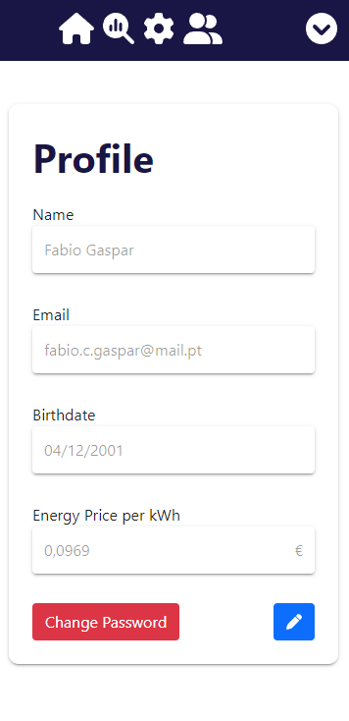

**22.** When the previous process has been completed, open the "Read" page to analyze the consumption of each device individually. For this phase, the steps presented on the WEB page must be carried out.

**The installation process has been completed successfully!**