Research Data Management Off-boarding

The following workflows are developed to ensure researchers and PhD candidates are aware of their data responsibilities and understand how to access their data when leaving the VU or closing a project.

It is required to archive all data collected and processed while working at the VU, both when closing a project or before you leave a position at the VU¹. Transferring research data when moving to another organisation is not compliant with university policy nor privacy regulation. This does not mean you cannot reuse your data or continue your project in a new position, but there are policies and procedures in place for ensuring that data is reused in an ethical and legal manner.

Following these workflows will help you identify your requirements and facilitate a smooth transition of data management upon the end of your employment at the VU. If your situation differs from the options presented here or you have further questions, please contact research.data.fgb@vu.nl for an individual consultation.

1: See When to archive for more information
Research Data Management Off-boarding
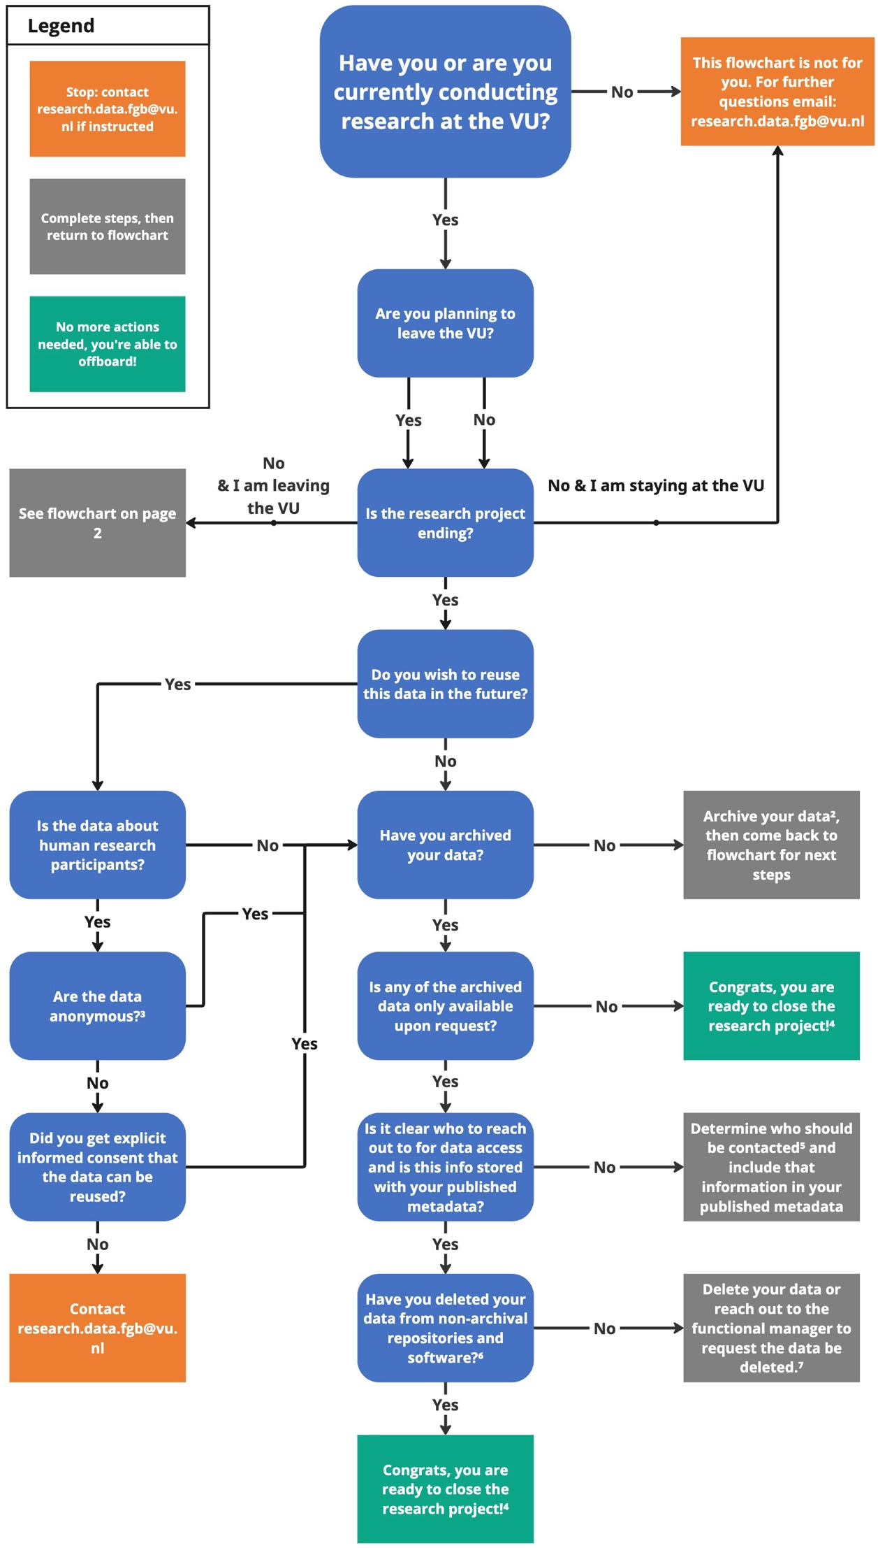
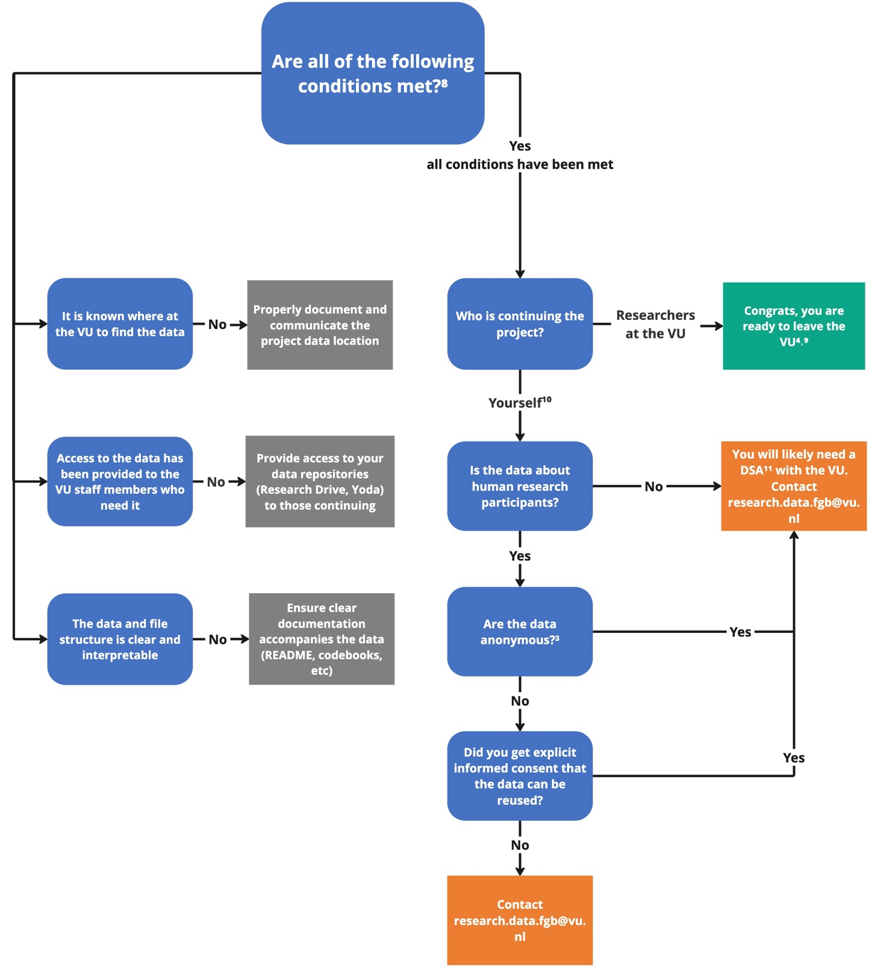
For individuals with an ongoing project, leaving the VU
2: See Archiving @FGB for more information
3: See Privacy Risks to understand whether the data are truly anonymous (Blue Data)
4: Don't forget, you as the researcher that collected this data must also submit a request, should you wish to access the data after you have left the VU. If you have any questions about this, please contact research.data.fgb@vu.nl
5: This should typically be REPS (research.data.fgb@vu.nl) and your department head.
6: This refers to repositories such as ResearchDrive, or software like Qualtrics or Castor.
7: See Additional Resources (page 3) for more information on how to delete your data. If you’re unsure what data can be deleted, please contact research.data.fgb@vu.nl
8: See Additional Resources (page 3) for more information about how best to fulfill these conditions.
9: Please ensure you are also following all HR (and PhD if you are a PhD candidate) off-boarding procedures prior to leaving.
10: This can include continuing the project with or without collaborating with researchers at the VU.
11: Please contact REPS for assistance, but should you want to read more about data sharing agreements checkout this source. For non-sensitive, non-personal data, this will likely be a very simple form to handle intellectual property.

Additional Resources

How do I archive my data?
Archiving Guidelines Summary
More information for archiving in Yoda

How do I request space in Yoda?
Yoda Request Form

How do I grant users access to my Yoda group?
User management

How do I select the right license for my data?
Selecting a license

What sort of information should accompany my data?
Guidance from the GDPR/FGB
Overview from Utrecht University
Metadata in Yoda

How do I delete my data?
!! Prior to deletion: ensure that all the data you plan to delete has been exported and archived to the proper repository (see How do I archive my data? above for more information) !!
Follow Castor Guidance on ending a study
- additionally, contact Castor Support to request your data to be deleted
From ResearchDrive:
- Deleting files and folders
- More information on deleting project folders
- for any questions, please contact the RDM Support Desk (rdm@vu.nl) to be put in contact with ResearchDrive’s functional manager
From Qualtrics
- Deleting response data
- Deleting an entire project (including all of its associated data)
  - To ensure the entire project is deleted, reach out to the RDM Support Desk (rdm@vu.nl) to be put in contact with Qualtric’s functional manager

