Preface

Welcome Aboard

The purpose of this Flightgear aircraft is to provide you with a selection of resources relevant to aerial navigation.
Next to links to online text, audio and hands on video resources you will also find a collection of hands on navigation practise flights.
These practise flights assume a comfortable level of flying your aircraft with or without auto pilot and a basic knowledge of aviation.
No consideration has been given to real world aspects such as communication with ATC, nor restrictions of other nature or multiplayer environment.
All of the practise flights can be performed offline provided one has access to pen, paper, ruler, copies of charts , etc.
You may need to download additional scenery from Terrasync as the flights more or less span around the globe.
Furthermore it is assumed that you are familiar with putting together a flightplan, how to calculate ETA and fuel consumption
The instructional material is by no means to be used for real world aviation and no guarantee of completelyness or correctness can be given, the sole purpose being to provide examples of instrument usuage within the context of the flight simulator.
For information on GPS/Waypoint navigation you need to search elsewhere as at present for small crafts there is no fully functional model available at the time of writing. For ATC vectoring look at the ATC topics like FGCOM, ATC etc.
Online links and references are valid at the time of writing, however should a link be broken you may find the relevant info by means of your favourite search engine.If you don't happen to have a dual monitor setup or expierence internet connection problems you might wish to print what is important to you as a fall back position. We certainly recommend to have at least hardcopies of the practise flights handy.
To commence your journey I would recommend a leisurely read of Charles Wood's comprehensive yet easy to read Flight Simulator Navigation, www.navfltsm.addr.com or the downloadable pdf at
www.anaspides.net/documents/flight_simulator_documents/Instrument%20course.pdf
The practical side of it leans heavily on Microsoft FS, however most of the practise flights work in FG as well.
For instrument related info and usage here is another comprehensive online FG manual
www.emmerich-j.de/HB/EN/RNAV
You also find topics like pilotage and dead reckoning in there or you may wish to check out www.experimentalaircraft.info/flight-planning/pilotage-dead-reckoning.php
The FG Navigator is based on David Megginson`s original Piper Cherokee Warrior II (1979 model).For relevant details such as technical specification or info on how to fly look up Help and consult the online Wikis. If completely new to the world of aviation you may wish to start with Chapter 8 of the offcial Flightgear manual titled A Basic Flight Simulator Tutorial using the default aircraft a Cessna.
The focus of the FGNavigator however purely rests on navigational aspects and practical guidance of how to do it.
Topics like flightplanning, ATC comms, pertinent rules and regulations as such form no part of this package.
Enjoy your journey

Panel Configuration
First up, your cockpit:
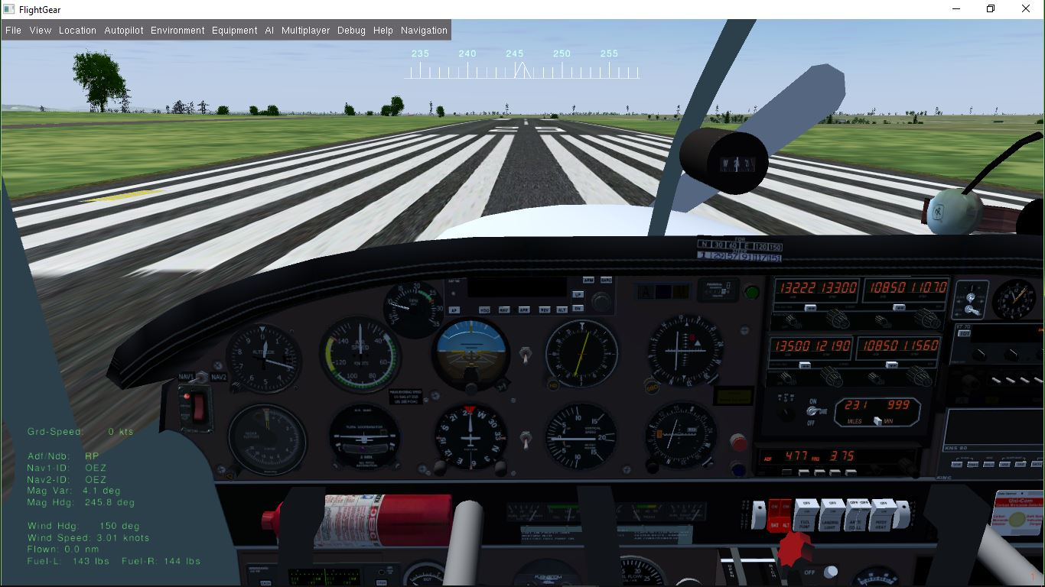
Top Down Left to Right (snaking):
- Nav1 Nav2 Switch
- ELT (Emergency Locator Switch)
- Altimeter
- Radio Altimeter
- ASI (Airspeed Indicator)
- VSI (Vertical Speed Indicator)
- Tacho (RPM)
- AI (Attitude Indicator)
- TC (Turn Coordinator)
- Autopilot (Custom KAP140)
- RMI Config Switch (toggle VOR Needle on/off)
- RMI (Radio Magnetic Indicator for ADF NDB)
- DG HSI Switch
- DG or HSI (Digital Gyro or Horizontal Situation Indicator – KCS55)
- ILS Marker Beacon
- HobbsMeter
- VOR 1
- VOR 2
- GS in Range Light /manual toggle Landing Light
- Stall Warning Light
- Master Light Button (red)
- Flaps Status Light) blue
- Nav 1 Radio
- Nav 2 Radio
- DME (Distance Measuring Equipment)
- ADF (Automatic direction Finder)
- HSI Slave Switch
- Transponder Unit
- KMA20 Audio Panel
- KNS80 Unit for RNAV
- other gauges below the main panel include GPS, Fuelgauge, Ampmeter, Lightswitches, Clock, AOA, OAT, Flaplever and other. For general information refer to http://wiki.flightgear.org/Avionics_and_instruments , for more specific info on navigation instrument usage we recommend the reading of www.emmerich-j.de/HB/EN/RNAV
TIPS: - knobs work in both directions
- mouse buttons on knobs advance or regress one degree or unit at a time
- mouse wheel depending on instrument between 3 and ten degrees
- to match the Compass with HI/DG heading look at the tooltips

Instrumentation

about your Navigation Instruments

Panel Switches:
Nav1-Nav2 Switch
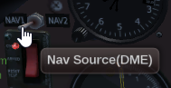
This switch will toggle the Nav radio source for the Autopilot, GPS, the RMI VOR needle and the DME

RMI+/-VOR Switch
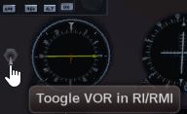
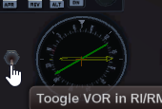

This switch will toggle a green VOR needle on or off. Once displayed the VOR needle nav source is determined by the settings of the Nav1-Nav2 switch.
The instrument it self is a combination of the Bendix King KI228 and KI229 which often is coupled with the KR87 ADF receiver.

DG-HSI Switch
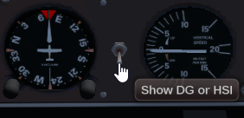
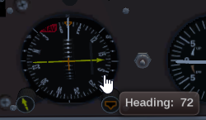
Switches between the two distinct instruments. When using the HSI be aware that by default it is slaved to Nav1 by means of the switch to the left of the clock.

The Toggle Sound Hotspot
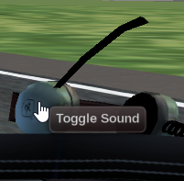
Allows you to turn all sounds on or off. If left muted on closing down a session at the next startup sound will be enabled again.
Hotspots in general are used to make an object clickable for some action to occur. If you want to see what is clickable on any aircraft within Flightgear simply press <CTRL> C (toggle)
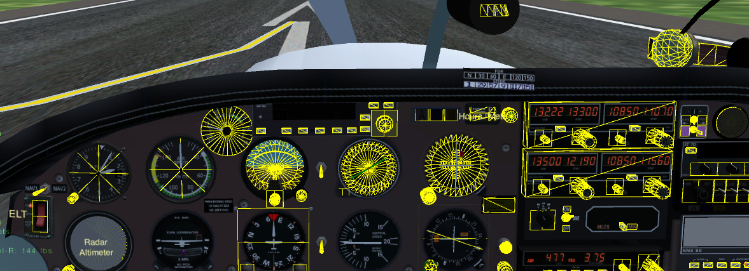

Hotspots & Digital Readouts(Tooltips)

Most of the hotspots are used to display instrument related properties such as speeds, rpm, radials, bearings etc.A select few however will invoke some action such as opening a dialog, turning knobs, pushing buttons and so forth.

Hotspots for displaying static or dynamic information are:
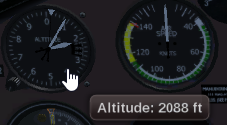 | 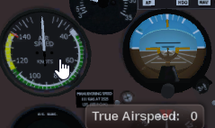  The ASI - air speed indicators needle shows IAS, whereas the tool tip on the face shows TAS
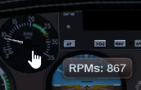 | 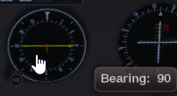
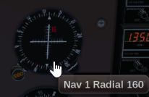 | 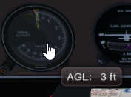  Lags in update, can use standard Hud as an alternative
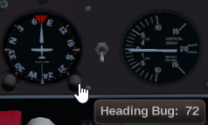
Heading bug = current heading, Knob + or -

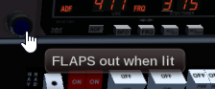  The blue light will be lit when flaps are not retracted. | 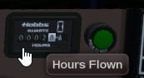  The Hobbs displays total accumulated flying time based on when the wheels are not on the ground.
Actions can be invoked by means of using the menu, shortcut (hotkeys) or alternatively hotspots

Hotspots for displaying static or dynamic information are:

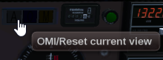  Resets the current view to default after moving around with the mouse or changes to zoom level | 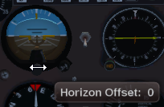  Clicking the knob will provide a nicer view for manouvering down the glide slope. Restore the view via OMI
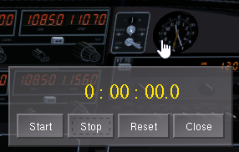  If the stopwatch gets into the way use the timer of the ADF instead for timing legs, procedure turns.. | 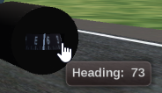  Use the readout for adjustment of DG and or HSI
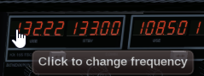  Opens the Radio Settings Dialog | 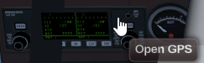  Opens the FG internal GPS Dialog
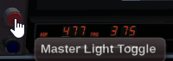  Toggles all Lights, Fuelpump and Pitot Heat on/off  except Landing light | 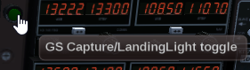  Manual toggle of Landing Light
In addition clicking the altimeter will pop up the QNH dialog.

Keyboard

The standard Flightgear keys apply in addition to the aircraft specific shortcut keys. These are listed in the Help Menu or can be loked at by pressing ?
Most of the custom key bindings are identical with the orioginal Piper Cherokee Warrior. So for instance
h calls up the Hud toggle
* toggles Carburator Heat
k opens the map dialog
r opens the Route Manager Dialog

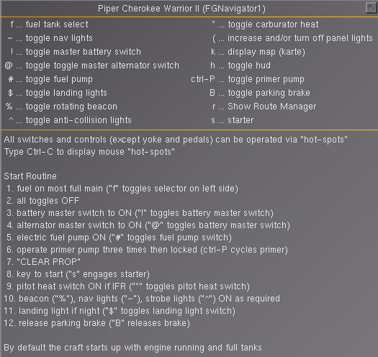

Auto Pilot(s)

The Navigator comes equipped with an auto pilot namely a modified version of the Bendix King KAP140.
Whilst the unit looks the same as the standard version, its core functionality has been modified and extended by the seemless integration of the more sophisticated IT_Autoflight (ITAF) Autopilot developed by Joshua Davidson.
This means the Hybrid now supports waypoint navigation via Route Manager/GPS including VNAV capability resulting in two NAV modes, one to follow the Route Manager and one for the original VOR Lock mode.

The auto pilot can be activated from either the panel embedded KAP140 unit as shown below
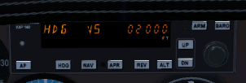
or alteratively from the ITAF dialog

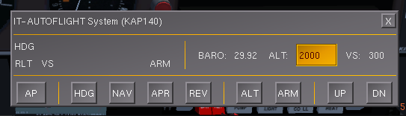
which provides both more functionality and a much friendlier interface. By default the dialog will open at the bottom left corner thus not obscuring the pilots view.
To display the ITAF press F11 or click the face of the Kap140 or choose the menu.

KAP140
If not already familiar with the operation of the generic KAP140, the following link will take you to a Wiki explaining its basic modus operandi. It is vital to be familiar with the equipment, its shortcomings in particular, as otherwise you might be in for some rather nasty surprises.
http://wiki.flightgear.org/Bendix/King_KAP140_Autopilot
Prior to examining the extended functionality the interface of the ITAF provides, a brief recap of the various modes:
AP turns the auto pilot on with ROL and VS modes activated, that is wings level and current pitch maintained be it level, ascent or descent.
WARNING
Pressing AP again will turn the autopilot off, however not immedeately. It will flash for a little while prior to receeding control to the pilot.
Due to that delay in release the auto pilot should not be used at take off and turned off well before touch down.

HDG the AP will follow the direction of the heading bug of either the digital gyro or the HSI
CAUTION
The Autopilot will always turn the shortest way to the left or right. A turn must not exceed 180 degrees or the autopilot will suddenly turn in the opposite direction midturn because the other side now has less degrees to turn to.
In order to turn more than 180 degrees you need to break up the turn into phases like the first turn to 120 and just before there turn another 90.

VS the AP will ascend or descend continuously at the fpm rate specified using the UP/DN buttons.
(Increments/Decrements are in 100ft lots)
One problem with VS may occur just after takeoff, when the AP senses the required VS based on pitch, air pressure and other parameters and sets your VS at 1500fpm or more. Your low powered engine can not sustain that and you will stall.

ALT activates the altitude control. Pressing ALT will stop the plane from its current climb or descend by levelling out provided no desired altitude has been preset.
If a wanted (preset) altitude has been set and armed, ALT will automatically activate with at first the plane slightly overshooting the target and levelling out on target.
Subtleties
If the armed preset altitude differs from the current altitude you are going to climb or descend based on the +/-fpm (UP/DN) settings.
preset/armed 6000 current 3000 +600fpm result altitude hold in 5 minutes preset/armed 4000 current 4200 +500fpm result climb until out of fuel
preset/armed 5000 current 3000 -300fpm result crash in 10 minutes
Clicking ALT again will cancel altitude hold whereas pressing (UP/DN) will take you back into VS mode.
Note:
To set the desired altitude using KAP140 use the wheel to increment/decrement setting by 100ft lots, using ITAF you simply nominate the wanted altitude in the ALT: box and then press the ARM button.

NAV switches from ROL or HDG mode to follow the course set in "NAV1“ or "NAV2". The AP will then attempt to intercept the radial set in the OBS and track it following the VOR CDI. The intercept angle however should be less than 60 degrees.

RM JOSHUA please note: Nav dual modus based on your switch for both vorlock and route manager or separate button RM or WP for waypoint???
APR arms the approach mode and activates the ILS/GS-Approach once the Nav receiver senses the Glide-slope in range.
REV switches to GS Back Course mode (refer to the ILS topic)

ITAF
compose once final

Flight Settings Reference Tables

FGN1 | RPM | KTS | Flaps | FPM | RW | WS kts | From | Mix | CarbH
Taxi
Climb
Climb
Cruise 5k
Cruise 7k
Descend
Descend
Decend
App Level
App Descend
Glide Slope

Add your specific scenarios

How To s...

Command Lines
It is assumed you had at least a glance at the offical manual and or are somewhat familiar with the concept of command lines. If not it may be useful to read up on the topic (either use the pdf found in the Flightgear Docs folder or the html version found in the Help menu.

A freshly installed FG version will come in plain vanilla i.e. You pick an aircraft, your departing airport, select a runway and of you go.
Depending on your version FG opens up with either FGRun or QT Launcher, both providing you with the option to specify command line options.

Sooner or later you may wish or need to change your settings, maybe just change the weather, use the moving map or turn other features or general options on or off.

Therefor we need to know whats available. A good start are the Command Line WIKIS
http://wiki.flightgear.org/Command_line Windows/Linux
http://wiki.flightgear.org/Command_line_options
Most of them are self explanatory and in order to use them you need to be in a Launcher like QT Launcher or other depending on your Operating System and Flightgear Version.
Alternatively you can also specify them directly using a command prompt or embed them in some sort of textfile ending with the extension .bat (a Windows BatchFile)

This is an example of one of the QT Launchers:

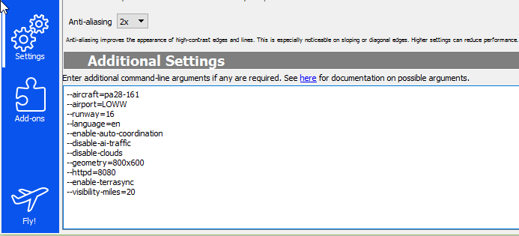

--aircraft=pa28-161
you want to fly the FGNavigator

--airport=LOWW
Vienna is your desired departure

--runway=16
this is your favorite runway

--language=en
your OS is Spanish but you really would like FG in English

--enable-auto-coordination
synchronises aelerons & rudder

--disable-ai-traffic
relevant only for multi player

--disable-clouds
in case you are a good weather pilot

--geometry=800x600
your systems recommended or best screen resolution

--httpd=8080
internet port for online moving map, some documentation shown in a browser,...
--visibility-miles=20
how far you want to be able to see

Thats an awful lot of typing and you need to do it again and again and to make matters worse if you accidentally close the dialog rather then fly, all the settings go to nirwana....

You can type one line at a time as shown above, but you can alsoput it all in a single line if you wish:

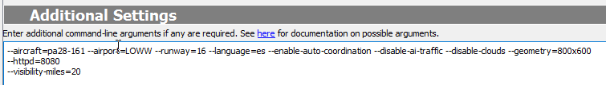

--altitude=3500 --heading=330 --vc=85 --nav1=160:108.5.3 --dme=nav1

Batch Files

Your FGNavigator1 contains a folder named BatchStarts which contains a number of quickstart options WINDOWS10 batchfiles. Copy that folder on to your desktop and you are on the runway or starting in the air with just two or three clicks completely bypassing the FG Launcher.

The current options to chose from are:

APCS.bat

Executing this batchfile by clicking on it will prompt you to nominate your aircraft and the desired airport to start from with some standard command line options.

LPPRD.bat

This file is designed for Approach and Landing Practise with or without the aid of the auto pilot.

LPYD.bat

you define the start up parameters

About these batch files - USE AT YOUR OWN RISK

Batchfiles are basically just containers of a list of command lines. Once the file is executed it simply
feeds the commands to Flightgear like the Launcher does.
Batchfiles can also prompt for input amongst other things. Yet they are just plain textfiles you create or modify with a text or wordprocessor and Save with a .bat extension

First of all the included batchfiles are designed to run on Windows10. Older Windows Versions use a slightly different syntax and as such the above mentioned files may not run.

If thats the case use your search engine to look up creating or modifying batch files.

The author of this document is not familiar with Apple or Ubuntu, KDE or other operating systems but rest assured there is plenty of info out there how to automate startup of FG with something similar to DOS/Windows batchfiles.

Here an example of a batchfile:

set /p ac=Aircraft:
set /p ap=Airport:

"C:\FlightGear 2017.2.1\bin\fgfs.exe" --fg-root="C:\FlightGear 2017.2.1\data" ^
--aircraft=%ac% ^
--airport=%ap% ^
--dme=nav1 ^
--timeofday=morning ^
--enable-auto-coordination ^
--disable-terrasync ^
--enable-freeze ^
--enable-fullscreen

line 1 and 2 will act as storage for user input for craft and airport by the means of prompts displayed by line 4 and 5.

IMPORTANT! Line 3 tells the batch file where on the PC it can find the Flightgear Installation. If you have an older version you need to change the 2017.2.1 bit to whatever your version is and possibly change the path as well.

--disable-terrasync

If enabled FG in the background downloads scenery as you fly or synchronises data in the background gobbling up system resource like memory....

--enable-fullscreen FG will open in full screen mode at default resolution unless otherwise specified.

Generally its a good idea to back up whatever customisations you put into place.

FG Wikis

