About the Piper PA28-Warrior - Navigator

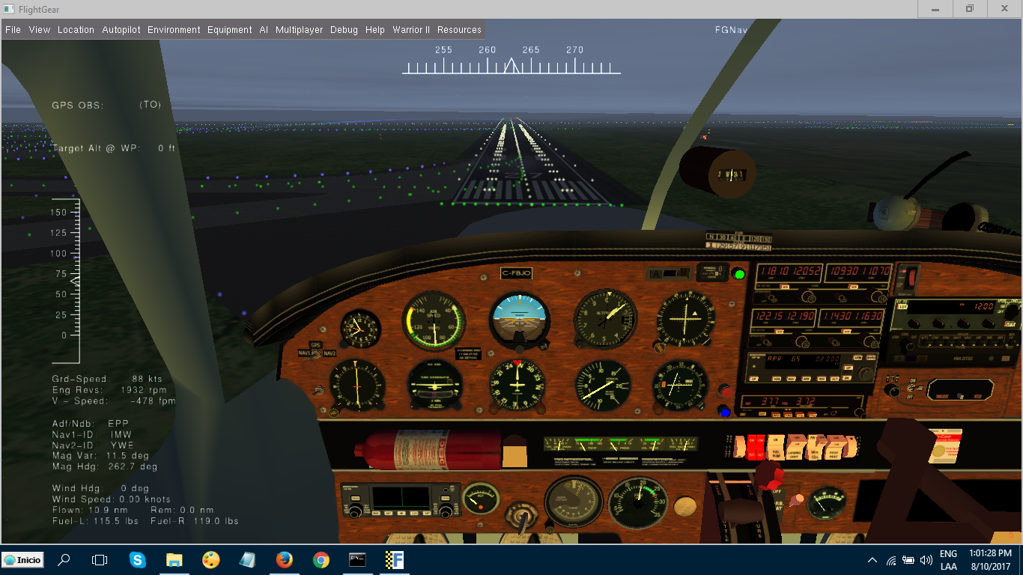

Purpose

This aircraft and navigation package was developed in response to the stated need of Flightgear Enthusiasts who would like to gain a basic understanding of instrument usage on General Aviation Aircraft’s as well as getting an insight of the various technologies and hidden workings of sophisticated Flight Management Systems found on large airliners.
There are many great tutorials and Wikis available to learn about how to operate aircrafts within Flightgear, yet most assume an understanding of Navigation Concepts as a given, which may or more likely not may be the case.
Most of you will find its relatively easy to fly a big bird after a little reading, just telling the autopilot to take me from A to B, yet most will not be aware of what makes the magic happen behind the scenes.
More over you will find its a lot harder to control a small aircraft which usually does not come equipped with bells and whistles on the instrument panel like a glass cockpit, super duper FMC and so forth.
Yet there are good reasons why all airline and military pilots start off with small aircrafts, one of them being to develop an understanding of aeronautical navigation systems detached from pure push button automation.
We hope you enjoy your journey s with the Navigator as much as we enjoyed putting the package together.

The aircraft was designed from FG Version 2016.x.x onwards to 2017.3.1, as such compatibility with future versions or backwards integration may or may not be guaranteed.
However the Navigator will notify you whenever updates become available.
At start-up you may be greeted with this:
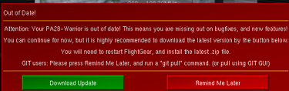
Select download and you may be prompted to select your download location
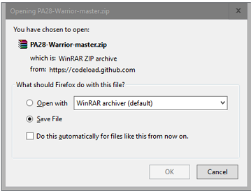
Accept Save File, then click OK or Download depending your extractor.
Once the file is downloaded, extract its contents to your //aircraft folder and rename it to PA28-Warrior.

Credits.......
First of all thank you to the developer of the original Cherokee David Megginson, a long-time contributor and driving force behind FG as I understand it from various Wikis.

Second, many thanks to Joshua Davidson for steering the project in the right direction, his endless hours of work and also thank you to Gabriel Hernandez who provided his expertise on lights and sounds as well as some of the interior models.

A great thank you also to the many unnamed developers whose ideas and previous work provided a rich resource of ideas

And a special thank you to you for your interest in taking the Simulator not just as a game but also as an opportunity to learn a little more about what’s happening behind the scenes.

