Assignments On Exception Handling

1. Write an application that accepts two numbers, divides the first number with the second number and display the result.

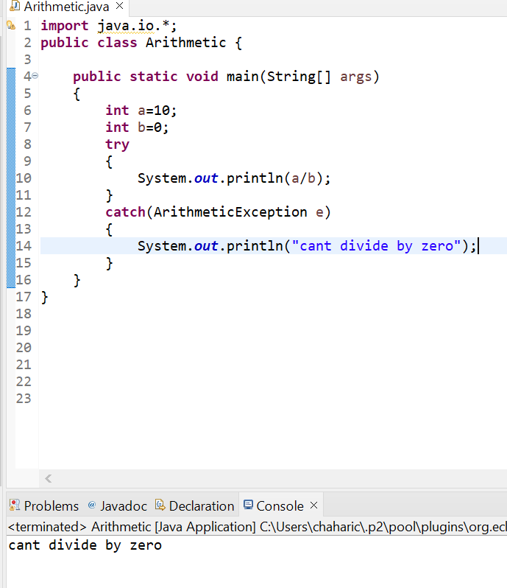  
2)Carrying forward with the above problem, handle Arithmetic Exception by raising Un Supported Operation Exception as a solution.

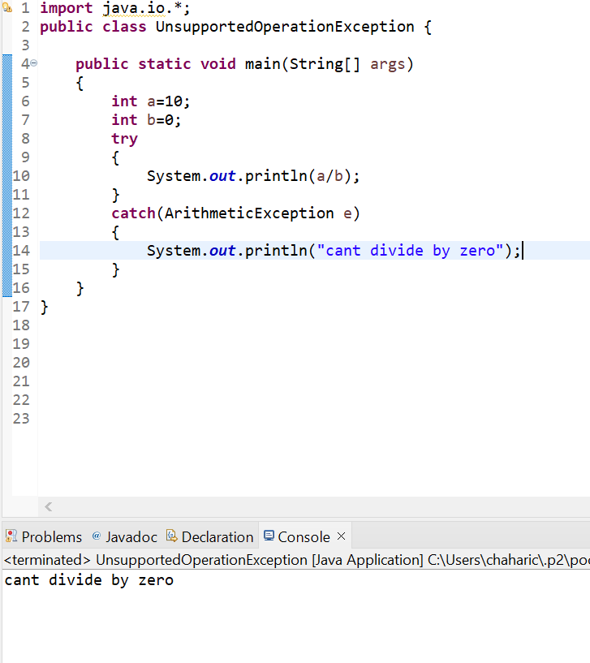

3)Write an application to perform withdraw functionality on a savings account object.

a) Raise an Insufficient balance exception if you are trying to withdraw more than balance or when you balance is zero.

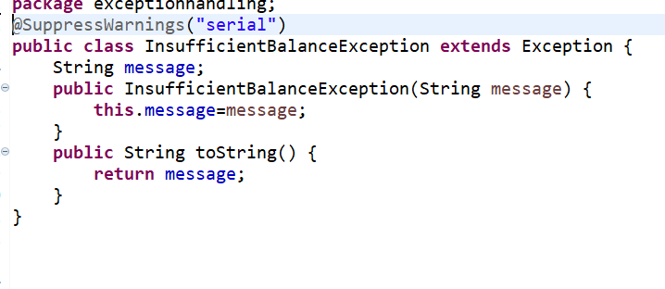

b) Raise an Illegal Bank Transaction Exception if you are trying to withdraw with a negative value.

