***IDG PA28X: About the Mini Panel***

The Mini Panel is an easy way to access commonly used items without taking up much space on the screen.

The panel can be shown by selecting “Mini Panel” from the Utilities menu.

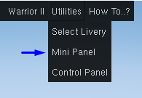

The mini panel will be open when FlightGear is restarted if it was open when FlightGear was closed.

The options on the Mini Panel are as follows:



Close the Mini Panel

Access this help document

Show Aircraft Configuration

Show Control Panel

Show Checklist Dialog

Switch tanks between left and right wing