***IDG PA28X: General Settings***

**Aircraft Config:**

This aircraft is equipped with our Aircraft Configuration system which allows you to easily manage the behavior and settings of the aircraft.

When starting FlightGear you will be greeted with the Welcome Dialog; should you not wish to see the Welcome Dialog, you can simply tick the box to not show it on startup.

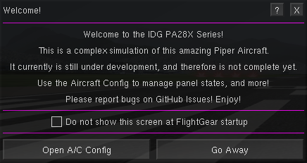

Aircraft Config can also be accessed via the Warrior II menu -> Welcome Dialog, or from the Mini Panel.

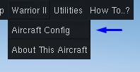

**Aircraft Configuration Dialog**

This dialog is where you can perform the most commonly used actions related to typical aircraft and flying operations.

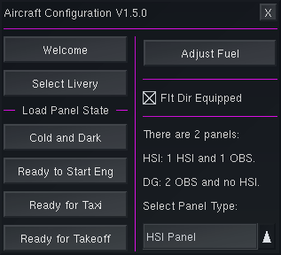

**Load Panel State:**

This area provides shortcuts to automatically configure the aircraft. These should only be used when the aircraft is on the ground, and not moving.

Cold and Dark: Puts the aircraft in a completely shut down state. This allows you to start the aircraft yourself.

Ready to Start Eng: Sets up the aircraft to right before the key is turned. All you need to do is start the engine, and do the after-startup items.

Ready for Taxi: Sets up the aircraft for taxiing. You will need to perform a few more items before takeoff.

Ready for Takeoff: Sets up the aircraft for takeoff. No addition actions are required before throttling up.

Warning: Do not move the throttle while the panel state is loading. The engine start may fail, and the panel state may not load if you do so.

**Equipment Fit:**

On the right of the dialog there are two options that allow the equipment that is fitted to the aircraft to be chosen. The equipment configuration applies to all variants of the aircraft, and any changes to the equipment fit be immediately saved so that this fit will be selected next time you start FlightGear.

1. Flt Dir Equipped: Equips the aircraft, and the S-TEC 55X Autopilot, with the optional flight director.
2. Select Panel Type: Changes the panel type. There are currently 2 options:
   * HSI Panel: The aircraft has an HSI for NAV1, and an OBS for NAV2.
   * DG Panel: The aircraft has an OBS for NAV1, and NAV2.

Note: A glass cockpit or EFIS varient may be added in the future.

**Control and Mini Panels:**

There are 2 dialogs that can be opened directly from the Utilities menu to help you access things that may not be in view inside the cockpit.

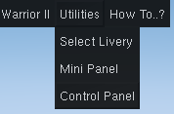

The Control Panel will allow you toggle many of the switches in the cockpit, including the Avionics switch, and Fuel Tank selector.

The Mini Panel appears on the lower left corner of the screen, and allows quick access to a few options. Click the “?” on the panel to learn more about it.