Piper Warrior II: General Settings

Aircraft Config:
This aircraft is equipped with the Aircraft Configuration system. This unique system manages the behavior and settings of the aircraft, in an efficient way.

When starting FlightGear, you will be greeted with the Welcome Dialog:

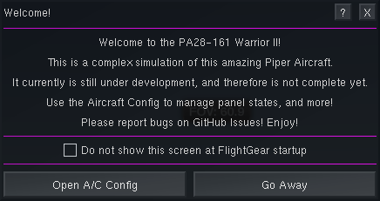

If you do not wish to see this dialog, simply tick the box, and it will not be displayed.

Aircraft Config can be accessed via the Warrior II menu, Welcome Dialog, or the Mini Panel.

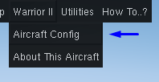
Here is the main dialog. This is where you perform most of the actions in Aircraft Config.

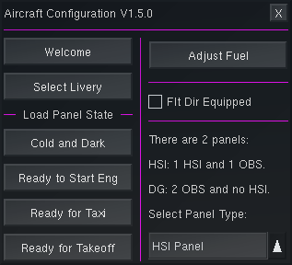

Panel States:
The panel states automatically configure the aircraft in a specific state. You can click them at any time, as long as the aircraft is on the ground, and not moving.

Cold and Dark: Puts the aircraft in a completely shut down state. This allows you to start the aircraft yourself.

Ready to Start Eng: Sets up the aircraft to right before the key is turned. All you need to do is start the engine, and do the after-startup items.

Ready for Taxi: Sets up the aircraft for taxiing. You will need to perform a few more items before takeoff.
Ready for Takeoff: Sets up the aircraft for takeoff. No addition actions are required before throttling up.

Warning: Do not move the throttle while the panel state is loading. The engine start may fail, and the panel state may not load if you do so.

Settings:
There are various settings you can change in the aircraft. These settings will be immeditalely saved, so if the sim is closed, or crashes, they will not be reset. They will also be saved across varients. As of currently, there are 2 settings which can be changed.

Flt Dir Equipped: Equips the aircraft, and the S-TEC 55X Autopilot, with the optional flight director.

Select Panel Type: Changes the panel type. There are currently 2 options:
HSI Panel: The aircraft has an HSI, for NAV1, and an OBS for NAV2.
DG Panel: The aircraft has an OBS for NAV1, and NAV2.
Note: A glass cockpit or EFIS varient may be added in the future.

Control and Mini Panels:
There are 2 dialogs available to help you access things which may not be in view. They can be opened from the Utilities menu:

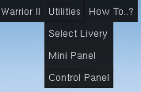

The Control Panel will allow you toggle many of the switches in the cockpit, including the Avionics switch, and Fuel Tank selector.

The Mini Panel appears on the lower left corner of the screen, and allows quick access to a few options.

To learn more about these dialogs, see the document about them.

