Piper Warrior II: About the Mini Panel

The Mini Panel is an easy way to access commonly used items without taking up much space on the screen.

The panel can be shown by selecting “Mini Panel” from the Utilities menu.
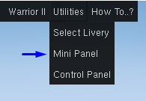

The mini panel will be open when FlightGear is restarted if it was open when FlightGear was closed.

The options on the Mini Panel are as follows:
Close the Mini Panel
Access this help document
Show Aircraft Configuration
Show Control Panel
Show Checklist Dialog
Switch tanks between left and right wing

