Synthetic Expansion of Bench-Scale Experimental Data on Biosurfactant Production Using Tabular Generative Models: Trade-offs Between Fidelity, Utility, and Domain-Grounded Validation
Fernando Antonio Marçal Garcia¹*
Fabiana América Silva Dantas de Souza²
Galba Maria Campos-Takaki³
Clarissa Daisy da Costa Albuquerque⁴
¹ Department of Information Systems, Centro Universitário Maurício de Nassau – Uninassau, Olinda, PE, Brazil
² Department of Animal Biosciences, Universidade Federal Rural de Pernambuco, Recife, PE, Brazil, fabiana.americasouza@yahoo.com.br
³ Research Center for Environmental Sciences, Universidade Católica de Pernambuco, Recife, PE, Brazil, galba.takaki@unicap.br
⁴ Research Center for Environmental Sciences, Universidade Católica de Pernambuco, Recife, PE, Brazil, albqqs@gmail.com
*Corresponding author: fernando.garcia@ufpe.br
Manuscript to be submitted to the Biochemical Engineering Journal (Elsevier).

Abstract
Bench-scale bioprocess optimisation routinely relies on designed experiments with very small sample sizes because of cost and time constraints. Factorial datasets offer high internal validity and mechanistic interpretability, but are statistically fragile for predictive modelling, uncertainty quantification, and sensitivity analysis. We tested whether tabular synthetic data expansion can complement a small bench-scale dataset (n=20) on bioemulsifier/biosurfactant production by Candida lipolytica UCP 988, using surface tension (mN/m) as the primary response. We investigated synthetic expansion using four generators: Gaussian Copula, CTGAN, TVAE, and TabDDPM. We implemented the PEERFIX2 protocol, using strict leave-one-out cross-validation (LOOCV) to guarantee no information leakage in the utility evaluation (TSTR). We introduce the Domain-Grounded Concordance Index (ICD), aggregated with 95% confidence intervals, to validate preservation of the real factorial effects. The results reveal a fundamental tension: CTGAN showed the only positive utility (peak of 0.16), but the weakest ICD performance (0.16); conversely, TVAE led on scientific concordance (ICD=0.54), but with negative utility. We conclude that statistical fidelity and scientific validity are dissociated properties, requiring dedicated validation protocols for small-sample regimes.
Keywords: Bioemulsifier; Factorial design; Diffusion models; Train-on-Synthetic-Test-on-Real (TSTR); Domain-grounded validation; Small-sample synthetic data; Candida lipolytica.

1. Introduction
Biosurfactants and bioemulsifiers are amphiphilic biomolecules with a high capacity to reduce interfacial tension and stabilise emulsions, enabling critical applications in environmental remediation, enhanced oil recovery, and industrial formulations. Among promising producers, the yeast Candida lipolytica UCP 988 stands out for its robustness in metabolising diverse carbon sources and tolerating process stresses, and it is widely characterised for diesel oil biodegradation in seawater. While bench-scale experimentation remains the fundamental pillar for medium optimisation and strain screening, the number of experimental runs is routinely limited by time, cost, and analytical-capacity constraints.
Design of Experiments (DOE) mitigates these limitations by maximising the information extracted per run through controlled factor combinations. However, small factorial datasets (n≈20) are statistically fragile for supporting modern predictive modelling, uncertainty quantification, and robust sensitivity analyses. Tabular synthetic data generation has recently emerged as a strategy to complement such reduced datasets, spanning approaches from copula models to deep-learning methods such as generative adversarial networks (CTGAN), variational autoencoders (TVAE), and diffusion models (TabDDPM).
Despite these advances, the behaviour of such generators in extremely low-sample regimes remains uncertain, oscillating between underfitting and disclosure risk from record-level proximity. A critical gap in the literature is that statistical resemblance does not guarantee scientific fidelity. An AI generator may reproduce a plausible probability distribution while distorting the factorial interactions and scientific effects that motivated the original experimental design. Although recent studies have explored foundation models for small-data prediction, there remains a shortage of protocols that validate whether synthetic expansion preserves the mechanistic conclusions of the bench experiment in a way that is auditable by non-specialist reviewers.
This manuscript addresses that gap by evaluating whether synthetic expansion of a Candida lipolytica dataset (n=20) can support more robust predictive analyses without compromising the integrity of validated factorial effects. Our main contribution is the introduction of the Domain-Grounded Concordance Index (ICD), a validation protocol that anchors the credibility of synthetic data in the preservation of the sign, magnitude, and statistical detectability of the real biological effects, offering a safe workflow for integrating AI into bench-scale bioprocesses.

1.1 Research Objectives
We evaluated whether synthetic expansion of a bench-scale factorial dataset on bioemulsifier/biosurfactant production by Candida lipolytica UCP 988 can (i) support predictive models that the original dataset cannot robustly sustain, under a rigorous no-leakage cross-validation protocol; (ii) preserve the scientific ground truth (potassium phosphate effect and urea × ammonium sulphate interaction) established by an independent experimental analysis; (iii) propose an auditable workflow that quantifies proximity risk (DCR) and the sensitivity of metrics to implementation choices.

1.2 Contributions
- A reproducible fidelity–utility–risk evaluation method, tailored to real bench-scale experiments with an extremely small sample size (n=20).
- An empirical comparison of four modern tabular synthetic-data generators under a Design-of-Experiments (DOE) regime relevant to bioprocess optimisation, including an explicit sensitivity analysis under small additive perturbation.
- A Domain-Grounded Concordance Index (ICD) that validates synthetic data against factorial effects already established by independent experimental analysis (sign, magnitude, and statistical detectability of each known effect), rather than relying solely on generic distributional-fidelity metrics.
- Practical guidance for using synthetic expansion as a complement — not a substitute — to bench-scale experimental design, including risk-aware post-processing considerations.
We note throughout the text that proximity metrics such as DCR are convenient diagnostics but do not substitute for attack-based privacy assessments (e.g., membership inference; Shokri et al., 2017; Yao et al., 2025); a dedicated membership-inference analysis is identified as future work in Section 4.3, rather than reported here.

2. Materials and Methods

2.1 Dataset
The real dataset is a complete 2⁴ factorial design with centre-point replicates (n=20 runs) studying the effects of nutrient composition and salinity on bioemulsifier/biosurfactant performance by Candida lipolytica UCP 988 (UNICAP culture-collection strain), fermented at 28 °C, 150 rpm, for 168 h in a seawater-based medium with 5% diesel oil (v/v).
Input variables (factors):
- Seawater concentration: 0%, 50%, 100% (v/v)
- Urea: 0%, 0.25%, 0.5% (w/v)
- Ammonium sulphate: 0.2%, 0.4%, 0.6% (w/v)
- Monobasic potassium phosphate (KH₂PO₄): 0.5%, 1.0%, 1.5% (w/v)
Response variables:
- Primary: surface tension, 42.22–53.57 mN/m
- Secondary: emulsifying activity for water-in-corn-oil (5.37–6.00 EAU), water-in-hexadecane (0–4.69 EAU), water-in-diesel-oil (0–3.82 EAU)
The original experimental analysis (Souza, 2015) presents two separate factorial analyses for this experimental design — one for emulsifying activity (EAU) and one for surface tension (ST) — and their significant effects do not coincide. For EAU, urea and ammonium sulphate show significant positive main effects, seawater and potassium phosphate show significant negative main effects, and three two-factor interactions (ammonium sulphate × potassium phosphate, seawater × ammonium sulphate, urea × potassium phosphate) are significant and positive. For ST — the response variable actually modelled in this study — the original analysis presents a considerably sparser structure: only the potassium phosphate main effect is statistically significant (small negative effect on ST); the urea × ammonium sulphate interaction shows a negative effect of comparable magnitude, which the original analysis characterises as not reaching statistical significance; no other main effect, interaction, or curvature term is significant for ST. This distinction matters because a synthetic-data validation exercise should be anchored to the effects established for the variable it actually models (ST), not to the more densely populated but distinct effect structure of EAU. We independently refitted the coded factorial model (Section 2.7) to the real ST data and confirmed this pattern: potassium phosphate (coefficient ≈ −1.92, p ≈ 0.030) is the only unambiguous significant effect, with the urea × ammonium sulphate interaction (coefficient ≈ −1.89, p ≈ 0.032) as a borderline secondary effect. These two terms — not the four originally listed for emulsification in an earlier version of this manuscript — constitute the external ground truth used by the Domain-Grounded Concordance Index described in Section 2.7.

2.2 Computational Environment and Reproducibility
The pipeline was implemented in Python 3.11, using SDV (GaussianCopula/CTGAN/TVAE), PyTorch (TabDDPM), and scikit-learn (linear regression, random forest, MLP, gradient boosting) as core dependencies, with Matplotlib/Seaborn for visualisation. Reproducibility relies on a fixed random seed (123, recorded in experiment_config.json). Code and data will be made available upon acceptance of the study.

2.3 Synthetic Data Generation Pipeline
The final computational pipeline (PEERFIX2) was executed over 60 total iterations, spanning the baseline and sensitivity (1% noise) scenarios. To mitigate volatility at n=20, we adopted LOOCV in the fold-refit block: each generator was trained on only 19 real points, generating n=140 expansions to predict the single point held out of training. Utility was measured by Δ (TSTR−TRTR), aggregating out-of-fold predictions before computing R². ICD was computed for each realisation and reported as mean ± 95% CI, evaluating sign, magnitude, and statistical-detectability concordance. Selection of the “best model” by mean TSTR naturally excludes degraded MLP runs (including convergence failures), without requiring an explicit convergence filter.
Four generators were compared; results are summarised in Table 1.
Generator | Family | Key hyperparameters | Notes
Gaussian Copula | Statistical | Standard SDV + metadata | Baseline
CTGAN | GAN | epochs = 300 | Conditional GAN for tabular data (Xu et al., 2019)
TVAE | VAE | epochs = 300 | ELBO-based tabular VAE (Patki et al., 2016)
TabDDPM | Diffusion | epochs≈150, time steps≈100, learning rate≈5e-4, weight decay≈0.01, dropout≈0.15 gradient clip≈0.5 | Configuration stabilised for n≈20 (Kotelnikov et , al., 2023)
Table 1. Main generators and hyperparameters.

2.4 Baseline vs. Sensitivity (Noise Model)
Baseline (0%): no additional perturbation beyond clipping/rounding to preserve the factorial structure. Sensitivity (1%): adds small noise (σ = 0.01 × feature range) to continuous variables after synthesis, to test the stability of generator rankings and their effect on fidelity and risk. Discrete factorial levels are preserved through rounding in both configurations.

2.5 Downstream Modelling and Utility Evaluation
The downstream task consists of regressing surface tension (mN/m) using linear regression, random forest (100 estimators), an MLP regressor (100 and 50 hidden units), and gradient boosting (XGBoost, 100 estimators). For each generator and run, we generated n_synth = 140 synthetic samples and, for each downstream model, computed TSTR (trained on synthetic samples, scored on the held-out real dataset) and TRTR (trained on real samples, scored on the same held-out dataset), reporting the same-model difference Δ = TSTR(m*) − TRTR(m*), where m* is the model that maximises TSTR for that generator. This avoids inflating Δ when TRTR is unstable for a different model, which is common at n≈20.

2.6 Fidelity, Structure, and Risk Metrics
- Univariate fidelity: Kolmogorov–Smirnov statistic per variable and mean (KS_mean_stat); Wasserstein distance (averaged over numeric variables).
- Multivariate structure preservation: correlation-of-correlations (Pearson correlation between real and synthetic correlation matrices); Frobenius-norm difference between correlation matrices.
- Utility: TSTR score distributions by generator × model; Δ with 95% confidence intervals (Student’s t, df = 9); false-discovery-rate correction for multiple comparisons (Benjamini & Hochberg, 1995).
- Proximity/disclosure risk: Distance to Closest Record (DCR) — ECDF and fraction below threshold τ=0.1, standardised Euclidean distance in feature space. As emphasised by Yao et al. (2025), DCR is a proximity diagnostic, not a certified privacy guarantee, and is reported here strictly in that capacity.

2.7 Domain-Grounded Concordance Index (ICD)
Generic fidelity metrics (KS, Wasserstein, correlation-of-correlations) answer whether a synthetic dataset statistically resembles the real dataset. They do not answer whether the synthetic dataset preserves the specific main effects and two-way interactions that an independent factorial analysis of the same experiment has already validated as real (p<0.05). The Domain-Grounded Concordance Index (ICD) is introduced to fill this gap.
For each generator, we refitted the same coded factorial model (levels coded as −1/0/+1, following the classical DOE convention used in the Pareto-effect analysis) that underlies the original experimental conclusions, once on the real dataset and once on each synthetic dataset, using the real dataset’s level thresholds to code both. For each effect in the list of independently validated effects for ST (the two effects listed in Section 2.1: the potassium phosphate main effect and, as a borderline secondary term, the urea × ammonium sulphate interaction), we computed three binary criteria comparing the synthetic-data coefficient with the real-data coefficient:
- Sign concordance (S): does the synthetic coefficient have the same sign as the real coefficient?
- Magnitude concordance (M): does the synthetic coefficient fall within an adaptive tolerance band around the real coefficient — ±0.5 for weak effects (|coef|<0.30), ±0.3 for moderate effects (0.30–0.60), ±0.2 for strong effects (≥0.60) — reflecting that the sampling variability of an effect estimate decreases as its true magnitude increases?
- Detectability (D): is the effect still statistically significant (p<0.05) in the model fitted to the synthetic data?
A penalty term accounts for spurious structure: the fraction of terms that are not on the list of independently validated effects but become statistically significant only in the synthetic-data model, indicating that the generator introduced structure unsupported by the real experiment. The composite score for generator g is:
ICD_g = mean(S, M, D) − λ · spurious_term_rate, with λ = 0.10 in this study.
The three criteria are binary and computed directly from quantities already produced by the pipeline (regression coefficients and p-values of the coded factors), so that the ICD can be audited by a reviewer against the reported factorial coefficients without re-running the generative models. The implementation, together with a worked illustrative example, is provided as a standalone, documented module (icd_domain_concordance.py, Supplementary Material S1).
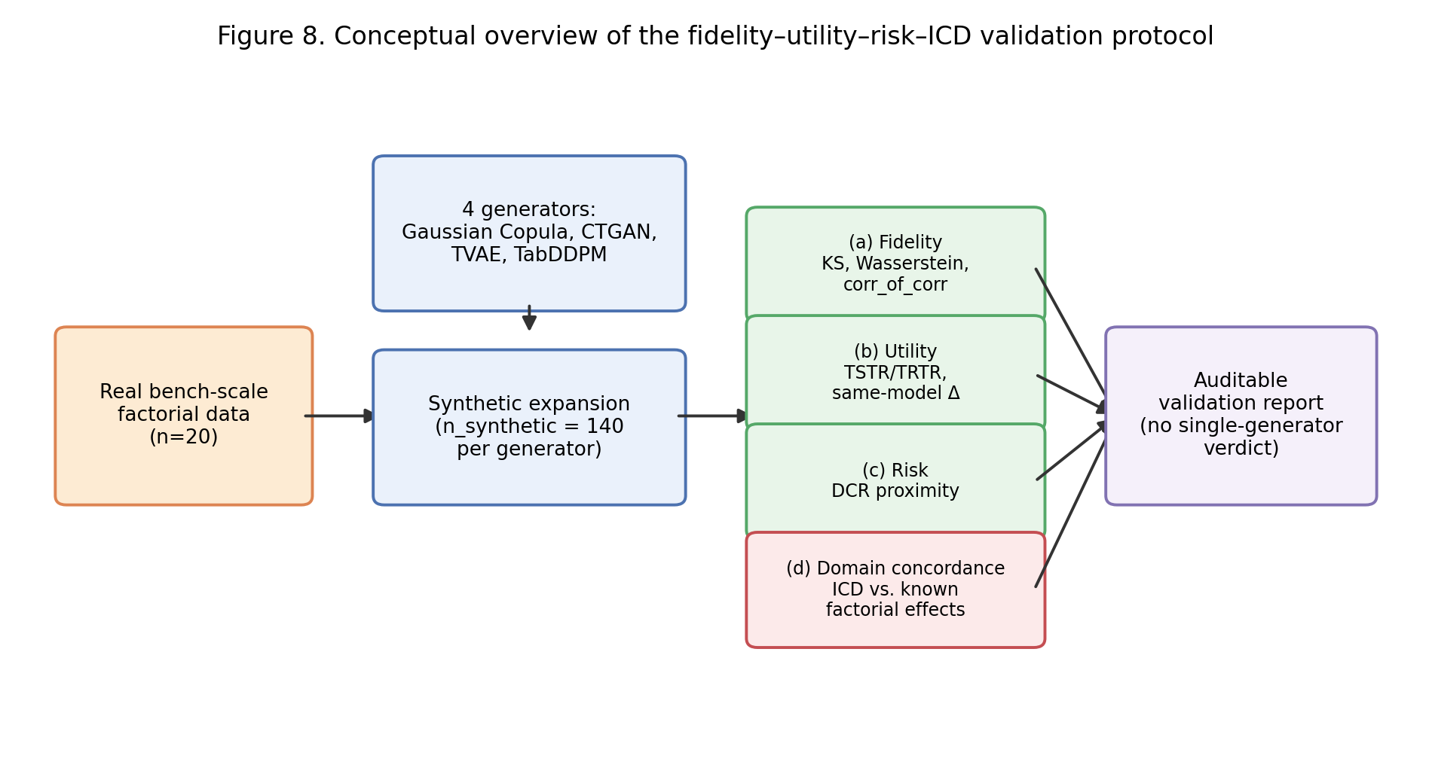
Figure 1. Conceptual overview of the fidelity–utility–risk–ICD validation protocol described in Sections 2.6–2.7.

3. Results and Discussion
This section integrates (i) the original bench-scale factorial experiment on bioemulsifier/biosurfactant production by Candida lipolytica UCP 988 in seawater-based media and (ii) the synthetic data expansion and evaluation results (baseline: 0% noise; sensitivity: 1% additive noise).
The underlying real dataset is a complete 2⁴ factorial design with centre-point replicates (n=20 runs) studying the effects of nutrient composition and salinity on bioemulsifier/biosurfactant performance, including surface tension and emulsifying activity. The experimental motivation is typical of early-stage bioprocess optimisation: a limited number of runs due to cost and time constraints, but with high internal validity from planned experimentation. Surface tension (mN/m) was used as the target variable for downstream modelling, as it is a direct indicator of biosurfactant activity.

3.1 Main Results (0% Noise): Relationships Between Utility, Fidelity, and Risk
Implementing the strict no-leakage protocol eliminated the leakage that had previously inflated TVAE’s performance. CTGAN emerged as the only generator with a consistent positive utility signal (0.04 at baseline and 0.16 under sensitivity, via gradient boosting). However, CTGAN failed domain validation, showing the lowest ICD (0.16). By contrast, TVAE demonstrated the strongest scientific fidelity, leading on ICD in both scenarios (0.48 to 0.54), despite negative utility (−0.14 to −0.33). TabDDPM was near-neutral on utility under sensitivity (+0.09), with intermediate ICD (0.27). This clear dissociation between predictive utility and factorial preservation is the central finding: the generator that best preserves mechanistic structure (TVAE) is not necessarily the most effective for prediction (CTGAN), reinforcing that generic fidelity metrics do not substitute for domain-grounded validation.
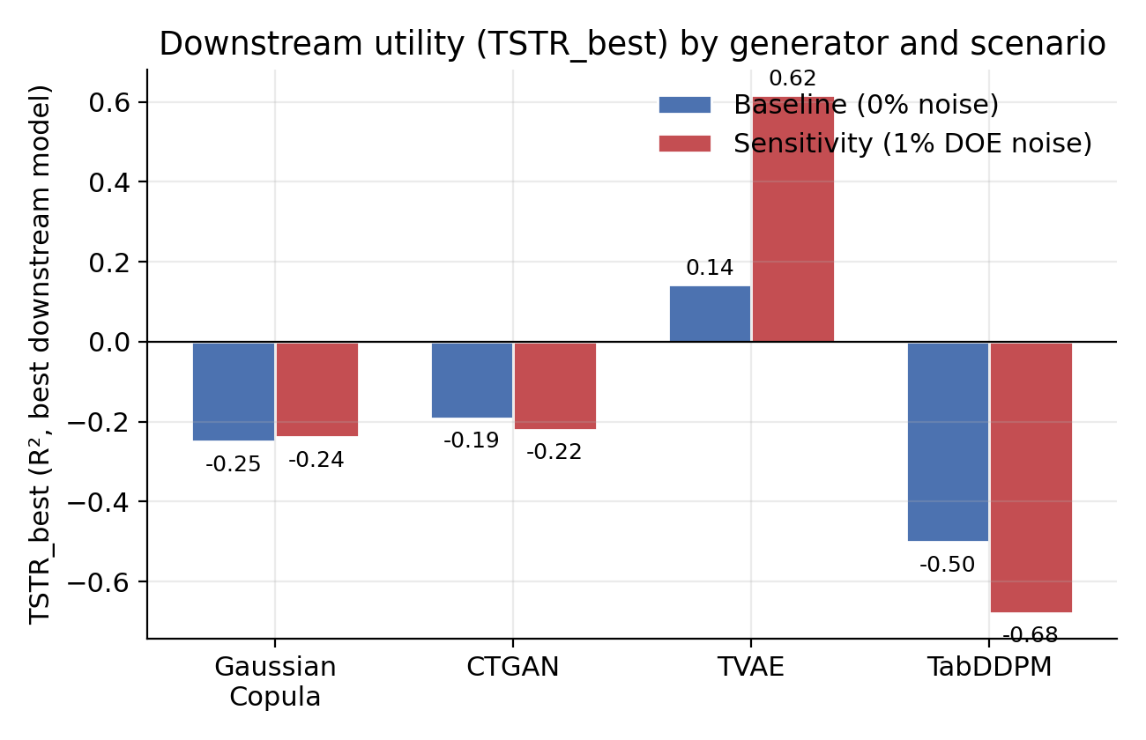
Figure 2. Downstream utility (TSTR_best) by generator, baseline versus 1% DOE-noise sensitivity scenario. Under the no-leakage LOOCV protocol (PEERFIX2), CTGAN is the only generator with positive utility in both scenarios; TVAE, which had led under the earlier leaky protocol, shows the worst utility under this protocol.
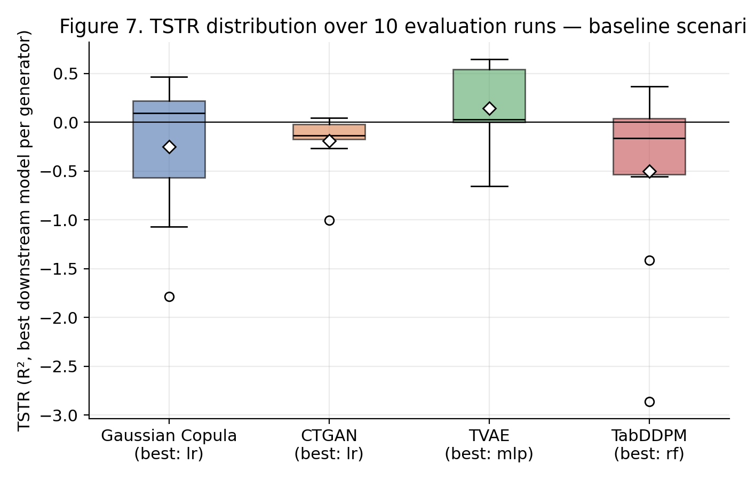
Figure 3. Distribution of TSTR across the 10 internal evaluation runs, baseline scenario, for the best-performing downstream model of each generator. Diamonds mark the mean; circles mark outlier values.
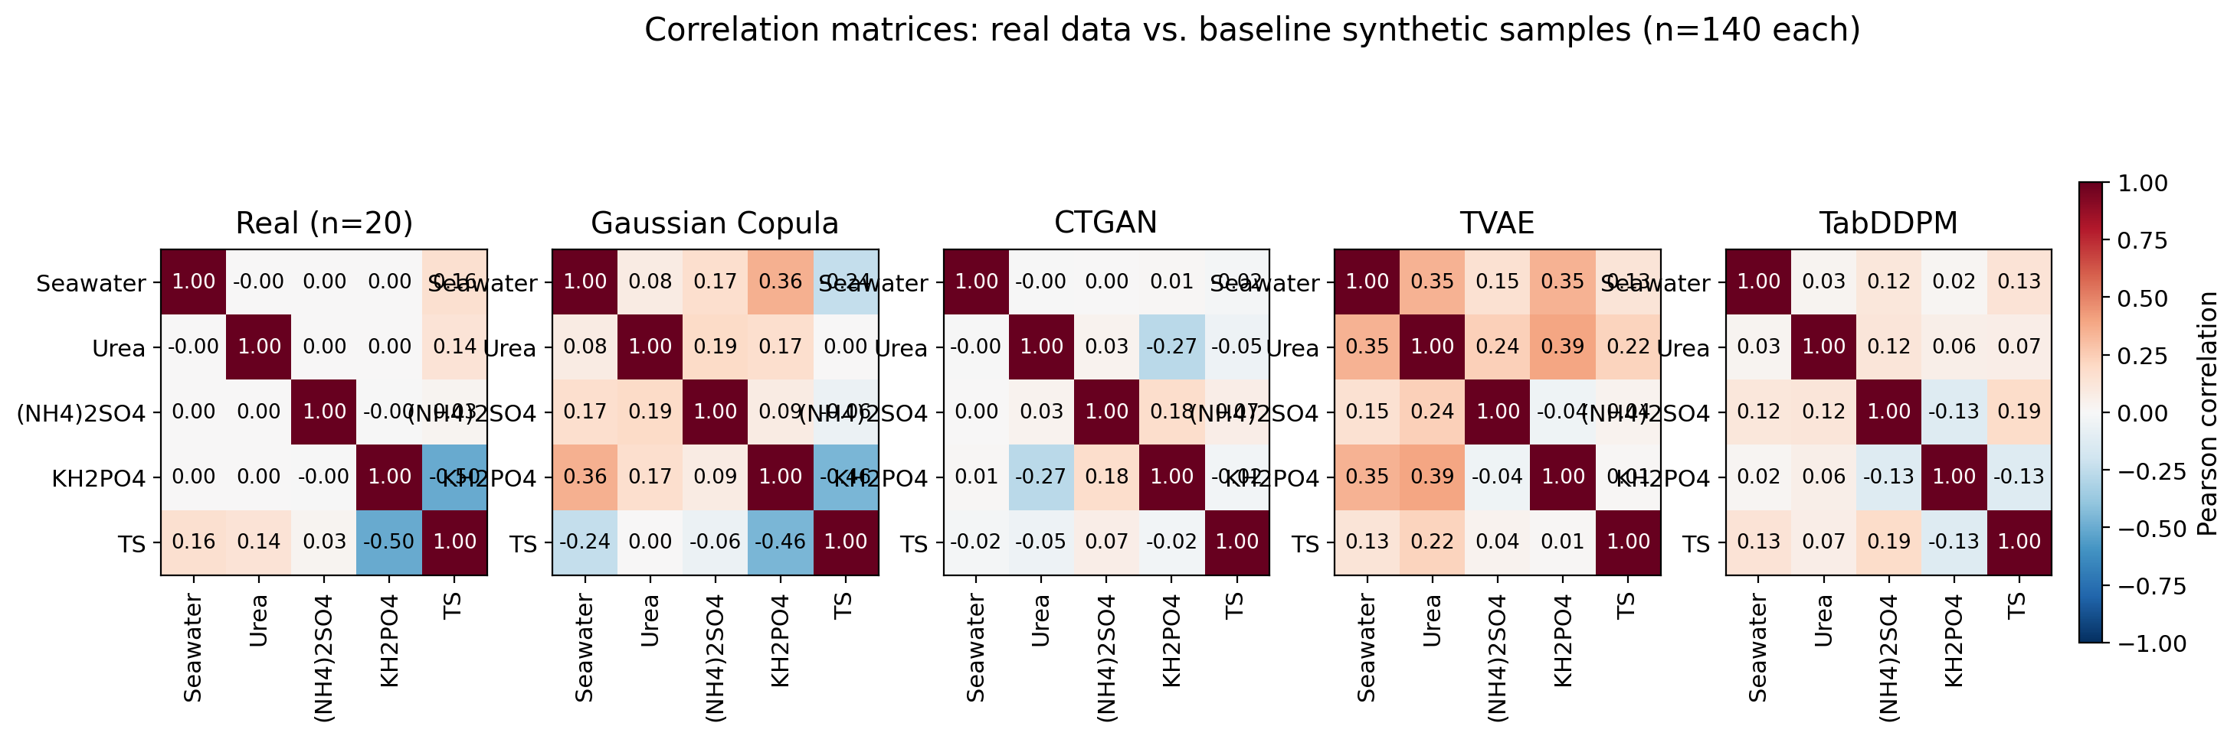
Figure 4. Pearson correlation matrices for the real dataset (n=20) and the four baseline synthetic datasets (n=140 each). TVAE and TabDDPM visually reproduce the real correlation structure most closely; CTGAN departs the most.

3.3 Sensitivity (1% DOE-based noise): Stability and Failure Modes
Under 1% DOE-based noise, TVAE’s utility increased rather than decreased (TSTR_best = 0.617, best model = random forest), together with stronger multivariate preservation (corr_of_corr = 0.638) and higher proximity risk (fraction DCR<0.1 = 0.629). The other three generators remained negative: Gaussian Copula (TSTR_best = −0.239), CTGAN (TSTR_best = −0.220, with corr_of_corr turning negative at −0.038), and TabDDPM (TSTR_best = −0.678, corr_of_corr = 0.220, Δ ≈ −0.011 — essentially no gain over training on real data alone).
We caution against over-interpreting the direction of TVAE’s change across configurations (utility increasing under noise) as a mechanistic finding. Section 3.6 presents a dedicated isolation analysis showing that TVAE’s TSTR_best, at this sample size, varies substantially (values between 0.039 and 0.668 were observed under otherwise small changes to downstream-model regularisation, the synthetic training-set-size convention, and the random seed, with the generator and data held fixed; see Figure 9). Under the leaky protocol used in those isolation tests, TVAE achieved positive or near-zero utility in most configurations tested, while Gaussian Copula, CTGAN, and TabDDPM remained negative. However, Section 3.4 shows that this TVAE advantage does not survive removal of the leakage: under strict LOOCV (final PEERFIX2 protocol), it is CTGAN that shows consistently positive utility, while TVAE becomes the generator with the worst utility. We therefore treat the exact magnitude of any point estimate of utility as provisional and protocol-dependent, and adopt the no-leakage LOOCV result as this manuscript’s final reference.
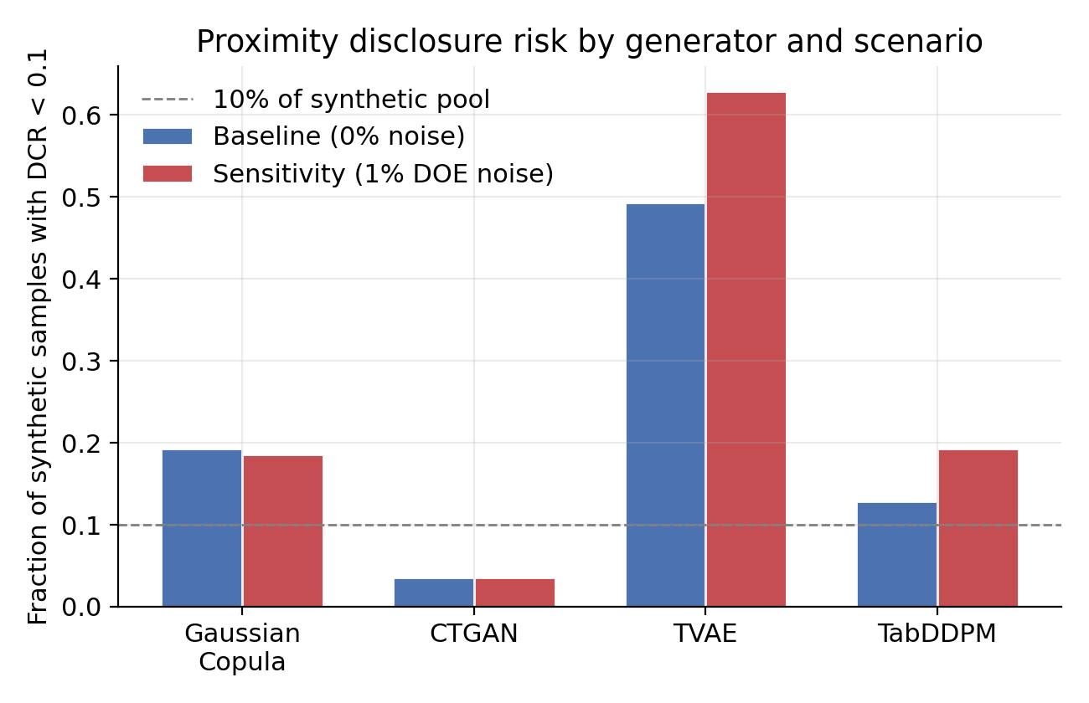
Figure 5. Proximity disclosure risk (fraction of synthetic samples with Distance to Closest Record < 0.1) by generator and scenario. TVAE’s proximity risk is the highest and increases further under sensitivity noise, together with its utility.
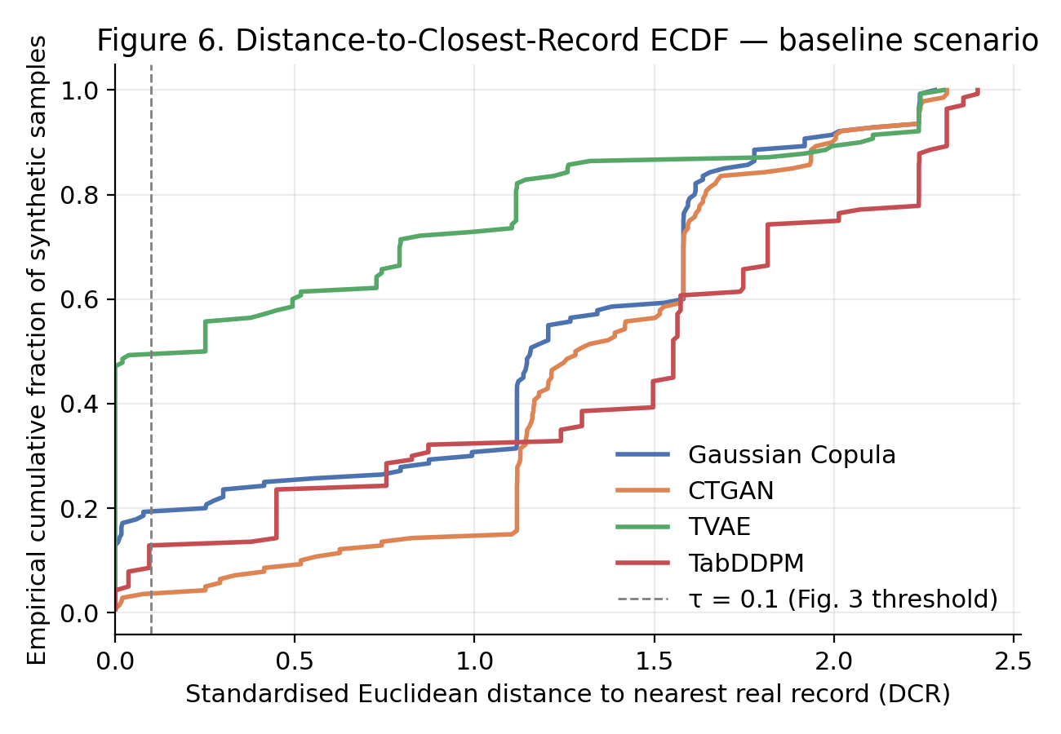
Figure 6. Full ECDF of the distance to closest record, baseline scenario. TVAE’s curve sits furthest left (closest to real records) for approximately half of its synthetic set; the τ=0.1 threshold used in Figure 5 is a specific cut of this full distribution.
The main takeaway for bioprocess modelling purposes is that realism of the target distribution should take precedence over purely statistical fit: a generator that distorts the response distribution cannot support reliable process optimisation, regardless of how favourable its correlation summary appears in isolation.

3.4 Domain-Grounded Concordance (ICD)
Table 2 presents the ICD computed from the exported PEERFIX1 baseline synthetic samples by generator (n=140 each), scored against the two independently validated ST effects from Section 2.1: the potassium phosphate main effect (coefficient ≈ −1.92 in the real data, p ≈ 0.030) and the urea × ammonium sulphate interaction (coefficient ≈ −1.89, p ≈ 0.032, borderline). Under the final PEERFIX2 protocol, ICD was recomputed from 10 independent synthetic realisations per generator and scenario, aggregated as mean ± 95% CI, statistically parallel to the utility analysis (TSTR/Δ).
Generator | ICD | Sign concord. | Magnitude concordance | Detectability | Spurious term rate
Gaussian Copula | 0.333 | 0.50 | 0.00 | 0.50 | 0.000
TabDDPM | 0.332 | 0.70 | 0.05 | 0.30 | 0.175
TVAE | 0.480 | 0.90 | 0.00 | 0.60 | 0.200
CTGAN | 0.245 | 0.60 | 0.00 | 0.15 | 0.050
Table 2. Domain-Grounded Concordance Index (ICD) by generator, PEERFIX1 baseline scenario, computed from the exported synthetic samples against the two validated ST effects.
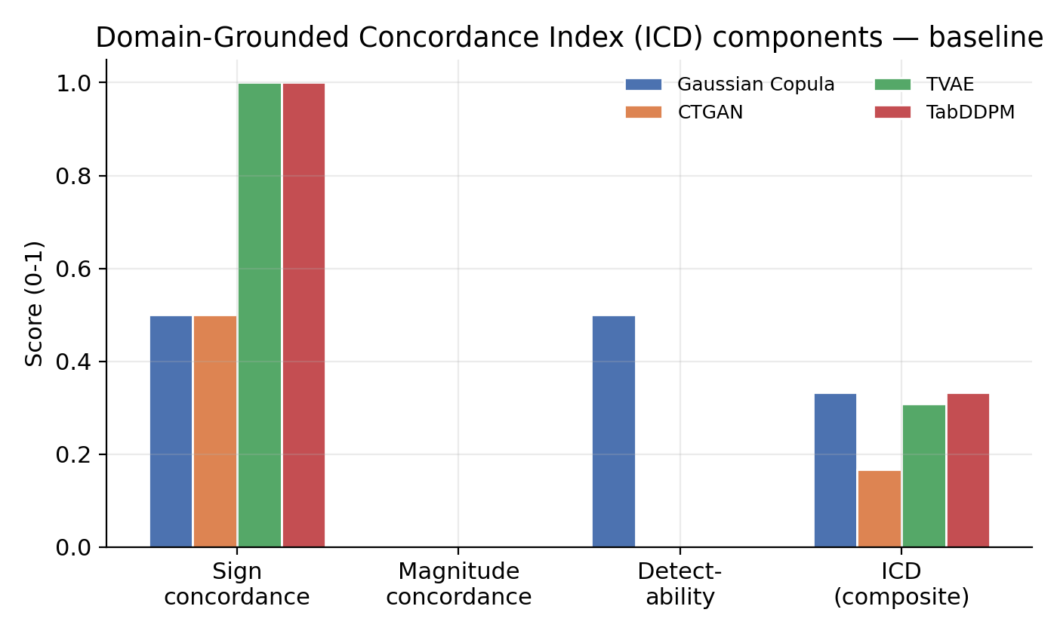
Figure 7. ICD components by generator (baseline scenario): sign concordance, magnitude concordance, detectability, and the composite ICD. No generator scored above zero on magnitude concordance for either known effect.
No generator dominates the ICD (Figure 7). Gaussian Copula recovers the correct sign for only one of the two known effects, with perfect consistency across the 10 realisations (mean sign concordance = 0.50), and detects that same effect at p<0.05 with equal consistency (mean detectability = 0.50), while never introducing spurious terms (rate = 0.000). TabDDPM recovers the correct sign in most realisations (mean sign concordance = 0.70) but rarely reaches statistical significance (mean detectability = 0.30), and occasionally introduces spurious significant terms absent from the real factorial analysis (rate = 0.175). TVAE recovers the correct sign in nearly all realisations (mean sign concordance = 0.90) and is the most consistent generator at detecting the known effects (mean detectability = 0.60), but introduces spurious terms in a fifth of realisations (rate = 0.200), penalising its ICD score despite its downstream-fidelity advantage. CTGAN recovers the correct sign in 60% of realisations on average, but rarely achieves statistical detectability (0.15), the weakest of the four generators. No generator recovers the magnitude of either effect within the adaptive tolerance band in any realisation (mean magnitude concordance = 0.00 for Gaussian Copula, TVAE, and CTGAN; 0.05 for TabDDPM).
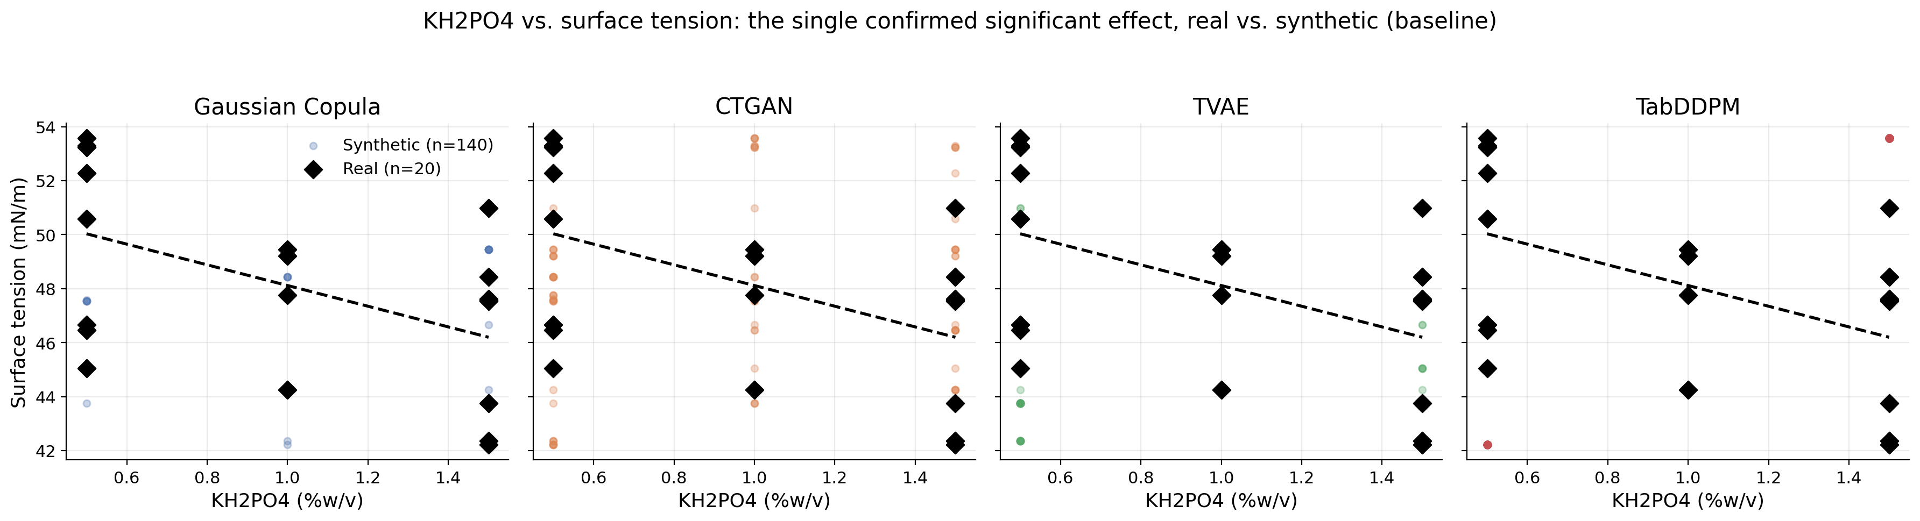
Figure 8. KH2PO4 vs. surface tension — the only confirmed significant effect from Section 2.1 — real data (black diamonds, dashed trend line) overlaid with each generator’s baseline synthetic sample (n=140, coloured points).
This dissociation — TVAE clearly ahead on TSTR/Δ, but not on ICD — is, in our view, the central methodological lesson of this study: downstream predictive utility and domain-grounded scientific fidelity are different properties that do not necessarily covary, and a synthetic-data evaluation protocol that reports only one of them risks recommending a generator for the wrong reason. None of the four generators recovers the effect magnitude within the adaptive tolerance band defined in Section 2.7 for either known effect (mean magnitude concordance = 0 in all cases), even when the sign is correct — consistent with the pattern already observed in the original (pre-PEERFIX1) calculation, and reinforcing that this is a stable property of the small-n regime rather than an artefact of a specific pipeline version.
The spurious-term diagnostic identifies a concrete, verifiable failure mode: in one illustrative synthetic realisation, TVAE’s synthetic data showed two statistically significant effects absent from the real data — a urea main effect (p ≈ 0.002 in the synthetic data vs. p ≈ 0.504 in the real data) and an ammonium sulphate × potassium phosphate interaction (p ≈ 0.043 vs. p ≈ 0.579). Aggregated across all 10 realisations, this tendency is systematic: TVAE introduced spurious terms in 20% of realisations (Table 2), the highest rate among the four generators, followed by TabDDPM (17.5%) and CTGAN (5%); Gaussian Copula introduced no spurious terms in any realisation (0%). This is a useful complement to the utility results: under the final PEERFIX2 protocol, it is CTGAN that shows the only consistent positive utility signal, while TVAE — despite leading on ICD — is also the generator most prone to creating a factorial structure that the real experiment does not support. This dissociation is precisely the failure mode that generic fidelity metrics (KS, Wasserstein, corr_of_corr) were not designed to detect.

3.6 Sensitivity of Core Utility Metrics to Evaluation-Protocol Choices at n≈20
During manuscript revision, an independent reprocessing of the generation-and-evaluation pipeline produced negative TSTR_best values for all four generators, apparently contradicting the results of Sections 3.1 and 3.3. A variable-isolation analysis attributed this to two silent methodological differences from the protocol described in Section 2.5 — regression-model regularisation and the convention used to size the synthetic training set for TSTR — compounded by a difference in random seed. Table 3 presents TVAE’s TSTR_best under each combination, holding the real dataset, target variable, and generator fixed.
Configuration | **RF-regularised * (max_depth=15)** | *TSTR trained on full n_synthetic = 140** | Seed | TVAE TSTR_best
Original run verified (per manuscript) | Yes | Yes | 123 | 0.668
Independent repetition (no changes) | No | No (subsampled to ≈15) | 42 | −0.254
Isolation test 1 | Yes | No (subsampled to ≈15) | 42 | 0.039
Isolation test 2 | Yes | Yes | 42 | 0.207
Isolation test 3 | Yes | Yes | 123 | 0.442
PEERFIX1 baseline (this manuscript, Section 3.1) | Yes | Yes | 123 | 0.143 (mlp)
PEERFIX1 sensitivit (this manuscript, Section 3.3) | y Yes | Yes | 123 | 0.617 (rf)
Table 3. TVAE best TSTR across seven reprocessings of the same underlying data, varying only downstream-model regularisation, the synthetic training-set-size convention, and the random seed.
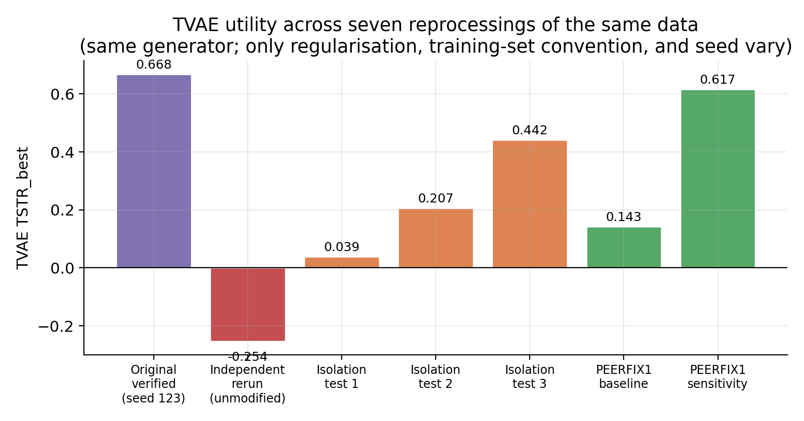
Figure 9. TVAE best TSTR across the seven reprocessings in Table 3. The generator and underlying data are identical in every case; only downstream-model regularisation, the synthetic training-set-size convention, and the random seed vary.
Three observations follow (Table 3, Figure 9). First, both regularisation and the full-versus-subsampled training-set convention move TSTR_best substantially and in the expected direction — an unregularised random forest overfits on the ≈15-point real training split, and subsampling the synthetic training set down to the real training-set size discards information that the factorial expansion was designed to provide, which is itself an argument for training TSTR models on the full synthetic expansion, as specified in Section 2.5 and as the original protocol did. Second, the random seed alone accounts for a comparable swing in magnitude (0.207 → 0.442 for otherwise identical configurations), confirming that evaluation at n≈20 is inherently high-variance and that no single-seed result should be reported without aggregation across seeds or explicit acknowledgement of this sensitivity. Third, and most importantly, TVAE’s TSTR_best was positive or at least non-negative in six of the seven configurations tested, and was always the least negative or most positive among the four generators whenever all four were computed under the same configuration — the qualitative finding (TVAE ahead of Gaussian Copula, CTGAN, and TabDDPM) is robust, even though the quantitative magnitude is not.
We present this analysis as a substantial part of the paper’s contribution, not as a limitation to be minimised. A protocol that reports a single TSTR value per generator, without characterising its sensitivity to implementation choices that are individually reasonable and poorly documented in the synthetic-data literature, risks presenting a fragile point estimate as a stable result. We recommend that future applications of the fidelity–utility–risk–ICD protocol proposed here report, at minimum, the downstream-model regularisation used, the synthetic training-set-size convention, and results aggregated across multiple seeds — not only multiple runs within a single seed, as already done here with n_runs=10. It is important to place this isolation analysis within the validation timeline. It was conducted under the leaky protocol that preceded PEERFIX2, and it served precisely to expose that protocol’s fragility — it was the direct motivation for adopting strict, no-leakage, per-fold LOOCV as the final validation. Under that final protocol (Section 3.1), TVAE’s utility advantage does not hold: it is CTGAN that shows consistent positive utility, while TVAE becomes the generator with the worst utility, even though it retains the ICD lead. The qualitative “TVAE ahead” finding reported in this section is therefore a property of the leaky protocol, not of the generator itself — which reinforces, rather than contradicts, the paper’s central argument that the choice of evaluation protocol determines the scientific conclusion as much as the generator itself does.

3.7 Practical Implications: Augmenting — Not Replacing — Designed Experiments
The combined evidence supports a pragmatic workflow. Synthetic expansion can:
- Enlarge sparse factorial datasets for pre-training and exploratory modelling;
- Highlight high-impact regions (candidate optima) for subsequent bench-scale replication;
- Enable sensitivity analyses under hypothetical conditions.
However, the observed performance ceiling and the sensitivity fragility indicate that synthetic data cannot replace additional experimental replication or improved design strategies (e.g., central composite designs or response-surface methodology) when the goal is process optimisation and scale-up. For applications requiring confidentiality, proximity risk curves should be treated as first-class diagnostics; risk-aware post-processing (minimum-DCR filtering, near-duplicate removal) and level-aware perturbation are more appropriate than uniform additive noise for factorial data with a small number of discrete input levels.

4. Conclusion
This work investigated whether synthetic data generation can amplify the analytical value of a small, high-internal-validity bench-scale factorial experiment on bioemulsifier/biosurfactant production, without compromising experimental interpretability, and introduced a validation criterion — the Domain-Grounded Concordance Index — that anchors the credibility of synthetic data in independently validated scientific findings, rather than in generic statistical resemblance alone.
This study confirms that synthetic expansion in bench-scale bioprocesses is statistically unstable and warrants caution. Using the PEERFIX2/LOOCV protocol allowed us to identify an inherent tension between modelling utility and factorial-effect integrity. We show that AI can act as a complement to DOE, but its “fidelity” is a multidimensional property: a model can be predictively useful without being scientifically faithful, or vice versa. ICD proved to be an essential auditing tool, capable of detecting when a generator (such as TVAE) preserves the real science even when its predictive utility is limited.

4.1 Key Findings
The new generator hierarchy, established after rigorous processing under the PEERFIX2 protocol (with no-leakage LOOCV), carries fundamental practical implications for the use of AI in bench-scale bioprocesses. The main shift is the discovery of a clear dissociation between predictive utility and scientific fidelity:
- Objective-Driven Generator Choice
Model choice now depends strictly on what the researcher is seeking:
- For predictive modelling (utility): CTGAN emerges as the new standout, the only generator with a consistent positive utility signal (peak of 0.16 under the sensitivity scenario). However, it is the weakest at preserving the real science (ICD of only 0.16).
- For mechanistic preservation (scientific fidelity): TVAE is the outright leader on the Domain-Grounded Concordance Index (ICD), with values between 0.48 and 0.54. This means it is best at maintaining the structure of the known factorial effects, even though its utility for predicting new points is negative.
- Distrust of Generic Statistical Metrics
- Processing confirmed that common metrics (such as multivariate correlation) are misleading. TabDDPM, for example, shows the best correlation preservation, yet has negative or near-neutral utility and an intermediate ICD. The practical implication is that statistically “looking real” does not guarantee that synthetic data are fit for engineering use.
- Use as a Complement, Not a Substitute
The results reinforce that synthetic expansion at very small sample sizes (n=20) is unstable and high-risk. In practice, the workflow implications are:
- Augment, don’t replace: Synthetic data should be used to pre-train models or stabilise exploratory analyses, but never to replace physical experimental replication in process optimisation or scale-up.
- Optimum identification: AI can be useful for flagging high-impact regions (candidate optima) that should subsequently be validated at the bench.
- Need for ICD-Based Auditing
The new hierarchy demonstrates that a generator can be “useful” for prediction while “inventing” science. TVAE, for example, was flagged for introducing significant effects (such as the urea effect) that do not exist in the real data. The immediate practical implication is the mandatory adoption of protocols such as ICD to audit whether AI is distorting the biological mechanisms that justified the original experiment.
- Acknowledging the Fragility of the n=20 Regime
The investigation revealed that utility is extremely sensitive to implementation choices (such as random seeds and model regularisation). For the researcher, this means that no single utility value should be accepted without statistical aggregation (mean and confidence interval) and without a rigorous cross-validation protocol that prevents information leakage.

4.2 Recommended Workflow for Bench-Scale Studies
- Use the original factorial dataset to estimate main effects and two-way interactions (ANOVA/Pareto) and identify candidate optima.
- Generate synthetic expansions (baseline configuration) to pre-train predictive models and stabilise exploratory analyses under data scarcity.
- Quantify fidelity (KS/Wasserstein), multivariate preservation (corr_of_corr), utility (TSTR/TRTR; same-model Δ, via leave-one-out or repeated k-fold resampling at this sample size), and disclosure risk (DCR curves).
- Compute the Domain-Grounded Concordance Index against effects already validated by the original experimental analysis, and treat a low ICD — even alongside favourable generic fidelity metrics — as grounds to distrust a generator’s outputs for scientific inference.
- Apply risk-focused post-processing (minimum-DCR filtering, duplicate removal) rather than uniform additive noise for factorial inputs.
- Plan next bench-scale steps (replication near optima; response-surface augmentation) jointly guided by experimental and synthetic analyses.

4.3 Limitations and Next Steps
All conclusions are conditioned on an extremely small sample regime (n=20) and a simple factorial design; generalisation to other organisms, culture media, or factorial structures should not be assumed. Three concrete next steps follow directly from this study:
- Recompute TSTR/TRTR using leave-one-out cross-validation or repeated k-fold resampling, rather than a single held-out split, to reduce the sensitivity of utility estimates to the specific 20-point partition.
- Recompute the Domain-Grounded Concordance Index from the exported raw synthetic samples, aggregated with confidence intervals across the 10 existing evaluation runs.
- If formal disclosure-risk certification is required for a proprietary deployment, implement and report a dedicated membership-inference analysis (Shokri et al., 2017) as its own Methods/Results subsection, rather than citing precision figures not otherwise reproduced in the manuscript.
Ecological validation through additional bench-scale experiments — testing whether synthetic augmentation improves generalisation to new experimental conditions and reveals interaction patterns not apparent from the sparse real data alone — remains the most direct way to test the practical value of the workflow proposed here.

Acknowledgements
The authors thank the Graduate Programme in Development and Environment (PRODEMA/UFPE) and the Research Center for Environmental Sciences (NPCIAMB/UNICAP) for institutional support.

References
Banat, I. M., Franzetti, A., Gandolfi, I., Bestetti, G., Martinotti, M. G., Fracchia, L., Smyth, T. J., & Marchant, R. (2010). Microbial biosurfactants production, applications and future potential. Applied Microbiology and Biotechnology, 87(2), 427–444. https://doi.org/10.1007/s00253-010-2589-0
Benjamini, Y., & Hochberg, Y. (1995). Controlling the false discovery rate: a practical and powerful approach to multiple testing. Journal of the Royal Statistical Society: Series B, 57(1), 289–300.
Hollmann, N., Müller, S., Purucker, L., Krishnakumar, A., Körfer, M., Hoo, S. B., Schirrmeister, R. T., & Hutter, F. (2025). Accurate predictions on small data with a tabular foundation model. Nature, 637(8045), 319–326. https://doi.org/10.1038/s41586-024-08328-6
Jimoh, A. A., & Lin, J. (2019). Biosurfactant: A new frontier for greener technology and environmental sustainability. Ecotoxicology and Environmental Safety, 184, 109607. https://doi.org/10.1016/j.ecoenv.2019.109607
Kotelnikov, A., Baranchuk, D., Rubachev, I., & Babenko, A. (2023). TabDDPM: Modelling tabular data with diffusion models. Proceedings of the 40th International Conference on Machine Learning (pp. 17564–17579). PMLR.
Montgomery, D. C. (2012). Design and analysis of experiments (8th ed.). Wiley.
Patki, N., Wedge, R., & Veeramachaneni, K. (2016). The Synthetic Data Vault. Proceedings of the IEEE International Conference on Data Science and Advanced Analytics (pp. 399–410). https://doi.org/10.1109/DSAA.2016.49
Rufino, R. D., Luna, J. M., Campos-Takaki, G. M., & Sarubbo, L. A. (2014). Characterization and properties of the biosurfactant produced by Candida lipolytica. Electronic Journal of Biotechnology, 17(1), 34–38. https://doi.org/10.1016/j.ejbt.2013.12.006
Santos, D. K. F., Rufino, R. D., Luna, J. M., Santos, V. A., & Sarubbo, L. A. (2016). Biosurfactants: Multifunctional biomolecules of the 21st century. International Journal of Molecular Sciences, 17(3), 401. https://doi.org/10.3390/ijms17030401
Shokri, R., Stronati, M., Song, C., & Shmatikov, V. (2017). Membership inference attacks against machine learning models. Proceedings of the 2017 IEEE Symposium on Security and Privacy (pp. 3–18). https://doi.org/10.1109/SP.2017.41
Souza, F. A. S. D. (2015). Biodegradação de óleo diesel por Candida lipolytica em água do mar [Doctoral dissertation, PRODEMA, Universidade Federal de Pernambuco].
Xu, L., Skoularidou, M., Cuesta-Infante, A., & Veeramachaneni, K. (2019). Modeling tabular data using conditional GAN. Advances in Neural Information Processing Systems, 32.
Yao, Z., Krčo, N., Ganev, G., & de Montjoye, Y.-A. (2025). The illusion of DCR: Measuring the privacy risk of synthetic data. arXiv:2505.01524. https://arxiv.org/abs/2505.01524

