**API REGISTRATION**

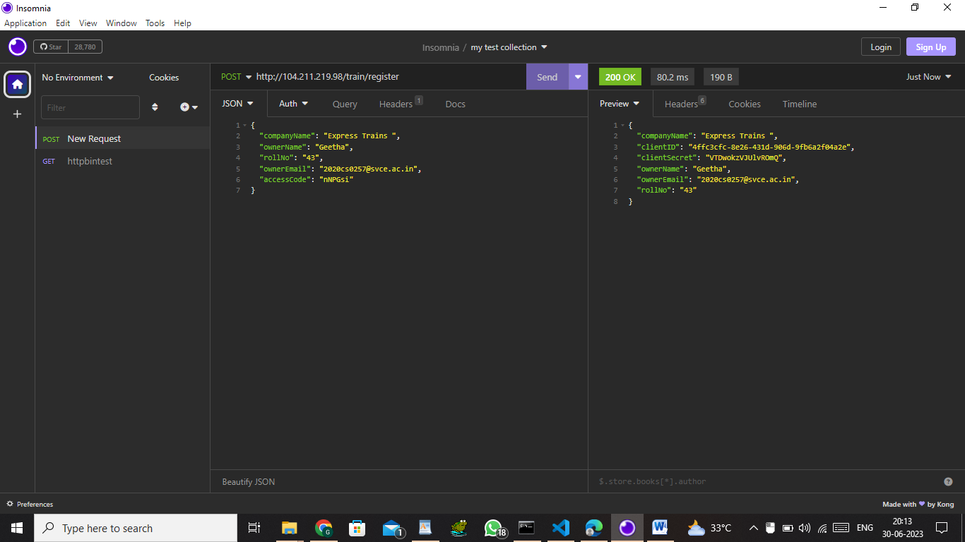

**API AUTHORIZATION TOKEN:**

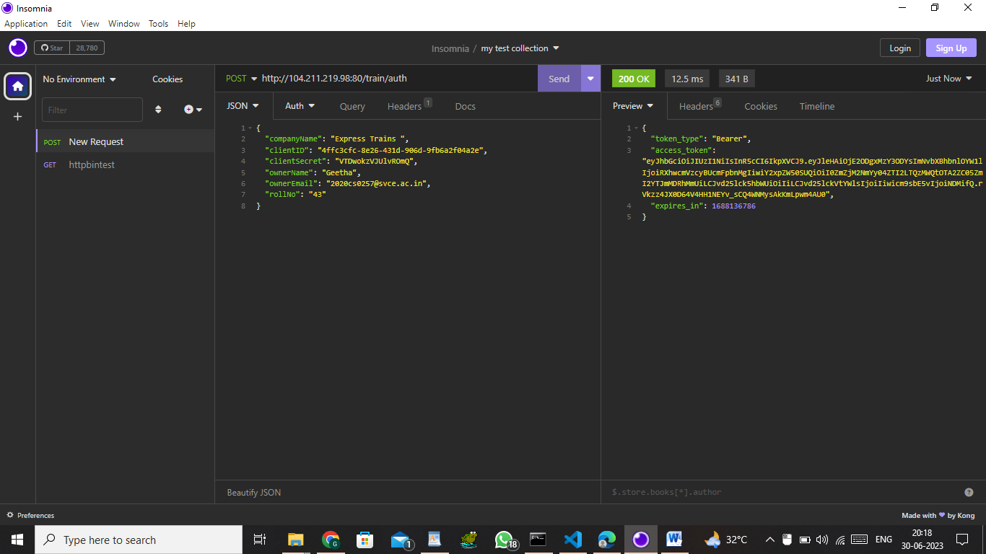

**RETURNS TRAIN DETAILS BY USING AUTHORIZATION TOKEN:**

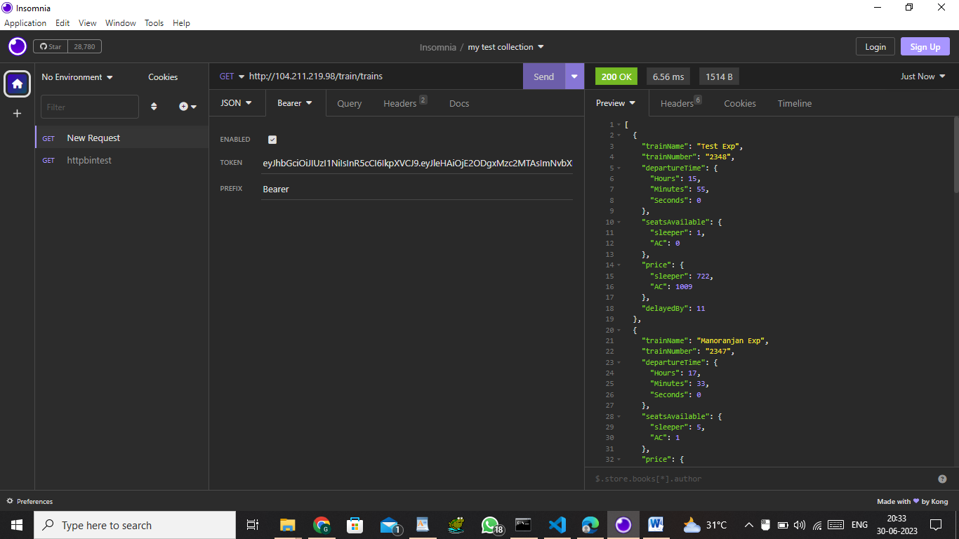

**GETTING INFO OF SINGLE TRAIN:**

