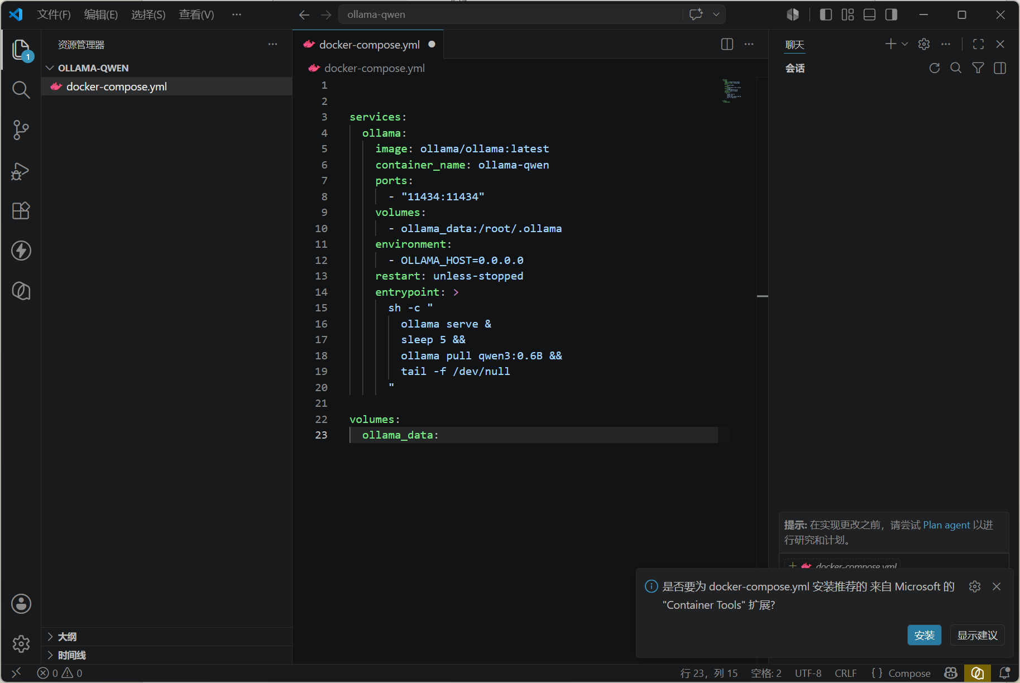
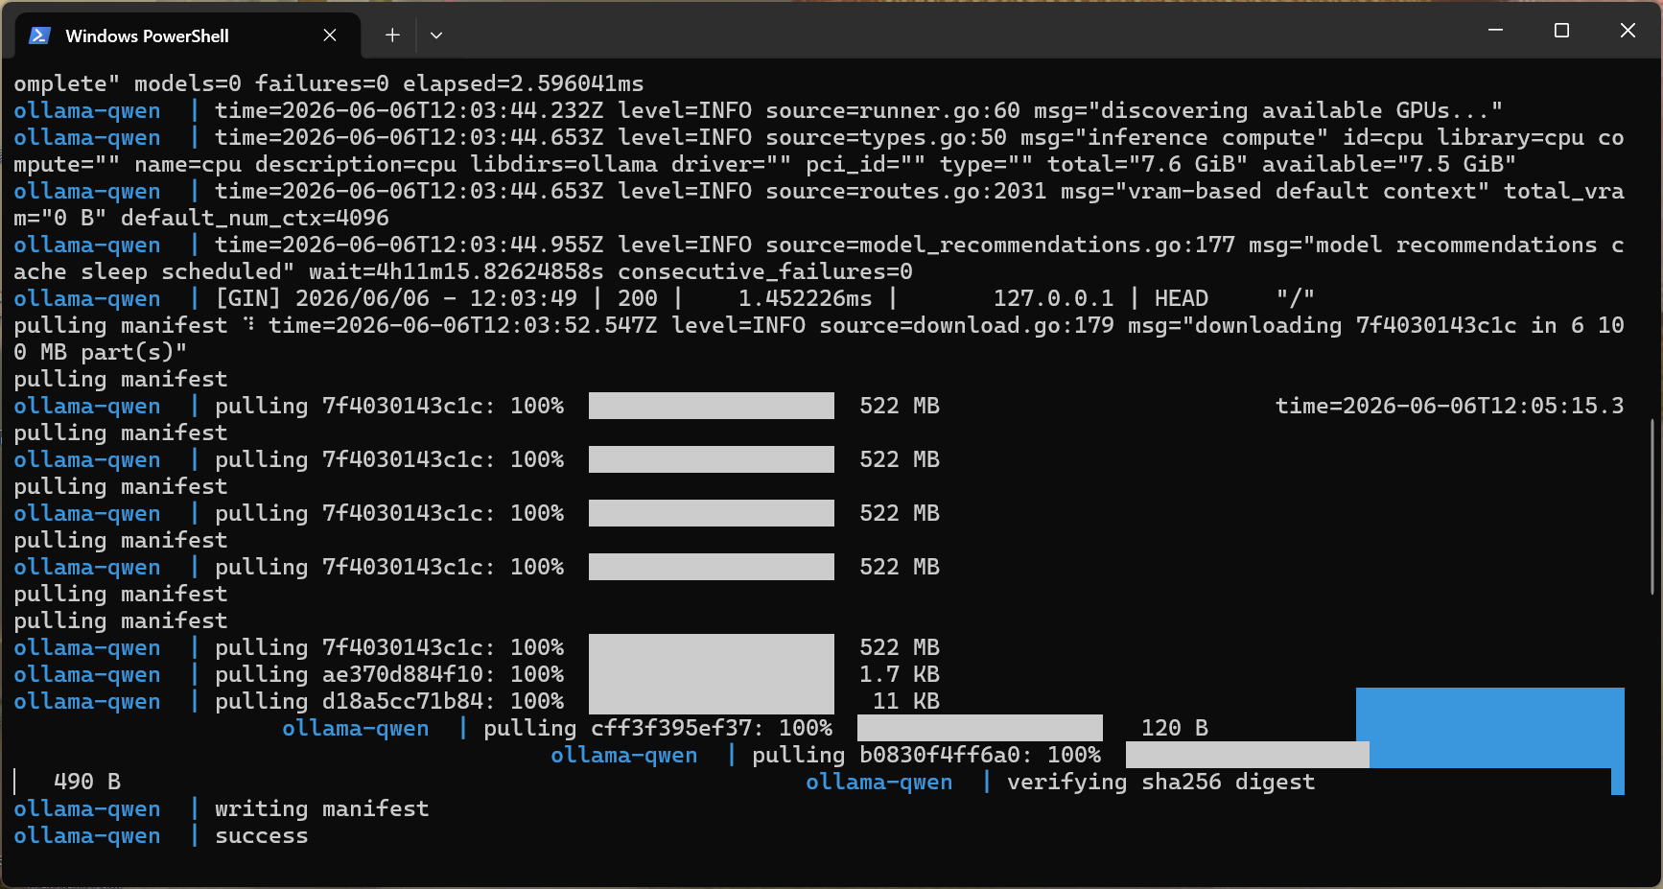
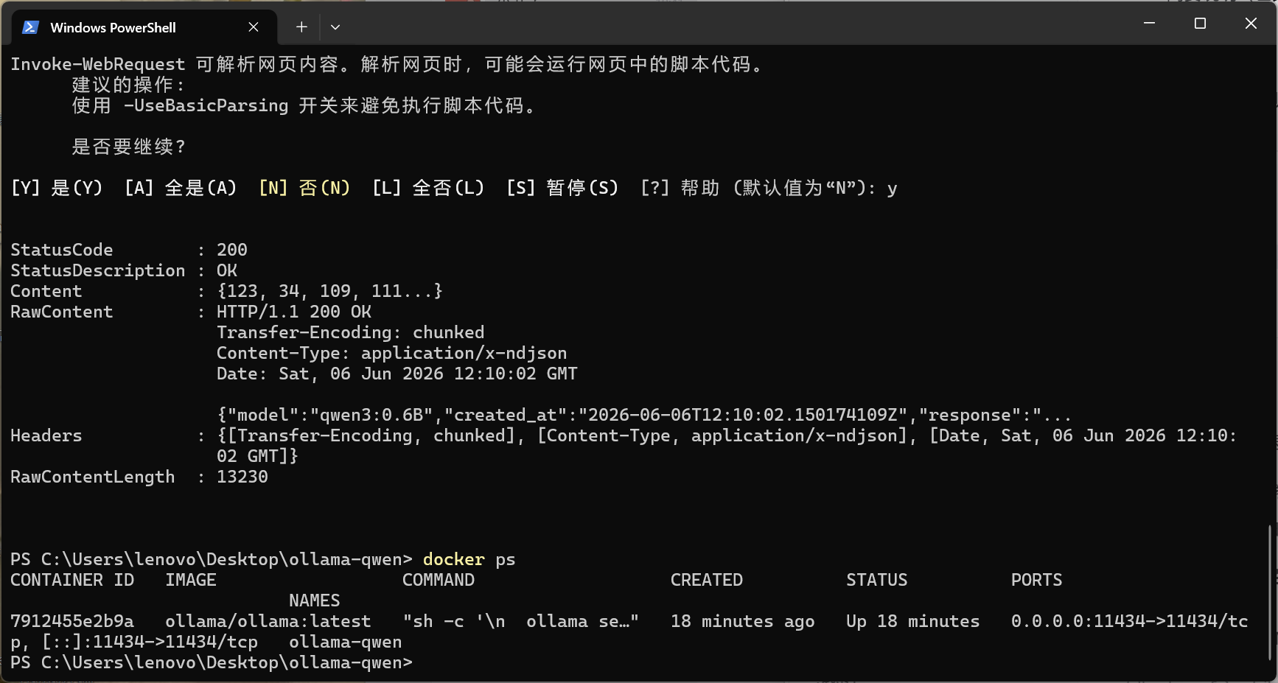
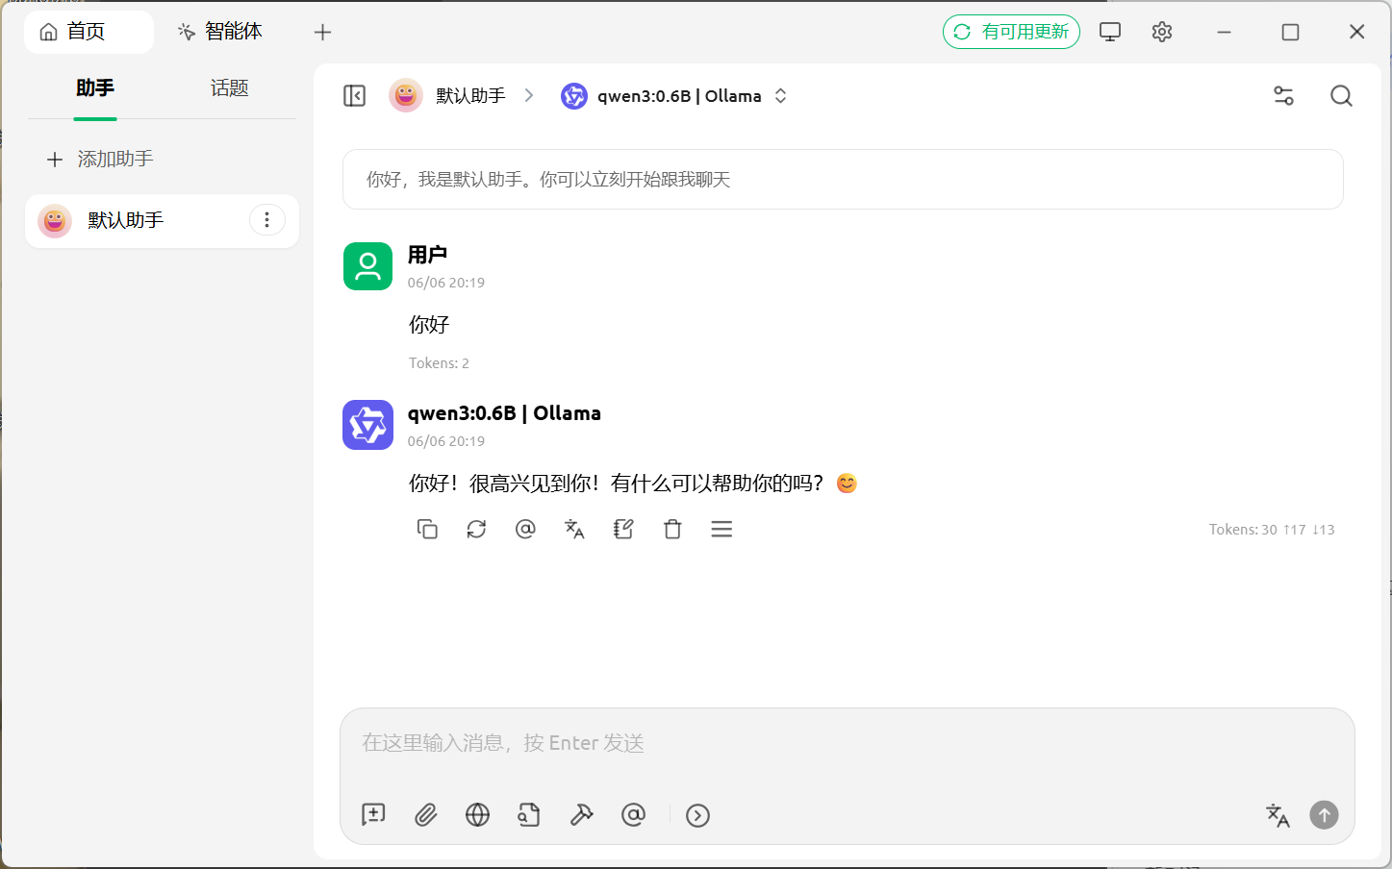

docker-compose.yml代码
services:
ollama:
image: ollama/ollama:latest
container_name: ollama-qwen
ports:
- "11434:11434"
volumes:
- ollama_data:/root/.ollama
environment:
- OLLAMA_HOST=0.0.0.0
restart: unless-stopped
entrypoint: >
sh -c "
ollama serve &
sleep 5 &&
ollama pull qwen3:0.6B &&
tail -f /dev/null
"

volumes:
ollama_data:

