|  |  |
| --- | --- |
| **CPU** | Intel I7-4700MQ 2.4 GHZ |
| **RAM** | 16 GB |
| **Graphics Card** | Nvidia GeForce GTX 770M |
| **Compute Level** | 3 |
| **Arch** | Kepler |
| **Pictures** | 25 (No carpet singular) |
| **Iterations** | 100 |
| **Size** | 5000 x 5000 |

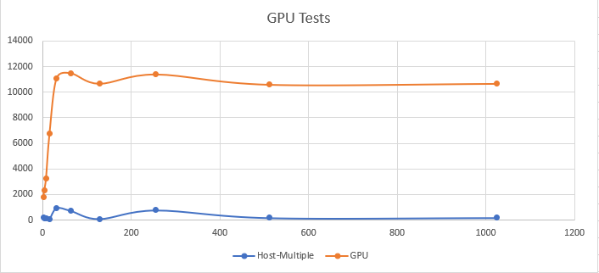

Of course, the GPU calculation is faster then the local parallel one.

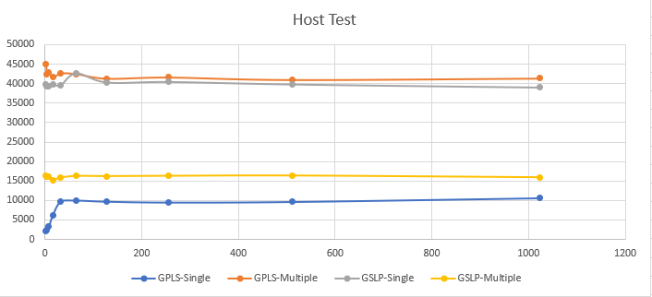

Global parallel local serial seems to be as good as global serial and local parallel.

Global serial local parallel is better than global serial and local parallel.

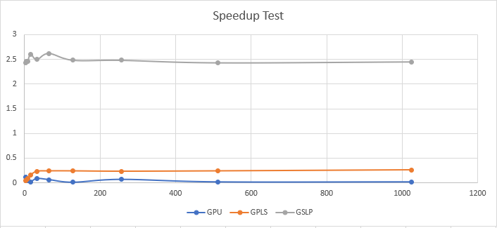

The speedup between single threaded and multiple threaded GSLP is the best speedup. They others couldn’t be improved that much.