How to set up the local temp database for debugging purposes.

Firstly, open the SQL Server Object Explorer

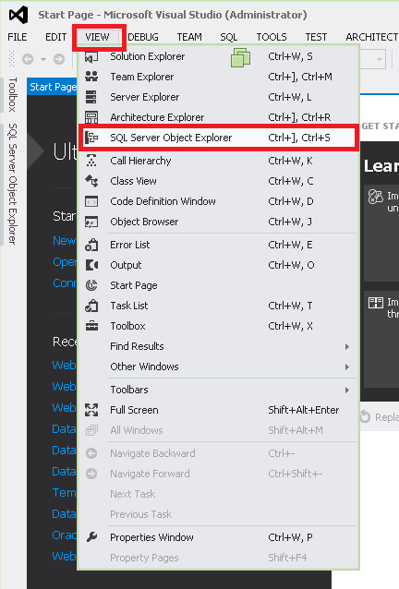

In the Object Explorer window, right click on the (probably) only SQL Server available. Usually it should be “(localdb)\Projects (….)”. Select New Query

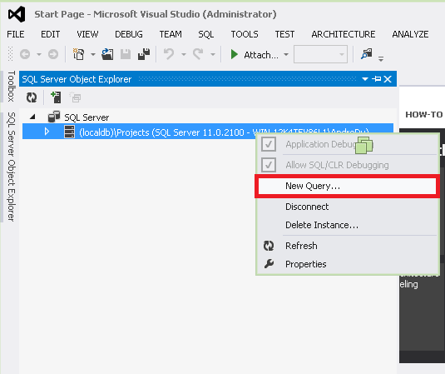

A new SQLQuery.sql window will open. Copy the script inside the DBCreate.sql file into this new window, and hit the run button.

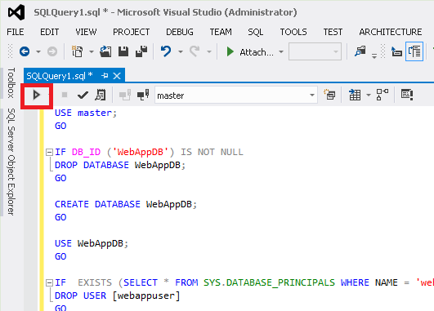

Delete the code in that window. Follow the same procedure with the TableCreate.sql file.