

COLLEGE OF COMPUTER AND INFORMATION SCIENCE
________________________________

Academic Year 2025 - 2026

CS199F (CS PRACTICUM) NARRATIVE REPORT

Submitted By:
Infante, Francis Homer O.

Submitted To:
Mrs. Jonalyn G. Ebron

Submitted to the Faculty of Mapua Malayan Colleges Laguna
In Partial Fulfillment of the Requirements for the degree of
Bachelor of Science in Computer Science
Overview of the Practicum Engagement

Company Background
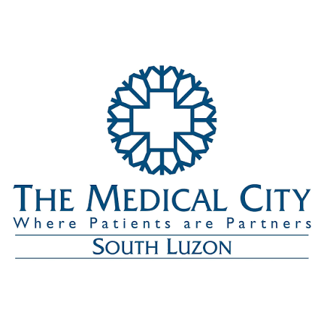
The Medical City South Luzon (TMC South Luzon) is an 80-bed hospital complex located in Sta. Rosa, Laguna. Formerly known as Southern Luzon Hospital and Medical Center (SLHMC), TMC South Luzon was inaugurated in October 2015. It serves as TMC's gateway to Southern Luzon covering the provinces of Laguna, Batangas, and Cavite.

In 2014, PSI Healthcare Development Services Corporation, a wholly-owned subsidiary of The Medical City, and Calamba Medical Center established a partnership venture where TMC took the management and shareholder lead for the future growth and expansion of the hospital then known as SLHMC. TMC South Luzon has a full complement of top-quality diagnostic and treatment services, drawing from the strengths of TMC's centers of excellence and flagship programs like Wellness, Cardiovascular, Diabetes, and Cancer Care.

The hospital has an expansion plan increasing bed capacity from 50 to 150 beds, reflecting the anticipated strong growth of Region IV. The hospital supports TMC's strategy to expand presence by developing a national network. TMC operates a network of hospitals located in Metro Manila, Pampanga, Pangasinan, and Iloilo, as well as medical clinics in the metropolis and in Luzon, with additional facilities in Guam (Guam Regional Medical City) and a clinic in Dubai.

The IT Department of TMC South Luzon is responsible for managing the hospital's information technology infrastructure, including the development and maintenance of internal systems, network administration, helpdesk support, and ensuring the reliability of critical healthcare technology systems.

Nature of work given

During my practicum at The Medical City South Luzon, I was assigned as a HelpDev Intern under the Information Technology Department, serving in a dual role as a Junior Developer and an IT support Helpdesk. This dual role allowed me to gain practical experience in developing enterprise applications while also providing technical assistance to hospital personnel and maintaining the organization's IT infrastructure.

My primary responsibility was the development of the frontend for the IT Management System (ITAM), an internal web-based application designed to streamline the IT department's asset management, ticketing, and operational workflows. The system was built with a backend using TypeScript and Node.js, with XAMPP managing the MySQL database. I was assigned to handle one half of the frontend development, translating UI/UX design specifications into functional HTML, CSS, and JavaScript code.

Throughout the development process, I participated in implementing UI updates, fixing bugs, unifying the interface across pages, and incorporating revisions based on feedback received during progress presentations to the IT supervisor and department heads.

Aside from software development, I actively participated in the daily operations of the IT Helpdesk. My responsibilities included responding to technical support requests, assisting end users with printer issues, network connectivity problems, and application latency concerns, setting up meeting requests, and providing professional customer support to staff throughout the facility.

My training also included hands-on exposure to network infrastructure. I learned cable termination by crimping LAN cables using RJ45 and RJ11 connectors, assisted in setting up PCs for new end users, installed application updates across hospital departments, and participated in preparing multiple LAN lines for an upcoming telephone and network connection update. Through this, I gained a deeper understanding of how the company's network infrastructure is structured, including fiber connections, core switches, firewalls, and patch cable distribution.

I rendered a total of approximately 265 hours from June 3, 2026, to the second or third week of August 2026, working on-site at The Medical City South Luzon in Sta. Rosa, Laguna.

Presentation of output

The following screenshots present the major modules of the IT Management System developed during the practicum at The Medical City South Luzon. The system was developed as a web-based application using HTML, CSS, and JavaScript for the frontend, with a TypeScript and Node.js backend and MySQL as the database management system. It was designed to streamline the management of IT assets, monitor asset deployment, manage requests, and support the daily operations of the Information Technology Department.

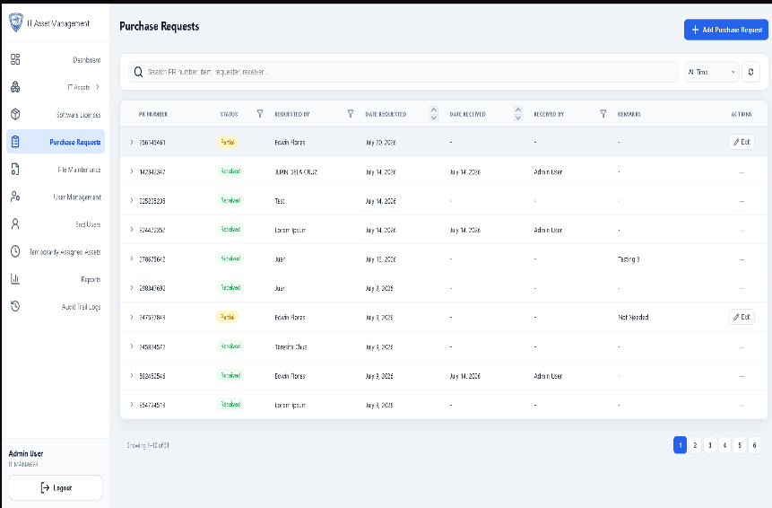
Figure 1. IT Asset Management (Purchase Request)

The Purchase Request module records and monitors requests for new IT assets and equipment. It stores relevant information such as requested items, quantities, vendors, request status, and other details to simplify procurement tracking and ensure that all purchasing activities are properly documented and accounted for.

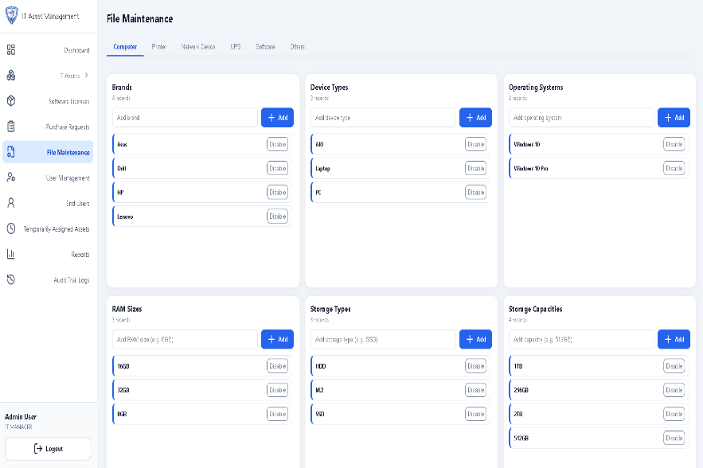
Figure 2. IT Asset Management (File Maintenance)

The File Maintenance module manages the master data used throughout the system, including dropdown options such as brands, vendors, departments, asset types, and other configurable entries. This improves scalability and allows administrators to update reference data without having to modify the system's core code.

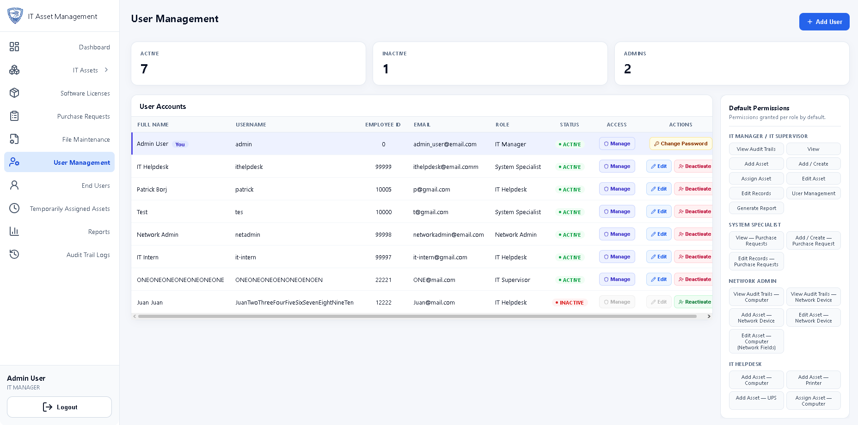
Figure 3. IT Asset Management (User Management)

The User Management module is responsible for creating and maintaining user accounts within the system. Administrators can assign roles, configure permissions based on role-based access control (RBAC), and grant or revoke special permissions for a specified period when necessary to ensure appropriate system access.

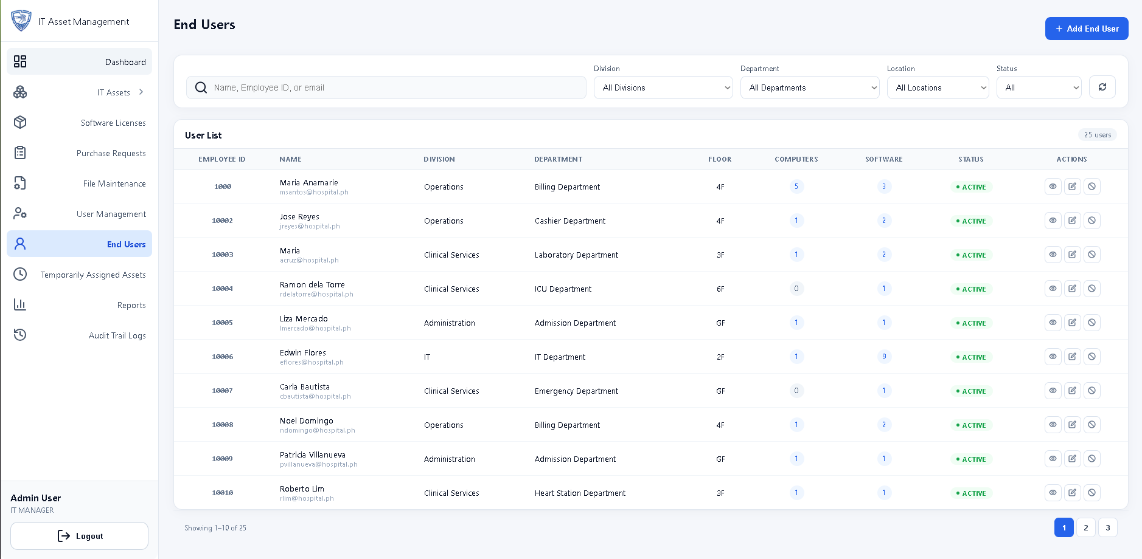
Figure 4. IT Asset Management (End User Management)

The End User Management module records the deployment history of assets by tracking the employees or departments currently assigned to each item. It helps maintain accountability and allows the IT Department to easily identify where every asset is deployed and who is responsible for each piece of equipment.

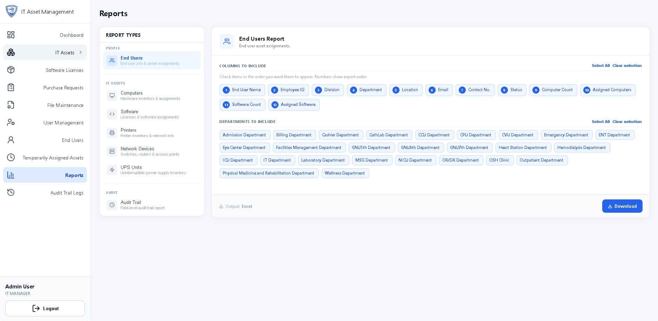
Figure 5. IT Asset Management (Reports Generation)

The Reports Generation module enables users to generate customized reports from the inventory database. Users can apply filters, select specific data fields, and export the results into CSV format for documentation, analysis, and reporting purposes to support data-driven decision making.

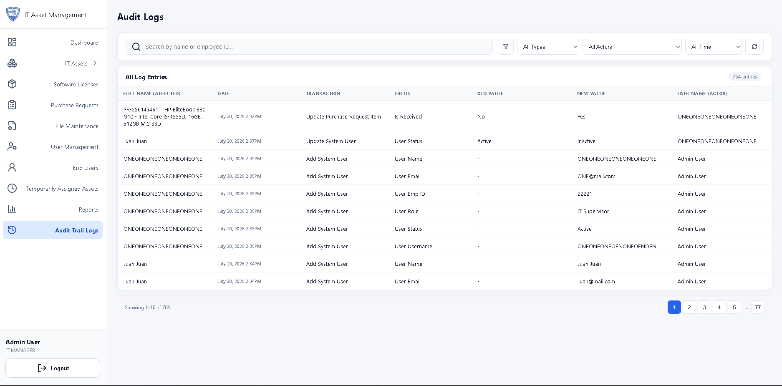
Figure 6. IT Asset Management (Audit Logs)

The Audit Logs module records user activities performed within the system. It maintains a history of actions such as creating, editing, deleting, and updating records, providing accountability, improving security, and simplifying system auditing by keeping a detailed trail of all system interactions.

Synthesis

My practicum at The Medical City South Luzon provided me with a comprehensive learning experience by exposing me to various areas of Information Technology in a real-world healthcare environment. Throughout the training, I was able to apply the knowledge and skills I acquired in the classroom while gaining practical experience in software development, technical support, and networking.

As part of the development team, I contributed to the creation of the IT Management System by developing frontend interfaces using HTML, CSS, and JavaScript while working alongside a TypeScript and Node.js backend with a MySQL database. I also participated in implementing UI improvements, fixing bugs, and incorporating revisions based on feedback from project presentations. This experience strengthened my understanding of the complete software development lifecycle and highlighted the importance of collaboration, testing, and continuous improvement.

In addition to software development, my responsibilities in the IT Helpdesk allowed me to develop technical troubleshooting and customer service skills. Assisting hospital personnel with hardware, software, printer, network, and account-related concerns taught me the importance of professionalism, effective communication, and timely problem resolution. My hands-on exposure to network infrastructure further broadened my technical knowledge beyond software development alone.

Overall, the practicum enabled me to integrate technical knowledge with practical workplace experience. It enhanced not only my programming and problem-solving abilities but also my adaptability, teamwork, communication, and professional work ethic.

Realization

My practicum at The Medical City South Luzon was one of the most valuable learning experiences in my academic journey. It allowed me to experience the realities of working in a professional IT environment, where technical knowledge alone is not enough. I realized that being an effective IT professional also requires strong communication skills, teamwork, adaptability, professionalism, and the ability to remain composed while solving problems under pressure.

One of my biggest realizations was that IT operations in a healthcare setting go beyond just writing code. The technology infrastructure directly impacts patient care and hospital operations. Every system downtime, network issue, or printer malfunction can affect the efficiency of medical staff and, ultimately, patient experience. This realization instilled a deeper sense of responsibility and purpose in the work being done.

Another significant realization was the importance of versatility. A typical day could involve debugging frontend code in the morning, crimping LAN cables in the afternoon, and troubleshooting a printer issue before the end of the shift. This variety, while demanding, builds resilience and adaptability that are essential for a career in IT.

The experience also highlighted the gap between academic knowledge and industry practice. While university coursework provided foundational knowledge, the practicum revealed that real-world problem-solving requires resourcefulness, collaboration, and the ability to learn unfamiliar technologies quickly.

Conclusion

The practicum at The Medical City South Luzon successfully bridged the gap between academic learning and professional practice by providing meaningful exposure to real-world Information Technology operations. Throughout the training, I gained hands-on experience in software development, IT helpdesk support, and networking while contributing to the development of the IT Management System and supporting the daily technical needs of the hospital.

The experience allowed me to strengthen both my technical and interpersonal skills through collaboration with IT professionals and by working on actual projects and support requests in a healthcare environment. It also enhanced my ability to adapt to workplace challenges, communicate effectively with end users, and apply problem-solving skills in practical situations.

Overall, the practicum has been a significant milestone in my professional development. It reinforced the knowledge I acquired during my academic studies while preparing me for the responsibilities and expectations of the IT industry. The knowledge, skills, and values I developed throughout this experience will serve as a strong foundation as I pursue a career in Information Technology and continue to grow as a future IT professional.

Appendices

Appendix A
Competency-Based CV
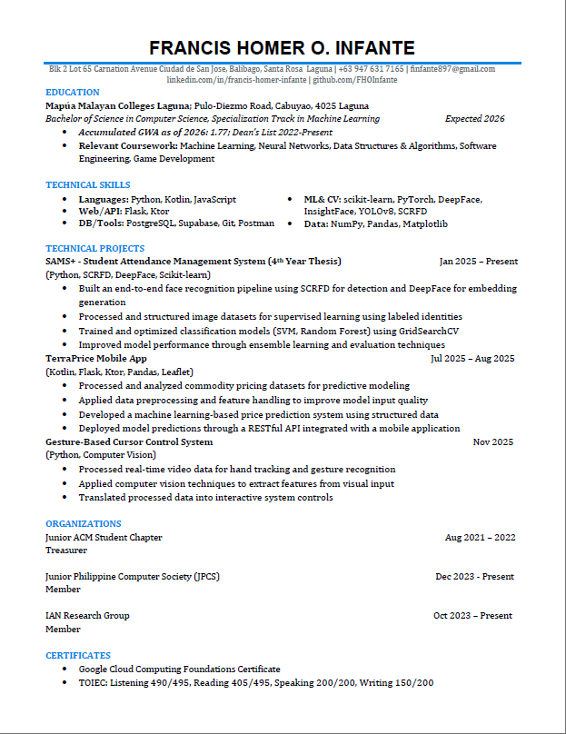
Appendix B
Endorsement Letter
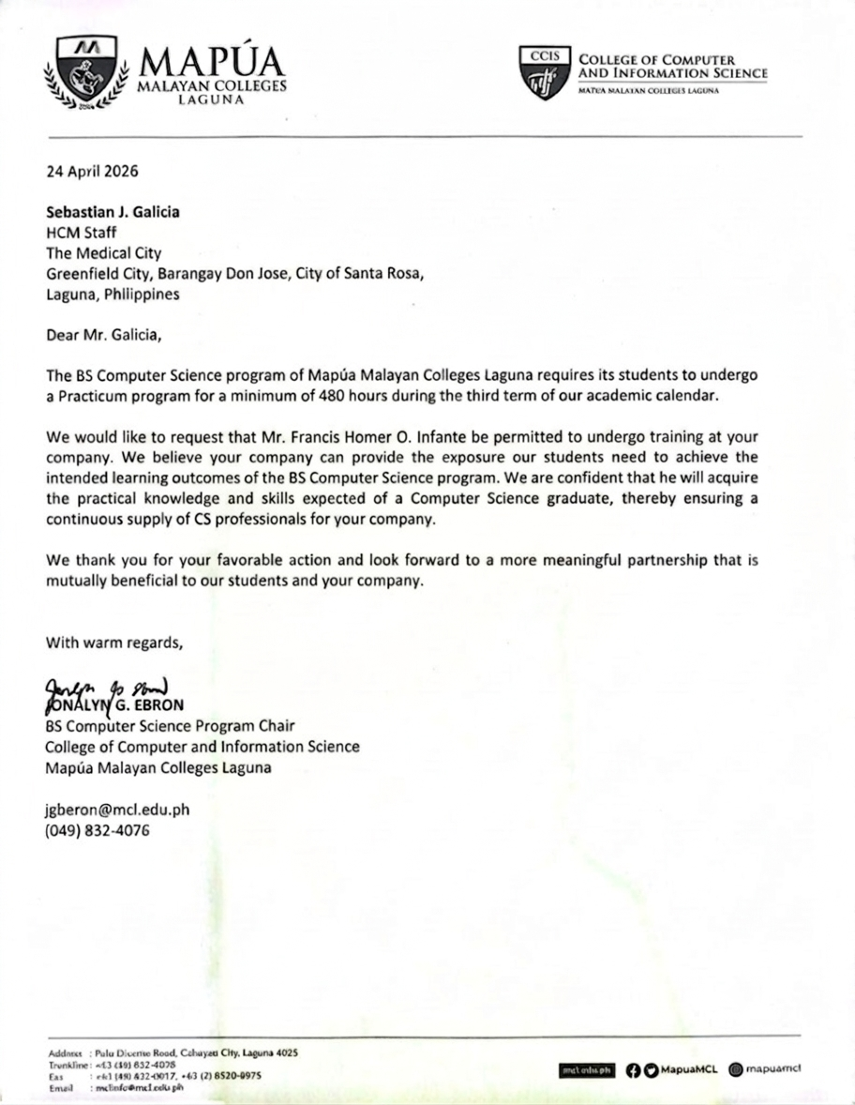
Appendix C
Practicum Acceptance Form
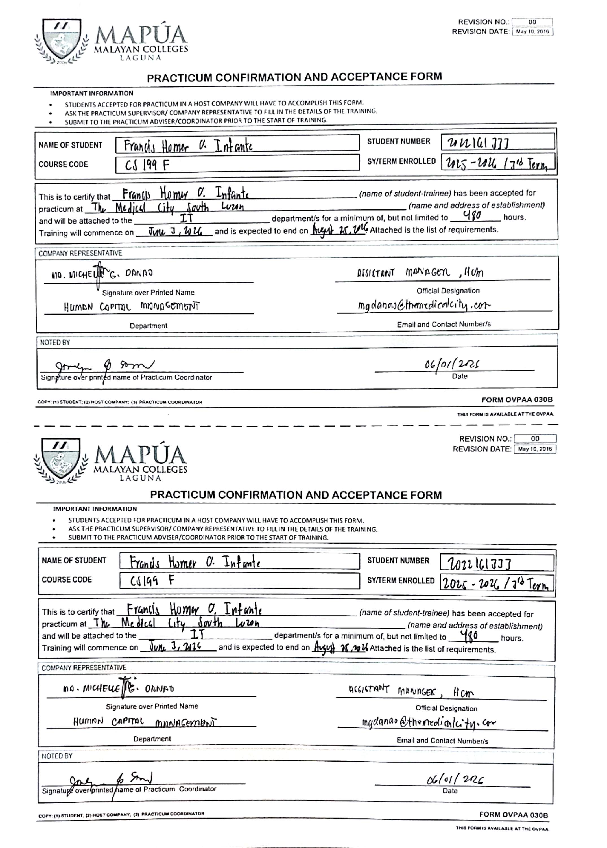

Appendix D
Liability Waiver
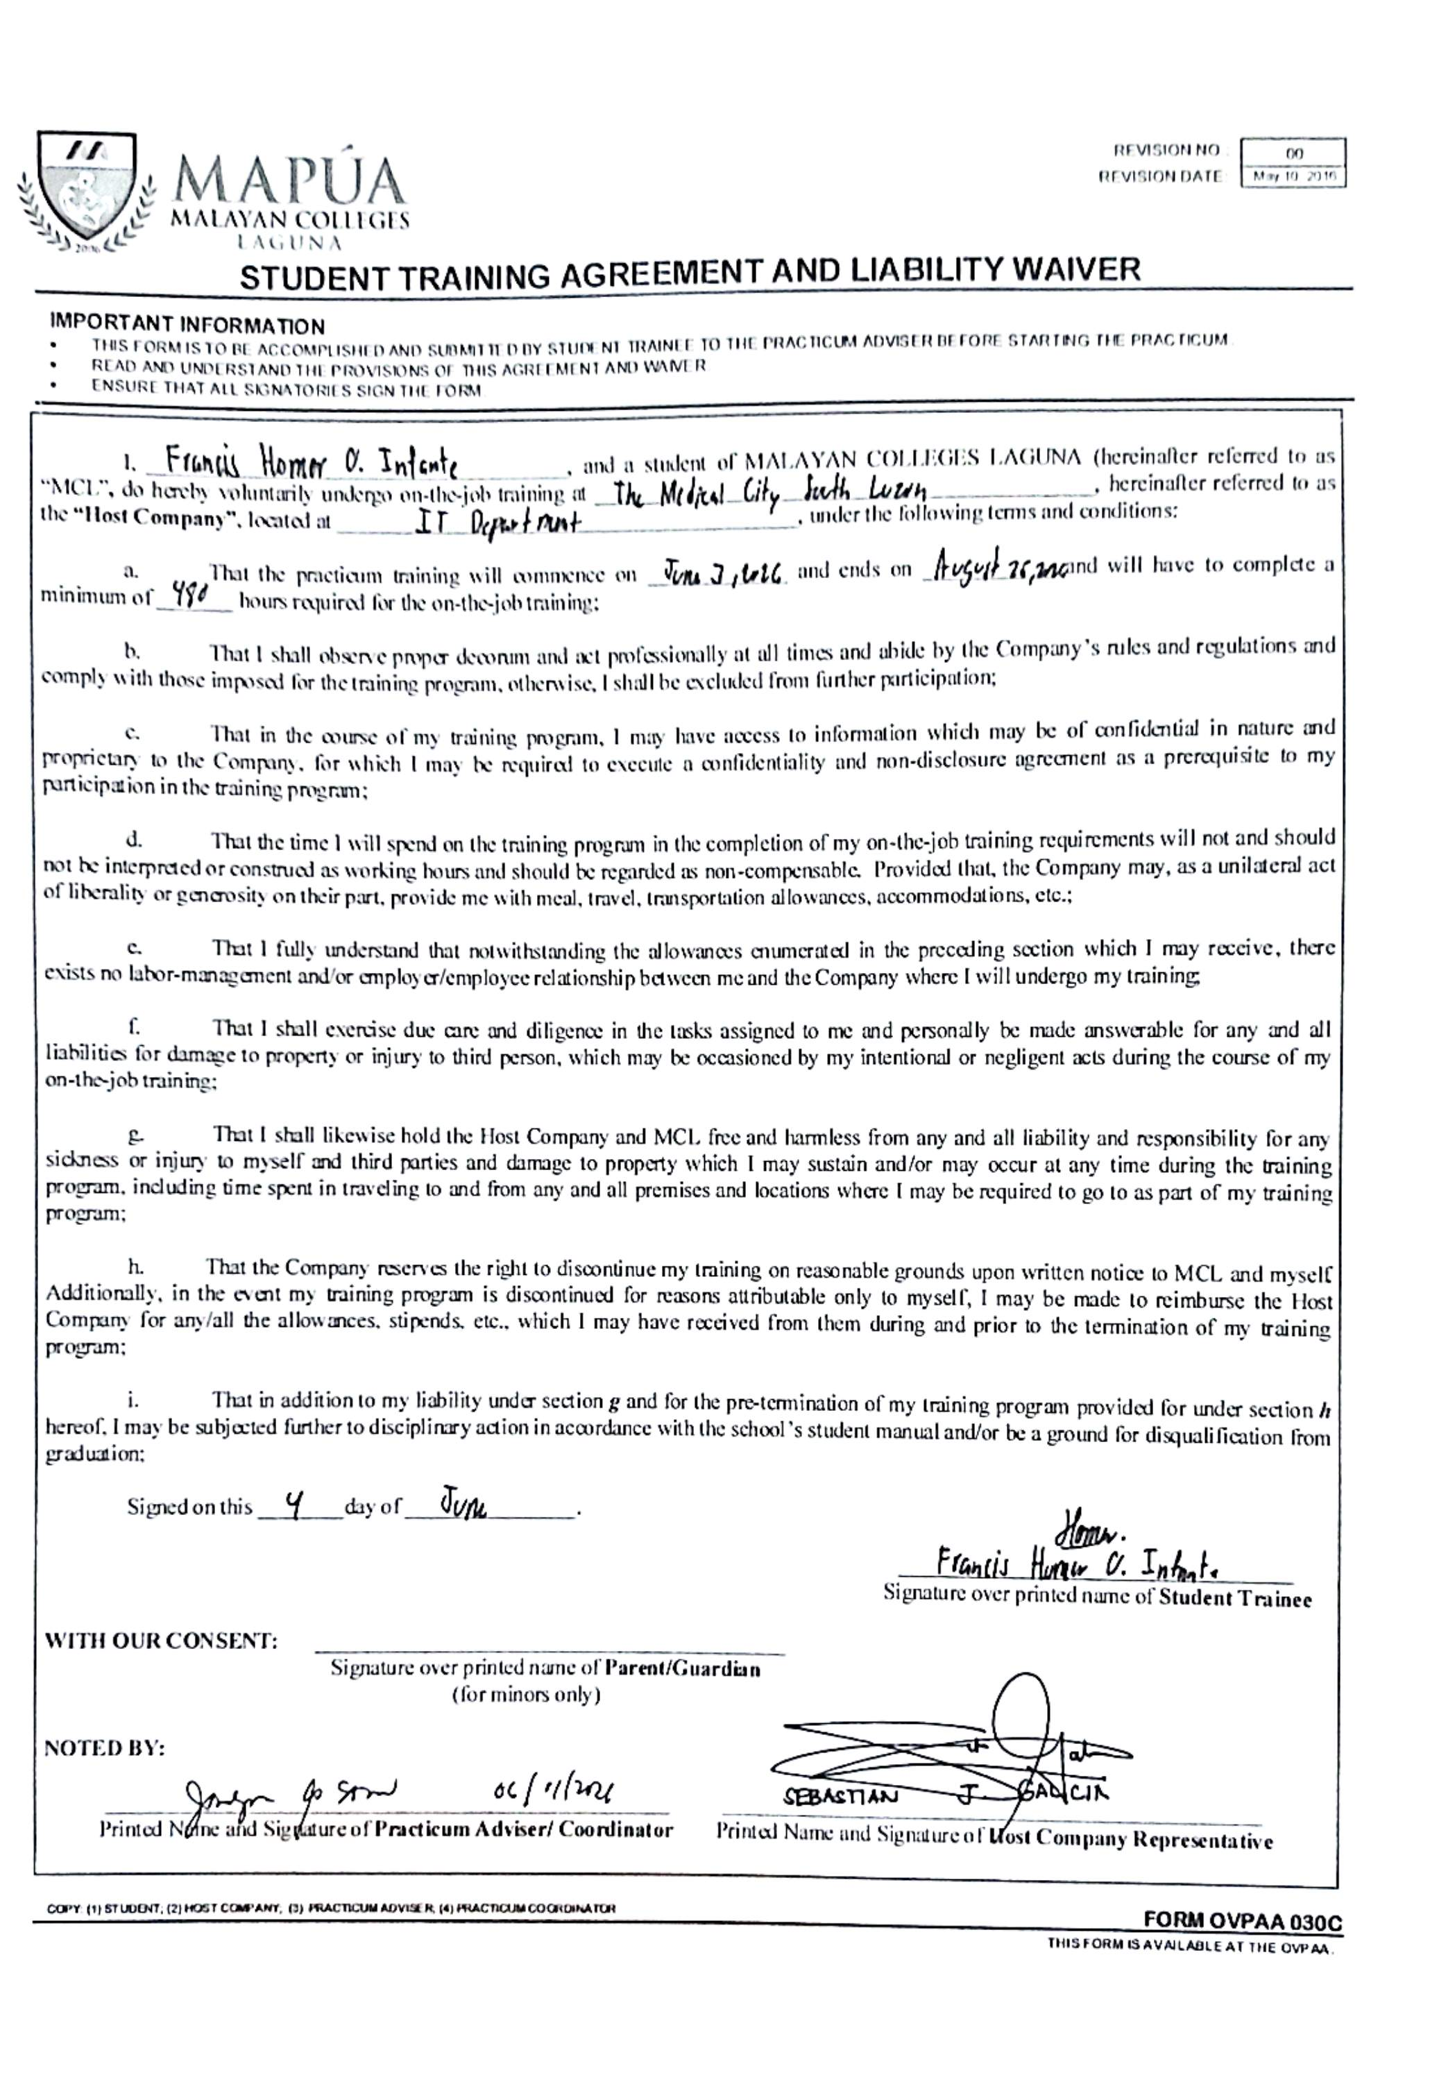

Appendix E
Training Plan
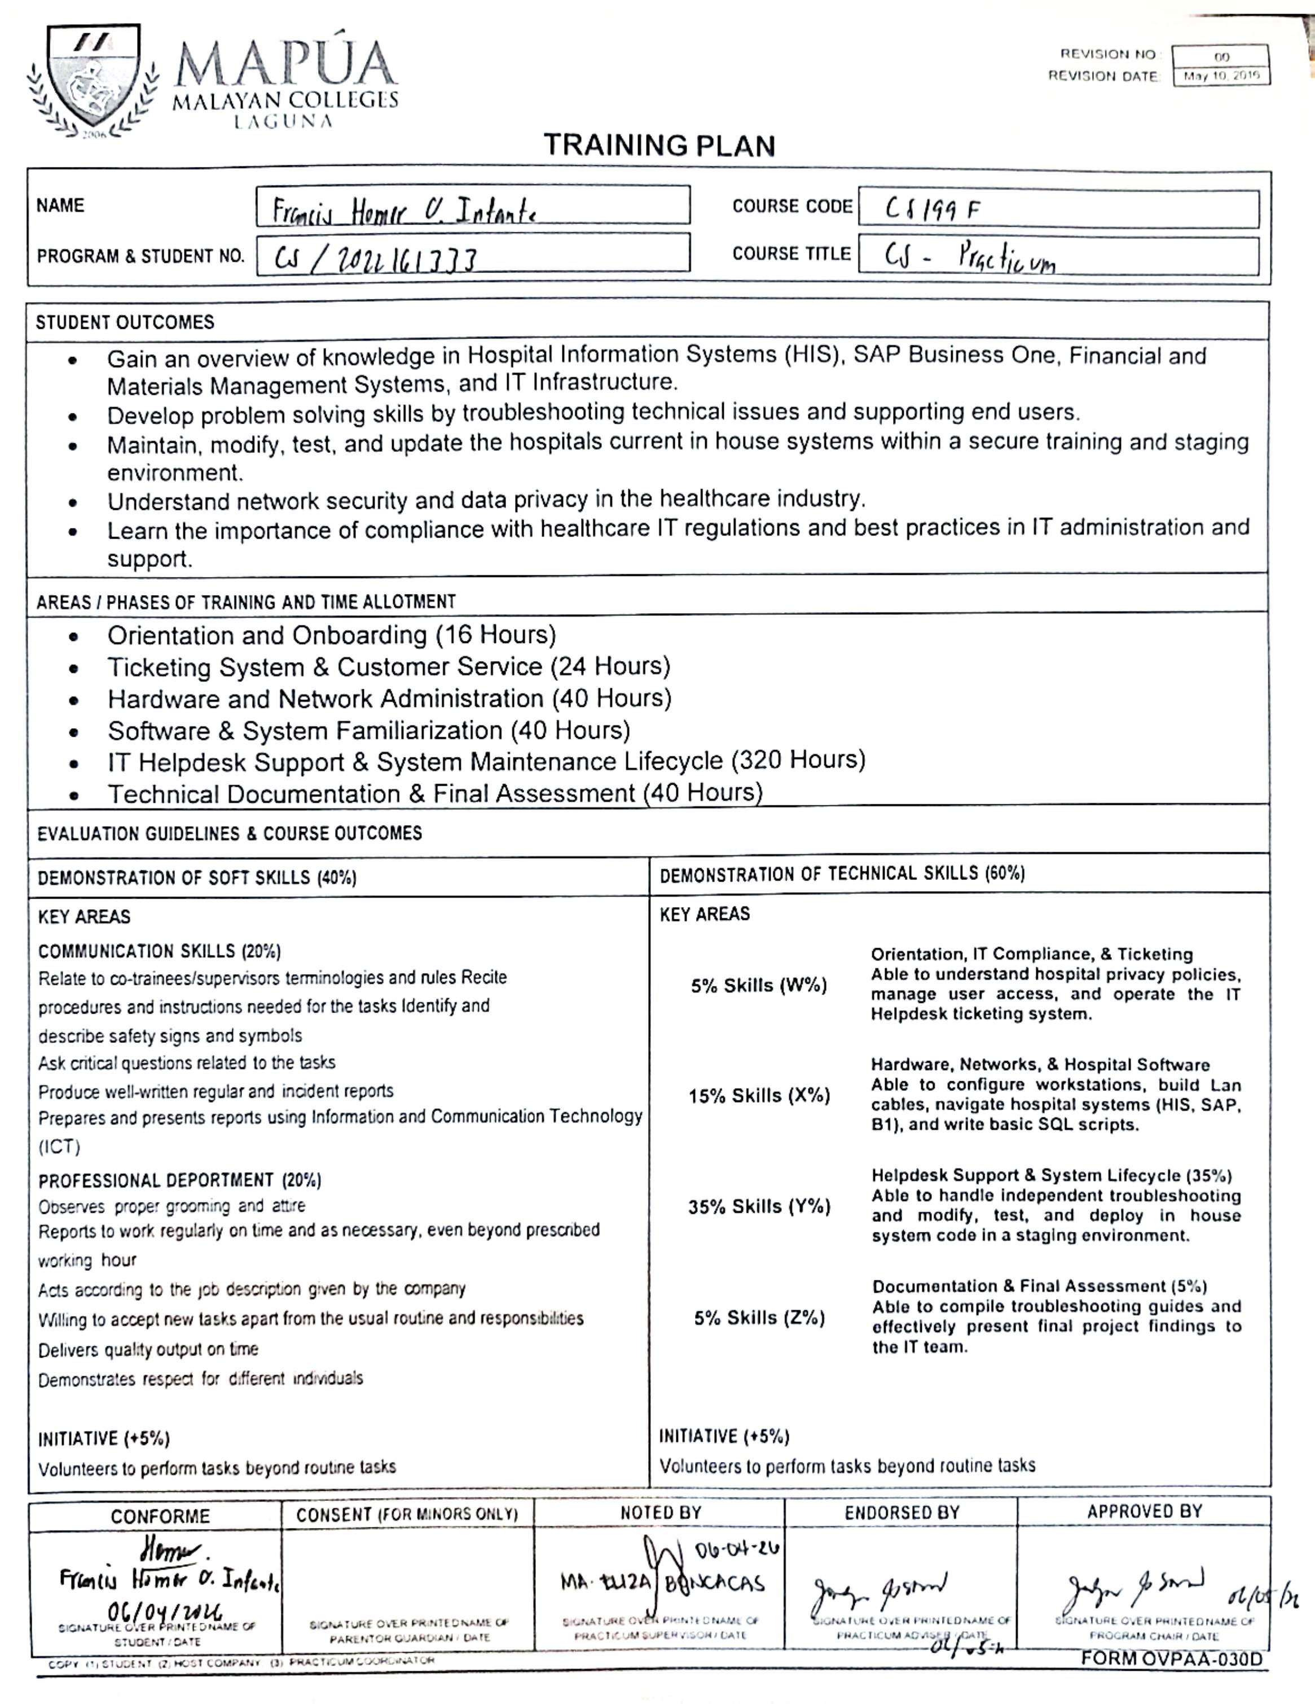
Appendix F
Daily Time Record
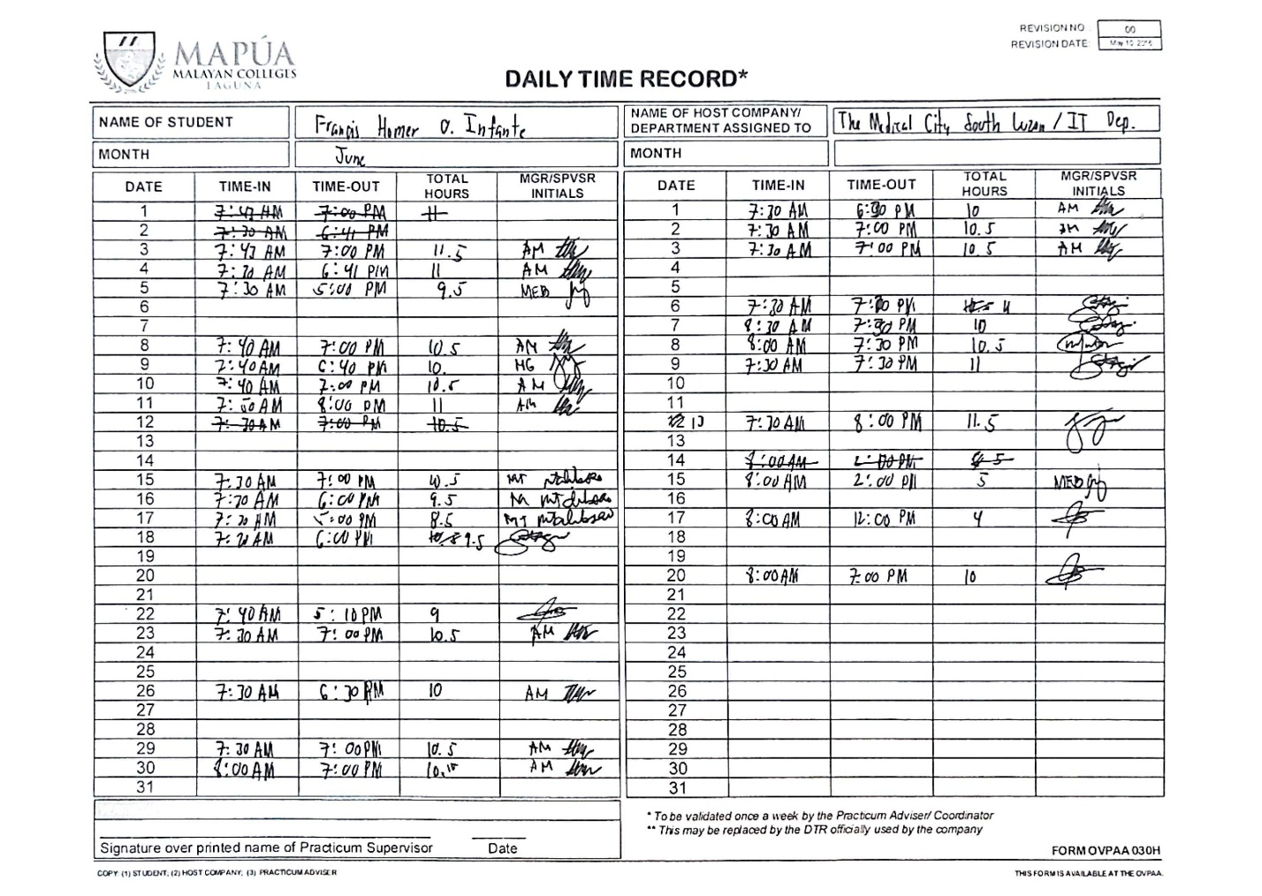

Appendix G
Daily Journal

