**Notice**

**Respected Pedestrians:**

This area is undergoing image **data collection** in the context of a scientific study, the purpose of the collection is to be used for pedestrian Re-Identification in the field of deep learning and artificial intelligence. In order to ensure your right to information and privacy, we hereby inform you of the following:

**Collection area:**

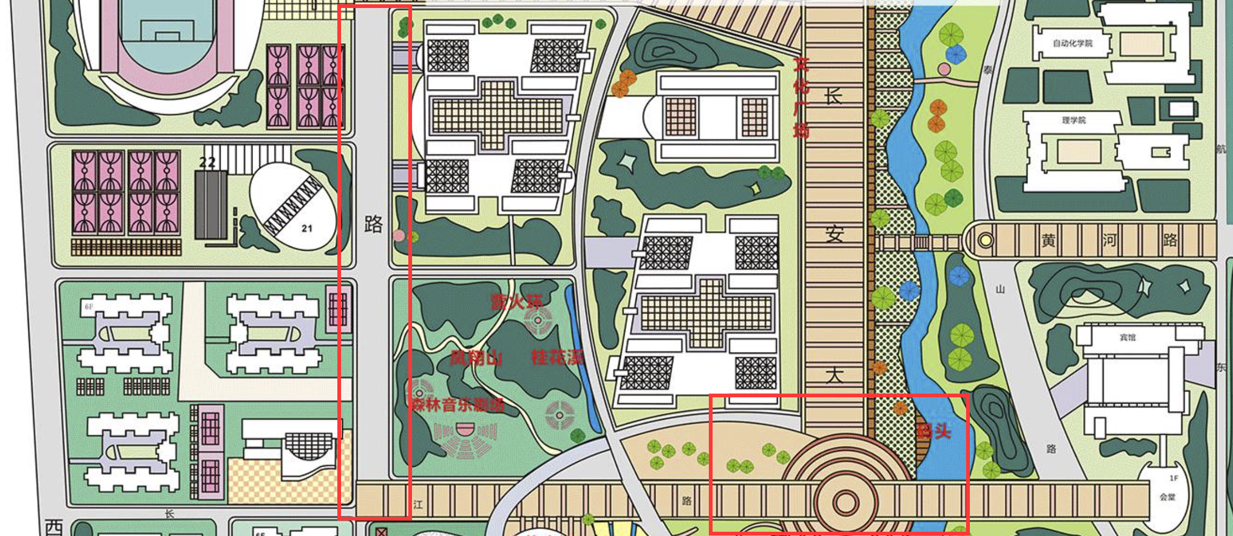

（1）华山路&长安大道十字路口

This area (**marked as red line box**) has been marked by a cordon. Please note that by entering this area you are **consenting** to image data collection.

**Data usage:**

The image data collected will be used strictly for **non-profit academic research** and will **not** be used for any commercial purposes.

**Privacy Practices:**

* The image data collected **will be anonymized** and no personally identifiable information will be recorded.
* We will use **mosaics to obscure pedestrian face** to minimize the privacy issue

**Your rights:**

* You have the right to **avoid being recorded by choosing to avoid the data collection area.** If you enter a data collection area by mistake, please **contact the staff present to have the data deleted.**
* If you have any concerns about image capture, please feel free to contact the staff on site or call the contact number below for more information.

Contact number: 17784474117

Research Team Leader: Luo Wenlong

Contact Email: luowenlong@mail.nwpu.edu.cn

Research Institution：Northwestern Polytechnical University, ASGO.

Thank you for your understanding and co-operation!

Northwestern Polytechnic University

31st May 2022