# Group Project Proposal – 3DAE

With this document you submit a “Group Project Proposal” for the 3rd year. It’s important that you take your time to fill in the proposal in detail. Based on the info and the quality of the document, we decide with the module managers whether your project qualifies for a group project.

You send the “Group Project Proposal” document, together with a working prototype build, to Alex Vanden Abeele via e-mail ([alex.vanden.abeele@howest.be](mailto:alex.vanden.abeele@howest.be)) before **02/09/2024 08:30**. On September 4th you’ll pitch this project before a jury. Afterwards you will be notified if your group project is accepted or not.

If you have any questions regarding this proposal do not hesitate to ask Alex. **Do not assume things, make sure you’re sure.**

Success in writing your Group Project Proposal!

## Students that participate in this proposal

*List here the students that participated on this proposal. Only students that really collaborated on the proposal can be listed here, do not list students that you would like to have in your team, that is not accepted.*

*Teams larger than 5 are not accepted either, so do not list more than 5 people here. It’s not needed to list a full 5-member team. If you’re with two people (or alone) that came up with a great idea and you would like to work with a team on that idea, that is perfect (preferred), enter those two names and the other students will be volunteers from 3DAE*

|  |  |
| --- | --- |
| Name | Major |
| Finian Horrie | GD |
| Mikail Kahya | GD |
| Artjoms Horosilovs | GGP |
|  |  |
|  |  |
|  |  |

## General description of the project

|  |  |
| --- | --- |
| Project Name |  |
| What kind of project/game is it? | Wave-based survival FPS |

## Description of the project

*Describe the project in about one page*

[Name] is a wave-based survival FPS game inspired by Killing Floor, Call of Duty zombies, Left 4 Dead, and Warhammer Vermintide. The player starts every game with the base equipment, throughout every round they gain more resources to upgrade their build to survive as long as they can. Every wave the enemies become tougher. These waves lead up to mini-boss encounters that become more frequent and difficult as the waves progress.

Enemies consist out of humans turned to monster through an affliction named the Shiflix. The player is afflicted with this virus but controls the mutation. They need to use the body parts of other monsters to become stronger. Slicing off specific body parts of a monster gives access to their abilities. Dismemberment of monster parts gives upgrade currency for that specific ability. Monsters will have either have an arm, a leg, and or head available to be dismembered and used.  
Some variants of the monsters will include:

* The common imp: small but it has sharp claws. Easily dealt with but always in a group.
* The brute: your standard strong charging enemy that stomps the ground. The brute works off vibrations as they have lost their head in the transformation.
* …

The player can change their equipment between every wave. Their equipment consists of 5 abilities, 2 arms, 2 legs, and 1 head. The head is always a passive ability while the other 4 are active abilities. When a monster body part is found, the other drops of that same body part will be used as currency to upgrade and change the ability. The player will get the equipment on the first dismemberment, if picked up in time as body parts decay quickly when not in contact with a host of the Shiflix virus. An example of this is the claws of an imp turning to one slower but harder hitting blade. Every monster part has their challenges the player can perform to increase the damage output, range, or cooldown of that ability. The upgrade station to do all of this is only available at the down time between rounds. The next round will be suspended while in the upgrade station for a limited time. If you are still in the station while the round starts, you will be forcefully removed from it and the round officially starts.

The map will be a few big zones with corridors between them and one upgrade station that switches between zones. We are taking heavy inspiration of Killing Floor and Warhammer for this. The map will have events happening every few waves which are scripted. These events can be from a building burning down closing off an entrance, to the brute bursting through a wall opening a new zone. This keeps the player moving between areas or restricting them to one area for a difficult battle. Monsters can enter from specific entry points on the map like a gated fence, a broken hole in a building, a burry hole in the ground, etc…

The game modes available to the player are an endless mode that tests the player’s endurance and a mode that has a final boss that tests the player’s speed.

* The endless mode will progressively get more difficult with the stats of enemies and the quantity they in attack in. Over time the mini bosses will spawn during rounds. The player’s survival time, number of monsters killed, number of dismemberments, and waves survived.
* The challenge mode has more scripted rounds and leads to a final boss encounter. The challenge mode consists of 15 rounds where every 5 rounds a scripted event such as a mini boss encounter happens. Round 15 is the final boss encounter. The player’s completion time, number of dismemberments, and waves completed will be shown upon finishing.

## What do you want to achieve with this project?

*Describe what you expect as an acceptable outcome of your project? What kind of result can we expect?*

We want to create a game that is fun to play for extended periods of time. We always liked these games and wanted to start the process of creating one with our ideas. There is a wide community out there that play Call of Duty zombies and make mods for these games, but a new experience is what we would like to create. Taking inspiration and creating an own identity is the result.

The mutations came from an old idea and stuck because it was a very interesting concept for lore and gameplay aspects. There is much to expand on with this.

The game should make you feel on edge and attentive throughout the experience. You are a powerhouse able to fight an army of creatures, but that is because you are wary and smart about your moves. You need to feel like you are strong, but never feel like there is no challenge.

The goal is to make at least 5 unique enemies, with some of those enemies having only one or two abilities to keep the workload in scope. It is scalable and can always be extended if the project allows that. The map will consist of 3 zones that will have corridors linking them to each other. These corridors will be blocked sometimes, creating a more dynamic map.

## What are your plans with the project once it is done?

*Be realistic about this – but we do expect you to have plans with the result. Projects just for fun are nice, but we want to achieve more with these projects. Do you plan to start a company when successful? Do you intend to compete somewhere? Do you intend to sell this game?*

Once the project is done, it would be nice to expand further. The core system can be expanded quite easily with the addition of extra monsters, new maps and even new minor mechanics specific to maps. For example, environmental traps, status effects, monster variants, etc...

Releasing this on console would be nice but consoles make that process a bit more difficult. Releasing it on itch and steam is the first step. If the game had an active audience on itch, the finished release would then be sold on steam.

## What technology do you plan to use?

*Describe the software and hardware you intend to use and whether you have access to everything you need.*

The game will be made in Unreal Engine with modeling being done in Maya/ZBrush. If we can’t find anyone to do animations for the game, we will need motion capture. The current members aren’t familiar with the process and as you use melee weapons predominantly, it is important to have some good-looking animations. Animations for leg abilities can be hidden with clever camera tricks, but both the arm abilities and enemies need to look scary, not cartoonish.

Sound will be mostly done through using online sounds and remixing them to what we need using royalty free sounds. If a specific sound can not be found, there is potential for it to be made locally.

For programmers, Rider is recommended to work in. Rider has great integration with Unreal Engine. This isn’t to say Microsoft Visual Studio does not have this, Rider has plugins to make working easier.

## On what platform do you want to release and via which store front?

*We intend to achieve this – be realistic.*

The first and focused on release would be PC. Extended platforms would be PlayStation and Xbox.  
Store fronts for this would be:

* Itch during development, for test builds and demos
* Initial release on Epic games store because Epic games allows games made in Unreal Engine to be released on their store front quite easily without additional fees, as long as we don’t release it anywhere else for one year.
* Steam release will be delayed for one year. Steam makes the process of releasing games easier.

## What is the target audience?

*Make sure this is well defined. “For everyone from 7 till 77” is not accepted, this range is too broad. Motivate your choice.*

The game is for a mature audience due to the concept of dismemberment being core to our game. The game uses horror aspects.

The target audience is players who like long sustain fights. Games can last hours if a player is good enough. People who are competitive in a PVE setting would enjoy a game like ours, even if it is improving on themselves and reaching a new personal record.

Attachments   
You can add additional info that enhance your project proposal; sketches, mockup, game design, life design, character design, moodboard, ...

**Moodboard**  
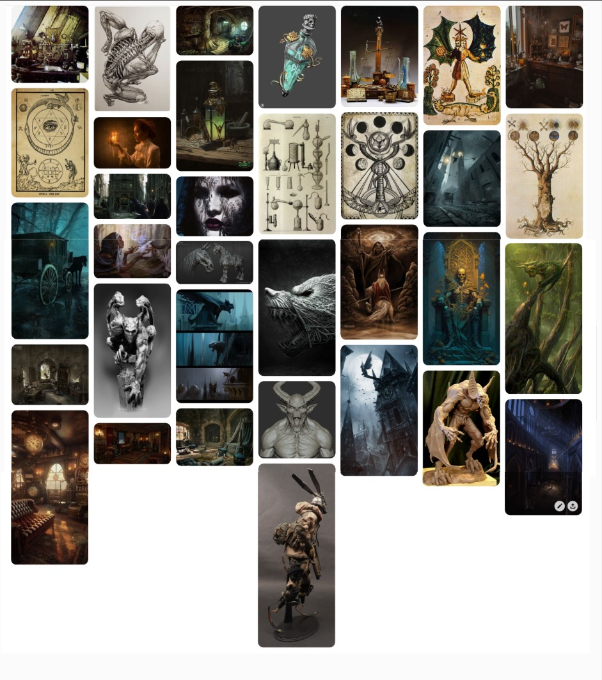

**Environment theme Monter ideas**

**(AI generated) (AI generated)**

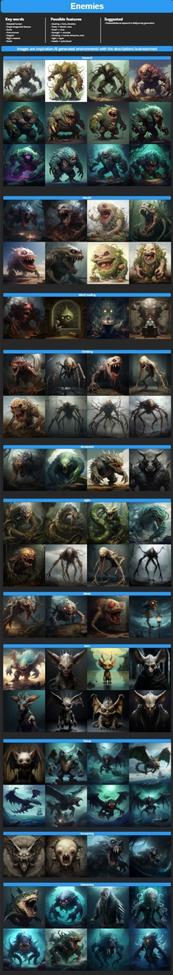

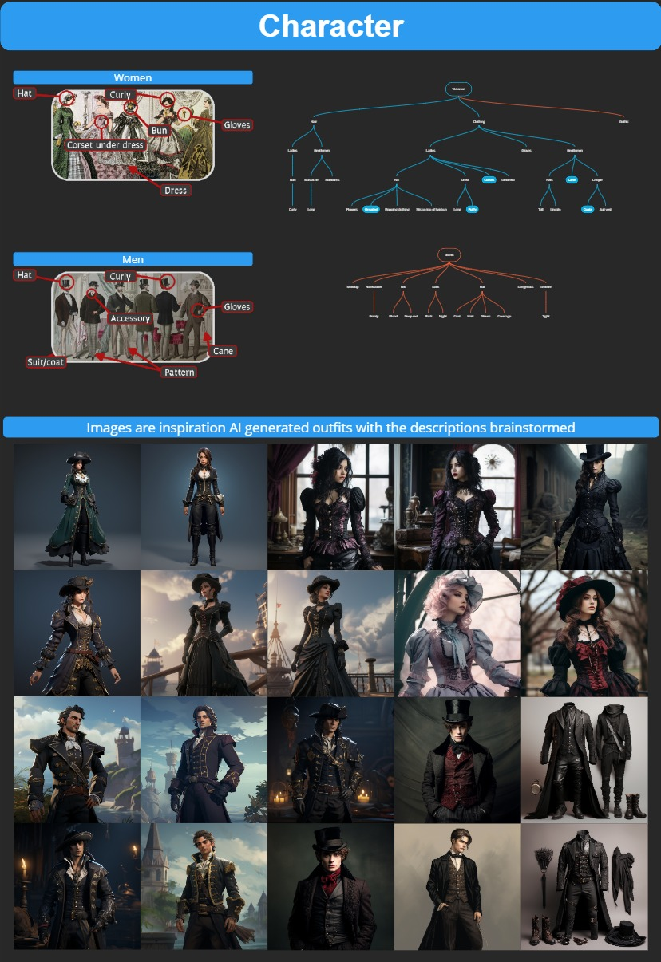

**Styleguide**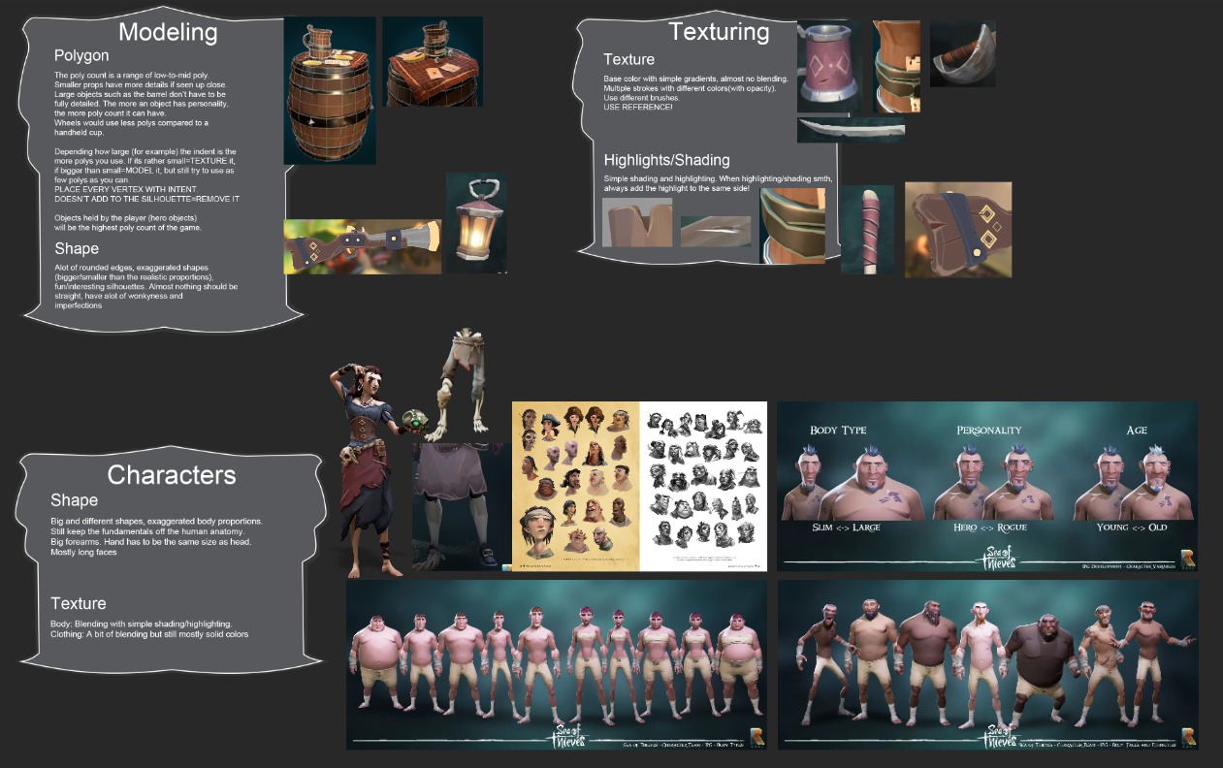

**Style dump**

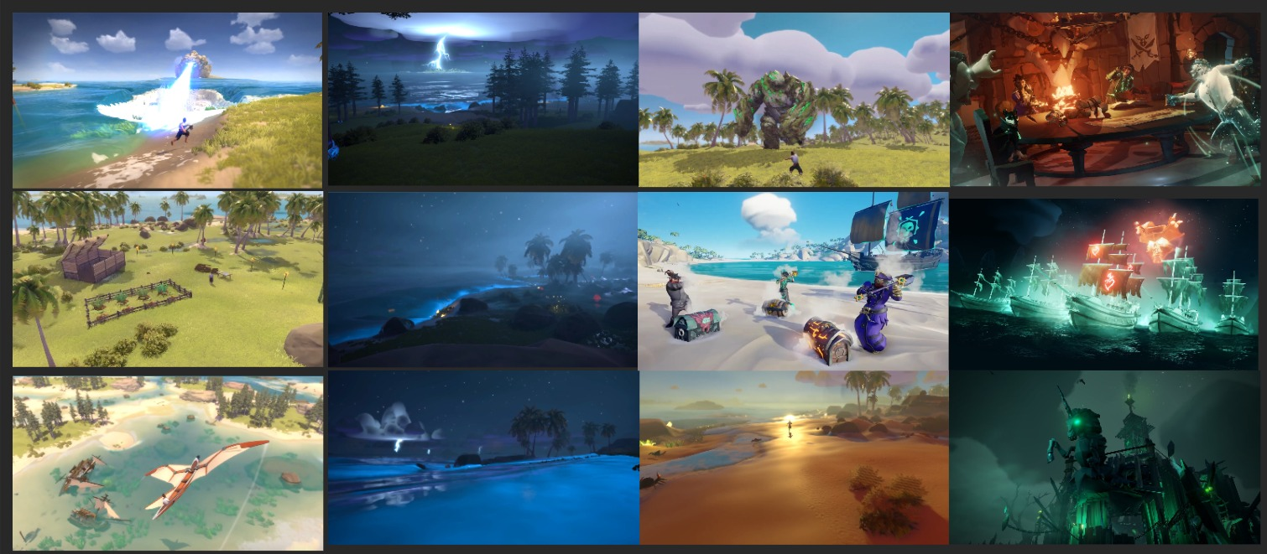

**Monster sketches**

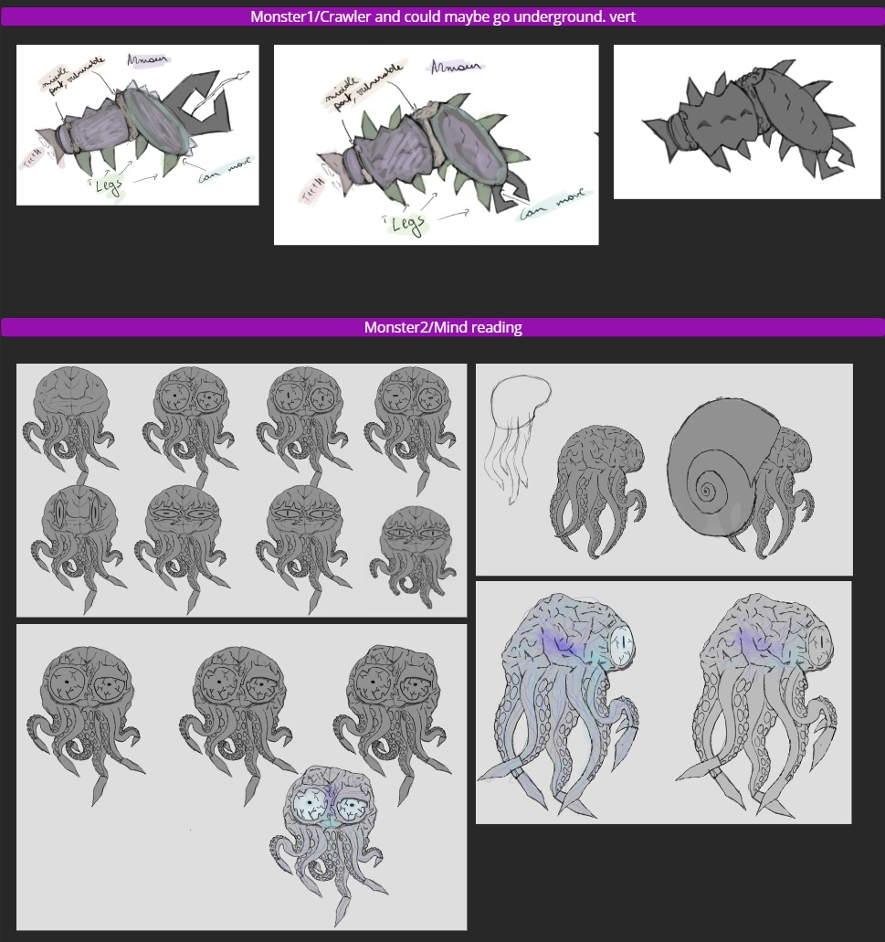

1.0 Sketches made by Cato Adriaensen­