Forbes Turley
CS 1501 Assignment 3
The first modification that was made was building a trie data structure capable of holding StringBuilder objects and maintaining an association between the characters from the traversal of the tree and a code. To this end, I modified my DLB trie from assignment one to fulfills both needs. The modified DLB has only two methods, add and searchPrefix. The add method takes a StringBuilder object and a generic type for the code, and adds to the tree just as in assignment one. Because only a single character can possibly be added at a time to this DLB based on how it is utilized by the LZW code, the add method simply assigns the code to the only node that is added, namely the node corresponding to the last character in the input StringBuilder. The only other method in the DLB, searchPrefix, serves a dual purpose to the LZW. It allows for the LZW to determine whether a given string is present within the tree, and if so, it returns the code corresponding to that string so that the LZW may encode the character string appropriately. If the string is not present in the tree, the searchPrefix returns null, notifying the LZW that the string is not present within the tree. This causes the LZW to add this new string to the tree, and to use the last code found by the DLB to encode the string minus the final character.
Other than the DLB, the only other modification necessary to allow the LZW to process the input file one byte at a time was to actually change the way that the LZW received the input file. I simply changed the input method of the LZW to a BufferedInputStream from System.In, and then grabbed one byte from this stream at a time until there were no characters remaining in the buffer. This allowed for the command line syntax of LZWmod to be identical to that of LZW.
In order to implement variable length codewords, the LZW must know when to increase the width of the codewords. This is done with the formula “(code + 1) & code == 0”, which is checking to see if the current value of “code” is a power of two. If so, then the maximum value for the current width has been hit, and so the width must be increased by one bit (if the width is less than 16). Then, when the next binary encoding is written to the output file during a compress, the new width is used. The trickiest part of this project was to ensure that during decompression, the width was increased at exactly the same spot as during the compression. If this was not done correctly, the result were immediately apparent, because every subsequent character would be shifted down and incorrect, yielding gibberish. The solution to this problem was to increase the width by one during decompression when “((code + 2) & (code +1) ==0”. Obviously, this is simply checking one character earlier in the decompression for the need to increase the bit width, which is due to the one-off nature of the LZW decompression scheme.
Results:
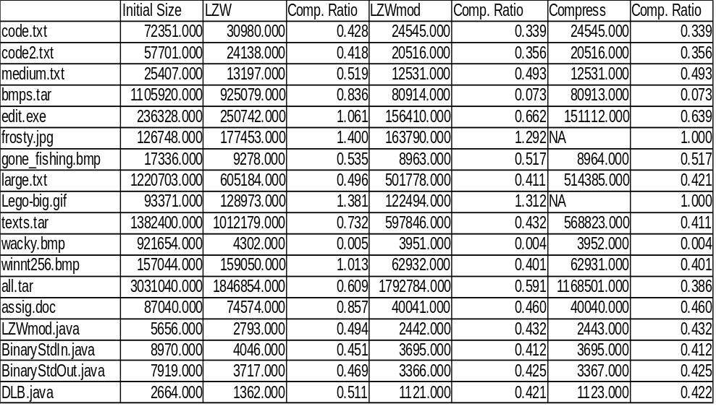

The LZWmod outperformed the original LZW on every single file, without fail. This intuitively makes sense because the LZWmod starts off with a much smaller code size (9 bits versus 12 bits), which allows it to attain compression earlier on. Then, since it can go to a much greater number of bits (16 versus 12), it can continue to achieve compression much further into the file. Compression varied greatly by file type, with moderate levels of compression being achieved in text files and java files, and huge levels of compression achieved in bmps. The bmps were able to be compressed so much because they are initially completely uncompressed, and they have large regions of the file with the same information (same color at many pixels). The JPGs and Gif on the other hand are already compressed filetypes, so the LZW actually achieved negative compression ratios on these files.
Compared to Unix Compress, the LZWmod generally achieved almost the exact same compression ratio, ofter down to the exact bit. Notable exceptions to this occurred in the jpg and gif, which compress left unchanged since it was intelligent enough to realize that it could not outperform the current compression of the file.
Bonus:
I have made a significant change to my file by allowing the user to specify whether they want the dictionary to be discarded during compression if the current dictionary fills up. This is a viable method of handling the complete filling of the dictionary, and can be significantly beneficial if the data within the file changes during the compression by allowing the LZW to start building the dictionary from the beginning. As a test, I compressed all.tar using LZWmod with rebuilding of the dictionary enabled, and found the size of the compressed all.tar to be 1178104 bytes. Almost 50% smaller than the LZWmod achieved without rebuilding the dictionary, and this stands to reason since the file is a tape archive and the type of data being compressed changes across the file. Note that if rebuilding of the dictionary is enabled during compression, it must also be enabled during decompression. The syntax for using LZWmod with rebuilding is the following:
java LZWmod - r <all.tar >all1.lzw
java LZWmod + r <all1.lzw >all1.tar
Note that excluding the “r” simply causes the LZWmod to compress in the typical way. In other words, no command line argument must be used in place of the “r”.

