Dynamic Modular Model of a Field Regulated Reluctance Flywheel Energy Storage System Utilizing a Superconductor Levitation Bearing

D. D. Arnett*,* D. J. Morehouse, C. Berven, H. L. Hess

*Abstract*— The flywheel energy storage system being modeled is intended for use in lunar surface applications for unusually long term storage of energy. This flywheel is composed of four systems; a control system, a contactless stabilization bearing, a self-bearing machine, and a passive superconductor levitation bearing.  
With the application in mind it is desired that the model be capable of reconfiguration to test the effects of parameter variations caused by design choices intended to improve the ability of the machine to store energy. Low rotational losses of a superconducting levitation system for the rotor improve the machine’s efficiency. A model of the superconductor bearing was created, its parameters based and refined on data collected during rotational testing. Composite materials specified for the rotor of the machine improved both the energy density and the mechanical strength of the machine. These composite materials in the rotor will affect the ability of the machine’s control and suspension systems to produce corrective forces on the rotor. The model is capable of rapid reconfiguration because the interaction forces between the subsystems of the machine are defined as functions of the parameters that change due to design iterations. Simulation results show the effect of the superconductor bearing on the energy storage capability of the machine and of the composite materials on the machine’s ability to produce corrective forces and torque.

[1]

*Index Terms*—Please choose four to five keywords or phrases in alphabetical order, separated by commas. A hierarchical list of terms is given in the IEEE Taxonomy located online at https://www.ieee.org/documents/taxonomy_v101.pdf

# Introduction

**T**

his document is a template and instruction set for Superconductor Dearing

# Superconductor Bearing

The superconductor bearing is composed of two components. The fixed component is a copper plate with internal coolant channels that acts as a heat sink for the high temp superconductors embedded in the surface. The moving component is a Halbach array that is embedded in the lower stainless steel cap of the rotor. This array is composed of layers of arranged rare earth metal permanent magnets.

# Field Regulated Reluctance Machine

## Selfbearing Machine

A field regulated reluctance machine is well suited for flywheel energy storage systems due to their capability to operate as a selfbearing machine [1]. A selfbearing machine a machine that relies on the resultant magnetic field to provide the corrective forces that would normally be provided by a traditional bearing. This provides one key advantage for an energy storage system, magnetic bearings can provide a much lower effective friction than traditional bearings [2]. This results in lower energy losses due to friction and reduced maintenance resulting in less down time.

## Composite Loss Factor

Flywheel energy storage systems store kinetic energy in the form of a rotating mass. This energy is greatly influenced by the rotational velocity of the mass. Rotational kinetic energy is proportional to the moment of inertia *J* and the square of the angular velocity *ω* as shown in (1)*.*

(1)

The relationship between rotational kinetic energy and the angular velocity indicates the advantages of developing a rotor that can withstand greater angular velocity.

The angular velocity of the rotor can only be increased within the limits of the mechanical strength of the rotor material. This indicates that a composite rotor can be utilized to increase the rotational velocity beyond the limits of a traditional iron rotor. Converting the rotor to a composite material has mechanical benefits in terms of greater strength and increased potential energy density [3] [4].

However, this conversion is not without cost. The cost of using a composite rotor is largely the reduction of the electromagnetic capability of the machine. To describe this loss a composite loss factor was developed by incorporating the material properties into Ampere’s Law. This composite loss factor *kcom* is defined using the length of the materials *l* and the permeability of the materials *μ* as shown in (2) [5].

(2)

# Modular Modeling

## Definition of Components

The core of modular modeling is to develop self-contained modules that define the components of a system. This concept can be applied at multiple levels of machine modeling depending on the application. The goal is to divide the system into components that are of interest.

Each of these components is then defined as a combination of characteristics such as geometry and physical properties. These characteristics should be chosen based on the goal of the model. For example, if the model is intended to predict the deformation of a surface the characteristics would be the material properties of the surface of interest.

## Definition of Interactions

The system components are then used to calculate the interactions between the components. This can be done using any form of interaction modeling from fundamental physics to lookup tables. The development of these interaction terms should be carefully considered and chosen with the desired outcome in mind.

There are several points to consider when developing these interaction terms: the model purpose, computing power, time, accuracy, and much more. If the calculation of the interaction terms is complex there will be more computing power or time required to converge on a solution. If the interactions are loosely defined the solution may be found quickly but the accuracy may be reduced.

## Superconductor Bearing Model

The superconductor bearing was defined as a single component at this stage of the project. This is a definition of the bearing derived from data collected during levitation experiments.

The experimental data was used to calculate an angular acceleration of . This angular deceleration is then multiplied by the moment of inertia of the rotor to determine the torque on the rotor from the superconductor bearing. This torque is considered to be the interaction between the rotor and the superconductor bearing.

As the model of the superconductor bearing is being developed the component can be updated and the interactions can be redefined to achieve the accuracy desired.

## Selfbearing Machine Model

The selfbearing machine was defined as two components, the rotor and the stator. These two components were used to develop several interactions of interest.

The components were defined as their material properties and geometry. At this stage the only material property being considered is the permeability of the material used. The geometry is defined based on radii, height, slot configuration and pole configuration.

The stator slot configuration is used to define a turns function, which represents the number of wire turns enclosed by a closed path [1].

The rotor and stator geometries are used to define an effective air gap function, which approximates the path the flux lines will travel between the stator surface and the rotor surface [5].

The turns function and effective air gap function are then used to define the modified winding function, which represents the effect of the machine windings and air gap on the magneto motive force produced by the stator [1].

The current used to energize the coils is then combined with the modified winding function to determine the MMF produced by the machine. This current can be treated as an output from the control system of the machine. If a model is provided for the control system the model can predict transient behavior of the machine as a result of the control algorithm.

The composite loss factor is then applied to the MMF. This effective MMF is then used to determine the energy stored in the magnetic field and the radial force. The energy stored in the magnetic field is used to calculate the torque produced by energizing the stator coils. The radial force is separated into x-axis and y-axis forces. These forces and the torque are considered the interactions between the rotor and stator components.

# Simulation Results

Fig. 1 reveals that the superconductor bearing increases the machine’s ability to store energy by over ten time that of the fabricated bearing. Also, the fabricated bearing reduces the ability of the machine to produce motoring torque when compared to the superconductor bearing, demonstrated in Fig. 2.

This model is capable of predicting the torque produced as the machine motors through 360 degrees of rotation in approximately ten seconds on a desktop computer. The first 45 degrees of the torque production are shown in Fig. 2 for both an iron rotor and a composite rotor. The benefit of this method of model development is seen when reconfiguration is desired.

One of the goals of this project was to determine the electromagnetic impact of a composite rotor. After developing the relationship between Ampere’s Law and incorporating composite materials in the loop, it takes approximately half a second to reconfigure the model to test the impact of various composites. This is due to the fact that only one parameter must be modified to change the composite.

In this same way any rotor or stator parameters can be adjusted to test the impact of various rotor and stator geometries on the machine performance.

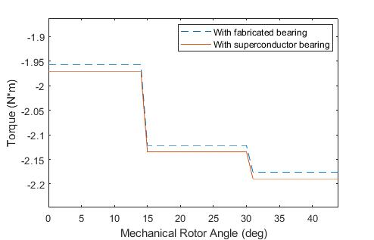

(a)

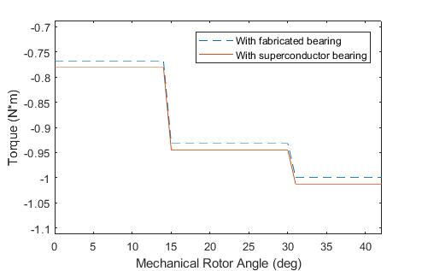

(b)

Fig. 2. Machine torque production with (a) an iron rotor and (b) a carbon fiber and iron composite rotor.

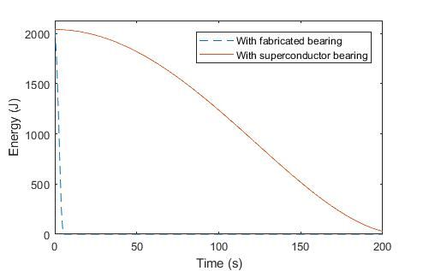

Fig. 1. Energy stored in the rotation of the rotor as a function of time and the bearing losses.

# Conclusion

A superconductor bearing will improve the efficiency of the machine by reducing the amount of energy lost to friction in the bearing. Also the inclusion of composite materials in the functional electromagnetic portion of the machine will reduce the machine’s ability to produce motoring torque. The intent is that this reduction will be countered by the increased material strength, which will allow the machine to achieve higher rotational velocities and therefore greater energy storage.

By taking a modular modeling approach a machine model can be developed that is highly flexible. This model can then be used to simulate the changes to the machines operation with regard to the machine’s parameters.

# Acknowledgment

The authors would like to thank the previous professors, graduate students, senior design teams, and undergraduate researchers who aided in the development of the models and the machine.

# References

1. B. T. Wimer, “Dynamic model and design of an integrated flywheel energy storage system,” Thesis, University of Idaho, May 2014.
2. H. Bleuler, M. Cole, P. Keogh, R. Larsonneur, E. Maslen, R. Nordmann, Y. Okada, G. Schweitzer, and A. Traxler, *Magnetic Bearings: Theory, Design, and Application to Rotating Machinery*. Springer, 2009.
3. B. F. Kaschmitter, “Modeling, design, and optimization of a high-speed flywheel for and energy storage system," Thesis, University of Idaho, May 2016.
4. J. D. Pettingill, “Multi-physic stochastic modeling of a high speed composite flywheel energy storage system," Thesis, University of Idaho, May 2017.
5. D. D. Arnett, “Dynamic modular model of a flywheel energy storage system,” Thesis, University of Idaho, May 2018.

1. The authors gratefully acknowledge the funding provided by NASA gran number NNX15AR81A.

   L. D. Cooley is with the Applied Superconductivity Center, National High Magnetic Laboratory, Tallahassee, FL 32310, USA and also with Florida State University (e-mail: ldcooley@asc.magnet.fsu.edu).

   S. B. Author was with Brookhaven National Laboratory, Upton, NY 11973 USA. She is now with Institution, City, State, Postal code, Country (e-mail: sbauthor@email.domain).

   T. Author is with Lawrence Berkeley National Laboratory, Berkeley, CA 94720-8203 USA (e-mail: third.author@email.domain).