**Chapter 1. Introduction**

* 1. **Motivation**

Whether it’s production or storage, energy has been an important topic over the last several years. Nearly every aspect of our lives revolves around the necessity of energy. Energy storage is valuable for its use later such as a battery or for storing excess power generation which can then be used when power demands are high. With the aim of the colonization of the moon, NASA will need an efficient and effective way of storing energy.

A critical consideration of possible energy storage devices for lunar applications is the ability of a storage device to withstand extreme conditions. The extreme lunar conditions are a result of the minimal atmosphere with daytime lasting 14 earth days and nighttime lasting 14 earth days with temperatures ranging from 100 K to 400 K between daylight and darkness [1]. The possible options for energy production includes solar and nuclear. The large period of darkness eliminates the possibility of producing power using solar panels for long periods of time. Nuclear generation is another feasible power source but is unable or limited in power production at the high daylight temperatures. Intermittent power sources expose the need for energy storage during generation for later use. With all storage devices, there are trade-offs of power and energy density, life or charge/discharge cycles, and cost [2]. Flywheels are a potential energy storage device that may be able to meet storage requirements.

* 1. **Flywheel Energy Storage Systems**

Flywheels are not a new concept and have been used for many mechanical systems. These systems often use flywheels to transfer energy mechanically through the system. Development of new technologies has arisen to the use of flywheel energy storage system (FESS). FESS’s are used to store energy mechanically which is then converted into electrical energy when the motor acts as a generator. The kinetic energy stored in a FESS is given in Equation (1.1):

|  |  |  |
| --- | --- | --- |
|  | where | (1.1) |

where *KE* is the kinetic energy, *I* is the mass moment of inertia for the flywheel, ω is the angular velocity of the flywheel in rad/s, *M* is the mass of the flywheel, and *ri* and *ro* are the inside and outside radius respectively for a single material.

FESS’s are currently being used in uninterruptible power supply (UPS) systems, store excess power for later consumption, and mitigate power fluctuations [2] [3]. These large scale models are often used for rapid discharge rates on the order of magnitude of several minutes resulting in a high power density but their large mass and lower angular velocity result in a lower energy density [2]. With the improvement of material technologies, FESS’s can operate at higher speeds allowing for a much greater energy density which results from the ω2 term in Equation (1.1). NASA is interested in the possibility of replacing batteries in space applications if energy density can exceed that of batteries [4].

There are many advantages for FESS’s that make them a good candidate for the possible replacement of batteries. With the use of Active magnetic bearings (AMB) the friction and maintenance can greatly be reduced [5] [6]. The use of an evacuated chamber in conjunction with AMB has the ability to increase the efficiency of the system to 90% [6] [7]. Figure 1.1 below is a schematic of a FESS used for an UPS.

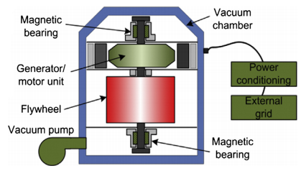

**Figure 1.1: Diagram of the key components used for a typical FESS** [7]

Unlike batteries with a typical lifetime of 5 years, flywheels have a capability of having a lifetime of approximately 20 years which may be able to offset the large initial startup cost. Chemical batteries have hazardous materials that have to be disposed of where flywheels have nearly none. Currently, FESS’s have an energy density in the range of 50-100 Wh/kg however NASA theorizes that FESS’s may eventually reach an energy density of 2,700 Wh/kg with an increase of carbon nanofiber technology [4] [7].

* 1. **University of Idaho FESS**

NASA has provided funding for Phase III of the Steckler Space Grant for the continuation of research into University of Idaho Flywheel Energy Storage System (UIFESS). The goals for this phase is the continuation of research for the use of a hubless, low-speed UIFESS, advancement of education for both undergraduate and graduate students in the STEM workforce, promote interdisciplinary work, develop, test and optimize a high-speed FESS. Concurrently, research is being done by professors and students from Electrical and Computer Engineering, Mechanical Engineering, and Physics departments on the UIFESS. The UIFESS is being designed to store excess power generated from an intermittent power source for later use.

The current low-speed UIFESS is intended to rotate at 1,800 rpm but has been overdesigned to operate at speeds up to 5,000 rpm [8]. At this speed much of the analysis can be done for control and debugging issues. As previously stated, the UIFESS is a hubless design. This corresponds to an “inside-out” configuration meaning that the rotor, or flywheel, rotates around a stationary stator. The flywheel consequently needs to be larger which greatly increase the moment of inertia resulting in greater energy storage. An “outside-in” design, incorporating a hub, developed at the NASA Glenn Research Center reached velocities of 60,000 rpm [9]. This flywheel is much smaller than required for actual implementation. The stator is responsible for producing the torque that converts electrical energy into kinetic energy as well as converting the kinetic energy back to electrical energy. Figure 1.2 illustrates the UIFESS.

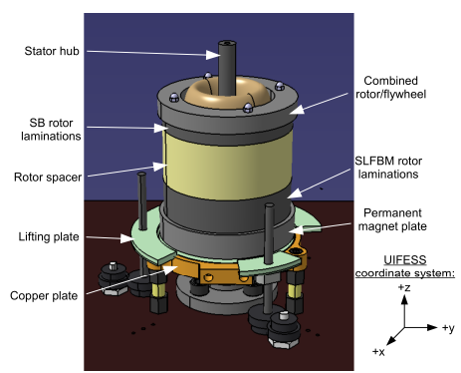

**Figure 1.2: Labeled diagram of the UIFESS** [8]

To increase the efficiency of the overall system, a Passive magnetic bearing (PMB) was implemented to decrease the friction produced from mechanical bearings. The PMB operates using high temperature YBCO superconductors and permanent magnets oriented in a Halbach array. The Halbach array orients permanent magnetics in specific directions which increases the “field gradient and intensity” thus increasing levitation forces [10]. These magnets are pressed into a stainless steel plate at the bottom of the rotor labeled as “Permanent magnet plate”. Many FESS’s currently being used operate using AMB similar to that shown in Figure 1.1. AMB’s require electrical power to create levitation force whereas PMB’s do not. The use of the PMB allows for a decrease in power consumption during operation increasing the efficiency. The superconductors do however require that they be cooled to a critical temperature for levitation to occur. A copper plate and liquid nitrogen are used to cool the superconductors which are size referenced to a guitar pick in Figure 1.3. To control the tilt of the flywheel, a stabilizer bearing, acting as an AMB, is used by delivering radial forces.

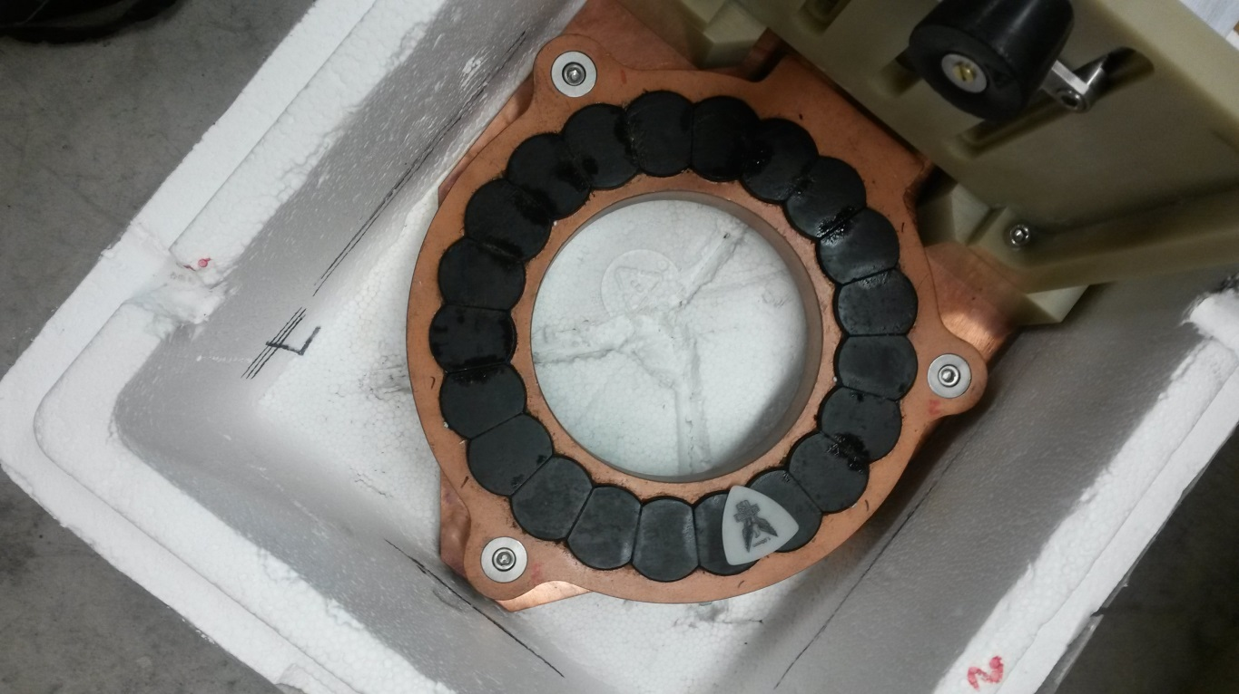

Copper Plate

Super Conductors

Guitar Pick

**Figure 1.3: Superconductor ring and copper heat conduction plate.**

The flywheel operates using a Field Regulated Reluctance Machine (FRRM). FRRM’s operate by exciting stator windings in a manner that allows the controlling of the torque and flux to be independent of each other [11]. As the flywheel accelerates or decelerates, a significant amount of heat is produced. The UIFESS uses cold water that is pumped through the stator shaft to cool the stator windings. A possible consideration for the high-speed flywheel is to use the outgassing of the liquid nitrogen for cooling the stator.

Additional features added to reduce losses include iron laminations and a vacuum chamber. 26 gauge M-36 electrical grade silicon steel is used for both the stator and rotor laminations. This steel is used for its relatively high magnetic saturation point. Laminations are used to reduce eddy current losses that form perpendicular to the magnetic flux flow when a change in flux occurs. Laminations restrict the size of the eddy current loops thus increasing the efficiency of the system. The geometry used for the stator and rotor laminations used for the FRRM is shown in Figure 1.4. A large magnetic flux will be penetrating the iron laminations making it desirable to have the ability of a degaussing routine. This is used to eliminate or greatly reduce residual flux in the laminations that occurs from extended use. For the stabilizing bearing, 8 poles are used on the stator laminations and the rotor laminations are simple laminate rings without any complex geometry [12]. Similar to mechanical bearings, wind drag can be an extensive source of friction loss especially so at high speeds. To reduce this, a vacuum chamber as shown in Figure 1.5 is used to evacuate the air pressure to 10-4 Torr (1.32X10-7 atm). Some commercial FESS’s use light gases such as helium-air mixtures to reduce losses by up to 42% for a 50% volume of helium [13].

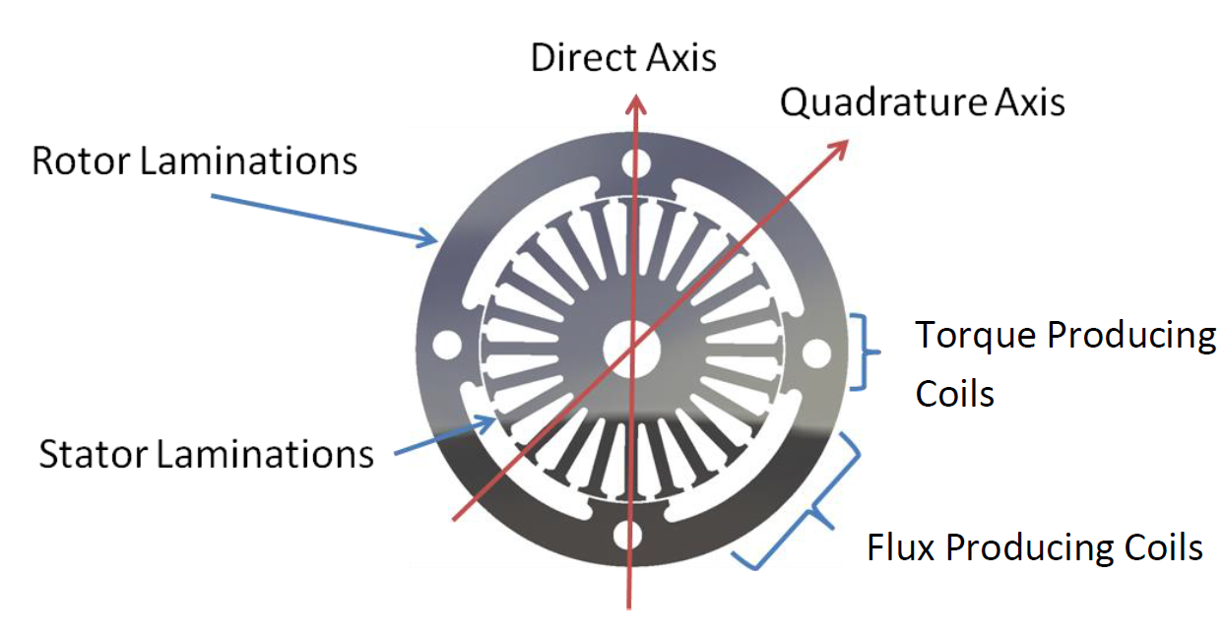

**Figure 1.4: Stator and rotor lamination geometry** [12]

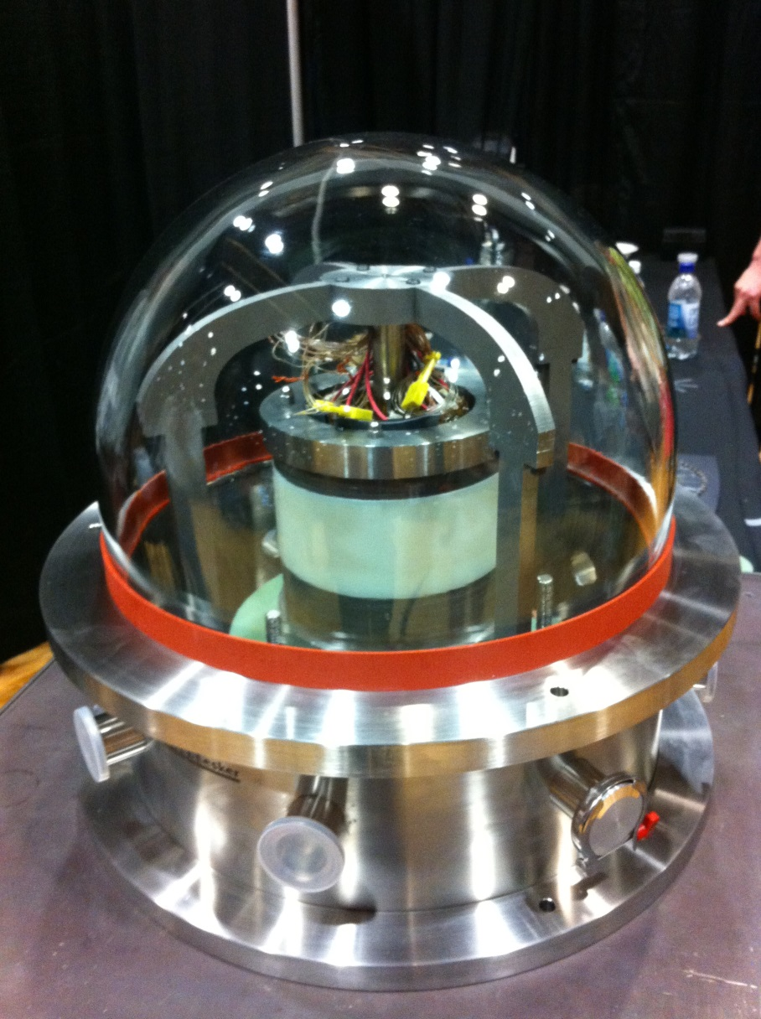

**Figure 1.5: UIFESS assembly with vacuum chamber. Power electronics excluded.**

The rotor is able to move on the x-y plane as defined by the triad in Figure 1.2. Eddy current position sensors, which are accurate to a micrometer, measure the radial location of the rotor to determine if the rotor is centered about the stator. The position sensors selected by Ramus are used to determine if the airgap needed between the stator and rotor is being maintained [Ramus]. An airgap of 1 mm was determined by Wimer to have an effective applied force for the stabilizing AMB and FRRM [Wimer]. The control and implementation of the AMB to maintain the 1 mm airgap was developed by Kisling [Kisling].

* 1. **Thesis Objectives**

The primary objective of the work covered in this thesis is to develop a numerical model that defines the stress state of the high-speed UIFESS. This model must include the needed materials for the FRRM as discussed by Wimer [12]. A numerical model is needed to incorporate the use of wrapped fiber composites. Fiber composites, specifically carbon fiber, can be used for high strength applications while simultaneously reducing weight. High strength materials are needed to withstand the stresses induced by the high rotational speeds. The model must be able to evaluate stresses through multiple physical layers for the iron laminations and possibly multiple composite rings. The non-isotropic properties of composites must be incorporated into the model as well.

The second objective is the modification and implementation of the model in an optimization scheme. Two optimization schemes are developed to meet specific requirements. One is to maximize the kinetic energy of the system while the other is to minimize the change in displacement of the inner surface. An intensive optimization scheme allows for the widespread coverage of the design space such that a multiple of design points are considered to find the optimum location. The optimization scheme must consider the strengths of the materials such that failure does not occur. It must likewise consider the needs of the electrical engineering parameters such as stator size.

The final objective is to investigate options for the substitution of the iron laminations and the replacement of the stainless “caps” on the rotor which are currently being used to hold the laminations together. The low strength and the geometry needed to contain the Halbach magnetic array will not be able to withstand the rotational speeds for the high-speed UIFESS. For this reason, an alternate method or material is required. A substitute for iron laminations may allow for the removal of the upper stainless steel plate completely and most likely the bottom plate as well. This will contribute to the finalization of the overall rotor design which will later be used to produce a dynamic model for the control algorithm.

* 1. **Scope**

The work described in this thesis is performed as part of Phase III of the Steckler Space Grant provided by NASA. Phase I resulted in analytical and experimental proof that losses can be reduced during idling periods. It also selected the FRRM as the driving mechanism for the FESS. Phase II is covered in the theses of Kevin Ramus [14], Brent Kisling [8], and Bridget Wimer [12]. Phase II is the design and construction of a low-speed proof-of-concept FESS. This low-speed flywheel is intended to be used for developing control algorithms and to test degaussing routines. Phase III is to evaluate the performance of the low-speed FESS then to design, build, and test the high-speed FESS. The results of Phase II greatly affect the Phase III. For this reason, I will list the main results from this thesis and that provided by Kevin Ramus [14], Brent Kisling [8], and Bridget Wimer [12].

In this thesis:

* Discussion of composite behaviors
* Development and modification for an axisymmetric rotor design
* Optimization schemes for the minimization of the inner rotor radius and maximization of energy

By Kisling [8]:

* AMB control algorithm
* Stabilizer bearing design
* FRRM control algorithm framework

By Ramus [14]:

* UIFESS component selection including microcontrollers, vacuum chamber, power amplifier, and sensors
* Printed circuit boards for interfacing power electronic components
* Investigation of the speed capabilities of power electronics

By Wimer [12]:

* Design of the FRRM
* Dynamic model and simulation for the UIFESS
* Derivation of AMB force expressions

The overview of analysis and behaviors of composite materials will be covered in Chapter 2 of this thesis. Chapter 3 contains the formulation of the model used to approximate the stresses in the rotor. This chapter will also give an overview of the modification made to the model used for the optimization schemes. Chapter 4 is the formulation of the optimization schemes used; one for the kinetic energy and another for displacement. Chapter 5 presents the summary, conclusion, and recommendations for future work.

**Chapter 2. Composite Overview**

1. **Composite Overview**

The application of composite materials is extremely vast and can be found anywhere between sports equipment to turbine blades. Composite materials often offer higher strength to weight ratios while maintaining the ability to be customized for strength, weight, and stiffness [15]. Composite materials are those that are a combination of two or more other materials. Two main types of composite materials exist: particulate and fibrous. The aerospace industry has been an extensive consumer of composite materials. These composite materials include fiber composites such as carbon fiber and metal composites such as hybrid titanium composite [16]. Both fiber and particulate composites use a matrix material to suspend the particulates or fibers. Fibrous composites are typically more effective than particulate composites [17]. This discussion on composites will be weighted towards the use of fibrous materials.

It is shown by Griffith that as the diameter of a rod or fiber gets smaller the strength increases [18]. Extrapolating his testing results shows that for large diameters the strength is that of the bulk properties but for smaller diameters the strength approaches the strength of the atomic bonds. This occurs because at a smaller diameter, the probability of microstructural discontinuities is smaller. It is therefore desirable to have very small fibers in high strength applications. This is comparable to the size affect used in the stress-life fatigue analysis for reducing the fatigue limit [19].

Four main types of fiber-reinforced composite exist; each with its own particular application. The four types, shown in Figure 2.1, are continuous fiber (Figure 2.1a), woven fiber (Figure 2.1b), chopped fiber (Figure 2.1c), and hybrid (Figure 2.1d) [17].

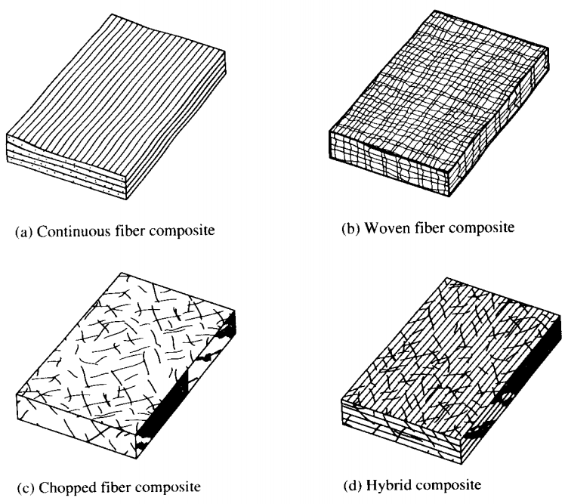

**Figure 2.1: Types of fiber-reinforced composites [17]**

Continuous fiber composites use fibers aligned in similar directions to form laminae. Multiple laminae are then used to construct a laminate. These laminae can, but don’t have to be, oriented in multiple directions. A major problem that exists is delamination which is typically characterized by the strength of the matrix material [17]. Woven fiber composites remove the possibility of delamination. The trade of for this however is a reduction in strength and stiffness. Chopped fiber composites use relatively short fibers randomly located throughout the matrix material. This type of composite is cheap and more suited for high-quantity manufacturing. The physical properties of chopped fiber composites are significantly reduced compared to continuous fiber composites. Hybrid composites are a mixture the other three types or a combination of multiple fiber types. Typical matrix materials include polymers, metals, and ceramics. Polymers are the most widely used matrix material and operate typically at lower temperatures. Metal and ceramic matrix materials are generally used at higher temperatures or when increased stiffness is required. Compatibility between the fiber and matrix material is need to ensure the bond strength, either physically or chemically, is susceptible [17].

Applications that require a component to be loaded predominately in bending often use foam or honeycomb cores sandwiched by fiber laminates [17]. The stress for an isotropic material in bending is described in Equation 2.1. The analysis of composite laminates in bending is more complicated yet is still a function of the perpendicular distance from the neutral axis of the beam to the location of interest. This means that the stress for a component in bending is much less at the center of the beam. Low stresses near the center allows for lighter, cheaper, inferior materials to be used at the center of the beam or component. The sandwiched configuration results in structure with a high flexural stiffness-to-weight ratio. Multiple possible combinations of fiber and matrix materials and laminate/structural layup make fiber composite design flexible and customizable for numerous applications.

1. **Composite Mechanics**

The stress state for composite materials is determined by the stain at a point and the stiffness matrix. Unlike isotropic materials, composite materials have different material properties in different directions. For a fully elastic anisotropic material the stress state is defined as Equation (2.1) [17]:

|  |  |  |
| --- | --- | --- |
|  |  | (2.1) |

where ***σ*** is the stress state at a point, ***C*** is the stiffness matrix defined as [Cij] where i,j = 1, 2,…,6, and **ε** is the strain vector at a point. Aligned fiber composites typically behave such that the material properties with respect to three mutually orthogonal planes or directions. Typically these principal planes are labeled as (123). This behavior is known as orthotropic. Specially orthotropic is when the non-principal directions (xyz) is oriented such that one of the principle and non-principal directions are aligned. The stiffness matrix for specially orthotropic materials is represented below [17]:

|  |  |  |
| --- | --- | --- |
|  |  | (2.2) |

Composite lamina properties change with respect to which direction is being considered, for this reason E1 ≠ E2 and ν12 ≠ ν21. E1 and E2 are the modulus of elasticity in the 1 and 2 direction respectively. The property ν12 is considered the major Poisson’s ratio while the other is called the minor Poisson’s ratio. The difference is a result of loading. For νij = -εj/εi where *i* is the load direction and *j* is the direction of the strain that is being affected. For isotropic materials, the direction of loading does not affect the property therefore ν12 = ν21. Although Poisson’s major and minor Poisson’s ratios are different, they are related to each other by νij/Ei = νji/Ej.

In Equation (2.1), the stiffness matrix ***C*** is a function of the material properties. However, it does not directly correspond to individual properties of the material. For this reason, the compliance matrix **S** is used. The relation between **S**, **σ**, and **ε** is given in Equation (2.3) [17].

|  |  |  |
| --- | --- | --- |
|  |  | (2.3) |

where *Gij* is the shear modulus, *γij* is the shear strain resulting from the shear stress *τij*. ***S*** and ***C*** are related by ***S****-1 =* ***C***.The relationship between the shear modulus, elastic modulus, and Poisson’s ratio is given as:

|  |  |  |
| --- | --- | --- |
|  |  | (2.4) |

Many specially orthotropic lamina are represented in a 2D stress state otherwise known as plane stress. Plane stress assumption results in σ3 = τ23 = τ31 = 0 from Equation (2.3). Most uses of orthotropic laminas result in the load directions not being aligned with the principle axis which is known as generally orthotropic. A coordinate transformation matrix is required to rotate the stresses and strains from one coordinate system to another. The transformation matrix in for rotating from the xy-coordinate system to the 12-coordinate system is defined below [17]:

|  |  |  |
| --- | --- | --- |
|  |  | (2.5) |

where θ is the angle between the x-axis and the 1-axis.

Having a large range of flexibility in composite materials makes it desirable to characterize the composite without testing for each individual property. Calculating the properties of aligned continuous fiber composites requires the properties of the fiber, matrix material, and the volume fraction. The elastic modulus in the fiber direction and the major Poisson’s ratio is shown to be *E1 = ΣEivi* and ν12 = *Σν12vi* where *vi* is the volume fraction of the individual components. The transverse and shear modulus equation (Equation (2.6)) was derived by Tsai and Hahn and correlated to experimental data for verification [17].

|  |  |  |
| --- | --- | --- |
|  | where | (2.6) |

Material properties for randomly oriented chopped fibers are an estimation based on the analysis of aligned short fibers. Aligned short fibers have an effect on the longitudinal modulus; however, Halpin concluded E2, G12, and ν12 were marginally affected by the fiber length [17]. Equation (2.7) is the resulting equation for the longitudinal modulus.

|  |  |  |
| --- | --- | --- |
|  | where with | (2.7) |

where *L* is the length of the fiber and *d* is the diameter of the fiber. Marginal effect on the transverse modulus allows for the use of the improved inverse rule of mixtures as given in Equation (2.8) [17]. Given the results of Equations (2.7) and (2.8), the averaged isotropic properties can be found using the Tsai and Pagano equation (Equation (2.9)).

|  |  |  |
| --- | --- | --- |
|  |  | (2.8) |
|  | and | (2.9) |

Poisson’s ratio for the randomly oriented, short fiber composite can be found by inputting Ẽ and from Equation (2.9) into Equation (2.4). The relationship between the fiber volume fraction, ratio between Ẽ and E1, and the ratio between Ef and E­m is shown in Figure 2.2 [17]. This gives a visual image for the effect of the fiber modulus on the effective modulus for the randomly oriented, short fiber composite.

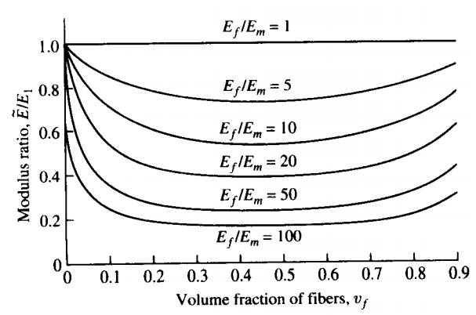

**Figure 2.2: Effect of short fiber modulus on the effective modulus [17]**

1. **Failure and Strength of Composites**

Three main types of failure criterion exist for composite laminas. These are the maximum stress, maximum strain, and Tsai-Hill criterions. The Maximum Stress Criterion states that if a stress in the lamina reaches the maximum stress of the component, whether tensile, compressive, or shear then failure will occur. Maximum Strain Criterion is the same as the Maximum Stress Criterion only with strains. The Tsai-Hill failure surface for plain stress is a function of the biaxial stresses and the shear stress. The three failure criterions are shown in σ1, σ2 space in Figure 2.3. The load direction is distinguished using (+) for tensile loading and (-) for compressive loading and the strength is signified by *s* with *T* and *L* signifying the fiber direction.

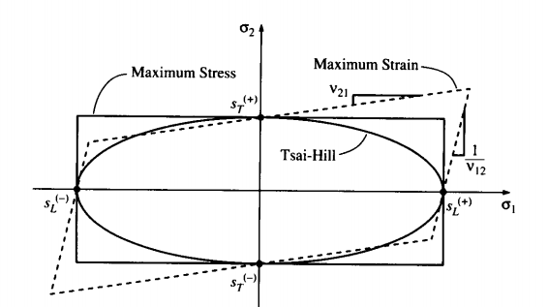

**Figure 2.3: Maximum stress, maximum strain, and Tsai-Hill failure criterions [17]**

Maximum Stress Criterion creates the rectangle shape shown in Figure 2.3. The interaction between stress components is not incorporated in this failure criterion. It has been shown to be accurate for uniaxial loadings as shown in Figure 2.4. Maximum Strain Criterion creates a parallelogram shape. This incorporates added strain in biaxial loading scenarios. Most physical evidence does not support this criterion at the intercepts of the parallelogram which can be seen in Figure 2.4. Tsai-Hill Criterion was developed as a modification to the commonly used maximum distortional energy criterion; otherwise known as the von Mises Criterion. The Tsai-Hill Criterion is a continuous function which accounts for loading in the 1 and 2 directions and the shear stress as shown in Equation (2.10) [17]:

|  |  |  |
| --- | --- | --- |
|  |  | (2.10) |

The directions are not specified in the Tsai-Hill equation because the loading can be either positive or negative. If the left-hand portion of Equation (2.10) is greater than one, then failure has occurred according to this criterion. This failure criterion is a reasonable fit for many composite materials and more conservative as shown in Figure 2.4. The fourth failure surface in Figure 2.4 is the Tsai-Wu Criterion. This is shown to be more accurate but requires strength tensors that are experimentally determined [17].

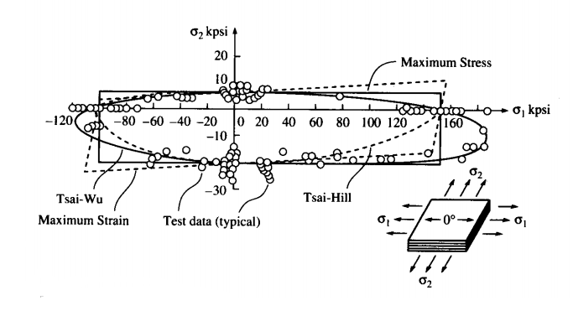

**Figure 2.4: Comparison of the maximum stress, maximum strain, and Tsai-Hill failure criterions [17]**

Approximating the physical strength of a composite can be a more difficult process. For the longitudinal strength, the method used to calculate the strength is dependent upon which material has a lower maximum strain. For practical purposes, fiber failure means that the entire composite has failed. A composite were the fiber strain is less than the critical matrix strain will result in the matrix supporting a stress that is equivalent product of the maximum strain of the fiber and the stiffness of the matrix. This is the strength addition from matrix at fiber failure and is denoted as where is the maximum longitudinal tensile strain for the fiber. The equation for the overall longitudinal tensile strength for a lamina as a function of the volume fraction becomes [17]:

|  |  |  |
| --- | --- | --- |
|  |  | (2.11) |

where is the strength of the lamina and is the strength of the fiber. Some composites have matrix materials that have a lower allowable strain than the fiber. For these materials, the longitudinal strength of the lamina is found using Equation (2.12) [17]:

|  |  |  |
| --- | --- | --- |
|  | where | (2.12) |

Transverse strength of a continuous fiber lamina is largely dependent on the matrix material used. This strength is much lower and often a limitation in laminate composites. The transverse strength can be found using Equations (2.13) and (2.14):

|  |  |  |
| --- | --- | --- |
|  |  | (2.13) |
|  |  | (2.14) |

*E2* is found using Equation (2.8). *F* is the strain concentration factor with *d* representing the fiber diameter and *s* representing the distance between the fibers.

Strength analysis for short, randomly oriented fibers is much different than continuous fiber analysis. A representative volume element (RVE), like the one shown in Figure 2.5, a single short fiber in an off-axis orientation is analyzed. The strength of this RVE is found calculated based on size and strength of the composite. Integrating the RVE over all possible orientations results in an average strength for randomly oriented, short fiber composites. Chen (Equation (2.15)) and Lees (Equation (2.16)) both developed approximations for the strength of the composite [17]:

|  |  |  |
| --- | --- | --- |
|  |  | (2.15) |
|  |  | (2.16) |

where sLT is the shear strength of the fiber, ψ is an efficiency factor which is assumed to be one when unknown, and and are the longitudinal and transverse strengths respectively. Given a well-defined fiber with the properties needed, the approximate strength of a composite lamina can be calculated. The shear strength is a limiting factor for chopped composites. This limitation is an effect of matrix material applying the stress to the fiber via shear loading [17].

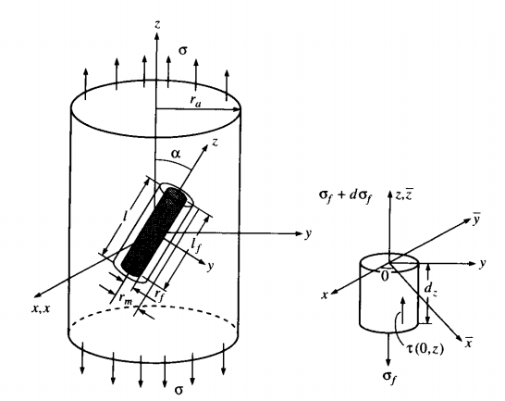

**Figure 2.5: RVE for off-axis short fiber [17]**

**Chapter 3. Model**

**3.1 Model Development**

This chapter introduces the development of a math model that calculates the stresses and displacements in the high-speed flywheel energy storage system. These outputs are necessary for their use in understanding and defining the feasible design region. The stresses can be used to determine approximately when the iron laminates will experience yielding. The displacement will determine if the 1 mm airgap can be maintained within the reasonable range required for the FRRM to operate [12].

The stress state of rotating isotropic materials is well understood. The stress equations are functions of the Poison’s ratio, density, and the angular velocity. These equations are used to describe an isotropic, homogeneous material undergoing elastic deformation. For this reason those equations cannot be used to describe the stress state in an anisotropic material.

The study of composite flywheels has become more abundant with newfound applications. This includes the study of solid rotating composite disks. Rajeev Jain, et al, derived an analytical result of a solid, constant thickness, uniform strength, anisotropic disc [20]. Their analysis also examined a disc radially varying modulus disc. Both cases were compared with a finite element method for validity. Similarly, Xu-Long Peng and Xian-Fang Li studied the stress distribution of a functionally graded solid disk [21]. A functionally graded composite disk is one where the properties vary radially. An example of this would be a disc that the fiber volume fraction increases radially. The benefit of a functionally graded material is the reduction large stress discontinuities that occur when rings with different physical properties are present.

The design and testing of a FESS with dome-type hub matched with reasonable precision of a FEM [22]. A cross-sectional view of the rotor is shown in Figure 3.1. Their rotor design was able to match radial growth to prevent separation. The 325 kg flywheel was tested to a maximum speed of 17,000 rpm at which the stored energy was 50 kWh.

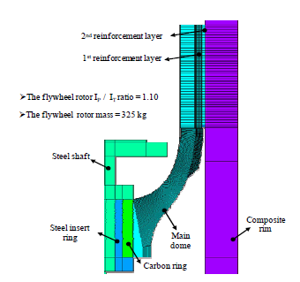

**Figure 3.1: Cross-sectional design 50 kWh FESS with a dome-type hub** [22]**.**

When helically wrapping a disc with a ply orientation of ±θ in the r-z plane, the resulting structure has a mosaic pattern as shown in Figure 3.2 [23]. Uddin, et al, modeled the flywheel as being hollow and the orientations as being orthotropic. Fiber-reinforced composites often behave in an orthotropic manner which is a special case of anisotropy. Orthotropic materials have properties that differ with respect to the three orthogonal axes. Their results compared the stress distribution in the mosaic patter to the typical analysis which is that of a laminated shell. The analysis conducted used a finite element model with different mosaic patterns.

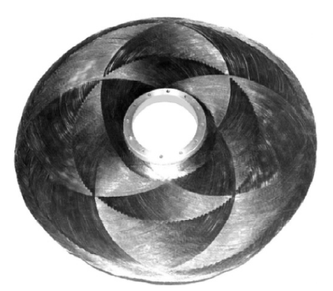

**Figure 3.2: Mosaic pattern resulting from ±θ continuous fiber helical wrapping.**

The model which was chosen to be developed uses a plain strain assumption for an axisymmetric flywheel [24]. The flywheel is assumed to be thick enough for this assumption to be valid. The stress state can then be described by the following relationship:

|  |  |  |
| --- | --- | --- |
|  | where | (3.1) |

where **σ** and **ε** are the stress and strain vectors and **Q** is the stiffness matrix for the axisymmetric material. A non-axisymmetric layered composite disc analysis was developed by Tahani, et al [25]. Their model includes the shear stress present when the flywheel is no longer axisymmetric. The out-of-plane composite properties not being readily available and the final flywheel design requiring a full finite element analysis led to the use of the axisymmetric model developed by Sung K. Ha, et al. The axisymmetric strains are defined as:

|  |  |  |
| --- | --- | --- |
|  | and | (3.2) |

where εθ and εr are the circumferential and radial strains respectively and ur is the radial displacement at a given r. To solve for **σ** numerically, the flywheel with multiple physical rings is divided into numerical rings. As the thickness of the numerical rings approaches zero the more precise the numerical solution. The stress and strain vectors are then used to develop the equations for radial displacement *ur* and normal stress *σr*:

|  |  |  |
| --- | --- | --- |
|  |  | (3.3)  (3.4) |

where *ρ* is the density of the physical ring, *C1* and *C2* are unknown constants which are solved for using boundary conditions. The values *κ* and *ϕi* are defined with respect to the material properties:

|  |  |  |
| --- | --- | --- |
|  | , , , and | (3.5) |

To eliminate the constants, the displacement vector is written as:

|  |  |  |
| --- | --- | --- |
|  |  | (3.6) |

The vectors ***u****,* ***uω****,* ***Φu***, and ***C*** from Equation (3.6) are defined as:

|  |  |  |
| --- | --- | --- |
|  | , , , and | (3.7) |

where *ri* represents the inner radius of the numerical ring and *ro* represents the outer radius of the same numerical ring. Similarly, the stress vector from Equation (3.4) is written as a force vector:

|  |  |  |
| --- | --- | --- |
|  |  | (3.8) |

where the ***fb****,* ***fω****, and* ***Φf*** from Equation (3.8) are defined as:

|  |  |  |
| --- | --- | --- |
|  | , , and | (3.9) |

Equations (3.6) and (3.8) is used to create the stress-displacement relation for both the inner and outer surfaces of each numerical ring while also eliminating ***C***. This relation is:

|  |  |  |
| --- | --- | --- |
|  |  | (3.10) |

where ***k*** is the stiffness matrix for the numerical ring is defined as:

|  |  |  |
| --- | --- | --- |
|  |  | (3.11) |

Continuity conditions must be satisfied for adjacent rings which are given as:

|  |  |  |
| --- | --- | --- |
|  | and | (3.12) |

where *j* is used to denote the *jth* numerical ring. Equation (3.10) satisfying Equation (3.12) is thus written globally as:

|  |  |  |
| --- | --- | --- |
|  |  | (3.13) |

where ***K*** is the global stiffness matrix and ***U*** is the global displacement vector which represents the displacement of each interface. ***Fb*** and ***Fω*** are the global force vectors given as:

|  |  |  |
| --- | --- | --- |
|  | and | (3.13) |

where *N* is the total number of numerical layers in the flywheel. The evaluation of ***Fb*** results in a vector with mostly zeros as a result of the internal stresses. Sung K. Ha, et al, modeled an internal permanent magnet as an isotropic material which applies a pressure on the inner surface. This resulted in a single non-zero term from this pressure in ***Fb***. The current low-speed flywheel was built using iron laminations which in this thesis are modeled by inserting the isotropic properties into ***Q*** from Equation (3.1). This results in ***Fb*** being completely zero by removing the pressure applied to the inner surface.

TheFor each *jth* ring, ***k*** is a (2 x 2) matrix. ***K*** results in a symmetric (*N*+1 x *N*+1) tridiagonal matrix found by:

|  |  |  |
| --- | --- | --- |
|  | **K =** | (3.14) |

Similarly, the operation for ***Fω***on each numerical ring *()* results in a (*N* x 2) matrix and is summed together in the following manner to create a (*N*+1 x 1) vector:

|  |  |  |
| --- | --- | --- |
|  |  | (3.15) |

Solving the system of linear equations for ***U*** in Equation (3.13) in conjunction with Equation (3.2) allows for the ***ε*** vector be solved. Substituting ***ε*** into Equation (3.1) allows for the solving of ***σ***.

**3.2 Model Validation**

The model is first developed to have two physical rings. Multiple other physical rings can be added with the addition of the other properties. Figure 3.XX shows a schematic of the FESS with multiple physical rings; however, instead of utilizing permanent magnets a material capable of transferring magnetic flux will be used for the FRRM. The top and bottom stainless caps are being excluded from this model because the machined geometry will require a finite element model. In order to validate the model the two physical rings are made to be the same isotropic material which is chosen to be the M-36 silicon-iron currently being in use. The physical properties are given in Table 3.1 [26].

|  |  |
| --- | --- |
| Properties | Value |
| Young’s Modulus (E) | 200 (GPa) |
| Poisson’s Ratio (ν) | 0.29 |
| Density (ρ) | 7700 (kg/m^3) |
| Yield Stress (Sy) | 290 (MPa) |

**Table 3.1: Physical properties for the M-36 laminations [26]**

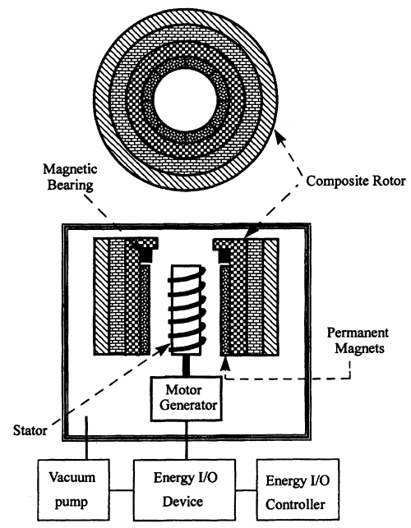

**Figure 3.XX: Composite flywheel diagram for FESS with multiple rings [24]**

The analytical stress and displacement equations for an isotropic stress state at a specific rotational velocity are given below [27]:

|  |  |  |
| --- | --- | --- |
|  |  | (3.16) |
|  |  | (3.17) |

where *a* and *b* are the inner and outer radii respectively, *r* is a continuous variable for the radial distance from *a* to *b*, and the other properties are given in Table 3.1. Equations (3.16) and (3.17) are developed under the plain stress assumption thus *σz* = 0 and is not considered in this comparison. An angular velocity of ω = 100,000 rpms is used for the model with an inner radius of r = 0.0762 meters (3 inches) and an outer radius of r = 0.1778 meters (7 inches). Using **σ** from Equation (3.1), and plotting it against Equation (3.16) for the same radii it is possible to compare the accuracy of the analytical model. The figures below are plots of the radial stress (Figure 3.XX) and the hoop stress (Figure 3.XX) as a function of the radial position.

E:\Brenden\Thesis stuff\Radial Stress.tif

**Figure 3.XX: Comparison of radial stress (GPa) vs radial distance (m) for the numerical equation and the analytical model.**

**E:\Brenden\Thesis stuff\hoop.tif**

**Figure 3.XX Comparison of hoop stress (GPa) vs radial distance (m) for the numerical equation and the analytical model.**

For the radial stress in Figure (3.XX), the model predicted a stress that iss greater than the radial stress from Equation (3.16). When using very few numerical rings, the model predicted the radial stress with an error that is approximately 5% greater than Equation (3.16). Using a large number of numerical rings marginally decreases this error to about 4%. The hoop stress, which is the highest stress, shows an error that is approximately 3% high at the inner radius and approximately 8.7% low at the outer surface. The number of numerical rings had a no influence on the changing of these values.

The stress output is important from a stance of mechanical failure; however, the displacement is critical for electrical control. The strength of the forces applied from the stator are greater the smaller the airgap between the stator and the rotor. The model will confirm whether or not previously determined 1 mm airgap can be maintained given the design and rotational velocity. In Figure (3.XX) the differences between the displacements of the model and Equation (3.17) is shown.

E:\Brenden\Thesis stuff\Displacement.tif

**Figure 3.XX: Comparison of radial displacement vs radial distance for the numerical equation and the analytical model.**

The model outputs a displacement that is approximately 6.2% low on the critical inner surface and approximately 16.2% low on the outer surface. The number of numerical rings and the change in angular velocity had negligible effects to these differences. The large error is a result of the numerical model being derived in plane strain and Equation (3.17) being derived in plane stress. The model predicts the stresses reasonably close while being more conservative. The model displacement is under-conservative. This is an effect of the strain induced by Poisson’s ratio from the stress in the vertical direction from the plane strain assumption.

**3.2 Model Adjustments**

Two physical rings where originally introduced into the model for simplicity of verification. Adjusting the stiffness matrix***Q*** allows for an axisymmetric composite ring to be incorporated into the model. Carbon fiber was chosen as the initial input for the ring for its ability to withstand high stresses. HexTow® HM63 with HexPly® 8552 Resin System, with properties found in Table 3.2, has a reasonably high yield stress while still having a modulus of elasticity greater than the iron laminations [28]. It is necessary that the material stiffness’s increase for each physical ring as you move out radially. This insures that the displacement is greatest nearest the center and decreases radially without which separation could occur. High modulus carbon fiber has a specific strength that is approximately 32 times greater than the M-36 iron laminates. The low density reduces the centrifugal forces by decreasing the mass while the higher modulus carries some of stress from the iron laminations. The three stresses for the solid iron flywheel as described previously are shown in Figure 3.XX. Figure 3.XX is the result of having an iron-carbon fiber rotor design.

|  |  |
| --- | --- |
| Properties | Value |
| Tensile Modulus (Eθ) | 200 (GPa) |
| Transverse Modulus (Er/Ez) | 7.5 (GPa) |
| In-plane Poisson’s Ratio\* (νθz/ νθr) | 0.25 |
| (r-z plane) Poisson’s Ratio\* (νθz/ νθr) | 0.2 |
| Density (ρ) | 1618 (kg/m^3) |

**Table 3.2: Physical properties for HM63 carbon fiber at 60% volume fraction. \*Approximate value [28]**

<http://www.hexcel.com/Resources/DataSheets/Prepreg-Data-Sheets/8552_us.pdf>

<http://www.hexcel.com/Resources/Documents/HexTow_HM63_Flyer.pdf>

H:\Thesis work\all Stresses_ironiron.tif

**Figure 3.XX: Radial, vertical, and circumferential stresses for iron-iron arrangement at ω = 100k RPM.**

****

**Figure 3.XX: Radial, vertical, and circumferential stresses for iron-carbon fiber arrangement at ω = 100k RPM.**

While the stresses are still very high in Figure 3.XX, overall stresses are much lower. Lower stresses indicate the possibility of adjusting dimensional parameters and rotational velocity in exchange for the deduction of stress to prevent failure while still maintaining high energy storage. While the circumferential and vertical stresses are discontinuous, the radial stress is continuous which is required for the displacement (Figure 3.XX) to be continuous throughout the flywheel. The confidence in the accuracy of the displacement is low however it does give an order of magnitude estimate for what the displacement will be. The high displacement towards the outside surface in Figure 3.XX is a result of the low transverse modulus for the carbon fiber.



**Figure 3.XX: Radial displacement for iron-carbon fiber arrangement at ω = 100k RPM.**

Large displacements at the inner radius require the flywheel to have a much lower angular velocity or a way to “capture” the flywheel to maintain the 1 mm airgap necessary for control. One proposed method is to taper the inside surface and stator. When radial expansion occurs, the superconducting plate could be actuated vertically. As a result, the required airgap can be maintained. To hold the iron laminations along with the top and bottom stainless steel plates in place, a stainless steel “sleeve” is implemented into the model between the iron and carbon fiber. Typical properties of 304 Stainless Steel are given in Table 3.3.

|  |  |
| --- | --- |
| Properties | Value |
| Young’s Modulus (E) | 193 (GPa) |
| Poisson’s Ratio (ν) | 0.29 |
| Density (ρ) | 8000 (kg/m^3) |
| Yield Stress (Sy) | 290 (MPa) |

**Table 3.3: Physical properties for 304 Stainless Steel {source}**

A geometrically non-uniform rotor induces the complication of non-uniform deformation vertically. This results in the inner tapered surface no longer being linear but arced. If the extent of this arc is too great, the shape of the flywheel will no longer match the taper of stator. To decrease this, an angle can be added between iron-stainless steel interface and another between the stainless steel-carbon fiber interface as shown in Figure 3.XX below.

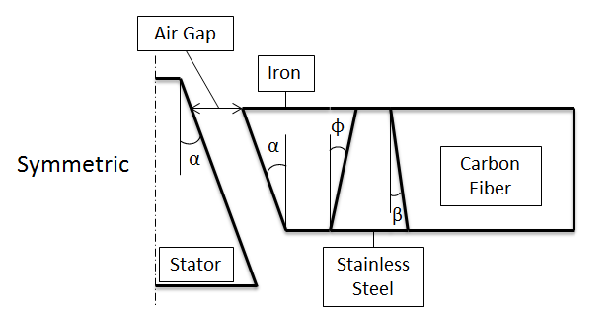

**Figure 3.XX: Schematic of the rotor’s cross-sectional view.**

Figure 3.XX portrays the taper angle α, iron-stainless steel angle φ, and the stainless steel-carbon fiber interface β. α and β shown in Figure 3.XX are defined as the positive direction. Given a value of α, φ and β can be adjusted such that the maximum difference of the internal surface’s deflection is minimized. Chapter 4 describes a heuristic approach to minimizing the deflections. Similarly, Chapter 4 also describes a heuristic method of maximizing the rotational kinetic energy such that the maximum stress in the iron laminations does not exceed the yield stress. For maximizing optimization, α = φ = β = 0 from Figure 3.XX.

**Chapter 4. Optimization**

1. **Latin Hypercube Sampling**

Initiation of a well spread population can be a critical component of starting an optimization method. One method of population initiation is random sampling. Selecting randomly risks the chance of points clustering in certain regions resulting in a poor distribution of the design space. This can be remedied with the use of Latin hypercube sampling (LHS). LHS is used to guarantee that each design variable is represented equally [29].

To select a population, the design space is gridded based on the size of the pre-selected population. The size of the population needed is problem to problem dependent but often correlates roughly to the number of design variables. The more design variables, the larger the population size will need to be. Once the design space is gridded points within that grid need to be selected. This is done by randomly selecting a permutation of the variables which represents a grid location. For a simple 2D case, if a grid location of for an (x,y) location is selected, no other data points can be selected in column of x nor the rows y occupied by that point. Figure 4.1 demonstrates the use of LHS to select five points in 5X5 grid. LHS results in each row and column containing a data point. This point is typically located at the midpoint of the grid however some extra randomness is built into LHS routine by adding a random number to the midpoint to shift it throughout the grid region.

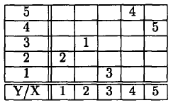

**Figure 4.XX: Schematic of the rotor’s cross-sectional view [29]**

1. **Particle Swarm Optimization**

The model developed in Chapter 3 analyses the stress state and radial displacement of the flywheel. For these reasons, each point in the population will have to be inputted into the model for the optimization. Unless enough points are inputted into the model to fit a response surface, gradient based optimization methods cannot be used. This consequently introduces the need for a heuristic optimization approach. Heuristic optimizations are optimizations that use searching algorithms rather than gradient based searching methods. An example of a heuristic optimization approach is Particle swarm optimization (PSO). PSO was developed in 1995 by James Kennedy and Russell Eberhart with methodologies comprised from bird flocking to food and evolutionary computing [30]. Their PSO algorithm is given in Equation (4.1):

|  |  |  |
| --- | --- | --- |
|  |  | (4.1) |

where *vx* is the velocity for the particle, *k* is the iteration number, rand is a random number between zero and one, *pincrement* is a modifying factor, *pbestx* is the group’s best point, and *presentx* is the current particle position. Since then Equation (4.1) has been modified to the following [31]:

|  |  |  |
| --- | --- | --- |
|  |  | (4.2) |

where *vid* is the velocity term, *w* is the inertial weight, *c1*and *c2* are constants greater than 1, *rand* and *Rand* are random numbers between 0 and 1, *pid* is the particle’s best point, *pgd* is the best neighbor’s location, and *xid* is the particle location. Equation (4.2) is more efficient than Equation (4.1). The inertial weight *w* is a number that is either less than one or initially one and updated at each iteration by a factor less than one. It can be adjusted on subsequent iterations such that the particles essentially slow down. This increases the rate at which the points converge. Having an inertial weight *w* too small increases convergence but decreases the ability of the particles to search the design space. The particle’s location is then updated using Equation (4.3) in conjunction with Equation (4.2):

|  |  |  |
| --- | --- | --- |
|  |  | (4.3) |

The objective function is what the PSO function is trying to minimize. This objective function value is the evaluation of the particle locations and can be written as shown in Equation (4.3) [32]:

|  |  |  |
| --- | --- | --- |
|  |  | (4.4) |

where *f* is the function evaluation, *Penval* is a scaling factor, and *g* is the constraint of the penalty function. The penalty function is the evaluation of constraints that are added to function that keep the particles from moving into an infeasible region or completely out of the design space. The constraints are a manifestation of Lagrange Multiplier Theorem which is implemented for the use of minimizing error [32]. When the objective function is subjected to multiple constraints the total error, often the sum squared error, is considered and not the individual constraint error.

Frequently, but not always, the optimum point is located near a boundary of one or multiple constraints. If a particle is in violation of a constraint near boundary, the error is comparatively small. This may result in the optimization function giving less precedence to the boundary condition. Incrementally increasing *Penval* as the point converges gives appropriate significance to the constraint.

1. **Displacement Optimization**

As previously stated and shown in Figure (3.XX), a way of maintaining a 1 mm airgap is to taper the rotor and flywheel then actuate the rotor vertically. The forces from the bearing are inversely proportional to the gap distance [12]. A small increase in the airgap distance significantly reduces the applied force to the flywheel. In an effort to control for uniform displacement for a given value of α, a PSO was tailored to minimize the change in displacement in the vertical direction. Incorporation of the angles α, φ, and β is done by separating rotor’s thickness into multiple discrete layers. The current radial lamination thickness is set to be the minimum thickness of the iron which is 0.02776 meters. If stainless steel or a similar material is used to hold the laminations and caps together, the probable assembly will require bolts to connect the components. For this reason, the minimum thickness of the stainless steel is set at 13 mm to allow for the connection. The smallest inner radius, at the top, is set to 0.0762 meters which is the approximate inner radius for the UIFESS. The outer radius is set at 0.1778 meters which is estimated based on the size UIFESS. The total height in the model is *h* = 0.2286 meters.

The design variables for the displacement PSO are *x1* = φ and *x2* = β where *x* = [*x1* *x2*]. The side bounds for this PSO are [-5° 10°] and ±5° for φ and β respectively. From Equation (4.4), *f* is the change in displacement and *g* is the violation of the side bound constraints. Population initiation is done by the use of LHS. A depiction of a population initiation is shown in Figure (4.XX).

****

**Figure 4.XX: Population initiation using LHS for the displacement PSO.**

The use of LHS resulted in a reasonable coverage of the design space. The population size for the two design variables is selected as 21 particles. Using six neighbors, the particles have the ability to converge to different optimum values. Values used in the PSO such as those for Equations (4.2) and (4.4) are given in Table 4.1. The variables containing *initial* are set for the first iteration value and are updated by a factor using those containing *update*. The exception to this is vid\_initial which is updated using Equation (4.2).

|  |  |
| --- | --- |
| Variable | Value |
| Population | 21 |
| # Neighbors | 6 |
| c­1 | 1.2 |
| c2 | 1.2 |
| winitial | 1 |
| wupdate | 0.75 |
| Penvalinitial | 0.1 |
| Penvalupdate | 2.0 |
| v­id\_initial | 0.4 |
| ω (rpm) | 100K |

**Table 4.1: Variable values needed for PSO.**

An exit criterion, also known as convergence criterion, is needed to determine if the PSO has located an optimum location. Many options for convergence exist; however, in the case of the displacement optimization the convergence criterion is defined as the all the particles stopped moving. Essentially, the distance between the particles’ location of the current iteration and the previous iteration must below a critical value, ε. The size and range of the design variables are small thus ε = 0.1 is a sufficiently tight tolerance for convergence.

This PSO converges to the given criterion in 90 iterations and approximately 1.75 hours. The large length of time is a result of multiple discrete layers in the model. Given the size and parameters, the optimal values are φ = 6.2136° and β = 1.9535°. These angles result in an overall difference in displacement of 0.4436 mm. The final iteration resulted in many particles converging near the point x = [6.1733 -1.7115°] with a difference in displacement of 0.4520 mm. This concludes that the displacement is much more sensitive to α than β. The shallower angle for β is more beneficial for manufacturing. The PSO also locates a less desirable local minimum near x = [-4.1916° -3.3523°] with a difference in displacement of 0.7790 mm. The PSO model converges to these locations every time. The first, middle, and last iterations are shown in Figure 4.XX. The relative shape of the flywheel with the optimized angles is shown in Figure 4.XX.

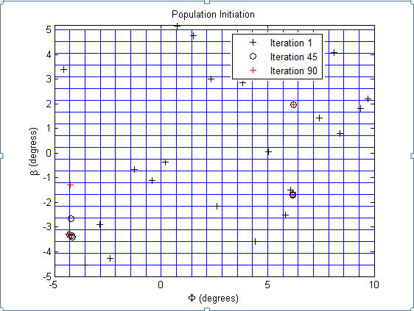

**Figure 4.XX: Particle convergence locations at different iterations.**

****

**Figure 4.XX: Geometrical comparison after deformation at 100K rpm.**

1. **Energy Optimization**

The goal of the high-speed UIFESS is to safely store large quantities of energy while structural integrity. The weakest portion of the rotor is the iron laminations with a yield stress of . The same material layup as Figure 3.XX is used however α = φ = β = 0. Two separate energy PSO functions are used to maximize the stored energy. One uses four independent variables which are the radiuses to the surfaces as shown in Figure 4.XX given an angular velocity. The second uses the same variables as the first with the inclusion of the angular velocity as a design variable. A fixed angular velocity will show the relation between angular velocity and the maximum kinetic energy. Optimization algorithms are formulated for the minimization of a value. In order to maximize a value, the minimization of the negative is used therefore Equation (4.4) becomes [32]:

|  |  |  |
| --- | --- | --- |
|  |  | (4.5) |

The function value of –*f* is the negative of the kinetic energy of the rotor. The constraint values are still positive making *f* larger and therefore a worse location according to the PSO algorithm.

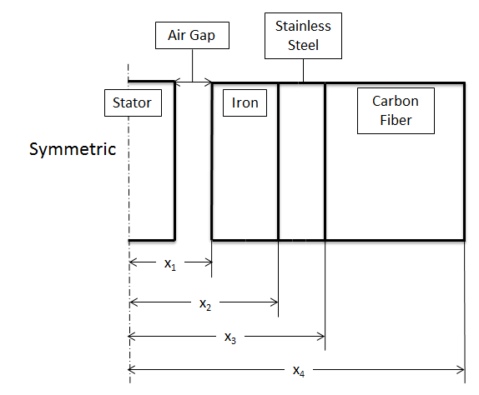

**Figure 4.XX: Independent design variable inputs.**

Each material ring is given a minimum and maximum value for the radial thickness. Initiation for both the four and five variable PSO functions is done using LHS. Multiple dimensions eliminate the possibility of giving a physical representation of the population scatter. For the 2D PSO with a well-defined design space, only 21 particles are needed. The design space for the four and five variable is a function of the thickness of the material layers making it less defined. Adding a constraint that hoop stress in the iron must be less than the yield stress creates a feasible region of the design space that is immensely uncharacterized. For this reason 125 particles are used for the 4D PSO and 151 particles for the 5D PSO. At ω = 35,000 rpm, the feasible region is much smaller and more difficult to find. To remedy this, 201 particles are used to increase the likelihood of a point starting in a feasible region. Subjecting the PSO to the yield constraint forces the PSO from making the flywheel very large and very fast. To increase the rate of convergence, the best, feasible particle is seeded at each iteration.

Implementing the design variables into the model requires that they be in meters for *x1*, *x2*, *x3*, and *x4* and for the 5D case *x5* is in rpm. The model outputs the stress in MPa. Large orders of magnitude between the dimensional inputs, stress, and rpm require scaling the values. Without scaling, the variables will be misrepresented. The dimensional values are scaled such that *x1*, *x2*, *x3*, and *x4* range from zero to one. The stress is scaled by the yield stress, and the angular velocity, ω, is scaled to range from one to ten with actual values ranging from 10,000 rpm to 100,000 rpm. Scaling the kinetic energy by 10-4 allows for proper representation of the penalty and constraints on the objective function value. Having too large a penalty at the first several iterations will force the particles in the PSO to move too far imposing the possibility of moving past the feasible design region.

At a higher angular velocity, the flywheel will need to be smaller to satisfy the stress constraint. Thus there is a tradeoff in the Equation (1.1) between a large moment of inertia, *I*, and the angular velocity ω. Evaluating the 4D PSO in 5K rpm increments results in the comparison of the stored energy and the angular velocity. This is shown in Figure 4.XX.



**Figure 4.XX: Comparison of the maximum energy and RPM (change)**

Energy storage at 35K rpm is smaller as a result the decrease in the rotor’s size. Beyond this point the optimization function is not able to locate a feasible point. The optimum radial values for the maximum energy storage is x = [0.0394 0.0544 0.0608 0.2631] meters at an angular velocity of approximately 32.2K rpm. [Compare size at 40K and 10K]

**Chapter 5. Summary, Conclusion, and Future Work**

1. **Summary**

The University of Idaho has and currently is developing a flywheel energy storage system. The low-speed UIFESS has been designed and a built but has not been fully completed. The completion and testing of the UIFESS will produce a foundation for which the high-speed FESS can be built upon as part of the Steckler Phase III portion of the project. This thesis presents the development of a numerical model that aids in design of the high-speed flywheel.

At high rotational speeds, the induced stresses from the centrifugal forces are significantly high. This model calculates the stress while incorporating the use of both isotropic and anisotropic materials. The isotropic material, such as the iron laminations, is needed for the field regulated reluctance machine. This machine is responsible for both the power input and power output of the FESS. The special case of anisotropy is the orthotropic continuous fiber composite. The use of composite materials increases the specific energy of the system by linearly increasing the mass but exponentially increasing the energy through an increase in size and rotational velocity. The addition of multiple rings into the model is possible if needed for further construction or a deduction in stress discontinuities. The comparison of the model with analytical equations revealed that the stress is calculated within reasonable bounds while the displacement varies as a result of the differences in developmental assumptions.

In addition to the development of the numerical model, two separate optimization functions were developed. One is to minimize the change in displacement for a tapered inner surface and the other is to maximize the kinetic energy of the rotor. Using outputs from the model requires that the optimization method be a heuristic method. Particle Swarm Optimization is the method which was selected. Heuristic methods are used in the absence of the possibility for taking the derivative of a function either symbolically or numerically. Heuristic optimization methods use a searching algorithm to find minimum locations. Wide range of applicability exists with these methods. With application, there is a sacrifice in computation time. Gradient based methods typically produce results in seconds to a few minutes where PSO can take up several minutes to hours to converge to a location.

Minimization of the change in displacement is significant if a taper is required for the flywheel. A tapered surface will be needed if airgap cannot be maintained within reasonable bounds at high rotational speeds. The introduction of such a surface will produce uniform displacement vertically. Minimal change in displacement will insure that more uniform forces can be applied to the rotor. Maximizing the kinetic energy in the rotor is a goal of the project. This optimization will bound the both the rotor size and the maximum angular velocity. Optimizing for the maximum kinetic energy will contribute to a finalization of material selection and parameters. The finalized rotor design will be used in the development of a dynamic model that is required for the control of the rotor. If it is discovered that a constraint is needed for the weight of the flywheel, this will be an easy addition to the optimization codes. The weight limit will depend on the levitation forces that can be produced with the magnetic Halbach array and superconductors.

1. **Conclusion**
2. **Future Work**

The iron laminations and stainless steel caps are the weakest components of the rotor itself. Further research is needed for possible solutions to resolve these issues. Complex geometry of the iron laminations need for the FRRM results stress concentrations. The ideal shape is a simple ring. Similar problems arise for the magnets and stainless steel caps. Stainless steel and the iron laminations have a density that is approximately four times great than the composite material that would be used. This increased density decreases the energy density and increases the stress in the rotor. If the density of the iron laminations was half of the actual value, the hoop stress in the laminations would decrease by approximately 100 MPa according to the model.

This large decrease in stress and density has steered focus to possible replacements. One theory is use of chopped fiber composites. To get magnetic properties need to create a flux path, iron particles could be doped into the composite. An advantage for this, other than reducing weight, is the possibility of having iron deposits in locations needed for the FRRM such as that shown Figure 1.4. Where there is currently an airgap, a composite material with similar properties as the doped area can fill the void. This would result in the ideal ring shape therefore reducing the stress concentrations while maintaining magnetic properties. Using iron particles decrease the effects of eddy current losses; however, it will reduce the amount of torque that can be induced.

Chopped fiber composites are typically used for cheaper, large quantity production. There applications are focused towards lower stress applications do to low strengths. The strengths are largely dependent upon the shear strength of the fiber as shown in Equations (2.15) and (2.16). The bulk production of lower stress applications of chopped fibers has resulted in a lack of well-defined material properties. To determine if this method is feasible from the point of view of the FRRM, a permittivity would be required. This will determine the volume fraction of the iron particles that would be needed. Mechanically, test specimens would need to be created and tested to determine strength, repeatability, and physical properties such the modulus. If the strength of this three material composite can come close to matching that of the iron laminations, it would be largely beneficial in decreasing stresses and increasing energy density. A reasonable strength chopped composite could replace the stainless steel magnetic ring as well.