Tyler Larson

Tmlarson94@gmail.com or Lars9996@vandals.uidaho.edu

Abstract

This is a general user guide on how to run the code that was produced for testing the flywheel and accompanying hardware during the summer term 2017.

Code Composer Tutorial

Importing and general code operation

Contents

Importing 2

Properties Configuration 11

Running 20

# Importing

* Click on “File”, hover over “New”, then click on “CSS Project”

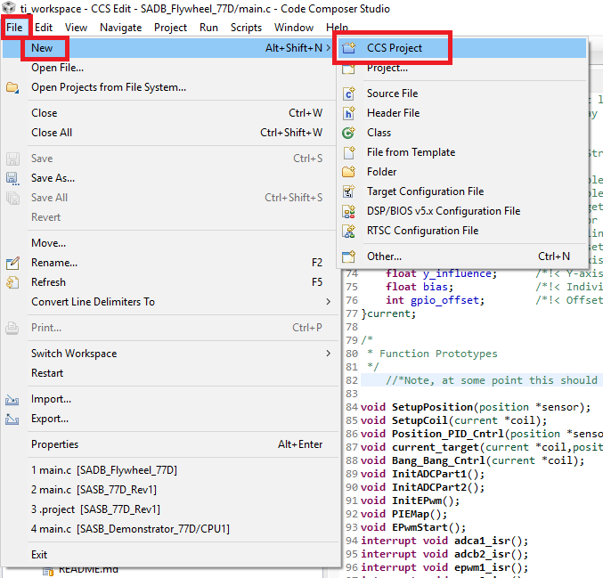

* Next click on the Dropdown by “Target”, and select “2837xD Delfino”

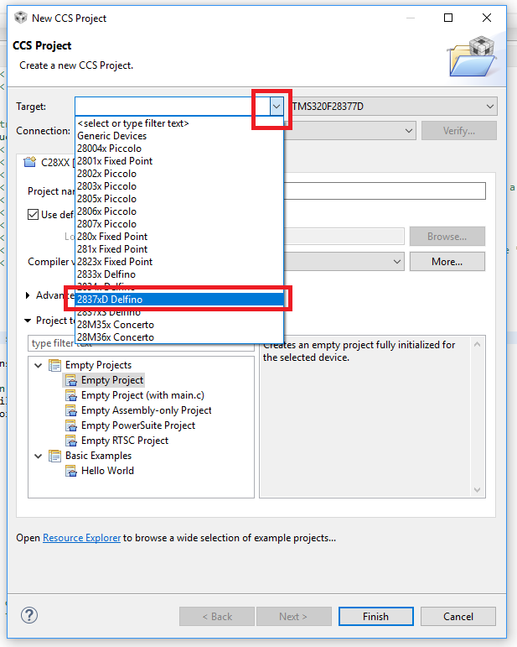

* After it is selected, the next dropdown automatically opens. Select “TMS320F28377D”

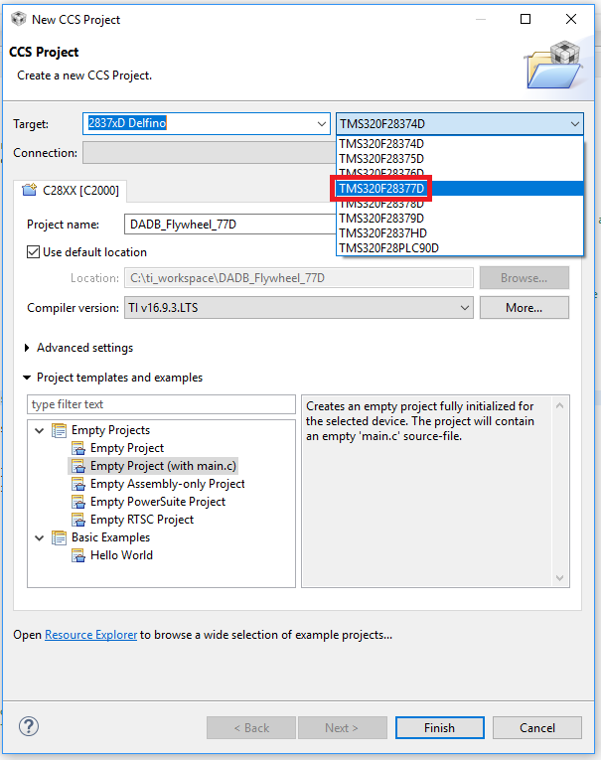

* Next make a name for the project and select a location to save it

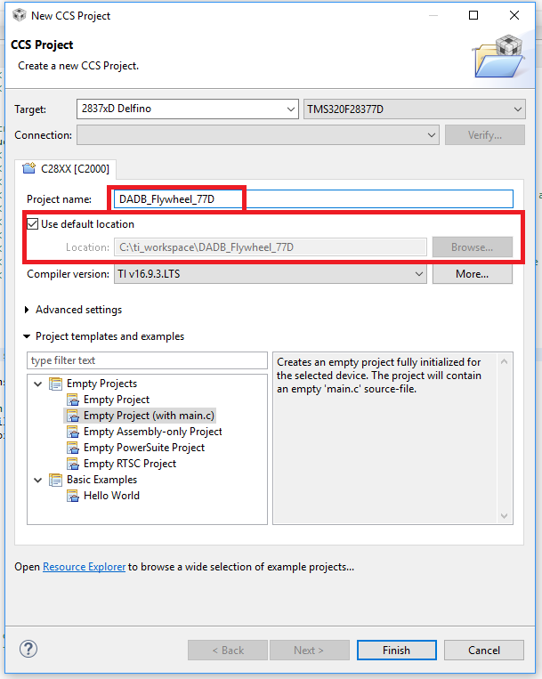

* Lastly select “Empty Project”, then click “Finish”

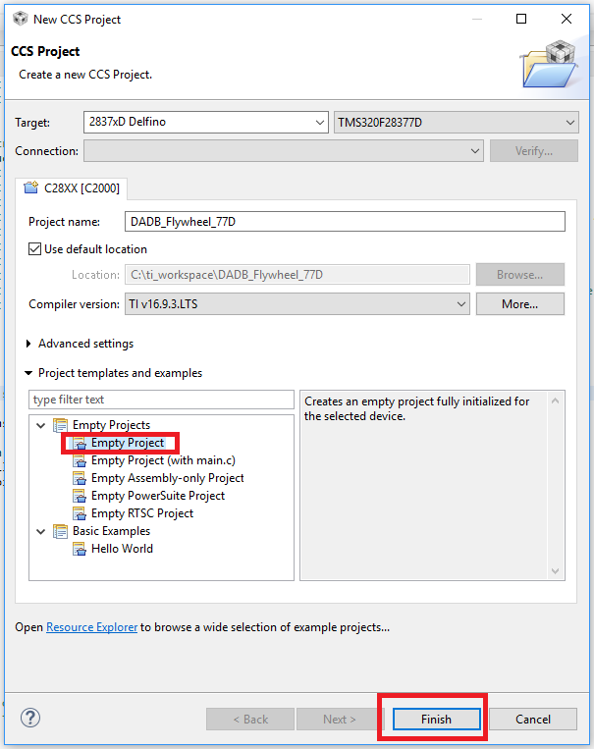

* Now right click on the new project and select “Add Files…”

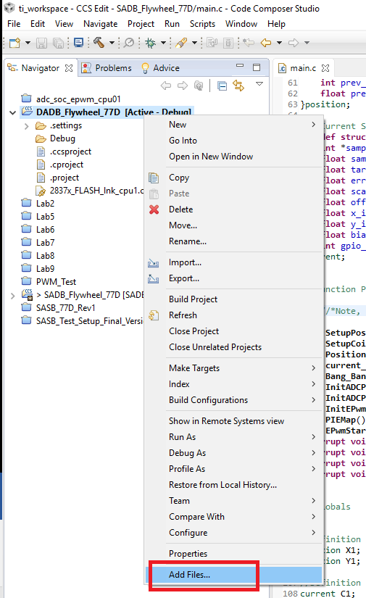

* Select the files shown in the image below and select “Open”

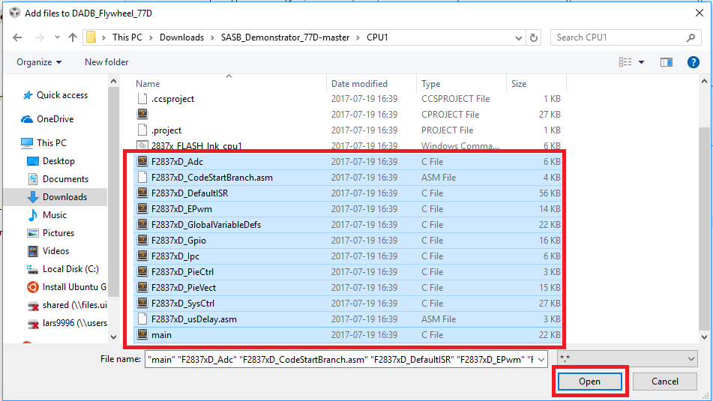

* Make sure that “Copy files” is selected, then press “OK”

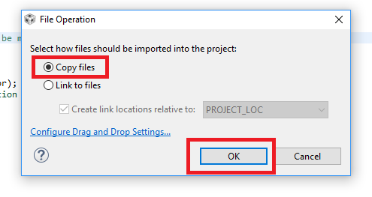

* The last step is to delete the “2837x_FLASH_lnk_cpu1.cmd” file from the resource list

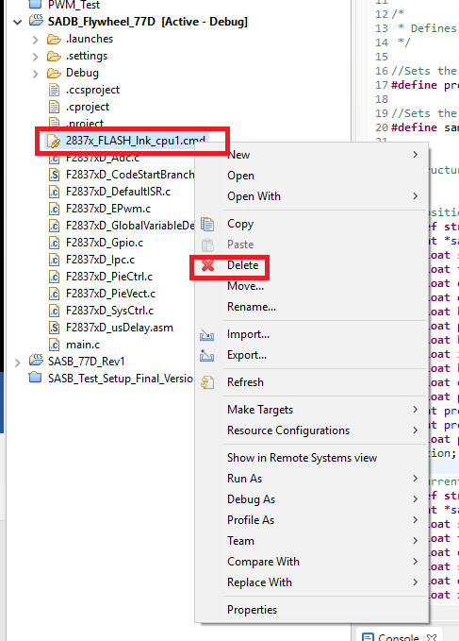

# Properties Configuration

* Right click on the project and select “Properties”, to open the properties window

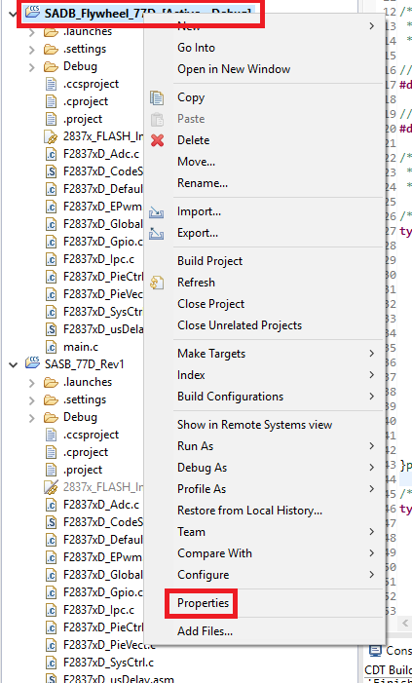

* In the left pane select “General”
  + In the right pane under the tab main, click on the drop down menu by “Linker command file:”
    - At the top of this list select “<none>”

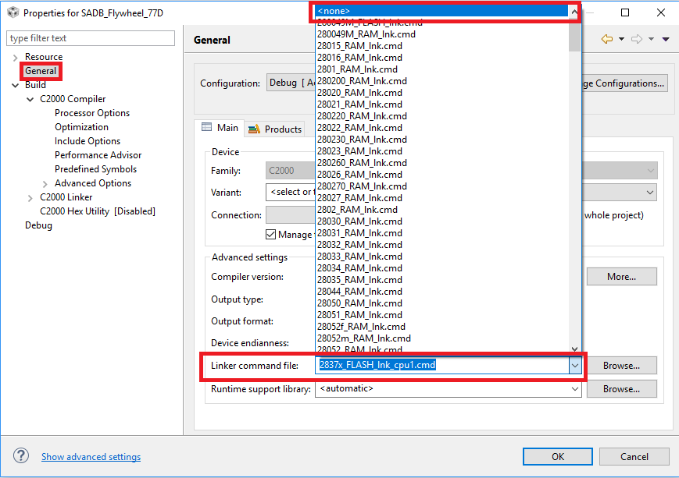

* Back in the left pane expand “Build” then under that expand “C2000 Compiler” then click on “Include Options”
  + In the top right pane titled “Add dir to…”, click the add to add these two paths separately
    - "C:\ti\controlSUITE\device_support\F2837xD\v210\F2837xD_common\include"
    - "C:\ti\controlSUITE\device_support\F2837xD\v210\F2837xD_headers\include"

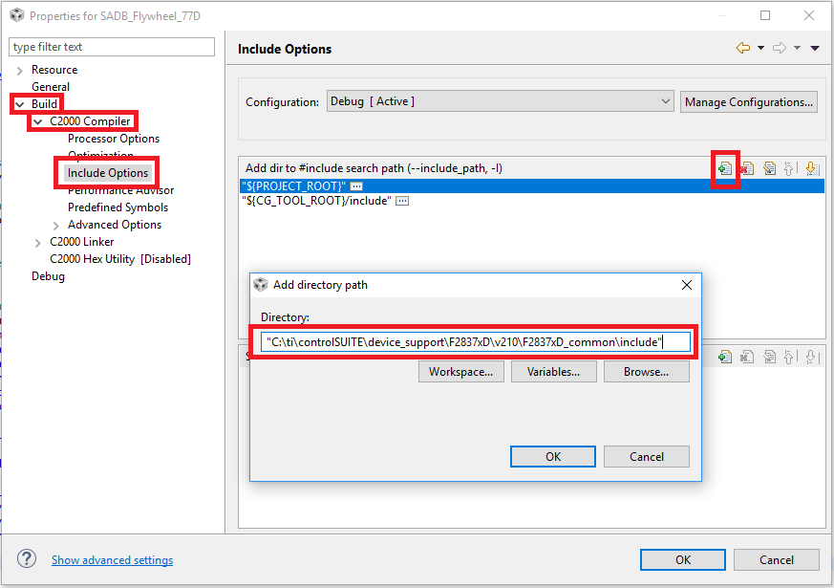

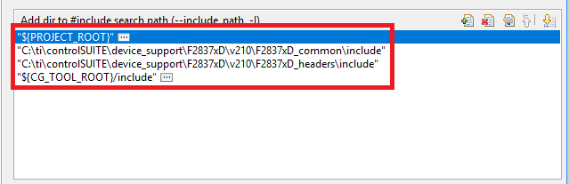

* Back in the left pane below “Include Options”, click on “Predefined Symbols”
  + In the top right window titled “Pre-define NAM…”, click on the add to add this name
    - CPU1

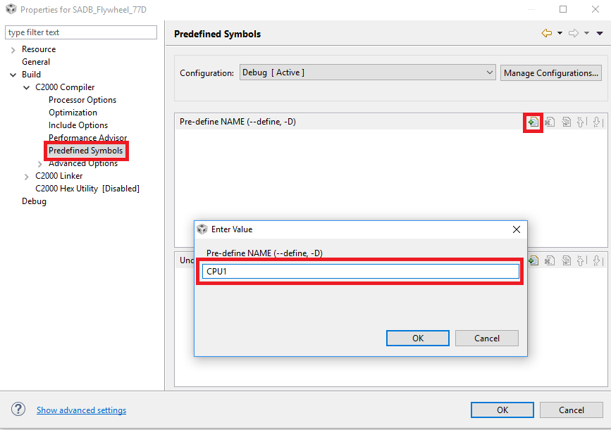

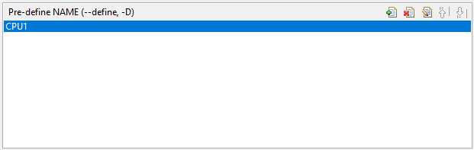

* Back in the left pane, in “Build”, below “C2000 Compiler”, expand “C2000 Linker”. Then select “File Search Path”
  + In the top right pane titled “Include library file or…”, click on the add to add these three paths (*you will have to add them one at a time)
    - "C:\ti\controlSUITE\device_support\F2837xD\v210\F2837xD_common\cmd\2837xD_RAM_lnk_cpu1.cmd"
    - "C:\ti\controlSUITE\device_support\F2837xD\v210\F2837xD_headers\cmd\F2837xD_Headers_nonBIOS_cpu1.cmd"
    - "C:\ti\ccsv7\tools\compiler\ti-cgt-c2000_16.9.3.LTS\lib\rts2800_fpu32.lib"

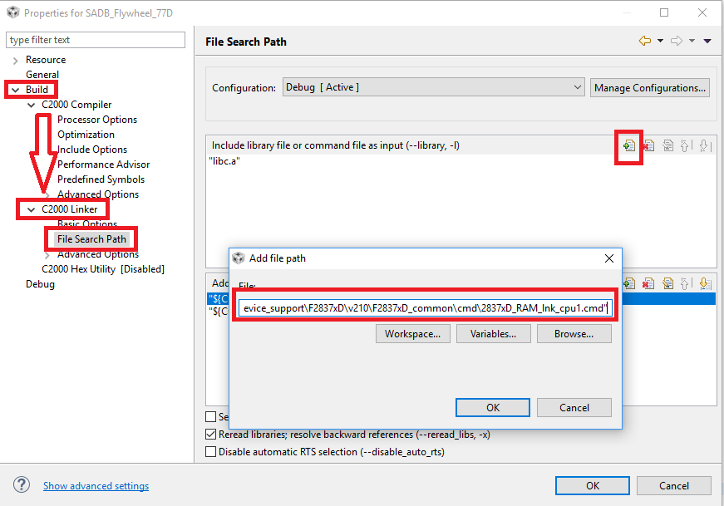

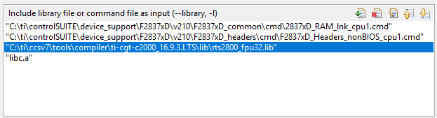

* + In this same pane select the line “libc.a” and delete it with the red x in the top right

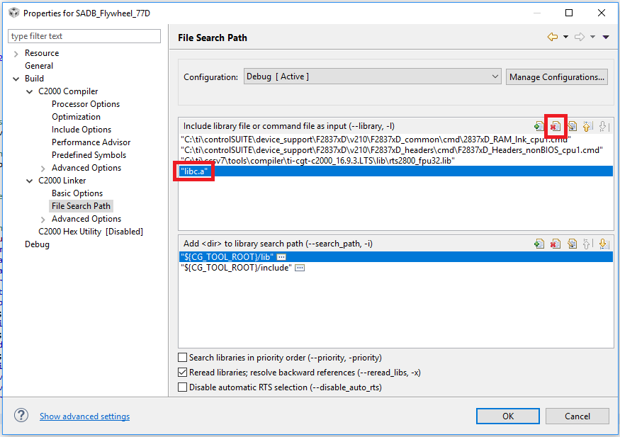

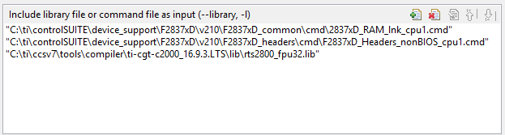

* + In the lower right pane titled “Add <dir> to…” click on the add to add these paths
    - "C:\ti\controlSUITE\device_support\F2837xD\v210\F2837xD_common\cmd"
    - "C:\ti\controlSUITE\device_support\F2837xD\v210\F2837xD_headers\cmd"

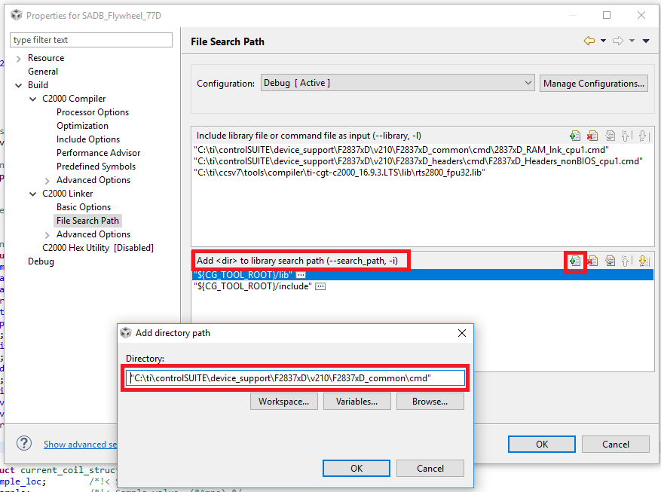

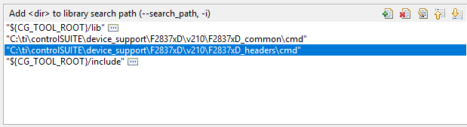

* Back in the left pane below “File Search Path”, expand “Advanced Options” and click on “Symbol Management”
  + Near the top of the right side of the window is a text entry box, in which type
    - code_start

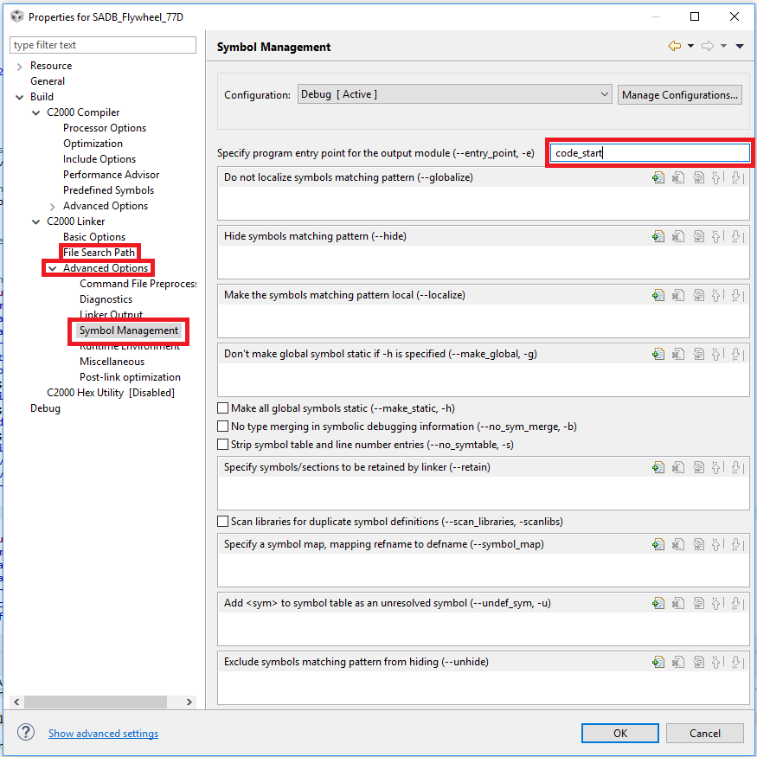

* At this point all the necessary changes have been made to the properties. Click the “OK” at the bottom of the window to close.

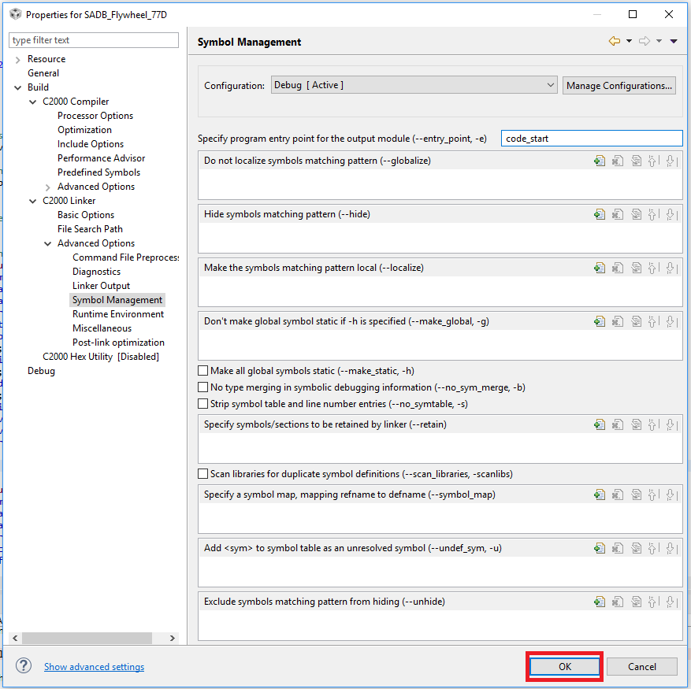

# Running

* At this point click on the image of the hammer to build
  + There should only be one warning and no errors, and the one warning is fine

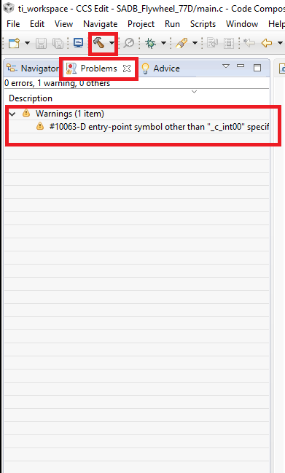

* Next click on the green bug to debug the program (same as running the program, but we get a few more options to change settings while the setup is running)

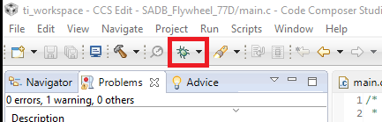

* After clicking on the debug button, a window will pop up
  + Uncheck the box for CPU2 and press OK

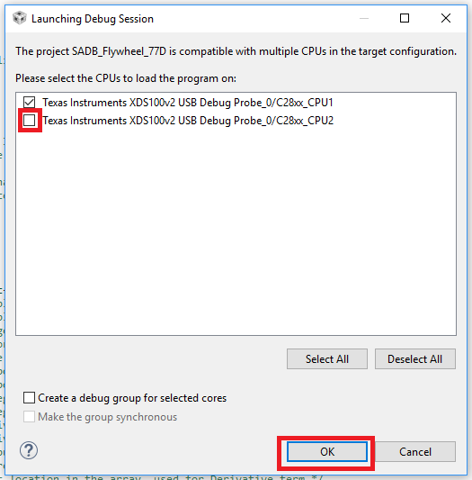

* Another prompt will come up asking if you want to reuse the debug settings previously set, click yes

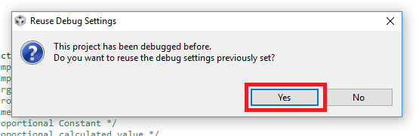

* Assuming all has gone well up until this point, a little arrow will appear next to the first line of the main() function, indicating that it is paused at this point in the code

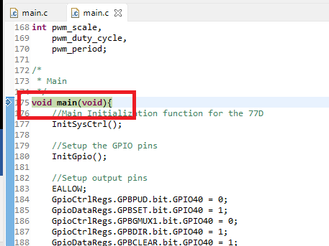

* From here we can begin the code by clicking on the green arrow to run

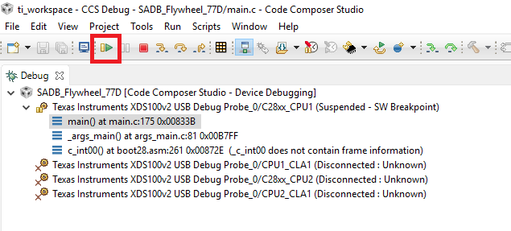

* While the code is running one can pause the code by pressing the yellow pause, or quit back to the code editing view by clicking on red square

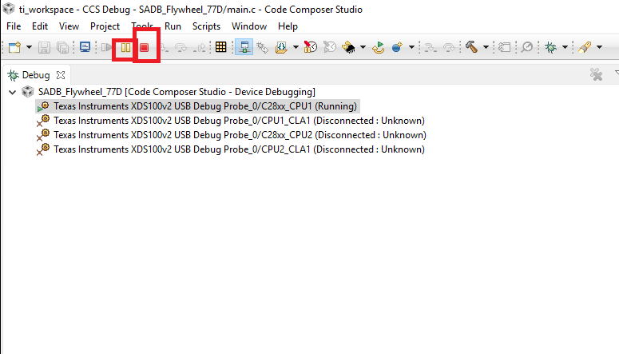

* Additionally, in the top right pane of the window is a list of some of the variables in use in the code at the moment. By clicking on the yellow pause/refresh sign in the top bar, the values will update to show what they currently are.

