we will learn how to handle DropDown in Selenium and Multiple Select Operations.

**Select Class in Selenium**

The **Select Class in Selenium** is a method used to implement the HTML SELECT tag. The html select tag provides helper methods to select and deselect the elements. The Select class is an ordinary class so New keyword is used to create its object and it specifies the web element location.

**Select Option from Drop-Down Box**

Following is a step by step process on how to select value from dropdown in Selenium:

Before handling dropdown in Selenium and controlling drop-down boxes, we must do following two things:

1. Import the package **org.openqa.selenium.support.ui.Select**
2. Instantiate the drop-down box as an object, Select in Selenium WebDriver

As an example, go to Mercury Tours’ Registration page (http://demo.guru99.com/test/newtours/register.php) and notice the “Country” drop-down box there.

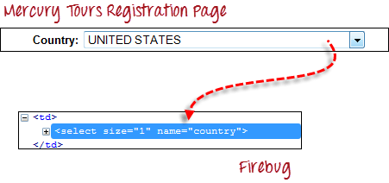

**Step 1**

Import the “Select” package.

How to Select Option from DropDown using Selenium Webdriver

Learn Java Programming with Beginners Tutorial

**Step 2**

Declare the drop-down element as an instance of the Select class. In the example below, we named this instance as “drpCountry”.

How to Select Option from DropDown using Selenium Webdriver

**Step 3**

We can now start controlling “drpCountry” by using any of the available Select methods to select dropdown in Selenium. The sample code below will select the option “ANTARCTICA.”

How to Select Option from DropDown using Selenium Webdriver

**Selecting Items in a Multiple SELECT elements**

We can also use the **selectByVisibleText()** method in selecting multiple options in a multi SELECT element. As an example, we will take <https://jsbin.com/osebed/2> as the base URL. It contains a drop-down box that allows multiple selections at a time.

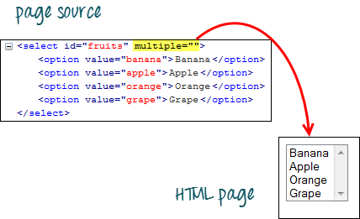

The code below will select the first two options using the selectByVisibleText() method.

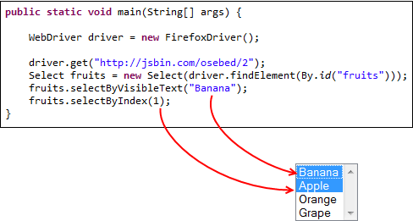

**Select Methods**

The following are the most common methods used on Selenium dropdown list.

|  |  |
| --- | --- |
| **Method** | **Description** |
| **selectByVisibleText()**and **deselectByVisibleText()**  *Example:*  How to Select Option from DropDown using Selenium Webdriver | * Selects/deselects the option that displays the text matching the parameter. * **Parameter**: The exactly displayed text of a particular option |
| **selectByValue()** and **deselectByValue()**  *Example:*  How to Select Option from DropDown using Selenium Webdriver | * Selects/deselects the option whose “value” attribute matches the specified parameter. * **Parameter**: value of the “value” attribute * Remember that not all drop-down options have the same text and “value”, like in the example below.   How to Select Option from DropDown using Selenium Webdriver |
| **selectByIndex()** and **deselectByIndex()**  *Example:*  How to Select Option from DropDown using Selenium Webdriver | * Selects/deselects the option at the given index. * **Parameter**: the index of the option to be selected. |
| **isMultiple()**  *Example:*  *How to Select Option from DropDown using Selenium Webdriver* | * Returns TRUE if the drop-down element allows multiple selections at a time; FALSE if otherwise. * **No parameters needed** |
| **deselectAll()**  *Example:*  *How to Select Option from DropDown using Selenium Webdriver* | * Clears all selected entries. This is only valid when the drop-down element supports multiple selections. * **No parameters needed** |

**Here is the complete code**

package newpackage;

import org.openqa.selenium.WebDriver;

import org.openqa.selenium.firefox.FirefoxDriver;

import org.openqa.selenium.support.ui.Select;

import org.openqa.selenium.By;

public class accessDropDown {

public static void main(String[] args) {

System.setProperty("webdriver.gecko.driver","C:\\geckodriver.exe");

String baseURL = "http://demo.guru99.com/test/newtours/register.php";

WebDriver driver = new FirefoxDriver();

driver.get(baseURL);

Select drpCountry = new Select(driver.findElement(By.name("country")));

drpCountry.selectByVisibleText("ANTARCTICA");

//Selecting Items in a Multiple SELECT elements

driver.get("http://jsbin.com/osebed/2");

Select fruits = new Select(driver.findElement(By.id("fruits")));

fruits.selectByVisibleText("Banana");

fruits.selectByIndex(1);

}

}