This document is outlining the details about setup mifosx database
- Install Workbench
- Mac
- https://dev.mysql.com/doc/workbench/en/wb-installing-mac.html
- For other OS
- http://dev.mysql.com/downloads/workbench/
- Open workbench and Click on "+" sign
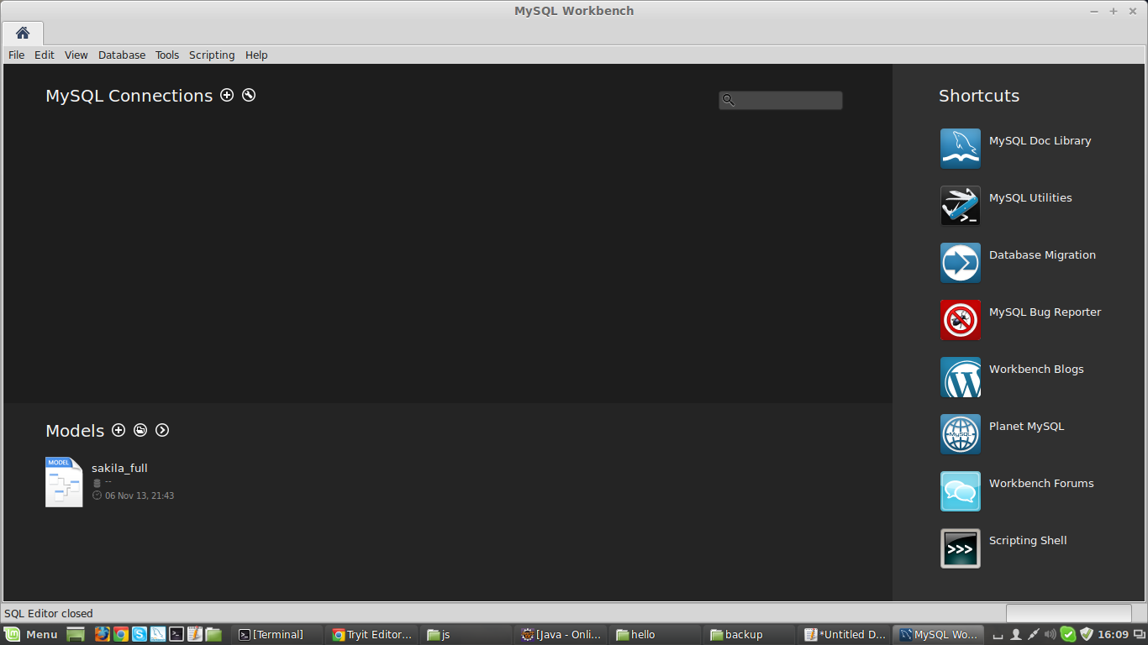
- Setup new connection with appropriate parameters
- For example, to connect mysql on localhost
  - Connection name = localhost
  - hostname="127.0.0.1"
  - Username=root(username of mysql on the "127.0.0.1" i.e. localhost)
- Click on Test Connection
- Enter your mysql password root(password of mysql on the "127.0.0.1" i.e. localhost) and click ok
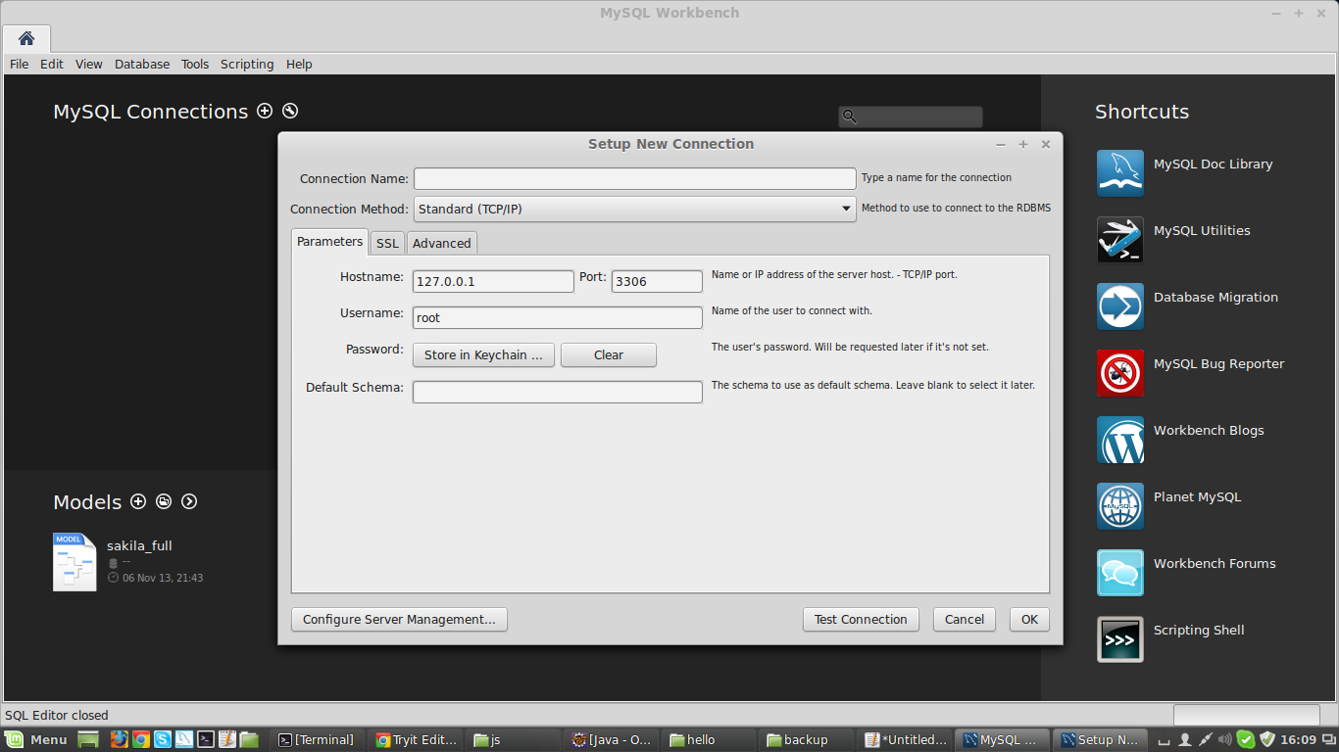
- Click on the connection (Here it is localhost)
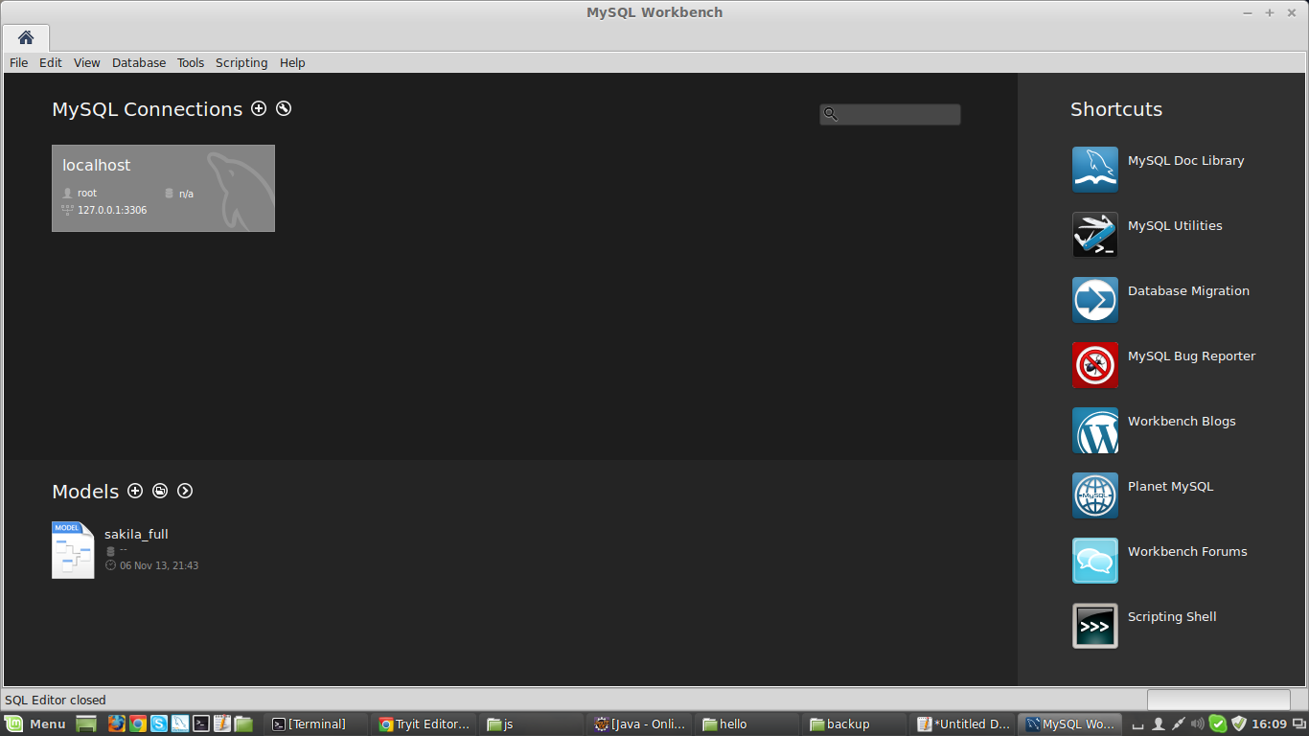
- Select "Database Import/Restore"
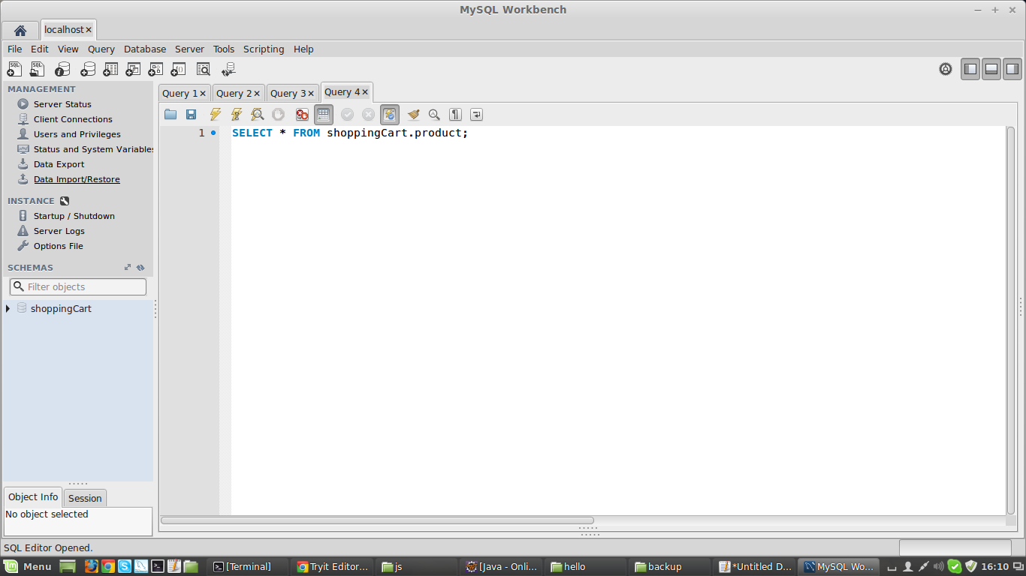

- Select file from "~/MIFOSX/mifosng-db/Mifos_Finemsys/2014_11_03.sql"
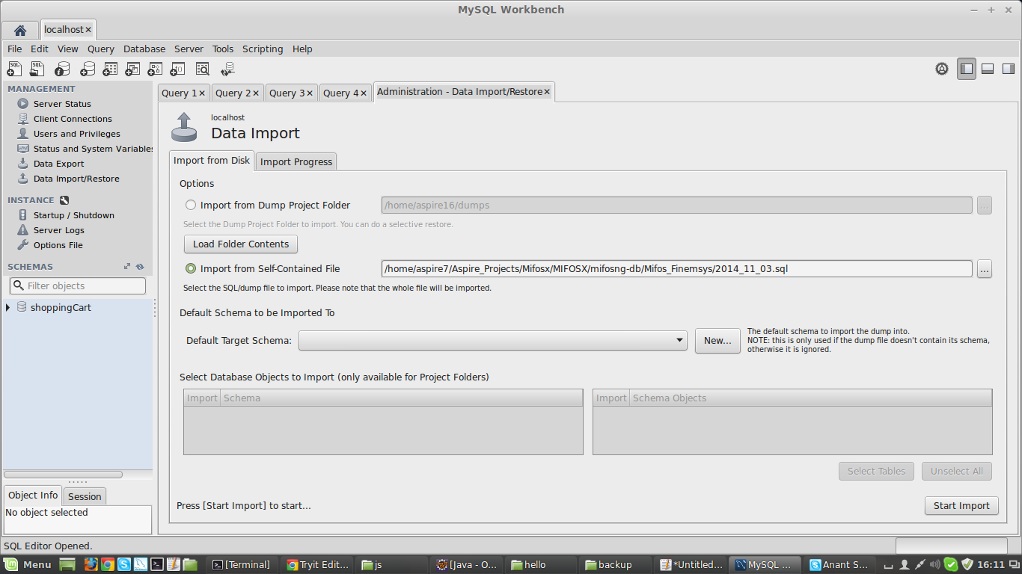
- Click on import (It may take few minutes)

- Refresh on the left panal below search icon
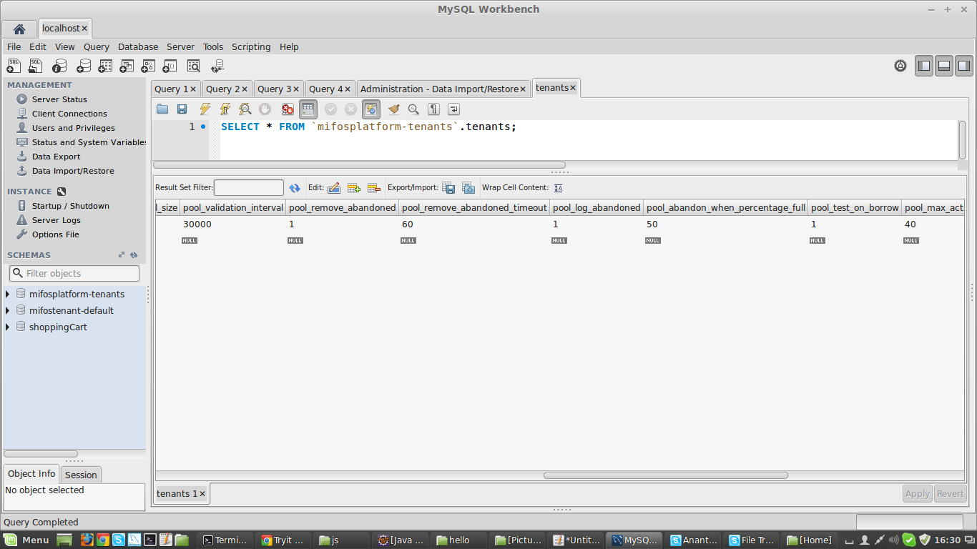
- Following parameters into "tenanants" table from mifosplatform-tenants database according to current database parameters.(Currently it is pointing to the amazon server database)
  - schema_server
  - schema_password
  - schema_username

- For localhost above parameters will be
  - localhost
  - root(username of mysql on the "127.0.0.1" i.e. localhost)
  - root(password of mysql on the "127.0.0.1" i.e. localhost)

