**Notch types**: Moclán and Domínguez-Rodrigo 2018

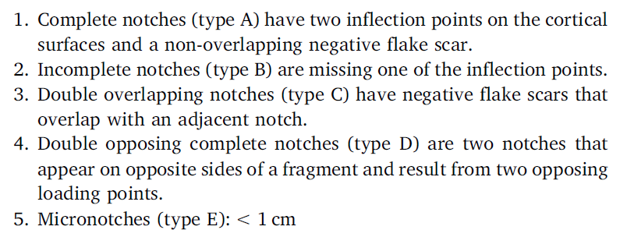

**Hot and Cold Zones** (Domínguez-Rodrigo et al. 2007, Deconstructing Olduvai)

*Maasai Mara*

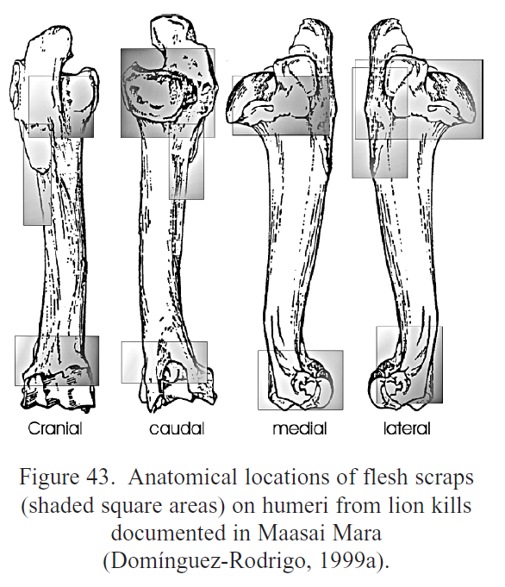 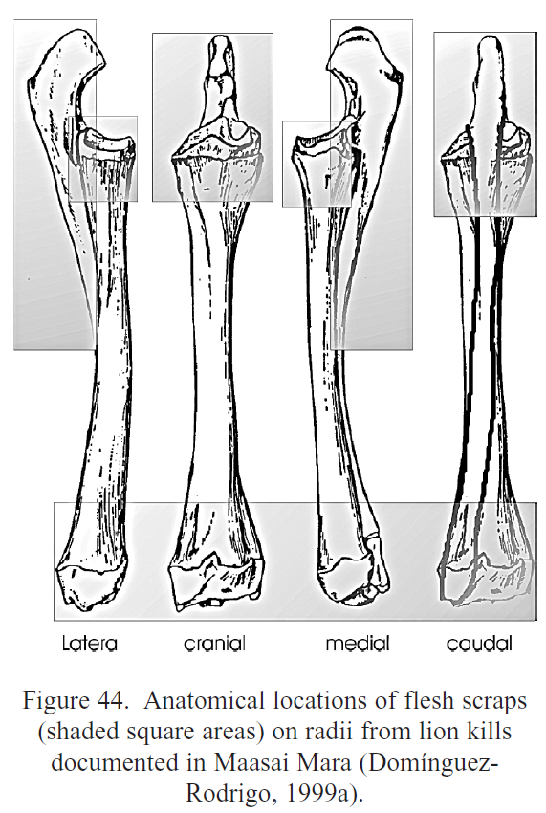

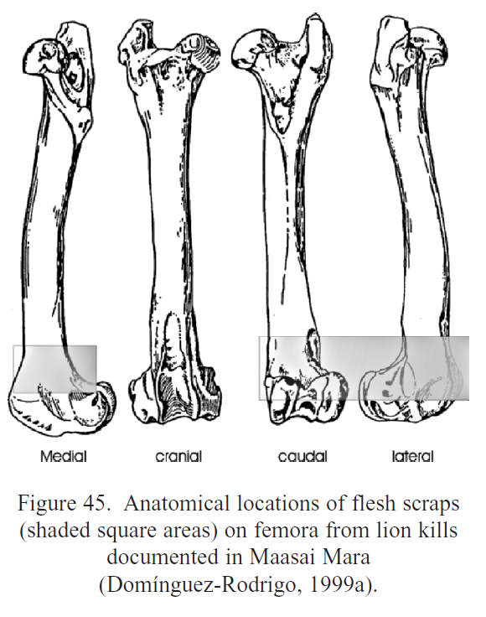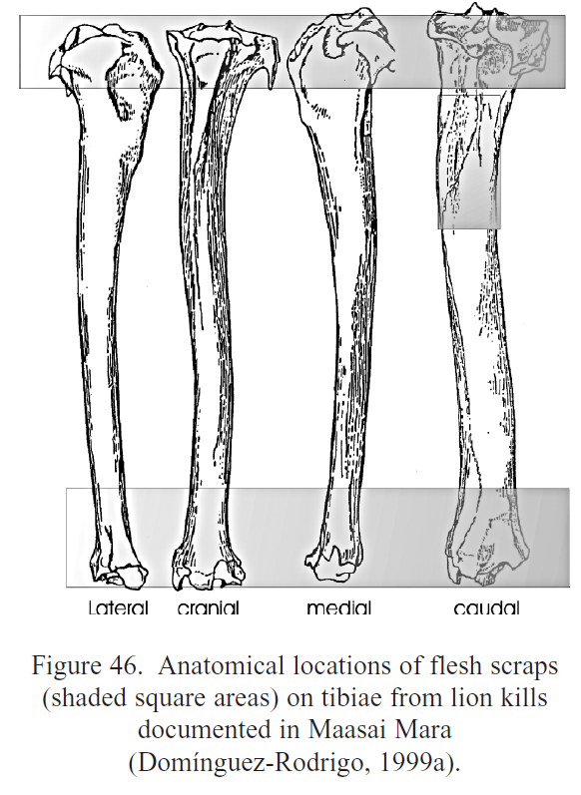

*Galana and Kulalu*

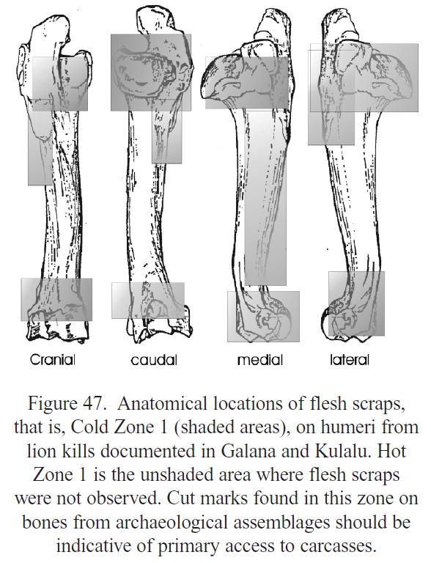 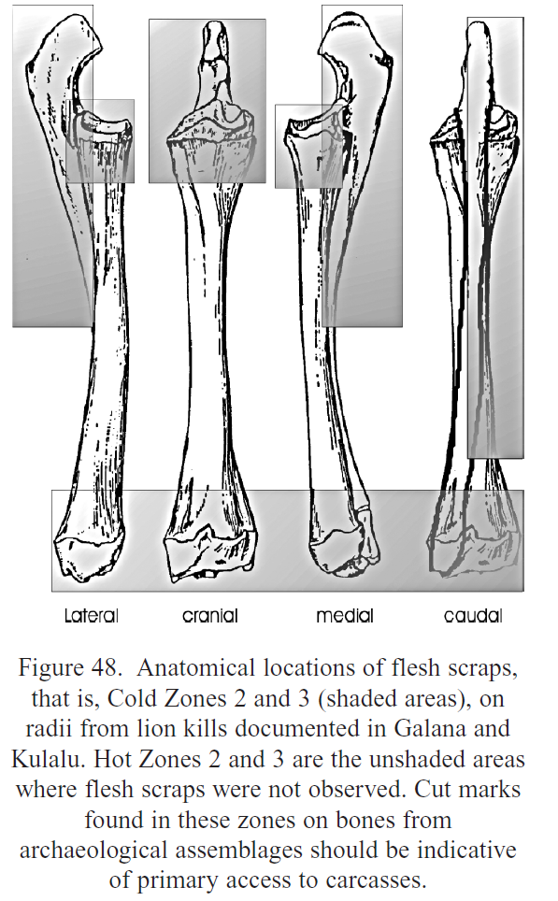

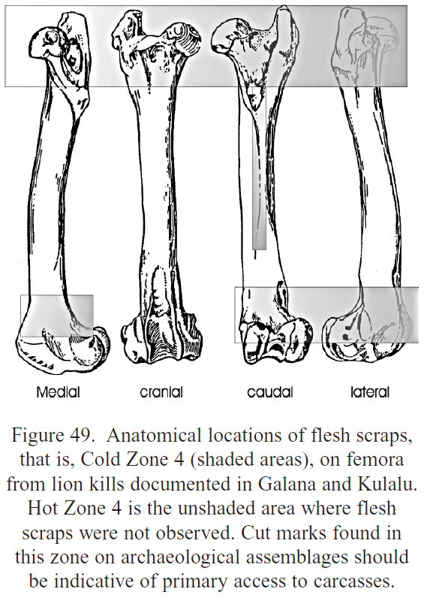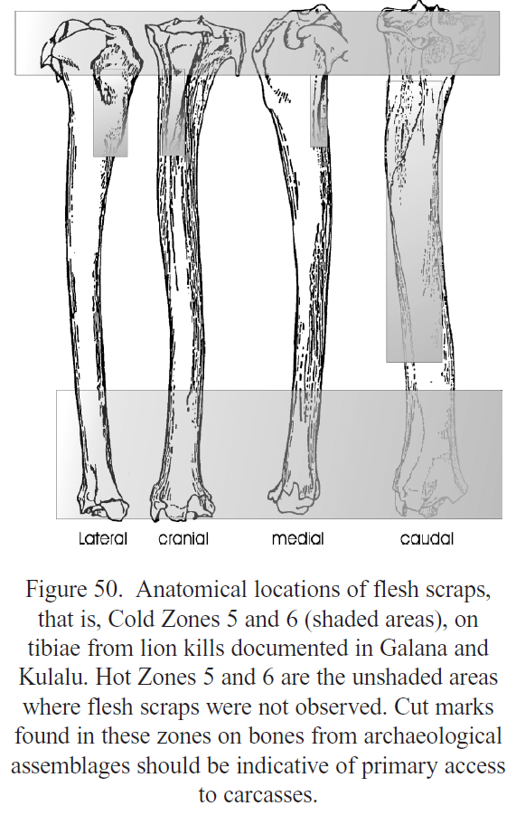

**Taphotypes** (Domínguez-Rodrigo et al. 2015)

*Classification System I*

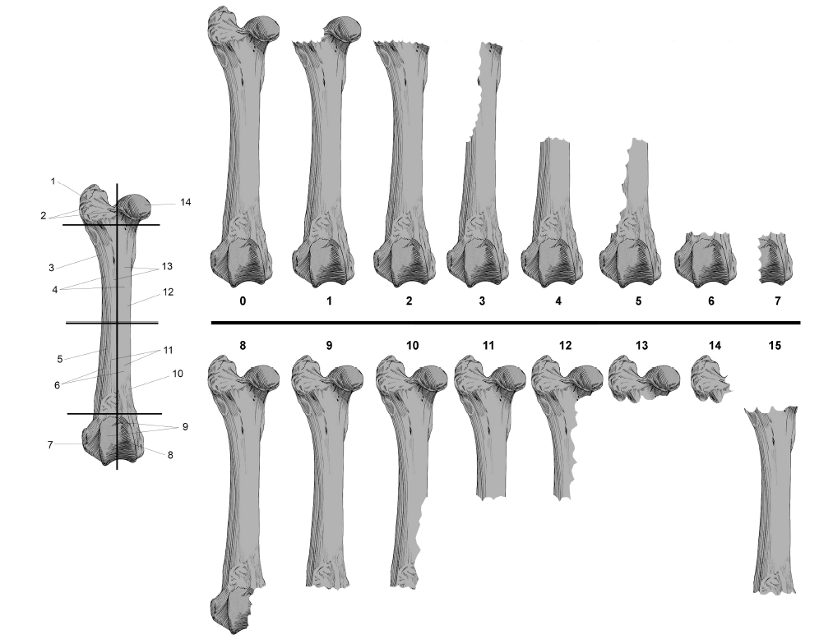

*Classification System II*

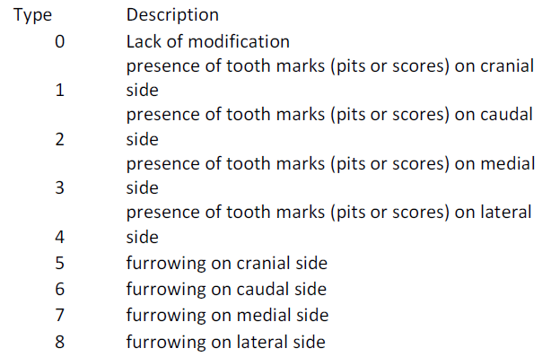

**Bone portions**

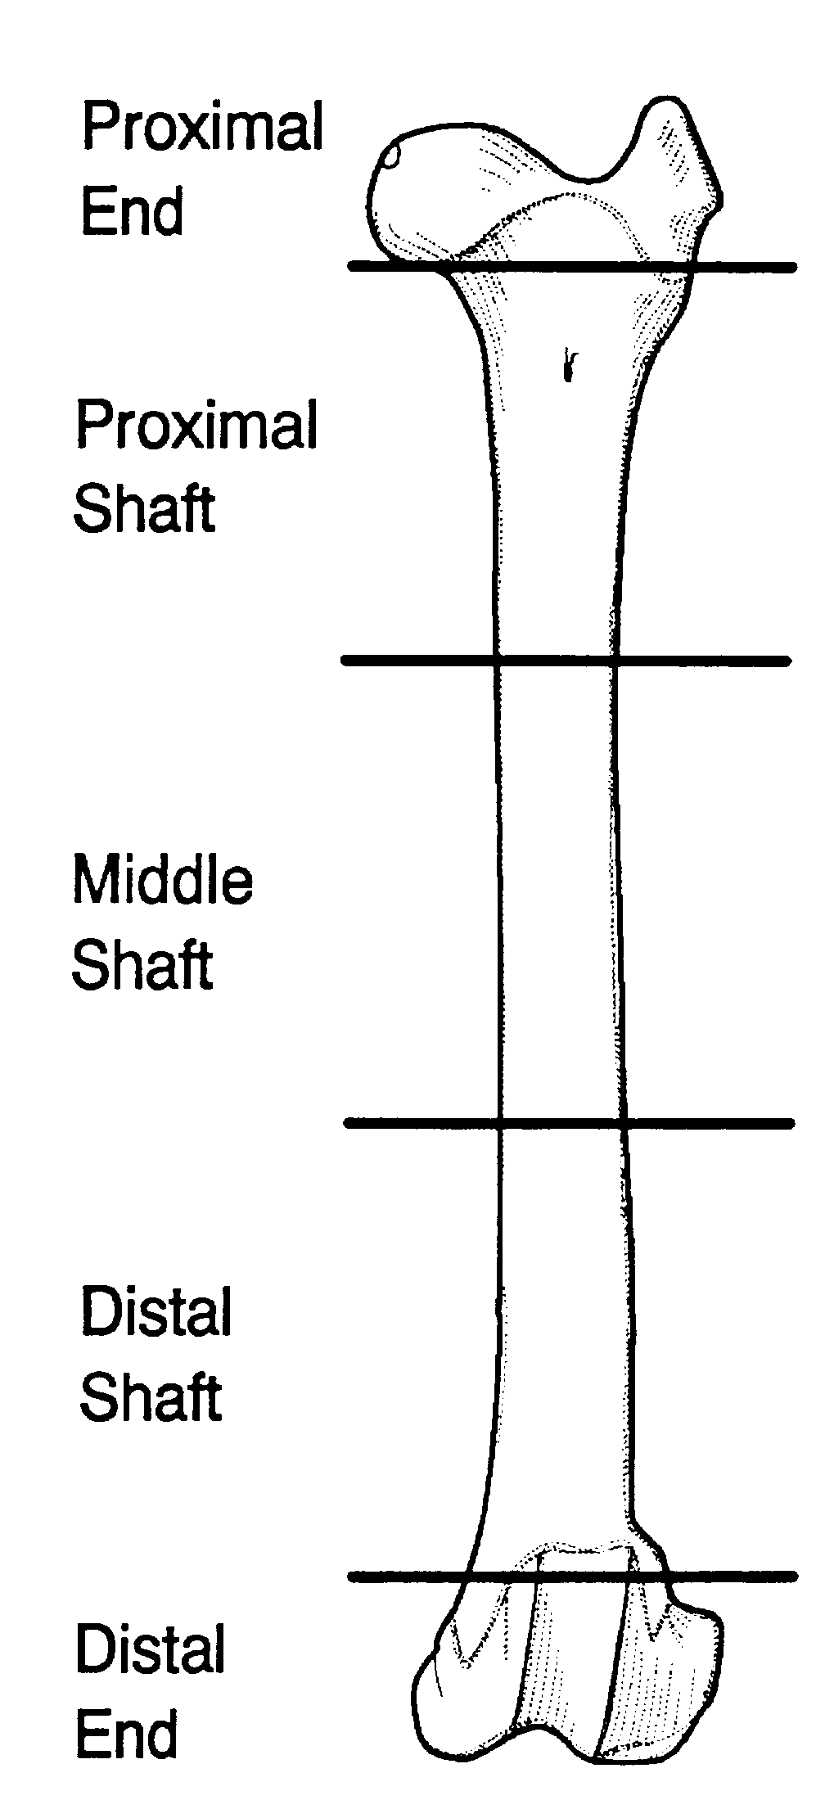

**Capaldo and Blumenschine** (1994) considered the length and the depth of the notches, as well as the medular ratio and the angle (the closer to 90 the least likely the notch was created by an impact. Humans tend to produce more acute angles).

 

* **Complete notch A: the notch is complete, we see the beginning and the end (we see two inflection points on the cortical surface and negative flake scars on the medullary surface)**
* **Incomplete notch: we only have one inflection point, the other is missing because of overlapping or truncation by a fracture edge**
* **Incomplete type B**
* **Incomplete type C notch or overlapping notch: two incomplete notches overlapping (this appears when carnivores alter the bones with their teeth)**
* **Type D notch or double opposing notches: when notches are opposing (no matter if they’re complete or not) (it may be produced by carnivores or could happen when we put the bone on a hard surface and then we hit it)**

**The notches of carnivores are smaller and deeper, and impacts create longer and shallower notches,** so we can differentiate static and dynamic loading (carnivore notches more closely approach a semicircular plan form). This difference is seen in the ratio of notch breadth to maximum notch depth. **Release angles for flakes removed from percussion notches are more obtuse than those removed from carnivore notches, which are closer to perpendicular.**

**Dynamic loading fractures bone conchoidally, producing many of the same fracture features seen on flaked-stone artifacts. In fact, notch production with a hammerstone seems to be closely akin mechanically to hard-hammer percussion flaking of stone. Bone-gnawing carnivores, on the other hand, break bone by statically loading it between their upper and lower jaws**

When you combine the single notches and overlapping notches (creating a ratio) we see humans create way more single notches than overlapping notches, but carnivores create more overlapping notches. We need to consider also the angle.