Source Data Mapping Approach to CDMV5.3.1

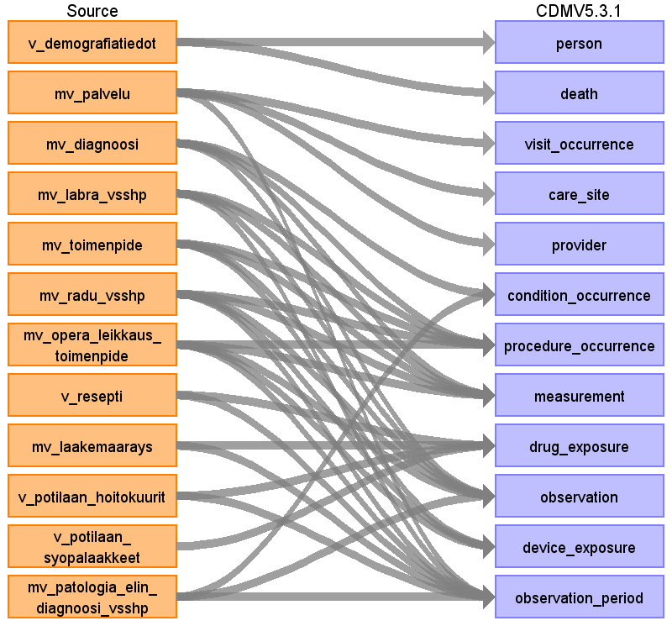

Table name: person

Reading from v_demografiatiedot

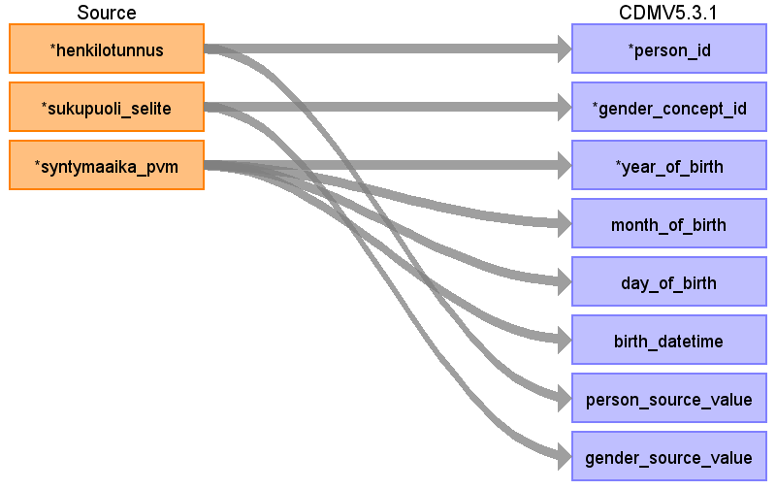

|  |  |  |  |
| --- | --- | --- | --- |
| Destination Field | Source Field | Logic | Comment |
| person_id | henkilotunnus | Henkilotunnus will be converted to person_id using link table link_henkilotunnus_to_pseudonym_to_person_id. |  |
| gender_concept_id | sukupuoli_selite | NAINEN = 8532 FEMALE  MIES = 8507 MALE  EI TIETOA/TUNTEMATON/MÄÄRITTELEMÄTTÄ = 8551 |  |
| year_of_birth | syntymaaika_pvm |  |  |
| month_of_birth | syntymaaika_pvm |  |  |
| day_of_birth | syntymaaika_pvm |  |  |
| birth_datetime | syntymaaika_pvm | " If time of birth is not given use midnight (00:00:0000)" |  |
| race_concept_id |  |  |  |
| ethnicity_concept_id |  |  |  |
| location_id |  |  |  |
| provider_id |  |  |  |
| care_site_id |  |  |  |
| person_source_value | henkilotunnus | This field will be filled with the pseudonymized primary henkilotunnus of the person. Henkilotunnus = the Finnish social security number. The person may have had one or more temporary henkilotunnus values in history. All these will be entered into a link table link_henkilotunnus_to_pseudonym_to_person_id. Link table will contain all henkilotunnus, their corresponding valid henkilotunnus, pseydonym of the valid henkilotunnus and person_id. |  |
| gender_source_value | sukupuoli_selite |  |  |
| gender_source_concept_id |  |  |  |
| race_source_value |  |  |  |
| race_source_concept_id |  |  |  |
| ethnicity_source_value |  |  |  |
| ethnicity_source_concept_id |  |  |  |

Table name: death

Reading from v_demografiatiedot

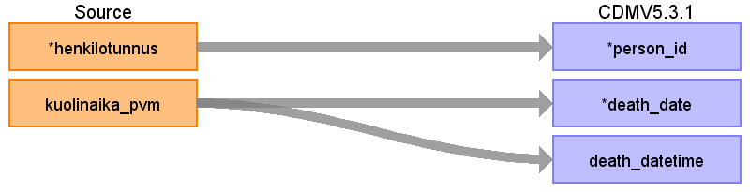

|  |  |  |  |
| --- | --- | --- | --- |
| Destination Field | Source Field | Logic | Comment |
| person_id | henkilotunnus |  |  |
| death_date | kuolinaika_pvm |  |  |
| death_datetime | kuolinaika_pvm |  | Supplemented with default time portion "00:00:00" |
| death_type_concept_id |  |  | 256 EHR Record underlying cause of death |
| cause_concept_id |  |  | Cause of death is not part of our data |
| cause_source_value |  |  |  |
| cause_source_concept_id |  |  |  |

Table name: visit_occurrence

Reading from mv_palvelu

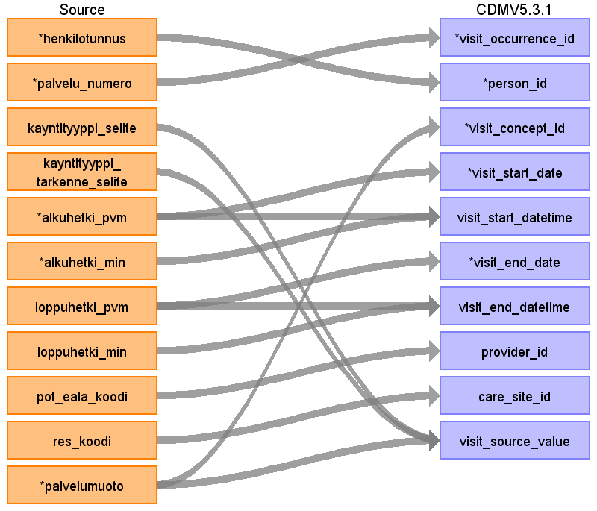

|  |  |  |  |
| --- | --- | --- | --- |
| Destination Field | Source Field | Logic | Comment |
| visit_occurrence_id | palvelu_numero | Palvelu_numero is the primary key of visit in source data. It will be converted to visit_occurrence_id using link table link_palvelu_numero_to_visit_occurrence_id. |  |
| person_id | henkilotunnus | Henkilotunnus will be converted to person_id using link table link_henkilotunnus_to_pseudonym_to_person_id. |  |
| visit_concept_id | palvelumuoto | kaynti = outpatient-type visit  osastohoito = inpatient-type visit  We abandoned the fields kayntityyppi_selite and kayntityyppi_tarkenne_selite for now. They provide more detailed information about the type of the visit. For future development, for rows where palvelumuoto = kaynti, we could find a more specific visit type by using the combination of kayntityyppi_selite and kayntityyppi_tarkenne_selite. | - inpatient-type visit visit_conept_id = 9201  - outpatient-type visit visit_conept_id = 9202. |
| visit_start_date | alkuhetki_pvm |  |  |
| visit_start_datetime | alkuhetki_pvm  alkuhetki_min |  |  |
| visit_end_date | loppuhetki_pvm |  |  |
| visit_end_datetime | loppuhetki_pvm  loppuhetki_min |  |  |
| visit_type_concept_id |  |  | 32817 EHR |
| provider_id | pot_eala_koodi | Using link table link_pot_eala_to_provider_id |  |
| care_site_id | res_koodi | Using link table link_toimipiste_vastuualue_pot_eala_to_care_site_id |  |
| visit_source_value | kayntityyppi_selite  kayntityyppi_tarkenne_selite  palvelumuoto |  | Concatination of palvelumuoto + kayntityyppi_selite + kayntityyppi_tarkenne_selite. |
| visit_source_concept_id |  |  |  |
| admitting_source_concept_id |  |  |  |
| admitting_source_value |  |  |  |
| discharge_to_concept_id |  |  |  |
| discharge_to_source_value |  |  |  |
| preceding_visit_occurrence_id |  |  |  |

Table name: care_site

Reading from mv_palvelu

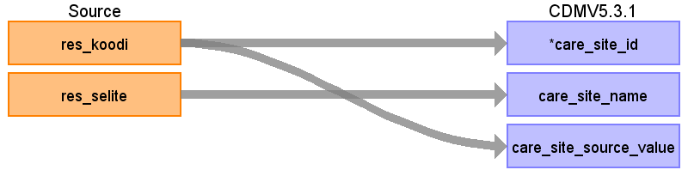

|  |  |  |  |
| --- | --- | --- | --- |
| Destination Field | Source Field | Logic | Comment |
| care_site_id | res_koodi | Each unique res_koodi (toimipiste or vastuualue) in source data maps to one care site, using link table link_toimipiste_vastuualue_pot_eala_to_case_site_id. |  |
| care_site_name | res_selite | The res_selite as it is |  |
| place_of_service_concept_id |  |  |  |
| location_id |  |  |  |
| care_site_source_value | res_koodi | The res_koodi as it is |  |
| place_of_service_source_value |  |  |  |

Table name: provider

Reading from mv_palvelu

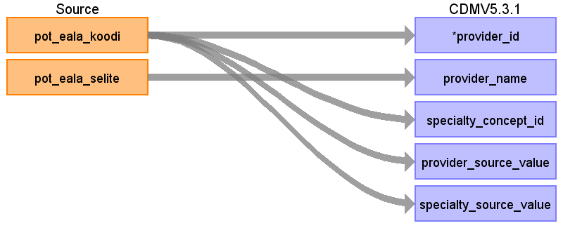

|  |  |  |  |
| --- | --- | --- | --- |
| Destination Field | Source Field | Logic | Comment |
| provider_id | pot_eala_koodi | Each unique pot_eala_koodi i.e. medical specialty will appear as one row in the provider table, using link table link_pot_eala_to_provider_id. Person-level data of doctors or nurses will not be included. |  |
| provider_name | pot_eala_selite |  |  |
| npi |  |  |  |
| dea |  |  |  |
| specialty_concept_id | pot_eala_koodi | Each unique pot_eala_koodi will be mapped to Medicare Specialty vocabulary. |  |
| care_site_id |  |  |  |
| year_of_birth |  |  |  |
| gender_concept_id |  |  |  |
| provider_source_value | pot_eala_koodi |  |  |
| specialty_source_value | pot_eala_koodi |  |  |
| specialty_source_concept_id |  |  | Our pot_eala_code vocabulary is not present in OMOP, so this will be left blank. |
| gender_source_value |  |  |  |
| gender_source_concept_id |  |  |  |

Table name: condition_occurrence

Reading from mv_diagnoosi

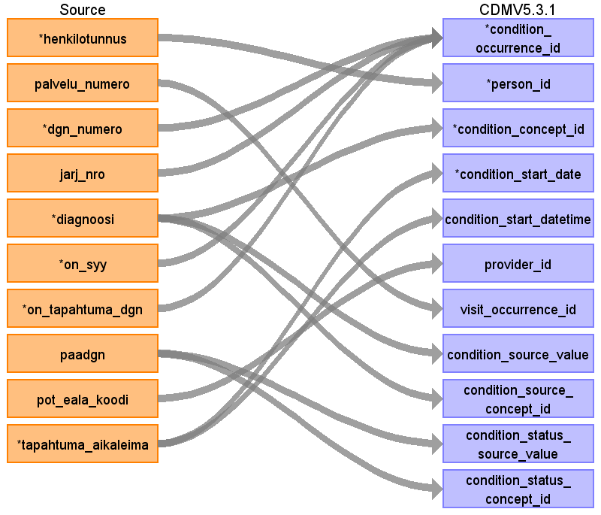

|  |  |  |  |
| --- | --- | --- | --- |
| Destination Field | Source Field | Logic | Comment |
| condition_occurrence_id | dgn_numero  jarj_nro  on_syy  on_tapahtuma_dgn |  | The primary key of a diagnosis in mv_diagnoosi is multi-column. There, condition_occurrence_id is generated for each unique combination of dgn_numero + jarj_nro + on_syy + on_tapahtuma_dgn + condition_concept_id. Condition_occurrence_id will be generated during the ETL process so that it covers all combinations and these combinations will get unique primary key in every case.  If several diagnoses were marked during one visit, this is the ordinal number depicting the position of this one on the list. |
| person_id | henkilotunnus | Henkilotunnus will be converted to person_id using link table link_henkilotunnus_to_pseudonym_to_person_id. |  |
| condition_concept_id | diagnoosi | Source codes are in a Finnish version of ICD10. It mainly follows the international ICD10, but it contains more specific codes for e.g. lung cancer histology types (e.g. C34.15) and some combination codes showing both symptom and cause (e.g. N08.39*E10.2 Type 1 diabetes related nephropathy). Finnish-only codes have been translated to standard concepts over 2020-2021 by FinOMOP. |  |
| condition_start_date | tapahtuma_aikaleima |  |  |
| condition_start_datetime | tapahtuma_aikaleima |  |  |
| condition_end_date |  |  | Our data has no end dates for diagnoses. |
| condition_end_datetime |  |  |  |
| condition_type_concept_id |  |  | 32817 EHR |
| stop_reason |  |  |  |
| provider_id | pot_eala_koodi | using link table eala_to_provider_id |  |
| visit_occurrence_id | palvelu_numero | using link table palvelu_numero_to_visit_occurrence_id |  |
| visit_detail_id |  |  |  |
| condition_source_value | diagnoosi |  | All source values |
| condition_source_concept_id | diagnoosi |  | Only those Finnish ICD10 values thare are present in the ICD10 version in OMOP |
| condition_status_source_value | paadgn | concatenate the literal "paadgn =" and the value of paadgn field, e.g. "paadgn=1" |  |
| condition_status_concept_id | paadgn | if on_paa = 1: 32902 Primary diagnosis.  else: 32908 Secondary diagnosis. |  |

Reading from mv_patologia_elin_diagnoosi_vsshp

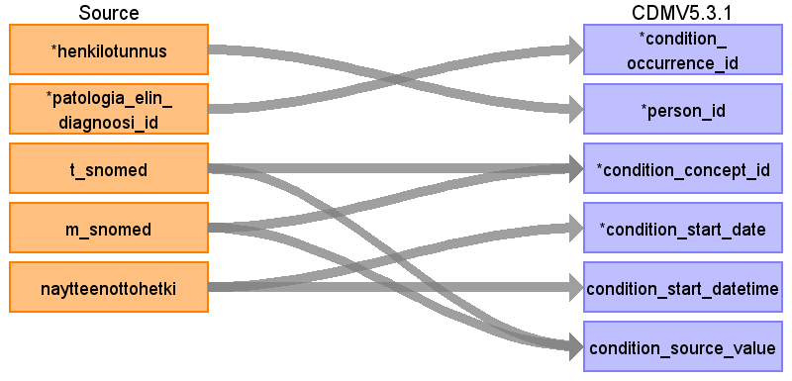

|  |  |  |  |
| --- | --- | --- | --- |
| Destination Field | Source Field | Logic | Comment |
| condition_occurrence_id | patologia_elin_diagnoosi_id | patologia_elin_diagnoosi_id is the primary key of pathology diagnoses in source data. |  |
| person_id | henkilotunnus | Henkilotunnus will be converted to person_id using link table link_henkilotunnus_to_pseudonym_to_person_id. |  |
| condition_concept_id | t_snomed  m_snomed | The concatenated combination of T and M snomed, seprated by " | " is used as the source code and mapped to Standard concepts. These codes are old Snomed II -like codes very loosely adapted by each pathology lab in Finland separately.  What would be needed here is a translation of old Snomed II -type topography and morphology code pairs from Snomed CT.Such a single concept is not available for all pathological observations. Some translations have been done on the most common T and M pairs locally, but Finnish collaboration in FinOMOP is only starting and is not far yet. There is a translation available in FinOMOP, made in Tampere Fimlab, that maps single T and M codes to single Snomed CT and sometimes ICDO3 codes. A listing was made in this project in Turku that deduces single target concepts for M and T pairs. This listing finds the target concept based on concepts in Athena that have a morphology attribute and topography attribute available which match the T and M pair in our data. This is a good start but the translation coverage is not yet very high. We have done some additional translations ourselves during the course of our EHDEN project. | Translation of old Snomed II -type morphology codes from the 1980's to Snomed CT. If possible, the topography information will be included. If possible, the morphology observation can be linked to the topography (which is Snomed CT domain Spec Anatomic Site) in the fact_relationship_table. The best solution would be to use a Snomed CT term that includes both morphology and topography information, but such terms are not available for all pathological observations. Some translations have been done on the most common T and M pairs locally, but Finnish collaboration in FinOMOP is only starting and is not far yet. |
| condition_start_date | naytteenottohetki |  |  |
| condition_start_datetime | naytteenottohetki |  |  |
| condition_end_date |  |  | Our data has no end dates for diagnoses. |
| condition_end_datetime |  |  |  |
| condition_type_concept_id |  |  | 32817 EHR |
| stop_reason |  |  |  |
| provider_id |  |  |  |
| visit_occurrence_id |  |  |  |
| visit_detail_id |  |  |  |
| condition_source_value | t_snomed  m_snomed | The concatenated combination of T and M snomed, seprated by " | " is used as the source code and mapped to Standard concepts. |  |
| condition_source_concept_id |  |  |  |
| condition_status_source_value |  |  |  |
| condition_status_concept_id |  |  |  |

Table name: procedure_occurrence

Reading from mv_opera_leikkaus_toimenpide

medical specialty code

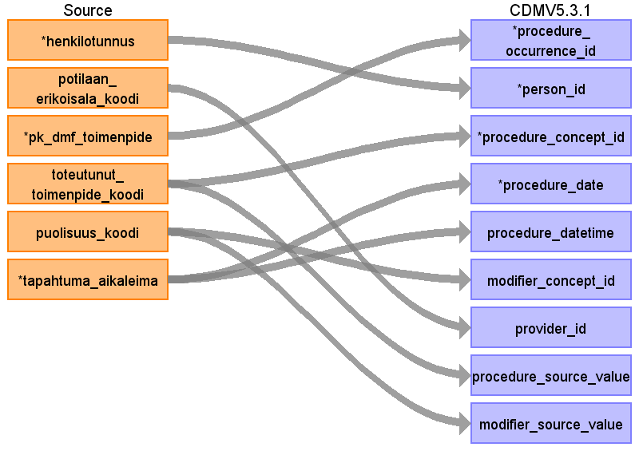

|  |  |  |  |
| --- | --- | --- | --- |
| Destination Field | Source Field | Logic | Comment |
| procedure_occurrence_id | pk_dmf_toimenpide | pk_dmf_toimenpide is the primary key of procedure in source data. Procedure occurrence table will be filled with unional result of three different source table, 1) mv_toimenpide, 2) mv_radu_vsshp and 3) mv_opera_leikkaus_toimenpide. Procedure_occurrence_id will be generated during the ETL process so that it covers all rows from all three different sources and there will be unique primary key in every case. |  |
| person_id | henkilotunnus | Henkilotunnus will be converted to person_id using link table link_henkilotunnus_to_pseudonym_to_person_id. |  |
| procedure_concept_id | toteutunut_toimenpide_koodi |  |  |
| procedure_date | tapahtuma_aikaleima |  |  |
| procedure_datetime | tapahtuma_aikaleima |  |  |
| procedure_type_concept_id |  |  | For lab-related source data, 32856 Lab. Otherwise, 32817 EHR. |
| modifier_concept_id | puolisuus_koodi |  | Puolisuus = procedure laterality |
| quantity |  |  | All our data represent single instances of a procedure. Hence this is always 1. |
| provider_id | potilaan_erikoisala_koodi |  | The specialty of the care unit (hoitava_osasto_koodi) will determine the provider. |
| visit_occurrence_id |  |  | Only minor procedures are connected to a visit, radiology or surgical procedures are not. |
| visit_detail_id |  |  |  |
| procedure_source_value | toteutunut_toimenpide_koodi |  |  |
| procedure_source_concept_id |  |  | Our Finnish NCSP codes are not present in OMOP, so this field will be left blank. |
| modifier_source_value | puolisuus_koodi |  | Puolisuus = procedure laterality |

Reading from mv_toimenpide

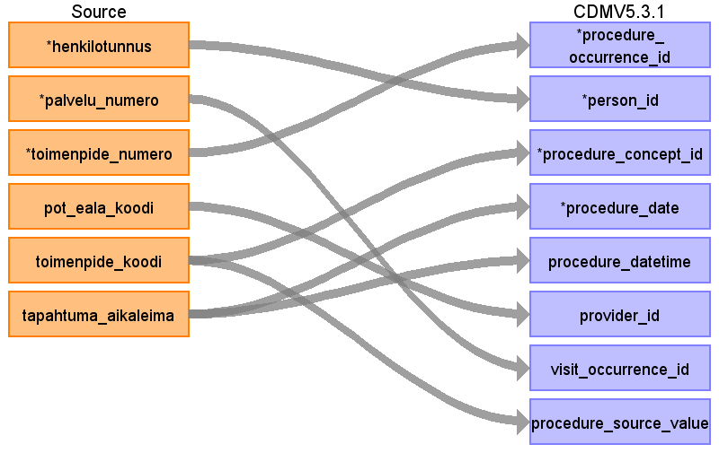

|  |  |  |  |
| --- | --- | --- | --- |
| Destination Field | Source Field | Logic | Comment |
| procedure_occurrence_id | toimenpide_numero | toimenpide_numero is the primary key of procedure in source data. Procedure occurrence table will be filled with unional result of three different source table, 1) mv_toimenpide, 2) mv_radu_vsshp and 3) mv_opera_leikkaus_toimenpide. Procedure_occurrence_id will be generated during the ETL process so that it covers all rows from all three different sources and there will be unique primary key in every case. |  |
| person_id | henkilotunnus | Henkilotunnus will be converted to person_id using link table link_henkilotunnus_to_pseudonym_to_person_id. |  |
| procedure_concept_id | toimenpide_koodi | Translated from Finnish NCSP codes to Standard Concepts by FinOMOP |  |
| procedure_date | tapahtuma_aikaleima |  |  |
| procedure_datetime | tapahtuma_aikaleima |  |  |
| procedure_type_concept_id |  |  | For lab-related source data, 32856 Lab. Otherwise, 32817 EHR. |
| modifier_concept_id |  |  |  |
| quantity |  |  | All our data represent single instances of a procedure. Hence this is always 1. |
| provider_id | pot_eala_koodi |  | The specialty of the care unit (hoitava_osasto_koodi) will determine the provider. |
| visit_occurrence_id | palvelu_numero | The visit_occurrence_id is looked up in the table cdm_help.link_palvelu_numero_to_visit_occurrence_id | Only minor procedures are connected to a visit, radiology or surgical procedures are not. |
| visit_detail_id |  |  |  |
| procedure_source_value | toimenpide_koodi |  |  |
| procedure_source_concept_id |  |  | Our Finnish NCSP codes are not present in OMOP, so this field will be left blank. |
| modifier_source_value |  |  |  |

Reading from mv_radu_vsshp

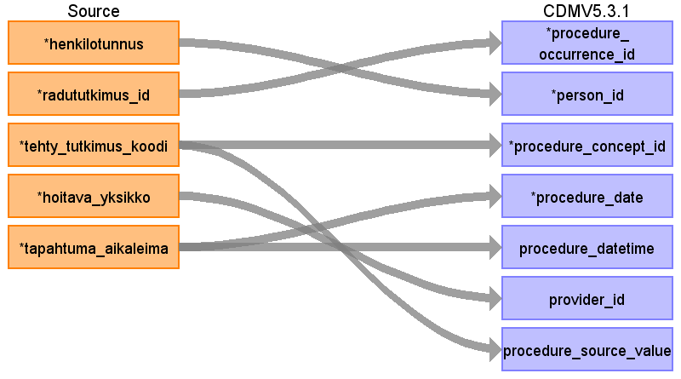

|  |  |  |  |
| --- | --- | --- | --- |
| Destination Field | Source Field | Logic | Comment |
| procedure_occurrence_id | radututkimus_id | radututkimus_id is the primary key of procedure in source data.Procedure occurrence table will be filled with unional result of three different source table, 1) mv_toimenpide, 2) mv_radu_vsshp and 3) mv_opera_leikkaus_toimenpide. Procedure_occurrence_id will be generated during the ETL process so that it covers all rows from all three different sources and there will be unique primary key in every case. |  |
| person_id | henkilotunnus | Henkilotunnus will be converted to person_id using link table link_henkilotunnus_to_pseudonym_to_person_id. |  |
| procedure_concept_id | tehty_tutkimus_koodi |  | Translated from Finnish NCSP codes to Standard Concepts. |
| procedure_date | tapahtuma_aikaleima |  |  |
| procedure_datetime | tapahtuma_aikaleima |  |  |
| procedure_type_concept_id |  |  | For lab-related source data, 32856 Lab. Otherwise, 32817 EHR. |
| modifier_concept_id |  |  |  |
| quantity |  |  | All our data represent single instances of a procedure. Hence this is always 1. |
| provider_id | hoitava_yksikko |  | The specialty of the care unit (hoitava_osasto_koodi) will determine the provider. |
| visit_occurrence_id |  |  | Only minor procedures are connected to a visit, radiology or surgical procedures are not. |
| visit_detail_id |  |  |  |
| procedure_source_value | tehty_tutkimus_koodi |  |  |
| procedure_source_concept_id |  |  | Our Finnish NCSP codes are not present in OMOP, so this field will be left blank. |
| modifier_source_value |  |  |  |

Reading from mv_diagnoosi

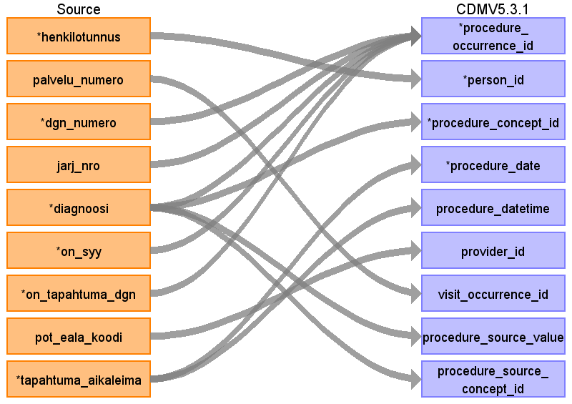

|  |  |  |  |
| --- | --- | --- | --- |
| Destination Field | Source Field | Logic | Comment |
| procedure_occurrence_id | dgn_numero  jarj_nro  diagnoosi  on_syy  on_tapahtuma_dgn |  | The primary key of a diagnosis in mv_diagnoosi is multi-column. There, procedure_occurrence_id is generated for each unique combination of dgn_numero + jarj_nro + on_syy + on_tapahtuma_dgn + condition_concept_id. Procedure_occurrence_id will be generated during the ETL process so that it covers all combinations and these combinations will get unique primary key in every case. |
| person_id | henkilotunnus | Henkilotunnus will be converted to person_id using link table link_henkilotunnus_to_pseudonym_to_person_id. |  |
| procedure_concept_id | diagnoosi |  |  |
| procedure_date | tapahtuma_aikaleima |  |  |
| procedure_datetime | tapahtuma_aikaleima |  |  |
| procedure_type_concept_id |  |  | For lab-related source data, 32856 Lab. Otherwise, 32817 EHR. |
| modifier_concept_id |  |  |  |
| quantity |  |  | All our data represent single instances of a procedure. Hence this is always 1. |
| provider_id | pot_eala_koodi | using link table eala_to_provider_id | The specialty of the care unit (hoitava_osasto_koodi) will determine the provider. |
| visit_occurrence_id | palvelu_numero | using link table palvelu_numero_to_visit_occurrence_id | Only minor procedures are connected to a visit, radiology or surgical procedures are not. |
| visit_detail_id |  |  |  |
| procedure_source_value | diagnoosi |  |  |
| procedure_source_concept_id | diagnoosi |  | Only those Finnish ICD10 values thare are present in the ICD10 version in OMOP  Our Finnish NCSP codes are not present in OMOP, so this field will be left blank. |
| modifier_source_value |  |  |  |

Reading from mv_labra_vsshp

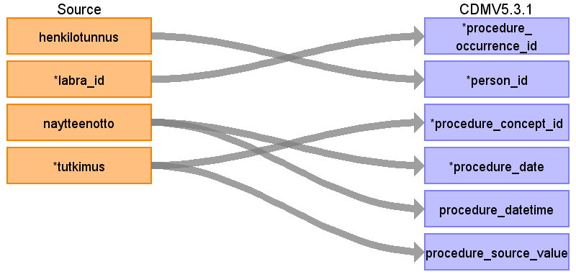

|  |  |  |  |
| --- | --- | --- | --- |
| Destination Field | Source Field | Logic | Comment |
| procedure_occurrence_id | labra_id | labra_id is the primary key of lab test in source data. Some lab data maps to the Procedure domain. | Procedure_occurrence_id will be generated during the ETL process as source_code could be mapped to multiple destination concepts. |
| person_id | henkilotunnus | Henkilotunnus will be converted to person_id using link table link_henkilotunnus_to_pseudonym_to_person_id. |  |
| procedure_concept_id | tutkimus |  | In our data source called mv_labra_vsshp, measurements are named in format "Abbreviation (CodeId)" e.g. "B-Hb (1552)". So that we can join this local source data measurement names to source_code made in mapping table source_to_concept field source_code, for this we have made help table called "help_local_lab_meas_names_to_abbreviation_and_source_code" where we have following fields:  original_name: "Abbreviation (CodeId)" => "B-Hb (1552)"  abbreviation: "Abbreviation" => "B-Hb"  source_code: "1552"  In some cases the numeric CodeId is missing from the original name, then it will be so that abbreviation is source_code. |
| procedure_date | naytteenotto |  |  |
| procedure_datetime | naytteenotto |  |  |
| procedure_type_concept_id |  |  | For lab-related source data, 32856 Lab. Otherwise, 32817 EHR. |
| modifier_concept_id |  |  |  |
| quantity |  |  | All our data represent single instances of a procedure. Hence this is always 1. |
| provider_id |  |  | The specialty of the care unit (hoitava_osasto_koodi) will determine the provider. |
| visit_occurrence_id |  |  | Only minor procedures are connected to a visit, radiology or surgical procedures are not. |
| visit_detail_id |  |  |  |
| procedure_source_value | tutkimus |  |  |
| procedure_source_concept_id |  |  | Our Finnish NCSP codes are not present in OMOP, so this field will be left blank. |
| modifier_source_value |  |  |  |

Table name: measurement

Reading from mv_labra_vsshp

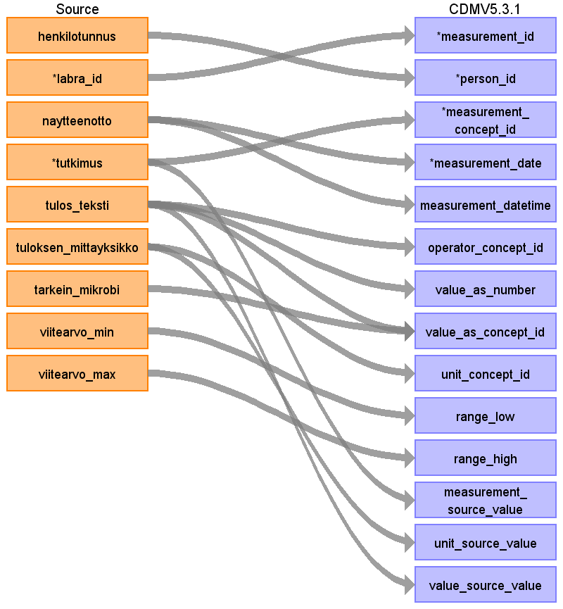

|  |  |  |  |
| --- | --- | --- | --- |
| Destination Field | Source Field | Logic | Comment |
| measurement_id | labra_id | labra_id is the primary key of lab test in source data. | Measurement_id will be generated during the ETL process as source_code could be mapped to multiple destination concepts. |
| person_id | henkilotunnus | Henkilotunnus will be converted to person_id using link table link_henkilotunnus_to_pseudonym_to_person_id. |  |
| measurement_concept_id | tutkimus | In Finland, there is a national laboratory coding system. Most laboratories follow it well, but in all laboratories, there are also local codes used in addition. In our data source called mv_labra_vsshp, measurements are named in format "Abbreviation (CodeId)" e.g. "B-Hb (1552)", which is the national standard format. So that we can join this local source data measurement names to source_code made in mapping table source_to_concept field source_code, for this we have made help table called "help_local_lab_meas_names_to_abbreviation_and_source_code" where we have following fields:  original_name: "Abbreviation (CodeId)" => "B-Hb (1552)"  abbreviation: "Abbreviation" => "B-Hb"  source_code: "1552"  In some cases the numeric CodeId is missing from the original name, then it will be so that abbreviation is source_code.  FinOMOP has been translating the Finnish standard codes to OMOP standard codes over 2020-2021. |  |
| measurement_date | naytteenotto |  |  |
| measurement_datetime | naytteenotto |  |  |
| measurement_time |  |  |  |
| measurement_type_concept_id |  |  | 32856 Lab, if row comes from mv_labra_vsshp. Otherwise, 32817 EHR. |
| operator_concept_id | tulos_teksti | The operator can be deduced based on the textual representation in the tulos_teksti field. The field can contain operators such as < or >, or their Finnish verbal equivalents "Alle" or "Yli". If the field contains no such modifier but only the result, the operator is presumed to be "=". |  |
| value_as_number | tulos_teksti | Numeric values go here. Using PostgreSQL syntax regexp_match(labra.tulos_teksti, '[0-9]+\.?[0-9]*'))[1]::numeric. |  |
| value_as_concept_id | tulos_teksti  tarkein_mikrobi | In our data, information that could go into the value_as_concept_id field is one of two types: The most important microbe finding, or whether the test result was positive or negative.  If tarkein_mikrobi ("most important microbe") is non-null in the source data, use that here primarily. If not, then use the contents of field tulos_teksti, but only if the are of the type "positive" or "negative". This is currently checked with the following PostgreSQL case statement bit:  WHEN tulos_teksti IN ('-') OR tulos_teksti ~* 'neg' THEN 45878583  WHEN tulos_teksti IN ('+','++','+++') OR tulos_teksti ~* 'pos' THEN 45884084  (Standard concepts that are used from MeasValue domain Loinc vocabulary are 45884084 Positive and 45878583 Negative)  Microbes are listed with their latin names in our lab data, they follow no specific coding system. We have treated the latin names as codes and translated them to standard codes. Some of them end up as Measurement.value_as_concept_id and some end up as separate Observations (depending on whether they map to Meas Value or Observation).  If tarkein_mikrobi (most prominent microbe) is filled, it may be relavant to enter as a value (e.g. urine bacterial screen result could be the microbe that was found). | Use translation in source_to_concept_map from vocabulary MIKROBI_FIN_VSSHP |
| unit_concept_id | tuloksen_mittayksikko |  | Source data is mapped to Standard Concepts in the Unit domain, UCUM vocabulary. |
| range_low | viitearvo_min |  |  |
| range_high | viitearvo_max |  |  |
| provider_id |  |  | Medical specialty and thus provider is not represented in our lab data. |
| visit_occurrence_id |  |  | Our lab data are not connected to visit occurrences. |
| visit_detail_id |  |  |  |
| measurement_source_value | tutkimus |  |  |
| measurement_source_concept_id |  |  | The Finnish laboratory examination vocabulary is not present in OMOP. |
| unit_source_value | tuloksen_mittayksikko |  |  |
| value_source_value | tulos_teksti | content of field tulos_teksti as it is |  |

Reading from mv_diagnoosi

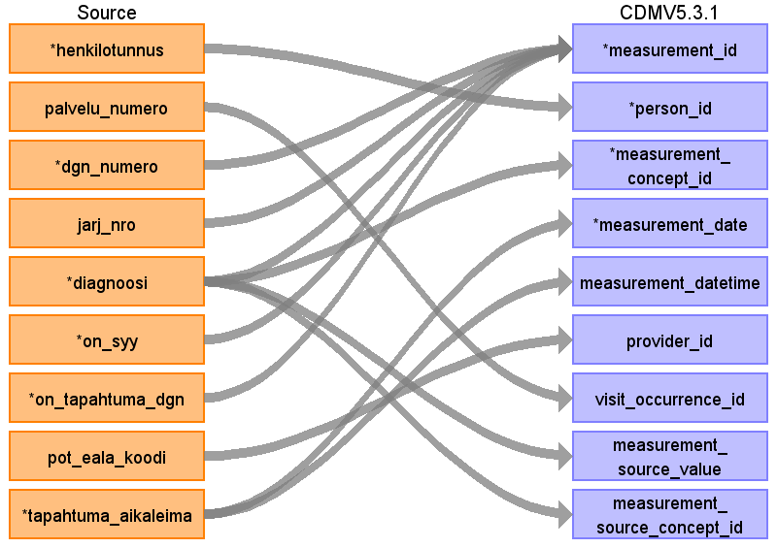

|  |  |  |  |
| --- | --- | --- | --- |
| Destination Field | Source Field | Logic | Comment |
| measurement_id | dgn_numero  jarj_nro  diagnoosi  on_syy  on_tapahtuma_dgn |  | The primary key of a diagnosis in mv_diagnoosi is multi-column. There, measurement_id is generated for each unique combination of dgn_numero + jarj_nro + on_syy + on_tapahtuma_dgn + observation_concept_id. Measurement_id will be generated during the ETL process so that it covers all combinations and these combinations will get unique primary key in every case. |
| person_id | henkilotunnus | Henkilotunnus will be converted to person_id using link table link_henkilotunnus_to_pseudonym_to_person_id. |  |
| measurement_concept_id | diagnoosi |  |  |
| measurement_date | tapahtuma_aikaleima |  |  |
| measurement_datetime | tapahtuma_aikaleima |  |  |
| measurement_time |  |  |  |
| measurement_type_concept_id |  |  | 32856 Lab, if row comes from mv_labra_vsshp. Otherwise, 32817 EHR. |
| operator_concept_id |  |  |  |
| value_as_number |  |  |  |
| value_as_concept_id |  |  |  |
| unit_concept_id |  |  |  |
| range_low |  |  |  |
| range_high |  |  |  |
| provider_id | pot_eala_koodi |  | Medical specialty and thus provider is not represented in our lab data. |
| visit_occurrence_id | palvelu_numero | using link table palvelu_numero_to_visit_occurrence_id | Our lab data are not connected to visit occurrences. |
| visit_detail_id |  |  |  |
| measurement_source_value | diagnoosi |  |  |
| measurement_source_concept_id | diagnoosi |  | Only those Finnish ICD10 values thare are present in the ICD10 version in OMOP  The Finnish laboratory examination vocabulary is not present in OMOP. |
| unit_source_value |  |  |  |
| value_source_value |  |  |  |

Reading from mv_toimenpide

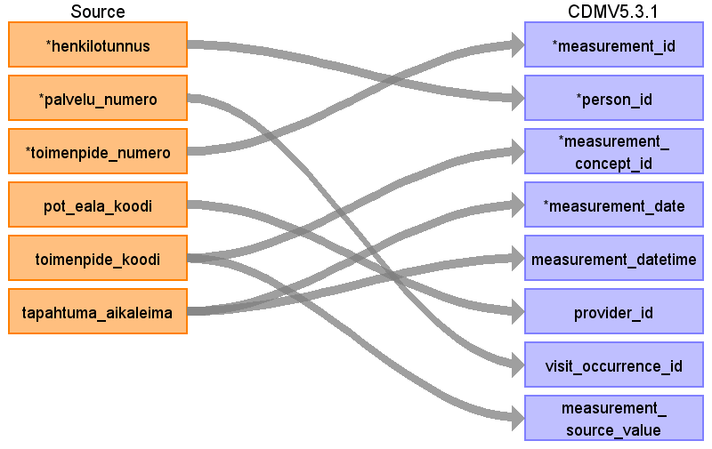

|  |  |  |  |
| --- | --- | --- | --- |
| Destination Field | Source Field | Logic | Comment |
| measurement_id | toimenpide_numero | toimenpide_numero is the primary key of procedure in source data. Some procedure data in the source tables maps to the measurement domain. The Measurement table will be appended with unional result of three different source tables, 1) mv_toimenpide, 2) mv_radu_vsshp and 3) mv_opera_leikkaus_toimenpide. Measurement_id will be generated during the ETL process so that it covers all rows from all three different sources and there will be unique primary key in every case. |  |
| person_id | henkilotunnus | Henkilotunnus will be converted to person_id using link table link_henkilotunnus_to_pseudonym_to_person_id. |  |
| measurement_concept_id | toimenpide_koodi |  | Translated from Finnish NCSP codes to Standard Concepts. |
| measurement_date | tapahtuma_aikaleima |  |  |
| measurement_datetime | tapahtuma_aikaleima |  |  |
| measurement_time |  |  |  |
| measurement_type_concept_id |  |  | 32856 Lab, if row comes from mv_labra_vsshp. Otherwise, 32817 EHR. |
| operator_concept_id |  |  |  |
| value_as_number |  |  |  |
| value_as_concept_id |  |  |  |
| unit_concept_id |  |  |  |
| range_low |  |  |  |
| range_high |  |  |  |
| provider_id | pot_eala_koodi |  | Medical specialty and thus provider is not represented in our lab data. |
| visit_occurrence_id | palvelu_numero |  | Our lab data are not connected to visit occurrences. |
| visit_detail_id |  |  |  |
| measurement_source_value | toimenpide_koodi |  |  |
| measurement_source_concept_id |  |  | The Finnish laboratory examination vocabulary is not present in OMOP. |
| unit_source_value |  |  |  |
| value_source_value |  |  |  |

Reading from mv_opera_leikkaus_toimenpide

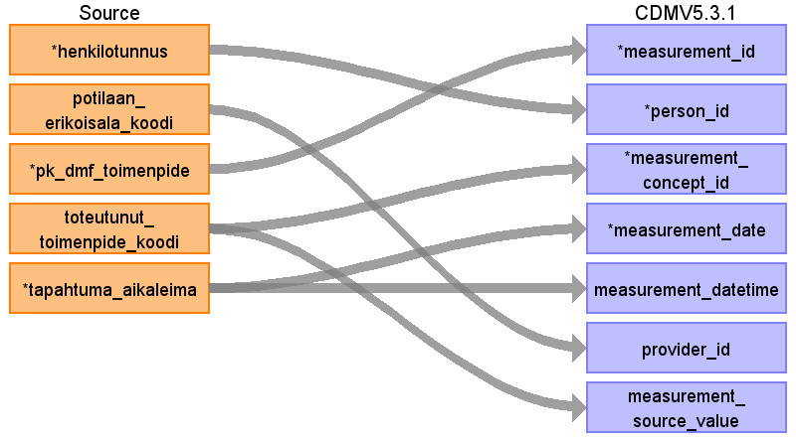

|  |  |  |  |
| --- | --- | --- | --- |
| Destination Field | Source Field | Logic | Comment |
| measurement_id | pk_dmf_toimenpide | pk_dmf_toimenpide is the primary key of procedure in source data. Some procedure data in the source tables maps to the measurement domain. Measurement table will be appended with unional result of three different procedure source tables, 1) mv_toimenpide, 2) mv_radu_vsshp and 3) mv_opera_leikkaus_toimenpide. Measurement_id will be generated during the ETL process so that it covers all rows from all three different sources and there will be unique primary key in every case. |  |
| person_id | henkilotunnus | Henkilotunnus will be converted to person_id using link table link_henkilotunnus_to_pseudonym_to_person_id. |  |
| measurement_concept_id | toteutunut_toimenpide_koodi |  |  |
| measurement_date | tapahtuma_aikaleima |  |  |
| measurement_datetime | tapahtuma_aikaleima |  |  |
| measurement_time |  |  |  |
| measurement_type_concept_id |  |  | 32856 Lab, if row comes from mv_labra_vsshp. Otherwise, 32817 EHR. |
| operator_concept_id |  |  |  |
| value_as_number |  |  |  |
| value_as_concept_id |  |  |  |
| unit_concept_id |  |  |  |
| range_low |  |  |  |
| range_high |  |  |  |
| provider_id | potilaan_erikoisala_koodi |  | Medical specialty and thus provider is not represented in our lab data. |
| visit_occurrence_id |  |  | Our lab data are not connected to visit occurrences. |
| visit_detail_id |  |  |  |
| measurement_source_value | toteutunut_toimenpide_koodi |  |  |
| measurement_source_concept_id |  |  | The Finnish laboratory examination vocabulary is not present in OMOP. |
| unit_source_value |  |  |  |
| value_source_value |  |  |  |

Reading from mv_radu_vsshp

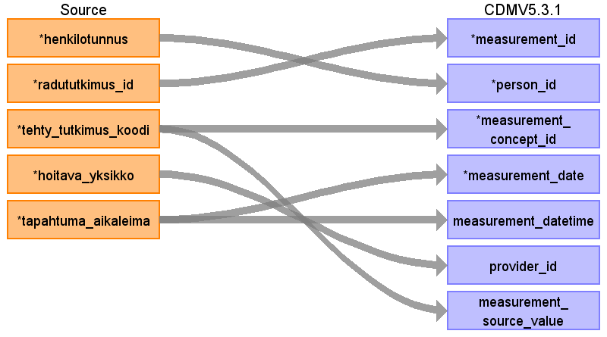

|  |  |  |  |
| --- | --- | --- | --- |
| Destination Field | Source Field | Logic | Comment |
| measurement_id | radututkimus_id | radututkimus_id is the primary key of procedure in source data. Some procedure data in the source tables maps to the Measurement domain. Measurement table will be appended with unional result of three different source table, 1) mv_toimenpide, 2) mv_radu_vsshp and 3) mv_opera_leikkaus_toimenpide. Measurement_id will be generated during the ETL process so that it covers all rows from all three different sources and there will be unique primary key in every case. |  |
| person_id | henkilotunnus | Henkilotunnus will be converted to person_id using link table link_henkilotunnus_to_pseudonym_to_person_id. |  |
| measurement_concept_id | tehty_tutkimus_koodi |  | Translated from Finnish NCSP codes to Standard Concepts. |
| measurement_date | tapahtuma_aikaleima |  |  |
| measurement_datetime | tapahtuma_aikaleima |  |  |
| measurement_time |  |  |  |
| measurement_type_concept_id |  |  | 32856 Lab, if row comes from mv_labra_vsshp. Otherwise, 32817 EHR. |
| operator_concept_id |  |  |  |
| value_as_number |  |  |  |
| value_as_concept_id |  |  |  |
| unit_concept_id |  |  |  |
| range_low |  |  |  |
| range_high |  |  |  |
| provider_id | hoitava_yksikko |  | Medical specialty and thus provider is not represented in our lab data. |
| visit_occurrence_id |  |  | Our lab data are not connected to visit occurrences. |
| visit_detail_id |  |  |  |
| measurement_source_value | tehty_tutkimus_koodi |  |  |
| measurement_source_concept_id |  |  | The Finnish laboratory examination vocabulary is not present in OMOP. |
| unit_source_value |  |  |  |
| value_source_value |  |  |  |

Table name: drug_exposure

From v_potilaan_syopalaakkeet itokuurit following records are excluded from the data:

geneerinen_nimi = '-' OR geneerinen_nimi ~* 'lume' OR kauppanimi ~* 'lume'.

It's seems to be so that these durgs records in data are used for clinical trials so we cannot be sure whether it is question about drug or placebo.

Reading from v_resepti

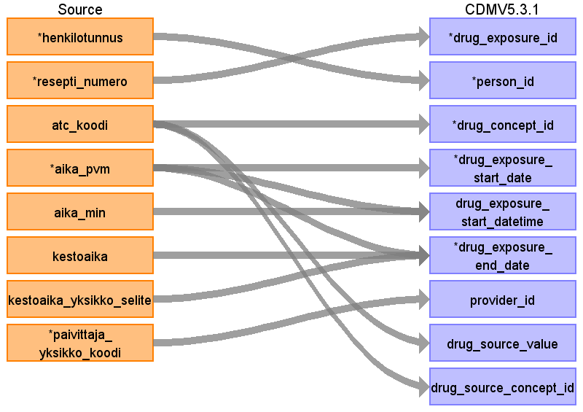

|  |  |  |  |
| --- | --- | --- | --- |
| Destination Field | Source Field | Logic | Comment |
| drug_exposure_id | resepti_numero | resepti_numero is the primary key of outpatient prescriptions in source data. Drug exposure table will be filled with unional result of three different source 1) v_resepti, 2) mv_laakemaarays and 3) v_potilaan_hoitokuurit|v_potilaan_syopalaakkeet. Drug_exposure_id will be generated during the ETL process so that it covers all rows from all three different sources and there will be unique primary key in every case. |  |
| person_id | henkilotunnus | Henkilotunnus will be converted to person_id using link table link_henkilotunnus_to_pseudonym_to_person_id. |  |
| drug_concept_id | atc_koodi |  | ATC will be translated to RxNorm using existing OMOP mappings.  The drug_concept_id information comes from v_potilaan_syopalaakkeet. See documentation for v_potilaan_syopalaakkeet. The tables are joined onv_potilaan_hoitokuurit.potilaan_hoitokuuri_numero = v_potilaan_syopalaakkeet.potilaan_hoitokuuri_numero. The field that contains the information identifying the drug is v_potilaan_syopalaakkeet.geneerinen_nimi. This is the generic name of the drug. It was locally translated to ATC code, which in turn are already translated to RxNorm within OMOP. |
| drug_exposure_start_date | aika_pvm |  | The start and end date information comes from v_potilaan_hoitokuurit. See documentation for v_potilaan_hoitokuurit. The tables are joined onv_potilaan_hoitokuurit.potilaan_hoitokuuri_numero = v_potilaan_syopalaakkeet.potilaan_hoitokuuri_numero. |
| drug_exposure_start_datetime | aika_pvm  aika_min |  | date component of timestamp  time component of timestamp |
| drug_exposure_end_date | aika_pvm  kestoaika  kestoaika_yksikko_selite | In v_resepti (outpatient prescription), end date is 2 years after the start date. There is no structured dosage information from which to derive an estimate of duration without text mining methodology. For about 15% of rows, there is content in the fields kestoaika and kestoaika_yksikko, which indicate the planned duration of the medication. These will be used when available. When not available, an estimate of start date + 30 days - 1 will be used in order to be compatible with rest of FinOMOP.  We are applying for grant funding with partners in Finland to develop mining methodology to extract actual dosage information from Finnish e-prescriptions.  Transformation logic:  Step 1: Convert kestoaika_yksikko ("duration unit") into multipliers that will allow the calculation of the time in days. (vuosi = year, vuorokausi = day, viikko = week, kuukausi = month)  VUOSI = 365.2425, VUOROKAUSI = 1, VIIKKO = 7, KUUKAUSI = 30.44  Step 2: Multiply the value of kestoaika with the multiplier, which produces the duration in days. This number of days will be added to the start date (aika_pvm) to produce the end date. | In v_resepti (outpatient prescription), end date is 2 years after the start date. There is no structured dosage information from which to derive an estimate of duration without text mining methodology. For about 15% of rows, there is content in the fields kestoaika and kestoaika_yksikko, which indicate the planned duration of the medication. These will be used when available. When not available, an estimate of start date + 30 days - 1 will be used in order to be compatible with rest of FinOMOP.  We are applying for grant funding with partners in Finland to develop mining methodology to extract actual dosage information from Finnish e-prescriptions.  Step 1: Convert kestoaika_yksikko ("duration unit") into multipliers  that will allow the calculation of the time in days. (vuosi = year, vuorokausi = day, viikko = week, kuukausi = month)  VUOSI = 365.2425, VUOROKAUSI = 1, VIIKKO = 7, KUUKAUSI = 30.44  Step 2: Multiply the value of kestoaika with the multiplier, which produces the duration in days.  This number of days will be added to the start time (aika_pvm). |
| drug_exposure_end_datetime |  |  |  |
| verbatim_end_date |  |  |  |
| drug_type_concept_id |  |  | v_resepti: 32838 EHR prescription.  mv_laakemaarays: 32830 EHR medication list |
| stop_reason |  |  | unavailable |
| refills |  |  | refills are shown as separate prescription rows in the data |
| quantity |  |  | Free-text information, impossible to decifer as a single float |
| days_supply |  |  | Not available |
| sig |  |  |  |
| route_concept_id |  |  | PO = 4132161  IV = 4171047  SC = 4142048  IH = 45956874  IM = 4302612  TD = 4262099  OP = 4184451  IN = 4262914  VG = 4057765  PR = 4290759  EP = 4225555  IO = 4157760  SL = 4292110  IA = 4240824  IP = 4243022  IT = 4217202  REKTAALISESTI = 4290759 |
| lot_number |  |  |  |
| provider_id | paivittaja_yksikko_koodi |  | Provider not available in chemotherapy data. |
| visit_occurrence_id |  |  | Drug data are not connected to a visit |
| visit_detail_id |  |  | Prescriptions are not linked to visits. |
| drug_source_value | atc_koodi |  | The ATC code as it appears in the data |
| drug_source_concept_id | atc_koodi |  | The concept_id of the ATC code in OMOP |
| route_source_value |  |  | PO = 4132161  IV = 4171047  SC = 4142048  IH = 45956874  IM = 4302612  TD = 4262099  OP = 4184451  IN = 4262914  VG = 4057765  PR = 4290759  EP = 4225555  IO = 4157760  SL = 4292110  IA = 4240824  IP = 4243022  IT = 4217202  REKTAALISESTI = 4290759 |
| dose_unit_source_value |  |  |  |

Reading from mv_laakemaarays

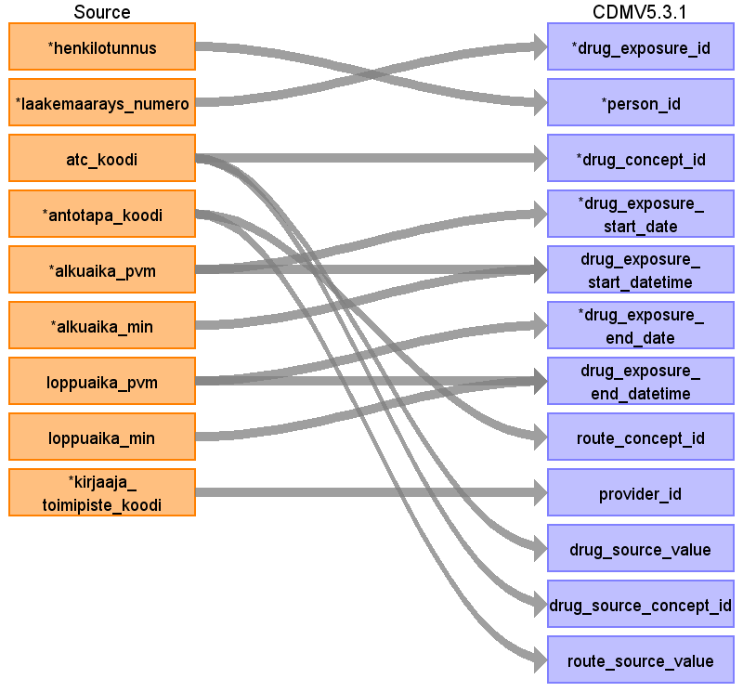

|  |  |  |  |
| --- | --- | --- | --- |
| Destination Field | Source Field | Logic | Comment |
| drug_exposure_id | laakemaarays_numero | laakemaarays_numero is the primary key of inpatient prescriptions in source data. Drug exposure table will be filled with unional result of three different source 1) v_resepti, 2) mv_laakemaarays and 3) v_potilaan_hoitokuurit|v_potilaan_syopalaakkeet. Drug_exposure_id will be generated during the ETL process so that it covers all rows from all three different sources and there will be unique primary key in every case. |  |
| person_id | henkilotunnus | Henkilotunnus will be converted to person_id using link table link_henkilotunnus_to_pseudonym_to_person_id. |  |
| drug_concept_id | atc_koodi |  | ATC will be translated to RxNorm using existing OMOP mappings.  The drug_concept_id information comes from v_potilaan_syopalaakkeet. See documentation for v_potilaan_syopalaakkeet. The tables are joined onv_potilaan_hoitokuurit.potilaan_hoitokuuri_numero = v_potilaan_syopalaakkeet.potilaan_hoitokuuri_numero. The field that contains the information identifying the drug is v_potilaan_syopalaakkeet.geneerinen_nimi. This is the generic name of the drug. It was locally translated to ATC code, which in turn are already translated to RxNorm within OMOP. |
| drug_exposure_start_date | alkuaika_pvm |  | The start and end date information comes from v_potilaan_hoitokuurit. See documentation for v_potilaan_hoitokuurit. The tables are joined onv_potilaan_hoitokuurit.potilaan_hoitokuuri_numero = v_potilaan_syopalaakkeet.potilaan_hoitokuuri_numero. |
| drug_exposure_start_datetime | alkuaika_pvm  alkuaika_min |  | date component of timestamp  time component of timestamp |
| drug_exposure_end_date | loppuaika_pvm |  | In v_resepti (outpatient prescription), end date is 2 years after the start date. There is no structured dosage information from which to derive an estimate of duration without text mining methodology. For about 15% of rows, there is content in the fields kestoaika and kestoaika_yksikko, which indicate the planned duration of the medication. These will be used when available. When not available, an estimate of start date + 30 days - 1 will be used in order to be compatible with rest of FinOMOP.  We are applying for grant funding with partners in Finland to develop mining methodology to extract actual dosage information from Finnish e-prescriptions.  Step 1: Convert kestoaika_yksikko ("duration unit") into multipliers  that will allow the calculation of the time in days. (vuosi = year, vuorokausi = day, viikko = week, kuukausi = month)  VUOSI = 365.2425, VUOROKAUSI = 1, VIIKKO = 7, KUUKAUSI = 30.44  Step 2: Multiply the value of kestoaika with the multiplier, which produces the duration in days.  This number of days will be added to the start time (aika_pvm). |
| drug_exposure_end_datetime | loppuaika_pvm  loppuaika_min |  | time component of timestamp |
| verbatim_end_date |  |  |  |
| drug_type_concept_id |  |  | v_resepti: 32838 EHR prescription.  mv_laakemaarays: 32830 EHR medication list |
| stop_reason |  |  | unavailable |
| refills |  |  | refills are shown as separate prescription rows in the data |
| quantity |  |  | Free-text information, impossible to decifer as a single float |
| days_supply |  |  | Not available |
| sig |  |  |  |
| route_concept_id | antotapa_koodi | Local antotapa_koodi (route of administration code) translation hard-coded in the ETL script. Standard codes selected from Snomed CT, domain Route. | PO = 4132161  IV = 4171047  SC = 4142048  IH = 45956874  IM = 4302612  TD = 4262099  OP = 4184451  IN = 4262914  VG = 4057765  PR = 4290759  EP = 4225555  IO = 4157760  SL = 4292110  IA = 4240824  IP = 4243022  IT = 4217202  REKTAALISESTI = 4290759 |
| lot_number |  |  |  |
| provider_id | kirjaaja_toimipiste_koodi |  | Provider not available in chemotherapy data. |
| visit_occurrence_id |  |  | Drug data are not connected to a visit |
| visit_detail_id |  |  | Prescriptions are not linked to visits. |
| drug_source_value | atc_koodi |  | The ATC code as it appears in the data |
| drug_source_concept_id | atc_koodi |  | The concept_id of the ATC code in OMOP |
| route_source_value | antotapa_koodi |  | PO = 4132161  IV = 4171047  SC = 4142048  IH = 45956874  IM = 4302612  TD = 4262099  OP = 4184451  IN = 4262914  VG = 4057765  PR = 4290759  EP = 4225555  IO = 4157760  SL = 4292110  IA = 4240824  IP = 4243022  IT = 4217202  REKTAALISESTI = 4290759 |
| dose_unit_source_value |  |  |  |

Reading from v_potilaan_hoitokuurit

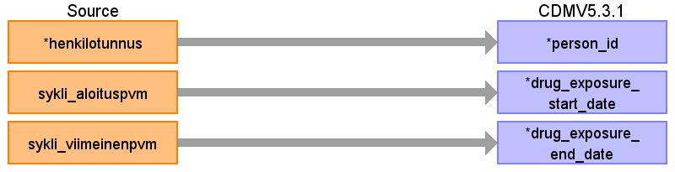

|  |  |  |  |
| --- | --- | --- | --- |
| Destination Field | Source Field | Logic | Comment |
| drug_exposure_id |  |  |  |
| person_id | henkilotunnus | Henkilotunnus will be converted to person_id using link table link_henkilotunnus_to_pseudonym_to_person_id. |  |
| drug_concept_id |  |  | The drug_concept_id information comes from v_potilaan_syopalaakkeet. See documentation for v_potilaan_syopalaakkeet. The tables are joined onv_potilaan_hoitokuurit.potilaan_hoitokuuri_numero = v_potilaan_syopalaakkeet.potilaan_hoitokuuri_numero. The field that contains the information identifying the drug is v_potilaan_syopalaakkeet.geneerinen_nimi. This is the generic name of the drug. It was locally translated to ATC code, which in turn are already translated to RxNorm within OMOP. |
| drug_exposure_start_date | sykli_aloituspvm |  | The start date of a chemotherapy drug is the minimum of start dates within one hoitokuuri (i.e. within henkilotunnus + hoitokuuri_numero combination)  The start and end date information comes from v_potilaan_hoitokuurit. See documentation for v_potilaan_hoitokuurit. The tables are joined onv_potilaan_hoitokuurit.potilaan_hoitokuuri_numero = v_potilaan_syopalaakkeet.potilaan_hoitokuuri_numero. |
| drug_exposure_start_datetime |  |  |  |
| drug_exposure_end_date | sykli_viimeinenpvm |  | The end date of a chemotherapy drug is the maximum of end dates within one hoitokuuri (i.e. within henkilotunnus + hoitokuuri_numero combination)  In v_resepti (outpatient prescription), end date is 2 years after the start date. There is no structured dosage information from which to derive an estimate of duration without text mining methodology. For about 15% of rows, there is content in the fields kestoaika and kestoaika_yksikko, which indicate the planned duration of the medication. These will be used when available. When not available, an estimate of start date + 30 days - 1 will be used in order to be compatible with rest of FinOMOP.  We are applying for grant funding with partners in Finland to develop mining methodology to extract actual dosage information from Finnish e-prescriptions.  Step 1: Convert kestoaika_yksikko ("duration unit") into multipliers  that will allow the calculation of the time in days. (vuosi = year, vuorokausi = day, viikko = week, kuukausi = month)  VUOSI = 365.2425, VUOROKAUSI = 1, VIIKKO = 7, KUUKAUSI = 30.44  Step 2: Multiply the value of kestoaika with the multiplier, which produces the duration in days.  This number of days will be added to the start time (aika_pvm). |
| drug_exposure_end_datetime |  |  |  |
| verbatim_end_date |  |  |  |
| drug_type_concept_id |  |  | v_resepti: 32838 EHR prescription.  mv_laakemaarays: 32830 EHR medication list |
| stop_reason |  |  | unavailable |
| refills |  |  | refills are shown as separate prescription rows in the data |
| quantity |  |  | Free-text information, impossible to decifer as a single float |
| days_supply |  |  | Not available |
| sig |  |  |  |
| route_concept_id |  |  | PO = 4132161  IV = 4171047  SC = 4142048  IH = 45956874  IM = 4302612  TD = 4262099  OP = 4184451  IN = 4262914  VG = 4057765  PR = 4290759  EP = 4225555  IO = 4157760  SL = 4292110  IA = 4240824  IP = 4243022  IT = 4217202  REKTAALISESTI = 4290759 |
| lot_number |  |  |  |
| provider_id |  |  | Provider not available in chemotherapy data. |
| visit_occurrence_id |  |  | Drug data are not connected to a visit |
| visit_detail_id |  |  | Prescriptions are not linked to visits. |
| drug_source_value |  |  |  |
| drug_source_concept_id |  |  |  |
| route_source_value |  |  | PO = 4132161  IV = 4171047  SC = 4142048  IH = 45956874  IM = 4302612  TD = 4262099  OP = 4184451  IN = 4262914  VG = 4057765  PR = 4290759  EP = 4225555  IO = 4157760  SL = 4292110  IA = 4240824  IP = 4243022  IT = 4217202  REKTAALISESTI = 4290759 |
| dose_unit_source_value |  |  |  |

Reading from v_potilaan_syopalaakkeet

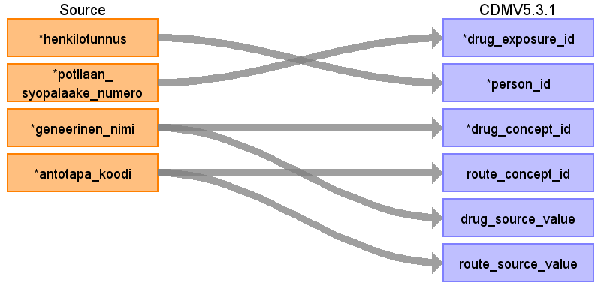

|  |  |  |  |
| --- | --- | --- | --- |
| Destination Field | Source Field | Logic | Comment |
| drug_exposure_id | potilaan_syopalaake_numero | potilaan_syopalaake_numero is the primary key of chemotherapy drug prescriptions in source data. Drug exposure table will be filled with unional result of three different source 1) v_resepti, 2) mv_laakemaarays and 3) v_potilaan_hoitokuurit|v_potilaan_syopalaakkeet. Drug_exposure_id will be generated during the ETL process so that it covers all rows from all three different sources and there will be unique primary key in every case. |  |
| person_id | henkilotunnus | Henkilotunnus will be converted to person_id using link table link_henkilotunnus_to_pseudonym_to_person_id. |  |
| drug_concept_id | geneerinen_nimi |  | The Finnish generic name of the active ingredient. This will be mapped to ATC code, which will be matched to a Standard Concept in RxNorm using mappings already available in OMOP.  The drug_concept_id information comes from v_potilaan_syopalaakkeet. See documentation for v_potilaan_syopalaakkeet. The tables are joined onv_potilaan_hoitokuurit.potilaan_hoitokuuri_numero = v_potilaan_syopalaakkeet.potilaan_hoitokuuri_numero. The field that contains the information identifying the drug is v_potilaan_syopalaakkeet.geneerinen_nimi. This is the generic name of the drug. It was locally translated to ATC code, which in turn are already translated to RxNorm within OMOP. |
| drug_exposure_start_date |  |  | The start and end date information comes from v_potilaan_hoitokuurit. See documentation for v_potilaan_hoitokuurit. The tables are joined onv_potilaan_hoitokuurit.potilaan_hoitokuuri_numero = v_potilaan_syopalaakkeet.potilaan_hoitokuuri_numero. |
| drug_exposure_start_datetime |  |  |  |
| drug_exposure_end_date |  |  | In v_resepti (outpatient prescription), end date is 2 years after the start date. There is no structured dosage information from which to derive an estimate of duration without text mining methodology. For about 15% of rows, there is content in the fields kestoaika and kestoaika_yksikko, which indicate the planned duration of the medication. These will be used when available. When not available, an estimate of start date + 30 days - 1 will be used in order to be compatible with rest of FinOMOP.  We are applying for grant funding with partners in Finland to develop mining methodology to extract actual dosage information from Finnish e-prescriptions.  Step 1: Convert kestoaika_yksikko ("duration unit") into multipliers  that will allow the calculation of the time in days. (vuosi = year, vuorokausi = day, viikko = week, kuukausi = month)  VUOSI = 365.2425, VUOROKAUSI = 1, VIIKKO = 7, KUUKAUSI = 30.44  Step 2: Multiply the value of kestoaika with the multiplier, which produces the duration in days.  This number of days will be added to the start time (aika_pvm). |
| drug_exposure_end_datetime |  |  |  |
| verbatim_end_date |  |  |  |
| drug_type_concept_id |  |  | v_resepti: 32838 EHR prescription.  mv_laakemaarays: 32830 EHR medication list |
| stop_reason |  |  | unavailable |
| refills |  |  | refills are shown as separate prescription rows in the data |
| quantity |  |  | Free-text information, impossible to decifer as a single float |
| days_supply |  |  | Not available |
| sig |  |  |  |
| route_concept_id | antotapa_koodi | Local antotapa_koodi (route of administration code) translation hard-coded in the ETL script. Standard codes selected from Snomed CT, domain Route. | PO = 4132161  IV = 4171047  SC = 4142048  IH = 45956874  IM = 4302612  TD = 4262099  OP = 4184451  IN = 4262914  VG = 4057765  PR = 4290759  EP = 4225555  IO = 4157760  SL = 4292110  IA = 4240824  IP = 4243022  IT = 4217202  REKTAALISESTI = 4290759 |
| lot_number |  |  |  |
| provider_id |  |  | Provider not available in chemotherapy data. |
| visit_occurrence_id |  |  | Drug data are not connected to a visit |
| visit_detail_id |  |  | Prescriptions are not linked to visits. |
| drug_source_value | geneerinen_nimi |  |  |
| drug_source_concept_id |  |  |  |
| route_source_value | antotapa_koodi |  | PO = 4132161  IV = 4171047  SC = 4142048  IH = 45956874  IM = 4302612  TD = 4262099  OP = 4184451  IN = 4262914  VG = 4057765  PR = 4290759  EP = 4225555  IO = 4157760  SL = 4292110  IA = 4240824  IP = 4243022  IT = 4217202  REKTAALISESTI = 4290759 |
| dose_unit_source_value |  |  |  |

Table name: observation

Reading from mv_patologia_elin_diagnoosi_vsshp

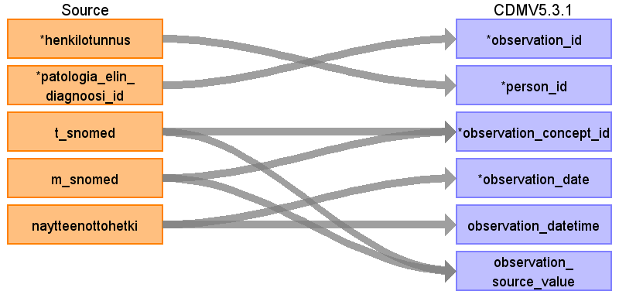

|  |  |  |  |
| --- | --- | --- | --- |
| Destination Field | Source Field | Logic | Comment |
| observation_id | patologia_elin_diagnoosi_id | patologia_elin_diagnoosi_id is the primary key of pathology diagnoses in source data. |  |
| person_id | henkilotunnus | Henkilotunnus will be converted to person_id using link table link_henkilotunnus_to_pseudonym_to_person_id. |  |
| observation_concept_id | m_snomed  t_snomed | The concatenated combination of T and M snomed, seprated by " | " is used as the source code and mapped to Standard concepts. These codes are old Snomed II -like codes very loosely adapted by each pathology lab in Finland separately.  What would be needed here is a translation of old Snomed II -type topography and morphology code pairs from Snomed CT.Such a single concept is not available for all pathological observations. Some translations have been done on the most common T and M pairs locally, but Finnish collaboration in FinOMOP is only starting and is not far yet. There is a translation available in FinOMOP, made in Tampere Fimlab, that maps single T and M codes to single Snomed CT and sometimes ICDO3 codes. A listing was made in this project in Turku that deduces single target concepts for M and T pairs. This listing finds the target concept based on concepts in Athena that have a morphology attribute and topography attribute available which match the T and M pair in our data. This is a good start but the translation coverage is not yet very high. We have done some additional translations ourselves during the course of our EHDEN project. |  |
| observation_date | naytteenottohetki |  |  |
| observation_datetime | naytteenottohetki |  |  |
| observation_type_concept_id |  |  | For pathology-related source tables, this is 32835 EHR Pathology report. For lab-related source tables, this is 32856 Lab. For other tables, this is 32817 EHR. |
| value_as_number |  |  |  |
| value_as_string |  |  |  |
| value_as_concept_id |  |  | Positive assertions, so using concept_id 4188539 meaning "Yes". |
| qualifier_concept_id |  |  |  |
| unit_concept_id |  |  | Positive assertions, so using concept_id 4188539 meaning "Yes" |
| provider_id |  |  | Pathology data are not linked to medical specialties or providers |
| visit_occurrence_id |  |  | Pathology data are not linked to visits |
| visit_detail_id |  |  |  |
| observation_source_value | t_snomed  m_snomed |  |  |
| observation_source_concept_id |  |  |  |
| unit_source_value |  |  |  |
| qualifier_source_value |  |  |  |

Reading from mv_diagnoosi

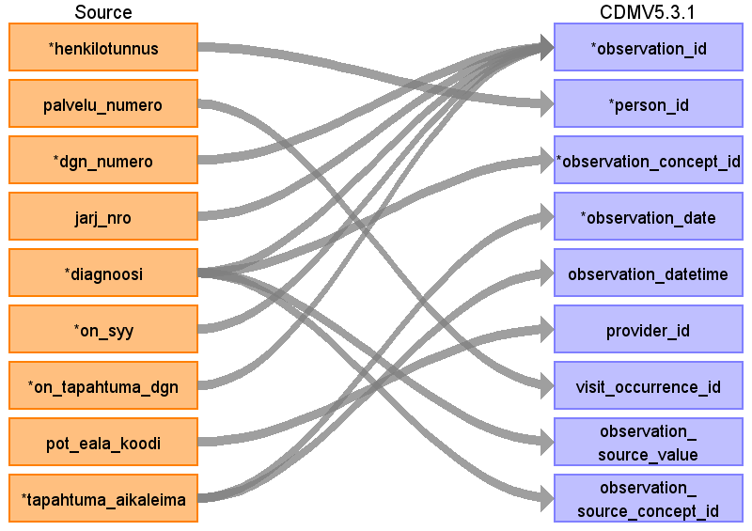

|  |  |  |  |
| --- | --- | --- | --- |
| Destination Field | Source Field | Logic | Comment |
| observation_id | dgn_numero  jarj_nro  diagnoosi  on_syy  on_tapahtuma_dgn |  | The primary key of a diagnosis in mv_diagnoosi is multi-column. There, observation_id is generated for each unique combination of dgn_numero + jarj_nro + on_syy + on_tapahtuma_dgn + observation_concept_id. Observation_id will be generated during the ETL process so that it covers all combinations and these combinations will get unique primary key in every case. |
| person_id | henkilotunnus | Henkilotunnus will be converted to person_id using link table link_henkilotunnus_to_pseudonym_to_person_id. |  |
| observation_concept_id | diagnoosi |  |  |
| observation_date | tapahtuma_aikaleima |  |  |
| observation_datetime | tapahtuma_aikaleima |  |  |
| observation_type_concept_id |  |  | For pathology-related source tables, this is 32835 EHR Pathology report. For lab-related source tables, this is 32856 Lab. For other tables, this is 32817 EHR. |
| value_as_number |  |  |  |
| value_as_string |  |  |  |
| value_as_concept_id |  |  | Positive assertions, so using concept_id 4188539 meaning "Yes". |
| qualifier_concept_id |  |  |  |
| unit_concept_id |  |  | Positive assertions, so using concept_id 4188539 meaning "Yes" |
| provider_id | pot_eala_koodi | using link table eala_to_provider_id | Pathology data are not linked to medical specialties or providers |
| visit_occurrence_id | palvelu_numero | using link table palvelu_numero_to_visit_occurrence_id | Pathology data are not linked to visits |
| visit_detail_id |  |  |  |
| observation_source_value | diagnoosi |  |  |
| observation_source_concept_id | diagnoosi |  | Only those Finnish ICD10 values thare are present in the ICD10 version in OMOP |
| unit_source_value |  |  |  |
| qualifier_source_value |  |  |  |

Reading from mv_toimenpide

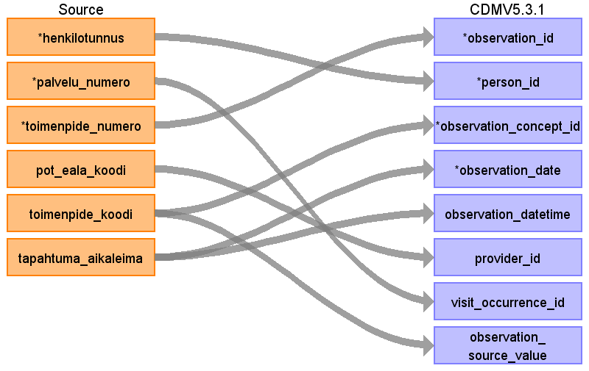

|  |  |  |  |
| --- | --- | --- | --- |
| Destination Field | Source Field | Logic | Comment |
| observation_id | toimenpide_numero | toimenpide_numero is the primary key of procedure in source data. Some procedure data in the source tables maps to the Observation domain. The Observation table will be appended with unional result of three different source tables, 1) mv_toimenpide, 2) mv_radu_vsshp and 3) mv_opera_leikkaus_toimenpide. Observation_id will be generated during the ETL process so that it covers all rows from all three different sources and there will be unique primary key in every case. |  |
| person_id | henkilotunnus | Henkilotunnus will be converted to person_id using link table link_henkilotunnus_to_pseudonym_to_person_id. |  |
| observation_concept_id | toimenpide_koodi |  | Translated from Finnish NCSP codes to Standard Concepts in Snomed. |
| observation_date | tapahtuma_aikaleima |  |  |
| observation_datetime | tapahtuma_aikaleima |  |  |
| observation_type_concept_id |  |  | For pathology-related source tables, this is 32835 EHR Pathology report. For lab-related source tables, this is 32856 Lab. For other tables, this is 32817 EHR. |
| value_as_number |  |  |  |
| value_as_string |  |  |  |
| value_as_concept_id |  |  | Positive assertions, so using concept_id 4188539 meaning "Yes". |
| qualifier_concept_id |  |  |  |
| unit_concept_id |  |  | Positive assertions, so using concept_id 4188539 meaning "Yes" |
| provider_id | pot_eala_koodi |  | Pathology data are not linked to medical specialties or providers |
| visit_occurrence_id | palvelu_numero |  | Pathology data are not linked to visits |
| visit_detail_id |  |  |  |
| observation_source_value | toimenpide_koodi |  |  |
| observation_source_concept_id |  |  |  |
| unit_source_value |  |  |  |
| qualifier_source_value |  |  |  |

Reading from mv_opera_leikkaus_toimenpide

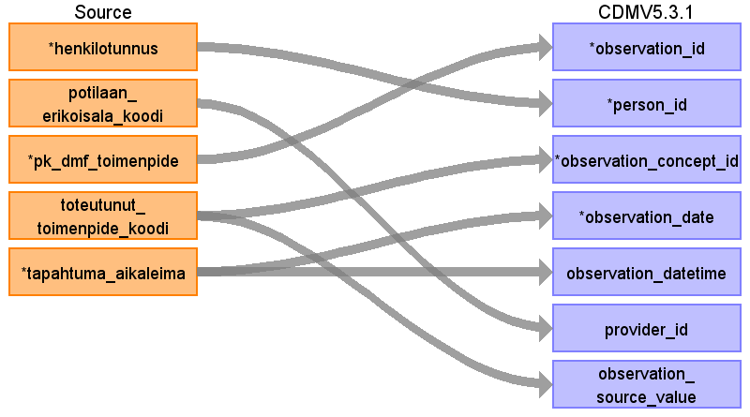

|  |  |  |  |
| --- | --- | --- | --- |
| Destination Field | Source Field | Logic | Comment |
| observation_id | pk_dmf_toimenpide | pk_dmf_toimenpide is the primary key of procedure in source data. Some procedure data in the source tables maps to the observation domain. Observation table will be appended with unional result of three different procedure source tables, 1) mv_toimenpide, 2) mv_radu_vsshp and 3) mv_opera_leikkaus_toimenpide. Observation_id will be generated during the ETL process so that it covers all rows from all three different sources and there will be unique primary key in every case. |  |
| person_id | henkilotunnus | Henkilotunnus will be converted to person_id using link table link_henkilotunnus_to_pseudonym_to_person_id. |  |
| observation_concept_id | toteutunut_toimenpide_koodi |  |  |
| observation_date | tapahtuma_aikaleima |  |  |
| observation_datetime | tapahtuma_aikaleima |  |  |
| observation_type_concept_id |  |  | For pathology-related source tables, this is 32835 EHR Pathology report. For lab-related source tables, this is 32856 Lab. For other tables, this is 32817 EHR. |
| value_as_number |  |  |  |
| value_as_string |  |  |  |
| value_as_concept_id |  |  | Positive assertions, so using concept_id 4188539 meaning "Yes". |
| qualifier_concept_id |  |  |  |
| unit_concept_id |  |  | Positive assertions, so using concept_id 4188539 meaning "Yes" |
| provider_id | potilaan_erikoisala_koodi |  | Pathology data are not linked to medical specialties or providers |
| visit_occurrence_id |  |  | Pathology data are not linked to visits |
| visit_detail_id |  |  |  |
| observation_source_value | toteutunut_toimenpide_koodi |  |  |
| observation_source_concept_id |  |  |  |
| unit_source_value |  |  |  |
| qualifier_source_value |  |  |  |

Reading from mv_radu_vsshp

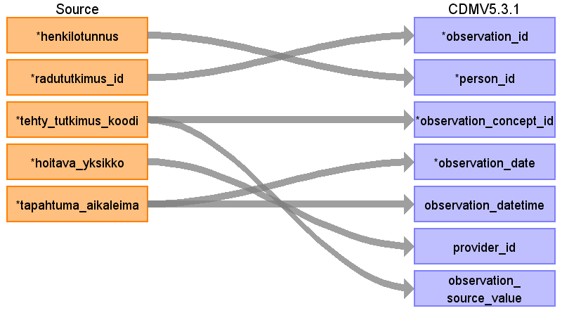

|  |  |  |  |
| --- | --- | --- | --- |
| Destination Field | Source Field | Logic | Comment |
| observation_id | radututkimus_id | radututkimus_id is the primary key of procedure in source data.Some procedure data in the source tables maps to the Observation domain. Observation table will be appended with unional result of three different source table, 1) mv_toimenpide, 2) mv_radu_vsshp and 3) mv_opera_leikkaus_toimenpide. Observation_id will be generated during the ETL process so that it covers all rows from all three different sources and there will be unique primary key in every case. |  |
| person_id | henkilotunnus | Henkilotunnus will be converted to person_id using link table link_henkilotunnus_to_pseudonym_to_person_id. |  |
| observation_concept_id | tehty_tutkimus_koodi |  |  |
| observation_date | tapahtuma_aikaleima |  |  |
| observation_datetime | tapahtuma_aikaleima |  |  |
| observation_type_concept_id |  |  | For pathology-related source tables, this is 32835 EHR Pathology report. For lab-related source tables, this is 32856 Lab. For other tables, this is 32817 EHR. |
| value_as_number |  |  |  |
| value_as_string |  |  |  |
| value_as_concept_id |  |  | Positive assertions, so using concept_id 4188539 meaning "Yes". |
| qualifier_concept_id |  |  |  |
| unit_concept_id |  |  | Positive assertions, so using concept_id 4188539 meaning "Yes" |
| provider_id | hoitava_yksikko |  | Pathology data are not linked to medical specialties or providers |
| visit_occurrence_id |  |  | Pathology data are not linked to visits |
| visit_detail_id |  |  |  |
| observation_source_value | tehty_tutkimus_koodi |  |  |
| observation_source_concept_id |  |  |  |
| unit_source_value |  |  |  |
| qualifier_source_value |  |  |  |

Reading from mv_labra_vsshp

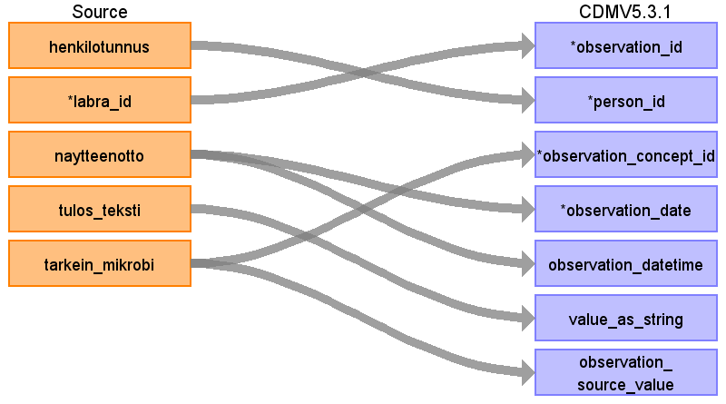

|  |  |  |  |
| --- | --- | --- | --- |
| Destination Field | Source Field | Logic | Comment |
| observation_id | labra_id | labra_id is the primary key of lab test in source data. Some lab tests map to Observation domain. | Observation_id will be generated during the ETL process as source_code could be mapped to multiple destination concepts. |
| person_id | henkilotunnus | Henkilotunnus will be converted to person_id using link table link_henkilotunnus_to_pseudonym_to_person_id. |  |
| observation_concept_id | tarkein_mikrobi |  |  |
| observation_date | naytteenotto |  |  |
| observation_datetime | naytteenotto |  |  |
| observation_type_concept_id |  |  | For pathology-related source tables, this is 32835 EHR Pathology report. For lab-related source tables, this is 32856 Lab. For other tables, this is 32817 EHR. |
| value_as_number |  |  |  |
| value_as_string | tulos_teksti |  |  |
| value_as_concept_id |  |  | Positive assertions, so using concept_id 4188539 meaning "Yes". |
| qualifier_concept_id |  |  |  |
| unit_concept_id |  |  | Positive assertions, so using concept_id 4188539 meaning "Yes" |
| provider_id |  |  | Pathology data are not linked to medical specialties or providers |
| visit_occurrence_id |  |  | Pathology data are not linked to visits |
| visit_detail_id |  |  |  |
| observation_source_value | tarkein_mikrobi |  |  |
| observation_source_concept_id |  |  |  |
| unit_source_value |  |  |  |
| qualifier_source_value |  |  |  |

Table name: visit_detail

Table name: device_exposure

Reading from mv_toimenpide

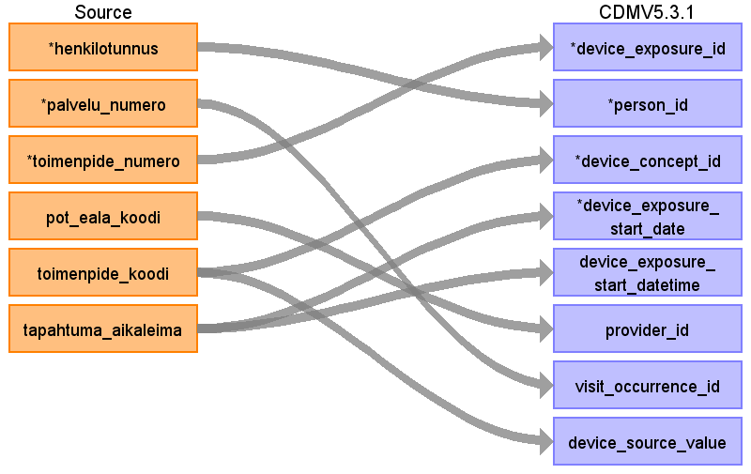

|  |  |  |  |
| --- | --- | --- | --- |
| Destination Field | Source Field | Logic | Comment |
| device_exposure_id | toimenpide_numero | toimenpide_numero is the primary key of procedure in source data. Some procedure data in the source tables maps to the Device domain. The Device_exposure table will be appended with unional result of three different source tables, 1) mv_toimenpide, 2) mv_radu_vsshp and 3) mv_opera_leikkaus_toimenpide. Device_exposure_id will be generated during the ETL process so that it covers all rows from all three different sources and there will be unique primary key in every case. |  |
| person_id | henkilotunnus | Henkilotunnus will be converted to person_id using link table link_henkilotunnus_to_pseudonym_to_person_id. | Translated from Finnish NCSP codes to Standard Concepts. |
| device_concept_id | toimenpide_koodi |  |  |
| device_exposure_start_date | tapahtuma_aikaleima |  |  |
| device_exposure_start_datetime | tapahtuma_aikaleima |  |  |
| device_exposure_end_date |  |  |  |
| device_exposure_end_datetime |  |  |  |
| device_type_concept_id |  |  | 32817 EHR |
| unique_device_id |  |  |  |
| quantity |  |  |  |
| provider_id | pot_eala_koodi |  |  |
| visit_occurrence_id | palvelu_numero |  |  |
| visit_detail_id |  |  |  |
| device_source_value | toimenpide_koodi |  |  |
| device_source_concept_id |  |  |  |

Reading from mv_opera_leikkaus_toimenpide

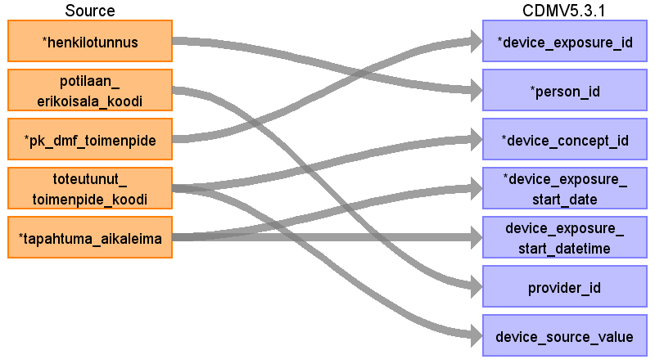

|  |  |  |  |
| --- | --- | --- | --- |
| Destination Field | Source Field | Logic | Comment |
| device_exposure_id | pk_dmf_toimenpide | pk_dmf_toimenpide is the primary key of procedure in source data. Device_exposure table will be filled with unional result of three different source table, 1) mv_toimenpide, 2) mv_radu_vsshp and 3) mv_opera_leikkaus_toimenpide. Device_exposure_id will be generated during the ETL process so that it covers all rows from all three different sources and there will be unique primary key in every case. |  |
| person_id | henkilotunnus | Henkilotunnus will be converted to person_id using link table link_henkilotunnus_to_pseudonym_to_person_id. |  |
| device_concept_id | toteutunut_toimenpide_koodi |  |  |
| device_exposure_start_date | tapahtuma_aikaleima |  |  |
| device_exposure_start_datetime | tapahtuma_aikaleima |  |  |
| device_exposure_end_date |  |  |  |
| device_exposure_end_datetime |  |  |  |
| device_type_concept_id |  |  | 32817 EHR |
| unique_device_id |  |  |  |
| quantity |  |  |  |
| provider_id | potilaan_erikoisala_koodi |  |  |
| visit_occurrence_id |  |  |  |
| visit_detail_id |  |  |  |
| device_source_value | toteutunut_toimenpide_koodi |  |  |
| device_source_concept_id |  |  |  |

Reading from mv_radu_vsshp

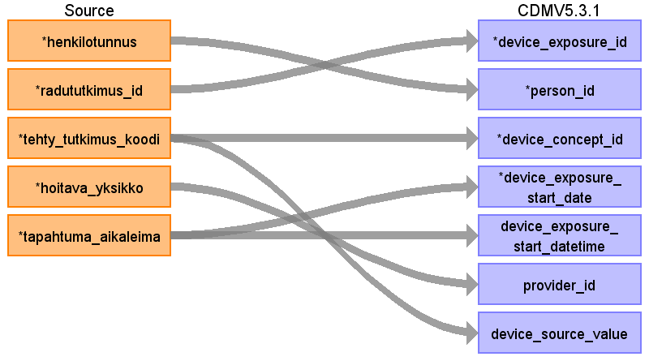

|  |  |  |  |
| --- | --- | --- | --- |
| Destination Field | Source Field | Logic | Comment |
| device_exposure_id | radututkimus_id | radututkimus_id is the primary key of procedure in source data. Some procedure data in the source tables maps to the Device domain. Device_exposure table will be appended with unional result of three different source table, 1) mv_toimenpide, 2) mv_radu_vsshp and 3) mv_opera_leikkaus_toimenpide. Device_exposure_id will be generated during the ETL process so that it covers all rows from all three different sources and there will be unique primary key in every case. |  |
| person_id | henkilotunnus | Henkilotunnus will be converted to person_id using link table link_henkilotunnus_to_pseudonym_to_person_id. |  |
| device_concept_id | tehty_tutkimus_koodi |  |  |
| device_exposure_start_date | tapahtuma_aikaleima |  |  |
| device_exposure_start_datetime | tapahtuma_aikaleima |  |  |
| device_exposure_end_date |  |  |  |
| device_exposure_end_datetime |  |  |  |
| device_type_concept_id |  |  | 32817 EHR |
| unique_device_id |  |  |  |
| quantity |  |  |  |
| provider_id | hoitava_yksikko |  |  |
| visit_occurrence_id |  |  |  |
| visit_detail_id |  |  |  |
| device_source_value | tehty_tutkimus_koodi |  |  |
| device_source_concept_id |  |  |  |

Table name: specimen

Table name: fact_relationship

Table name: observation_period

The observation_period table is filled with the help of cdm_help.help_observation_period table. The formulation of this table is shown in ETL script 005_help_observation_period.sql. The logic on high level, as pseudo-SQL:

with cte as (select min and max from each source table group by person),

select overall min and max/death_date per person, incrementing the max by 60 days

One person will have only one observation period.

Reading from mv_palvelu

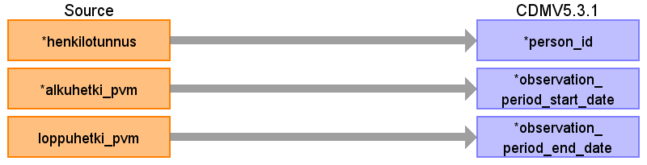

|  |  |  |  |
| --- | --- | --- | --- |
| Destination Field | Source Field | Logic | Comment |
| observation_period_id |  |  | Extract the min and max timestamp of the person from each source table into help_observation_period table. From there, calculate the total min and max to form the final information for observation_period. Observation_period_id is an auto-increment primary key. |
| person_id | henkilotunnus | Henkilotunnus will be converted to person_id using link table link_henkilotunnus_to_pseudonym_to_person_id. |  |
| observation_period_start_date | alkuhetki_pvm |  | The minimum for the person accross all tables. Diagnosis and minor procedure tables are not included in the determination of observation periods because all diagnoses and minor procedures are connected to visits, so periods inferred from visits (from mv_palvelu) are sufficient for this purpose. |
| observation_period_end_date | loppuhetki_pvm |  | The maximum for the person accross all tables. Diagnosis and minor procedure tables are not included in the determination of observation periods because all diagnoses and minor procedures are connected to visits, so periods inferred from visits (from mv_palvelu) are sufficient for this purpose.  Observation Period end date:  If the person is dead:  Date of death + 60 days is a Themis convention to allow events after death.  If the person is not dead:  Last clinical event + 60 days is the assumption is a person will return to the same health provider if an adverse reaction/complication/unresolved condition occurs. |
| period_type_concept_id |  |  | 32817 EHR |

Reading from mv_opera_leikkaus_toimenpide

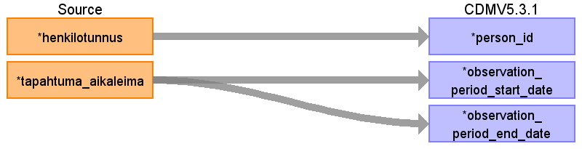

|  |  |  |  |
| --- | --- | --- | --- |
| Destination Field | Source Field | Logic | Comment |
| observation_period_id |  |  | Extract the min and max timestamp of the person from each source table into help_observation_period table. From there, calculate the total min and max to form the final information for observation_period. Observation_period_id is an auto-increment primary key. |
| person_id | henkilotunnus | Henkilotunnus will be converted to person_id using link table link_henkilotunnus_to_pseudonym_to_person_id. |  |
| observation_period_start_date | tapahtuma_aikaleima |  | The minimum for the person accross all tables. Diagnosis and minor procedure tables are not included in the determination of observation periods because all diagnoses and minor procedures are connected to visits, so periods inferred from visits (from mv_palvelu) are sufficient for this purpose. |
| observation_period_end_date | tapahtuma_aikaleima |  | The maximum for the person accross all tables. Diagnosis and minor procedure tables are not included in the determination of observation periods because all diagnoses and minor procedures are connected to visits, so periods inferred from visits (from mv_palvelu) are sufficient for this purpose.  Observation Period end date:  If the person is dead:  Date of death + 60 days is a Themis convention to allow events after death.  If the person is not dead:  Last clinical event + 60 days is the assumption is a person will return to the same health provider if an adverse reaction/complication/unresolved condition occurs. |
| period_type_concept_id |  |  | 32817 EHR |

Reading from mv_radu_vsshp



|  |  |  |  |
| --- | --- | --- | --- |
| Destination Field | Source Field | Logic | Comment |
| observation_period_id |  |  | Extract the min and max timestamp of the person from each source table into help_observation_period table. From there, calculate the total min and max to form the final information for observation_period. Observation_period_id is an auto-increment primary key. |
| person_id | henkilotunnus | Henkilotunnus will be converted to person_id using link table link_henkilotunnus_to_pseudonym_to_person_id. |  |
| observation_period_start_date | tapahtuma_aikaleima |  | The minimum for the person accross all tables. Diagnosis and minor procedure tables are not included in the determination of observation periods because all diagnoses and minor procedures are connected to visits, so periods inferred from visits (from mv_palvelu) are sufficient for this purpose. |
| observation_period_end_date | tapahtuma_aikaleima |  | The maximum for the person accross all tables. Diagnosis and minor procedure tables are not included in the determination of observation periods because all diagnoses and minor procedures are connected to visits, so periods inferred from visits (from mv_palvelu) are sufficient for this purpose.  Observation Period end date:  If the person is dead:  Date of death + 60 days is a Themis convention to allow events after death.  If the person is not dead:  Last clinical event + 60 days is the assumption is a person will return to the same health provider if an adverse reaction/complication/unresolved condition occurs. |
| period_type_concept_id |  |  | 32817 EHR |

Reading from mv_labra_vsshp

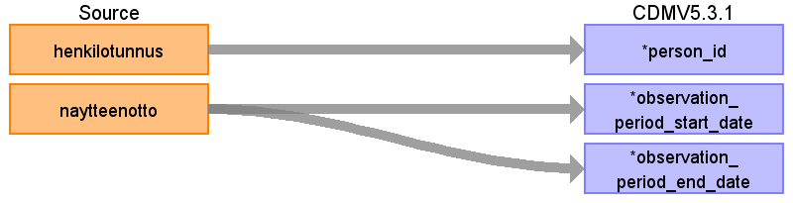

|  |  |  |  |
| --- | --- | --- | --- |
| Destination Field | Source Field | Logic | Comment |
| observation_period_id |  |  | Extract the min and max timestamp of the person from each source table into help_observation_period table. From there, calculate the total min and max to form the final information for observation_period. Observation_period_id is an auto-increment primary key. |
| person_id | henkilotunnus | Henkilotunnus will be converted to person_id using link table link_henkilotunnus_to_pseudonym_to_person_id. |  |
| observation_period_start_date | naytteenotto |  | The minimum for the person accross all tables. Diagnosis and minor procedure tables are not included in the determination of observation periods because all diagnoses and minor procedures are connected to visits, so periods inferred from visits (from mv_palvelu) are sufficient for this purpose. |
| observation_period_end_date | naytteenotto |  | The maximum for the person accross all tables. Diagnosis and minor procedure tables are not included in the determination of observation periods because all diagnoses and minor procedures are connected to visits, so periods inferred from visits (from mv_palvelu) are sufficient for this purpose.  Observation Period end date:  If the person is dead:  Date of death + 60 days is a Themis convention to allow events after death.  If the person is not dead:  Last clinical event + 60 days is the assumption is a person will return to the same health provider if an adverse reaction/complication/unresolved condition occurs. |
| period_type_concept_id |  |  | 32817 EHR |

Reading from v_resepti

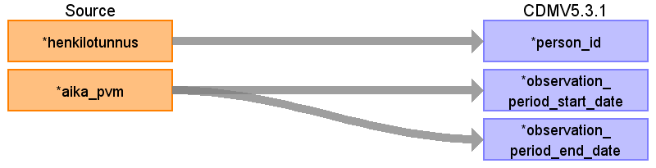

|  |  |  |  |
| --- | --- | --- | --- |
| Destination Field | Source Field | Logic | Comment |
| observation_period_id |  |  | Extract the min and max timestamp of the person from each source table into help_observation_period table. From there, calculate the total min and max to form the final information for observation_period. Observation_period_id is an auto-increment primary key. |
| person_id | henkilotunnus | Henkilotunnus will be converted to person_id using link table link_henkilotunnus_to_pseudonym_to_person_id. |  |
| observation_period_start_date | aika_pvm |  | The minimum for the person accross all tables. Diagnosis and minor procedure tables are not included in the determination of observation periods because all diagnoses and minor procedures are connected to visits, so periods inferred from visits (from mv_palvelu) are sufficient for this purpose. |
| observation_period_end_date | aika_pvm |  | The maximum for the person accross all tables. Diagnosis and minor procedure tables are not included in the determination of observation periods because all diagnoses and minor procedures are connected to visits, so periods inferred from visits (from mv_palvelu) are sufficient for this purpose.  Observation Period end date:  If the person is dead:  Date of death + 60 days is a Themis convention to allow events after death.  If the person is not dead:  Last clinical event + 60 days is the assumption is a person will return to the same health provider if an adverse reaction/complication/unresolved condition occurs. |
| period_type_concept_id |  |  | 32817 EHR |

Reading from mv_laakemaarays

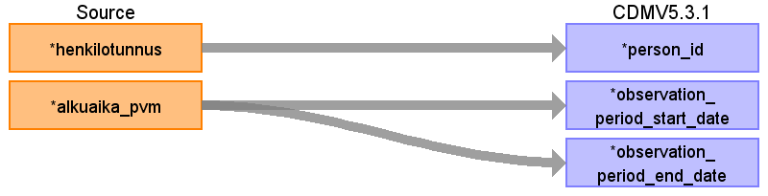

|  |  |  |  |
| --- | --- | --- | --- |
| Destination Field | Source Field | Logic | Comment |
| observation_period_id |  |  | Extract the min and max timestamp of the person from each source table into help_observation_period table. From there, calculate the total min and max to form the final information for observation_period. Observation_period_id is an auto-increment primary key. |
| person_id | henkilotunnus | Henkilotunnus will be converted to person_id using link table link_henkilotunnus_to_pseudonym_to_person_id. |  |
| observation_period_start_date | alkuaika_pvm |  | The minimum for the person accross all tables. Diagnosis and minor procedure tables are not included in the determination of observation periods because all diagnoses and minor procedures are connected to visits, so periods inferred from visits (from mv_palvelu) are sufficient for this purpose. |
| observation_period_end_date | alkuaika_pvm |  | End date is also taken from alkuaika, because it is not 100% certain that the patient is still in the hospital at the end date of the inpatient drug prescription.  The maximum for the person accross all tables. Diagnosis and minor procedure tables are not included in the determination of observation periods because all diagnoses and minor procedures are connected to visits, so periods inferred from visits (from mv_palvelu) are sufficient for this purpose.  Observation Period end date:  If the person is dead:  Date of death + 60 days is a Themis convention to allow events after death.  If the person is not dead:  Last clinical event + 60 days is the assumption is a person will return to the same health provider if an adverse reaction/complication/unresolved condition occurs. |
| period_type_concept_id |  |  | 32817 EHR |

Reading from v_potilaan_hoitokuurit

Extract the min and max timestamp of the person from each source table into help_observation_period table. From there, calculate the total min and max to form the final information for observation_period.

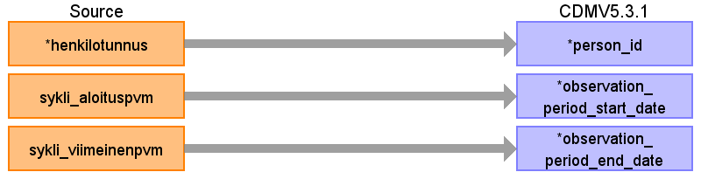

|  |  |  |  |
| --- | --- | --- | --- |
| Destination Field | Source Field | Logic | Comment |
| observation_period_id |  |  | Extract the min and max timestamp of the person from each source table into help_observation_period table. From there, calculate the total min and max to form the final information for observation_period. Observation_period_id is an auto-increment primary key. |
| person_id | henkilotunnus | Henkilotunnus will be converted to person_id using link table link_henkilotunnus_to_pseudonym_to_person_id. |  |
| observation_period_start_date | sykli_aloituspvm |  | The minimum for the person accross all tables. Diagnosis and minor procedure tables are not included in the determination of observation periods because all diagnoses and minor procedures are connected to visits, so periods inferred from visits (from mv_palvelu) are sufficient for this purpose. |
| observation_period_end_date | sykli_viimeinenpvm |  | The maximum for the person accross all tables. Diagnosis and minor procedure tables are not included in the determination of observation periods because all diagnoses and minor procedures are connected to visits, so periods inferred from visits (from mv_palvelu) are sufficient for this purpose.  Observation Period end date:  If the person is dead:  Date of death + 60 days is a Themis convention to allow events after death.  If the person is not dead:  Last clinical event + 60 days is the assumption is a person will return to the same health provider if an adverse reaction/complication/unresolved condition occurs. |
| period_type_concept_id |  |  | 32817 EHR |

Reading from mv_patologia_elin_diagnoosi_vsshp

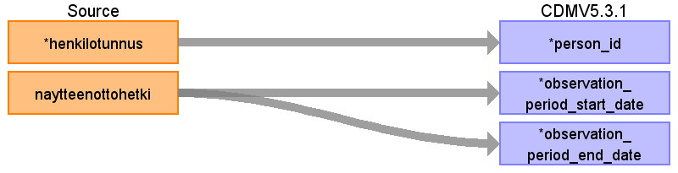

|  |  |  |  |
| --- | --- | --- | --- |
| Destination Field | Source Field | Logic | Comment |
| observation_period_id |  |  | Extract the min and max timestamp of the person from each source table into help_observation_period table. From there, calculate the total min and max to form the final information for observation_period. Observation_period_id is an auto-increment primary key. |
| person_id | henkilotunnus | Henkilotunnus will be converted to person_id using link table link_henkilotunnus_to_pseudonym_to_person_id. |  |
| observation_period_start_date | naytteenottohetki |  | The minimum for the person accross all tables. Diagnosis and minor procedure tables are not included in the determination of observation periods because all diagnoses and minor procedures are connected to visits, so periods inferred from visits (from mv_palvelu) are sufficient for this purpose. |
| observation_period_end_date | naytteenottohetki |  | The maximum for the person accross all tables. Diagnosis and minor procedure tables are not included in the determination of observation periods because all diagnoses and minor procedures are connected to visits, so periods inferred from visits (from mv_palvelu) are sufficient for this purpose.  Observation Period end date:  If the person is dead:  Date of death + 60 days is a Themis convention to allow events after death.  If the person is not dead:  Last clinical event + 60 days is the assumption is a person will return to the same health provider if an adverse reaction/complication/unresolved condition occurs. |
| period_type_concept_id |  |  | 32817 EHR |

Table name: note

Table name: note_nlp

Table name: cohort

Table name: cohort_attribute

Table name: condition_era

Table name: dose_era

Table name: drug_era

Table name: cost

Table name: payer_plan_period

Table name: location

Table name: cdm_source

Table name: metadata

Table name: attribute_definition

Table name: cohort_definition

Appendix: source tables

Table: v_demografiatiedot

|  |  |  |  |
| --- | --- | --- | --- |
| Field | Type | Most freq. value | Comment |
| henkilotunnus | character varying |  | Finnish social security number |
| sukupuoli_selite | character varying | NAINEN | Sex |
| syntymaaika_pvm | date |  | Birth date |
| kuolinaika_pvm | date |  | Death date |
| sukunimi | character varying |  |  |
| etunimi | character varying | POIKA |  |
| jakeluosoite | character varying |  |  |
| postinumero | character varying |  |  |
| postitoimipaikka | character varying |  |  |
| ammatti | character varying |  |  |
| aidinkieli_selite | character varying | suomi |  |
| pot_kotikunta_selite | character varying | TUNTEMATON |  |
| pot_kotikunta_koodi | character varying | 853 |  |
| vrk_kotikunta_selite | character varying |  |  |
| vrk_kotikunta_koodi | character varying |  |  |
| ominaisuus1 | character varying | VSSHP |  |
| paivityshetki_stage | timestamp without time zone | 2017-08-21 10:01:36.275802 |  |
| tapahtuma_aikaleima | timestamp without time zone |  |  |

Table: mv_palvelu

|  |  |  |  |
| --- | --- | --- | --- |
| Field | Type | Most freq. value | Comment |
| henkilotunnus | character varying |  | Finnish social security number |
| potilasnumero | character varying |  |  |
| palvelu_numero | character varying |  | Primary key of visit or episode of care |
| varaus_numero | character varying |  |  |
| varaushetki_pvm | date |  |  |
| kotikunta_selite | character varying | TURKU |  |
| kayntityyppi_selite | character varying | 01 Poliklinikkakäynti | The type of visit, such as visit to doctor, phone call, visit to nurse, multidisciplinary treatment meeting etc. |
| kayntityyppi_tarkenne_selite | character varying |  | Further specification of type of visit, such as emergency, multidisciplinary, containing procedure, phone call, etc. |
| alkuhetki_pvm | timestamp without time zone |  | start date |
| alkuhetki_min | character varying | 1000 | start time |
| loppuhetki_pvm | timestamp without time zone |  | end date |
| loppuhetki_min | character varying | 2359 | end time |
| vo_toimipiste_koodi | character varying | ECU |  |
| yksikko_nimi | character varying | Päivystys |  |
| tulosyksikko | character varying | TO6 |  |
| tulosyksikko_selite | text | Operatiivinen toiminta ja syöpätaudit |  |
| vastuualue | character varying | SYO |  |
| pot_eala_koodi | character varying | 70 | medical specialty code |
| pot_eala_selite | character varying | PSYKIATRIA |  |
| kustannuspaikka | text | TO6E |  |
| hoi_laakari_koodi | character varying |  |  |
| hoi_laakari_nimi | character varying |  |  |
| hoi_laakari_yksilointitunnus | character varying |  |  |
| res_koodi | character varying |  | resource code. Resource is a term used for a wide range of specific mecical functions that can be offered to a patient, such as orthopedic outpatient reception or radiotherapy treatment session. |
| res_selite | character varying | Lääkärin vastaanotto | The verbal description explaining the meaning of resource code (res_koodi) |
| siirto_palvelulta | character varying |  |  |
| hoiko_numero | character varying |  |  |
| tulotapa_selite | character varying |  |  |
| mista_tuli_selite | character varying | Koti |  |
| jatkoh_laitos_nimi | character varying |  |  |
| siirto_pkl_os | character varying |  |  |
| siirto_os_os | character varying |  |  |
| siirto_osastolle | character varying |  |  |
| jh_selite | character varying |  |  |
| laitossiirto | character varying |  |  |
| jatkoh_toimipiste_nimi | character varying |  |  |
| palvelumuoto | text | kaynti | Mode of service. Either visit (outpatient) or episode of care (inpatient). |
| view_refreshed | timestamp with time zone | 2021-04-09 01:17:21.949071+03 |  |
| paivityshetki_stage | timestamp without time zone | 2017-08-21 10:11:28.007806 |  |
| tapahtuma_aikaleima | timestamp without time zone |  | event timestamp |

Table: mv_diagnoosi

|  |  |  |  |
| --- | --- | --- | --- |
| Field | Type | Most freq. value | Comment |
| henkilotunnus | character varying |  | Finnish social security number |
| potilasnumero | character varying |  |  |
| dgn_pvm | timestamp without time zone |  |  |
| ika | integer | 72 |  |
| palvelu_numero | character varying |  | Primary key of visit or episode of care |
| kotikunta_selite | character varying | TURKU |  |
| dgn_numero | character varying |  | One component of the primary key of diagnosis. This is the original primary key of the separate source tables where acute and long term diagnoses are taken from to form the mv_diagnoosi materialized view. As such, it is not necessarily unique in mv_diagnoosi. |
| jarj_nro | numeric | 1 |  |
| diagnoosi | character varying | I10 | Finnish ICD10 code of the diagnosis |
| on_syy | boolean | true | Whether the diagnosis was marked as a cause or a symptom of the patient's problem |
| on_tapahtuma_dgn | boolean | true | Whether the diagnosis is acutely relevant to the visit where it was marked (TRUE) or whether it is marked as a background long-term diagnosis (FALSE). |
| selite | character varying | Essentiaalinen (primaarinen) verenpainetauti |  |
| paadgn | character varying | 1 | Whether the diagnosis is primary (TRUE) or secundary (FALSE) in this visit |
| tarkenne1 | character varying |  |  |
| tarkenne2 | character varying |  |  |
| vo_toimipiste_koodi | character varying | SYO |  |
| yksikko_nimi | character varying | Syöpäklinikka |  |
| tulosyksikko | character varying | TO5 |  |
| tulosyksikko_selite | text | Medisiininen |  |
| vastuualue | character varying | SYO |  |
| kustannuspaikka | text | TO6E |  |
| res_koodi | character varying |  | resource code. Resource is a term used for a wide range of specific mecical functions that can be offered to a patient, such as orthopedic outpatient reception or radiotherapy treatment session. |
| res_selite | character varying | Lääkärin vastaanotto | The verbal description explaining the meaning of resource code (res_koodi) |
| pot_eala_koodi | character varying | 70 | medical specialty code |
| pot_eala_selite | character varying | PSYKIATRIA |  |
| paivityshetki_stage | timestamp without time zone | 2017-08-21 10:11:28.007806 |  |
| tapahtuma_aikaleima | timestamp without time zone |  | event timestamp |

Table: mv_labra_vsshp

|  |  |  |  |
| --- | --- | --- | --- |
| Field | Type | Most freq. value | Comment |
| henkilotunnus | character varying |  | Finnish social security number |
| labra_id | bigint |  | Primary key of the lab data |
| tutkimusriviavain | text |  |  |
| naytetunnus | text |  |  |
| putkien_lkm | text | 0 |  |
| naytteenotto | timestamp without time zone |  | Timestamp when sample was taken |
| paatutkimuspaketti | character varying | Selite puuttuu (0 ) |  |
| tutkimus | character varying | B-HKR (1358) | A combination of a textual and numeric code that describes the lab test. E.g. B-HKR (1358) means hematocrit (HKR) measured from blood (B-). Some explanation for these codes is found in source table dim_tutkimus. These codes are mostly from the Finnish lab terminology and will be translated to Standard Concepts in Loinc. |
| tutkimuksen_tyyppi | character varying |  |  |
| tulos_teksti | text | tehty | Result of lab test. This can be numeric, textual, pos/neg, or just a value indicating "test done" |
| tuloksen_mittayksikko | text |  | Unit of the measurement. The following uninterpretable values are filtered out: 'Lausunto', 'LAUSUNTO', '930', 'bakt/ml'. |
| tarkein_mikrobi | character varying | Tieto puuttuu | main microbe that was found in the sample (only filled for tests that target microbial findings) |
| viitearvo_min | double precision |  | Age and sex specific reference minimum value |
| viitearvo_max | double precision |  | Age and sex specific reference maximum value |
| viitearvojen_ulkopuolella | character varying | Ei |  |
| tilaaja_taso_0 | character varying | TYKS |  |
| tilaaja_taso_1 | character varying | TYKS-TA5-Medisiininen |  |
| tilaaja_taso_2 | character varying | 950-teho-osasto |  |
| tilaaja_taso_3 | character varying | 950-teho-os |  |
| ulkoinen_asiakas | character varying | Ei |  |
| kiireellinen_tutkimus | character varying | Ei |  |
| ulkopuolella_teetetty | character varying | Ei |  |
| projektin_tunnus | character varying |  |  |
| sisainen_kustannus | double precision | 0.0 |  |
| laskutettu_hinta | double precision | 0.0 |  |
| paivityshetki_main | timestamp without time zone | 2016-11-28 15:43:22.038022 |  |
| stage_labdw_transform_id | bigint |  |  |
| potilas_asia_id | bigint |  |  |
| lahde_koodi_id | integer |  |  |
| tiedon_omistaja_koodi_id | integer |  |  |
| tiedon_omistaja | character varying |  |  |
| potilas_id | bigint |  |  |
| vastaus_kuuluu_vsshp | boolean | true |  |
| tapahtuma_aikaleima | timestamp without time zone |  | event timestamp |

Table: mv_toimenpide

|  |  |  |  |
| --- | --- | --- | --- |
| Field | Type | Most freq. value | Comment |
| henkilotunnus | character varying |  | Finnish social security number |
| tyyppi | text | paa |  |
| palvelu_numero | character varying |  | Primary key of visit or episode of care |
| toimenpide_numero | character varying |  |  |
| rivi_numero | double precision | 1.0 |  |
| toimenpidekok_numero | character varying |  |  |
| palvelu_tunnus | character varying | KÄYNTI |  |
| pot_eala_koodi | character varying |  | medical specialty code |
| pot_eala_selite | character varying |  |  |
| kayntityyppi_koodi | character varying | 25 |  |
| kayntityyppi_selite | character varying | 01 Poliklinikkakäynti |  |
| toimenpide_koodi | character varying | XF400 | Mainly Nomesco NCSP (Finnish adaptation) codes describing the procedure |
| toimenpide_selite | character varying | 12-KYTKENTÄINEN EKG |  |
| ominaisuus1 | character varying |  |  |
| ominaisuus2 | character varying |  |  |
| ominaisuus3 | character varying |  |  |
| kiireellinen | character varying | 0 |  |
| toimenpide_hetki_pvm | date |  |  |
| toimenpide_hetki_min | character varying |  |  |
| suor_toimipiste_koodi | character varying |  |  |
| suor_toimipiste_nimi | character varying |  |  |
| vo_toimipiste_koodi | character varying | SYO |  |
| vo_toimipiste_nimi | character varying | SYO |  |
| luontihetki_s | timestamp without time zone |  |  |
| toimenpidekok_lkm | double precision | 1.0 |  |
| lisa_tmp_lkm | double precision | 0.0 |  |
| muutos_syy | character varying |  |  |
| muutos_selite | character varying |  |  |
| paivityshetki_stage | timestamp without time zone | 2017-08-21 10:49:12.777335 |  |
| tapahtuma_aikaleima | timestamp without time zone |  | event timestamp |

Table: mv_radu_vsshp

|  |  |  |  |
| --- | --- | --- | --- |
| Field | Type | Most freq. value | Comment |
| henkilotunnus | character varying |  | Finnish social security number |
| radulahete_id | bigint |  |  |
| radututkimus_id | bigint |  | Primary key of radiology procedure source data |
| tehty_tutkimus_koodi | character varying | GD1AA | Mainly Nomesco NCSP (Finnish adaptation) codes describing the procedure |
| tehty_tutkimus_selite | character varying | Thoraxin röntgen |  |
| tutkimuksen_tyyppi | character varying |  |  |
| tutkimusryhman_selite | character varying | NATIIVITUTKIMUS |  |
| tutkimushetki | timestamp without time zone |  |  |
| onko_paivystys | character varying | E |  |
| tutkimuksen_hinta | numeric | 0.00 |  |
| lahetehetki | timestamp without time zone |  |  |
| ajanvaraushetki | timestamp without time zone |  |  |
| tilaava_yksikko | character varying | ECT301F |  |
| hoitava_yksikko | character varying | ECT301F | The unit ordering the radiology examination. A unit operates under a specific medical specialty. |
| ulkopuolinen_tutkimus | integer | 0 |  |
| suorittava_toimipiste | character varying | 940 |  |
| kuvaushuone_lyhenne | character varying | 940/21 |  |
| potilaan_kotikunta | character varying | 853 |  |
| lausunto_idt | character varying |  |  |
| tutkimuksen_ac_numero | character varying |  |  |
| dw_radututkimus_id | bigint |  |  |
| dw_tutkimus_paivityshetki | timestamp without time zone | 2013-02-27 14:05:30.503000 |  |
| dw_lahete_paivityshetki | timestamp without time zone | 2013-02-27 14:05:30.503000 |  |
| on_tiede | boolean | false |  |
| tiedeluvannumero | character varying |  |  |
| tiedeluvannimi | character varying |  |  |
| paivityshetki_stage | timestamp without time zone |  |  |
| tapahtuma_aikaleima | timestamp without time zone |  | event timestamp |

Table: mv_opera_leikkaus_toimenpide

|  |  |  |  |
| --- | --- | --- | --- |
| Field | Type | Most freq. value | Comment |
| henkilotunnus | character varying |  | Finnish social security number |
| pk_dmf_leikkaus | bigint |  |  |
| leikkaus_tmp_act_id | bigint |  |  |
| hoitopaatospvm | date |  |  |
| varaus_pvm | character varying |  |  |
| suunniteltu_pvm | date |  |  |
| toteutunut_pvm | date |  |  |
| pituus | character varying |  |  |
| paino | character varying |  |  |
| asa_luokka | character varying | ASA 2 |  |
| kiireellisyys_luokka | character varying | h. 1-3 kk |  |
| potilaan_erikoisala_koodi | character varying | 20O |  |
| potilaan_erikoisala_nimi | character varying | ORTOPEDIA JA TRAUMATOLOGIA |  |
| hoitava_osasto_koodi | character varying | OFT |  |
| hoitava_osasto_nimi | character varying | SILMÄKLINIKKA |  |
| hoitava_laitos_koodi | character varying | 50230K |  |
| hoitava_laitos_nimi | character varying | TURUN YLIOPISTOLLINEN KESKUSSAIRAALA |  |
| toimenpideosasto_koodi | character varying | UTOTEK |  |
| toimenpideosasto_nimi | character varying | U-SAIRAALAN TOIMENPIDEPALVELUT |  |
| lahettava_osasto_koodi | character varying | OFTAB3 |  |
| lahettava_osasto_nimi | character varying | OFTAB3 Päiki Silmäklinikka |  |
| jatkohoito_osasto_koodi | character varying | KOTI |  |
| jatkohoito_osasto_nimi | character varying | KOTI |  |
| jonoonasetuspvm | timestamp without time zone |  |  |
| jonottamisen_syy | character varying |  |  |
| leikkaussali_koodi | character varying | SLOS-2 |  |
| leikkaussali_nimi | character varying | SLOS-2 |  |
| anestesiamuotovalue | character varying | 120 Yleisanestesia |  |
| lahettavayksikkovalue | character varying | OFTAB3 Päiki Silmäklinikka |  |
| potilasryhmavalue | character varying |  |  |
| pk_dmf_toimenpide | bigint |  | Primary key of procedure |
| toimenpide_act_id | bigint |  |  |
| toteutunut_toimenpide_koodi | character varying | WX408 | Mainly Nomesco NCSP (Finnish adaptation) codes describing the procedure |
| toteutunut_toimenpide_nimi | character varying | YLEISANESTESIAN YLLÄPITO SEKÄ LASKIMOON ANNETTAVALLA ETTÄ INHALOITAVALLA ANESTEETILLA |  |
| diagnoosi_koodi | character varying |  |  |
| diagnoosi_nimi | character varying |  |  |
| preopdiagnoosicodein | character varying |  |  |
| preopdiagnoosivalue | character varying |  |  |
| postopdiagnoosicodein | character varying |  |  |
| postopdiagnoosivalue | character varying |  |  |
| toimenpide_laakari | character varying | Westerlund Taina |  |
| puolisuus_koodi | character varying |  |  |
| puolisuus_nimi | character varying |  |  |
| on_paatoimenpide | smallint | 0 |  |
| on_anestesiatoimenpide | smallint | 0 |  |
| on_paivystys | smallint | 0 |  |
| on_ajanvaraus | smallint | 1 |  |
| tulotapa | character varying | PÄIKI |  |
| suunniteltu_toimenpide_koodi | character varying |  |  |
| suunniteltu_toimenpide_nimi | character varying |  |  |
| toimenpide_paivityshetki_stage | timestamp without time zone |  |  |
| potilassaliin | timestamp without time zone |  |  |
| potilassalista | timestamp without time zone |  |  |
| leikkausalkanut | timestamp without time zone |  |  |
| leikkausvalmis | timestamp without time zone |  |  |
| leikkauksenkesto | character varying | 01:00 |  |
| potilaskotiin | timestamp without time zone |  |  |
| potilasvalmiskotiin | timestamp without time zone |  |  |
| tapahtuma_aikaleima | timestamp without time zone |  | event timestamp |

Table: v_resepti

|  |  |  |  |
| --- | --- | --- | --- |
| Field | Type | Most freq. value | Comment |
| henkilotunnus | character varying |  | Finnish social security number |
| resepti_numero | character varying |  | Primary key of outpatient prescription |
| atc_koodi | character varying | N02BE01 | ATC code of the prescribed drug |
| atc_selite | character varying |  |  |
| laakeaine | character varying | parasetamoli |  |
| laakeainetyyppi | text | vaikuttava_aine |  |
| kauppanimi | character varying | BURANA |  |
| aika_pvm | date |  | date of prescription |
| aika_min | character varying |  | time component of prescription timestamp |
| annostelu | character varying |  |  |
| annos | character varying | 100 kpl |  |
| pakkauskoko_kokonaismaara | numeric | 100.00 |  |
| pakkaus_lkm | smallint | 1 |  |
| kestoaika | integer |  |  |
| kestoaika_yksikko_selite | character varying |  |  |
| vahvuus | character varying | 500 mg |  |
| muoto | character varying | tabletti, kalvopäällysteinen |  |
| paivittaja_yksikko_koodi | character varying | ECU | The unit where the prescription was made. A unit operates under a specific medical specialty. |
| paivittaja_yksikko_nimi | character varying | ECU |  |
| paivityshetki_stage | timestamp without time zone | 2017-08-21 11:25:47.556976 |  |
| tapahtuma_aikaleima | timestamp without time zone |  | event timestamp |

Table: mv_laakemaarays

|  |  |  |  |
| --- | --- | --- | --- |
| Field | Type | Most freq. value | Comment |
| henkilotunnus | character varying |  | Finnish social security number |
| laakemaarays_numero | character varying |  | Primary key of inpatient prescription |
| kauppanimi | character varying | OXYNORM |  |
| vaikuttava_aine | character varying | parasetamoli |  |
| atc_koodi | character varying | N02BE01 | ATC code of the prescribed drug |
| vahvuus | character varying | 5 mg |  |
| muoto | character varying | tabl |  |
| antotapa_koodi | character varying | PO | Code describing the route of administration (based on latin) |
| antotapa_selite | character varying | suun kautta, nieltäväksi |  |
| kotilaake | smallint | 0 |  |
| n_laake | smallint | 0 |  |
| antibiootti | smallint | 0 |  |
| ex_tempore | smallint | 0 |  |
| alkuaika_pvm | date |  | date of prescription |
| alkuaika_min | character varying | 0000 | time component of prescription timestamp |
| loppuaika_pvm | date |  | end date of validity of prescription |
| loppuaika_min | character varying |  | time component of end of validity of prescription |
| lopetus_syy_koodi | character varying |  |  |
| lopetus_syy_selite | character varying |  |  |
| poisto_syy_koodi | character varying |  |  |
| poisto_syy_selite | character varying |  |  |
| muutos_syy_koodi | character varying |  |  |
| muutos_syy_selite | character varying |  |  |
| maarayksen_tila_koodi | smallint | 0 |  |
| maarayksen_tila_selite | character varying | Normaali |  |
| maaraystapa_koodi | character varying |  |  |
| maaraystapa_selite | character varying |  |  |
| annostelu_tyyppi_koodi | character varying | REGULAR |  |
| annostelu_tyyppi_selite | character varying | Säännöllinen |  |
| annostelu_profylaksia | smallint | 0 |  |
| annostelu_lisatieto | character varying |  |  |
| annostelu_eril_ohje | character varying |  |  |
| annostelu_tarv_annos | character varying |  |  |
| annostelu_tarv_pvm_max_annos | numeric |  |  |
| annostelu_annos | numeric |  |  |
| annostelu_annos_yksikko | character varying | MG |  |
| annostelu_esilaake | smallint |  |  |
| annostelu_saan_pvm_annos | integer |  |  |
| annostelu_muuttuva_toistuvuus | character varying |  |  |
| annostelu_muuttuva_ajan_tyyppi | character varying |  |  |
| annostelu_voimassaolo_pvm | date |  |  |
| annostelu_suun_antoaika | character varying |  |  |
| rivi_numero | integer | 0 |  |
| poisto_aika_pvm | date |  |  |
| poisto_aika_min | character varying |  |  |
| kotilaake_arv_alkuaika | date |  |  |
| kotilaake_arv_loppuaika | date |  |  |
| kirjaaja_toimipiste_koodi | character varying | COR | The unit where the prescription was made. A unit operates under a specific medical specialty. |
| kirjaaja_toimipiste_nimi | character varying | COR |  |
| paivityshetki_stage | timestamp without time zone | 2017-08-21 11:00:23.886267 |  |
| tapahtuma_aikaleima | timestamp without time zone |  | event timestamp |

Table: v_potilaan_hoitokuurit

|  |  |  |  |
| --- | --- | --- | --- |
| Field | Type | Most freq. value | Comment |
| henkilotunnus | character varying |  | Finnish social security number |
| potilaan_hoitokuuri_numero | character varying |  |  |
| hoitokuuri_numero | character varying | 918799060111062214 |  |
| hoitokuurin_nimi | character varying | KAPESITABIINI |  |
| aloituspaiva | smallint | 1 |  |
| jarjestysnumero | smallint | 1 |  |
| projektinumero | character varying |  |  |
| tutkimusnumero | character varying |  |  |
| hoidon_vaste | character varying |  |  |
| zubrod | character varying |  |  |
| tavoite_markkeri | character varying |  |  |
| pituus | numeric | 170.0 |  |
| paino | numeric | 70.0 |  |
| laskenta_pvm | date |  |  |
| laskettu_pinta_ala | double precision | 1.75 |  |
| kaytetty_pinta_ala | double precision | 2.0 |  |
| kreatiini | double precision | 0.0 |  |
| hoidon_kreatiini | double precision | 0.0 |  |
| ika | smallint | 66 |  |
| sukupuoli | character varying | NAINEN |  |
| sykli | smallint | 21 |  |
| sykli_aloituspvm | date |  | Chemotherapy cycle start date. A cycle is a (usually repeating) schedule of drug combination administration. E.g. a cycle can be 21 days long, and drugs A, B and C can be administered on days 1, 8, and 15, respectively. |
| sykli_viimeinenpvm | date |  | Chemotherapy cycle end date. A cycle is a (usually repeating) schedule of drug combination administration. E.g. a cycle can be 21 days long, and drugs A, B and C can be administered on days 1, 8, and 15, respectively. |
| keskeytetty | character varying | 0 |  |
| keskeytyksen_syy | character varying |  |  |
| ohjeet | character varying | ja |  |
| paivityshetki_s | timestamp without time zone |  |  |
| tiedon_paivittaja | character varying | TUKIAINS |  |
| paivityshetki_ods | timestamp without time zone | 2018-01-25 20:01:10.000000 |  |
| tapahtuma_aikaleima | timestamp without time zone |  | event timestamp |

Table: v_potilaan_syopalaakkeet

|  |  |  |  |
| --- | --- | --- | --- |
| Field | Type | Most freq. value | Comment |
| henkilotunnus | character varying |  | Finnish social security number |
| potilaan_syopalaake_numero | character varying |  | Primary key of chemotherapy drug row |
| potilaan_hoitokuuri_numero | character varying |  | Foreign key referencing v_potilaan_hoitokuurit. |
| vnr_numero | character varying |  |  |
| geneerinen_nimi | character varying | Fluorourasiili | Name of active ingredient in Finnish. |
| kauppanimi | character varying | Fluorourasiili-inj/infuusioneste 0 Fluorourasiili |  |
| biologinen_laake | character varying | 1 |  |
| vahvuus | character varying | inj/inf 0 |  |
| antojarjestysnumero | smallint | 1 |  |
| sivuvaikutukset | character varying | ja |  |
| antotapa_koodi | character varying | IV | Code describing the route of administration (based on latin) |
| antotapa_selite | character varying | iv |  |
| maksimi_kerta_annos | double precision |  |  |
| annosmaara | double precision | 600.0 |  |
| hoitokuurin_perusannosmaara | double precision | 600.0 |  |
| maksimi_kum_annosmaara | double precision |  |  |
| annoskaava_koodi | character varying | MG/M2 |  |
| annoskaava_selite | character varying | mg/m2 |  |
| kaytetty_annos | double precision | 100.0 |  |
| infuusioneste_koodi | character varying | NACL |  |
| infuusioneste_selite | character varying | NaCl |  |
| infuusion_kesto | character varying |  |  |
| infuusion_kesto_yksikko | character varying | 1 |  |
| infuusiomaara | smallint | 250 |  |
| maksimi_infuusiomaara | smallint |  |  |
| lisatiedot | character varying |  |  |
| tiputusohjelma | character varying | 1 |  |
| lopetus_pvm | date |  |  |
| lopetus_syy | character varying |  |  |
| apteekista_tilattava | smallint | 0 |  |
| laakitysviennin_id | character varying |  |  |
| paivityshetki_s | timestamp without time zone |  |  |
| tiedon_paivittaja | character varying | RISTAMAR |  |
| paivityshetki_ods | timestamp without time zone |  |  |
| tapahtuma_aikaleima | timestamp without time zone |  | event timestamp |

Table: mv_patologia_elin_diagnoosi_vsshp

|  |  |  |  |
| --- | --- | --- | --- |
| Field | Type | Most freq. value | Comment |
| henkilotunnus | character varying |  | Finnish social security number |
| patologia_elin_diagnoosi_id | bigint |  | Primary key of pathological diagnosis data |
| patologia_vastaus_id | bigint |  |  |
| naytenumero | character varying |  |  |
| pyynto | integer |  |  |
| vastaus | integer |  |  |
| rivinumero | integer |  |  |
| elin_etuliite | character varying |  |  |
| elin | character varying |  | Verbal explanation (mainly English) of T-Snomed code |
| elin_takaliite | character varying |  |  |
| diagnoosi | character varying |  | Verbal explanation (mainly English) of M-Snomed code |
| diagnoosi_takaliite | character varying |  |  |
| t_snomed | character varying |  | Topography code based loosely on 1980's print copy of Snomed II. |
| m_snomed | character varying |  | Morphology code based loosely on 1980's print copy of Snomed II. |
| naytteenottohetki | timestamp without time zone |  | Sampling time for specimen which this analysis is based on |
| ktp_paivityshetki | timestamp without time zone |  |  |
| tapahtuma_aikaleima | timestamp without time zone |  | event timestamp |

Table: dim_tutkimus

Lab vocabulary. No person-specific data. Will not be mapped to any CDM table.

|  |  |  |  |
| --- | --- | --- | --- |
| Field | Type | Most freq. value | Comment |
| id | integer |  |  |
| lyhenne | character varying |  |  |
| nimi | character varying |  |  |
| kuntaliiton_numero | character varying |  |  |
| erikoisala | character varying | KEMIA |  |
| ulkoinen_tunniste | integer |  |  |
| dw_luonti_aika | timestamp without time zone |  |  |
| dw_muutos_aika | timestamp without time zone |  |  |
| paivityshetki_stage_carein | timestamp without time zone | 2017-02-17 15:06:00.298000 |  |

Table: mv_patologia_taulukkoarvo_vsshp

|  |  |  |  |
| --- | --- | --- | --- |
| Field | Type | Most freq. value | Comment |
| henkilotunnus | character varying |  | Finnish social security number |
| patologia_taulukkoarvo_id | bigint |  |  |
| patologia_vastaus_id | bigint |  |  |
| naytenumero | character varying |  |  |
| pyynto | integer | 1 |  |
| vastaus | integer | 1 |  |
| taulukon_nimi | character varying | SOLULÖYDÖS.tbl | Name of sructured table template in which the pathologist fills data (e.g. RINTASYÖVÄN OMINAISUUDET.7.tbl = "Properties of breast cancer, table template v7") |
| suure | character varying | Neutrofiilejä: | The name of the analyte or feature of the sample that is being observed, e.g. tumor grade or percentage of sample cells that are of a specific type. |
| arvo | character varying | + | Value of the analyte or feature being observed. May be numeric, boolean or free text. |
| naytteenottohetki | timestamp without time zone |  | Sampling time for specimen which this analysis is based on |
| ktp_paivityshetki | timestamp without time zone | 2019-08-22 22:44:17.001095 |  |
| tapahtuma_aikaleima | timestamp without time zone |  | event timestamp |