R Notebook

This is an [R Markdown](http://rmarkdown.rstudio.com) Notebook. When you execute code within the notebook, the results appear beneath the code.

Try executing this chunk by clicking the *Run* button within the chunk or by placing your cursor inside it and pressing *Cmd+Shift+Enter*.

wierd code disappear

plot(cars)

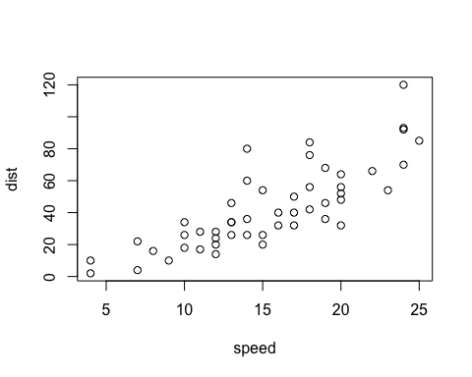

Add a new chunk by clicking the *Insert Chunk* button on the toolbar or by pressing *Cmd+Option+I*.

When you save the notebook, an HTML file containing the code and output will be saved alongside it (click the *Preview* button or press *Cmd+Shift+K* to preview the HTML file).

head(cars)

## speed dist  
## 1 4 2  
## 2 4 10  
## 3 7 4  
## 4 7 22  
## 5 8 16  
## 6 9 10