Analiz Raporu

# Veri setinin genel bilgileri:

None

# Temel istatistikler:

Timestamp Gender Country Occupation self_employed family_history treatment Days_Indoors Growing_Stress Changes_Habits Mental_Health_History Mood_Swings Coping_Struggles Work_Interest Social_Weakness mental_health_interview care_options  
count 292364 292364 292364 292364 287162 292364 292364 292364 292364 292364 292364 292364 292364 292364 292364 292364 292364  
unique 580 2 35 5 2 2 2 5 3 3 3 3 2 3 3 3 3  
top 8/27/2014 11:43 Male United States Housewife No No Yes 1-14 days Maybe Yes No Medium No No Maybe No No  
freq 2384 239850 171308 66351 257994 176832 147606 63548 99985 109523 104018 101064 154328 105843 103393 232166 118886

# Eksik veriler:

Timestamp 0  
Gender 0  
Country 0  
Occupation 0  
self_employed 5202  
family_history 0  
treatment 0  
Days_Indoors 0  
Growing_Stress 0  
Changes_Habits 0  
Mental_Health_History 0  
Mood_Swings 0  
Coping_Struggles 0  
Work_Interest 0  
Social_Weakness 0  
mental_health_interview 0  
care_options 0

# Kapalı Geçirilen Günler Dağılımı

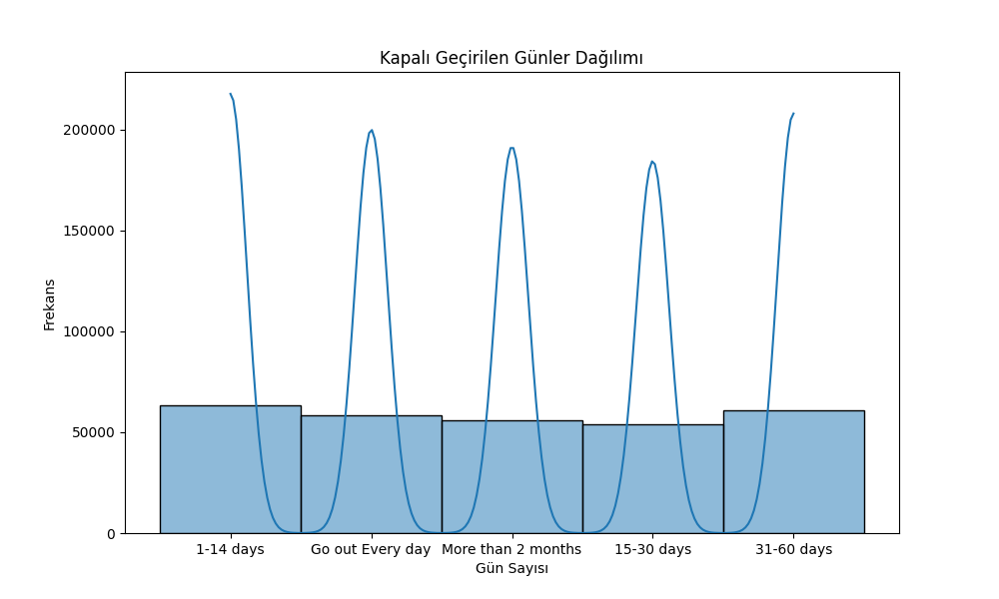

# Ailede mental sağlık geçmişi olanların yüzdesi:

No 60.483507  
Yes 39.516493

# İş İlgi Düzeyi Dağılımı

