******GALGOTIAS UNIVERSITY

Plot No.2, Sector -17 A, Yamuna Expressway,

Greater Noida, Gautam Buddha Nagar, U.P., India

SCHOOL OF COMPUTING SCIENCE & ENGINEERING

CAT-3 Case Study Report File Submission

ON

ROBOTICS

Course Name: ARTIFICIAL INTELLIGENCE

Course Code: BCSE2354

School: SCSE

Program: B.Tech

Year: 2nd Semester: 3

Session: 2022-2023

|  |  |
| --- | --- |
| Submitted By: | Submitted To: |
| SHRISTI YADAV -21SCSE1011202  SHAGUN SAHU – 21SCSE1010748  RESHAM KUMARI- 21SCSE1011245 | Mazid Abdul |

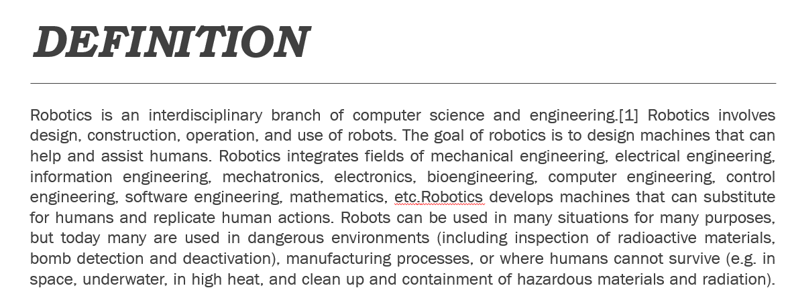

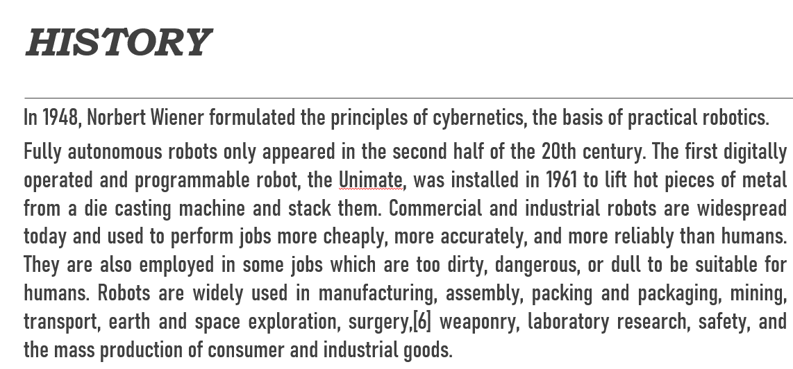

***APPLICATIONS***

* As more and more robots are designed for specific tasks, this method of classification becomes more relevant. For example, many robots are designed for assembly work, which may not be readily adaptable for other applications. They are termed "assembly robots". For seam welding, some suppliers provide complete welding systems with the robot i.e. the welding equipment along with other material handling facilities like turntables, etc. as an integrated unit. Such an integrated robotic system is called a "welding robot" even though its discrete manipulator unit could be adapted to a variety of tasks. Some robots are specifically designed for heavy load manipulation, and are labeled as "heavy-duty robots".[29] Current and potential applications include:
* Military robots.
* Industrial robots. Robots are increasingly used in manufacturing (since the 1960s). According to the Robotic Industries Association US data, in 2016 the automotive industry was the main customer of industrial robots with 52% of total sales.[30] In the auto industry, they can amount for more than half of the "labor". There are even "lights off" factories such as an IBM keyboard manufacturing factory in Texas that was fully automated as early as 2003.[31]

***HUMAN-ROBOT INTERACTION***

Kismet can produce a range of facial expressions.

The state of the art in sensory intelligence for robots will have to progress through several orders of magnitude if we want the robots working in our homes to go beyond vacuum-cleaning the floors. If robots are to work effectively in homes and other non-industrial environments, the way they are instructed to perform their jobs, and especially how they will be told to stop will be of critical importance. The people who interact with them may have little or no training in robotics, and so any interface will need to be extremely intuitive. Science fiction authors also typically assume that robots will eventually be capable of communicating with humans through speech, gestures, and facial expressions, rather than a command-line interface. Although speech would be the most natural way for the human to communicate, it is unnatural for the robot. It will probably be a long time before robots interact as naturally as the fictional C-3PO, or Data of Star Trek, Next Generation. Even though the current state of robotics cannot meet the standards of these robots from science-fiction, robotic media characters (e.g., Wall-E, R2-D2) can elicit audience sympathies that increase people's willingness to accept actual robots in the future.

***CONTROL***

The mechanical structure of a robot must be controlled to perform tasks.[153] The control of a robot involves three distinct phases – perception, processing, and action (robotic paradigms).[154] Sensors give information about the environment or the robot itself (e.g. the position of its joints or its end effector). This information is then processed to be stored or transmitted and to calculate the appropriate signals to the actuators (motors), which move the mechanical structure to achieve the required co-ordinated motion or force actions.The processing phase can range in complexity. At a reactive level, it may translate raw sensor information directly into actuator commands (e.g. firing motor power electronic gates based directly upon encoder feedback signals to achieve the required torque/velocity of the shaft). Sensor fusion and internal models may first be used to estimate parameters of interest (e.g. the position of the robot's gripper) from noisy sensor data. An immediate task (such as moving the gripper in a certain direction until an object is detected with a proximity sensor) is sometimes inferred from these estimates. Techniques from control theory are generally used to convert the higher-level tasks into individual commands that drive the actuators, most often using kinematic and dynamic models of the mechanical structure.

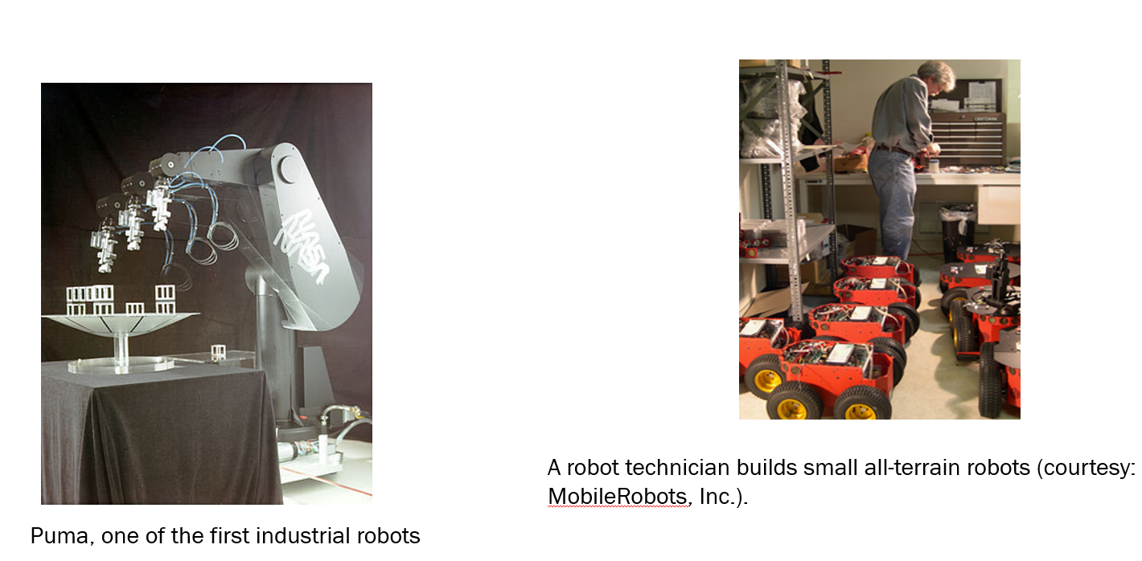

***EMPLOYMENT***

* Robotics is an essential component in many modern manufacturing environments. As factories increase their use of robots, the number of robotics–related jobs grow and have been observed to be steadily rising.[170] The employment of robots in industries has increased productivity and efficiency savings and is typically seen as a long-term investment for benefactors. A paper by Michael Osborne and Carl Benedikt Frey found that 47 percent of US jobs are at risk to automation "over some unspecified number of years".[171] These claims have been criticized on the ground that social policy, not AI, causes unemployment.[172] In a 2016 article in The Guardian, Stephen Hawking stated "The automation of factories has already decimated jobs in traditional manufacturing, and the rise of artificial intelligence is likely to extend this job destruction deep into the middle classes, with only the most caring, creative or supervisory roles remaining".[173]According to a GlobalData September 2021 report, the robotics industry was worth $45bn in 2020, and by 2030, it will have grown at a compound annual growth rate (CAGR) of 29% to $568bn, driving jobs in robotics and related industries.

**USER EXPERIENCE**

Great user experience predicts the needs, experiences, behaviors, language and cognitive abilities, and other factors of each user group. It then uses these insights to produce a product or solution that is ultimately useful and usable. For robots, user experience begins with an understanding of the robot's intended task and environment, while considering any possible social impact the robot may have on human operations and interactions with it.[179]

It defines that communication as the transmission of information through signals, which are elements perceived through touch, sound, smell and sight.[180] The author states that the signal connects the sender to the receiver and consists of three parts: the signal itself, what it refers to, and the interpreter. Body postures and gestures, facial expressions, hand and head movements are all part of nonverbal behavior and communication. Robots are no exception when it comes to human-robot interaction. Therefore, humans use their verbal and nonverbal behaviors to communicate their defining characteristics. Similarly, social robots need this coordination to perform human-like behaviors.

